## Cell properties panel

The cell properties panel provides detailed information about the estimation cell including data, suppression reasons, and underlying schedules. If the post-estimation screening option is enabled, you can also modify the confidentiality of schedules and rescreen existing estimates.

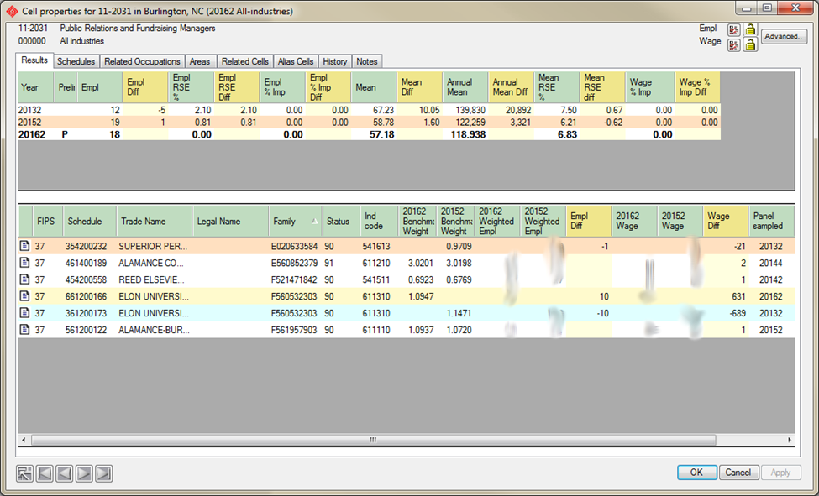

### Navigation buttons

Navigation buttons provide a convenient way of moving between cells. The cell order is established on the “Results” tab or “Search” panel by double-clicking on a column header.

back The “back” button returns control back to the panel that the cell properties panel was launched from. It is useful if multiple cell panels are active.

first The “first” button is used to display the first cell in the sorted list that the cell properties panel was launched from.

prev The “prev” button is used to display the previous cell in the sorted list that the cell properties panel was launched from.

next The “next” button is used to display the next cell in the sorted list that the cell properties panel was launched from.

last The “last” button is used to display the last cell in the sorted list that the cell properties panel was launched from.

### Cell Properties - Results Tab

This tab indicates historical results and cell composition for the cell.



### The top table compares the current cell against any historical results on file for the same geographic area, industry, occupation, and ownership. The current cell is shown in bold.

### *The geographies selected are based on the counties or towns selected for the estimate rather than the assigned geocodes. If this year’s area definition has changed from previous years, you may not see historical data.*

### *Because area composition is matched rather than the geocodes, other comparable estimates may appear. For example, a workforce area that is composed of exactly the same counties as this year’s MSA may be used to review changes.*

### The bottom table compares the component schedules for a prior year with the current one. To select a prior year, click on an estimate in the top table. The bottom table then displays all schedules in both estimates.

### Schedules in common between both estimates are white. These may also be identified by entries in both benchmark weight columns.

### Schedules that are in the compared estimate but are not in the current one appear blue. These may also be identified by entries in the right benchmark weight column but no entry in the left benchmark weight column.

### Schedules that are in the compared estimate but not in the current one appear yellow. These may also be identified by entries in the left benchmark weight column but no entry in the right benchmark weight column.

### *Tips:*

### *To reorder the table on a specific column, click on its column heading.*

### *To reorder columns, drag the column to the desired location.*

### If a schedule has comments in SPAM and those comments have been imported into Lewis, you can view those comments by clicking the icon in the first column.

### To view the detailed microdata for a schedule, double click on that schedule.

### Marking a cell for BLS review:

### On the Notes tab, indicate the justification and click Apply or OK.

### Cell Properties - Schedules tab

This tab indicates the schedules used in the calculation of the cell. And, it provides a convenient way to view the data reported on a schedule or release it when an employer gives permission to do so. This tab also provides the ability to designate “poison schedules”.

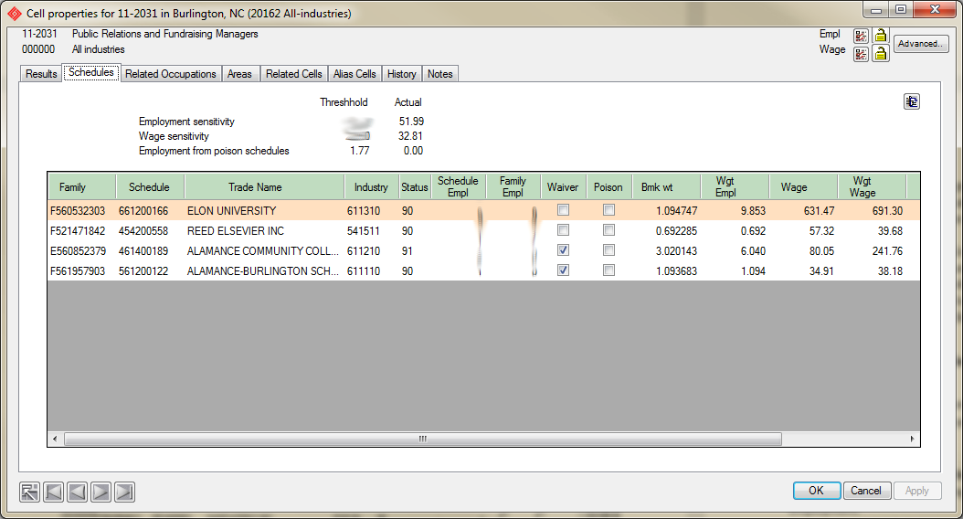

 The copy to clipboard button copies the tabular results to the clipboard. From there, it can be pasted into a variety of programs including Wordpad and Excel.

Tip: These lists of underlying schedules are produced by the standard employment estimation process and by either the standard or alternate wage estimation methods. Since all cells on file are not required to utilize these methods, underlying schedules may not always be available.

In particular, cells imported from a BLS publication file have no underlying schedules supplied in the publication file. If you want to see the underlying schedules, you must use LEWIS to estimate the cells.

Additionally, cells calculated using the alternate employment estimation method currently display no underlying schedules for the employment portion of the cell. The strata tab offers a method of determining how the result was derived. If it becomes necessary to view individual schedules or microdata for a strata, estimate the area and industry level shown for the staffing pattern using LEWIS and view its cell details.

#### Modifying Schedule Confidentiality and Rescreening Results

If the totals at the top of the panel are displayed in red, it indicates that family employment for the top employer or the top two employers exceeds the thresholds for those tests.

The **Schedules Used In Calculating This Cell** table shows all schedules that reported this occupation and the current confidentiality setting for each schedule. These are ordered by decreasing family employment.

To change the setting for a schedule, click its release box either on or off. A checked box indicates that employer has either given permission to release the data or the data is public information as might be the case for government employees. Beginning with 4.0, cells are not immediately rescreened. You must “Apply” the change (or “Close” the panel) for the change to take effect.

*Note: In accordance with BLS’s confidentiality procedure, you must make a separate election for each schedule sent to the employer. The election will apply to all occupations reported on the schedule for that year. This election will remain in effect for all future estimates that you calculate.*

When all desired changes are made, click Close. At that point, all cells for all modified schedules will be rescreened. Depending on the number and complexity of these schedules, this may take considerable time. A log will indicate progress and record any changes made to cell confidentialities.

*Note: Post-estimation screening may not always be possible for all cells. Depending on the setting of the “Enable post-estimation screening” option on the “Estimate Options” tab at the time the estimates were calculated or pub files were imported, the component schedules, necessary for rescreening, may not have been tracked.*

#### Poison Schedules

Beginning with LEWIS 4.0, an analyst may designate a schedule as “poison”.

To understand this concept, consider what might happen if you dropped a box of rat pellets in the ocean. While it might be noticed by a few local members of the fish community, it would largely go unnoticed. Put that same amount in your fish tank at home and all the inhabitants would be floating belly-up on the surface in no time. Its effect in a larger body of water ultimately depends on how much "dilution" takes place. Questionable data, if diluted enough in the final result, probably doesn't matter in the long run. But, the more questionable data in a cell the more likely that cell's results are going to be questionable too.

Every experienced analyst has seen these. Maybe the data was imputed from a donor that did not adequately represent the non-responding unit. Perhaps, the cell was an actual response but you can clearly see that the answers provided are out of line with reality.

As a default, any cell that has weighted “poison” employment in excess of 10% of the cells sum total “wage” employment is automatically suppressed.

This designation is remembered. So, any cells that may be created in the future that utilize that schedule will also consider that schedule's contribution as "poison". This leverages screening work already done and reduces the effort needed to get new estimates ready for publication.

*Note: This process affects WAGES only. Differences in employment are addressed during the imputation and benchmarking processes.*

To designate "poison" schedules, check the “poison” box on the appropriate. This is done on the "Cell properties" panel by checking the “poison” box in much the same way that you would check the “release” box to indicate a waiver. The threshold poison employment based on current screening criteria and accumulated poison employment is shown at the top of the tab.

When the contribution of "poison employment" to a cell's overall result exceeds a pre-defined percentage, the accumulated poison employment turns red. This indicates that the cell will fail the test when the changes made on the panel are applied.

### Cell Properties - Strata Tab

This tab is only available if the alternate employment calculation was in effect when the cell was calculated.

It indicates which strata were used to calculate the cell and how estimated employment results are distributed across them. It also indicates which staffing pattern has been applied to each strata.

It is possible to sort the data on any column by double-clicking on the column header. Double-clicking a second time on the header reverses the order.

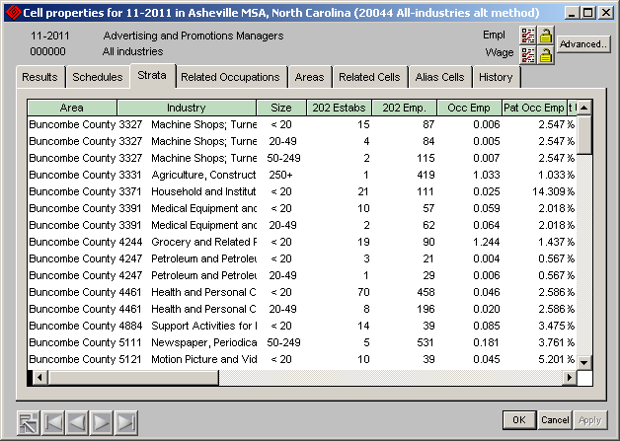

### Cell Properties – Related Occupations Tab

This tab is only available if one or more “related occupations” have been defined for the selected occupation and cells were produced for those occupations in the current estimate.

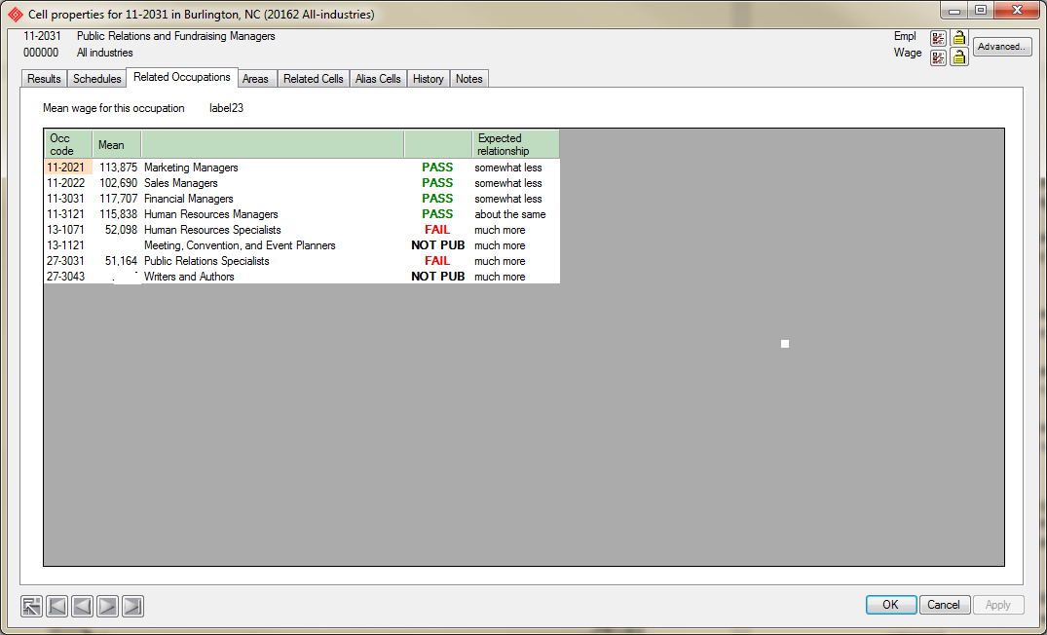

The occupations and expected relationships are defined on the “System options” panel’s “Related occupations” tab. The related occupations are based on the O*Net related occupations table. This is a O*Net code table but, within LEWIS the O*Net codes are collapsed into their base SOC codes.  
  
The default "relationships" were derived from 20032 national salaries and were done by taking observed differences and trying to develop five viable categories from them. Using five categories allows you to address situations where an occupation really should pay more or less even though that difference might be small.  
  
The criteria for initial assignment are as follows:  
  
1. The related occupation's national salary had to pay at least 25% less in order for it to be assigned to this category. There are 1,020 relations in this group.

2. The related occupation's national salary had to pay at least 10% less but no more than 25% less in order for it to be assigned to this category. There are 630 relations in this group.  
  
3. The related occupation's national salary had be within 10% in order to be assigned to this category. There are 1,253 relations in this group.  
  
4. The related occupation's national salary had to pay at least 110% but no more than 125% in order for it to be assigned to this category. There are 886 relations in this group.  
  
5. The related occupation's national salary had to pay at least 125% of the base occupation in order for it to be assigned to this category. There are 1,077 relations in this group.  
  
6. There were also a number of related occupations where there was not available 20032 wage estimate. The related occupation is assigned to a "not comparable" category. Occupations in this category are not considered by the test. There are 251 relations in this group.  
  
In all, there are about 5,000 pre-defined salary relationships. Note that this is based entirely on national data and each category is discrete (i.e. a relation can fall into only one category).  
  
But, we recognize that these differences are based on statistics with errors of their own. And they will be applied to statistics that we calculate which also have errors. So, the next step is to broaden the bands. In effect, this means that a related occupation’s wage that is 107% of the base is treated the same as one where it is 113%.  
  
As a result, the following categories were developed. Let's take the example of an occupation paying $40K per year.  
  
1 - Pays much less, related occupation must pay at least 10% less (Note that during default assignment, we required a 25% difference)  
  
For our $40K occupation, related occupations using this category can pay no more than $36K per year but can pay all the way down to the wage provided by the COW A minimum. So, it could pay as little as $10,712 ($5.15 * 2080) (A range  
of nearly $26K)  
  
2 - Pays somewhat less, the related occupation must pay less but not less than 50% (Note that during default assignment, we required at least 10% but not more than 25% difference)  
  
For our $40K occupation, related occupation s using this category can pay no more than $40K per year because they have to pay less. But, an occupation could pay as little as $20K and still pass the test. (A range of $20K)  
  
3 - Pays about the same, +/- 20% (Note that during default assignment, we required < +/- 10%)  
  
For our $40K occupation, related occupations using this category can pay as little as $32K per year and as much as $48K. (A range of $16K)  
  
4 - Pays somewhat more, related occupation must pay more but not more than 150% (50% more) (Note that during default assignment, we required at least 10% but not more than 25% difference)  
  
For our $40K occupation, related occupation s using this category must pay at least $40K per year because they have to pay more. But, an occupation could pay as much as $60K and still pass the test. (A range of $20K)  
  
5 - Pays much more, related occupation must pay at least 110% (10% more) (Note that during default assignment, we required a 25% difference)

For our $40K occupation, related occupations using this category would have to pay at least $44K per year but could go all the way up the COW L maximum of $202K per year. (A range of $158K)

*Wow! With tests that broad and limited to otherwise "publishable" data , how could ANYTHING fail? But, fail they do. That's why it scores the failures versus the successes. A cell "passes" if a mere 50% of its related occupation tests pass.*

Derivation of the 50% threshold was based on the percentages that occur when you run this test with limited data. This might occur for a small sub-state area or with industry aggregations like NAICS-3. The idea is that if you have two relations, at least one of them should be upheld for the cell to publish.

During the screening test, only those occupations that are otherwise eligible for publication are considered. So, all occupations that have already failed another screening test or have been marked by the analyst to be UNCONDITIONALLY suppressed are ignored. These occupations will appear in this table as “NOT PUB”.

Occupations are compared to one another only within a single estimate and industry. As you recall, a single estimate is represented as a single icon on the main selection tree and, by definition, all cells within a single estimate must have been created with the same class selections and estimation options and produced at the same time.

To view the “Cell properties” for any related occupation shown in the table, double-click on the occupation in the table.

To add or remove occupations from the list or to change the expected relationship, launch the “System Options” panel, and select the “Related Occupations” tab.

### Cell Properties – Areas Tab

This tab displays similar cells on file for the indicated occupation and industry.

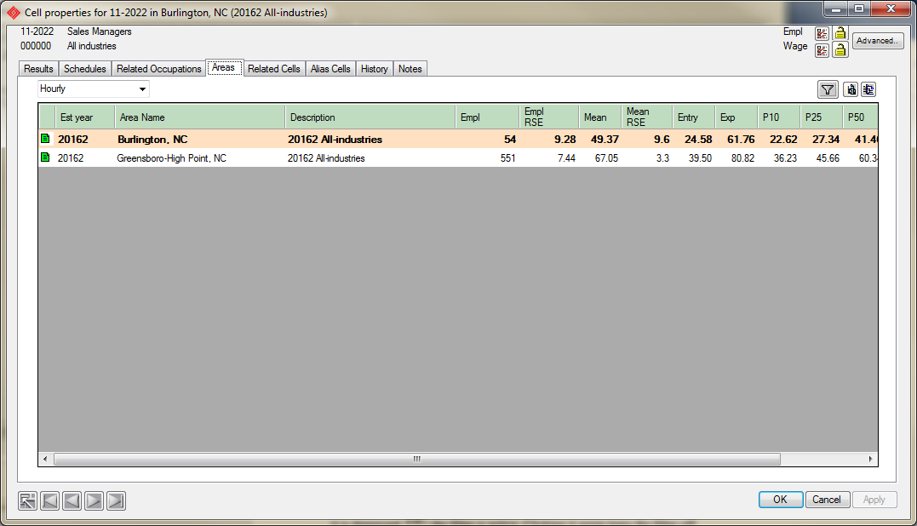

The current cell always displayed in **bold**. Publishable data is displayed in black while suppressed results are displayed in red.

It is possible to sort the data on any column by double-clicking on the column header. Double-clicking a second time on the header reverses the order.

To view the “Cell properties” for any related occupation shown in the table, double-click on the occupation in the table.

filter Launches a filter panel that allows you to control the estimates displayed and processed by the program using additional criteria such as industry class, area type, or year. This button is a toggle. When it is depressed, filterin the filter is active. Clicking it again turns the filter off.

details This button also displays the “Cell properties” for any related occupation shown in the table

 The copy to clipboard button copies the tabular results to the clipboard. From there, it can be pasted into a variety of programs including Wordpad and Excel.

### Cell Properties – Related Cells Tab

*Note: Beginning with Lewis 5.1, secondary screening is performed during the publication step. Relationships that appear on this tab reflect suppressions created prior to this change.*

This tab displays related cells involved in secondary suppression screening. Only groups having a single confidential cell in the aggregation are shown. Since a cell often appears in more than one aggregation, there can be multiple groups.

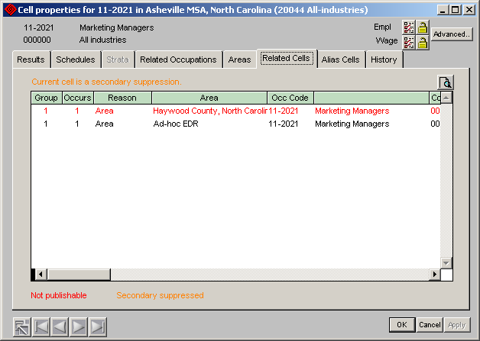

To launch a new Cell Properties panel for a given cell in the list, double click on that cell.

To sort a column in the table, double click on the column header. Double-clicking a second time reverses the order.

### Cell Properties – Alias Cells Tab

This tab displays a list of “alias” cells for the current cell. Although they may be assigned to a differently-designated area, LEWIS considers these cells equivalent in every respect. They normally should receive equivalent screening.

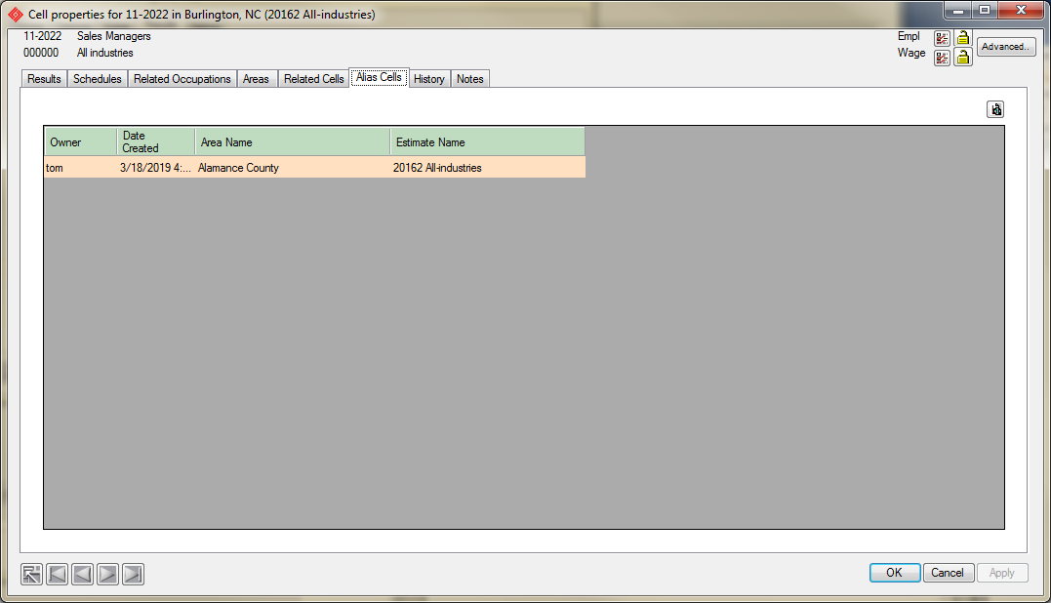

To launch a new Cell Properties panel for a given cell in the list, double click on that cell.

To sort a column in the table, double click on the column header. Double-clicking a second time reverses the order.

### Cell Properties – History Tab

This tab displays a transcript of the specific tests that have experienced status changes since the cell was created.

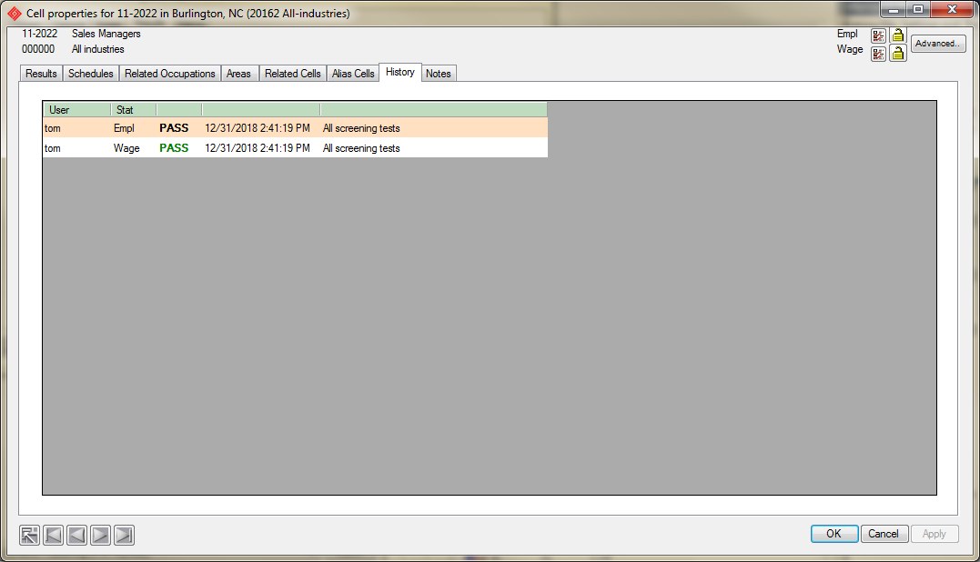

**Cell Properties – Notes tab**

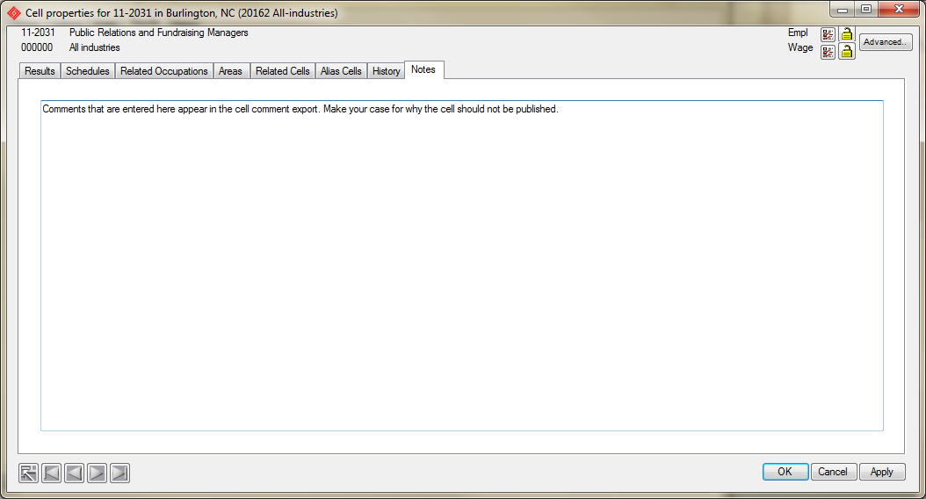

## Unconditionally suppressing and releasing estimates

LEWIS allows the analyst to unconditionally suppress a cell that is eligible for publication or to release a cell that would otherwise be suppressed. When cells are processed this way, the screening rules are ignored.

***FAQ: Why might this be necessary?***

All automated tests are not foolproof and may result in false positives or negatives. Using this feature allows the analyst to reverse a decision that they do not agree with.

Often, an analyst may bring additional information into the process that is not immediately evident in the data itself. For example, a serious anomaly might have been discovered in the data too late to get the microdata file corrected. Since the data cannot be changed, results based on it are going to be wrong. Unconditional suppression is an only alternative to marking the schedules with anomalies as “poison”.

In a different situation, the data and estimate are correct and pass all tests, but the estimate cannot rationally be explained. It is simpler to suppress the cell than invent an explanation for it.

In still another case, one industry segment for an occupation is publishable but others, including the all-industry, are not. It may be desirable to suppress the publishable industries to avoid the confusion associated with having no all-industry aggregate.

Employment and wages are screened separately:

 The “checklist” icon indicates that screening tests selected on the “System options” tab are applied to the indicated statistic and that publication is based on the results of those tests (default).

 The “stop” icon indicates that the indicated statistic is NEVER published.

 The “check” icon indicates that the indicated statistic is ALWAYS published.

To change this setting, click the icon until the desired setting is displayed. While the results of the setting are immediately displayed on the “Results” tab, you must click “Apply” to make any change permanent.

*FAQ: Why can’t I change the screening?*

*If the screening is locked at the estimate level, these buttons are all disabled.*

## Screening locks

 The depressed “lock” button indicates that the estimate is locked and is not eligible to be rescreened.

 The “unlocked” icon indicates that the estimate can be rescreened at any time either by a manual or automated process.

*Tip: Applying an “analyst suppression” or an “analyst release” automatically locks the screening for the statistic. Returning a statistic to “checklist screening” automatically unlocks the statistic.*

**Advanced Rescreening**

By clicking the  button, it is possible to make screening changes that affect a range of cells.

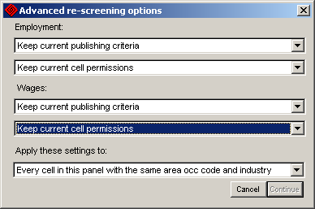

In addition to the options on the “Cell properties” panel, it is also possible to keep the current setting for both publishing criteria and permissions.

The publishing options are:

1. Maintain current criteria
2. Publish based on screening
3. Never publish
4. Always publish

The permission options are:

1. Maintain current permissions
2. Anyone can rescreen (unlocked)
3. Locked (no one can rescreen)

Settings can be applied to:

1. Every cell in this panel with the same area, occ code. and industry
2. Every cell in this panel with the same area and occ code. (Note that for an all-industry estimate, this is the same as option 1)
3. Every cell in this panel with the same area and industry (Note that for an all-industry estimate, this is the same as option 4)
4. Every cell in this estimate

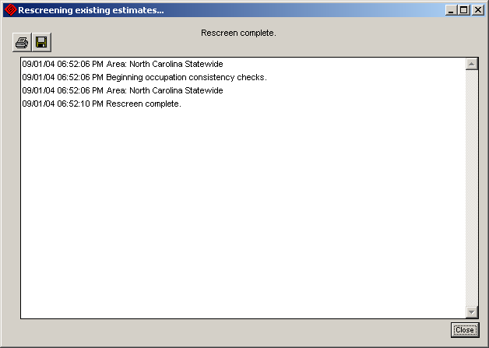

Note 1: Unlocked cells remain subject to subsequent rescreening. If you suppress or release a cell, later changes to a component schedule’s confidentiality or poison status or changes to a related occupation **will** cause the cell to be rescreened.

After reviewing the log, click **Close**.

# Displaying microdata

It is possible to display the establishment and detail microdata used to calculate the cell by double clicking on the line containing the schedule number.

**Navigation buttons**

Navigation buttons provide a convenient way of moving between schedules. The cell order is established on the “Cell Details” panel’s “Schedules” tab by double-clicking on a column header.

back The “back” button returns control back to the panel that the underlying microdata panel was launched from. It is useful if multiple underlying microdata panels are active.

first The “first” button is used to display the first cell in the sorted list that the underlying microdata panel was launched from.

prev The “prev” button is used to display the previous cell in the sorted list that the underlying microdata panel was launched from.

next The “next” button is used to display the next cell in the sorted list that the underlying microdata panel was launched from.

last The “last” button is used to display the last cell in the sorted list that the underlying microdata panel was launched from.

**SPAM Comments**

Loading SPAM comments is optional. If loaded, an icon will appear in the first column on the “Cell Properties”, “Results” tab for each schedule where notes are present. To view the notes, click on the icon.

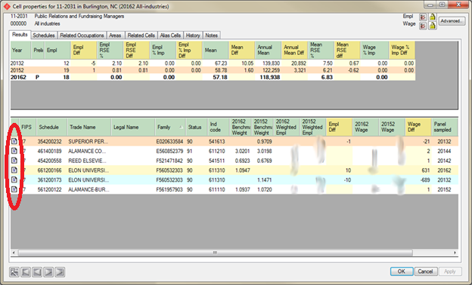

To begin the import, select “SPAM comments” as the import type and click “Import”. When the panel below appears, enter the network name or IP address of the SPAM SQL Anywhere server and user/password credentials authorized to read the “comments” table.

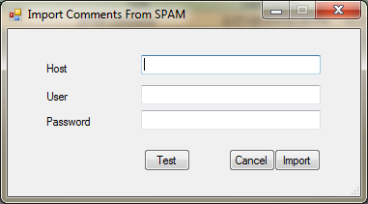

To test the connection to the SPAM server, click “Test”.

To begin the import, click “Import.

*Note: This is not a live link. It captures a snapshot of the comments on SPAM at the time of the import. To refresh the comments, repeat the import.*

## Cell Comments Export

The cell comments export contains the notes information for all cells where cell notes have been added. This file is suitable for transmission to BLS as a record of suppression recommendations made by the state.

The format of the file is described in Appendix E.

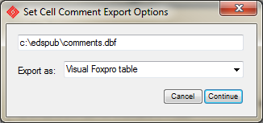

**Target:** Select the directory and target file name. Click **Browse** to view the contents of any existing file.

**Export as:** Indicate whether the file should be exported as a Visual Foxpro free table or an Excel worksheet.

To begin the export, click **Continue**.

## Appendix E: Suppression change export file

Format: Visual FoxPro free table, Excel worksheet, Access file, or pipe-delimited text file.

|  |  |  |  |
| --- | --- | --- | --- |
|  |  |  | |
| Stfips | Char(2) | State FIPS code, zero padded, right justified | |
| Areatype | Char(2) | WID area type code, zero padded, right justified | |
|  |  | 00 ­– National  01 – Statewide  02 – MSA  03 – SDA  04 – County  05 - Minor civil divison  06 - BLS Region  07 - Broad geographic  areas (BGA)  08 - Economic develop-  ment region  09 – Planning regions | 10 - Labor Market Area  11 – Cities  12 – Town  13 – Township  14 - Municipality/suburb  15 - Workforce investment  region  16 - One Stop Area  17 - Workforce Development  Area  18 - Job Center Area  30 - Balance of State |
| Area | Char(6) | WID area code, zero padded, right justified as assigned when the estimation area was created.  For statewide, MSA, county, or township data, the appropriate FIPS code should be used.  For all other area types, the assigned codes may be arbitrary. | |
| Estyear | Char(4) | Year of the last survey included in the estimates | |
| Panel | Char(1) | Panel (if more than one panel per year) | |
| Indclass | Char(1) | Industry class  1 – All-industry  2 – SIC Industry-division  3 – SIC-2  4 – SIC-3  5 – NAICS supersector  6 – NAICS sector  7 – NAICS-3  8 – NAICS-4  9 – NAICS-5 | |
| Indcode | Char(6) | SIC or NAICS code | |
| Occcd | Char(7) | Standard occupational classification, hyphen included. | |
| Soctitle | Int | Occupation title | |
| Estdate | Datetime | Date and time that estimate was calculated | |
| User | Char(16) | User name that created cell | |
| Notes | Text | Analyst comment from the notes tab. In Excel exports, only the first 254 characters are displayed. | |

1 Introduced with EDS 4.