Machine learning against the lattice propagator
λ = 0.01, 0.1 and 0.3, with λ = 0.5 at the end. N = 16, η = 0.05, endpoints 0 to 0, T = 2 to 4 in steps of 0.2.
Every comparison below is the machine-learning path integral against the lattice propagator on the same 16-site contour. The error is |K_ML − K_lattice| / |K_lattice|. A bounce contribution is added twice, once for each sign.

What has worked
The method tracks the lattice through most of the λ = 0.01 scan, through λ = 0.1 up to T = 2.6, and at several separated times for λ = 0.3. Where a bounce is required, the result is good only when that bounce is actually found and sampled.

λ = 0.01
Ten of the eleven times land on the lattice. From T = 2.6 onward the bounce is doing real work: the trivial thimble alone is 20% off at T = 2.6 and 45% off at T = 2.8, while the bounce pair brings both under 0.2%. From T = 3.2 to T = 4.0 no bounce is required, and the trivial thimble by itself stays within 0.24%.
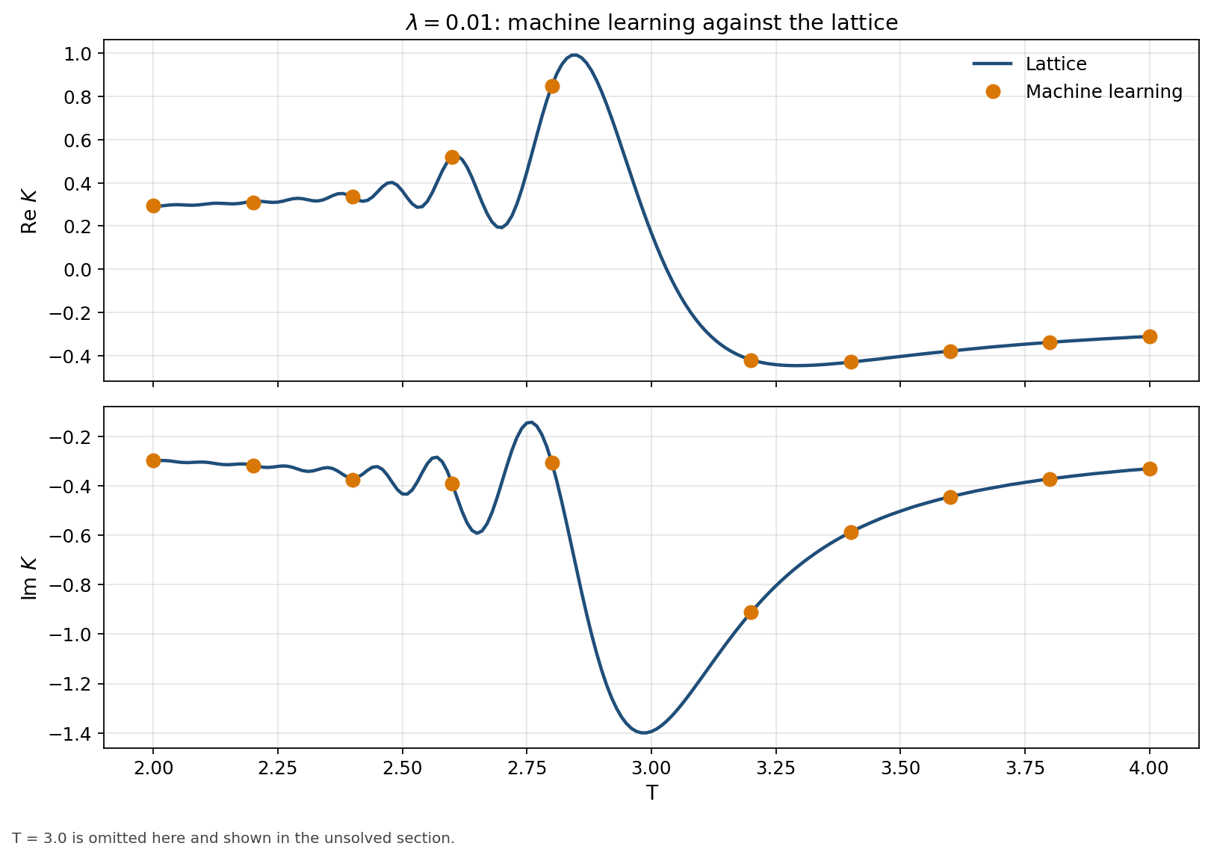
Figure 1. λ = 0.01. Lattice curve and machine-learning values, excluding the failed point at T = 3.0.
T | Machine learning | Lattice | Error
2.0 | +0.2934 − 0.2977i | +0.2913 − 0.2984i | 0.54%
2.2 | +0.3093 − 0.3190i | +0.3143 − 0.3160i | 1.31%
2.4 | +0.3362 − 0.3744i | +0.3329 − 0.3695i | 1.19%
2.6 | +0.5190 − 0.3896i | +0.5200 − 0.3902i | 0.18%
2.8 | +0.8490 − 0.3054i | +0.8479 − 0.3042i | 0.17%
3.2 | -0.4206 − 0.9124i | -0.4182 − 0.9121i | 0.24%
3.4 | -0.4288 − 0.5871i | -0.4291 − 0.5871i | 0.05%
3.6 | -0.3776 − 0.4436i | -0.3775 − 0.4435i | 0.03%
3.8 | -0.3374 − 0.3714i | -0.3375 − 0.3713i | 0.03%
4.0 | -0.3105 − 0.3301i | -0.3110 − 0.3303i | 0.11%

λ = 0.1
One bounce pair is already essential at T = 2. The trivial thimble alone is 50% to 111% off on T = 2.0–2.6, and the paired sum is within 1.5%. At T = 3.6 the first time scan missed the bounce and was 32% off. Finding that bounce, K = +0.0432 + 0.0453i with an effective-sample fraction of 0.91, brings the same trivial piece to 0.099% of the lattice.
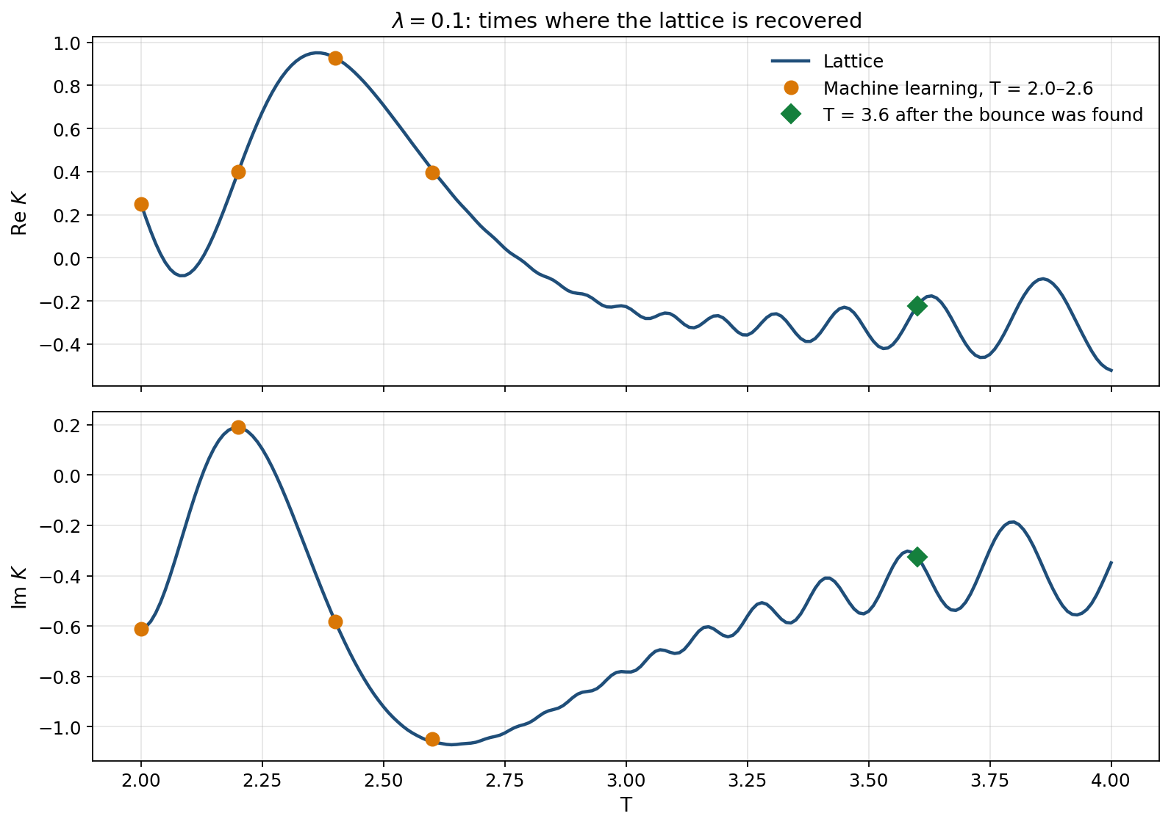
Figure 2. λ = 0.1. The early times, and T = 3.6 after the missing bounce was included.
T | Machine learning | Lattice | Error
2.0 | +0.2492 − 0.6122i | +0.2488 − 0.6119i | 0.07%
2.2 | +0.3986 + 0.1898i | +0.3975 + 0.1890i | 0.31%
2.4 | +0.9261 − 0.5835i | +0.9288 − 0.5803i | 0.38%
2.6 | +0.3979 − 1.0473i | +0.4094 − 1.0595i | 1.48%
3.6, bounce found | -0.2236 − 0.3246i | -0.2233 − 0.3247i | 0.10%

λ = 0.3
These runs use the trivial thimble plus three bounce pairs. T = 2.0, 2.2 and 3.6 are inside 0.6%. T = 3.4 and 3.8 follow the same curve and sit at 1.40% and 1.24%.
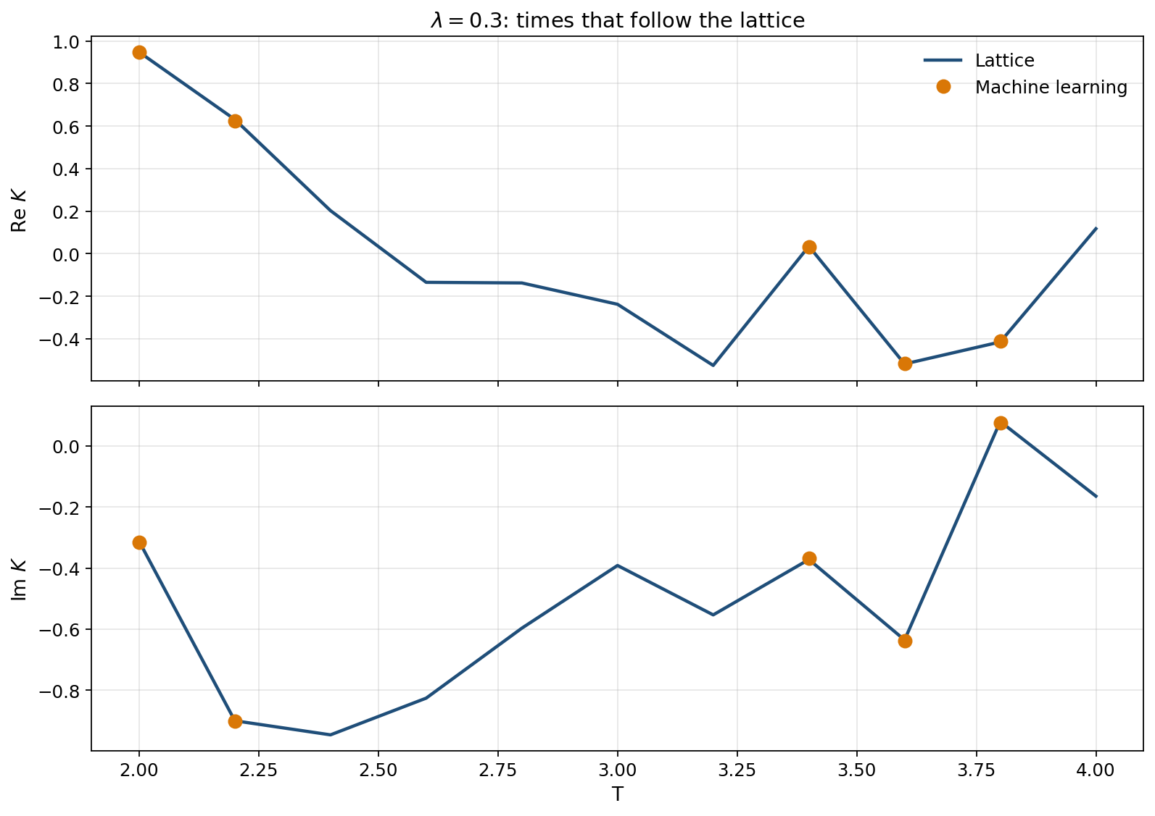
Figure 3. λ = 0.3. Lattice values at every scanned time, with the machine-learning results that follow them.
T | Machine learning | Lattice | Error
2.0 | +0.9480 − 0.3152i | +0.9481 − 0.3126i | 0.26%
2.2 | +0.6257 − 0.9020i | +0.6312 − 0.8999i | 0.54%
3.4 | +0.0329 − 0.3671i | +0.0351 − 0.3719i | 1.40%
3.6 | -0.5166 − 0.6375i | -0.5187 − 0.6353i | 0.37%
3.8 | -0.4116 + 0.0761i | -0.4152 + 0.0799i | 1.24%

At T = 4 the seven-thimble sum is 271% off, K = +0.5317 − 0.5234i against the lattice +0.1175 − 0.1645i. One bounce causes it. That bounce is +0.2043 − 0.1775i with an effective-sample fraction of 3.8×10⁻⁴, about 0.08 effective samples out of 200,000, and it is counted twice. The other two bounces are sampled (effective-sample fractions 0.027 and 0.175). Removing only the noisy pair leaves K = +0.1231 − 0.1683i, which is 3.4% from the lattice.
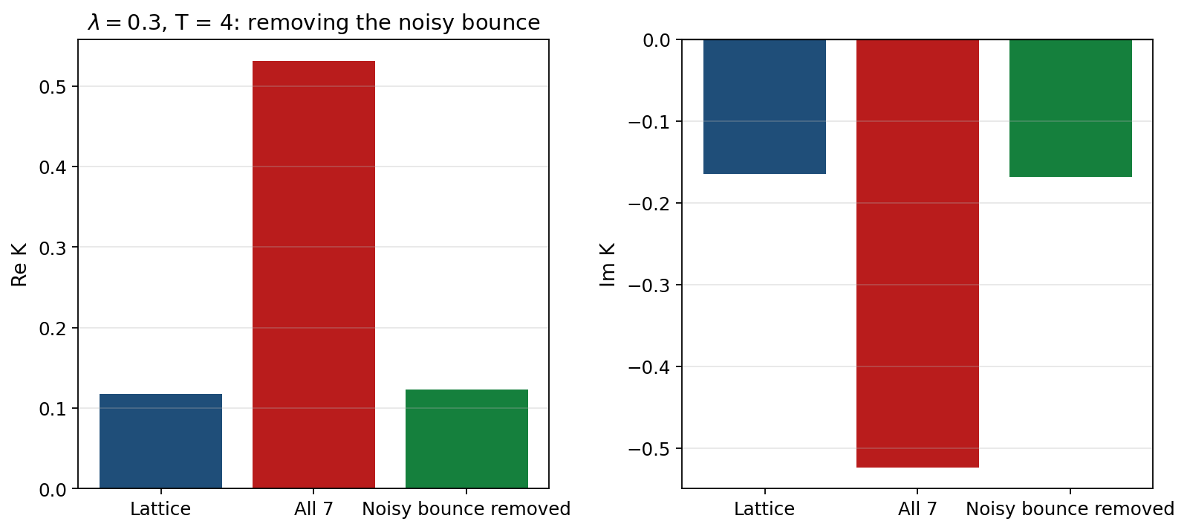
Figure 4. λ = 0.3 at T = 4. The full seven-thimble sum, and the same sum without the noisy bounce, against the lattice.

What still has to be solved
The failures are not spread evenly. Each coupling has a short list of times where the sampler either misses a bounce, samples one too poorly to use, or diverges. Those are the next calculations.
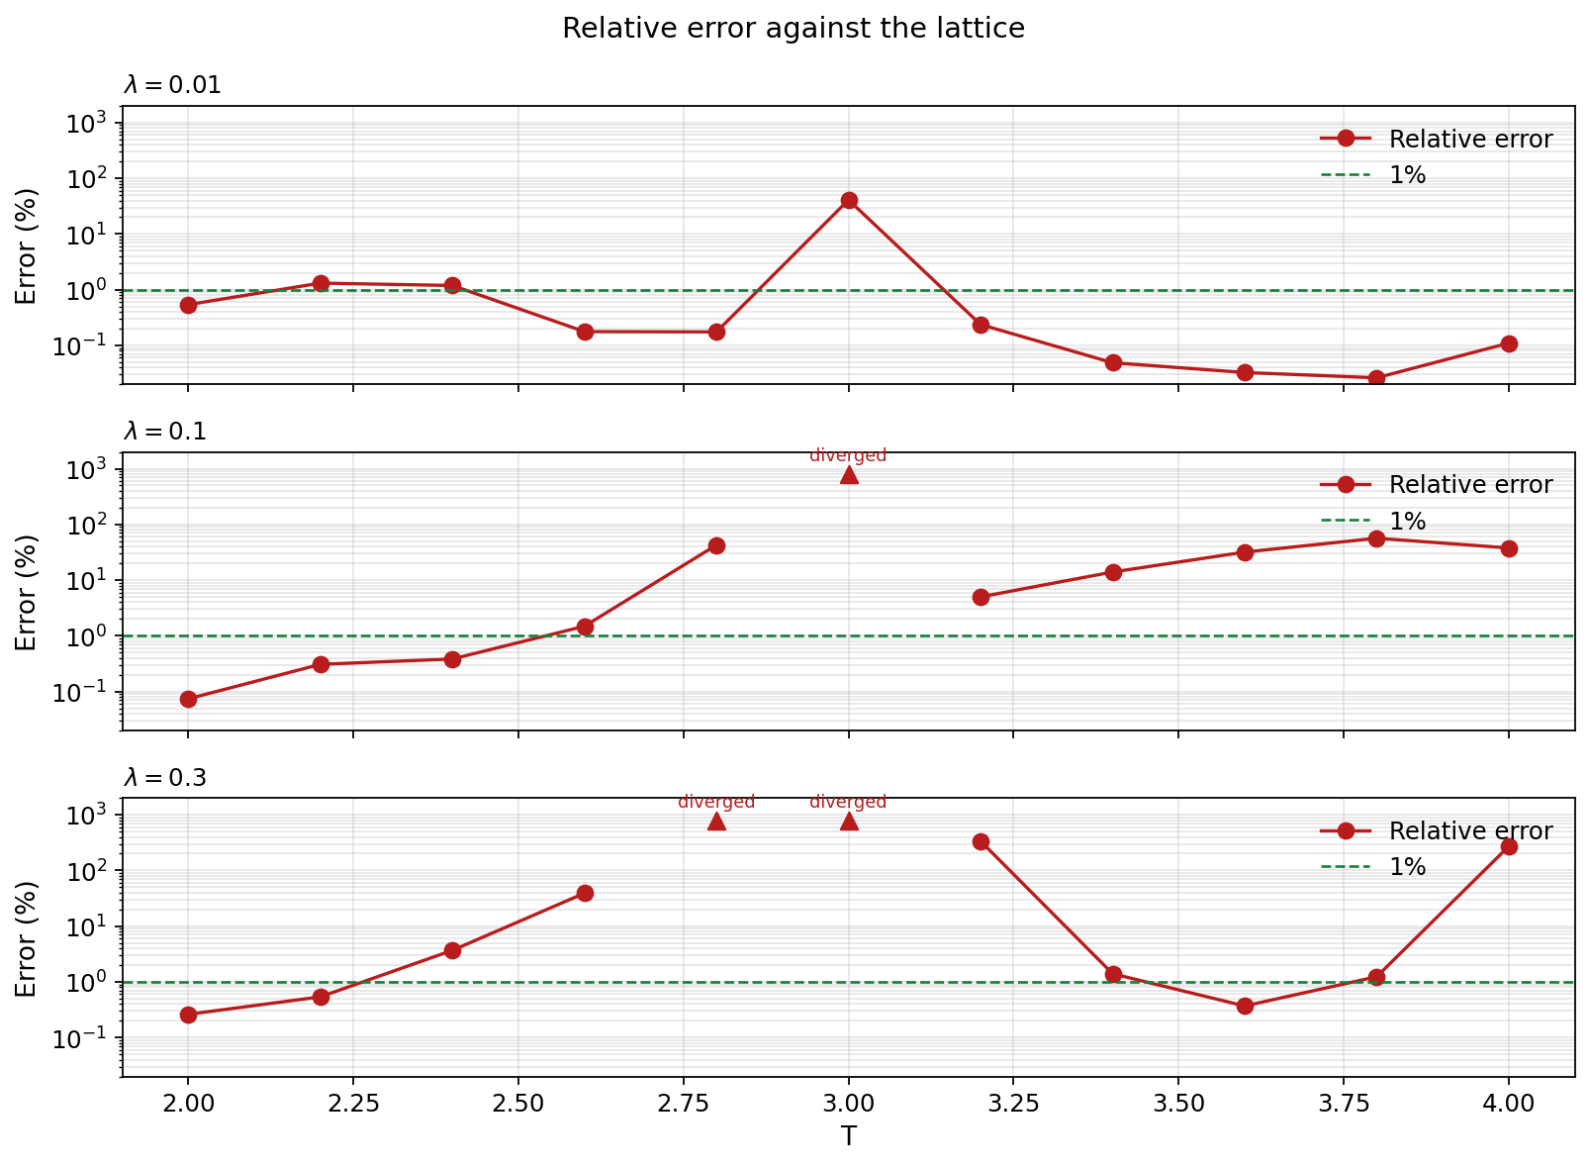
Figure 5. Relative error at every scanned time. Triangles mark results that diverged or left the scale. The dashed line is 1%.

λ = 0.01 at T = 3.0
This is the only λ = 0.01 miss. The estimate is -0.2412 − 0.9908i against the lattice +0.1680 − 1.3945i, an error of 40.9%. The bounce effective-sample fraction falls to 3.0×10⁻⁵. The times on either side already work, so this is one unstable integral, not a failure of the contour at this coupling.
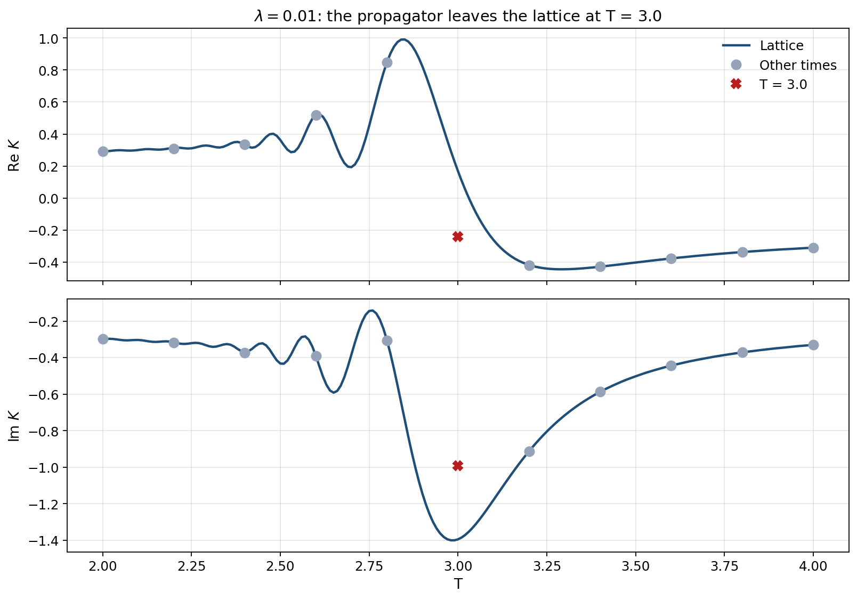
Figure 6. λ = 0.01. T = 3.0 is the point that leaves the lattice curve.

λ = 0.1 from T = 2.8 onward
T = 2.8 is 43% off, with a bounce effective-sample fraction of 5.7×10⁻⁵. T = 3.0 diverges. T = 3.2, 3.4, 3.8 and 4.0 were finished with no bounce and miss by 5% to 56%. T = 3.6 shows what is missing: the same trivial thimble, once its bounce is found, matches the lattice to 0.099%. The next step at this coupling is to repeat that bounce search at the other failing times, and to restabilise the divergent run at T = 3.0.
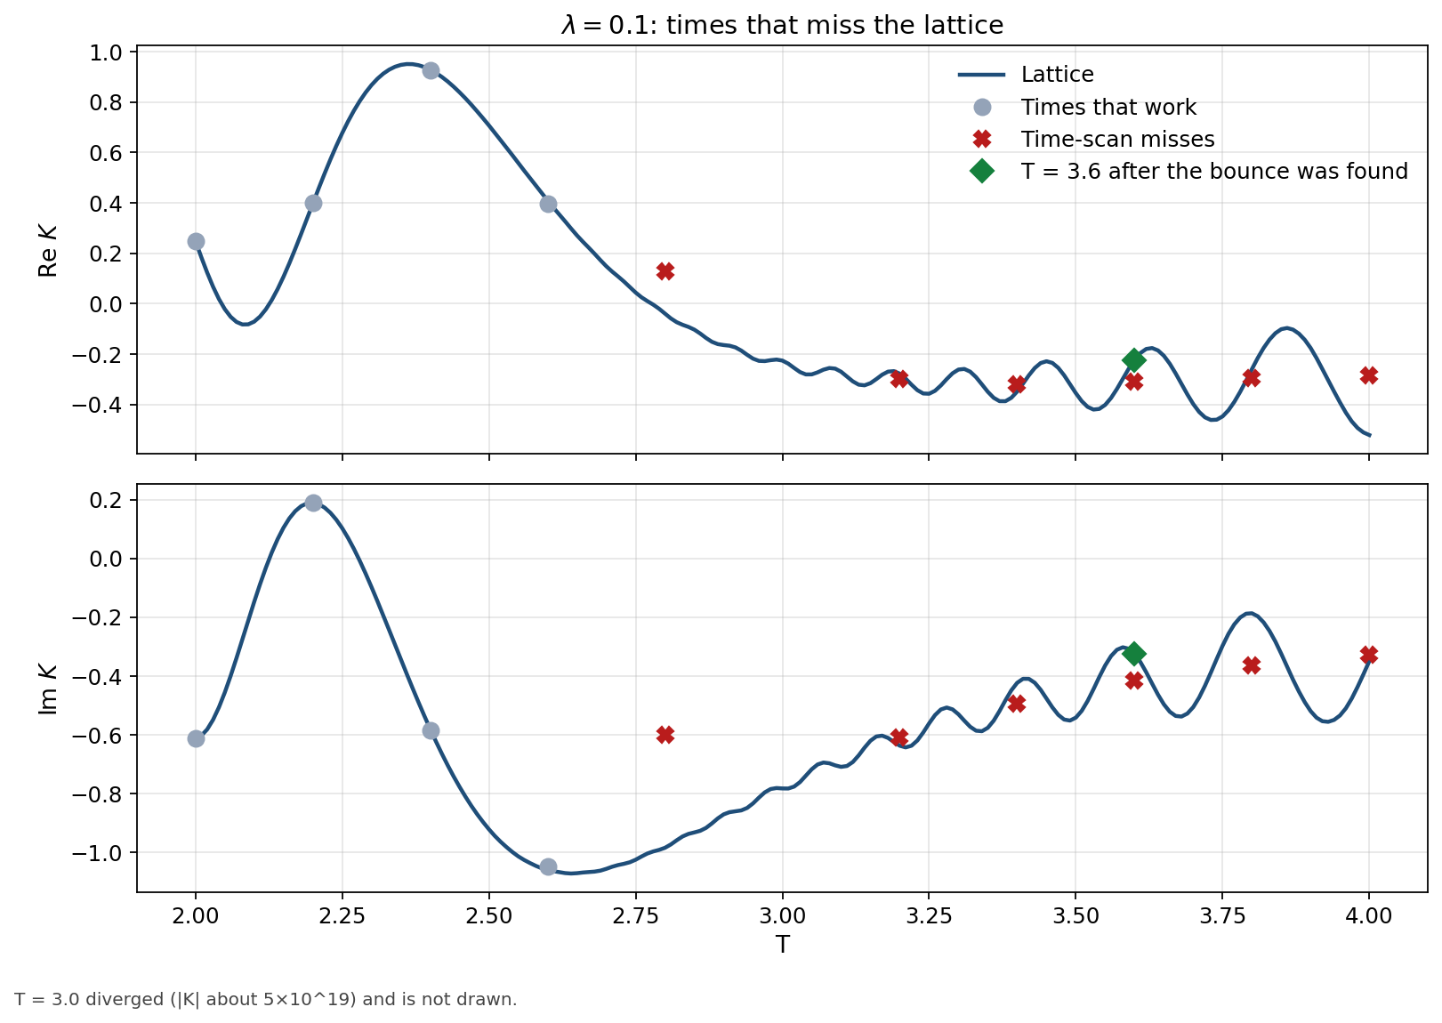
Figure 7. λ = 0.1. Red crosses are the time-scan misses. The green diamond is T = 3.6 after the bounce was included. T = 3.0 diverged and is not shown.
T | Machine learning | Lattice | Error
2.8 | +0.1295 − 0.5994i | -0.0397 − 0.9839i | 42.7%
3.0 | diverged | -0.2261 − 0.7822i | diverged
3.2 | -0.3002 − 0.6102i | -0.2780 − 0.6369i | 5.00%
3.4 | -0.3190 − 0.4935i | -0.3492 − 0.4232i | 14.0%
3.6 | -0.3100 − 0.4152i | -0.2233 − 0.3247i | 31.8%
3.8 | -0.2972 − 0.3634i | -0.2599 − 0.1867i | 56.4%
4.0 | -0.2854 − 0.3290i | -0.5216 − 0.3492i | 37.8%

λ = 0.3 at the broken times, and the T = 4 bounce
T = 2.4 is 3.7% off. T = 2.6 is 39% off. T = 2.8 and T = 3.0 leave the scale, and at T = 3.0 and 3.2 the trivial thimble itself is unstable (effective-sample fractions 1.3×10⁻⁵ and 6.0×10⁻⁶). T = 3.4 and 3.8 are already close, at 1.4% and 1.2%, and are the easiest remaining tightening. At T = 4 the 3.4% result is not finished: it was obtained by discarding the noisy one-hump bounce rather than integrating it. That bounce has to be sampled properly and put back into the sum.
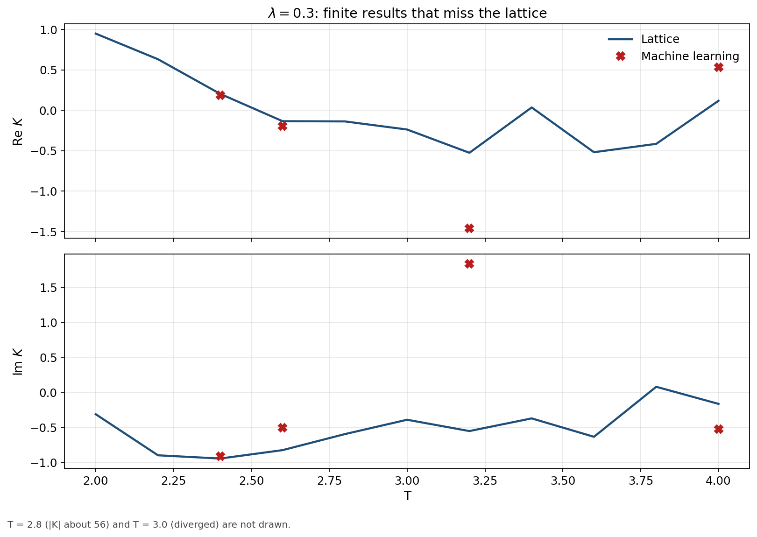
Figure 8. λ = 0.3. Finite machine-learning results that do not follow the lattice. T = 2.8 and T = 3.0 are off the scale.
T | Machine learning | Lattice | Error
2.4 | +0.1848 − 0.9151i | +0.2025 − 0.9460i | 3.68%
2.6 | -0.1950 − 0.5044i | -0.1348 − 0.8258i | 39.1%
2.8 | diverged | -0.1376 − 0.5967i | 9033%
3.0 | diverged | -0.2380 − 0.3914i | diverged
3.2 | -1.4604 + 1.8386i | -0.5257 − 0.5532i | 337%
4.0 | +0.5317 − 0.5234i | +0.1175 − 0.1645i | 271%

λ = 0.5
The λ = 0.5 scan used five thimbles: the trivial saddle plus two bounce pairs. Adding a third or fourth pair at the T = 2.6 probe did not change the answer, so the scan stayed at five.
It works at T = 2.0. The five-thimble result is +0.6933 − 0.8348i against the lattice +0.6956 − 0.8303i, an error of 0.46%.
It also works at T = 3.6 once the same five thimbles are integrated with a larger network (rank 32, 2,000 epochs). That gives +0.1595 − 0.0231i against +0.1582 − 0.0209i, an error of 1.58%. The original five-thimble scan at this time was 14% off. Going from five thimbles to seven moves the answer the wrong way, to 15%. Nine thimbles do the same. Extra thimbles are not the fix here; a stable integral of the five that were already selected is.
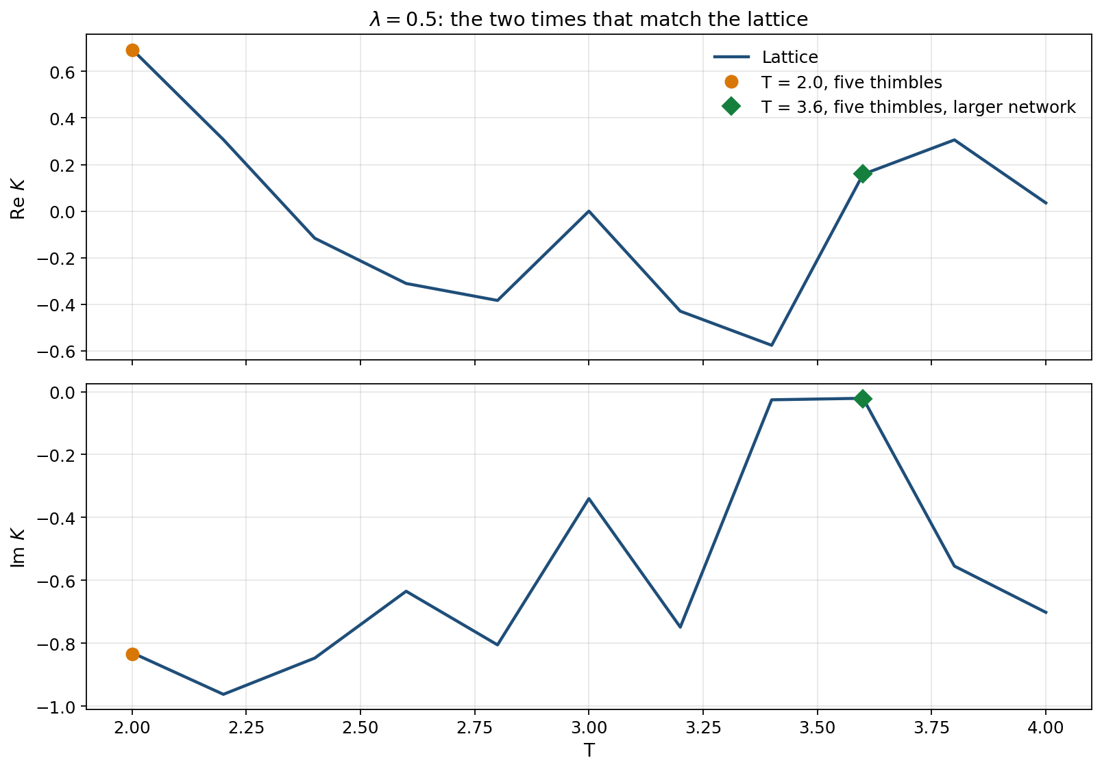
Figure 9. λ = 0.5. The lattice at every scanned time, with the two machine-learning results that match it.
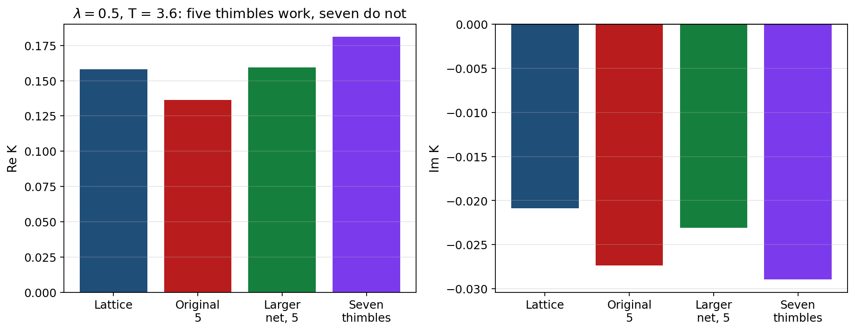
Figure 10. λ = 0.5 at T = 3.6. The larger five-thimble network meets the lattice. The original scan and the seven-thimble sum do not.
Everywhere else in the scan, it does not work. T = 2.2 is 7.6% off and T = 2.4 is 119% off. T = 2.6 is K = −12.68 + 3.90i against −0.311 − 0.635i, an error of 1,864%, and the extra thimbles tried there did not move it. T = 2.8, 3.0, 3.2 and 3.8 diverge. T = 3.4 remains 5.1% off, and T = 4.0 is 133% off.
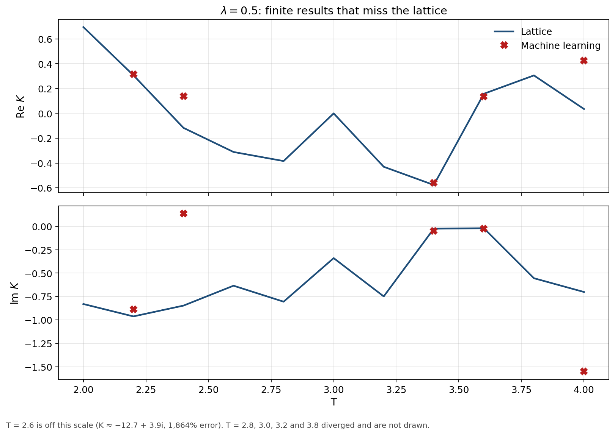
Figure 11. λ = 0.5. Finite misses against the lattice. The divergent times, and the T = 2.6 blow-up, are left off this scale.
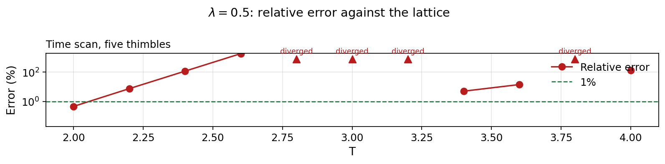
Figure 12. λ = 0.5. Relative error of the five-thimble time scan. Triangles are results that diverged or left the scale.
T | Machine learning | Lattice | Error | Outcome
2.0 | +0.6933 − 0.8348i | +0.6956 − 0.8303i | 0.46% | works
2.2 | +0.3145 − 0.8866i | +0.3072 − 0.9627i | 7.57% | does not work
2.4 | +0.1384 + 0.1345i | -0.1167 − 0.8474i | 119% | does not work
2.6 | -12.6831 + 3.9019i | -0.3112 − 0.6348i | 1864% | does not work
2.8 | diverged | -0.3841 − 0.8054i | diverged | does not work
3.0 | diverged | -0.0002 − 0.3401i | diverged | does not work
3.2 | diverged | -0.4304 − 0.7490i | diverged | does not work
3.4 | -0.5609 − 0.0502i | -0.5768 − 0.0257i | 5.06% | does not work
3.8 | diverged | +0.3059 − 0.5549i | diverged | does not work
4.0 | +0.4257 − 1.5520i | +0.0352 − 0.7019i | 133% | does not work
3.6, original | +0.1362 − 0.0274i | +0.1582 − 0.0209i | 14.4% | does not work
3.6, larger network | +0.1595 − 0.0231i | +0.1582 − 0.0209i | 1.58% | works
3.6, seven thimbles | +0.1811 − 0.0289i | +0.1582 − 0.0209i | 15.2% | does not work

The next λ = 0.5 work is therefore the times other than T = 2.0 and T = 3.6: stop the divergent trivial thimbles, and get a controlled integral at T = 2.2, 2.4, 2.6, 3.4 and 4.0. At T = 3.6 the five-thimble answer should be kept; adding the further thimbles already made it worse.

