Machine learning against the lattice
N = 16, η = 0.05, T = 2 to 4. Amber: machine learning. Navy: lattice. Green: that time with the bounce put back, or with a larger network.

λ = 0.01. On the lattice except at T = 3.
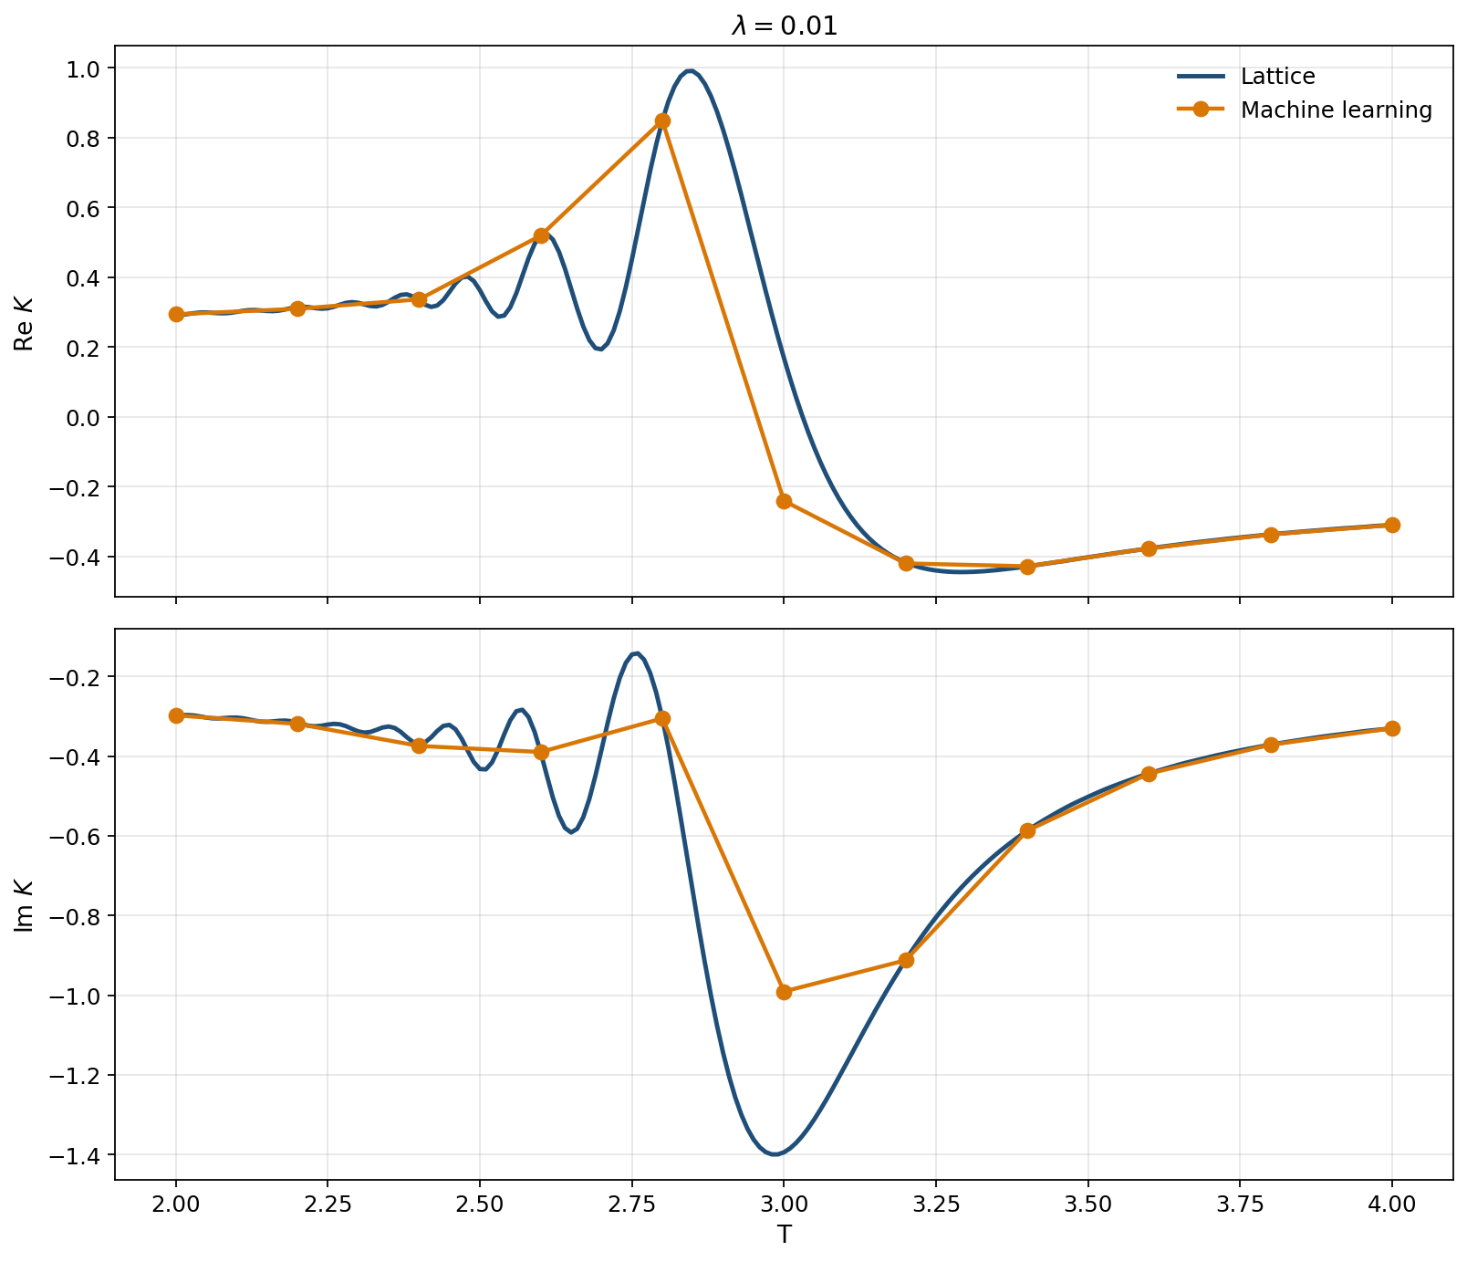
Every sampled time is on the curve except T = 3.0.
T = 3.0 is 41% off. Every other time is within 1.3%. The bounce is what holds T = 2.6 and 2.8 there.

λ = 0.1. On the lattice through T = 2.6. Off after that, except T = 3.6 with the bounce.
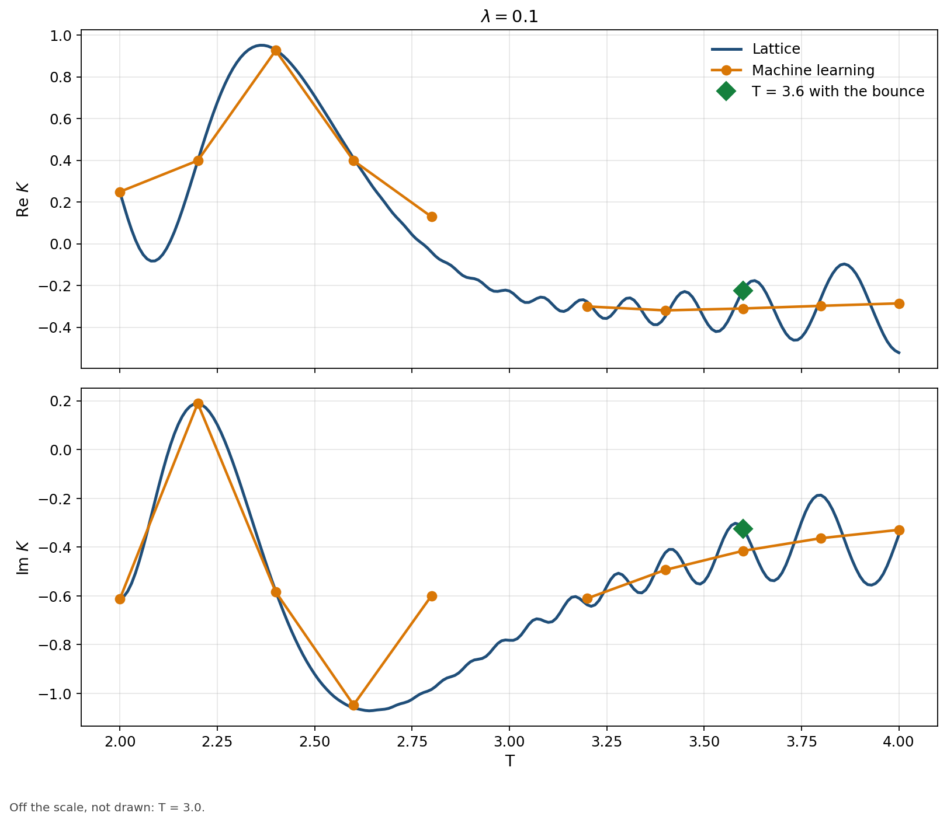
Green marker: T = 3.6 with the bounce included.
T = 2.0–2.6 stay within 1.5%. T = 2.8 is 43% off. T = 3.0 leaves the scale. T = 3.2–4.0 miss by 5%–56%. With the bounce, T = 3.6 is 0.1%.

λ = 0.3. On the lattice at T = 2.0, 2.2 and 3.4–3.8. Off around the caustic and at T = 4.
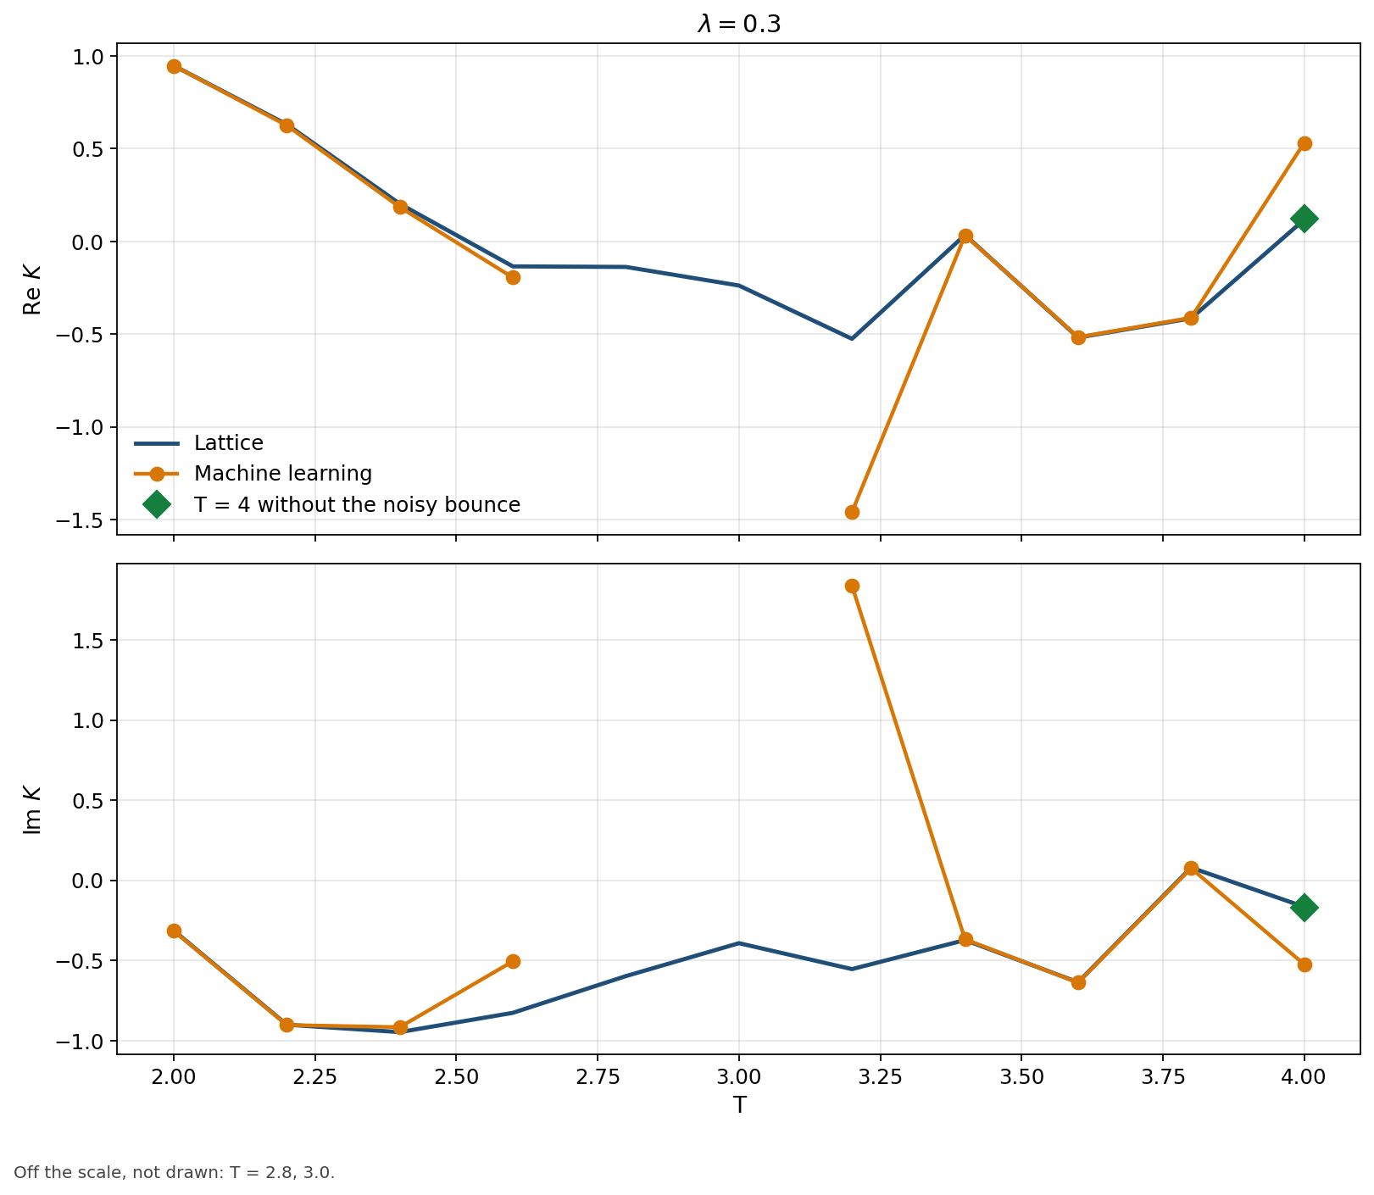
Green marker: T = 4 with the noisy bounce removed.
T = 2.4 is 3.7% off and T = 2.6 is 39% off. T = 3.2 is far off the curve. T = 2.8 and 3.0 leave the scale. T = 4 is 271% off; without the noisy bounce, 3.4%.

λ = 0.5. Works at T = 2.0, and at T = 3.6 with a larger network.
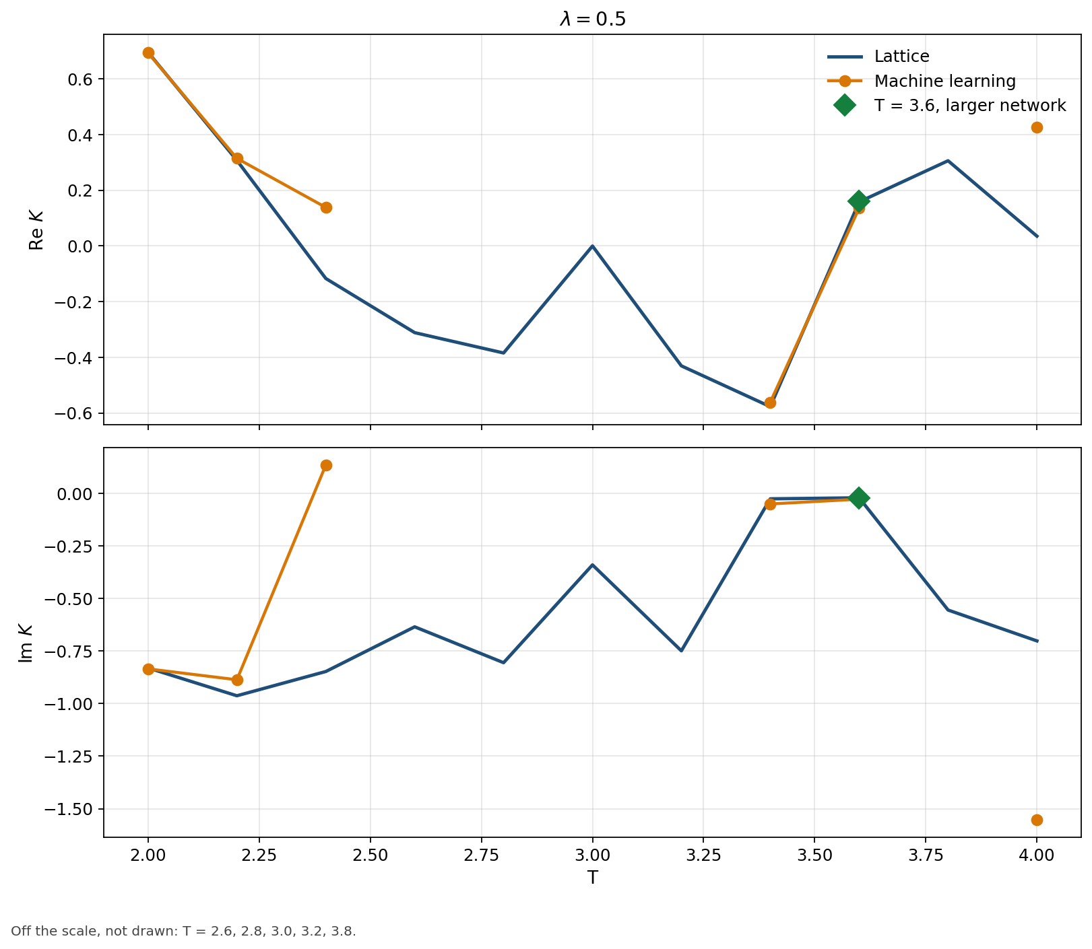
Green marker: T = 3.6, five thimbles, larger network. Seven thimbles there are worse.
T = 2.0 is 0.5% off. The T = 3.6 scan is 14% off; the larger network is 1.6%, and seven thimbles go back to 15%. T = 2.2 is 7.6% off, T = 2.4 is 119% off, T = 3.4 is 5.1% off and T = 4.0 is 133% off. T = 2.6, 2.8, 3.0, 3.2 and 3.8 leave the scale.

