Three saddles against the lattice
N = 16, η = 0.05, T = 2 to 4. The amber line is three saddles: the one centered at zero, plus one opposite pair. The navy line is the lattice. A green marker is five saddles, drawn only where that extra pair improves the result.
Three saddles track the lattice away from the caustics. Around T ≈ 3 they leave the curve, or the samples diverge and drop off the scale.

λ = 0.01. On the lattice except at the T = 3 caustic.
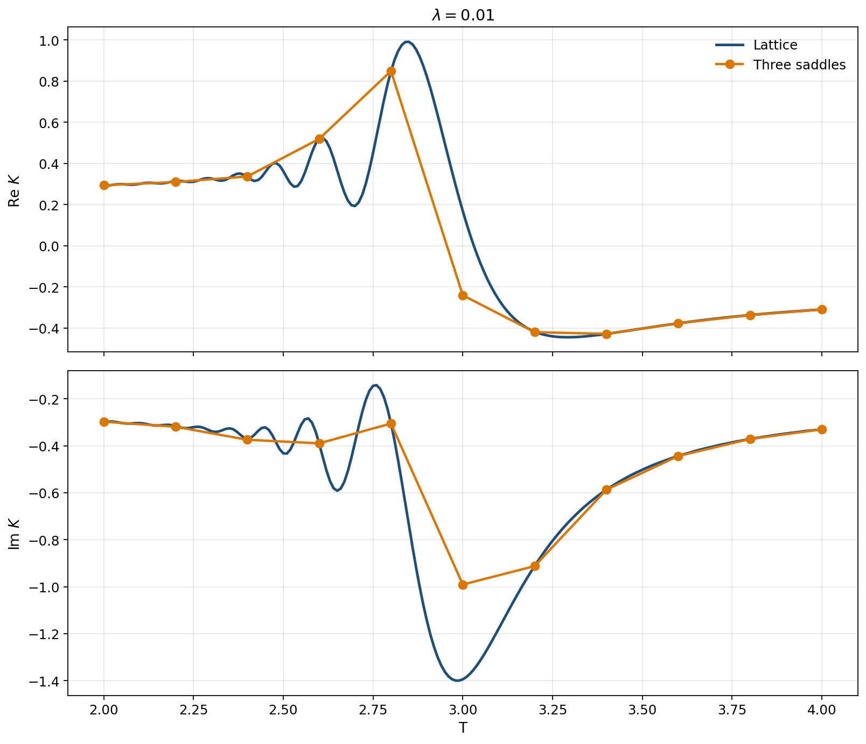
Three saddles. The miss is T = 3.0.
T = 3.0 is 41% off. Every other time is within 1.3%. From T = 3.2 only the zero-centered saddle is present, and it stays on the lattice.

λ = 0.1. On the lattice except at the caustic.
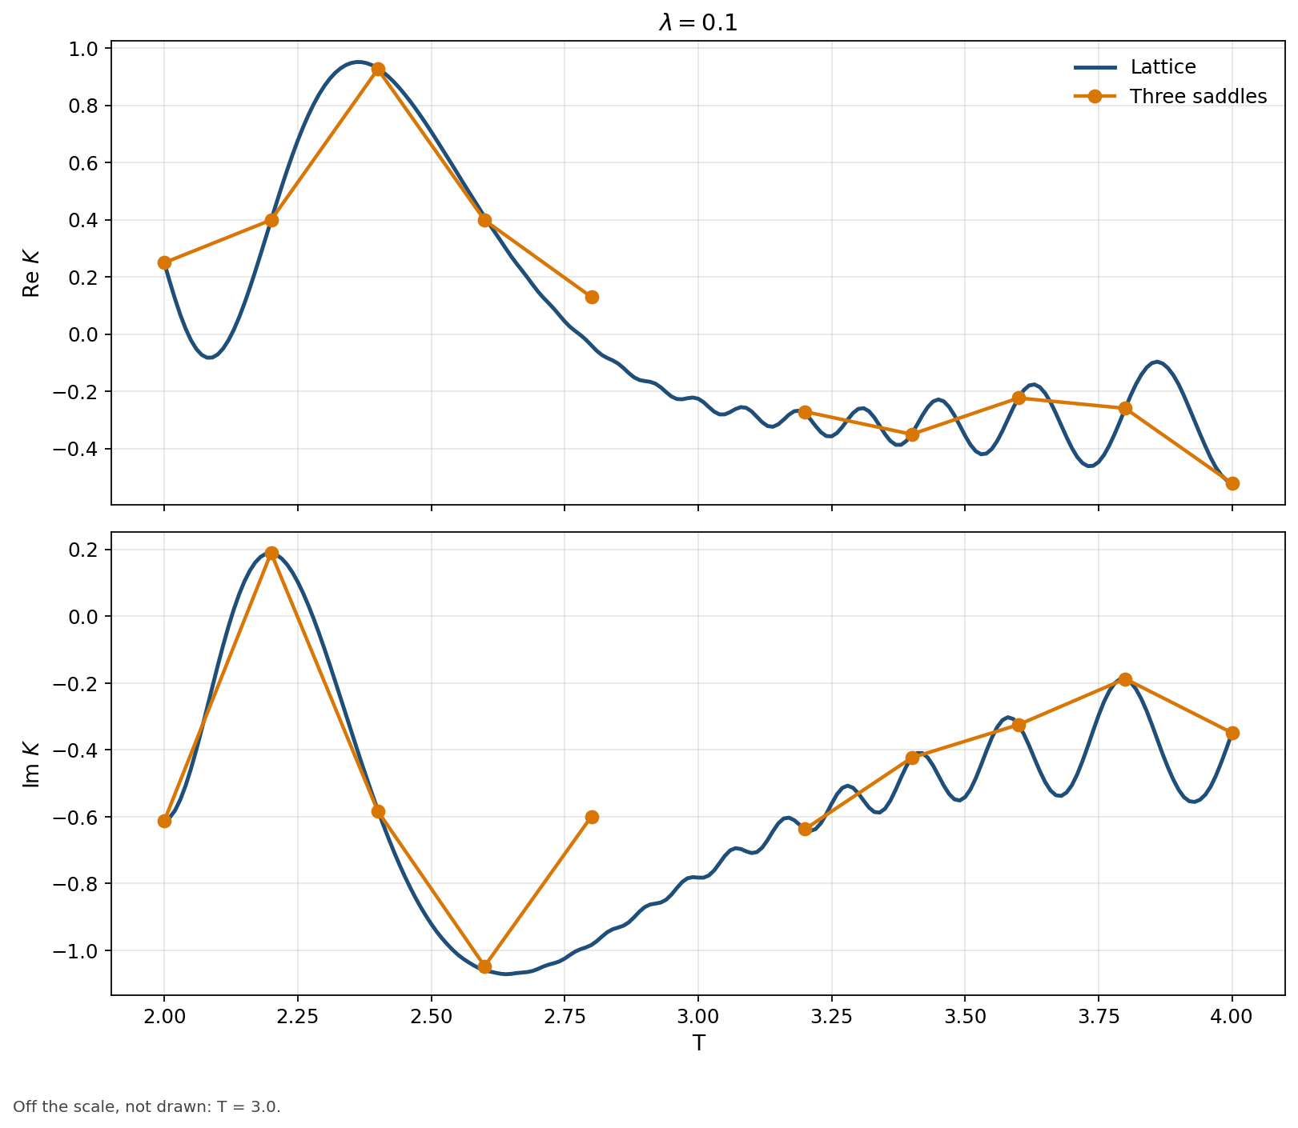
Three saddles. T = 3.2–4.0 include the pair found in the later search.
T = 2.0–2.6 stay within 1.5%, and T = 3.2–4.0 stay within 1%. T = 2.8 is 43% off, and T = 3.0 leaves the scale. A fifth saddle leaves these results unchanged.

λ = 0.3. Three saddles work at the early times and at T = 3.4. The caustic does not.
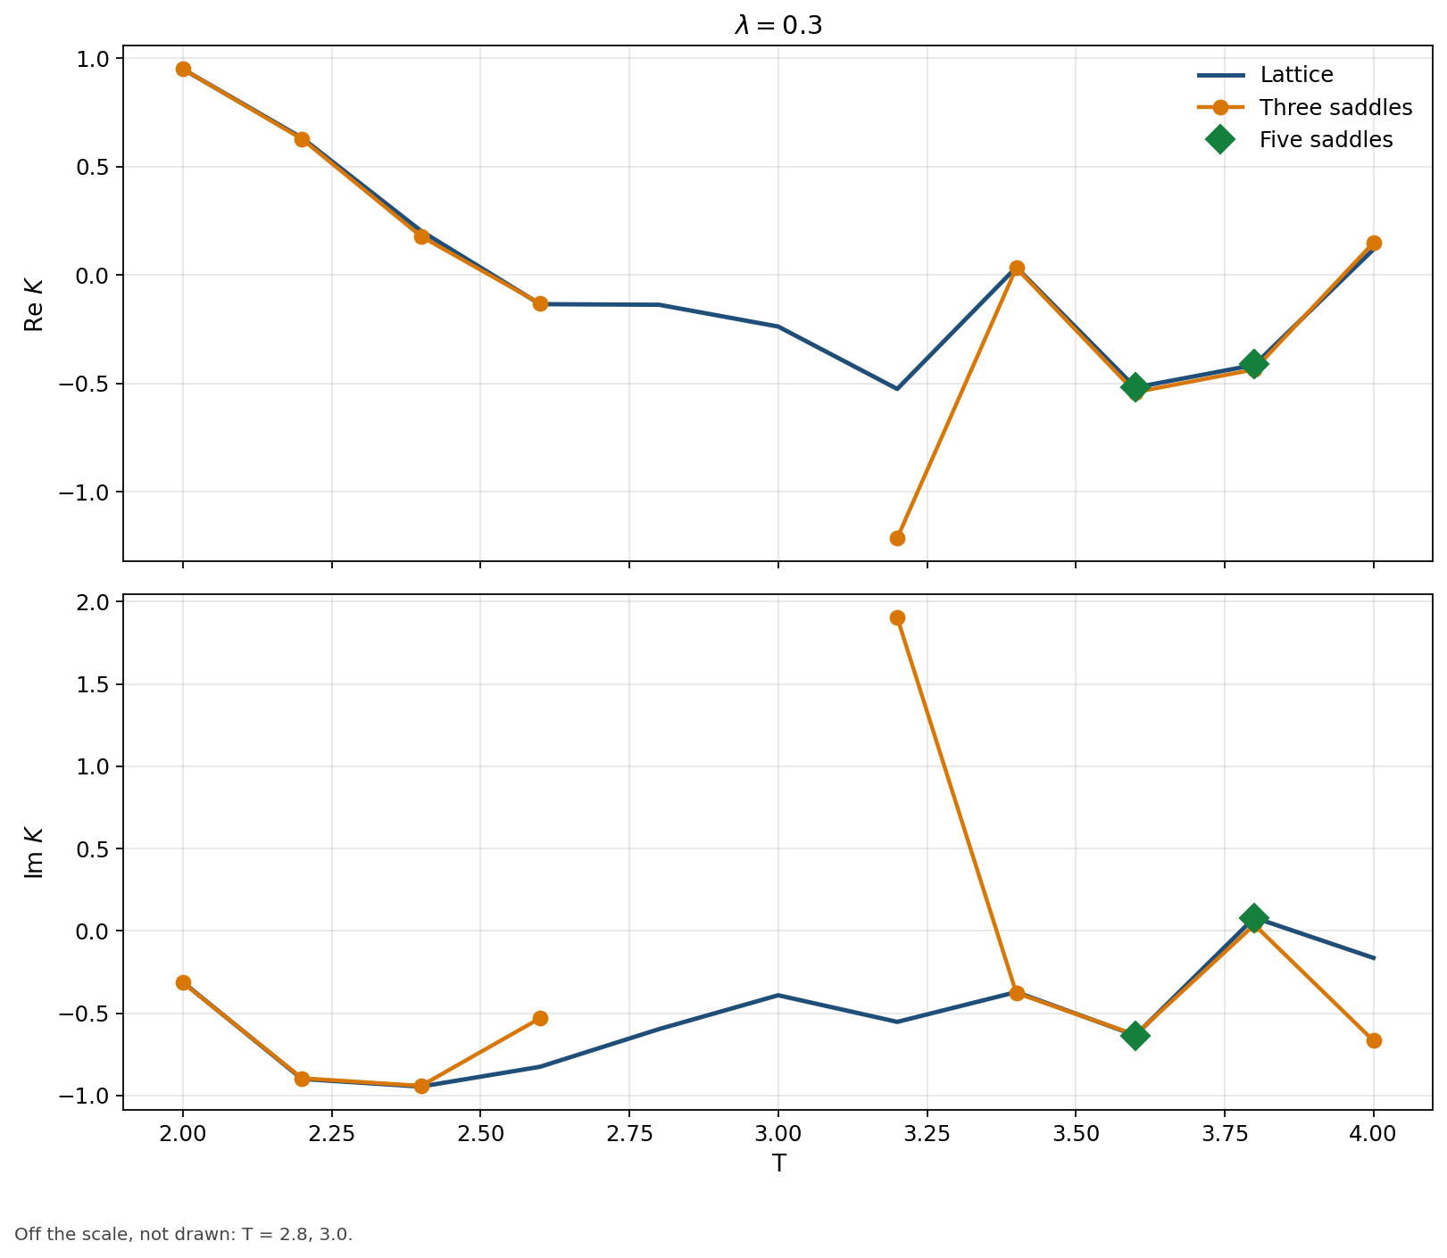
Green markers: five saddles at T = 3.6 and T = 3.8.
T = 2.0 and 2.2 are within 0.6%, and T = 3.4 is 1.7%. T = 2.4 is 2.6% off, T = 2.6 is 35% off, and T = 3.2 and T = 4 are far off the curve. T = 2.8 and 3.0 leave the scale. Five saddles bring T = 3.6 from 2.7% to 0.4%, and T = 3.8 from 11% to 1.2%.

λ = 0.5. Three saddles stay off the lattice. Five saddles land at T = 2.0.
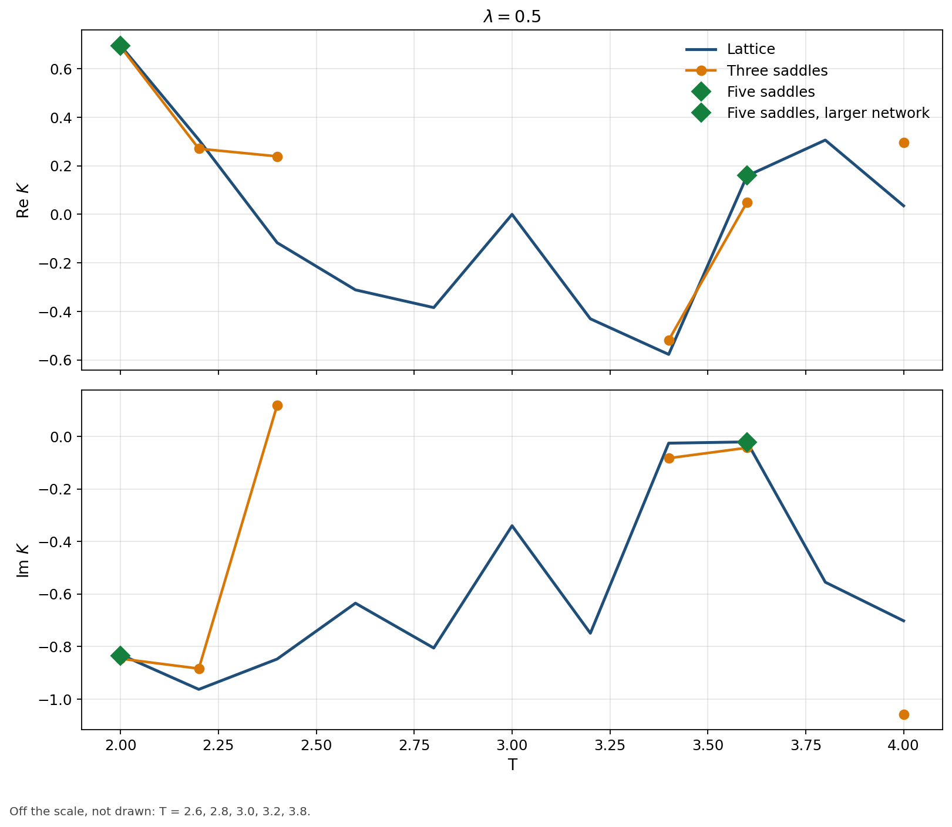
Green markers: five saddles at T = 2.0, and five saddles with a larger network at T = 3.6.
Three saddles are 1.5% off at T = 2.0; five saddles bring that to 0.5%. Elsewhere three saddles miss or leave the scale: T = 2.2 is 8.6%, T = 2.4 is 120%, T = 3.4 is 14%, T = 3.6 is 69% and T = 4.0 is 63%. Five saddles move T = 3.4 to 5.1% and T = 3.6 to 14%. A larger network at T = 3.6 reaches 1.6%.

