A project that inspired me to develop this work were the noise circle mirrored project which we did in class. This was what I based the mirrored look of my project on. Another project that we did in class that inspired me was the random motion project that I based my motion on. An artist that I was inspired by was Dragan Bajcic. He showcased a very intricate random motion code that produced amazing art.

During my development I did try to shorten my code using the code that can be seen in the screenshot below.

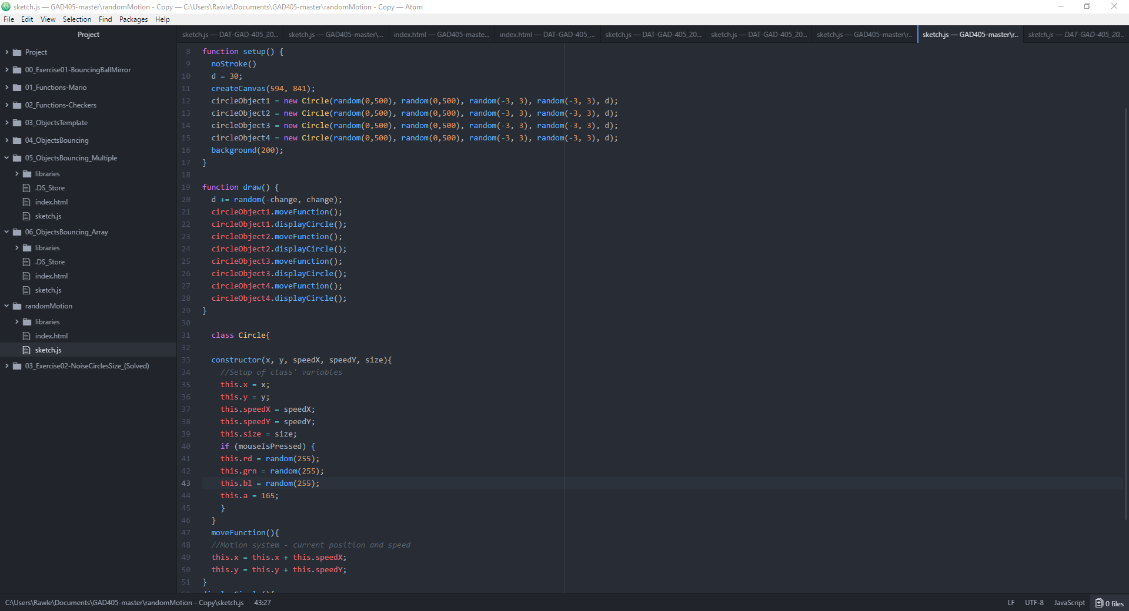

However this did not produce the results I wanted as the randomness was smooth and transitioned whereas I wanted a complete randomness to my work. Therefore I had to settle on making my code much longer however it produced my desired effect. It may have been possible to use arrays to shorten my code however due to my limited knowledge of js I did not feel comfortable in doing this.

The main problem I had with my code was the length of it. I knew that I could make it much shorter had I had more knowledge on the subject. However due to illness I missed the lecture about arrays and therefore could not catch up in time before making my project.

Therefore the upgrade I would make to this project in the future is to add arrays to shorten my code. This will be possible once I gain further knowledge of javascript.