Adaptation and Synaptic Depression Bring Recurrent Neural Networks to the Edge of Chaos

Thomas J. Richner, Martynas Dervinis, Brian N. Lundstrom

Abstract

The brain is a highly recurrent neural network (RNN) that must maintain consistent dynamical stability despite extensive, distributed connectivity. Recurrent connections create intricate positive and negative feedback loops, which, without careful regulation, can lead to excessive chaos or convergence, both are detrimental to neural information processing. Networks which reside near the edge of chaos, being neither convergent nor divergent over time, have several theoretical benefits. How can RNNs find the edge of chaos when so much of connectivity and development is distributed spatially. Often it is assumed that a combination of neuroplasticity rules is responsible for ensuring (1) dynamical stability of the network, (2) homeostatic stability of the synaptic weight distributions, and (3) associative learning, e.g., via spike-time dependent plasticity. However, these three essential functions can run counter to each other, especially when the timescales of each are considered. We hypothesized that short-term synaptic depression (STD) and spike frequency adaptation (SFA) stabilize RNNs. Note that STD and SFA are two forms of adaptation which act on the weights and biases of the network, respectively.

We found that (1) STD and SFA stabilizes a wide RNNs with randomized connection weights, (2) even randomly connected RNNs reside near the edge of chaos, and (3) external stimulation engages STD and SFA to suppress hyperexcitability. In our model, all three results require both STD and SFA.

In conclusion, dynamic adaptation of both weights and biases via STD and SFA renders a wide range of networks stable and near the edge of chaos without any tuning of synaptic weights. Therefore, adaptation may be as important as connectivity with respect to stability, and neuroplasticity mechanisms need not ensure dynamical stability over the short term. Further, we propose that stimulation may improve stability by engaging adaptation rather than simply inducing recurrent inhibition. Together, STD and SFA stabilize the dynamics of the brain.

Introduction
The brain is vastly recurrent with innumerable positive and negative feedback loops within its network connectivity. The stability of dynamical systems typically depends on connectivity, and connectivity develops over time according to plasticity. Therefore, one might assume that plasticity must be well-coordinated to ensure dynamical stability. However, plasticity is a spatially local, distributed process, while dynamically stability is a global, emergent property. Therefore, we hypothesized that connectivity alone cannot account the maintenance of dynamical stability. We hypothesize that short-term synaptic depression (STD) and spike frequency adaptation (SFA) improve global, emergent properties, such stability, in recurrent neural networks (RNNs), yielding robust, flexible, networks.

Too much positive feedback causes linear systems to become unstable and nonlinear systems to become chaotic. Excessive chaos is detrimental to network performance as internal, chaotically generated information, Kolmogorov-Sanai (KS) entropy (Kolmogorov, 1958; Shiryayev, 1993), fills and mixes the system state, drowning out information about past external inputs. Intuitively, if a network has a finite state size, then as KS entropy burden increases, the timescale over which a neural network can readily maintain its encoding of external sensory information decreases (James et al., 2014). However, stable networks, which fall into a local basin of attraction from a wide range of initial conditions, lose encoded information (James et al., 2014). Therefore, overly chaotic as well overly stable networks are suboptimal for computations requiring extended memory, while networks near the edge of chaos have many advantages (Langton, 1990; Bertschinger & Natschläger, 2004; Jaeger & Haas, 2004; Toyoizumi & Abbott, 2011; Boedecker et al., 2012; Haruna & Nakajima, 2019).

Most plasticity rules do not help maintain dynamical stability—in fact, many make networks unstable. Hebbian plasticity, in which neurons that fire-together, wire-together (Hebb, 1949), is provably destabilizing (Principe et al., 1999; Zenke et al., 2017) because excitatory neurons re-excite each other, further wiring together, strengthening positive feedback loops. Indeed, the vast majority of potential learning rules do not result in stable spike rates over time (Confavreux et al., 2025). Oja’s rule, a heterosynatpic, locally normalized version of Hebb’s rule (Oja, 1982), stabilizes synaptic weight distributions, but it does not ensure dynamical stability. Moreover, Zenke et al. pointed out that the differing time constants of Hebbian learning, metaplasticity, and homeostatic plasticity create a paradox in which an additional fast mechanism is need to ensure dynamical stability (Zenke et al., 2017).

We hypothesize that short-term synaptic depression (STD) and spike frequency adaptation (SFA) stabilize RNNs by dynamically adjusting weights and biases, respectively, in real time. Many excitatory synapses exhibit STD and many excitatory neurons exhibit SFA. These dual forms of adaptation are seen to a lesser degree in inhibitory neurons. Intuitively, it is okay for the accelerator of an automobile to fade, but the brakes should not.

The connection strength between neurons is dynamic in time and can govern theoretical network dynamics (Dong & and Hopfield, 1992; Liaw & Berger, 1996). Theoretically and experimentally, short-term synaptic depression (STD) controls cortical gain (Abbott et al., 1997; Tsodyks & Markram, 1997) with a multiplicative nonlinearity on the output of each neuron that reduces output at high firing rates (e.g., due to synaptic depletion). Nevertheless, neural networks with dynamic synapses can exhibit complex, chaotic dynamics when connected recurrently (M. Tsodyks et al., 1998; Dror & Tsodyks, 2000a, 2000b).

STD can be thought of as an adaptive weight that scales the output spike rate of each neuron, while spike frequency adaptation (SFA) reduces the spike rate itself over time in response to repetitive stimuli, an adaptive bias (Benda & Herz, 2003; Tripp & Eliasmith, 2010). At the neural code level, multiple timescale SFA improves efficiency and reduces ambiguity (Fairhall et al., 2001). We found that the timescales of SFA in slice and in vivo are well-balanced with a characteristic constant phase-advance relative to stimulus across timescales which is indicative of fractional dynamics and power-law scaling (Lundstrom et al., 2008, 2010). Our feed-forward models of multiple timescale SFA (Lundstrom, 2015; Lundstrom et al., 2021) and in combination with multiple timescale STD (Lundstrom & Richner, 2023), suggested that adaptation regulates amplification and may explain reduced low-frequency power near the seizure onset zone in patients with epilepsy (Lundstrom et al., 2021). What is the effect of multiple timescale SFA and STD in recurrent networks on global dynamical properties?

We hypothesized that multiple timescale STD and SFA, single neuron properties, moderate dynamical properties at the network level, potentially helping maintain homeostatic levels of neural activity and chaos, and without requiring excessive self-negative feedback or precise excitatory-inhibitory balancing. To test this hypothesis, we developed a recurrent spike rate network model that includes both forms of adaptation and analyzed the level of chaos and neural activity across a range of connectivity parameters and inputs. By analyzing randomly connected, unbalanced networks, we investigated the interaction of connectivity and intrinsic gain modulation in highly recurrent networks.

Methods

We constructed a recurrent neural network which included neurons with a rectifying nonlinearity, multiple timescale SFA and STD, a low-pass synaptic filter, and a connectivity matrix. We extended our model of spike frequency adaptation and short-term synaptic depression (Lundstrom & Richner 2023) to include recurrent network connectivity. We integrated the equations for the network through time and computed their stability, or level of chaos, using Benettin’s method to estimate the largest Lyapunov exponent. Systematically, we varied the connectivity parameters to analyze the sensitivity of stability to connectivity parameters in networks with or without SFA and STD.

Network model

The spike rate $r$ of each neuron is the dendritic input $u_{d}$ minus the SFA adaptation variables $a_{n}$ passed through a rectifier, ReLU. Half-wave rectification ${\left[\right]}_{+}$ ensures that neurons cannot have negative spike rates.

$$r(t)={\left[u_{d}\left(t\right)-c_{SFA}\sum_{k}{a_{k}\left(t\right)}\right]}_{+}$$
1
This equation for the spike rate is not dynamical itself, but it depends on $u_{d}$ and $a_{k}\left(t\right)$ which are dynamical state variables. $u_{d}$ is the input from the dendrite and is detailed further below. Multiple timescale SFA is modeled with $k$ adaptive biases $a_{k}\left(t\right)$ per neuron, and $k$ time constants $τ_{a_{k}}$. The dynamics of each SFA state variable is governed by a linear first-order differential equation.
$$\frac{da_{k}}{dt}=\frac{-a_{k}+r}{τ_{a_{k}}}$$
2
When the spike rate $r$ increases, the SFA variables $a_{k}$ increases, reducing the total bias $-c_{SFA}\sum_{k}{a_{k}\left(t\right)}$ of the neuron. The vector $c_{SFA}$, which is greater than or equal to zero, determines the strength of SFA which is applied to each neuron. The equation for SFA is linear first-order negative feedback (eq. 2), while the equation for STD (eq. 3) contains a multiplicative nonlinearity $br$ representing the neurotransmitter release rate. We used the standard (Tsodyks & Markram, 1997) resource model of synaptic depletion to model timescale short-term synaptic depression . The rate of STD onset was modeled as $\frac{br}{τ_{STD}}$, while the rate of recovery was modeled as $\frac{1-b}{τ_{b}}$. The fraction of vesicles ready to be released $b$ was kept between zero and one.

$$\frac{db}{dt}=\frac{1-b}{τ_{b}}-\frac{br}{τ_{STD}}$$
3
Note that only excitatory neurons had SFA and STD. For inhibitory neurons, $a_{k}$ was set to zero and $b$ was set to one.

The neurons were linked together into a network. The dendrite of each neuron collects synaptic inputs from other connected neurons via the connection matrix $M$. The synaptic input is the connectivity matrix multiplied by the neurotransmitter release rate $M*br$. The dendrite is a first-order low-pass filter with a time constant $τ_{d}=$ 25 ms.
$$\frac{du_{d}}{dt}=\frac{-u_{d}+u_{ex}+ M*br}{τ_{d}}$$4
Our typical network included 10 neurons. The connectivity obeyed Dale’s law with an 70%-30% split of excitatory and inhibitory neurons. Connections were sparse with each neuron making 5 outward and 5 inward connections on average. The network was strongly connected (from graph theory) such that there were no isolated subnetworks. The mean connection strength was 0.5 with a standard deviation of 0.5 for all connections (E-E, E-I, and I-E), except for inhibitory-to-inhibitory connections (I-I), which were half as strong. Therefore, if adaptation is disabled with $b=1$ and $a_{k}=0$, then the branching factor is 5 x 0.5 = 2.5,150% above unity. The branching factor for the E-E subnetwork alone is $0.7 x 0.5 x 5=1.75$, again, well above unity. With more than twice as many excitatory neurons than inhibitory neurons, a large fraction of networks with this default connectivity will be quite divergent through much of state space if adaptation is disabled.

We used Ralston’s improved 4th order Kutta method to numerically integrate the system of equations at 1000 samples/second. We chose three timescales of SFA $τ_{a_{k}}$ logarithmically spaced from 0.3 to 15 seconds. STD had a 0.5 second onset time constant $τ_{STD}$ and 2 second recovery time constant $τ_{b}$. Figure 2 shows a typical simulation of 10 neurons with sinusoidal and square wave external input applied to one neuron.

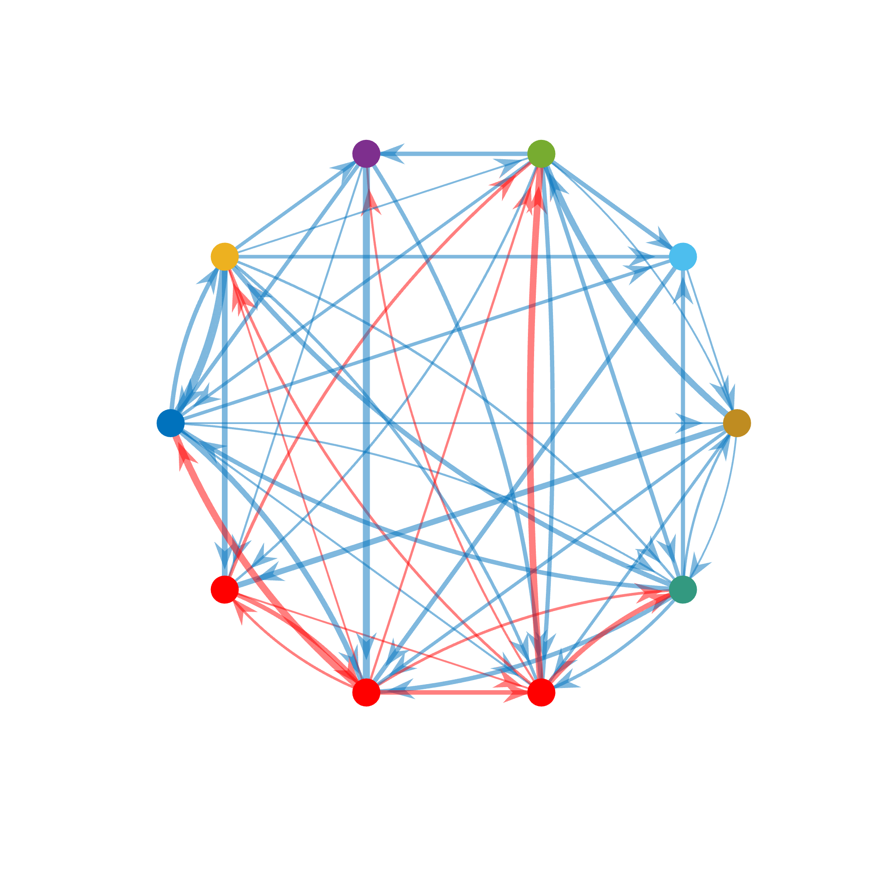
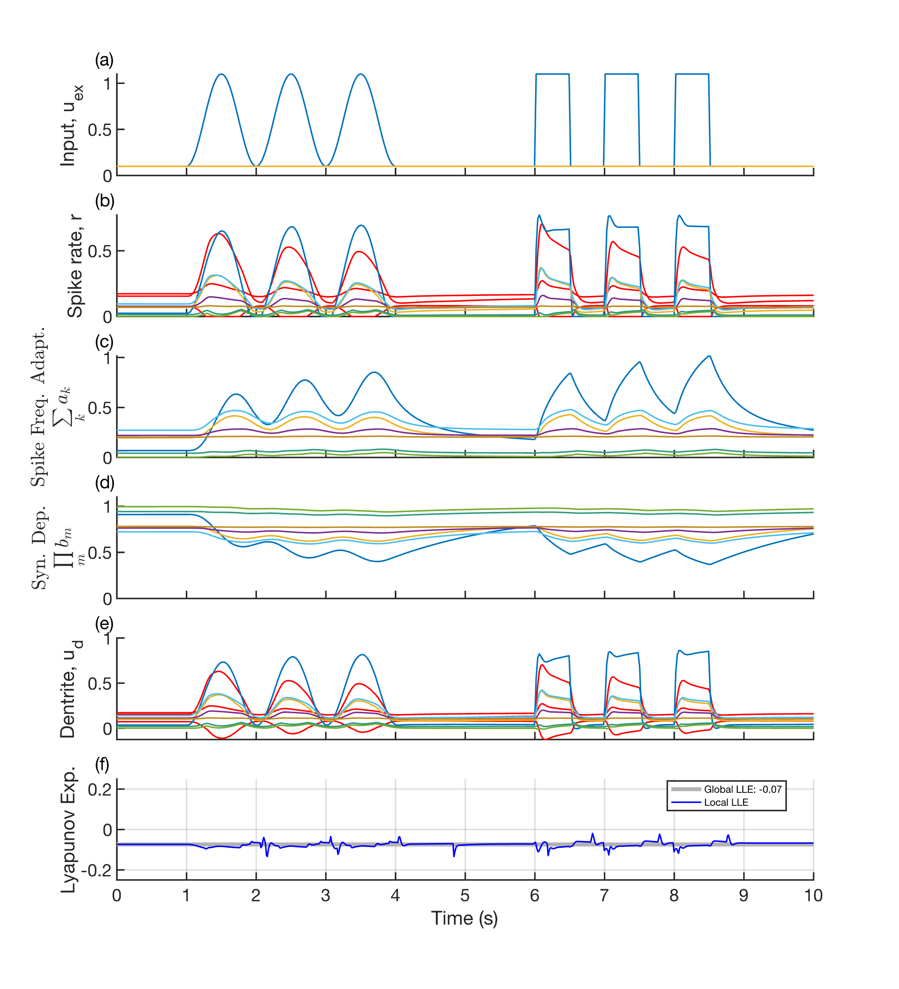
Figure 1. Spike frequency adaptation and short-term synaptic depression dynamically stabilizes an example network based on equations 1-4. The neurons were randomly connected and external stimuli (a) were applied. The spike rate (b) shows the characteristic phase-advance relative to sinusoidal stimulation and decay in response to square wave stimulation due to SFA (c) and STD (d). This dual form of adaptation

Changes in stimulation caused to transient instability as shown by the local largest Lyapunov exponent (f), but adaptation (c, d) rapidly rebalanced the network to keep the global largest Lyapunov exponent stable (less than zero) over time. Interestingly, synaptic inputs (e) clustered bimodally and maintained a dynamic balance.

Stability

We are interested to understand how multiple timescale SFA and STD affect the level of chaos or convergence at the network level. However, the network has rectification nonlinearity and multiplicative nonlinearity. Therefore, the system cannot be reduced to a system of first-order differential equations where the stability can be directly calculated as the eigenvalues of the state transition matrix. Instead, we calculated the largest Lyapunov exponent $λ_{1}$ using Benettin’s method (Benettin et al., 1976, 1980). In brief, a small perturbation is applied to the state of the system and the exponential rate of divergence (or convergence) of the perturbed trajectory is tracked over time. If $λ_{1}$ is negative, then the system is nonchaotic, and if it is positive, then the system is chaotic. If the $λ_{1}$ is near zero, the system is on the edge of chaos.

To understand the effect of SFA and STD on dynamical stability, we created a large number of randomly connected networks and calculated the $λ_{1}$ while systematically varying key network parameters. We compared networks with no adaptation, SFA alone, STD alone, both SFA and STD. The purpose of using randomly connected networks is to explore whether network connectivity need to be carefully tuned to ensure a specific level of stability. Randomly connecting the network represents a worst-case scenario in which there is no coordination of synaptic strengths. We present a sensitivity analysis in figure 3 in which we vary each connectivity parameter one at a time. In figure 4, we simulated networks throughout a six-dimensional parameter space to test for potential regions in parameter space which could render networks with SFA and STD overly convergent or unstable.

We explored networks that became transiently unstable and exhibited large discharges. We found that this occurred most in a subset of networks with a four-fold increase in excitatory-excitatory weights.

Together, these methods explore the interaction of multiple timescale SFA and STD, as well as their effect on the level of divergence.

Results

To test our hypothesis that adaptation promotes network stability and flexibility, we analyzed the dynamical behavior of our recurrent neural network model with and without STD and multiple timescale SFA.

Adaptation leads to the edge of chaos

We performed a sensitivity analysis of stability, as measured by the largest Lyapunov exponent, by varying key connectivity parameters: mean connection strength, network size, the fraction of excitatory neurons, and the excitatory-to-excitatory connection strength. Increasing any one of these parameters is expected to create additional positive feedback on average. We 50 randomly connected networks at each parameter combination and computed their stability (Figure 4). Networks without adaptation (Figure 4, m-p) became unstable as each connectivity parameter increased. Networks with SFA alone (Figure 4, e-h) were only slightly more stable, but networks with STD alone (Figure 4, i-l) were much more stable. Networks with both SFA and STD maintained a $λ_{1}$ close to zero (on the edge of chaos) across a wide range of connectivity parameters. This shows that the stability of networks with SFA and STD is largely insensitive to connectivity.

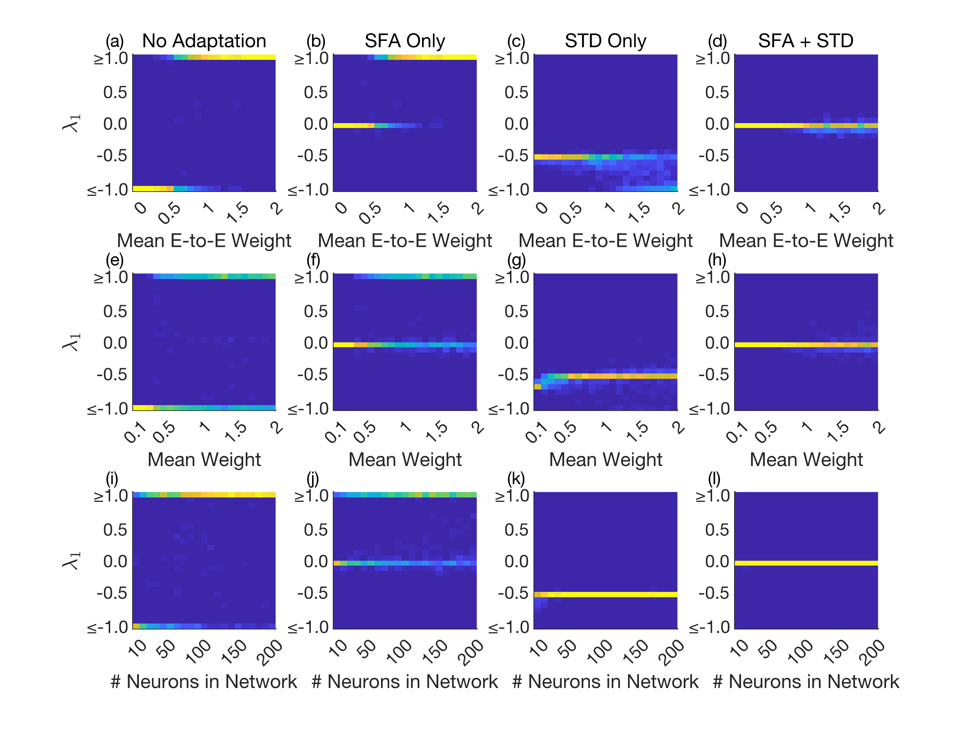
Figure 2. The combination of multiple timescale SFA and STD leads to robust networks on the edge of chaos over a wide range of connectivity parameters. We performed a sensitivity analysis of $λ_{1}$ across a range of connectivity parameters. We compared four conditions along each column: (1) no adaptation, (2) SFA alone, (3) STD alone, and (4) both SFA and STD. We systematically varried network parameters along four dimensions: mean excitatory-excitatory weight (a-d), and the overall (both excitatory and inhibitory) mean weight (e-h), and the number of neurons in the network (i-l). The largest Lyapunov exponent $λ_{1}$ quantifies rate of divergence between nearby network states over time. 1,000 networks were simulated for each sensitivity and the distribution of $λ_{1}$ is shown as each parameter is varried. Networks with no adaptation were either highly convergent or highly unstable (a, e, i) Some networks with SFA only were stable and near the edge of chaos, but many were still highly unstable (b, f, j). STD ensured that no networks were highly, but they were more convergent with $λ_{1}$ near -1/2 (c, g, k). In fact, increasing E-E connectivity made networks with STD only more convergent (c). Networks with both SFA and STD were stable but near the edge of chaos across a wide range of network connectivity parameters (d, h, j). Even as the connection weights quadrupled (d, h) and network size grew by two orders of magnitude in size (j), networks with both SFA and STD remained near the edge of chaos.

We see that networks with multiple timescale SFA and STD naturally exhibit edge-of-chaos dynamics (Fig. 3). But, what does this entail for the overall level of activity (i.e. mean spike rate)? We simulated networks throughout a 6-dimensional parameter space while computing the mean firing rate of the network and $λ_{1}$ (Figure 3). We found that unstable networks, those lacking STD, had extremely high mean spike rates. Networks with STD alone had moderated mean spike rates, but they were highly convergent. The combination of SFA and STD helped maintain low spike rates and stability near the edge of chaos.


Figure 3. Together, multiple timescale SFA and STD regulate the mean spike rate and level of chaos. We simulated 8,500 randomly connected networks and measured their large Lyapunov exponent $λ_{1}$ and their mean spike rate. The six-dimensional parameter space included: mean excitatory-excitatory connection weight, mean inhibitory-to-excitatory connection weight, mean overall connection weight, excitatory-inhibitory neuron ratio, mean in and out degree, and the time constant of SFA. We compared networks with no adaptation (a, e), SFA alone (b, f), STD alone (c, g), and both together (d, h). While SFA alone was unable to regulated mean spike rate (e), it interacted with STD to achieve the regulated both stability (d) and mean spike rate (h).

Networks with both SFA and STD are typically stable but near the edge of chaos (Figs. 2 and 3). How close they come to the edge of chaos depended on the longest timescale of adaptation, SFA or STD (see figure 4).

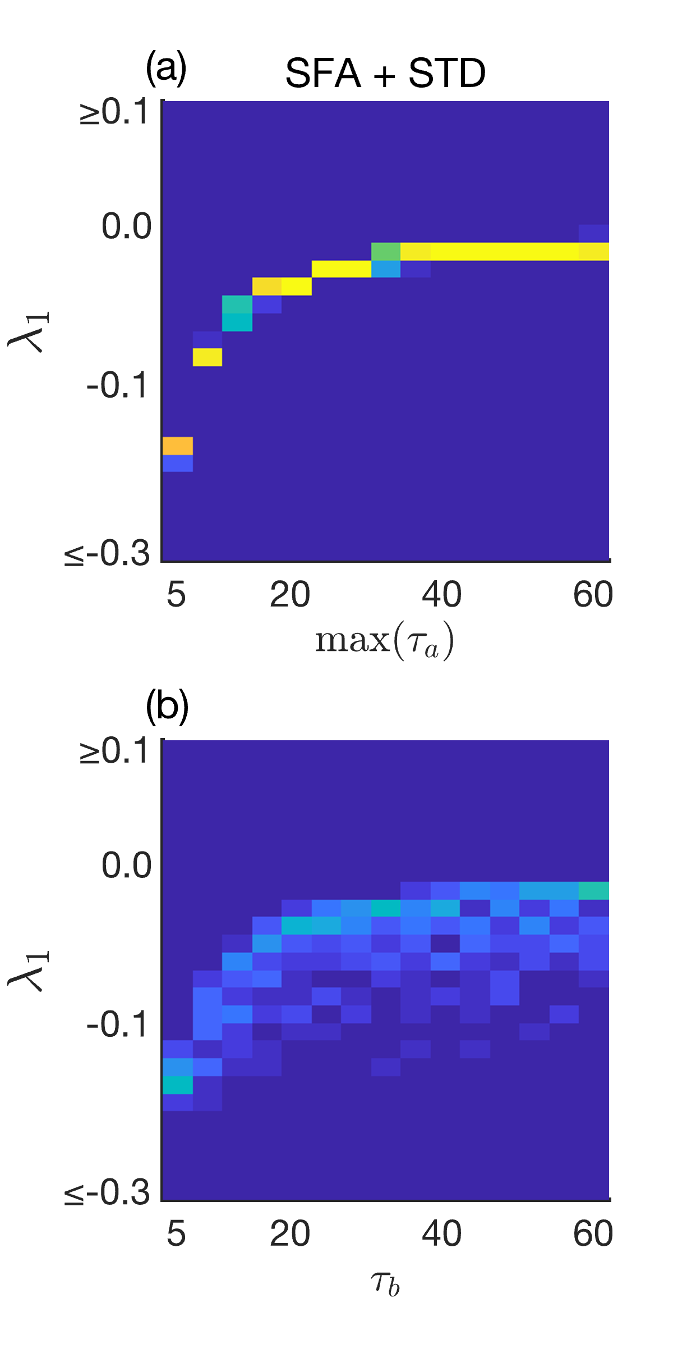
Figure 4. Long timescales of adaptation put networks onto the edge of chaos . As the longest time constants of SFA (a) or STD (b) increased from 5 to 60 seconds, randomly connected networks moved towards the edge of chaos, $λ_{1}=0$. To better see the effect of $τ_{b}$, we set $max⁡(τ_{a})=5 s$ in (b), because otherwise with the default of $max⁡(τ_{a})=15 s$, the networks would already be close to the edge of chaos.

STD and multiple timescale SFA helps maintain low firing rates (Fig. 3) while positioning the network onto the edge of chaos (Fig. 2). SFA and STD achieve this via a nonlinear interaction between SFA and STD (Lundstrom & Richner, 2023). As a result, in recurrent networks with excitatory neurons that have multiple timescale SFA and excitatory connections with STD, stability is largely insensitive to connectivity.

Large discharges respond to stimulation

We observed large discharges involving all neurons in networks where excitation is much greater than inhibition and external input is low. Strong external input (i.e. stimulation) suppressed these discharges. However, weak stimulation made the discharges smaller in amplitude and more frequent (see figure 5).

Intuitively, these discharges occur in networks that without adaptation are very unstable but have a low basal firing rate such that the adaptation variables $b$ and $a_{k}$ are able to reset into a highly divergent region of state space. There is a trivial unstable critical point at $b=1, a_{k}=0$ and when $r=0$ and $u_{ex}=0$. At this point, all derivatives are zero, but any small perturbation can set off a large discharge. SFA, STD, and rectification interact to bring the network towards the critical point. After a discharge, spike rates $r$ are suppressed to zero by SFA and rectification. Since SFA recovers more slowly than STD, $\max\left(τ_{a_{3}}\right)<τ_{b}$, the STD variable $b$ recovers nearly to unity while SFA recovers towards zero. Therefore the network approaches the saddle node from below with many neurons unable to contribute. Near the critical point, $\frac{da_{k}}{dt}$ and $\frac{db}{dt}$ are nearly zero, so we can consider eigenvalues of a reduced fast subsystem. From equation 1, $r=u_{d}$, which we can substitute into equation 3, and we substitute equation 6 into 7 to get
$$\frac{du_{d}}{dt}=\frac{1}{τ_{d}}\left(M-I\right)*u_{d}$$
5
If $M$ has eigenvalues $λ_{i}$, then the eigenvalues of $\frac{1}{τ_{d}}\left(M-I\right)$ are
$$\frac{1}{τ_{d}}\left(λ_{i}-1\right)$$
6
If the connection matrix has at least one eigenvalue with real part greater than 1, then since $τ_{d}$ is only 10 ms, the eigenvalues of the fast subsystem near the critical point are very large, leading to a sharp discharge.

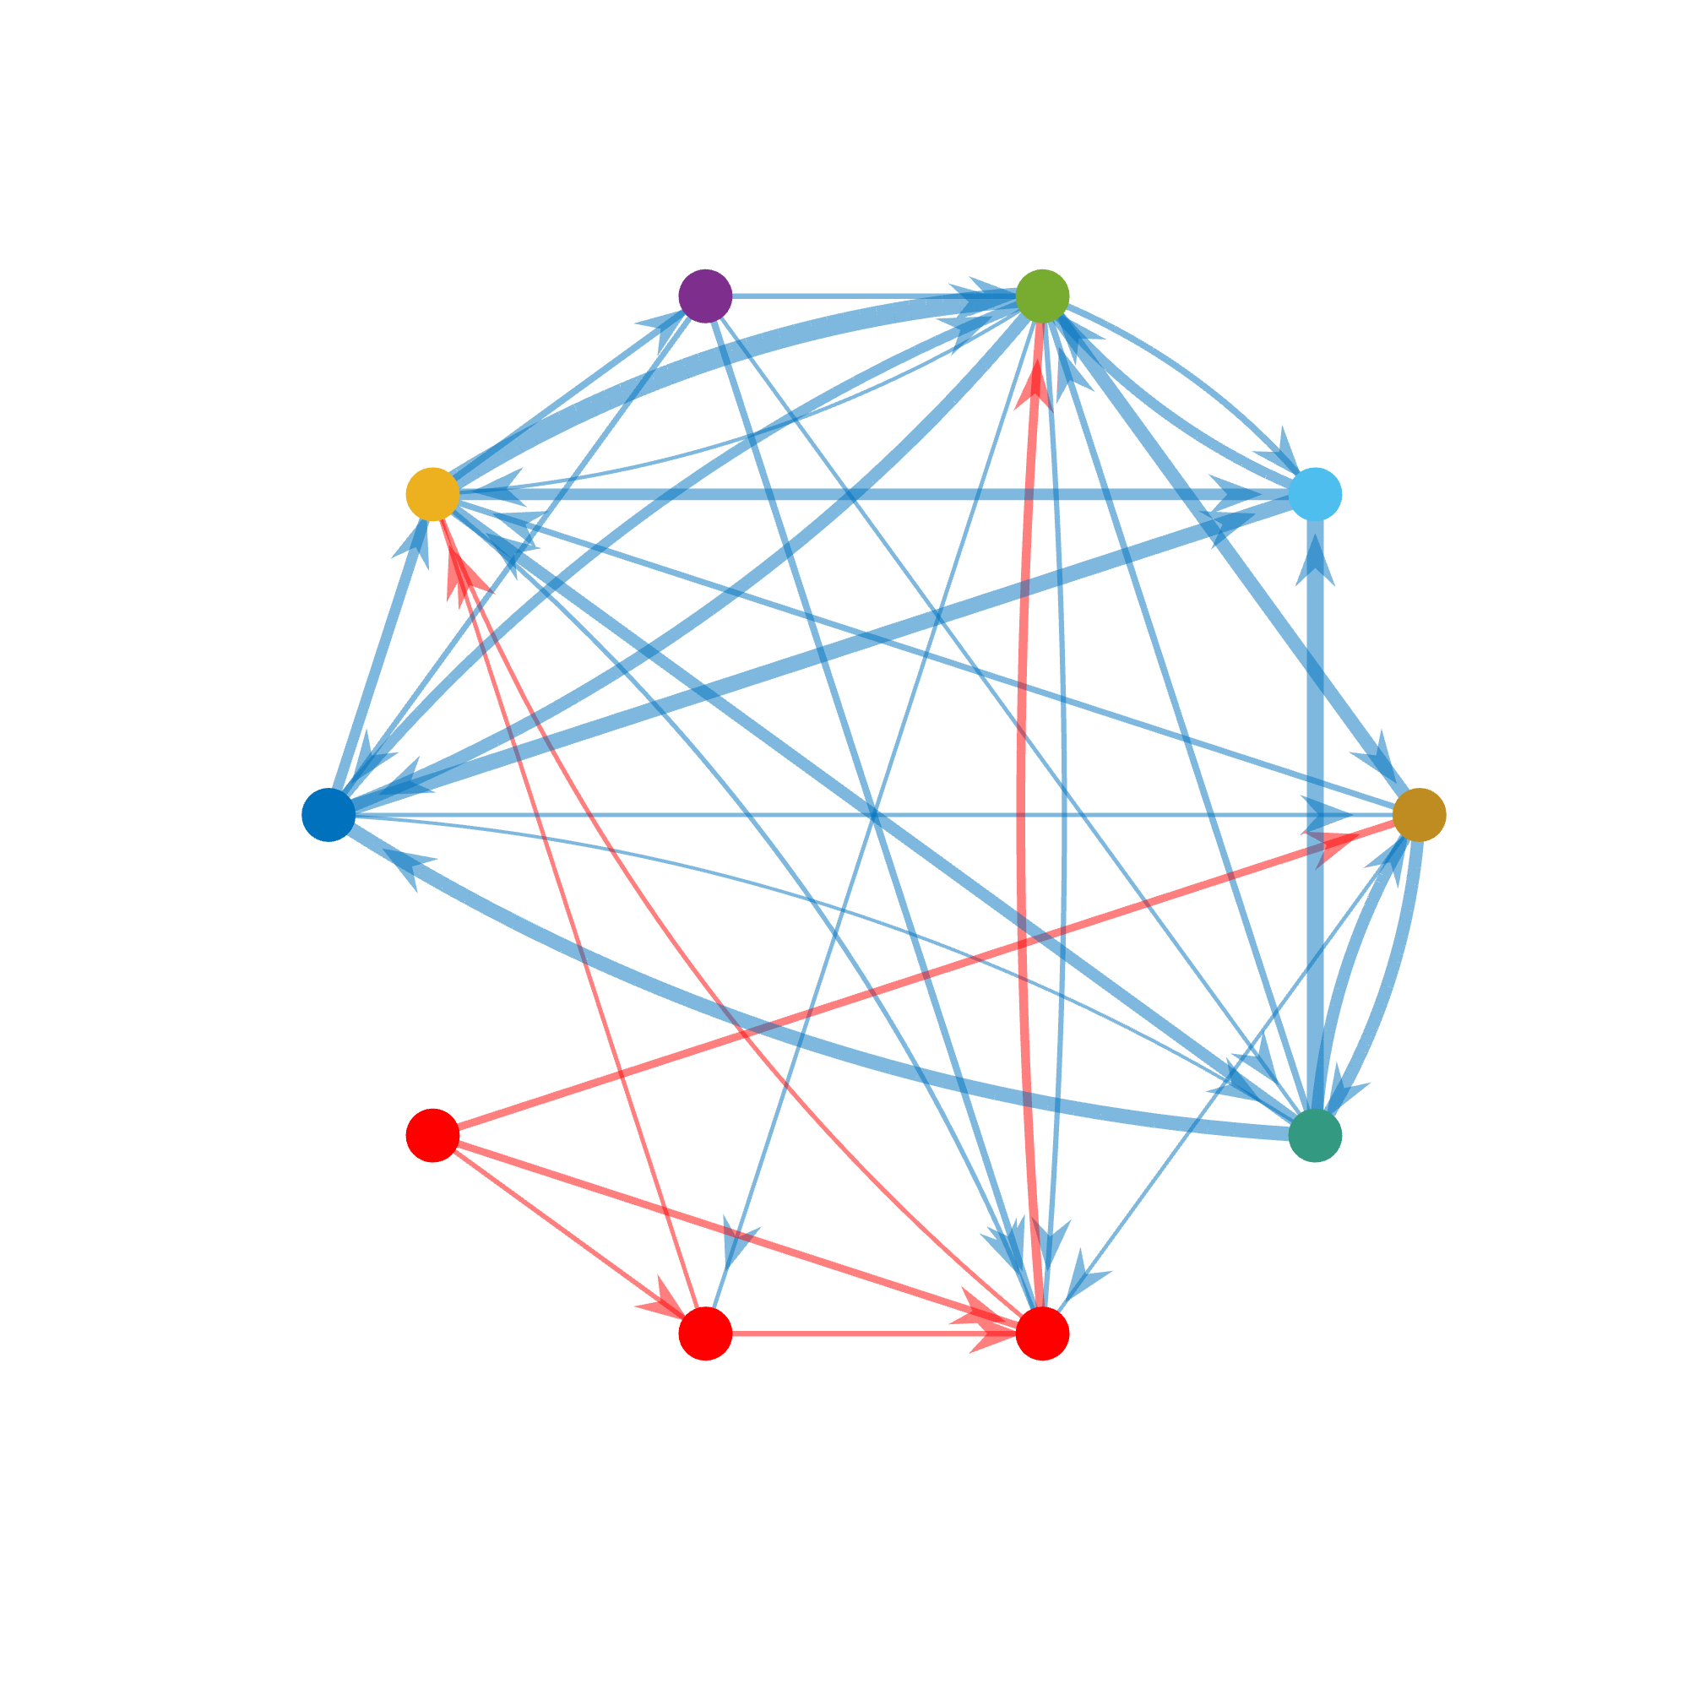
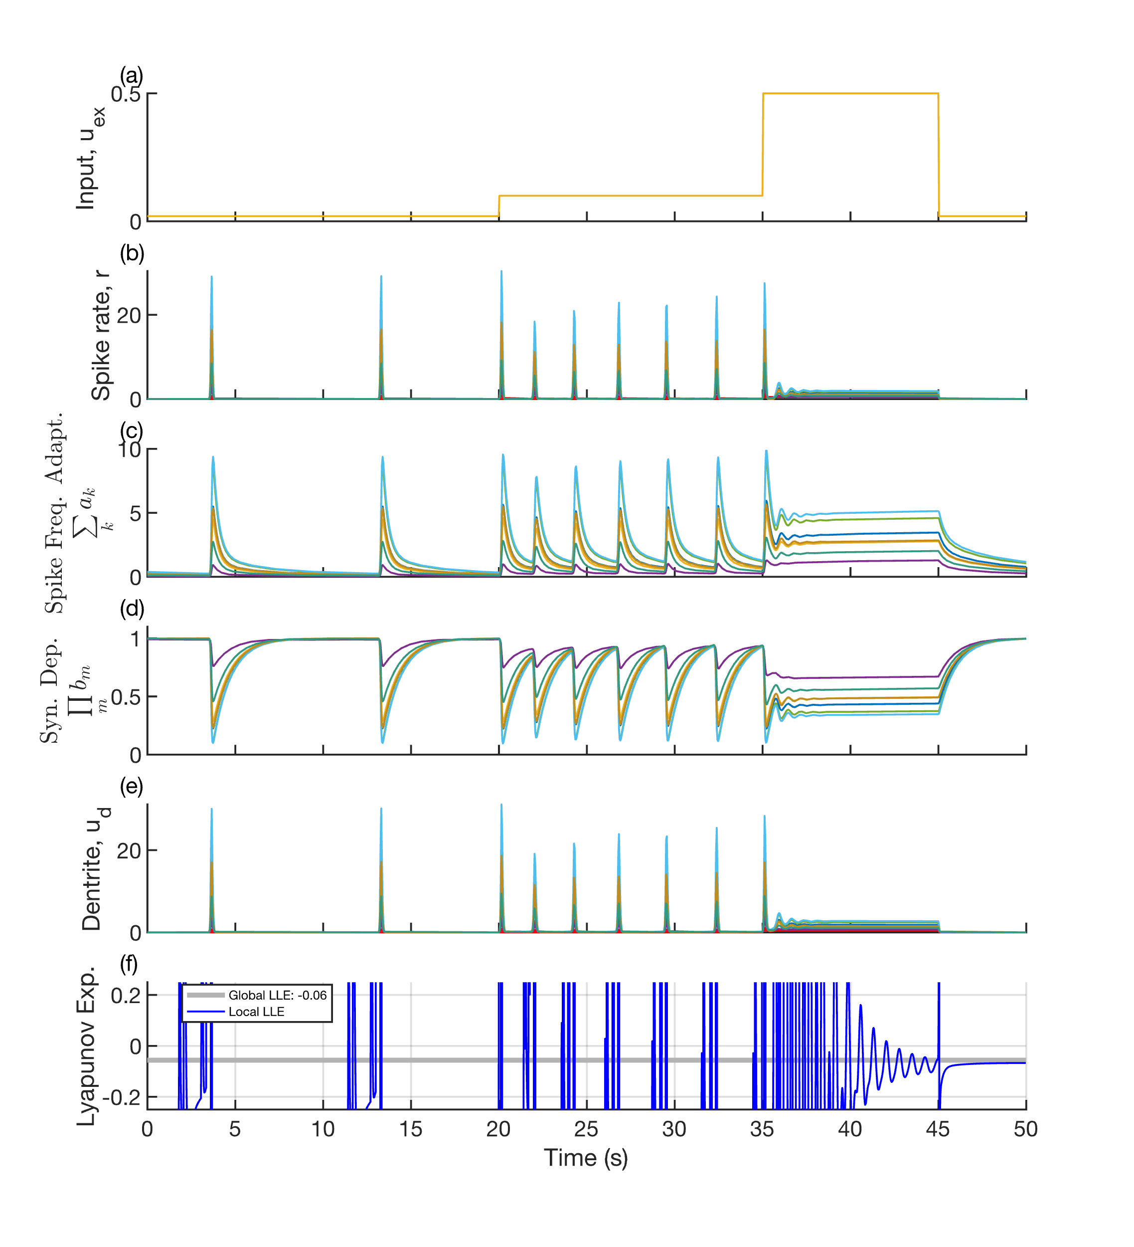
Figure 5. Large discharges develop in networks with excess excitatory connectivity which can be suppressed with external input (i.e. stimulation). With minimal input, the network exhibits strong, periodic spike rate discharges (b) which are due to an interaction between SFA (c) and rectification of spike rate (b) enabling STD (d) to fully reset to unity. Weakly increasing the external input (a) to all neurons causes these discharges to become more frequent, but strongly increasing external input suppresses discharges by preventing STD (d) from resetting to unity, annihilating the unstable critical point with a fixed point.

However, if sufficient external input (i.e. stimulation) is delivered (Fig. 5), or if SFA is absent (data not shown), the network is unable to reset to the critical point. Instead, it settles to a fixed point or a limit cycle and exhibits qualitatively “well-behaved” dynamics. For this reason, we chose to apply a DC input of $1/{10}$ to all neurons for figures, which can be thought of as akin to a leak current. Alternatively, we can modify equation 3 with the addition of a constant bias $a_{0}>0$ which raises the baseline firing rate of each neuron towards $a_{0}$, engaging STD and therefore avoiding discharges.

$$\frac{da_{k}}{dt}=\frac{a_{k}-a_{k}+r}{τ_{a_{k}}}$$
7
From figure 5, we can also see that external input engages STD and SFA, which can be viewed as dynamic weights and biases. As a result, different subnetworks become active, depending on the input level.

Discussion

Adaptation of synaptic weights by STD and biases by SFA regulated intrinsic gain such that a wide range of networks were stable and near the edge of chaos without explicit tuning of connectivity. By stabilizing network dynamics independently of synaptic wiring, STD and SFA removed the dual, and otherwise conflicting, requirements for synaptic plasticity to both facilitate learning and maintain dynamical stability. Interestingly, we observed that pronounced periodic population spikes reminiscent of interictal epileptiform discharges can be suppressed by external stimulation. Importantly, these findings necessitated both STD and SFA, underscoring their complementary roles in maintaining global dynamical properties without synaptic tuning.

Together, STD and SFA establish a robust negative feedback control system within recurrent networks. We previously found a paradoxical effect where increased stimulation of excitatory neurons can decrease firing in feedforward networks due to a nonlinear interactions between input, STD and SFA (Lundstrom & Richner, 2023). This is reminiscent but distinct from the paradoxical effect observed in inhibitory stabilized networks in which external inhibition of inhibitory neurons results in increase inhibitory neuron firing rates, because this effect requires recurrence (M. V. Tsodyks et al., 1997; Wu & Gjorgjieva, 2023). Therefore, we explored how STD, SFA, and external input interact in recurrent neural networks in the current investigation. In our network, STD and SFA created a control system in which elevated excitatory firing rates decrease synaptic efficacy and spike rate, respectively, jointly intervening to halt runaway excitation. From a computational perspective, adaptive biases and weights function similarly to layer normalization techniques employed in feedforward artificial neural networks. However, in recurrent networks, there are no distinct layers; the neuron itself becomes the functional unit requiring normalization. Chaotic and persistent activity has been studied previously in recurrent neural networks with "dynamic synapses" (i.e., STD) (Dong & and Hopfield, 1992; M. Tsodyks et al., 1998; Dror & Tsodyks, 2000b; Barak & Tsodyks, 2007). However, connectivity tuning or additional stabilization (e.g., with SFA) seems necessary to find the edge of chaos.

Networks on the edge of chaos are flexible enough to be interesting but stable enough to be useful. Complexity peaks on the edge of chaos (Bertschinger & Natschläger, 2004). Similarly, reservoir networks achieve optimal performance in terms of both information storage and transfer when positioned near the edge (Maass et al., 2002; Jaeger & Haas, 2004; Boedecker et al., 2012). Dynamic synapses have been shown to naturally drive spiking networks toward criticality, producing scale-free avalanche distributions characteristic of self-organized criticality and maximizing sensitivity to inputs (Levina et al., 2007). Furthermore, dynamic synapses at critical transitions significantly enhance computational capacity and memory storage, contributing to diverse and robust computational outcomes (Torres & Kappen, 2013). However, keeping linear networks on the edge of chaos is nontrivial according to random matrix theory (Ginibre, 1965; Girko, 1985; Rajan & Abbott, 2006). In our network, random unbalanced networks position onto the edge of chaos over time, but we observed transient divergent excursions when external input changed as evident in the local Lyapunov exponent (Fig. 2f). A benefit of chaos is that it spreads information across the network in a structured way (Lajoie et al., 2013). Therefore, transient divergent excursions that are temporally aligned with changing external inputs may be a beneficial feature of our network.

Negative feedback mechanisms such as spike frequency adaptation (SFA) and short-term synaptic depression (STD) provide stability, which in turn increases the flexibility of neural connectivity. Without these mechanisms, learning rules face a conflicting mandate to simultaneously encode new information and ensure dynamical stability, creating a significant constraint on possible learning algorithms (Zenke et al., 2017). Although Hebbian plasticity inherently promotes instability through positive feedback loops, the presence of rapid compensatory processes, like STD and SFA, effectively mitigates these instabilities by acting on faster timescales than traditional homeostatic plasticity mechanisms. Consequently, SFA and STD collectively remove the need for synaptic plasticity to concurrently manage learning and stability. Long-term homeostatic plasticity mechanisms can thus focus on maintaining synaptic distributions over extended periods, decoupled from short-term dynamical constraints. This division of roles allows synaptic connectivity greater flexibility and enables evolutionarily and developmentally more diverse and robust plasticity rules (Baldi & Sadowski, 2016; Confavreux et al., 2025). Thus, SFA and STD jointly resolve the temporal paradox described by Zenke and colleagues, facilitating flexible yet stable neural dynamics.

Developing a broader conception of excitatory-inhibitory balance that includes other forms of negative feedback and gain scaling such as SFA and STD could build on pioneering research in epileptology using eigen analysis of patient-specific estimated connectivity to localize the seizure onset zone and plan interventions (Sritharan & Sarma, 2014; Ehrens et al., 2015; Kamali et al., 2020; Smith et al., 2020; Li et al., 2021; Smith et al., 2022). However, when connectivity matrices are used as the state transition matrix of an LTI dynamical system, connectivity entirely determines stability (Routh, 1877), and this reintroduces the initial motivating problem for this paper, highly recurrent neural networks are difficult to stabilize on short timescales with local learning rules. Incorporating SFA and STD, which may play crucial roles in stabilizing large recurrent networks, could enhance patient-specific models aimed at guiding epilepsy surgery and informing device implantation strategies. Moreover, our computational model demonstrates that network discharges can be effectively suppressed through stimulation, a phenomenon reminiscent of interictal epileptiform discharge (IED) suppression by stimulation observed experimentally (Lundstrom et al., 2016, 2019; Gregg et al., 2025). This suppression also aligns with broader findings in the literature on stimulus-dependent reduction of chaotic dynamics (Rajan et al., 2010; Deco & Hugues, 2012). Perhaps targeted stimulation protocols could be utilized to probe and quantify adaptive neural dynamics directly in patients with neurological conditions involving hyperexcitability.

In conclusion, adaptation of weights and biases by STD and SFA, keep a wide range of unbalanced neural networks stable and near the edge of chaos.

References

Abbott, L. F., Varela, J. A., Sen, K., & Nelson, S. B. (1997). Synaptic Depression and Cortical Gain Control. Science, 275(5297), 221–224. https://doi.org/10.1126/science.275.5297.221
Baldi, P., & Sadowski, P. (2016). A theory of local learning, the learning channel, and the optimality of backpropagation. Neural Networks, 83, 51–74. https://doi.org/10.1016/j.neunet.2016.07.006
Barak, O., & Tsodyks, M. (2007). Persistent activity in neural networks with dynamic synapses. PLoS Computational Biology, 3(2), e35.
Benda, J., & Herz, A. V. M. (2003). A Universal Model for Spike-Frequency Adaptation. Neural Computation, 15(11), 2523–2564. https://doi.org/10.1162/089976603322385063
Benettin, G., Galgani, L., Giorgilli, A., & Strelcyn, J.-M. (1980). Lyapunov Characteristic Exponents for smooth dynamical systems and for hamiltonian systems; a method for computing all of them. Part 1: Theory. Meccanica, 15(1), 9–20. https://doi.org/10.1007/BF02128236
Benettin, G., Galgani, L., & Strelcyn, J.-M. (1976). Kolmogorov entropy and numerical experiments. Physical Review A, 14(6), 2338–2345. https://doi.org/10.1103/PhysRevA.14.2338
Bertschinger, N., & Natschläger, T. (2004). Real-Time Computation at the Edge of Chaos in Recurrent Neural Networks. Neural Computation, 16(7), 1413–1436. https://doi.org/10.1162/089976604323057443
Boedecker, J., Obst, O., Lizier, J. T., Mayer, N. M., & Asada, M. (2012). Information processing in echo state networks at the edge of chaos. Theory in Biosciences, 131(3), 205–213. https://doi.org/10.1007/s12064-011-0146-8
Confavreux, B., Agnes, E. J., Zenke, F., Sprekeler, H., & Vogels, T. P. (2025). Balancing complexity, performance and plausibility to meta learn plasticity rules in recurrent spiking networks. PLOS Computational Biology, 21(4), e1012910. https://doi.org/10.1371/journal.pcbi.1012910
Dale, H. (1935). Pharmacology and Nerve-Endings. Proceedings of the Royal Society of Medicine, 28(3), 319–332. https://doi.org/10.1177/003591573502800330
Deco, G., & Hugues, E. (2012). Neural Network Mechanisms Underlying Stimulus Driven Variability Reduction. PLoS Computational Biology, 8(3), e1002395. https://doi.org/10.1371/journal.pcbi.1002395
Dong, D. W., & and Hopfield, J. J. (1992). Dynamic properties of neural networks with adapting synapses. Network: Computation in Neural Systems, 3(3), 267–283. https://doi.org/10.1088/0954-898X_3_3_002
Dror, G., & Tsodyks, M. (2000a). Activity of coupled excitatory and inhibitory neural populations with dynamic synapses. Neurocomputing, 32–33, 359–364. https://doi.org/10.1016/S0925-2312(00)00186-7
Dror, G., & Tsodyks, M. (2000b). Chaos in neural networks with dynamic synapses. Neurocomputing, 32–33, 365–370. https://doi.org/10.1016/S0925-2312(00)00187-9
Eccles, J. C., Fatt, P., & Koketsu, K. (1954). Cholinergic and inhibitory synapses in a pathway from motor-axon collaterals to motoneurones. The Journal of Physiology, 126(3), 524–562. https://doi.org/10.1113/jphysiol.1954.sp005226
Ehrens, D., Sritharan, D., & Sarma, S. V. (2015). Closed-loop control of a fragile network: Application to seizure-like dynamics of an epilepsy model. Frontiers in Neuroscience, 9. https://doi.org/10.3389/fnins.2015.00058
Fairhall, A. L., Lewen, G. D., Bialek, W., & de Ruyter van Steveninck, R. R. (2001). Efficiency and ambiguity in an adaptive neural code. Nature, 412(6849), Article 6849. https://doi.org/10.1038/35090500
Ginibre, J. (1965). Statistical Ensembles of Complex, Quaternion, and Real Matrices. Journal of Mathematical Physics, 6(3), 440–449. https://doi.org/10.1063/1.1704292
Girko, V. L. (1985). Circular Law. Theory of Probability & Its Applications, 29(4), 694–706. https://doi.org/10.1137/1129095
Gregg, N. M., Valencia, G. O., Pridalova, T., Huang, H., Kremen, V., Lundstrom, B. N., Van Gompel, J. J., Miller, K. J., Worrell, G. A., & Hermes, D. (2025). Thalamic stimulation induced changes in network connectivity and excitability in epilepsy. medRxiv, 2024.03.03.24303480. https://doi.org/10.1101/2024.03.03.24303480
Haruna, T., & Nakajima, K. (2019). Optimal short-term memory before the edge of chaos in driven random recurrent networks. Physical Review E, 100(6), 062312. https://doi.org/10.1103/PhysRevE.100.062312
Hebb, D. O. (1949). The organization of behavior; a neuropsychological theory (pp. xix, 335). Wiley.
Jaeger, H., & Haas, H. (2004). Harnessing nonlinearity: Predicting chaotic systems and saving energy in wireless communication. Science, 304(5667), 78–80. https://doi.org/10.1126/science.1091277
James, R. G., Burke, K., & Crutchfield, J. P. (2014). Chaos forgets and remembers: Measuring information creation, destruction, and storage. Physics Letters A, 378(30), 2124–2127. https://doi.org/10.1016/j.physleta.2014.05.014
Kamali, G., Smith, R. J., Hays, M., Coogan, C., Crone, N. E., Sarma, S. V., & Kang, J. Y. (2020). Localizing the seizure onset zone from single pulse electrical stimulation responses using transfer function models. 2020 42nd Annual International Conference of the IEEE Engineering in Medicine Biology Society (EMBC), 2524–2527. https://doi.org/10.1109/EMBC44109.2020.9175954
Kolmogorov, A. N. (1958). A new metric invariant of transient dynamical systems and automorphisms in Lebesgue spaces. Doklady Akademii Nauk, 119(5), 861–864.
Lajoie, G., Lin, K. K., & Shea-Brown, E. (2013). Chaos and reliability in balanced spiking networks with temporal drive. Physical Review E, 87(5), 052901. https://doi.org/10.1103/PhysRevE.87.052901
Langton, C. G. (1990). Computation at the edge of chaos: Phase transitions and emergent computation. Physica D: Nonlinear Phenomena, 42(1), 12–37. https://doi.org/10.1016/0167-2789(90)90064-V
Levina, A., Herrmann, J. M., & Geisel, T. (2007). Dynamical synapses causing self-organized criticality in neural networks. Nature Physics, 3(12), 857–860. https://doi.org/10.1038/nphys758
Li, A., Huynh, C., Fitzgerald, Z., Cajigas, I., Brusko, D., Jagid, J., Claudio, A. O., Kanner, A. M., Hopp, J., Chen, S., Haagensen, J., Johnson, E., Anderson, W., Crone, N., Inati, S., Zaghloul, K. A., Bulacio, J., Gonzalez-Martinez, J., & Sarma, S. V. (2021). Neural fragility as an EEG marker of the seizure onset zone. Nature Neuroscience, 24(10), Article 10. https://doi.org/10.1038/s41593-021-00901-w
Liaw, J.-S., & Berger, T. W. (1996). Dynamic synapse: A new concept of neural representation and computation. Hippocampus, 6(6), 591–600. https://doi.org/10.1002/(SICI)1098-1063(1996)6:6<591::AID-HIPO4>3.0.CO;2-K
Lundstrom, B. N. (2015). Modeling multiple time scale firing rate adaptation in a neural network of local field potentials. Journal of Computational Neuroscience, 38(1), 189–202. https://doi.org/10.1007/s10827-014-0536-2
Lundstrom, B. N., Brinkmann, B. H., & Worrell, G. A. (2021). Low frequency novel interictal EEG biomarker for localizing seizures and predicting outcomes. Brain Communications, 3(4), fcab231. https://doi.org/10.1093/braincomms/fcab231
Lundstrom, B. N., Fairhall, A. L., & Maravall, M. (2010). Multiple Timescale Encoding of Slowly Varying Whisker Stimulus Envelope in Cortical and Thalamic Neurons In Vivo. Journal of Neuroscience, 30(14), 5071–5077. https://doi.org/10.1523/JNEUROSCI.2193-09.2010
Lundstrom, B. N., Gompel, J. V., Khadjevand, F., Worrell, G., & Stead, M. (2019). Chronic subthreshold cortical stimulation and stimulation-related EEG biomarkers for focal epilepsy. Brain Communications, 1(1). https://doi.org/10.1093/braincomms/fcz010
Lundstrom, B. N., Higgs, M. H., Spain, W. J., & Fairhall, A. L. (2008). Fractional differentiation by neocortical pyramidal neurons. Nature Neuroscience, 11(11), 1335–1342. https://doi.org/10.1038/nn.2212
Lundstrom, B. N., & Richner, T. J. (2023). Neural adaptation and fractional dynamics as a window to underlying neural excitability. PLOS Computational Biology, 19(2), e1010527. https://doi.org/10.1371/journal.pcbi.1010527
Lundstrom, B. N., Van Gompel, J., Britton, J., Nickels, K., Wetjen, N., Worrell, G., & Stead, M. (2016). Chronic Subthreshold Cortical Stimulation to Treat Focal Epilepsy. JAMA Neurology, 73(11), 1370–1372. https://doi.org/10.1001/jamaneurol.2016.2857
Lyapunov, A. (1892). The general problem of the stability of motion. Kharkov Mathematical Society.
Maass, W., Natschläger, T., & Markram, H. (2002). Real-time computing without stable states: A new framework for neural computation based on perturbations. Neural Computation, 14(11), 2531–2560. https://doi.org/10.1162/089976602760407955
Nyquist, H. (1932). Regeneration Theory. Bell System Technical Journal, 11(1), 126–147. https://doi.org/10.1002/j.1538-7305.1932.tb02344.x
Oja, E. (1982). Simplified neuron model as a principal component analyzer. Journal of Mathematical Biology, 15(3), 267–273. https://doi.org/10.1007/BF00275687
Principe, J. C., Euliano, N. R., & Lefebvre, W. C. (1999). Neural and Adaptive Systems: Fundamentals through Simulations. Wiley.
Rajan, K., & Abbott, L. F. (2006). Eigenvalue Spectra of Random Matrices for Neural Networks. Physical Review Letters, 97(18), 188104. https://doi.org/10.1103/PhysRevLett.97.188104
Rajan, K., Abbott, L. F., & Sompolinsky, H. (2010). Stimulus-dependent suppression of chaos in recurrent neural networks. Physical Review E, 82(1), 011903. https://doi.org/10.1103/PhysRevE.82.011903
Routh, E. J. (1877). A Treatise on the Stability of a Given State of Motion: Particularly Steady Motion. Being the Essay to which the Adams Prize was Adjudged in 1877, in the University of Cambridge. Macmillan and Company.
Sherrington, S. C. S. (1906). The Integrative Action of the Nervous System. Yale University Press.
Shiryayev, A. N. (1993). New Metric Invariant of Transitive Dynamical Systems and Automorphisms of Lebesgue Spaces. In A. N. Shiryayev (Ed.), Selected Works of A. N. Kolmogorov: Volume III: Information Theory and the Theory of Algorithms (pp. 57–61). Springer Netherlands. https://doi.org/10.1007/978-94-017-2973-4_5
Smith, R. J., Hays, M. A., Kamali, G., Coogan, C., Crone, N. E., Kang, J. Y., & Sarma, S. V. (2022). Stimulating native seizures with neural resonance: A new approach to localize the seizure onset zone. Brain, 145(11), 3886–3900. https://doi.org/10.1093/brain/awac214
Smith, R. J., Kamali, G., Hays, M., Coogan, C. G., Crone, N. E., Sarma, S. V., & Kang, J. Y. (2020). State-space models of evoked potentials to localize the seizure onset zone. 2020 42nd Annual International Conference of the IEEE Engineering in Medicine & Biology Society (EMBC), 2528–2531. https://doi.org/10.1109/EMBC44109.2020.9176697
Sritharan, D., & Sarma, S. V. (2014). Fragility in Dynamic Networks: Application to Neural Networks in the Epileptic Cortex. Neural Computation, 26(10), 2294–2327. https://doi.org/10.1162/NECO_a_00644
Torres, J. J., & Kappen, H. J. (2013). Emerging phenomena in neural networks with dynamic synapses and their computational implications. Frontiers in Computational Neuroscience, 7. https://doi.org/10.3389/fncom.2013.00030
Toyoizumi, T., & Abbott, L. F. (2011). Beyond the edge of chaos: Amplification and temporal integration by recurrent networks in the chaotic regime. Physical Review E, 84(5), 051908. https://doi.org/10.1103/PhysRevE.84.051908
Tripp, B. P., & Eliasmith, C. (2010). Population Models of Temporal Differentiation. Neural Computation, 22(3), 621–659. https://doi.org/10.1162/neco.2009.02-09-970
Tsodyks, M., & Markram, H. (1997). The neural code between neocortical pyramidal neurons depends on neurotransmitter release probability. Proceedings of the National Academy of Sciences, 94(2), 719–723. https://doi.org/10.1073/pnas.94.2.719
Tsodyks, M., Pawelzik, K., & Markram, H. (1998). Neural Networks with Dynamic Synapses. Neural Computation, 10(4), 821–835. https://doi.org/10.1162/089976698300017502
Tsodyks, M. V., Skaggs, W. E., Sejnowski, T. J., & McNaughton, B. L. (1997). Paradoxical Effects of External Modulation of Inhibitory Interneurons. Journal of Neuroscience, 17(11), 4382–4388. https://doi.org/10.1523/JNEUROSCI.17-11-04382.1997
Wu, Y. K., & Gjorgjieva, J. (2023). Inhibition stabilization and paradoxical effects in recurrent neural networks with short-term plasticity. Physical Review Research, 5(3), 033023. https://doi.org/10.1103/PhysRevResearch.5.033023
Zenke, F., Gerstner, W., & Ganguli, S. (2017). The temporal paradox of Hebbian learning and homeostatic plasticity. Current Opinion in Neurobiology, 43, 166–176. https://doi.org/10.1016/j.conb.2017.03.015

Appendix A

Briefly, we will review feedback and eigenvalues for the benefit of a wider audience. Many homeostatic processes can be well described by a first-order differential equation.
$$τ\frac{dr}{dt}=-r+u$$
1
In this system, $-r$ creates negative feedback such that $x$ will stably converge towards $u$, the setpoint, with an exponential decay rate of $\frac{-1}{τ}$. This decay is the eigenvalue. If, however, we flip the sign of the feedback to $+r$ and $u$ to zero, positive feedback will cause the system to diverge exponentially towards positive or negative infinity with solution
$$r\left(t\right)= r_{0}e^{t/τ}$$
2
Continuous, linear, recurrent neural networks are set $n$ equations similar to (eq. 1) with an $n$ x $n$ connection matrix $M$. The system becomes
$$\frac{dr}{dt}=Mr+u$$
3
with bold notation indicating vectors. This network has $n$ eigenvalues $λ_{1:n}$ corresponding to $n$ resonant modes of the system. These modes grow or decay according to the real component of the eigenvalues. Therefore, if the any of the eigenvalues have a positive real component, then the entire system will be unstable and grow exponentially, an unsustainable problem. Therefore, control theory is concerned with ways to modify $M$ to ensure no eigenvalues have positive growth rates. If possible, the positive and negative weights within $M$ can be modified to ensure stability, or controller can be used to make $u$
Such linear time invariant (LTI) dynamical system

of neurons where the $n$ x 1 vector of spike rates $\frac{dr}{dt}$ depends on the spike rates of all other neurons according to an $n$ x $n$ connectivity matrix $M$. Such LTI dynamical systems are of the form
$$\frac{dr}{dt}=Mr+u$$
4
This network has $n$ eigenvalues $λ_{1:n}$ corresponding to $n$ resonant modes of the system. These modes grow or decay which is the real component of the eigenvalues, $R(λ_{1:n})$. If the any of the eigenvalues have a positive real component, then the entire system will be unstable and grow exponentially towards infinity. Therefore, control theory is very concerned with ways to use modify $M$ to ensure all eigenvalues have negative growth rates. If possible, connection weights within $M$ can be directly modified to ensure stability, or a feedback controller can be designed with
$$u\left(t\right)= -Kr$$
$$\frac{dr}{dt}=(M-K)r$$
5
such the eigenvalues of $M-K$ are favorable.

Supplementary figures

Single vs. Multiple Timescale Adaptation

We began by analyzing how single versus multiple timescales of adaptation influence the frequency response characteristics of an individual neuron (Figure 3). When adaptation was modeled with a single timescale, either for SFA (Figure 3a,b) or STD (Figure 3c,d), the neuron's gain (output amplitude vs. input frequency) and phase response were strongly dependent on the specific adaptation time constant ($τ_{a_{n}}$ and $τ_{s_{n}}$). A key characteristic of adaptation is the introduction of a phase lead, where the output phase precedes the input phase; however, for single timescales, this characteristic phase advance was prominent only within a relatively narrow frequency band determined by the time constant. In contrast, implementing multiple timescales for both SFA and STD (Figure 3e,f) resulted in filtering properties that were more consistent across a broader range of frequencies. Notably, the phase response exhibited a relatively constant phase advance across lower frequencies (below approximately 1 Hz). This flatter, broadband phase lead is a signature characteristic consistent with the neuron performing fractional differentiation, suggesting that multiple timescales enable more robust temporal processing compared to the frequency-specific effects of single timescales. Interestingly, the phase lead due to multiple timescale SFA and STD was similar to multiple timescale SFA alone and greater than STD alone, while single timescale STD had a stronger peak phase lead than single timescale SFA. These effects subtly point to nonlinear interactions between SFA and STD.
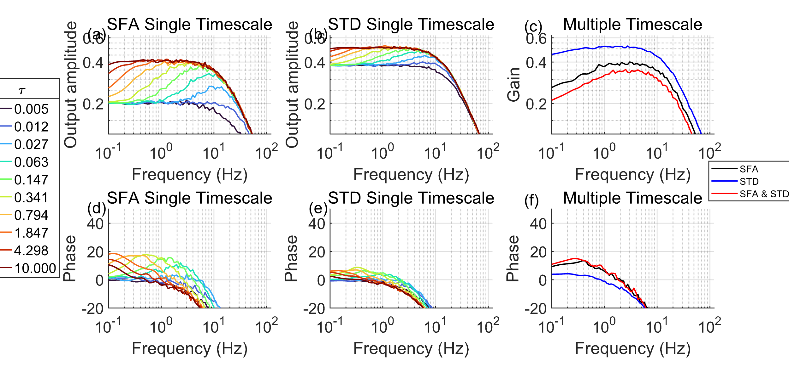
Supplementary figure 1. Multiple timescale adaptation has a broader range of frequencies over which gain and phase are consistent (e,f), while the frequency response of neurons with a single timescale of adaptation depends strongly on the adaptation time constant $τ$ (a-d). Most notably, the characteristic phase advance is seen at a narrow frequency band (b, d), while neurons with multiple timescale adaptation show a fairly constant phase advance over all frequencies below 1 Hz.

We further explored the interaction of SFA and STD in single neurons before exploring networks. While increasing either SFA or STD decreases the output of the neuron (Figure 4a,b), applying both partially restore output amplitude (Figure 4c). Increased SFA reduces the spike rate which in turn decreases STD, increasing synaptic output. We then explored 3 levels of input. With SFA alone, increased input yielded increased output (Figure 4d), but with STD alone, increased input decreased output. This is explainable by the multiplicative nonlinearity in equation 5. When these counteracting effects are combined, the output was kept steady even as the input varied (Figure 4f). This suggests that at the single neuron level, SFA interact in a nonlinear way to regulate the output level.

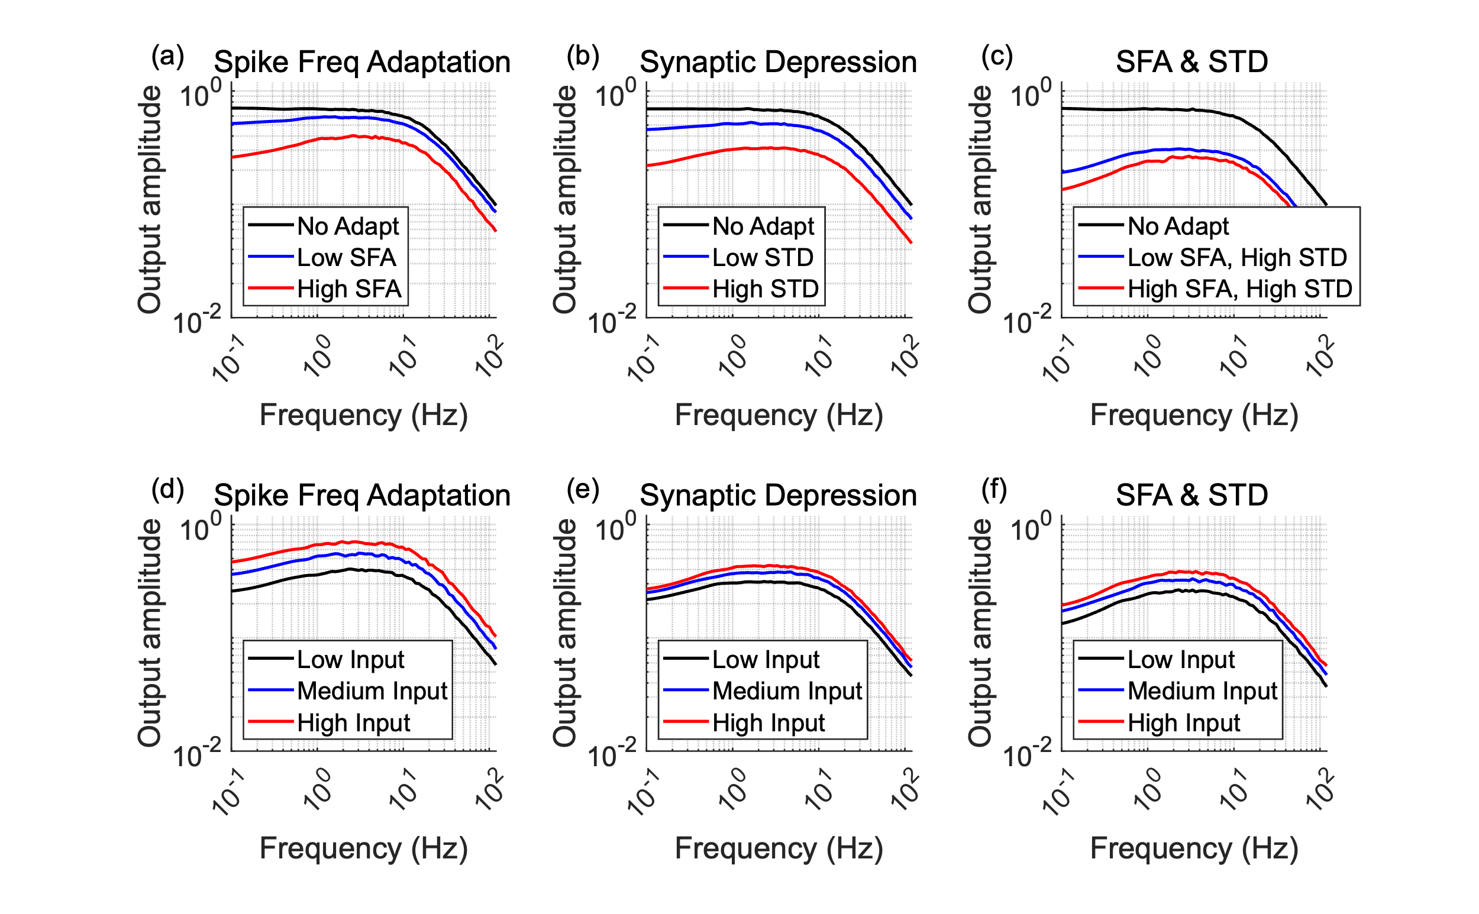
Supplementary figure 2. Together, multiple timescale SFA and STD help maintain a consistent output level in single neurons. Both SFA and STD alone decrease the output of the neuron (a, b). Interestingly, when combined (c), high SFA and high STD had greater gain than low SFA and high STD, suggesting that SFA and STD interact nonlinearly. Moreover, increasing the input level to the neuron yielded greater output in the case of SFA alone (d), but with STD alone (e), increasing the input level paradoxically reduce the output level due to the multiplicative nonlinearity of STD. Intriguingly, the combination of SFA and STD causes the output level of the neuron to stabilize, even as the input level changes (f). Perhaps this will help maintain stability at the network level.

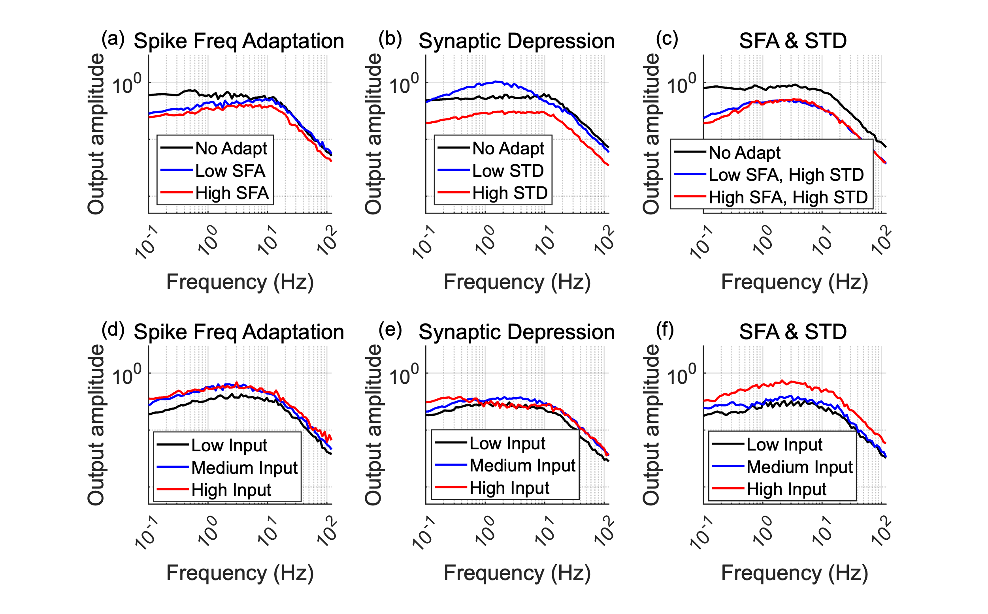
Supplementary figure 3. Network frequency response mirrors single-neuron behavior and shows stabilization with combined SFA and STD. This figure extends the analysis of Figure 4 to a randomly connected 10-neuron network. White noise was injected into 5 input neurons, and the average synaptic response was measured across the remaining 5 output neurons. Panels show the estimated network transfer function (output PSD / input PSD). (a, b) Both SFA and STD alone reduce the network gain compared to no adaptation. (c) Similar to single neurons, combining high SFA and high STD resulted in greater network gain than low SFA and high STD, indicating nonlinear interactions persist at the network level. (d) With SFA alone, increasing the input level increased the network gain. (e) Conversely, with STD alone, increasing the input level paradoxically decreased network gain, reflecting the impact of STD's multiplicative nonlinearity on network dynamics. (f) Intriguingly, when both multiple timescale SFA and STD were present, the network's gain became markedly less sensitive to changes in the input level. This stabilization likely arises from the opposing gain dependencies on input level observed for SFA and STD individually, suggesting that combined adaptation helps maintain consistent network processing across varying input intensities.

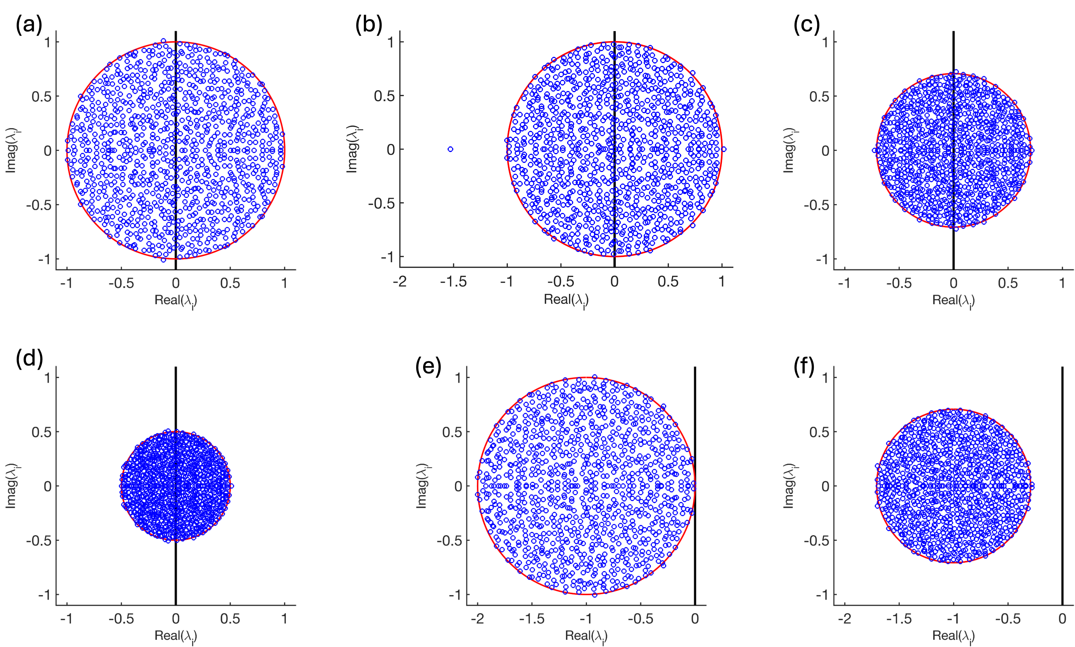
Supplementary figure 4. Continuous recurrent neural networks of the form $\frac{dx}{dt}=Mx$ with random connection matrices $M$ are unstable, even if excitation and inhibition are balanced. (a) The eigenvalues of a random n x n connection matrix $M$ with mean $μ=0$ and variance $σ^{2}=\frac{1}{n}$ are uniformly distributed within the unit circle, Girko’s circle law. Eigenvalues right of the y-axis means the system is unstable. (b) Making the mean connection weight negative with $μ<0$ moves only a single eigenvalue to $μn$. (c) Removing half of the connections reduces the radius of the bounding circle to $\sqrt{1-1/2}= \sqrt{1/2}$ , but half of the eigenvalues are still right of the y-axis. (d) Halving the connection weights such that $σ^{2}= \frac{{\left(1/2\right)}^{2}}{n}$ reduces the bounding circle to $1/2$, but does not shift the eigenvalues left. (e) Adding self-negative feedback along the main diagonal of $M$ with $M-I$, shifts the entire eigenspectrum left, now centered at -1, and coincidentally makes the system neutrally stable with an eigenvalue near the origin. (f) Combining self-negative feedback with sparsity makes the network stable, with all eigenvalues left of the origin. Across these examples, only self-negative feedback (e) shifted all eigenvalues towards stability. Spike frequency adaptation is a type of self-negative feedback.
(Old notation below)
Calculation of the fixed point under different constant input levels c.

spike rate  external input | $$r=\left|σ+u+\sum_{n}{b_{n}+c}\right|$$
synaptic output | $$p=\prod_{m}{a_{m}}*r$$
STD gain | $$τ_{a_{m}}\frac{da_{m}}{dt}=1-a_{m}-F_{a_{m}}r$$
 | $$0≤a_{m}≤1$$
SFA bias | $$τ_{b_{n}}\frac{db_{n}}{dt}=b_{0}-b_{n}-F_{b_{n}}r$$
$s$ynapse  connection Matrix | $$τ_{σ}\frac{dσ}{dt}=-σ+ M*p$$

When u = 0, and c >0, but $\frac{db_{n}}{dt}$=0, $\frac{da_{m}}{dt}=0$ and $\frac{dσ}{dt}=0$ at equilibrium then we have

$$\left\{\begin{aligned}r=\left|σ+\sum_{n}{b_{n}+c}\right| \\ \begin{matrix}\begin{matrix}p=\prod_{m}{a_{m}}.*r \\ 0≤a_{m}≤1\end{matrix} \\ 0=1-a_{m}-F_{a_{m}}p \\ 0=-b_{n}-F_{b_{n}}r\end{matrix} \\ 0=-σ+ M*p\end{aligned}\right.$$

which is just an algebraic equation which we can solve with substitutions

$$r=\left|M*\left(\prod_{m}{\left(1-F_{a_{m}}p\right)}.*r\right)-\sum_{n}{F_{b_{n}}r+c}\right|$$

which potentially has many solutions due to the piecewise linear nature of r and the multiplicative nonlinearities.

We can give it an initial condition and iterate the map to find if there is a stable fixed point, assuming a local basin of attraction.

$$\left\{\begin{aligned}r=M∙\left(r∘\prod_{m}{\left(1-F_{a_{m}}p\right)}\right)-\sum_{n}{F_{b_{n}}r+c} \\ \begin{matrix}0≤1-F_{a_{m}}r≤1 \\ 0<r\end{matrix} \\ \end{aligned}\right.$$

We can use randomized initial conditions to check for more than one stable fixed point. However, having one fixed point is enough for the system to be stable. Can we show that the saddle node and this stable fixed point annihilate as c0?

