Adaptation and Synaptic Depression Bring Recurrent Neural Networks to the Edge of Chaos

Thomas J. Richner, Martynas Dervinis, Brian N. Lundstrom

Abstract

The brain is a highly recurrent neural network (RNN) that must remain dynamically stable, but near the edge of chaos. However, the dynamical stability of large continuous RNNs is tenuous, because the probability of unstable modes increases dramatically as network size and connectivity grows (May, 1972). Intuitively, positive feedback loops within the brain have the potential to cause runaway re-excitation, leading to chaos. However, overly chaotic systems, as well as overly stable systems, underperform those on the edge of chaos (Langton, 1990). Moreover, the stability of linear dynamical systems depends entirely on connectivity (Lyapunov, 1892), so we might expect that learning rules must ensure dynamical stability. However, the brain is highly nonlinear and adaptive due to rectification, short-term synaptic depression (STD), and spike frequency adaptation (SFA). We hypothesized that STD and SFA, which dynamically adapt connection weights and biases, respectively, will improve the stability of RNNs. We investigated the scenario in which connectivity is random, sparse, and unbalanced. We found that (1) STD and SFA stabilize a wide range of RNNs, (2) STD and SFA keep these networks near the edge of chaos, depending on the longest timescale of adaptation, and (3) external stimulation engages STD and SFA to suppress hyperexcitability.

In conclusion, dynamic adaptation of both weights and biases via STD and SFA renders a wide range of networks stable and near the edge of chaos without any tuning of synaptic weights. Therefore, adaptation may be as important as connectivity with respect to stability, and learning rules need not ensure dynamical stability over the short term. Further, we propose that stimulation may improve stability by engaging adaptation rather than simply inducing recurrent inhibition. Together, STD and SFA may be sufficient to stabilize the brain onto the edge of chaos.

Introduction

The brain is a vastly recurrent neural network (RNN) that must maintain dynamical stability near the edge of chaos. The recurrent connectivity of the brain contains innumerable negative and positive feedback loops. Positive feedback, if left unchecked, can make networks unstable or chaotic. Overly chaotic or overly stable networks underperform those near the edge of chaos (Langton, 1990). However, the level of chaos (or stability) is an emergent, network-level, property, that seems to depend on connectivity. And connectivity is updated at the local level (between pairs of neurons) by biologically plausible learning rules. This motivates the question: How does the brain maintain dynamical stability near the edge of chaos?

Dynamical stability is entirely determined by connectivity for the simplest type of continuous-time recurrent neural networks, linear time-invariant (LTI) dynamical systems of the form ${dr}/{dt}=Mr$ (Lyapunov, 1892). The eigenvalues of the connectivity matrix $M$ determine whether the network is stable or unstable. If M has any eigenvalues with a positive real component, then the network has an unstable mode which will grow exponentially. Analytically, we know that as random sparsely connected LTI systems grow in size, connection strength, or connection density, the probability that they are stable shrinks to zero unless a compensatory level of negative feedback is applied (Ginibre, 1965; May, 1972; Girko, 1985). While sufficient negative feedback can stabilize any LTI system (May, 1972), achieving a specific level of stability (e.g., at which the network has maximal performance) requires network-level information: network size, connection weight variance, and connection density (Ginibre, 1965; May, 1972; Girko, 1985). Therefore, there is a spatial mismatch between dynamical properties which emerge globally and biologically plausible learning rules which operate locally.

Most learning rules do not help maintain dynamical stability—in fact, many make networks unstable. Hebbian plasticity, in which neurons that fire-together, wire-together (Hebb, 1949), is destabilizing (von der Malsburg, 1973; Abbott & Nelson, 2000) because excitatory neurons can re-excite each other, further wiring together, strengthening positive feedback loops. Indeed, only a small subset of learning rules produce stable spike rates over time (Confavreux et al., 2025). Oja’s rule, a heterosynatpic, locally normalized version of Hebb’s rule (Oja, 1982), stabilizes synaptic weight distributions, but it does not necessarily ensure dynamical stability. Zenke et al. further pointed out that homeostatic plasticity is too slow to counteract the destabilizing effect of Hebbian learning and proposed that an additional rapid compensatory mechanism is needed to counteract positive feedback (Zenke et al., 2017; Zenke & Gerstner, 2017).

Too much positive feedback causes linear systems to become unstable and nonlinear systems to become chaotic. Excessive chaos negatively impacts information processing, because internal chaotically generated information, Kolmogorov-Sanai (KS) entropy (Kolmogorov, 1958; Shiryayev, 1993), fills and mixes the system state, drowning out information about past external inputs. Similarly, overly stable systems lose information as distinct initial conditions converge (James et al., 2014). Networks near the edge of chaos have several information processing advantages (Langton, 1990; Bertschinger & Natschläger, 2004; Jaeger & Haas, 2004; Toyoizumi & Abbott, 2011; Boedecker et al., 2012; Haruna & Nakajima, 2019). Given that edge of chaos dynamics are important, but homeostatic plasticity is too slow, how can networks find the edge of chaos?

We hypothesize that short-term synaptic depression (STD) and spike frequency adaptation (SFA) stabilize RNNs by dynamically scaling the network’s weights and biases, respectively. The multiplicative nonlinearity of STD and the interaction of SFA with rectification could reduce the extent to which stability depends on connectivity. Noting that STD and SFA are generally more prominent in excitatory synapses and neurons (Connors & Gutnick, 1990; Varela et al., 1999; Zaitsev & Lewis, 2013), these dual forms of adaptation could regulate excitability at the network level.

The connection strength between neurons is dynamic in time and can govern network dynamics (Dong & and Hopfield, 1992; Liaw & Berger, 1996). Theoretically and experimentally, short-term synaptic depression (STD) controls cortical gain (Abbott et al., 1997; Tsodyks & Markram, 1997) with a multiplicative nonlinearity on the output of each neuron that reduces the output during sustained high firing rates (e.g., due to synaptic depletion). STD can be thought of as an adaptive weight that scales the output spike rate of each neuron, while spike frequency adaptation (SFA) reduces the spike rate itself over time in response to repetitive stimuli, an adaptive bias (Benda & Herz, 2003; Tripp & Eliasmith, 2010).

SFA occurs across multiple timescales. This improves coding efficiency and reduces ambiguity (Fairhall et al., 2001). We found that the timescales of SFA in slice and in vivo are well-balanced with a characteristic constant phase-advance relative to stimulus which is indicative of fractional dynamics and power-law scaling (Lundstrom et al., 2008, 2010). Our feed-forward models of multiple timescale SFA (Lundstrom, 2015; Lundstrom et al., 2021), and in combination with STD (Lundstrom & Richner, 2023), suggested that STD and SFA interact to regulate excitability and may explain reduced low-frequency power near the seizure onset zone in patients with epilepsy (Lundstrom et al., 2021).

In the current paper, we explore the effect of multiple timescale SFA and STD in recurrent networks. We develop a continuous spike rate RNN that includes both forms of adaptation and analyze the stability of these networks across a wide range of connectivity parameters. By analyzing randomly connected, unbalanced networks, we investigate whether STD and SFA are sufficient (within the model) to stabilize RNNs.

Methods

We constructed an RNN which included neurons with a rectifying nonlinearity, multiple timescale SFA, STD, a low-pass synaptic filter, and a connectivity matrix. We integrated the equations for the network through time and computed their stability, or level of chaos, using Benettin’s method (Benettin et al., 1976) to estimate the largest Lyapunov exponent. We systematically varied a range of connectivity parameters to analyze the sensitivity of stability to connectivity in networks with or without SFA and STD.

Network model

In our model, the spike rate $r$ of each neuron is the dendritic input $u_{d}$ minus the SFA adaptation variables $a_{n}$ passed through a rectifier. Half-wave rectification ${\left[\right]}_{+}$, which is also known as the rectified linear unit (ReLU), ensures that neurons cannot have negative spike rates.

$$r(t)={\left[u_{d}\left(t\right)-c_{SFA}\sum_{k}{a_{k}\left(t\right)}\right]}_{+}$$
1
This equation for the spike rate $r$ depends on $u_{d}$ and $a_{k}\left(t\right)$ which are dynamical state variables. Multiple timescale SFA is modeled with $k$ adaptive state variables $a_{k}\left(t\right)$ per neuron and $k$ time constants $τ_{a_{k}}$. The dynamics of each SFA state variable is governed by a linear first-order differential equation.
$$\frac{da_{k}}{dt}=\frac{-a_{k}+r}{τ_{a_{k}}}$$
2
When the spike rate increases, SFA increases, reducing the spike rate over time. The strength of SFA feedback is scaled by $c_{SFA}$.

The dendrite $u_{d}$ which collects input from other neurons via the connection matrix $M$ as well as the external input (or stimulus) $u_{ex}$. The dendrite is a first-order low-pass filter with time constant $τ_{d}$.
$$\frac{du_{d}}{dt}=\frac{-u_{d}+u_{ex}+ M*br}{τ_{d}}$$
3
That the spike rate of each neuron $r$ is multiplied by $b$, the STD state variable for each neuron. This multiplicative nonlinearity, $br$, represents the neurotransmitter release rate. We used the standard resource model of synaptic depletion (Tsodyks & Markram, 1997) to model STD. The rate of STD onset was modeled as $\frac{br}{τ_{STD}}$, while the rate of recovery was modeled as $\frac{1-b}{τ_{b}}$. The fraction of vesicles ready to be released $b$ was kept between zero and one.

$$\frac{db}{dt}=\frac{1-b}{τ_{b}}-\frac{br}{τ_{STD}}$$
4
Note that only excitatory neurons and excitatory synapses had SFA and STD. For inhibitory neurons and inhibitory synapes, $a_{k}$ was set to zero and $b$ was set to one.
Our typical network included 10 neurons. The connectivity obeyed Dale’s law with an 70%-30% split of excitatory and inhibitory neurons. Connections were sparse with each neuron making 5 outward and 5 inward connections on average. The network was strongly connected (from graph theory) such that there were no isolated subnetworks. The mean connection strength was 0.5 with a standard deviation of 0.5 for all connections (E-E, E-I, and I-E), except for inhibitory-to-inhibitory connections (I-I), which were half as strong. Table 1 summarizes the variables and typical parameters that were used in the model.

Table 1. State variables and parameters of the RNN with SFA and STD
Param. Description Value Dims. Notes
$$n_{E}$$ | # exc. neurons | 7 | 1 | 70% excitatory neurons
$$n_{I}$$ | # inh. neurons | 3 | 1 | 30% inhibitory neurons
$$r$$ | spike rate | dependent var. | 10 x 1 | Sike rates are rectified, $r≥0$, Hz
$$u_{d}$$ | dendrite | state var. | 10 x 1 | Hz
$$τ_{d}$$ | dendritic time const. | 25 | 1 | milliseconds
$$a_{k}$$ | SFA | state var. | 10 x 3 | Three SFA variables per neuron, Hz
$$c_{SFA}$$ | SFA strength | 0 or $1/6$ | 10 x 1 | 0 for inhibitory neurons, $1/6$ for excitatory neurons, unitless. With 3 SFA variables per excitatory neuron, total SFA strength is $1/2$.
$$τ_{a_{k}}$$ | SFA time constants | [0.3, 2.12, 15] | 3 x 1 per neuron | Logarithmically spaced, seconds
$$u_{ex}$$ | external input | user defined | 10 x 1 | Hz
$$b$$ | STD | state var. | 10 x 1 | One STD variable is applied to the output of each excitatory neuron, unitless  $0≤b≤1$ for excitatory neurons  $b=1$ for inhibitory neurons
$$τ_{STD}$$ | STD onset time const. | $$1/2$$ | 1 | seconds
$$τ_{b}$$ | STD recovery t. const. | 2 | 1 | seconds
$$M$$ | connection matrix | parameterized | 10 x 10 | Sparse with gaussian random connection weights, no self-connections, unitless
$$E(w_{EE})$$ | mean E to E weight | 0.5 |  | ${0≤w}_{EE}$, unitless
$$E(w_{EI})$$ | mean E to I weight | 0.5 |  | $${0≤w}_{EI}$$
$$E(w_{IE})$$ | mean I to E weight | 0.5 |  | $$w_{IE}≤0$$
$$E(w_{II})$$ | mean I to I weight | 0.25 |  | $$w_{II}≤0$$

We used Ralston’s improved 4th-order Runge-Kutta (RK4) method (Ralston, 1962) to numerically integrate the system of equations at 1000 samples/second. We tested RK4 against slower multistep methods, Matlab’s ode45 and ode15s, to ensure that we had sufficient accuracy and precision to estimate the largest Lyapunov exponent.

Figure 1 shows a typical simulation of 10 neurons with sinusoidal and square wave external input applied three of the excitatory neurons..
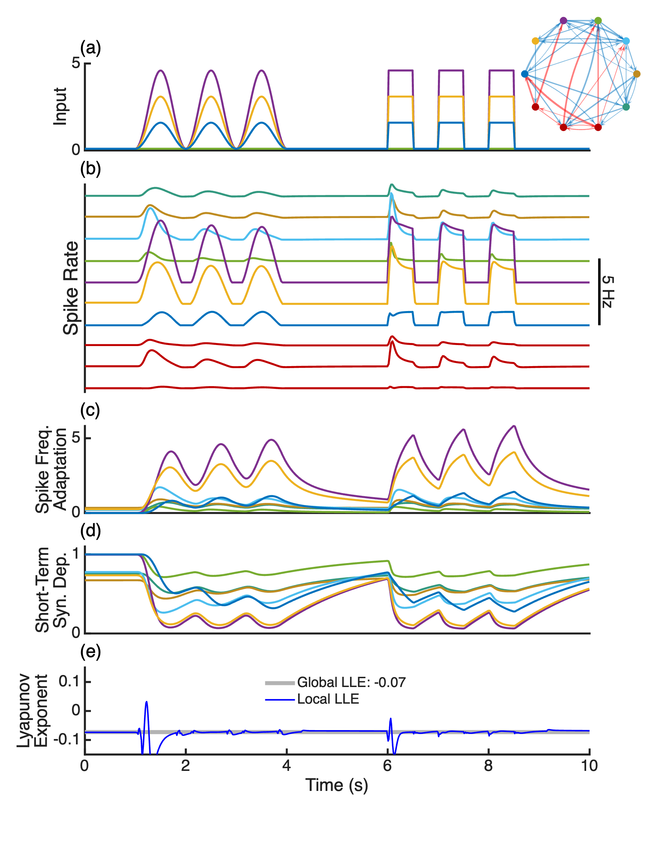

Figure 1. Spike frequency adaptation (SFA) and short-term synaptic depression (STD) dynamically stabilizes an example network based on equations 1-4 and Table 1. The neurons were randomly connected (upper right) and external input (a) was applied. (b) The spike rate of excitatory neurons (multi-color) and inhibitory neurons (red) show the characteristic phase-advance response relative to sinusoidal input and decay in response to square wave input due to SFA (c) and STD (d). Abrupt input changes cause transient instability as shown by the local largest Lyapunov exponent (e), but adaptation (c, d) rapidly rebalances the network to keep the global largest Lyapunov exponent stable (less than zero) over time.

Stability

We were interested to quantify how multiple timescale SFA and STD affect the stability, or level of chaos. However, the network has rectification and multiplicative nonlinearity. Therefore, the system cannot be reduced to a system of first-order differential equations where the stability can be directly calculated as the eigenvalues of the state transition matrix. Instead, we calculated the largest Lyapunov exponent $λ_{1}$ using Benettin’s method (Benettin et al., 1976, 1980). In brief, small perturbations are applied to the state of the system and the exponential rate of divergence (or convergence) $λ_{1}$ of the perturbed trajectory is tracked over time. If $λ_{1}$ is negative, then the system is stable in the sense of Lyapunov, and if it is positive, then the system is chaotic. If the $λ_{1}$ is very close to zero, the system is on the edge of chaos.

Sensitivity Analysis

To understand the effect of SFA and STD on dynamical stability, we created a large number of randomly connected networks and calculated $λ_{1}$ while systematically varying key network parameters. We compared networks with no adaptation, SFA alone, STD alone, both SFA and STD. We present a sensitivity analysis in figure 2 in which we vary each connectivity parameter one at a time. In figure 3, we simulated networks throughout a six-dimensional connectivity parameter space and report the distribution of $λ_{1}$ and mean spike rate for a wider range of networks.

Results

To test our hypothesis that STD and SFA improve stability, we analyzed the dynamical stability of our RNN model with and without STD and multiple timescale SFA.

Adaptation leads to the edge of chaos

We performed a sensitivity analysis of stability, as measured by the largest Lyapunov exponent $λ_{1}$, by varying three key connectivity parameters: mean excitatory-to-excitatory connection strength, overall mean connection strength, and network size. Increasing any one of these parameters is expected to create additional positive feedback on average. We randomly connected 50 networks at each parameter combination and computed their stability (Figure 2). Networks without adaptation (Figure 2, a) transitioned sharply from being overly stable to highly unstable as each connectivity parameter increased. Networks with SFA alone (Figure 2, b) remained near the edge but still transitioned sharply to highly unstable as each parameter increased. In contrast, networks with STD alone (Figure 2, c) were much more stable, but further from the edge of chaos with $λ_{1}$ near -0.5. Networks with both SFA and STD (Figure 2, d) maintained a negative $λ_{1}$ which was close to zero (i.e., on the edge of chaos) across a wide range of connectivity parameters. This shows that the stability of randomly connected RNNs with SFA and STD is largely insensitive to connectivity.

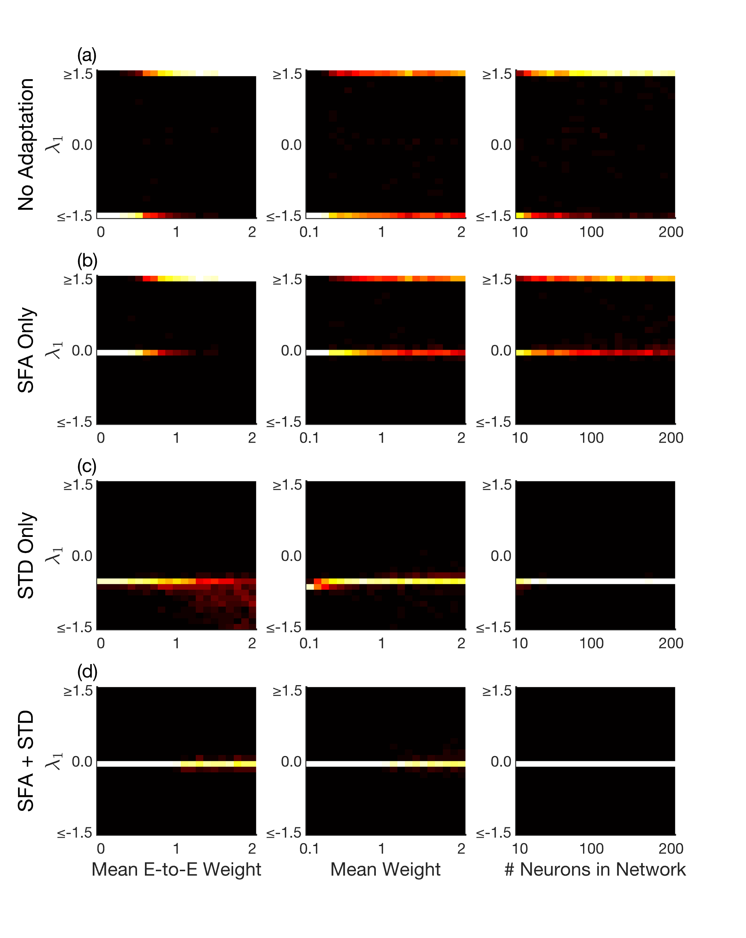
Figure 2. The combination of multiple timescale SFA and STD leads to robust networks on the edge of chaos over a wide range of connectivity parameters. The sensitivity of the largest Lyapunov exponent $λ_{1}$ to changes in three connectivity parameters, mean excitatory-to-excitatory weight, mean overall weight, and the network size, is plotted. Networks without adaptation (a) or SFA only (b) became highly unstable above a sharp transition. Networks with STD (c) were more stable, perhaps overly stable. Only networks with both SFA and STD (d) were stable and near the edge of chaos across the entire parameter range. Even as the connection weights quadrupled from 0.5 to 2.0 and network size grew by 20-fold, networks with both SFA and STD remained near the edge of chaos.

Networks with multiple timescale SFA and STD naturally exhibit edge-of-chaos dynamics (Figure 2, d). But, what does this entail for the overall level of activity (i.e. mean spike rate)? We simulated networks throughout a 6-dimensional parameter space while computing the mean firing rate of the network and $λ_{1}$ (Figure 3). The six-dimensional parameter space included: mean excitatory-excitatory connection weight, mean inhibitory-to-excitatory connection weight, mean overall connection weight, excitatory-inhibitory neuron ratio, mean in and out degree, and the time constant of SFA. We found that unstable networks, those lacking STD (Figure 3, a-b), had very high mean spike rates. Networks with STD alone (Figure 3, c) had moderated mean spike rates, but they were also highly convergent with no networks with $λ_{1}$ near zero. The combination of SFA and STD helped maintain low spike rates and stability near the edge of chaos (Figure 3, d).

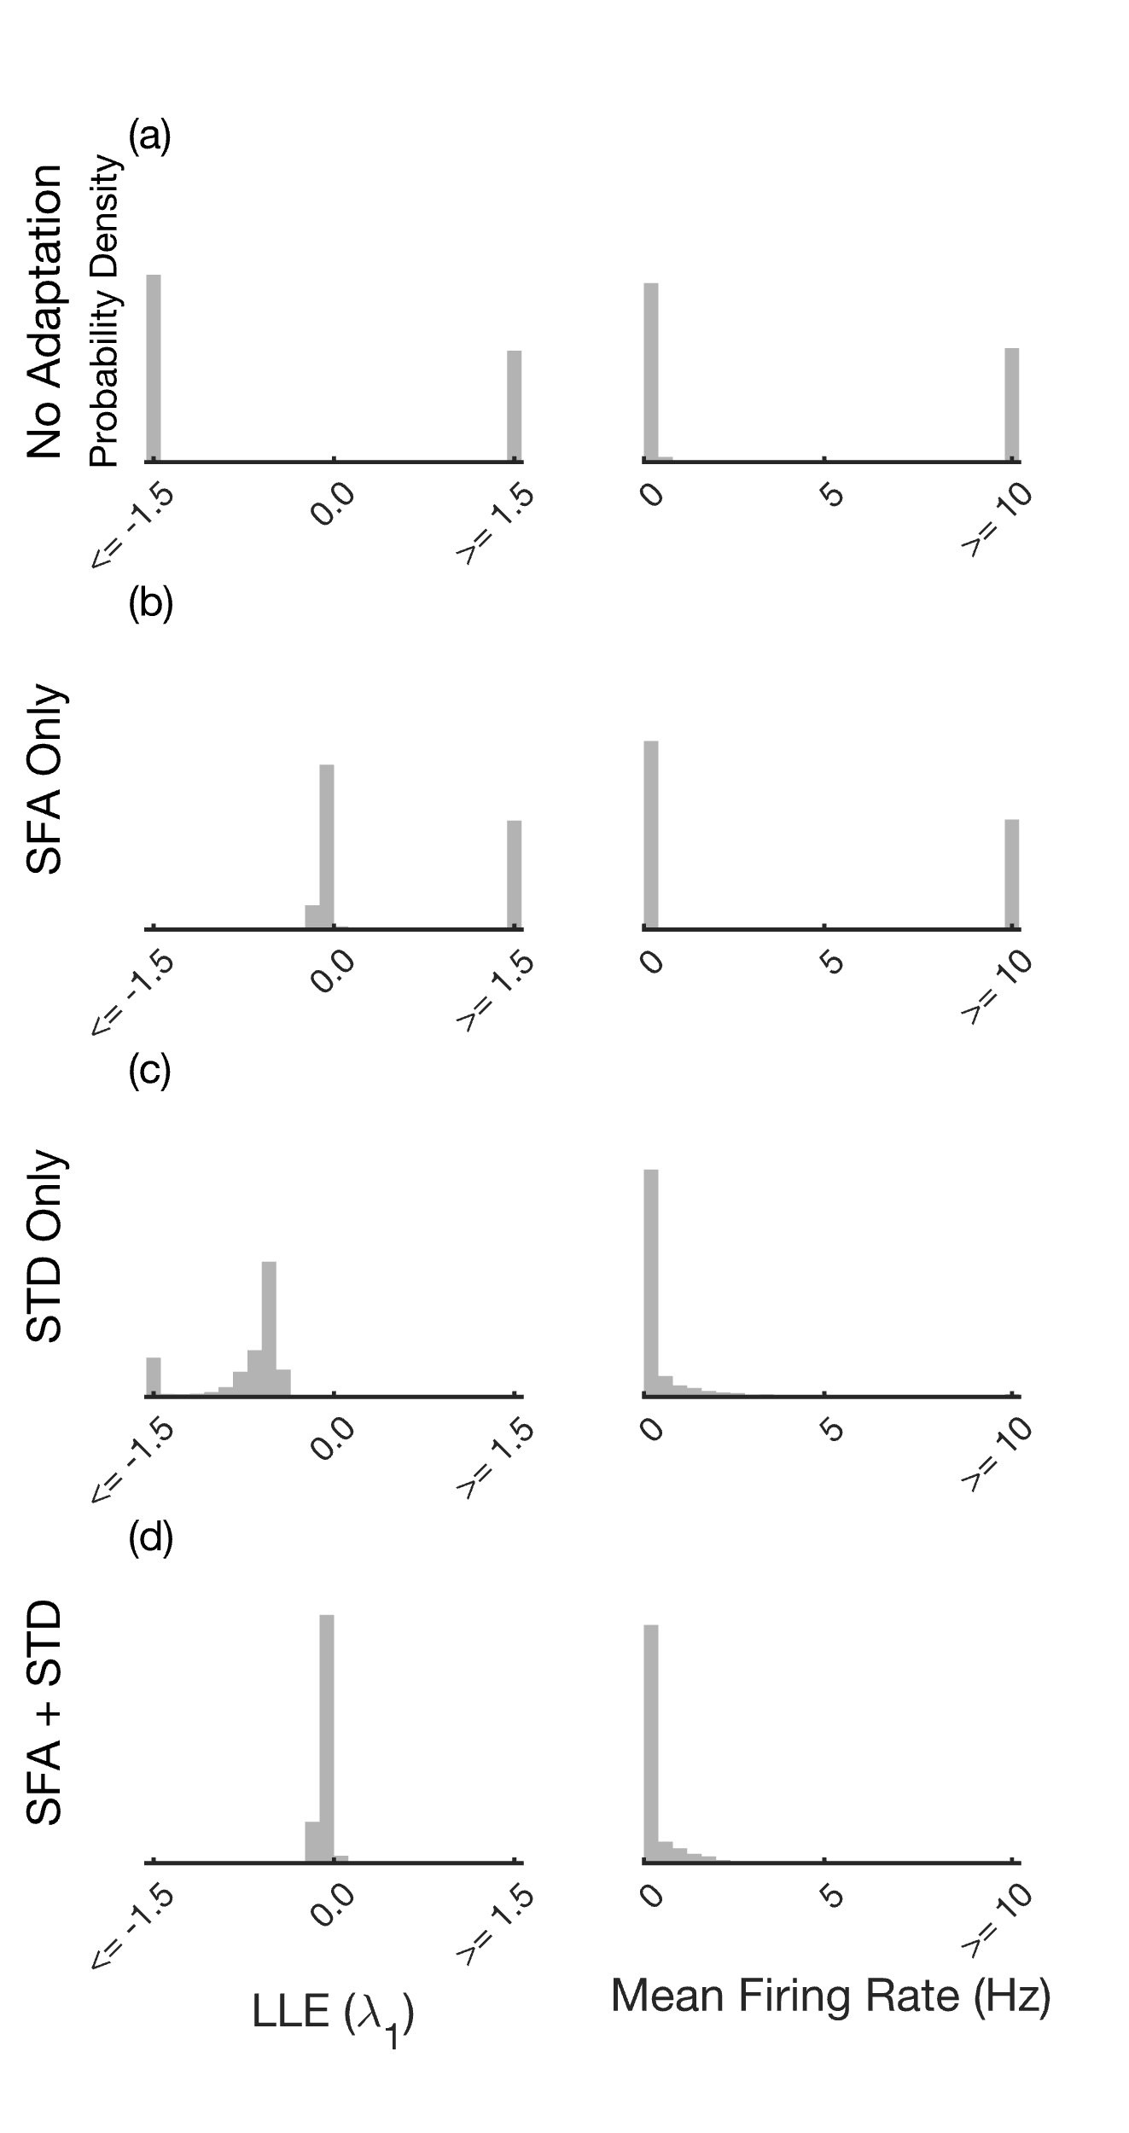
Figure 3. Together, multiple timescale SFA and STD regulated the mean spike rate and level of chaos. We simulated 8,500 randomly connected networks and measured their largest Lyapunov exponent $λ_{1}$ and their mean spike rate. We compared networks with no adaptation (a), SFA alone (b), STD alone (c), and both SFA and STD (d). While SFA alone was unable to regulated mean spike rate (a), it interacted with STD to regulate both stability and mean spike rate (d).

Networks with both SFA and STD were typically stable but near the edge of chaos (Figs. 2 and 3). How close they come to the edge of chaos depended on the longest timescale of adaptation, SFA or STD (see figure 4).

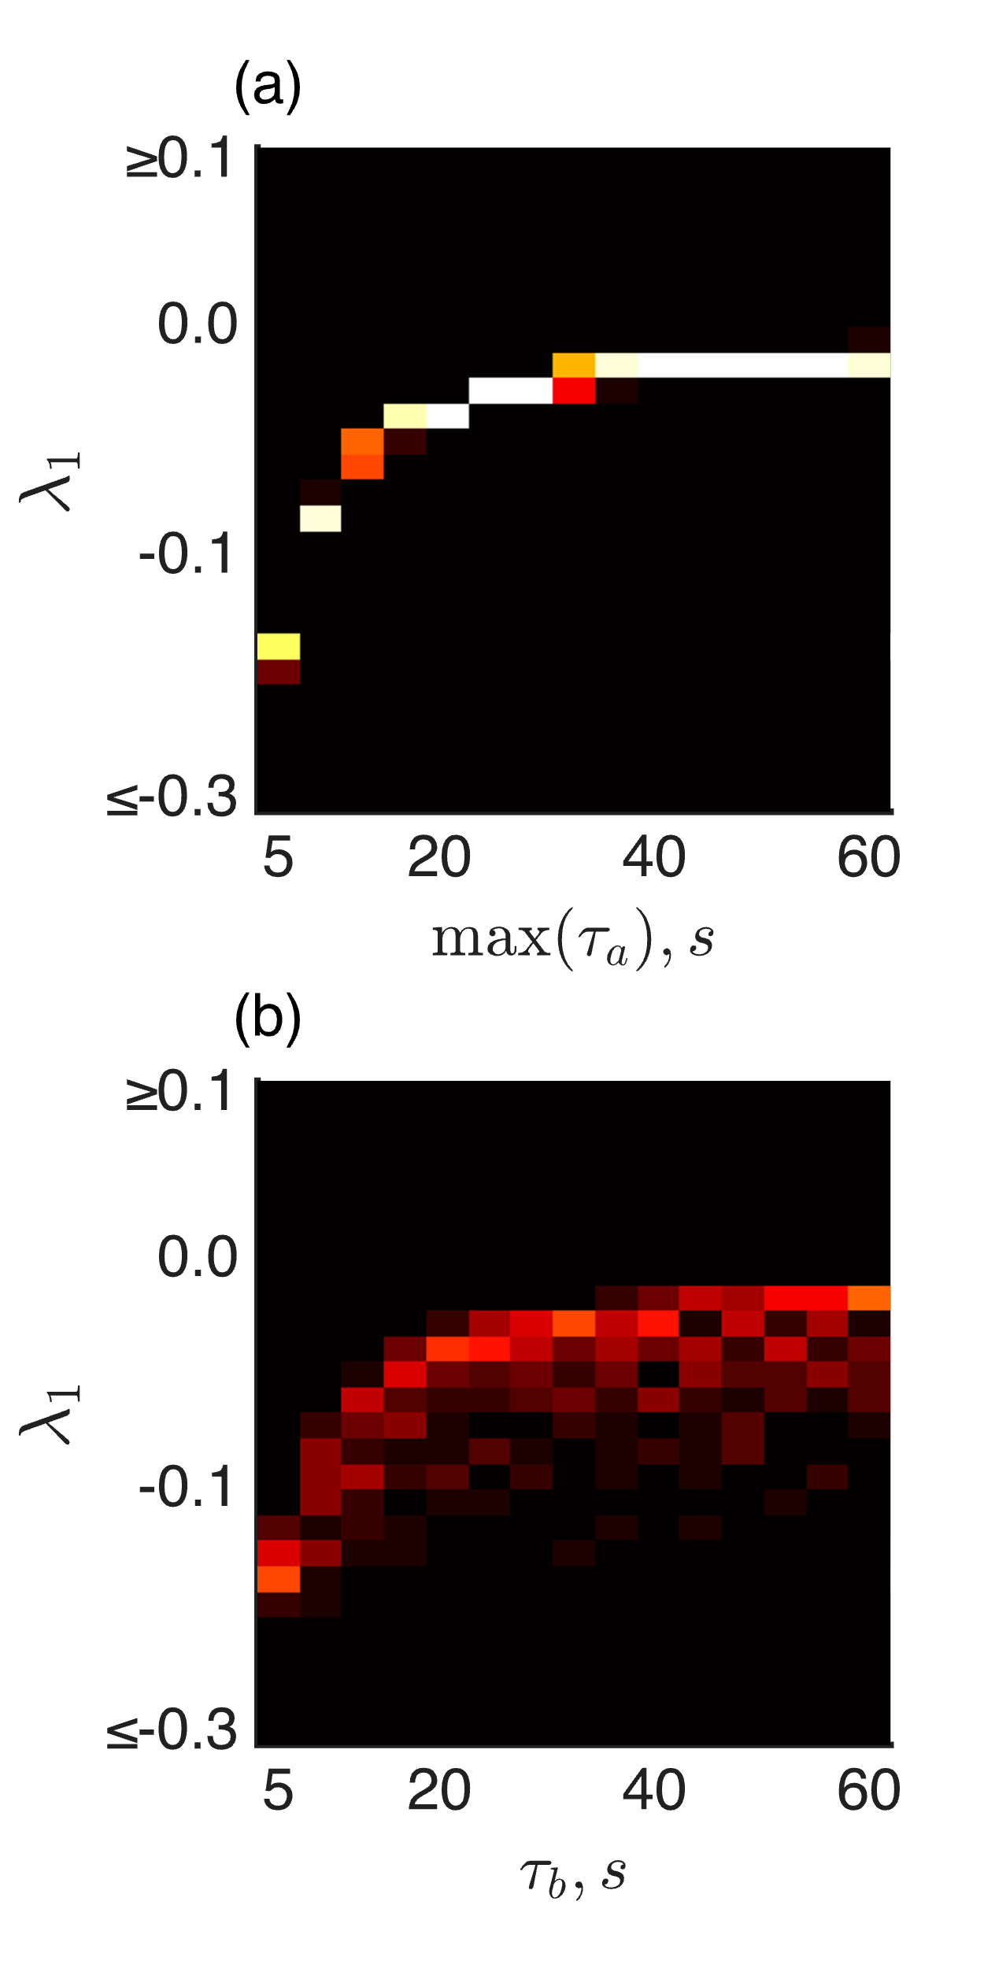
Figure 4. Long timescales of adaptation put networks onto the edge of chaos. As the longest time constants of SFA (a) or the recovery time constant of STD (b) increased from 5 to 60 seconds, randomly connected networks moved towards the edge of chaos, $λ_{1}=0$. To better see the effect of $τ_{b}$, we set $max⁡(τ_{a})=5 s$ in (b), because otherwise with the default of $max⁡(τ_{a})=15 s$, the networks would already be close to the edge of chaos.

Discharges suppressed by stimulation

We observed large discharges involving all neurons in networks where excitation is much greater than inhibition and external input is low. External input (i.e. stimulation) was able to modulate and suppress the discharges (Figure 5).
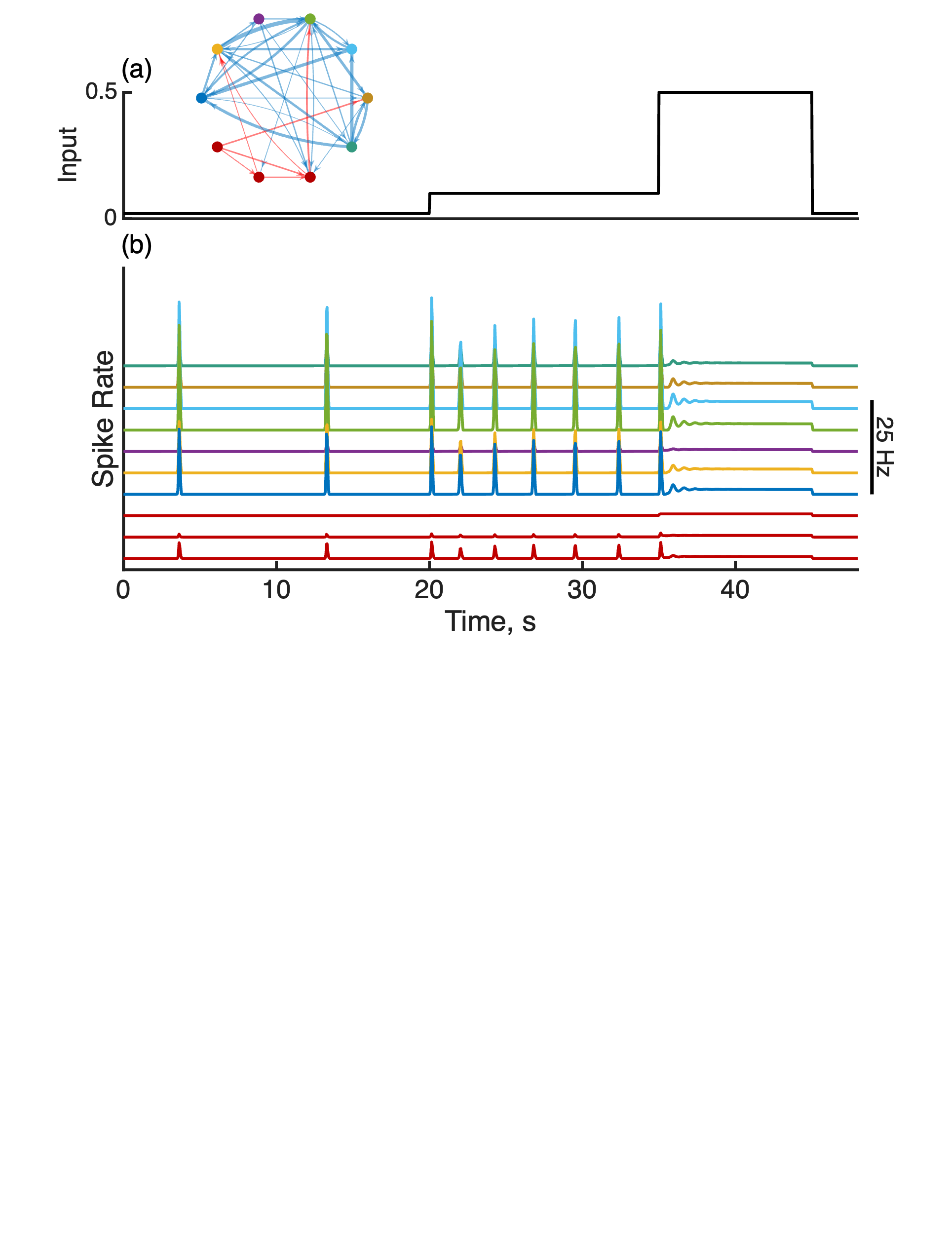
Figure 5. Large spontaneous discharges can be suppressed by external input which engages STD and SFA. This example network (upper left) has very sparse inhibitory connectivity and strong excitatory-excitatory connectivity. As a result, large discharges develop (b). Increasing the input level (a) a small amount increases the rate of discharges, but further increasing the level of input suppresses the discharges by engaging STD and SFA.

These discharges occur in networks that, without adaptation, are very unstable. There is a trivial unstable critical point at $b=1, a_{k}=0$ and when $r=0$ and $u_{ex}=0$. At this point, all derivatives are zero, but any small perturbation can set off a large discharge. Following a discharge, SFA, STD, and rectification interact to bring the network towards the critical point. After a discharge, spike rates $r$ are suppressed to zero by SFA and rectification. Since SFA recovers more slowly than STD, $\max\left(τ_{a_{3}}\right)<τ_{b}$, the STD variable $b$ recovers nearly to unity while SFA recovers towards zero. Therefore, the network approaches the unstable critical point from below with many neurons unable to contribute due to rectification. At the critical point, $\frac{da_{k}}{dt}$ and $\frac{db}{dt}$ are zero, so we can consider eigenvalues of a reduced system. From equation 1, $r=u_{d}$, which we can substitute into equation 3, and we substitute equation 6 into 7 to get
$$\frac{du_{d}}{dt}=\frac{1}{τ_{d}}\left(M-I\right)*u_{d}$$
5
If $M$ has eigenvalues $λ_{i}$, then the eigenvalues of $\frac{1}{τ_{d}}\left(M-I\right)$ are
$$\frac{1}{τ_{d}}\left(λ_{i}-1\right)$$
6
If the connection matrix has at least one eigenvalue with real part greater than 1, then since $τ_{d}$ is only 25 ms, the eigenvalues of the fast subsystem near the critical point are very large, leading to a sharp discharge.

However, if sufficient external input (i.e. stimulation) is delivered, or if SFA is absent (data not shown), the network is unable to reset to the unstable critical point. Instead, it settles to a fixed point or a limit cycle. Added input can engage STD and SFA to create a stable fixed point or limit cycle. For this reason, we chose to apply a DC input of 0.1 to all neurons for figures 1-4, which can be thought of as akin to a leak current. Alternatively, we can modify equation 2 with the addition of a constant bias $a_{0}>0$ which raises the baseline firing rate of each neuron towards $a_{0}$, engaging STD and SFA and thereby avoiding discharges.

$$\frac{da_{k}}{dt}=\frac{a_{0}-a_{k}+r}{τ_{a_{k}}}$$
7

Discussion

Adaptation of synaptic weights by STD and biases by SFA regulated intrinsic gain such that a wide range of networks were stable and near the edge of chaos without explicit tuning of connectivity. By stabilizing network dynamics independently of synaptic wiring, STD and SFA removed the dual, and otherwise conflicting, requirements for synaptic plasticity to both facilitate learning and maintain dynamical stability. Interestingly, we observed that pronounced periodic population spikes reminiscent of interictal epileptiform discharges can be suppressed by external stimulation. Importantly, these findings necessitated both STD and SFA, underscoring their complementary roles in maintaining global dynamical properties.

Together, STD and SFA created a robust negative feedback system which stabilized randomly connected RNNs. We previously found a paradoxical effect where increased stimulation of excitatory neurons can decrease firing in feedforward networks due to a nonlinear interaction between input, STD and SFA (Lundstrom & Richner, 2023). This is reminiscent but distinct from the paradoxical effect observed in inhibitory stabilized networks (ISNs) in which external inhibition of inhibitory neurons results in increase inhibitory neuron firing rates (M. V. Tsodyks et al., 1997; Wu & Gjorgjieva, 2023). ISNs require recurrence while our previously reported interaction between STD and SFA does not necessarily require recurrence. Still, we were interested to explored how STD, SFA, and external input interact in RNNs. In our network, STD and SFA created a control system in which elevated excitatory firing rates decrease synaptic efficacy and spike rate, respectively, jointly intervening to halt runaway excitation. From a computational perspective, adaptive weights and biases function similarly to layer normalization techniques employed in feedforward artificial neural networks. However, in recurrent networks, there are no distinct layers; the neuron itself becomes the functional unit requiring normalization. Chaotic and persistent activity has been studied previously in recurrent neural networks with "dynamic synapses" (i.e., STD) (Dong & and Hopfield, 1992; M. Tsodyks et al., 1998; Dror & Tsodyks, 2000; Barak & Tsodyks, 2007). However, connectivity tuning or additional stabilization (e.g., with SFA) seems necessary to find the edge of chaos.

Networks on the edge of chaos are flexible enough to be interesting but stable enough to be useful. Complexity peaks on the edge of chaos (Bertschinger & Natschläger, 2004). Similarly, reservoir networks achieve optimal performance in terms of both information storage and transfer when positioned near the edge (Maass et al., 2002; Jaeger & Haas, 2004; Boedecker et al., 2012). Dynamic synapses have been shown to naturally drive spiking networks toward criticality, producing scale-free avalanche distributions characteristic of self-organized criticality and maximizing sensitivity to inputs (Levina et al., 2007). However, keeping linear networks on the edge of chaos is nontrivial according to random matrix theory (Ginibre, 1965; Girko, 1985; Rajan & Abbott, 2006). Our random, sparse, unbalanced networks with STD and SFA were stable but near the edge of chaos. We observed transient divergent excursions in response to changing external inputs as evident in the local largest Lyapunov exponent (Figure 1, e). A benefit of chaos is that it spreads information across the network in a structured way (Lajoie et al., 2013). Therefore, transient divergent excursions that are temporally aligned with changing external inputs may be a beneficial feature of our network.

Negative feedback mechanisms such as spike frequency adaptation (SFA) and short-term synaptic depression (STD) provide stability, which in turn increases the flexibility of neural connectivity. Without these mechanisms, learning rules face a conflicting mandate to simultaneously encode new information and ensure dynamical stability, creating a significant constraint on possible learning algorithms (Zenke et al., 2017). Although Hebbian plasticity inherently promotes instability through positive feedback loops, the presence of rapid compensatory processes, like STD and SFA, effectively mitigates these instabilities by acting on faster timescales than traditional homeostatic plasticity mechanisms. Consequently, STD and SFA collectively remove the need for synaptic plasticity to concurrently manage learning and stability. Long-term homeostatic plasticity mechanisms can thus focus on maintaining synaptic distributions over extended periods, decoupled from short-term dynamical constraints. This division of roles could allow synaptic connectivity greater flexibility and enable evolutionarily and developmentally more diverse and robust plasticity rules (Baldi & Sadowski, 2016; Confavreux et al., 2025). Thus, SFA and STD jointly resolve the temporal paradox described by Zenke and colleagues, facilitating flexible yet stable neural dynamics.

Developing a broader conception of excitatory-inhibitory balance that includes other forms of negative feedback and gain scaling such as STD and SFA could build on pioneering research in epileptology using eigen analysis of patient-specific estimated connectivity to localize the seizure onset zone and plan interventions (Sritharan & Sarma, 2014; Ehrens et al., 2015; Kamali et al., 2020; Smith et al., 2020; Li et al., 2021; Smith et al., 2022). However, when connectivity matrices are used as the state transition matrix of an LTI dynamical system, connectivity entirely determines stability (Lyapunov, 1892), and this reintroduces the initial motivating problem for this paper, highly recurrent neural networks are difficult to stabilize on short timescales with local learning rules. Incorporating SFA and STD, which may play crucial roles in stabilizing large recurrent networks, could enhance patient-specific models aimed at guiding epilepsy surgery and informing device implantation strategies. Moreover, our computational model demonstrates that network discharges can be effectively suppressed through stimulation, a phenomenon reminiscent of interictal epileptiform discharge (IED) suppression by stimulation observed experimentally (Lundstrom et al., 2016, 2019; Gregg et al., 2025). This suppression also aligns with broader findings in the literature on stimulus-dependent reduction of chaotic dynamics (Rajan et al., 2010; Deco & Hugues, 2012). Perhaps targeted stimulation protocols could be utilized to probe and quantify adaptive neural dynamics directly in patients with neurological conditions involving hyperexcitability.

In conclusion, adaptation of weights and biases by STD and SFA, keep a wide range of unbalanced neural networks stable and near the edge of chaos.

References

Abbott, L. F., & Nelson, S. B. (2000). Synaptic plasticity: Taming the beast. Nature Neuroscience, 3(11), 1178–1183. https://doi.org/10.1038/81453
Abbott, L. F., Varela, J. A., Sen, K., & Nelson, S. B. (1997). Synaptic Depression and Cortical Gain Control. Science, 275(5297), 221–224. https://doi.org/10.1126/science.275.5297.221
Baldi, P., & Sadowski, P. (2016). A theory of local learning, the learning channel, and the optimality of backpropagation. Neural Networks, 83, 51–74. https://doi.org/10.1016/j.neunet.2016.07.006
Barak, O., & Tsodyks, M. (2007). Persistent activity in neural networks with dynamic synapses. PLoS Computational Biology, 3(2), e35.
Benda, J., & Herz, A. V. M. (2003). A Universal Model for Spike-Frequency Adaptation. Neural Computation, 15(11), 2523–2564. https://doi.org/10.1162/089976603322385063
Benettin, G., Galgani, L., Giorgilli, A., & Strelcyn, J.-M. (1980). Lyapunov Characteristic Exponents for smooth dynamical systems and for hamiltonian systems; a method for computing all of them. Part 1: Theory. Meccanica, 15(1), 9–20. https://doi.org/10.1007/BF02128236
Benettin, G., Galgani, L., & Strelcyn, J.-M. (1976). Kolmogorov entropy and numerical experiments. Physical Review A, 14(6), 2338–2345. https://doi.org/10.1103/PhysRevA.14.2338
Bertschinger, N., & Natschläger, T. (2004). Real-Time Computation at the Edge of Chaos in Recurrent Neural Networks. Neural Computation, 16(7), 1413–1436. https://doi.org/10.1162/089976604323057443
Boedecker, J., Obst, O., Lizier, J. T., Mayer, N. M., & Asada, M. (2012). Information processing in echo state networks at the edge of chaos. Theory in Biosciences, 131(3), 205–213. https://doi.org/10.1007/s12064-011-0146-8
Confavreux, B., Agnes, E. J., Zenke, F., Sprekeler, H., & Vogels, T. P. (2025). Balancing complexity, performance and plausibility to meta learn plasticity rules in recurrent spiking networks. PLOS Computational Biology, 21(4), e1012910. https://doi.org/10.1371/journal.pcbi.1012910
Connors, B. W., & Gutnick, M. J. (1990). Intrinsic firing patterns of diverse neocortical neurons. Trends in Neurosciences, 13(3), 99–104. https://doi.org/10.1016/0166-2236(90)90185-d
Deco, G., & Hugues, E. (2012). Neural Network Mechanisms Underlying Stimulus Driven Variability Reduction. PLoS Computational Biology, 8(3), e1002395. https://doi.org/10.1371/journal.pcbi.1002395
Dong, D. W., & and Hopfield, J. J. (1992). Dynamic properties of neural networks with adapting synapses. Network: Computation in Neural Systems, 3(3), 267–283. https://doi.org/10.1088/0954-898X_3_3_002
Dror, G., & Tsodyks, M. (2000). Chaos in neural networks with dynamic synapses. Neurocomputing, 32–33, 365–370. https://doi.org/10.1016/S0925-2312(00)00187-9
Ehrens, D., Sritharan, D., & Sarma, S. V. (2015). Closed-loop control of a fragile network: Application to seizure-like dynamics of an epilepsy model. Frontiers in Neuroscience, 9. https://doi.org/10.3389/fnins.2015.00058
Fairhall, A. L., Lewen, G. D., Bialek, W., & de Ruyter van Steveninck, R. R. (2001). Efficiency and ambiguity in an adaptive neural code. Nature, 412(6849), Article 6849. https://doi.org/10.1038/35090500
Ginibre, J. (1965). Statistical Ensembles of Complex, Quaternion, and Real Matrices. Journal of Mathematical Physics, 6(3), 440–449. https://doi.org/10.1063/1.1704292
Girko, V. L. (1985). Circular Law. Theory of Probability & Its Applications, 29(4), 694–706. https://doi.org/10.1137/1129095
Gregg, N. M., Valencia, G. O., Pridalova, T., Huang, H., Kremen, V., Lundstrom, B. N., Van Gompel, J. J., Miller, K. J., Worrell, G. A., & Hermes, D. (2025). Thalamic stimulation induced changes in network connectivity and excitability in epilepsy. medRxiv, 2024.03.03.24303480. https://doi.org/10.1101/2024.03.03.24303480
Haruna, T., & Nakajima, K. (2019). Optimal short-term memory before the edge of chaos in driven random recurrent networks. Physical Review E, 100(6), 062312. https://doi.org/10.1103/PhysRevE.100.062312
Hebb, D. O. (1949). The organization of behavior; a neuropsychological theory (pp. xix, 335). Wiley.
Jaeger, H., & Haas, H. (2004). Harnessing nonlinearity: Predicting chaotic systems and saving energy in wireless communication. Science, 304(5667), 78–80. https://doi.org/10.1126/science.1091277
James, R. G., Burke, K., & Crutchfield, J. P. (2014). Chaos forgets and remembers: Measuring information creation, destruction, and storage. Physics Letters A, 378(30), 2124–2127. https://doi.org/10.1016/j.physleta.2014.05.014
Kamali, G., Smith, R. J., Hays, M., Coogan, C., Crone, N. E., Sarma, S. V., & Kang, J. Y. (2020). Localizing the seizure onset zone from single pulse electrical stimulation responses using transfer function models. 2020 42nd Annual International Conference of the IEEE Engineering in Medicine Biology Society (EMBC), 2524–2527. https://doi.org/10.1109/EMBC44109.2020.9175954
Kolmogorov, A. N. (1958). A new metric invariant of transient dynamical systems and automorphisms in Lebesgue spaces. Doklady Akademii Nauk, 119(5), 861–864.
Lajoie, G., Lin, K. K., & Shea-Brown, E. (2013). Chaos and reliability in balanced spiking networks with temporal drive. Physical Review E, 87(5), 052901. https://doi.org/10.1103/PhysRevE.87.052901
Langton, C. G. (1990). Computation at the edge of chaos: Phase transitions and emergent computation. Physica D: Nonlinear Phenomena, 42(1), 12–37. https://doi.org/10.1016/0167-2789(90)90064-V
Levina, A., Herrmann, J. M., & Geisel, T. (2007). Dynamical synapses causing self-organized criticality in neural networks. Nature Physics, 3(12), 857–860. https://doi.org/10.1038/nphys758
Li, A., Huynh, C., Fitzgerald, Z., Cajigas, I., Brusko, D., Jagid, J., Claudio, A. O., Kanner, A. M., Hopp, J., Chen, S., Haagensen, J., Johnson, E., Anderson, W., Crone, N., Inati, S., Zaghloul, K. A., Bulacio, J., Gonzalez-Martinez, J., & Sarma, S. V. (2021). Neural fragility as an EEG marker of the seizure onset zone. Nature Neuroscience, 24(10), Article 10. https://doi.org/10.1038/s41593-021-00901-w
Liaw, J.-S., & Berger, T. W. (1996). Dynamic synapse: A new concept of neural representation and computation. Hippocampus, 6(6), 591–600. https://doi.org/10.1002/(SICI)1098-1063(1996)6:6<591::AID-HIPO4>3.0.CO;2-K
Lundstrom, B. N. (2015). Modeling multiple time scale firing rate adaptation in a neural network of local field potentials. Journal of Computational Neuroscience, 38(1), 189–202. https://doi.org/10.1007/s10827-014-0536-2
Lundstrom, B. N., Brinkmann, B. H., & Worrell, G. A. (2021). Low frequency novel interictal EEG biomarker for localizing seizures and predicting outcomes. Brain Communications, 3(4), fcab231. https://doi.org/10.1093/braincomms/fcab231
Lundstrom, B. N., Fairhall, A. L., & Maravall, M. (2010). Multiple Timescale Encoding of Slowly Varying Whisker Stimulus Envelope in Cortical and Thalamic Neurons In Vivo. Journal of Neuroscience, 30(14), 5071–5077. https://doi.org/10.1523/JNEUROSCI.2193-09.2010
Lundstrom, B. N., Gompel, J. V., Khadjevand, F., Worrell, G., & Stead, M. (2019). Chronic subthreshold cortical stimulation and stimulation-related EEG biomarkers for focal epilepsy. Brain Communications, 1(1). https://doi.org/10.1093/braincomms/fcz010
Lundstrom, B. N., Higgs, M. H., Spain, W. J., & Fairhall, A. L. (2008). Fractional differentiation by neocortical pyramidal neurons. Nature Neuroscience, 11(11), 1335–1342. https://doi.org/10.1038/nn.2212
Lundstrom, B. N., & Richner, T. J. (2023). Neural adaptation and fractional dynamics as a window to underlying neural excitability. PLOS Computational Biology, 19(2), e1010527. https://doi.org/10.1371/journal.pcbi.1010527
Lundstrom, B. N., Van Gompel, J., Britton, J., Nickels, K., Wetjen, N., Worrell, G., & Stead, M. (2016). Chronic Subthreshold Cortical Stimulation to Treat Focal Epilepsy. JAMA Neurology, 73(11), 1370–1372. https://doi.org/10.1001/jamaneurol.2016.2857
Lyapunov, A. (1892). The general problem of the stability of motion. Kharkov Mathematical Society.
Maass, W., Natschläger, T., & Markram, H. (2002). Real-time computing without stable states: A new framework for neural computation based on perturbations. Neural Computation, 14(11), 2531–2560. https://doi.org/10.1162/089976602760407955
May, R. M. (1972). Will a Large Complex System be Stable? Nature, 238(5364), 413–414. https://doi.org/10.1038/238413a0
Oja, E. (1982). Simplified neuron model as a principal component analyzer. Journal of Mathematical Biology, 15(3), 267–273. https://doi.org/10.1007/BF00275687
Rajan, K., & Abbott, L. F. (2006). Eigenvalue Spectra of Random Matrices for Neural Networks. Physical Review Letters, 97(18), 188104. https://doi.org/10.1103/PhysRevLett.97.188104
Rajan, K., Abbott, L. F., & Sompolinsky, H. (2010). Stimulus-dependent suppression of chaos in recurrent neural networks. Physical Review E, 82(1), 011903. https://doi.org/10.1103/PhysRevE.82.011903
Ralston, A. (1962). Runge-Kutta Methods with Minimum Error Bounds. Mathematics of Computation, 16(80), 431–437. https://doi.org/10.2307/2003133
Shiryayev, A. N. (1993). New Metric Invariant of Transitive Dynamical Systems and Automorphisms of Lebesgue Spaces. In A. N. Shiryayev (Ed.), Selected Works of A. N. Kolmogorov: Volume III: Information Theory and the Theory of Algorithms (pp. 57–61). Springer Netherlands. https://doi.org/10.1007/978-94-017-2973-4_5
Smith, R. J., Hays, M. A., Kamali, G., Coogan, C., Crone, N. E., Kang, J. Y., & Sarma, S. V. (2022). Stimulating native seizures with neural resonance: A new approach to localize the seizure onset zone. Brain, 145(11), 3886–3900. https://doi.org/10.1093/brain/awac214
Smith, R. J., Kamali, G., Hays, M., Coogan, C. G., Crone, N. E., Sarma, S. V., & Kang, J. Y. (2020). State-space models of evoked potentials to localize the seizure onset zone. 2020 42nd Annual International Conference of the IEEE Engineering in Medicine & Biology Society (EMBC), 2528–2531. https://doi.org/10.1109/EMBC44109.2020.9176697
Sritharan, D., & Sarma, S. V. (2014). Fragility in Dynamic Networks: Application to Neural Networks in the Epileptic Cortex. Neural Computation, 26(10), 2294–2327. https://doi.org/10.1162/NECO_a_00644
Toyoizumi, T., & Abbott, L. F. (2011). Beyond the edge of chaos: Amplification and temporal integration by recurrent networks in the chaotic regime. Physical Review E, 84(5), 051908. https://doi.org/10.1103/PhysRevE.84.051908
Tripp, B. P., & Eliasmith, C. (2010). Population Models of Temporal Differentiation. Neural Computation, 22(3), 621–659. https://doi.org/10.1162/neco.2009.02-09-970
Tsodyks, M., & Markram, H. (1997). The neural code between neocortical pyramidal neurons depends on neurotransmitter release probability. Proceedings of the National Academy of Sciences, 94(2), 719–723. https://doi.org/10.1073/pnas.94.2.719
Tsodyks, M., Pawelzik, K., & Markram, H. (1998). Neural Networks with Dynamic Synapses. Neural Computation, 10(4), 821–835. https://doi.org/10.1162/089976698300017502
Tsodyks, M. V., Skaggs, W. E., Sejnowski, T. J., & McNaughton, B. L. (1997). Paradoxical Effects of External Modulation of Inhibitory Interneurons. Journal of Neuroscience, 17(11), 4382–4388. https://doi.org/10.1523/JNEUROSCI.17-11-04382.1997
Varela, J. A., Song, S., Turrigiano, G. G., & Nelson, S. B. (1999). Differential Depression at Excitatory and Inhibitory Synapses in Visual Cortex. The Journal of Neuroscience, 19(11), 4293–4304. https://doi.org/10.1523/JNEUROSCI.19-11-04293.1999
von der Malsburg, Chr. (1973). Self-organization of orientation sensitive cells in the striate cortex. Kybernetik, 14(2), 85–100. https://doi.org/10.1007/BF00288907
Wu, Y. K., & Gjorgjieva, J. (2023). Inhibition stabilization and paradoxical effects in recurrent neural networks with short-term plasticity. Physical Review Research, 5(3), 033023. https://doi.org/10.1103/PhysRevResearch.5.033023
Zaitsev, A. V., & Lewis, D. A. (2013). Functional properties and short-term dynamics of unidirectional and reciprocal synaptic connections between layer 2/3 pyramidal cells and fast-spiking interneurons in juvenile rat prefrontal cortex. The European Journal of Neuroscience, 38(7), 2988–2998. https://doi.org/10.1111/ejn.12294
Zenke, F., & Gerstner, W. (2017). Hebbian plasticity requires compensatory processes on multiple timescales. Philosophical Transactions of the Royal Society B: Biological Sciences, 372(1715), 20160259. https://doi.org/10.1098/rstb.2016.0259
Zenke, F., Gerstner, W., & Ganguli, S. (2017). The temporal paradox of Hebbian learning and homeostatic plasticity. Current Opinion in Neurobiology, 43, 166–176. https://doi.org/10.1016/j.conb.2017.03.015

