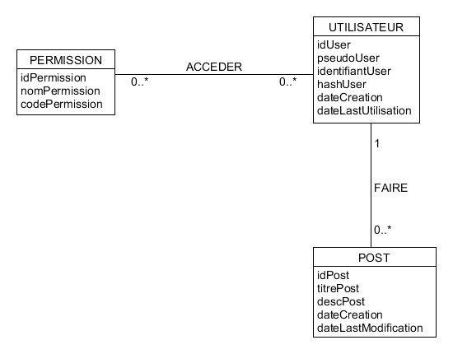

PERMISSION(IdPermission, nomPermission, codePermission)

UTILISATEUR(idUser, pseudoUser, identifiantUser, hashUser, dateCreation, dateLastUtilisation)

POST(idPost, titrePost, descPost, dateCreation, dateLastModification, #idUser)

ACCEDER(#idUser, #idPermission)