Technical Documentation of MATTS TripCost Pro
The dashboard is created for all members of the MATTS company to help them plan cost effective trips using the company car fleet and expected commodity fuel prices (electricity/diesel/gas) at their given trip date. The tool also allows users to maintain the car fleet pool and also look at the historical (and future predicted) development of fuel prices.

Tech Stack
TripCost Pro is built in streamlit and uses interactive graphs with plotly. We also use css to have a more fine-grained designing option: this is important as it would be very easy to use MATTS corporate design (if we had that) with css.
The choice of streamlit was mainly due to previous experience with it and the ability to keep everything in Python. Additionally, streamlit dashboards do a good job making the dashboard responsive without the need to do any web development.
All package management is done with uv as it is generally faster than pip.

Procedure
We started by making a concept of the main functionality. We early on decided to separate different use cases and functionalities into different tabs. We created a simple mockup on paper and created individual mockups for each tab.  After creating our MVP, we decided to add more functionalities: e.g., choosing dates in the future will lead to a warning message that the prices are predictions and not actual prices; automatic updates when changing input etc. | 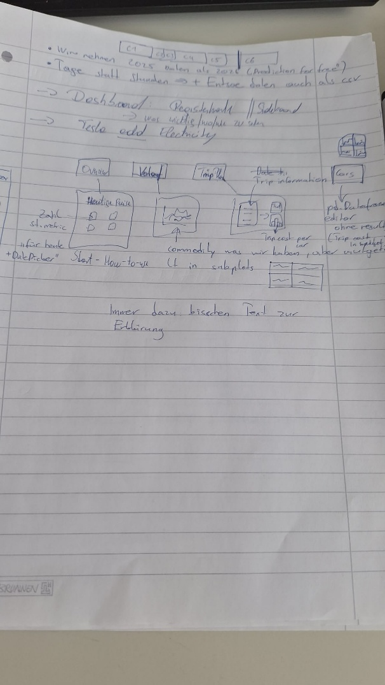
We then decided to add helpful text and put additional information that is not always necessary or optional into containers that can be expanded (st.expander) and in the sidebar. Further versions may also include a login area for the administration and an interface to the actual fleet database: right now this is just hardcoded.
For development and deployment purposes, we used both devcontainers and docker file. Code was shared via Github.

Reflection
Overall, this was kind of fun: we learned that throwing together a prototype is quite easy, but the last 20% of the product requires the most effort. We wonder if the “code-only” approach is really a good idea for later maintenance and if PowerBI or something similar may have been preferable for business stakeholders.

