**Artificial intelligence (AI)**

**Types of AI systems:**

**Machine Learning:**

* Computers learn from data
* Intersection of computer science and statistics
* Algorithms perform specific task without explicit programming
* Recognize patterns in data and make predictions

**Deep Learning:**

* Evolution of machine learning
* Solve Complex problems
* Work with Large amount of data
* More capable learning model
* Based on Neural network (ANN) design inspired by human brain

**Maschine Learning Methods:**

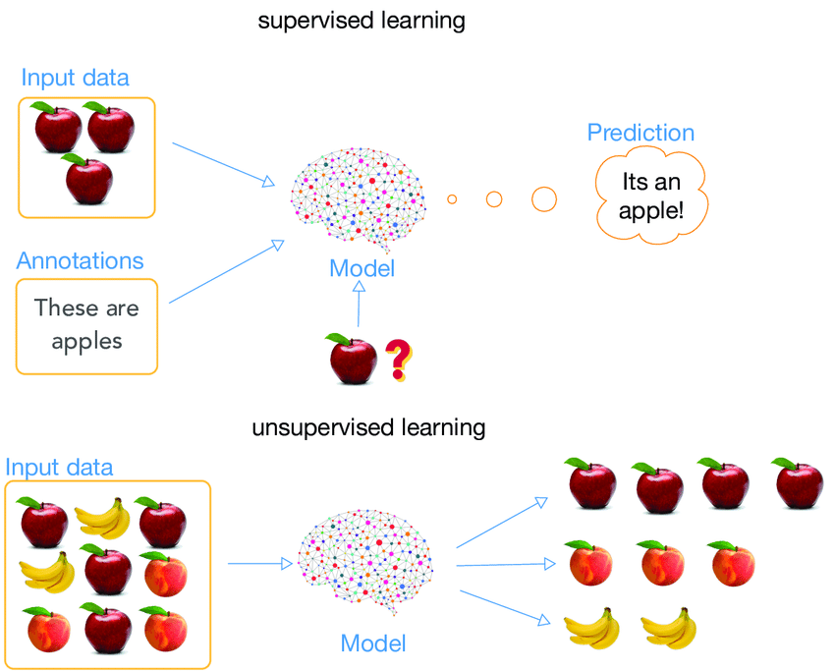**Supervised Learning:**

* Use of known data
* Clear definition of inputs and target outputs
* Development of a prediction or classification capability

**Unsupervised Learning:**

* 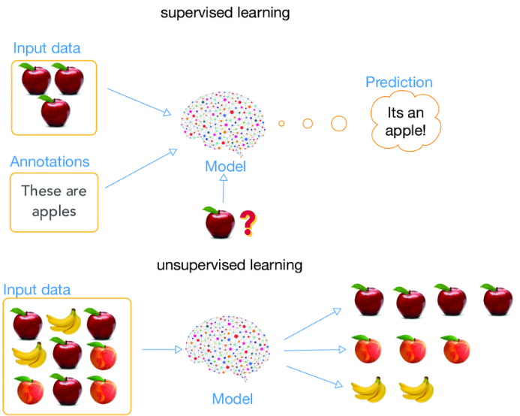Use of known data
* Clear definition of inputs and target outputs
* Development of a prediction or classification capability



**AI in industry:**

Ein Bild, das Outdoorobjekt enthält.

**AI Based Robots:**

* Find part in bin
* Plan path from pick to place avoiding singularities and joint limits
* Enter bin in specific pose for part orientation
* Avoid damaging nearby parts
* Exit bin and place part in correct orientation without hitting environment

**Ein Bild, das drinnen enthält.
**

**Product Development:**

* Minimize part weight
* Maximize stiffness
* Reduce cost
* Optimize material usage

**Visual Inspections and Quality Control:**

**Ein Bild, das Text, drinnen, Wand enthält.
**

**Detection of:**

* Positioning
* Completeness
* Cracks
* **Ein Bild, das Text, verschieden, alt, mehrere enthält.

  Automatisch generierte Beschreibung**Scratches
* Color
* Differences
* External defects