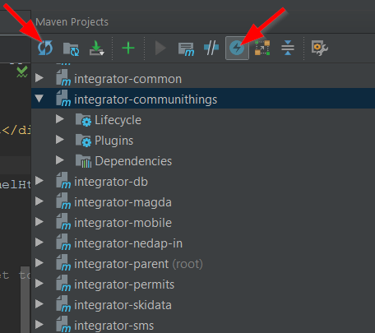

Reimport all maven projects

Toggle ‘Skip tests’ mode