MAE-94 Extra Credit – Dandelion

Chenyang Wang, 105425757

Date: 07/07/2020

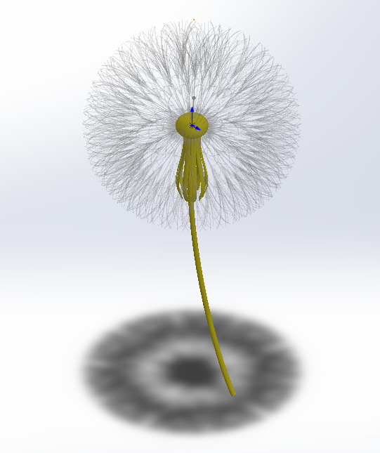

Figure 1. Screenshot of the Dandelion