Title

Final Design Report

Prof. R.S. Shaefer

TA: Amirhossein Ahmadian

Author

MAE94 – Introduction to Computer Aided-Design and Drafting

Mechanical and Aerospace Engineering Department

University of California Los Angeles

(Date)

#### Abstract

This report….

Table of Contents

I. Introduction 6

I.1 Problem Statement 6

I.2 Design Requirements 6

II. Design Description 6

II.1 Design Concept Development 6

II.2 Design Overview 6

II.3 System Specifications 6

II.4 Mechanical Systems 7

III. FEA Analysis 7

III.1 Description of FEA Analysis 7

III.2 Boundary Conditions 8

III.3 Analysis Results 8

IV. Product Fabrication 8

V. Summary and Conclusions 8

VI. References 8

VII. Appendix 8

#### List of Figures

Figure 1: Sketch of rubber band powered mini-car 6

Figure 2: Solid model of rubber band powered mini-car. 7

#### List of Tables

Table 1: Device Specifications and Dimensions 7

#### List of Symbols

|  |  |  |
| --- | --- | --- |
| **Symbol** | **Description** | **Unit** |
|  |  |  |
|  |  |  |
|  |  |  |
|  |  |  |
|  |  |  |
|  |  |  |
|  |  |  |

# Introduction

## Problem Statement

….

## Design Requirements

….

# Design Description

….

## Design Concept Development

….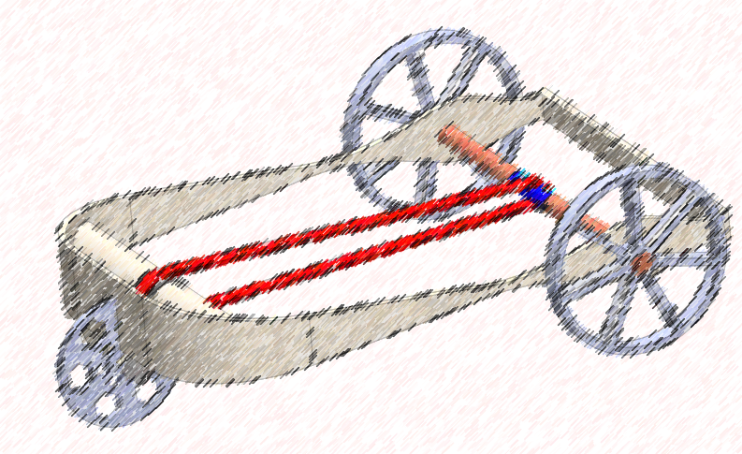

Figure 1: Sketch of rubber band powered mini-car

## Design Overview

…

## System Specifications

….

Table 1: Device Specifications and Dimensions

|  |  |
| --- | --- |
| **Parameter** | **Value** |
|  |  |
|  |  |
|  |  |
|  |  |
|  |  |
|  |  |
|  |  |

## Mechanical Systems

….

# FEA Analysis

## Description of FEA Analysis

….

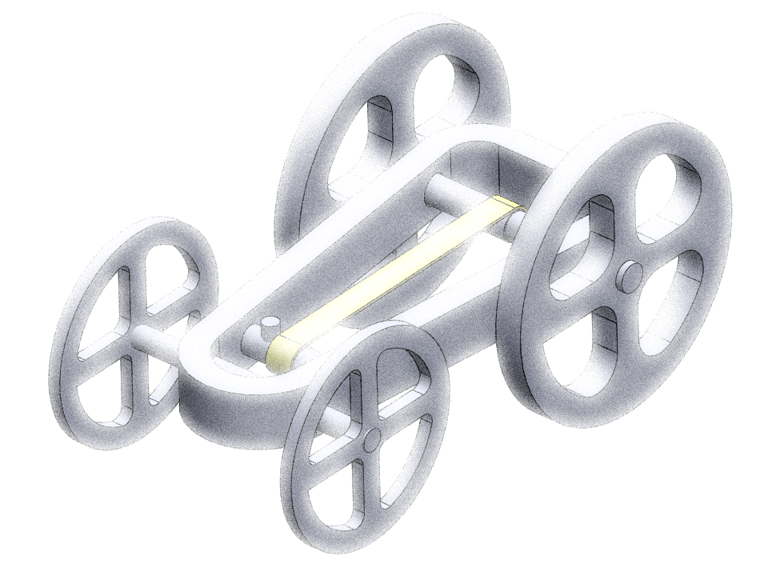

Figure 2: Solid model of rubber band powered mini-car.

….

## Boundary Conditions

….

## Analysis Results

….

# Product Fabrication

….

# Summary and Conclusions

….

# References

1. Seth Freitas, “Recent partnership between UC and Dignity Health raises concerns of discrimination,” Daily Bruin, January 6, 2020.
2. Harrison Liddiard, “The 25 best and worst UCLA classes, according to students,” Daily Bruin, May 8, 2017.

# Appendix

A. Isometric view of a shaded image of the assembled device

B. Working Drawing Package