MAE-94 Lab Assignment – 1A

Chenyang Wang, 105425757

Date: 06/25/2020

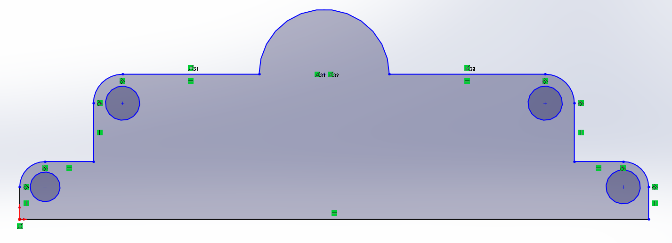

Figure 1. Three_Level_Sketch showing sketch relations.

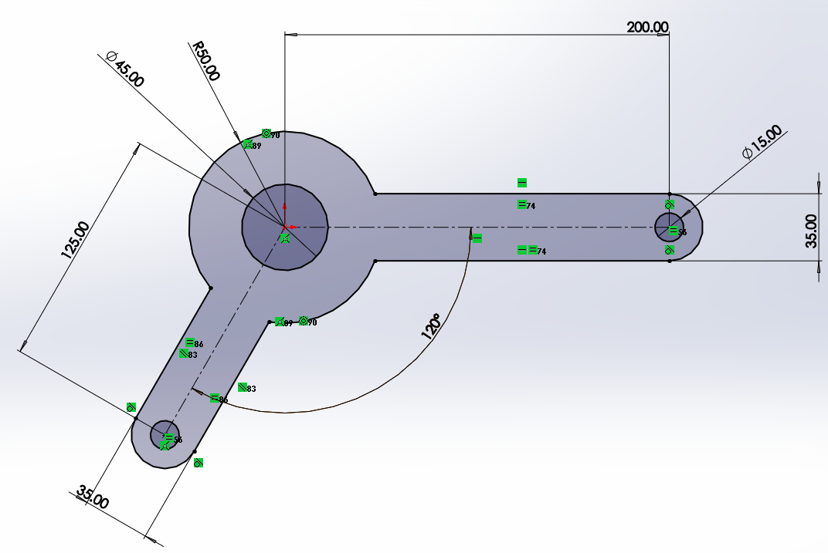

Figure 2. Dual_Lever_Sketch showing sketch relations.

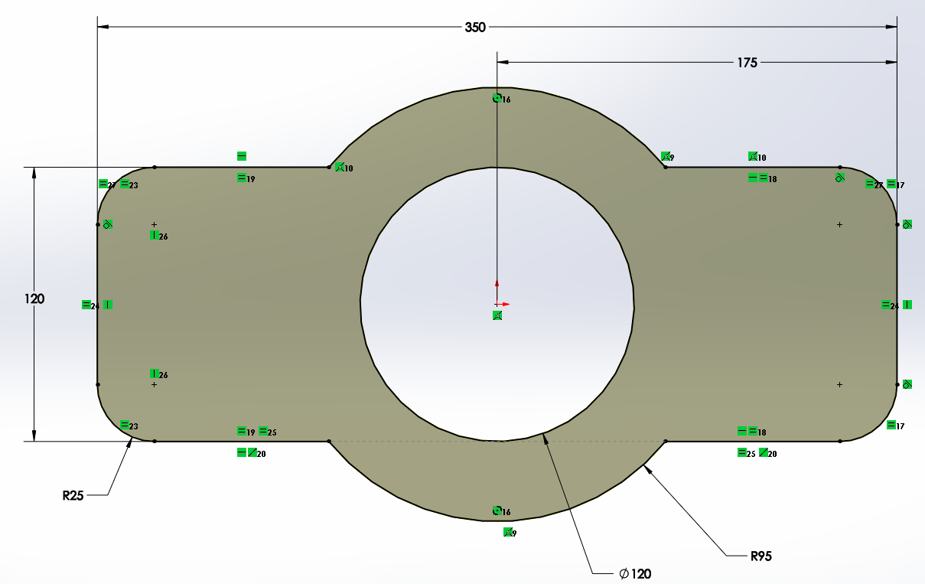

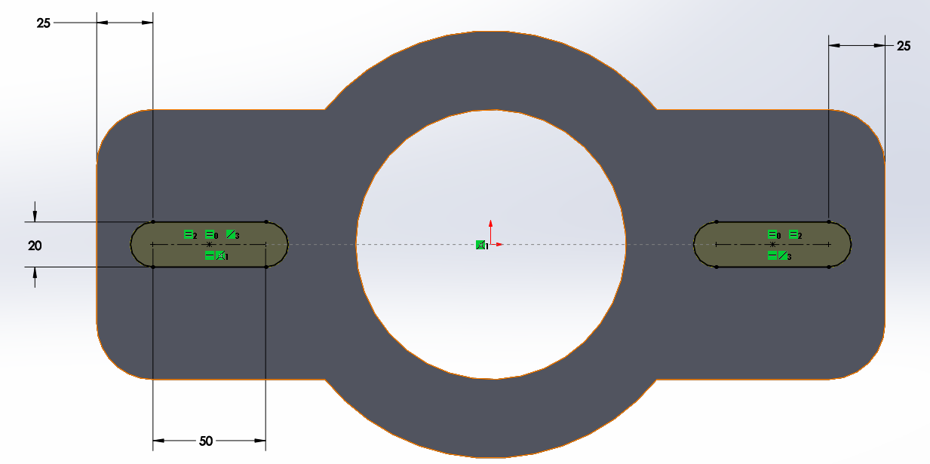

Figure 3. Two_Slot_Gasket sketches showing sketch dimensions and sketch relations.