MAE-94 Lab Assignment – 1B

Chenyang Wang, 105425757

Date: 06/30/2020

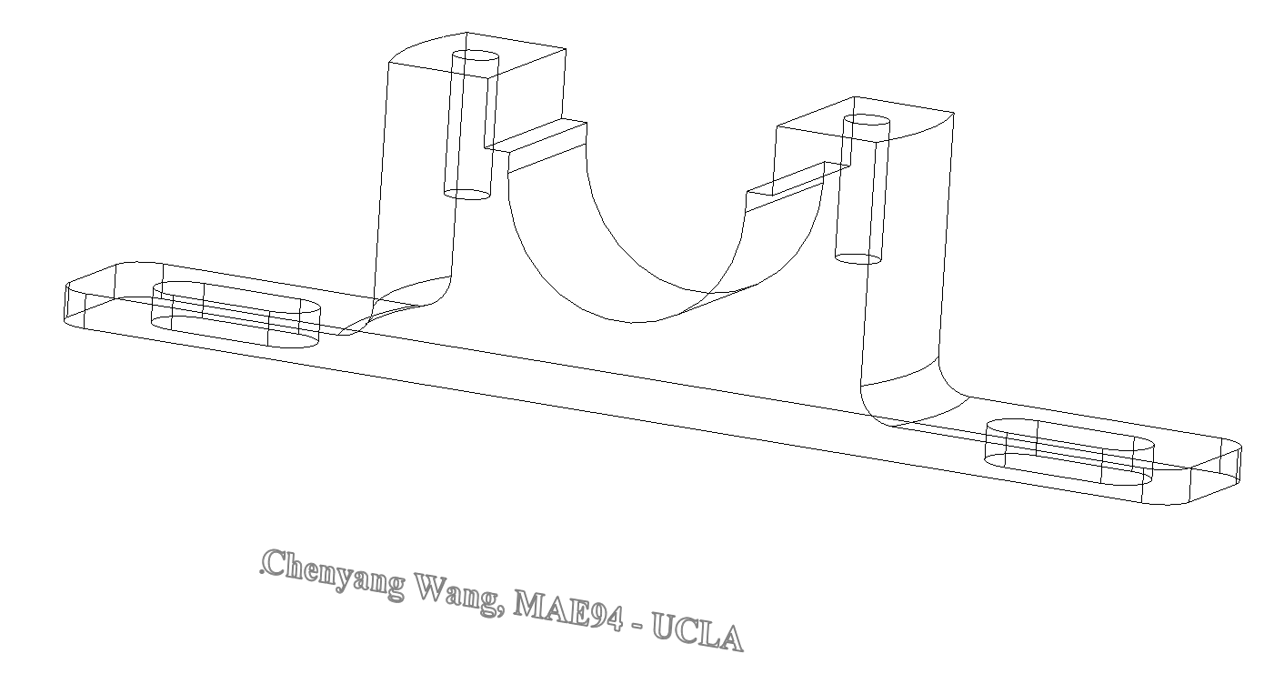

Figure 1. Screenshot of the Plummer_Block (mass = 71.03g; ABS)

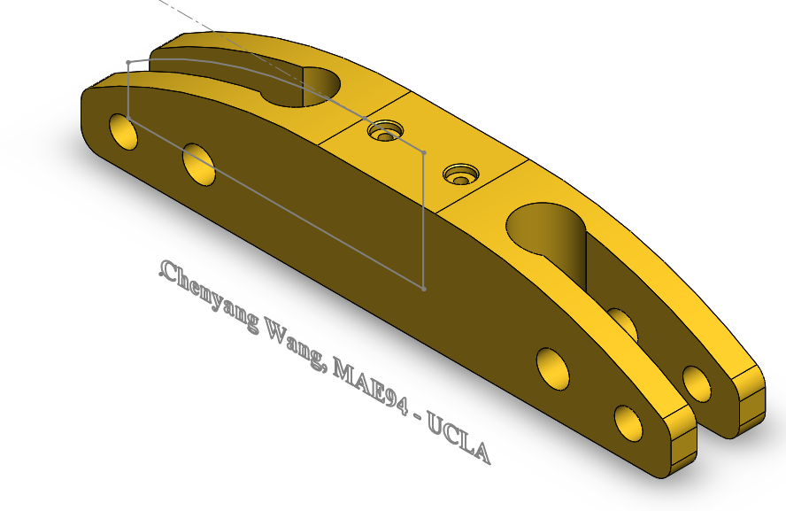

Figure 2. Screenshot of the Hanger Bracket (mass = 2447.99g; Brass)

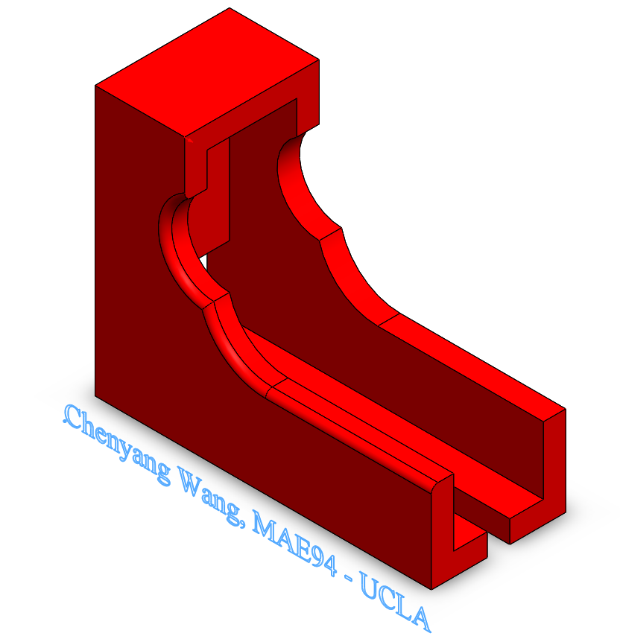

Figure 3. Configuration A of the Slide_Lock_Housing

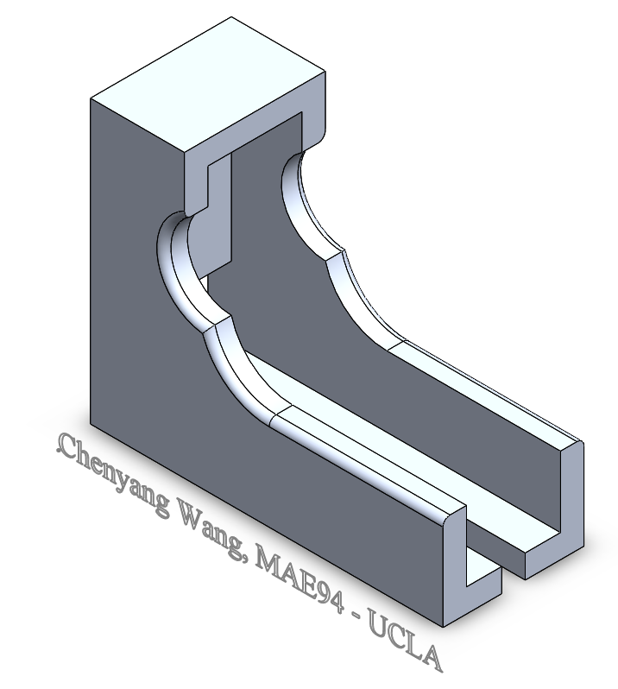

Figure 4. Configuration C and D of the Slide_Lock_Housing (mass is 92.929g; 1060 Alloy)