MAE-94 Lab Assignment – 2A

Chenyang Wang, 105425757

Date: 07/02/2020

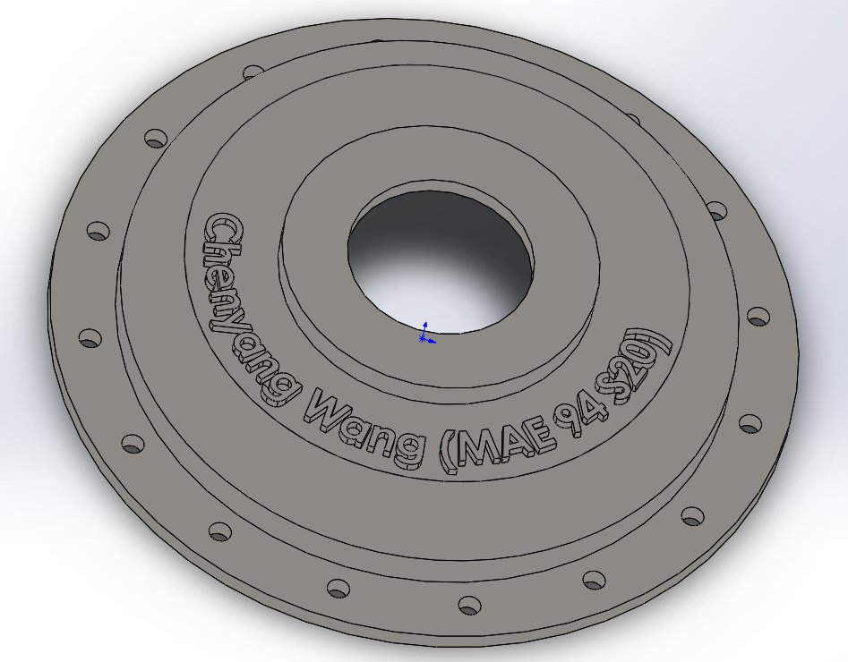

Figure 1. Screenshot of the pressure disc

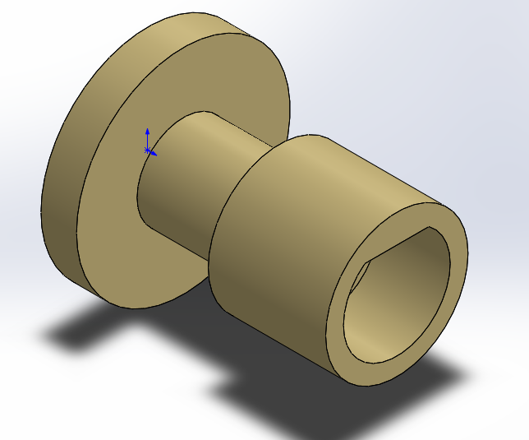

Figure 2. Screenshot of the gear mount

|  |  |
| --- | --- |
| **Material** | **Mass (gram)** |
| Plain Carbon Steel | 551.28 |
| Nickel | 600.75 |
| Cast Alloy Steel | 515.94 |
| Pure Gold | 1342.86 |

Table 1. Mass of Gear Mount

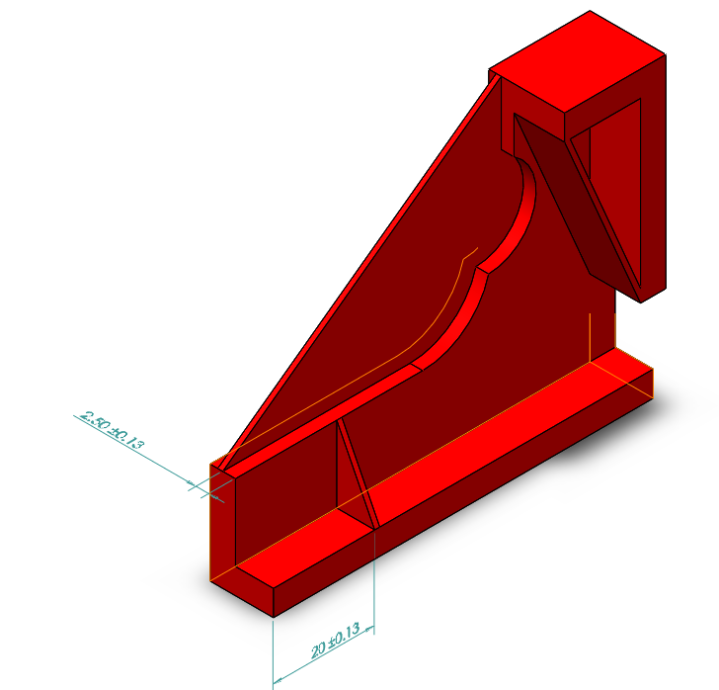

Figure 3. Screenshot of the original “Slide Lock Housing” part with no fillet and added ribs