MAE-94 Lab Assignment – 7A

Finite Element Analysis on the Mini-Car

Chenyang Wang, 105425757

Date: 08/07/2020

In this assignment, we are going to perform a Finite Element Analysis (FEA) of the chassis of the Mini-Car we created in Solidworks for the final project. Note that the material of the chassis is Acrylic (medium-high impact). The first step is to simplify the solid model for FEA. The original model is shown below:

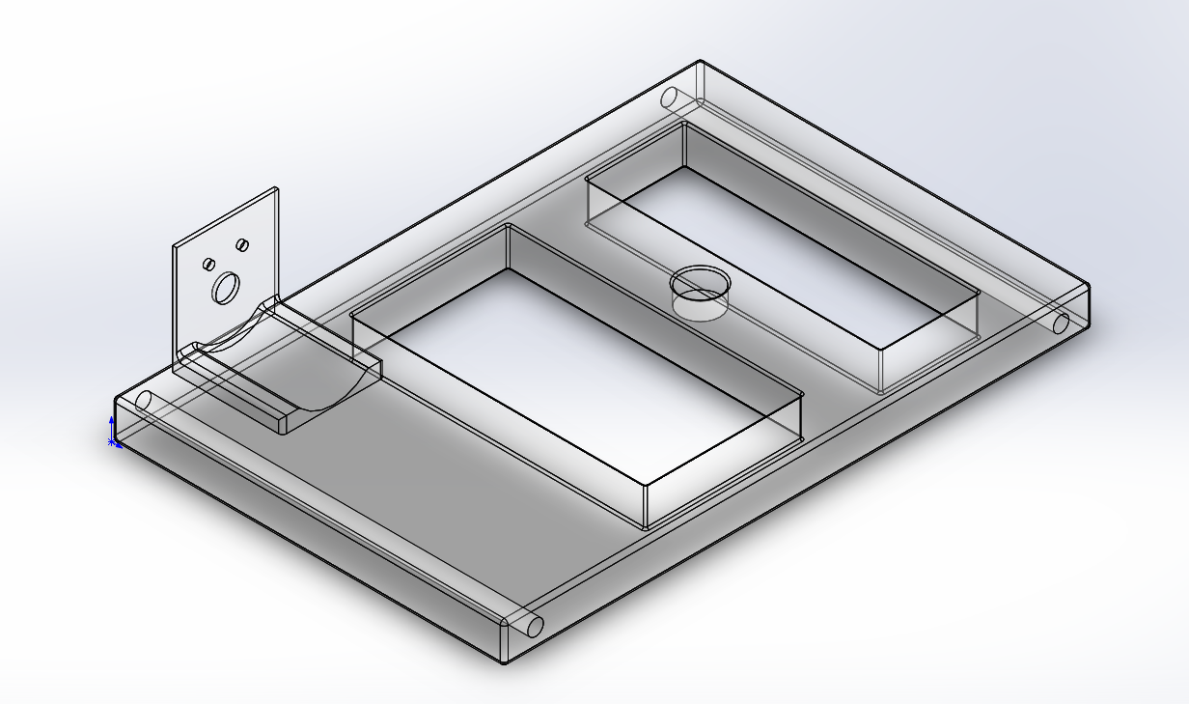

Figure 1. The original model of the chassis

To simplify the model, we need to suppress features or parts that are not contributing to the strength of the chassis, and we can see in the above figure, the motor holder and fillets can be removed, as these features are critical to the strength of the chassis. Thus, the simplified model of the chassis is shown below:

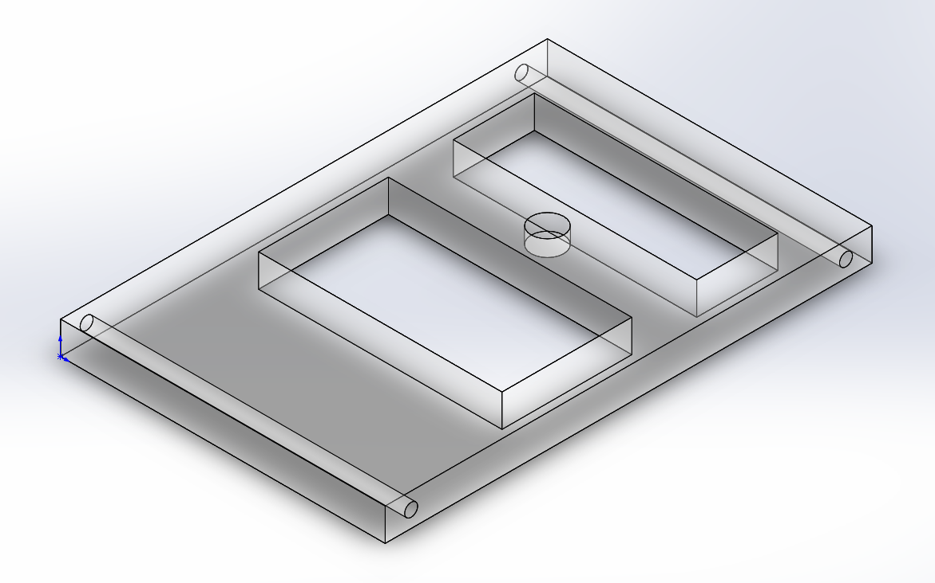

Figure 2. Simplified chassis (motor holder and fillets removed)

With the chassis simplified, the next step is to apply the boundary conditions, i.e. the fixtures and loads. Since the axles are pushing up against the top face of the axle holes, we need to split the axle holes using **split lines** and only fix the top halves inside the axle holes. For the load, I am going to use the assumption mentioned in the lab handout, that someone steps on the chassis. Thus, given this information, a figure of the chassis showing applied loads and fixtures is shown below:

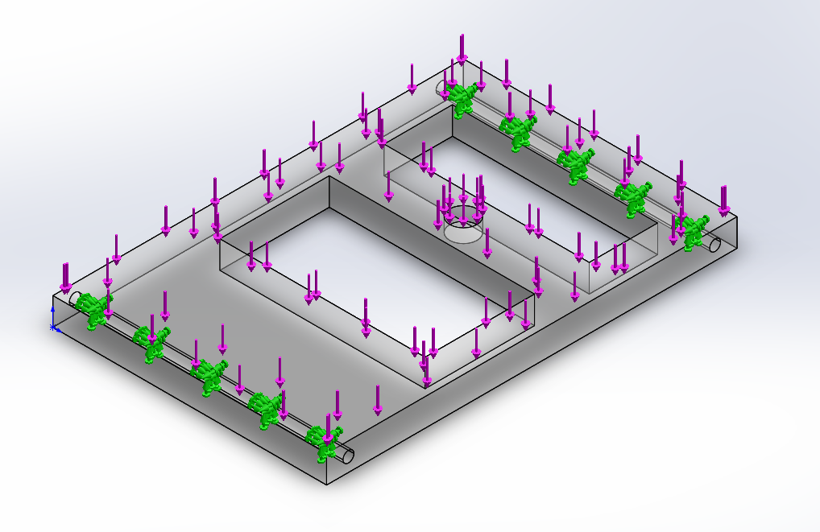

Figure 3. FEA model of chassis showing applied loads and fixtures (BCs)

Note here, I am assuming that someone will step on the entire chassis, not just a part of it, and a load of 500 N was used to initiate the analysis. The result of the first run is shown below:

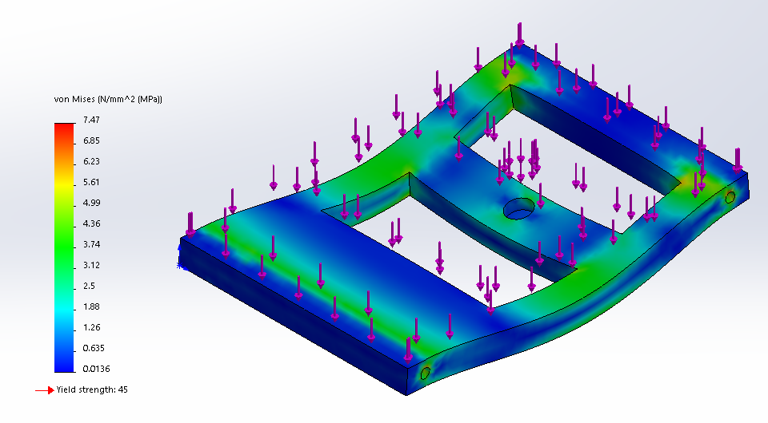

Figure 4. Chassis stress contours resulting from an applied load of 500 N (maximum stress is 7.47 MPa;

yield strength is 45 MPa)

Next, I will not try to optimize the design, instead I will try to find out what is the maximum stress that the chassis can withstand without yielding. For the second run, the load is increased from 500 N to 2000 N, and the result is shown below:

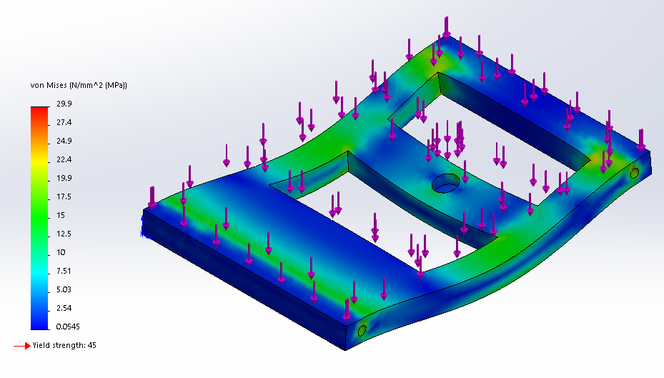

Figure 5. Chassis stress contours resulting from an applied load of 2000 N (maximum stress is 29.9 MPa;

yield strength is 45 MPa)

We can see that the applied load can still be increased, thus for the third run, the load is increased from 2000 N to 3000 N, and the result is shown below:

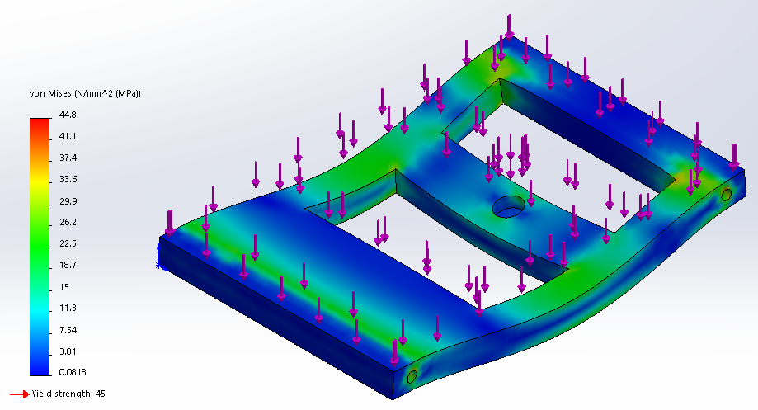

Figure 6. Chassis stress contours resulting from an applied load of 3000 N (maximum stress is 44.8 MPa;

yield strength is 45 MPa)

We can see that the maximum stress is really close to the yield strength, and at this point we can almost say that 3000 N is the maximum stress that the chassis can withstand. However, I want to see the result when the applied load is increased a little over 3000 N to be more precise, thus for the fourth run, the load is increased to 3100 N, and the result is shown below:

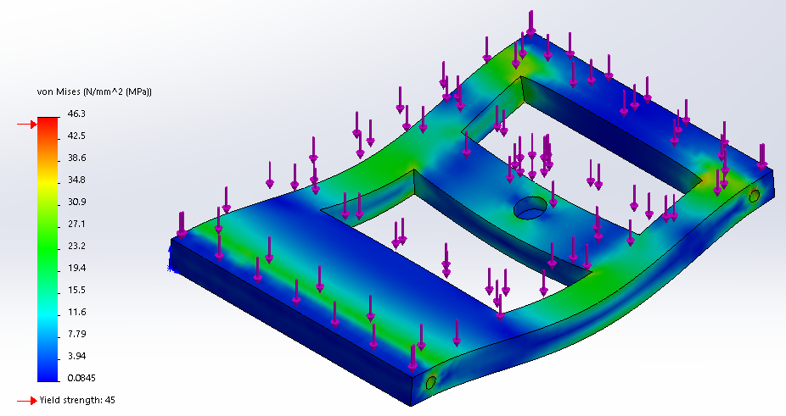

Figure 7. Chassis stress contours resulting from an applied load of 3100 N (maximum stress is 46.3 MPa;

yield strength is 45 MPa)

We can see that yielding happens, thus the applied load is decreased to 3050 N, and the result is shown below:

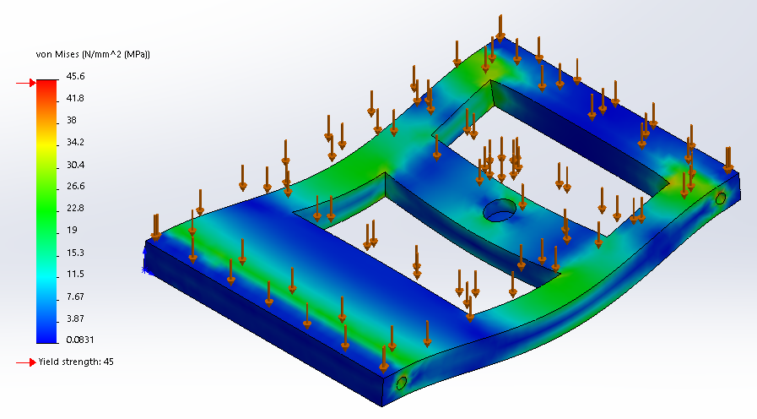

Figure 8. Chassis stress contours resulting from an applied load of 3050 N (maximum stress is 45.6 MPa;

yield strength is 45 MPa)

We can see that yielding still happens, thus it is safe to say that the maximum load is 3000 N.