Vehicle Recorder
Technical Manual
Prepared By
Document Owner(s) | Project/Organization Role
Anthony Baccala | Developer

Technical Documentation Version Control
Version | Date | Author | Change Description
1.0.0 | 29/04/17 | Anthony Baccala | Start

TABLE OF CONTENTS
1 INTRODUCTION 3
2 Abstract Design 4
3 Images 5

INTRODUCTION
This documentation has been developed by Anthony Baccala, It is intended to view and manage the car renting system of the desired company. It Handles car information such as brand, model and year. It also manages the journey the car takes whilst it is rented.

Abstract Design
This is where the abstract design or design diagram is to be placed listing the inputs the outputs and the processes in a table format
Inputs | Processes | Output
ListBox Item | Click on List box item, display the desired item | Text corresponding to the item is shown
Enter Car Info/ Add Car | Gets text from input boxes and attach them to the desired car index in array. | Display text in ListBox
Add journey | Get inputs from boxes and add the required information to the selected car | Km/fuel/service funtions are called and applied to the Vehicle Class.

Images
Error/Testing
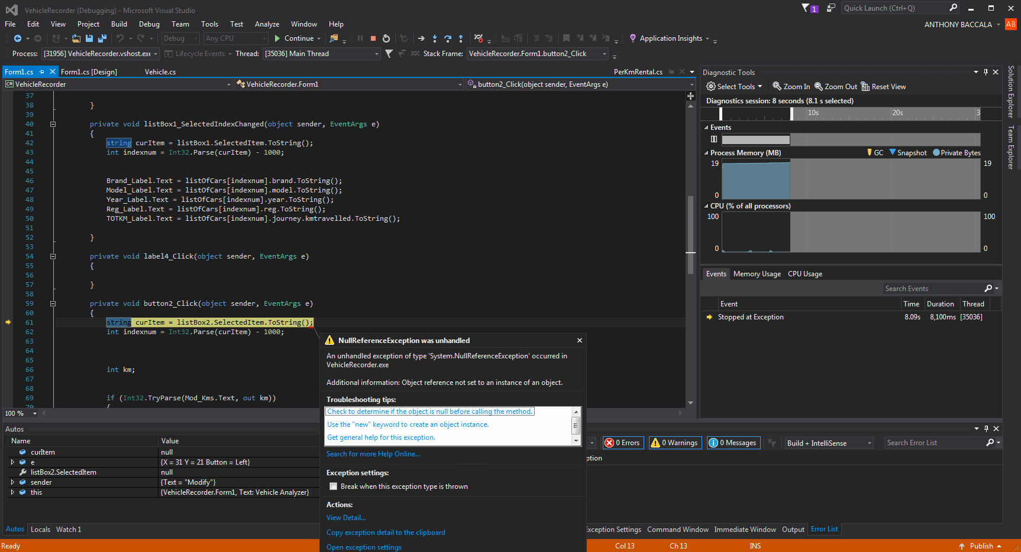
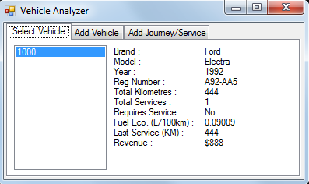
Application

