**Problem 1:**

False positive = 2%

False negative = 5%

P(D | T) = (P(T | D) * P(D))/P(T)

P(T | !D) = 2% => P(!T | !D) = 98%

P(!T | D) = 5% => P(T | D) = 95%

P(D) = 0.1%

P(T) = P(T | D) * P(D) + P(T | !D) * P(!D) = 0.95 * 0.001 + 0.02* 0.999 = 0.02093

P(D | T) = (P(T | D) * P(D))/P(T)

= (0.95 * 0.001)/0.02093

= 0.0454

= 4.54%

The result of analysis to ensure that P(D | T) >= 0.3 is:





Therefore, the constraints are:

prior probability of having the disease P(D) >= 0.008942

the false positive for the test P(T | !D) <= 0.002322

the false negative for the test P(!T | D) <= 0.005966

**Problem 2:**

After the EM learning, I got the resulting network with probabilities showing as below:

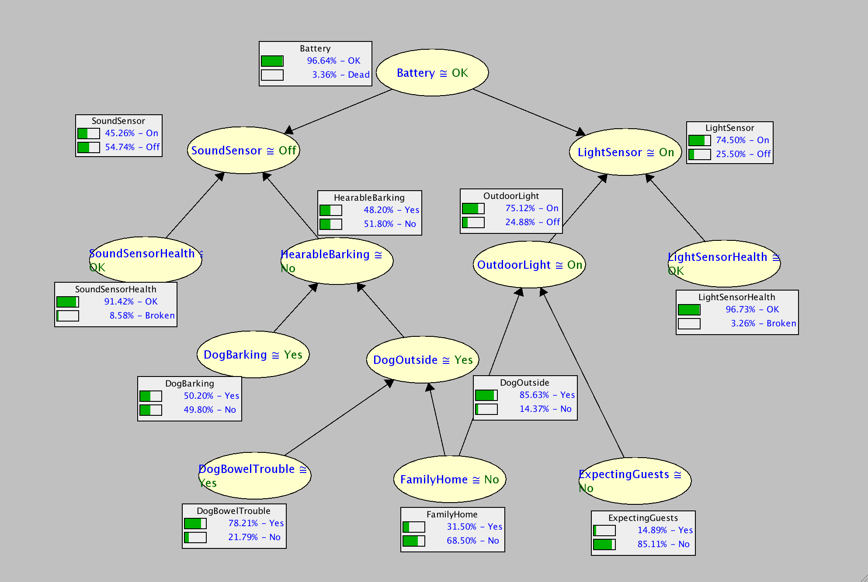

1. The most likely instantiation of all variables given that Sambot has sensed the lights to be on, but has sensed no bark. Explain how you obtained this answer (for partial credit in case you get the wrong answer):

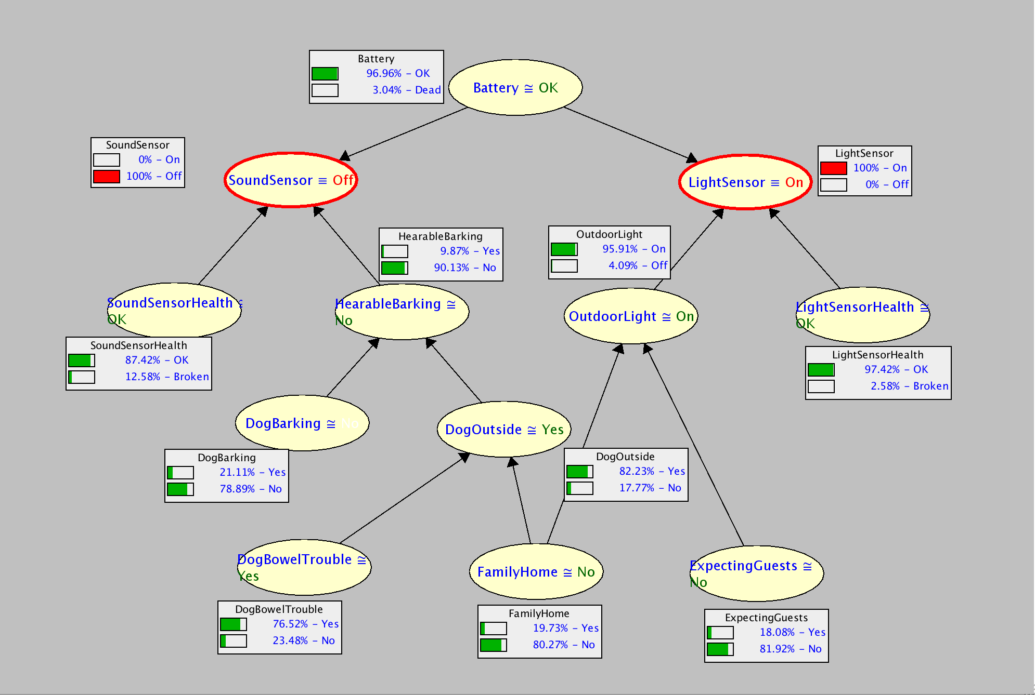

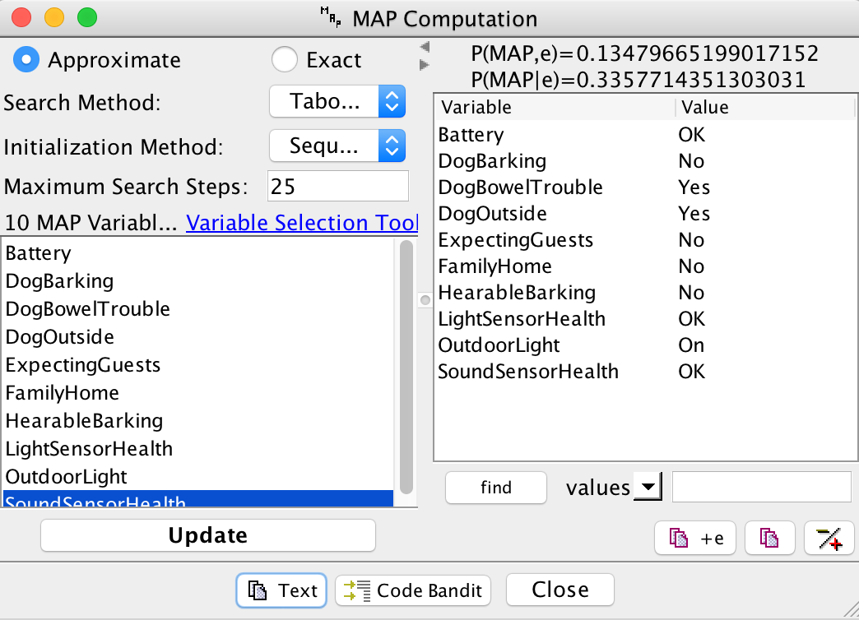

Since the question asked the instantiation of all variables when light is on and no bark, I set the SoundSensor to be Off and LightSensor to be On. And thus I get the graph showing above, of the instantiation of all variables.

1. The most likely instantiation of the sensors given that the family is home and no guests are expected. Explain how you obtained this answer (for partial credit in case you get the wrong answer).

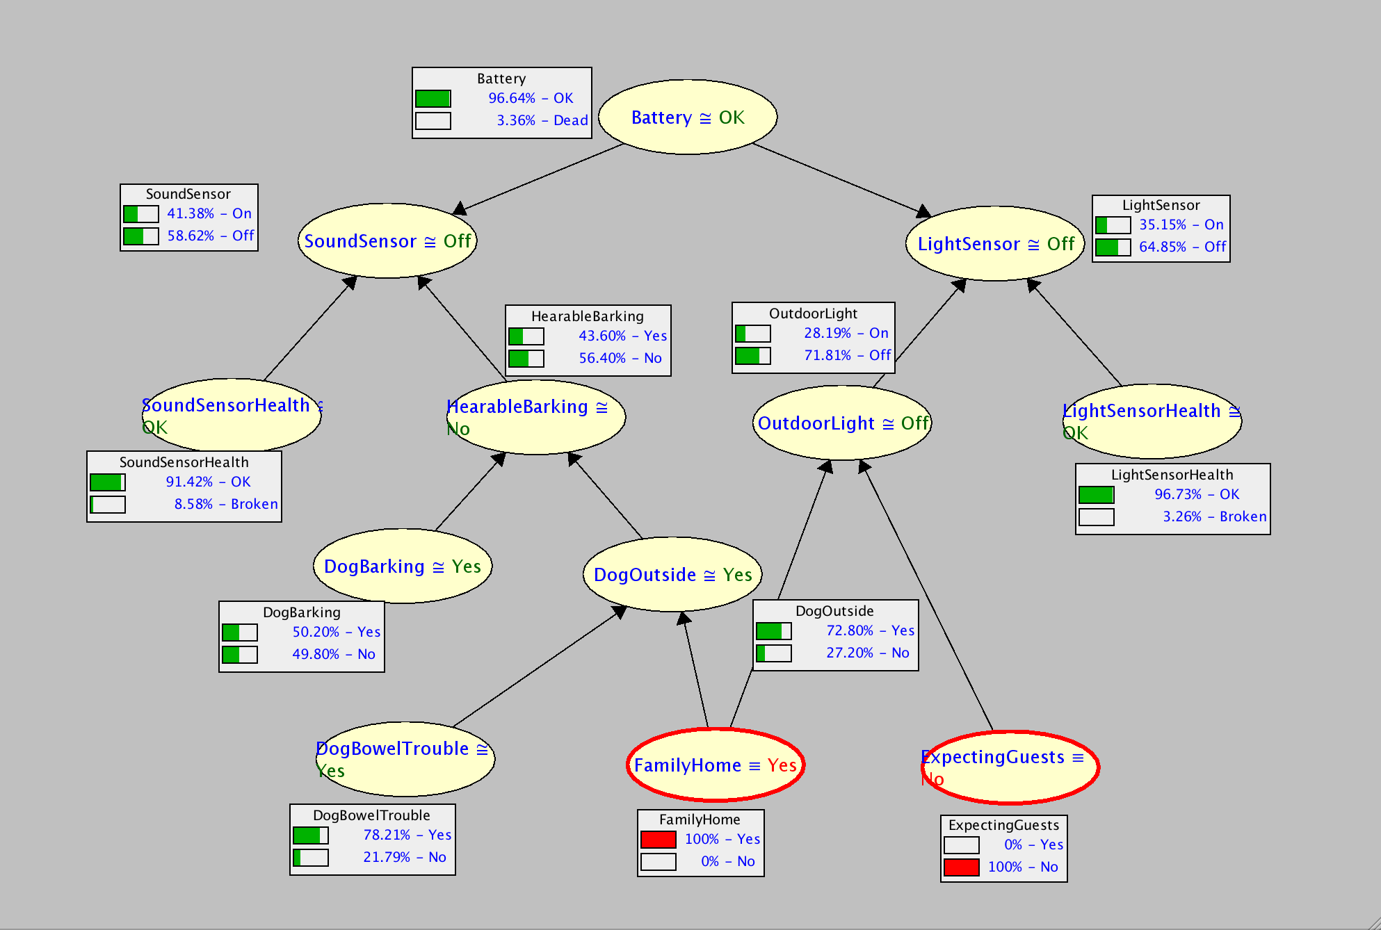

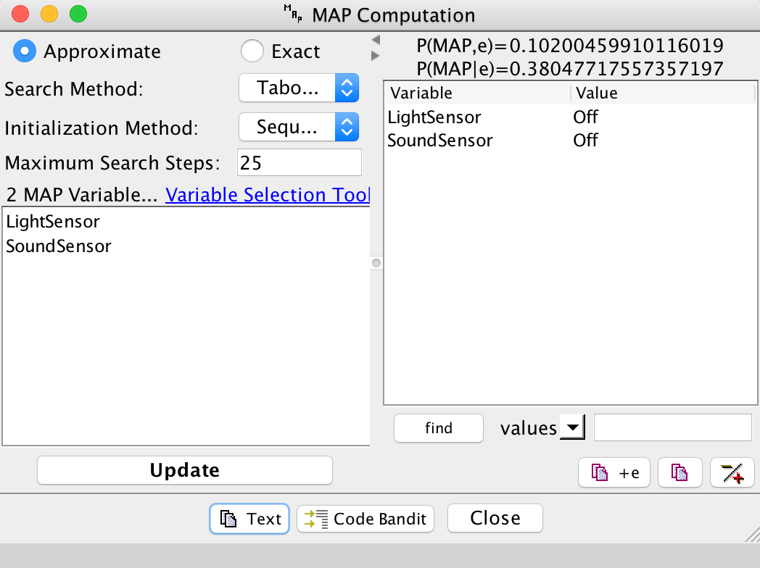

Same as last question. In this question, I set the FamilyHome and ExpectingGuests variables to Yes and No to satisfy the situation declared in the question, then I got the answer that both Sound and Light sensors are most likely to be Off.

1. The smallest set of variables Z in your network such that the two sensors are independent given Z. Justify your answer based on d-separation.

Z = {‘Battery’, ‘FamilyHome’}

When Battery is given, path of [SoundSensor -> Battery -> LightSensor] is blocked, and when FamilyHome is given, path of [SoundSensor -> HearableBarking -> DogOutsie -> FamilyHome -> OutdoorLight -> LightSensor] is blocked. And since only these two path between SoundSensor and LightSensor.

Therefore, d-sep(SoundSensor, Battery FamilyHome, LightSensor) is true. Since this is d-separated, SoundSensor and LightSensor are independent when Battery and FamilyHome are given.

1. The type of network you constructed: tree, polytree (singly-connected network), or multiply-connected network.

The network I constructed is a multiply-connected network, since it is directed, and there are two paths between SoundSensor and LightSensor.