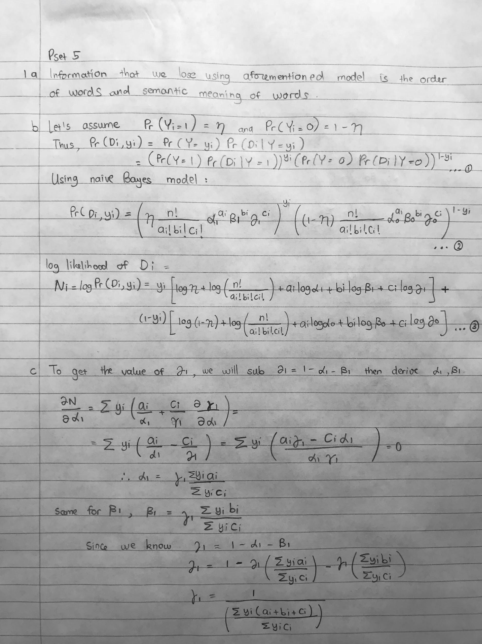

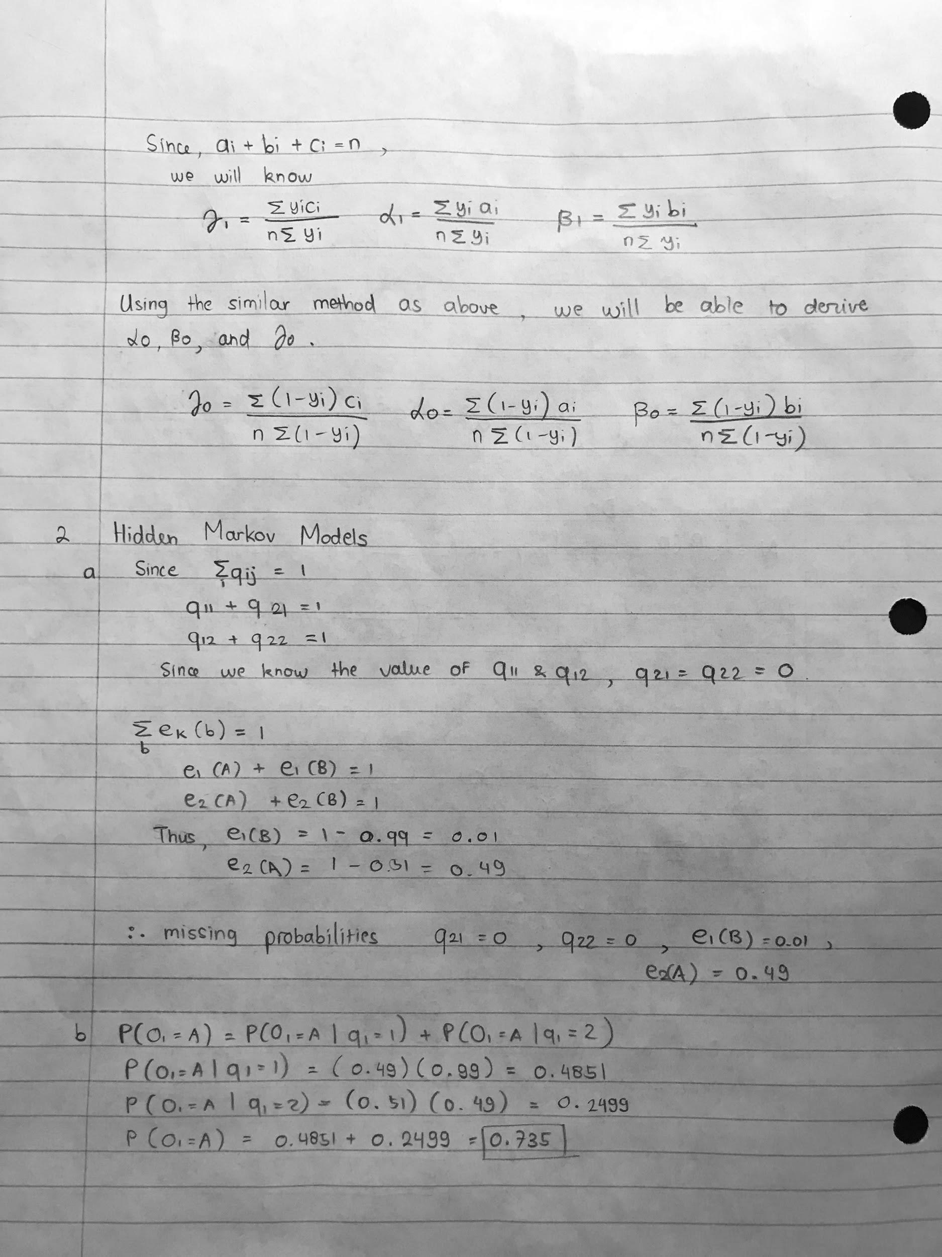

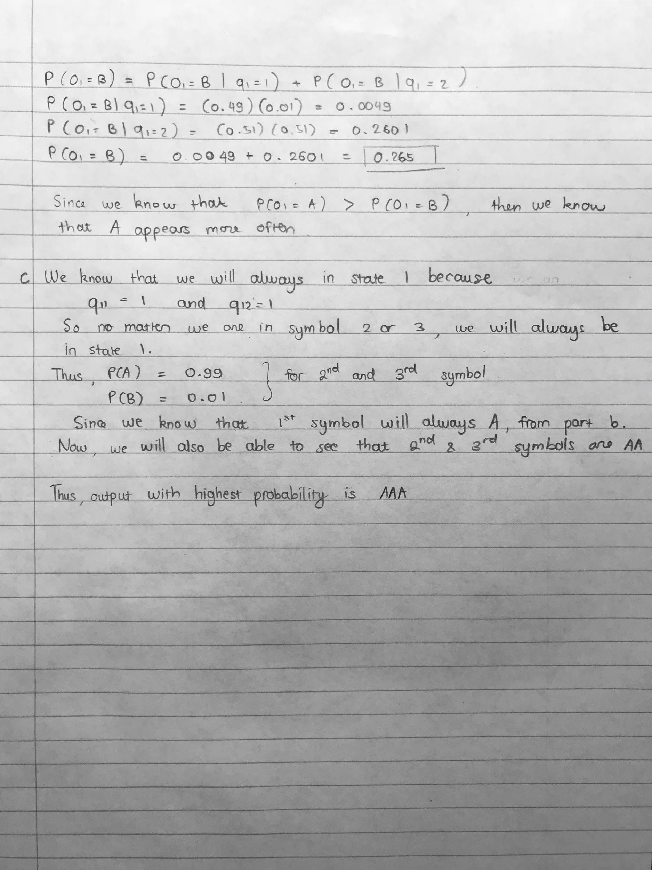

3. Facial Recognition by using K-Means and K-Medoids

1. The minimum objective value is 0. We can get this result if we set k = n, where it means that every object has its own cluster within n different cluster. The value of Ci = i and Mj=x(i). This is a bad idea because clustering is basically grouping some data by its similarity. However, having an individual cluster for each given data is not going to provide an ideal clustering method.
2. Implemented in the code.
3. Implemented in the code.
4. 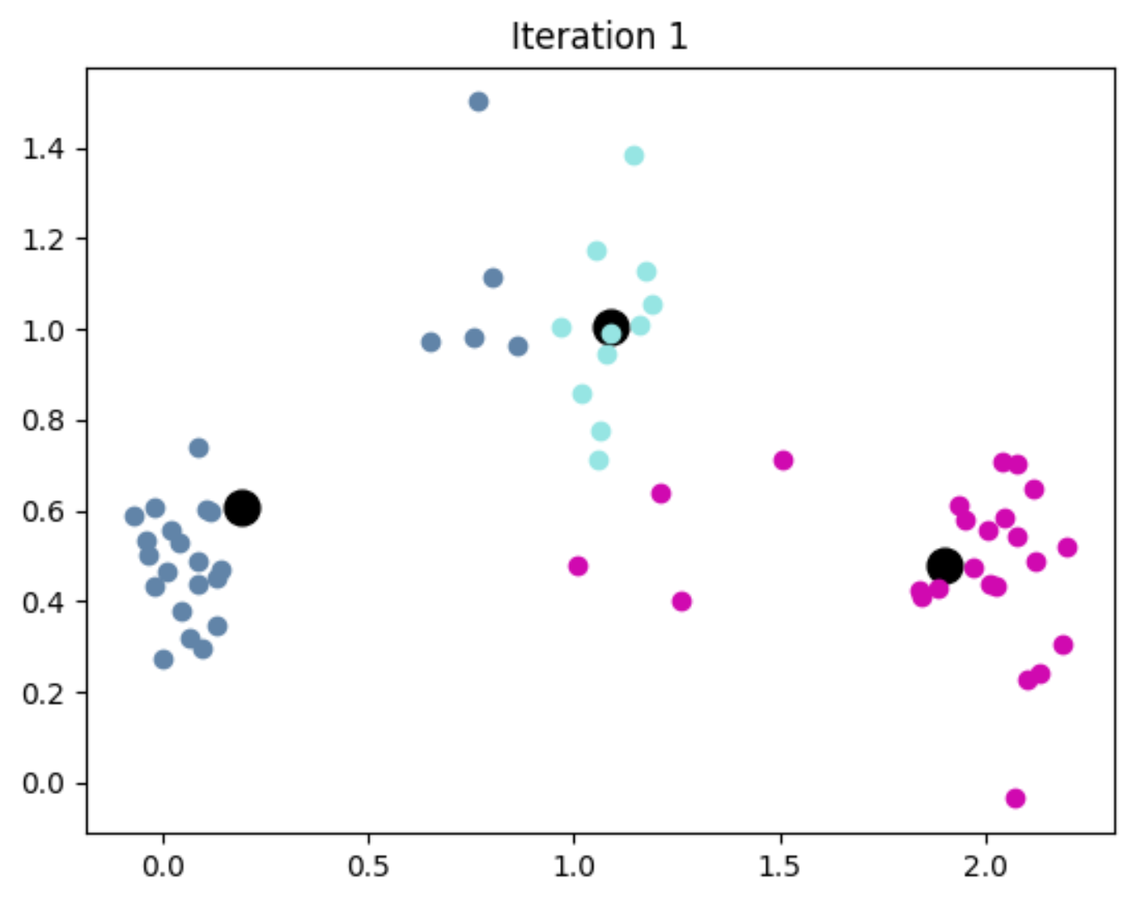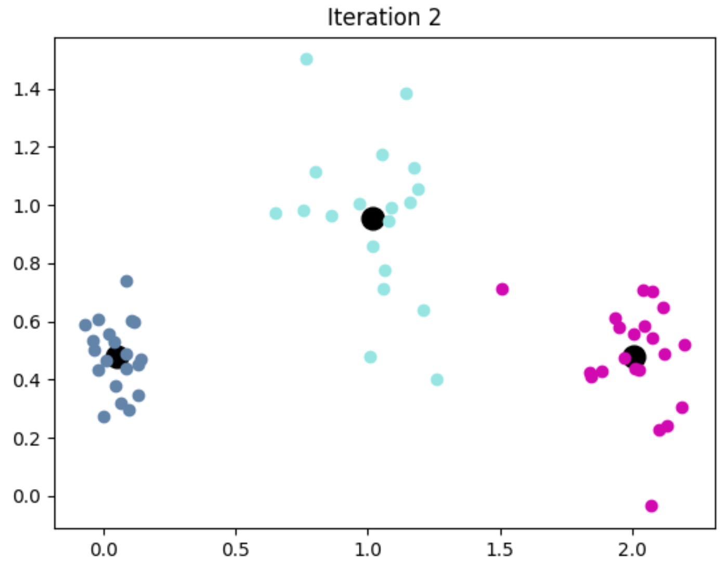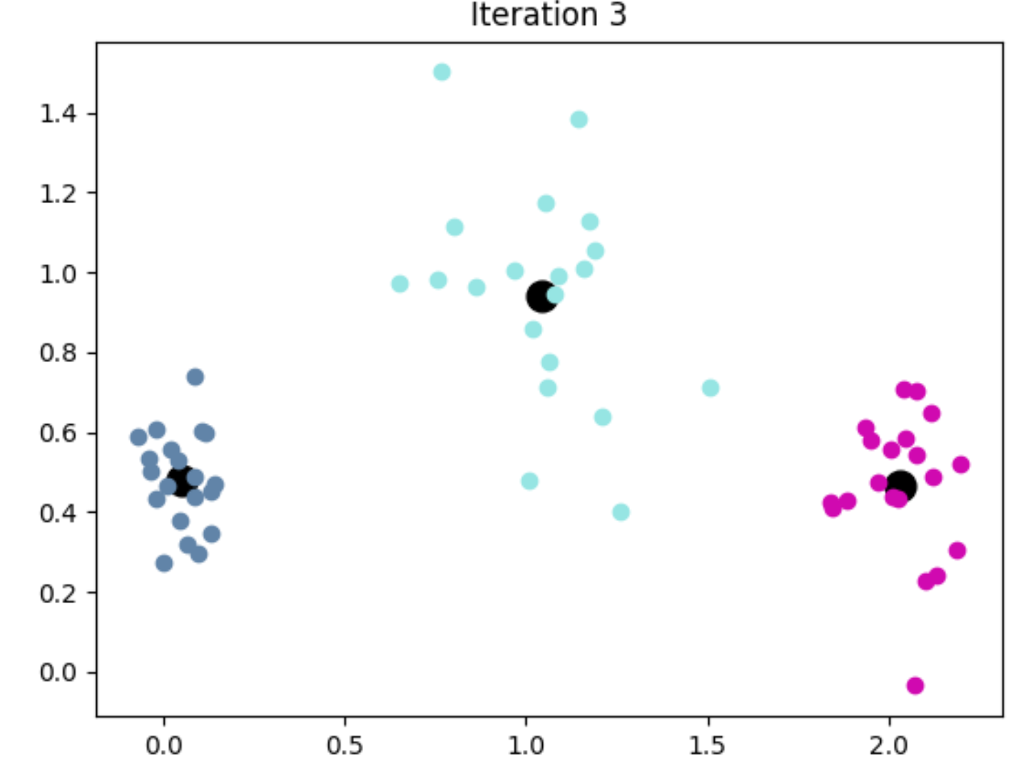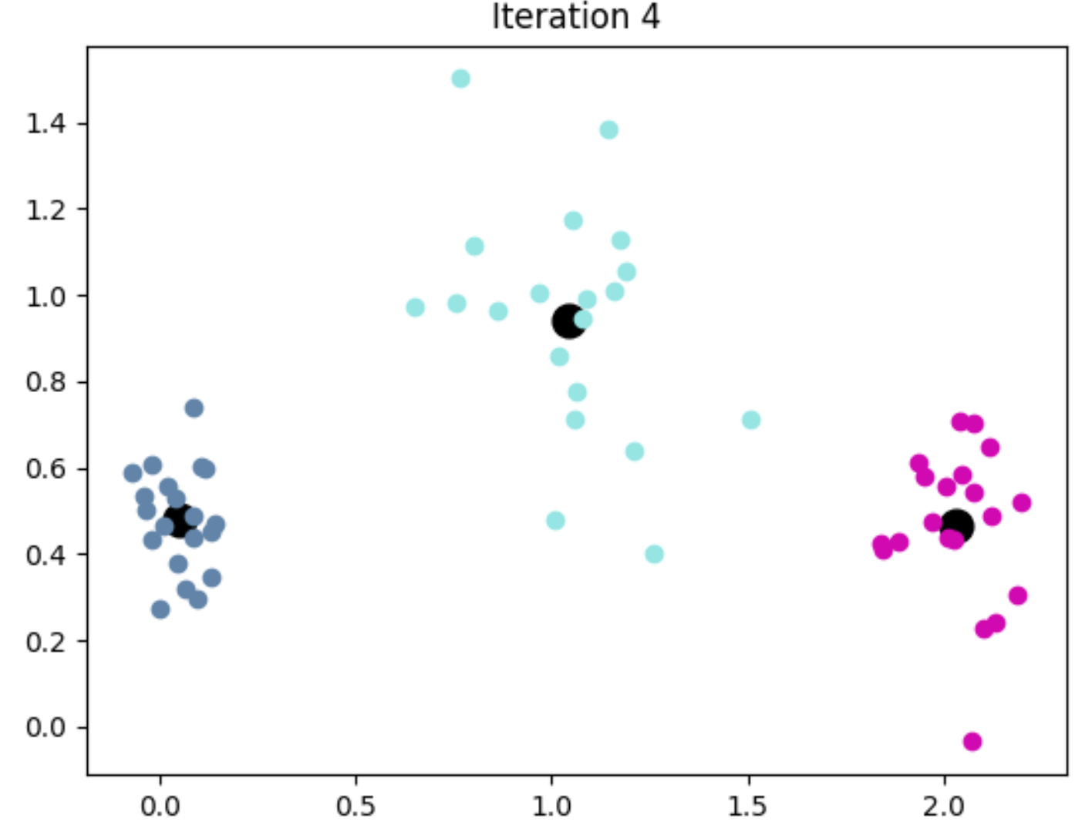

Plots above is implemented using k-means cluster assignments in iteration 1, 2, 3, and 4 with random initialization.

1. 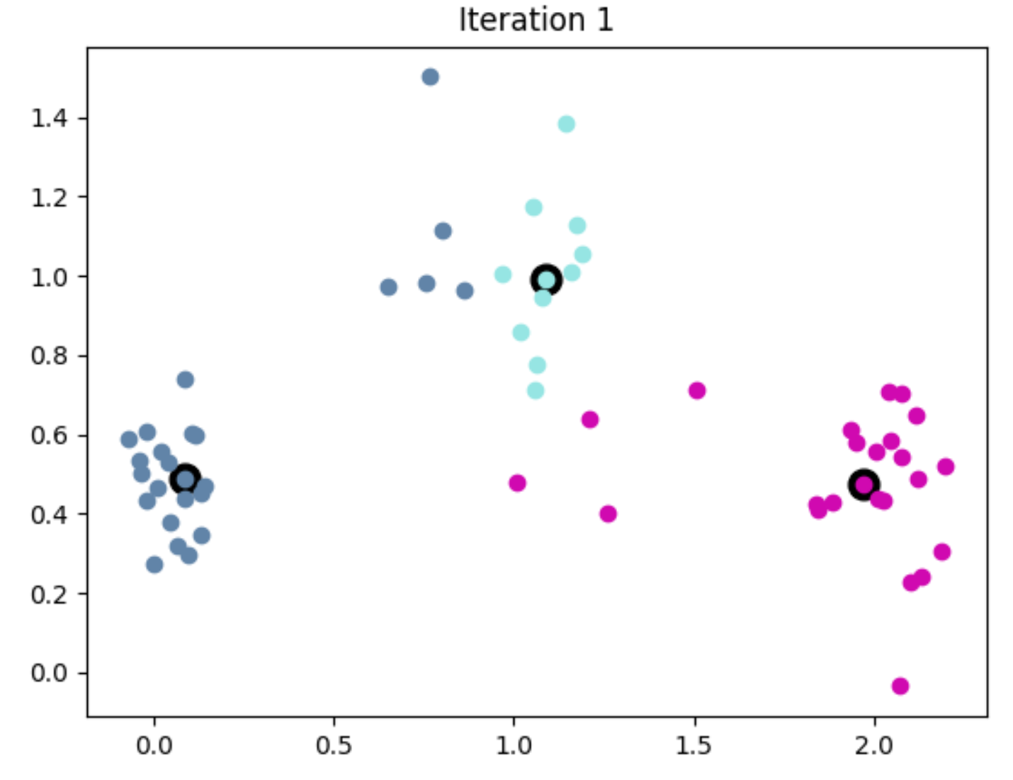

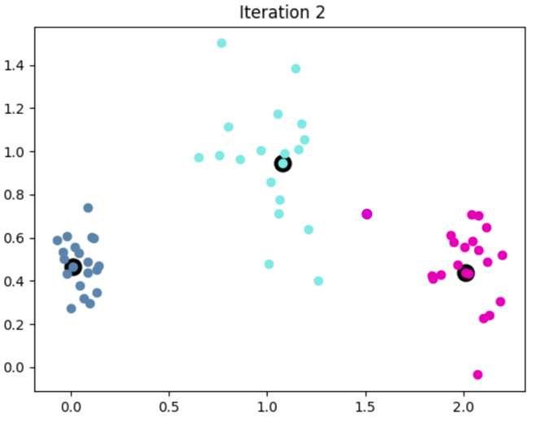

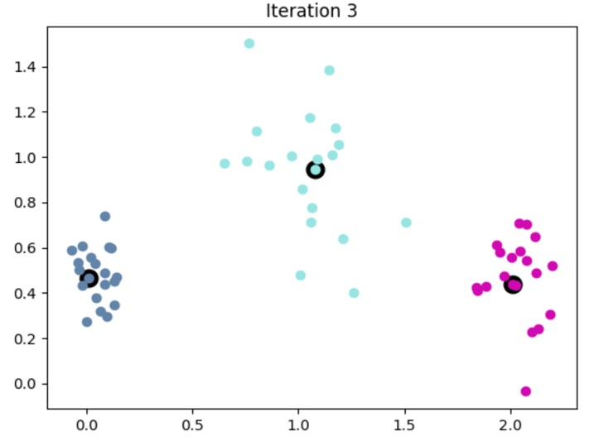

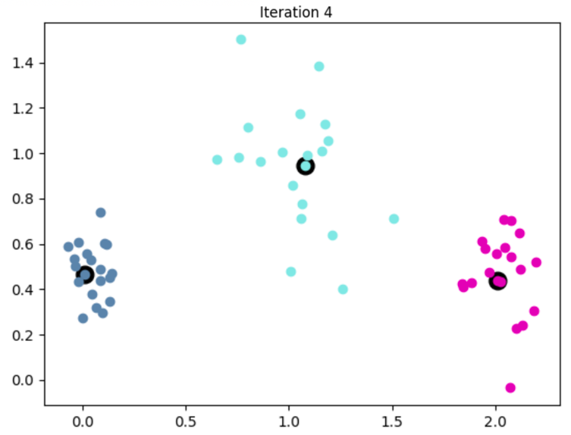

Plots above is implemented using k-medoids cluster assignments in iteration 1, 2, 3, and 4 with random initialization.

f. k-means plot using cheat_init():

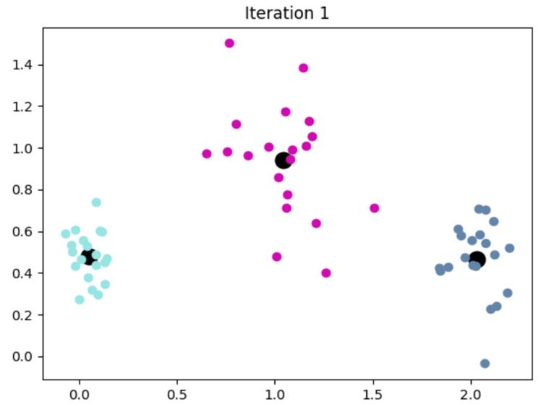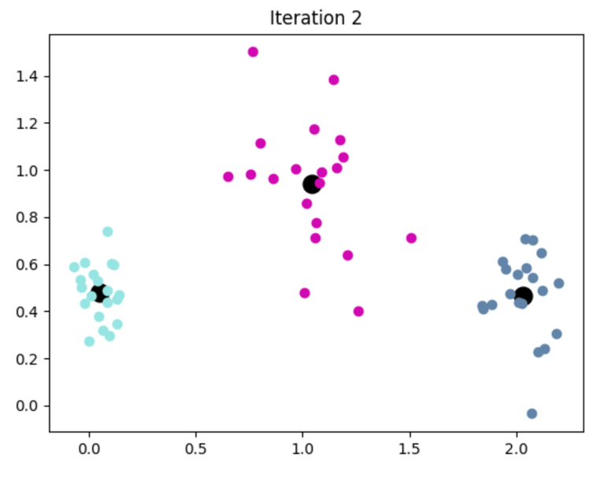

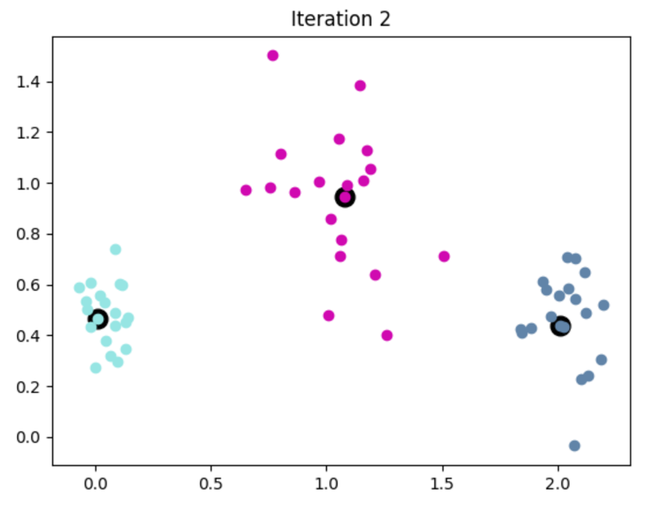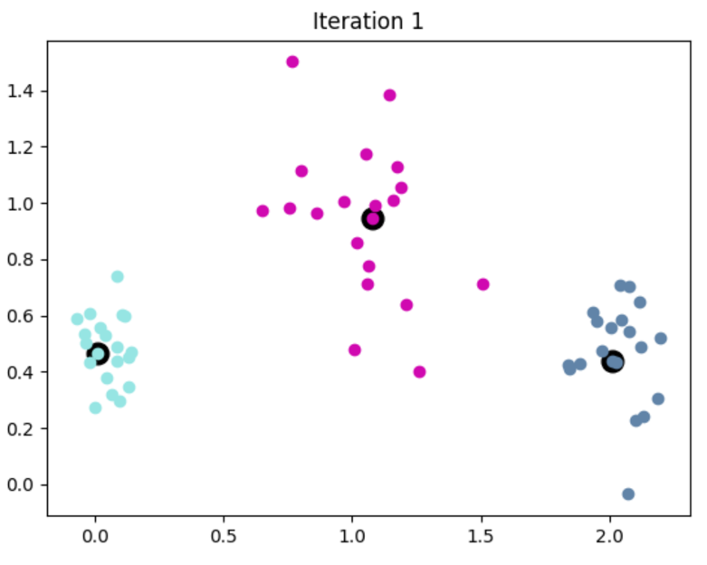k-medoids plot cheat_init():