|  |  |  |  |  |  |
| --- | --- | --- | --- | --- | --- |
| **Test case ID** | **Test description** | **Test data** | **Expected result** | **Actual result** | **Pass/Fail** |
| 1 | Start application | the account number | the current account number should be shown | account number not showing | fail |
| 2 | Start application | the account balance | the current account balance should be shown | account balance showing | pass |
| 3 | Start application | list of transactions | the list should be empty | transaction list empty | pass |
| 4 | Add transactions | list of transactions | the added transactions should be displayed in the session | transactions are displayed | pass |
| 5 | Start application | list of transaction types | The user should be able to choose Credit or Withdrawal transaction type | transaction type is selectable | pass |
| 6 | enter a transaction amount and saves the transaction | saved transaction | a string representation of the transaction should be added to the list of transactions | transaction shows in the list | pass |
| 7 | enter a transaction amount and saves the transaction | saved transaction | the saved transaction should have the specified amount and type | the transaction type and amount shows in the list | pass |
| 8 | enter a transaction amount and saves the transaction | saved transaction | the updated account balance should be displayed | the balance gets updated after saving the transaction | pass |
| 9 | save withdrawal transaction that would cause negative balance | higher transaction amount than balance | an error message should be shown and the transaction should not be added | error message showed, transaction denied | pass |
| 10 | save withdrawal transaction where the amount is > £350 | transaction amount >350 | an error message  should be shown and the transaction should not be added | error message showed, transaction denied | pass |
| 11 | enter non- numeric data to amount field and save transaction | non numeric data | an error message should be shown | error message showed | pass |

System test

System test – failed test documentation

# Failed tests:

|  |  |  |  |  |  |
| --- | --- | --- | --- | --- | --- |
| **Test case ID** | **Test description** | **Test data** | **Expected result** | **Actual result** | **Pass/Fail** |
| 1 | Start application | the account number | the current account number should be shown | account number not showing | fail |



Account number not showing!

# Reason for failing the test:

Task 3, “binding expression” part is not implemented yet.

# Test after proper implementation:

|  |  |  |  |  |  |
| --- | --- | --- | --- | --- | --- |
| **Test case ID** | **Test description** | **Test data** | **Expected result** | **Actual result** | **Pass/Fail** |
| 1 | Start application | the account number | the current account number should be shown | account number not showing | pass |

Unit Tests

# GetBalanceTest()

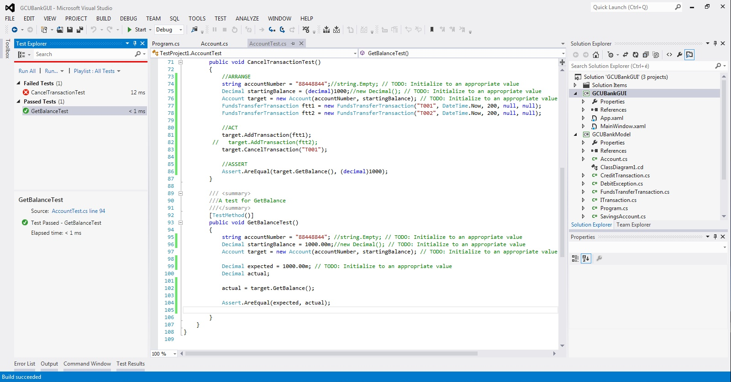

# CancelTransactionTest()

