Viewpoint-Based Map Point Existence Estimation for
Episodic Keypoint-Based Visual SLAM
A THESIS
SUBMITTED TO THE FACULTY OF THE UNIVERSITY
OF MINNESOTA
BY
Thomas Zurales
IN PARTIAL FULFILLMENT OF THE REQUIREMENTS
FOR THE DEGREE OF
MASTER OF SCIENCE
Dr. Arshia Khan
2026

Abstract
Keypoint-Based Visual SLAM algorithms perform well over short durations or in unchanging environments, but struggle with increasing map size and outdated map points when environments change. Methods exist to improve performance in dynamic environments over large time scales by removing old or inconsistent data from generated maps. However, no existing method integrates both geometric consistency and historic observability to identify outdated map data. This thesis presents a novel viewpoint aware probabilistic method for map point culling in keypoint-based visual SLAM systems. The system generates and maintains a model of each map point’s global observability, allowing the likelihood of observing a map point to be estimated from arbitrary locations. These model values are combined with new observations of the map point using Bayesian methods to estimate the probability of the map point’s continued existence. The implementation is released as an open-source library along with an ORB-SLAM3 integration utilizing the library for point culling and RANSAC improvement. Additionally, a set of stereo visual datasets are provided, containing scenarios specifically intended to exercise and characterize the performance of the system. Effects on standard non-dynamic SLAM datasets are discussed alongside the effects on the dynamic datasets.

Acknowledgements

Contents
List of Figures vi
List of Tables vii
- Introduction 1
  - Problem Context . . . . . . . . . . . . . . . . . . . . . . . . . . . . . . . . . 1
  - Problem Statement . . . . . . . . . . . . . . . . . . . . . . . . . . . . . . . . 2
  - Objectives and Scope . . . . . . . . . . . . . . . . . . . . . . . . . . . . . . . 5
  - Research Questions . . . . . . . . . . . . . . . . . . . . . . . . . . . . . . . . 8
  - Contribution . . . . . . . . . . . . . . . . . . . . . . . . . . . . . . . . . . . . 9
    - The VBEE Library . . . . . . . . . . . . . . . . . . . . . . . . . . . . 9
    - ORB-SLAM3 Integration . . . . . . . . . . . . . . . . . . . . . . . . . 9
    - Episodic Change Datasets . . . . . . . . . . . . . . . . . . . . . . . . 9
  - Road Map . . . . . . . . . . . . . . . . . . . . . . . . . . . . . . . . . . . . . 10
- Background 11
  - Keypoint-Based Visual SLAM . . . . . . . . . . . . . . . . . . . . . . . . . . 11
    - Image Features . . . . . . . . . . . . . . . . . . . . . . . . . . . . . . 12
    - Robust Estimation and RANSAC . . . . . . . . . . . . . . . . . . . . 12
    - Tracking and Mapping . . . . . . . . . . . . . . . . . . . . . . . . . . 14
    - Loop Closure and Relocalization . . . . . . . . . . . . . . . . . . . . . 15
    - Map Reuse . . . . . . . . . . . . . . . . . . . . . . . . . . . . . . . . 16
  - ORB-SLAM3 . . . . . . . . . . . . . . . . . . . . . . . . . . . . . . . . . . . 17
- Related Work 18
  - Place Recognition over Long Time Horizons . . . . . . . . . . . . . . . . . . 18
  - Change Detection for Map Maintenance . . . . . . . . . . . . . . . . . . . . 19

  - Dynamic Rejection . . . . . . . . . . . . . . . . . . . . . . . . . . . . . . . . 20
  - Lifelong SLAM . . . . . . . . . . . . . . . . . . . . . . . . . . . . . . . . . . 20
  - Map Point Observability . . . . . . . . . . . . . . . . . . . . . . . . . . . . . 20
- Implementation 21
  - Definitions and Functions . . . . . . . . . . . . . . . . . . . . . . . . . . . . 21
  - Method Overview . . . . . . . . . . . . . . . . . . . . . . . . . . . . . . . . . 23
    - The Observability Model . . . . . . . . . . . . . . . . . . . . . . . . . 23
    - Existence Probability Estimator . . . . . . . . . . . . . . . . . . . . . 25
    - The Existence Estimation Framework . . . . . . . . . . . . . . . . . . 25
    - Overall Observability . . . . . . . . . . . . . . . . . . . . . . . . . . . 26
  - System Implementation . . . . . . . . . . . . . . . . . . . . . . . . . . . . . . 27
    - Existence Estimation Framework Implementation . . . . . . . . . . . 27
    - Observability Models . . . . . . . . . . . . . . . . . . . . . . . . . . . 28
    - Existence Probability Estimator . . . . . . . . . . . . . . . . . . . . . 31
  - Dataset Creation . . . . . . . . . . . . . . . . . . . . . . . . . . . . . . . . . 32
  - Observability Scenarios Dataset . . . . . . . . . . . . . . . . . . . . . . . . . 32
    - Static Episodic Visual SLAM Dataset . . . . . . . . . . . . . . . . . . 33
    - Changing Episodic Visual SLAM Datasets . . . . . . . . . . . . . . . 33
  - ORB-SLAM3 Integration . . . . . . . . . . . . . . . . . . . . . . . . . . . . . 34
    - Map Point . . . . . . . . . . . . . . . . . . . . . . . . . . . . . . . . . 34
    - VBEE Post-Processing Operations . . . . . . . . . . . . . . . . . . . 35
    - RANSAC Integration . . . . . . . . . . . . . . . . . . . . . . . . . . . 35
  - Parameter Optimization . . . . . . . . . . . . . . . . . . . . . . . . . . . . . 36
  - Experimental Setup . . . . . . . . . . . . . . . . . . . . . . . . . . . . . . . . 42
- Results 47
  - Experiment 2: VBEE Integrated SLAM Performance with Static Episodic
Operations . . . . . . . . . . . . . . . . . . . . . . . . . . . . . . . . . . . . . 48
  - Experiment 3: VBEE Integrated SLAM Performance with Changing Episodic
Operations . . . . . . . . . . . . . . . . . . . . . . . . . . . . . . . . . . . . . 50
  - Experiment 4: VBEE + RANSAC SLAM Performance with Changing Episodic
Operations . . . . . . . . . . . . . . . . . . . . . . . . . . . . . . . . . . . . . 51
- Future Work and Conclusions 53
  - Future Work . . . . . . . . . . . . . . . . . . . . . . . . . . . . . . . . . . . . 53
Bibliography 55
- Appendices 59
  - Absolute and Relative Pose Error . . . . . . . . . . . . . . . . . . . . . . . . 59
  - Key Algorithm Implementations . . . . . . . . . . . . . . . . . . . . . . . . . 59
Key Algorithm Implementations . . . . . . . . . . . . . . . . . . . . . . . . . . . . 59
Full Results . . . . . . . . . . . . . . . . . . . . . . . . . . . . . . . . . . . . . . . 60

List of Figures
1 OMR Method Comparison . . . . . . . . . . . . . . . . . . . . . . . . . . . . | 5
2 SLAM Family Tree . . . . . . . . . . . . . . . . . . . . . . . . . . . . . . . . | 11
3 Image Feature Extraction and Matching . . . . . . . . . . . . . . . . . . . . | 13
4 2D RANSAC Example . . . . . . . . . . . . . . . . . . . . . . . . . . . . . . | 14
5 Loop Closure Example . . . . . . . . . . . . . . . . . . . . . . . . . . . . . . | 15
6 Simplified ORB-SLAM3 Operational Diagram . . . . . . . . . . . . . . . . . | 17
7 2D Global Observability . . . . . . . . . . . . . . . . . . . . . . . . . . . . . | 24
8 Existence Estimation Framework . . . . . . . . . . . . . . . . . . . . . . . . | 26
9 2D cutaways of examples from the Observability Scenarios Dataset . . . . . . | 33
10 Example images from each trajectory of the episodic visual SLAM dataset . | 33

List of Tables
1 Brier scores for three observability models across 10 independent trials . . . | 47
- Brier score averages and standard deviations by model . . . . . . . . . . . .  - Pairwise comparisons of VBEE observability model Brier scores to baseline | 48
Brier scores . . . . . . . . . . . . . . . . . . . . . . . . . . . . . . . . . . . .  4 Metrics from 10 independent trials of the baseline SLAM system run on the | 48
static All Machine Halls episodic dataset. . . . . . . . . . . . . . . . . . . .  5 Metrics from 10 independent trials of the VBEE integrated SLAM system run | 48
on the static All Machine Halls episodic dataset. . . . . . . . . . . . . . . .  6 Per-metric comparison between the baseline SLAM system and the VBEE | 49
integrated SLAM system . . . . . . . . . . . . . . . . . . . . . . . . . . . . .  7 Metrics from 10 independent trials of the baseline SLAM system run on the | 49
changing All Days episodic dataset. . . . . . . . . . . . . . . . . . . . . . . .  8 Metrics from 10 independent trials of the VBEE integrated SLAM system run | 50
on the changing All Days episodic dataset. . . . . . . . . . . . . . . . . . . .  9 Per-metric comparison between the baseline SLAM system and the VBEE | 50
integrated SLAM system . . . . . . . . . . . . . . . . . . . . . . . . . . . . .  10 Metrics from 10 independent trials of the VBEE + RANSAC SLAM system | 51
run on the changing All Days episodic dataset. . . . . . . . . . . . . . . . . .  11 Per-metric comparison between the VBEE + RANSAC SLAM system, the | 51
baseline SLAM system, and VBEE integrated SLAM system . . . . . . . . . | 52

1 Introduction
The research presented in this thesis addresses a challenge common in long-term usage of SLAM systems: the need to continuously localize and map in non-static environments. This thesis presents a novel, lightweight method for culling outdated map points from previously generated maps using a probabilistic, viewpoint-aware model of map point observability. This method is designed to operate efficiently on mobile robotics platforms with limited computational resources. The effectiveness of this approach is demonstrated in identifying outdated map points, improving localization accuracy, and improving the robustness of SLAM between different runs of the system.

1.1 Problem Context
The International Space Station (ISS) has three robots on board known as Astrobees. These robots were launched with the intention of being a platform for zero-gravity robotics research, a camera rig for recording astronaut activity, and a sensor platform for performing station keeping and monitoring tasks [1]. Core to each of these missions is the ability for Astrobee to autonomously localize and navigate throughout the U.S. Orbital Segment (USOS). Unfortunately, the harsh realities of navigation on board the ISS quickly became apparent. The high-level structure of the station is constant, but the visual features within the station are not stable, changing due to equipment resupplies, hardware movements, astronaut activity, and lighting changes. The irregularity in the visual features of the ISS degraded the performance of the Astrobee localizer, which relied on visual features stored in a pre-generated map [2]. Mapping the ISS required input from ground crew and astronauts, which, due to the tight timetables associated with ISS operations, led to infrequent map updates. These outdated maps caused frequent lost states, inaccurate localization estimations, and overall poor performance of the navigation stack. Eventually, Astrobee activities were restricted almost entirely to the Japanese Experiment Module (JEM), a relatively small area which could be kept visually stable, and could be quickly remapped when needed [3].
A project was proposed to augment Astrobee’s navigation stack with a keypoint-based visual SLAM (KV-SLAM) system. The idea behind this change was to have the SLAM system load an initial map from the previous mission, localize within this map, then update the map with the latest visual features from the environment. At the end of the operation, the updated map could be saved off for use in the next mission [4]. For this research, this operational concept of iteratively updating previous maps between operations is referred to as episodic SLAM. Testing of the SLAM system presented the same issues encountered by the Astrobee localizer when attempting to reuse outdated maps. The conjecture stemming from these results was that for reused maps to be useful, they must not only be updated with the latest visual features, but must also remove features which have become outdated.
Three key lessons were learned from the Astrobee work which motivated the research presented here. First, the episodic operating model has potential in a wide variety of applications, providing a method for regular, large-scale environmental monitoring of changing environments such as factories, warehouses, and offices. Second, map reuse is a powerful tool for robotic systems operating in the same environment over long periods of time, allowing for the preservation of structural map data and the global reference frame. Finally, SLAM systems are not inherently robust to outdated maps, showing degraded performance as the initial map diverges from the true environment.

1.2 Problem Statement
A future use case of episodic KV-SLAM would be for operations in environments that are intermittently occupied, such as workplaces. The benefit of this method is that the robot can avoid operating during highly dynamic times, with the trade-off being that the environment may be significantly changed between sessions of operation. In the case of Astrobee, the navigation system struggled to reconcile inconsistencies between the internal map and the real world, regularly requiring astronaut assistance to recover. Trust in autonomous systems is already precarious, quickly falling upon the observation of failure [5]. Robotic SLAM failures can lead to navigational instability, task failure, and even the possibility of physical damage to the surrounding environment or the robot itself [6]. Therefore, in order for autonomous SLAM-based robotic navigation to see widespread use, it must be accurate in its estimations and capable of withstanding a wide variety of failure cases. This research focuses on reducing failures caused by the existence of outdated map features in reused maps during episodic KV-SLAM operations. For simplicity, the topic of reusing previously generated maps that have gone out of date is referred to as outdated map reuse (OMR).
There are three critical issues that appear in systems that do not handle the challenges of OMR sufficiently well. The first relates to the size of the map, as only adding newly observed features without removing outdated ones results in a monotonically increasing map size. This puts an ever-increasing strain on compute resources to deal with the large map and increases the complexity of optimization steps. The second issue concerns relocalization, which is the process by which a KV-SLAM system redetermines its position within the map after being lost. Relocalization starts by identifying candidate positions within the map that are visually similar to the current camera image. A high proportion of outdated map points in the map interferes with this candidate selection, as the map’s understanding of the visual features of the environment no longer matches reality. The final issue affects the RANSAC process, a function that is run regularly as part of determining the 3D transformation between successive frames. The RANSAC algorithm selects a random sample of points from the map and the new image to be localized and attempts to determine a consistent 3D transformation that explains the correspondence. High proportions of outdated map points increase the risks of the RANSAC algorithm failing to find a consistent pose for the new frame, even if one exists. The map representation, relocalization, and RANSAC will be covered in greater detail in section 2.1.
All of these issues with OMR stem from the existence of bad data in the KV-SLAM map.
There are two ways to prevent such bad data from affecting the map. The first option is to proactively prevent map features with potential to become outdated (i.e., located on an object that can move) from ever entering the map. In this case, the map will never be outdated because no features in the map can move. The second option is to retroactively identify and remove outdated features from the map once it has been loaded for reuse. The mechanism at play in the proactive case tends to be semantic identification and segmentation of input images, allowing semantic labels to determine whether map points that fall on certain objects are kept or not. These semantic processes require significant compute and storage resources, often making them unsuitable for compute-constrained applications such as small-scale mobile autonomous vehicles (MAVs). In the reactive case, the methods stray away from semantics and towards change detection. Change detection identifies inconsistencies between the map and the camera observations, flagging points for removal once confidence in their existence drops below some threshold. However, a gap can be noticed in the change detection methods available today. This operation of removing map points based on some criteria comes up frequently in SLAM, and will be referred to as map point removal (MPR) throughout this research. While change detection methods do collect point-level metadata, to the author’s knowledge no change detection methods collect metadata on the global observability of each map point, leaving today’s systems susceptible to overzealously flagging map points that are temporarily obstructed from certain viewpoints for removal. The semantic and change-detection methods will be discussed in greater detail in section 3.
The key takeaway is that OMR can greatly benefit episodic KV-SLAM systems, but without proper handling of outdated data, OMR utilization creates new failure cases that degrade the system’s performance. The methods available that allow OMR to be successfully integrated make a trade-off between computational requirements, storage requirements, and effectiveness as illustrated in Figure 1. As an engineering problem, the constraints that drive the decision of methodology for MPR are size, weight, power, and cost. It is not always possible to simply use a better computer, and in those cases, when accurate outdated MPR is needed, the available methods can fall short of requirements. The conjecture of this research
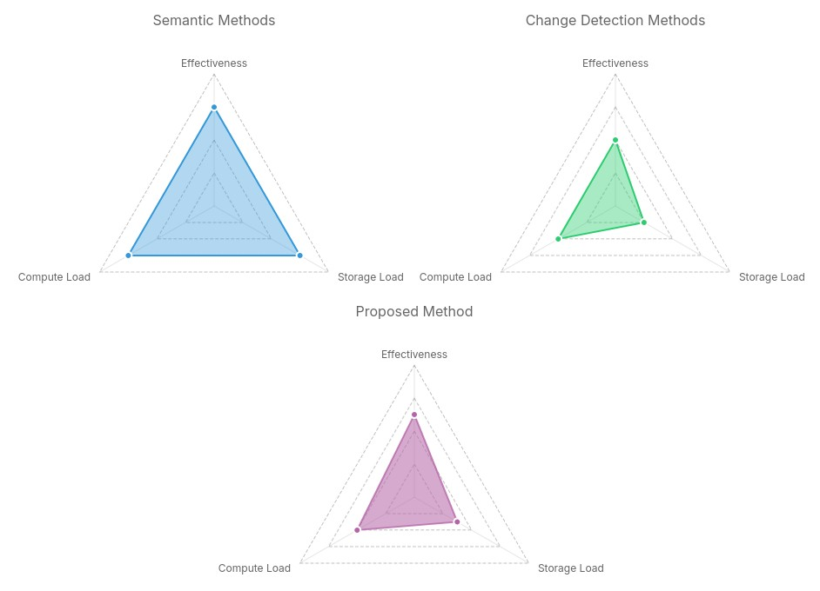
Figure 1: A qualitative comparison of compute load, storage load, and effectiveness between various OMR point removal methods.
is that a novel change detection method that models the global observability of map features at the point level could increase the accuracy of outdated map point identification without a significant increase in computational power requirements.

1.3 Objectives and Scope
The research presented in this thesis was inspired by and is limited in scope to map reuse in episodic KV-SLAM operations. Limiting the scope does mean that some relevant topics will not be explored in depth, but will be mentioned in section 6.1 as potential areas for follow-on research. The justification for the scope selection is given here.
The methods presented in this research will not work for all SLAM systems, or on all SLAM-generated maps. While change detection techniques do exist for dense maps, the method presented here would not be suitable, as it relies on locating the same map features at different points in time. Dense maps identify matching positions through geometric correspondence, as opposed to feature descriptors. This applies to LiDAR-based SLAM systems as well, as no descriptor is generated for each point. The method presented here relies on the capability to apply and persist metadata to a particular map point, something that is not possible without point descriptors, leaving KV-SLAM as the only option for this work.
The focus on map reuse and the episodic operating model can be motivated by the use cases discussed previously. On the ISS, the ideal navigation system would be a self-updating localizer rather than a SLAM system. The primary difference is that a localizer utilizes the same map and reference frame for all operations, while a SLAM system generates and uses its own map. SLAM’s features are extremely useful for exploration of unknown areas, but less so for repeated operations in known areas. The combination of map reuse and the episodic operating model allows the system to act as a self-updating localizer, maintaining a map that is up-to-date with the last observed state of the world while preserving as much previously collected data as possible. Within this scope, the objectives of this research can be defined.
This research has two primary objectives. The first is the implementation of a novel viewpoint-based MPR method that considers the historical, point-level, viewpoint-dependent observability of map points in the decision to keep or discard points. The second is the integration of this MPR method into an existing KV-SLAM system. Both objectives have several sub-goals, which are detailed below.

Objective 1: Implementation of a viewpoint-based MPR method
Goal 1: Speed
Although this system is implemented as a post-processing step performed at the end of each episodic run rather than during real-time SLAM operations, computational efficiency remains important. The post-processing step must complete in a reasonable time relative to the length of the run, and should not become a bottleneck for the overall episodic pipeline.
This goal also refers to the speed of identifying outdated map points, meaning a point that is outdated should be identified and culled with a minimal number of observations.
Goal 2: Size
To run well on resource-constrained hardware, additional space requirements (RAM and disk) must be kept low. The space complexity of the system should be constant, and not a function of the number of map points or observations.
Goal 3: Accuracy
The system must only identify points as outdated once sufficient evidence of them being out of date has been collected. The system should be robust to falsely identifying active map points as outdated and outdated map points as active.

Objective 2: Integration into an existing KV-SLAM system
To verify the performance and effectiveness of the viewpoint-based MPR method, it must be implemented into an existing SLAM system and benchmarked in various scenarios.
Goal 1: Maintain performance in the general case
This research is focused on outdated map reuse and therefore should not affect the performance of the SLAM system when not reusing an outdated map. The modified system should perform identically to the base system in this case.
Goal 2: Improve performance when using outdated maps
To be considered successful, the SLAM implementation should perform better than the base system when using an outdated initial map. The criteria for better performance are defined in section ??.
Goal 3: Maintain computational requirements
As the MPR method operates as a post-processing step, its integration should not significantly affect the computational requirements of the SLAM system during real-time operation. The post-processing step itself should complete within a reasonable time.
With these objectives in hand, a set of questions can now be defined which, when answered, will determine whether the goals of the objectives have been successfully achieved.

1.4 Research Questions
Question 1: How can the historical viewpoint-dependent observability of points be modeled in order to meet the objectives laid out in Objective 1?
Integrating historical viewpoint-dependent observability into existing change detection approaches requires a compact model of observability at the point level. Two model implementations are explored in section 4.3.2. An initial KNN-based approach is presented as a precursor, and a Discrete Boundary model that exploits geometric visibility structure is developed as the primary method. Both are evaluated in section ??.
Question 2: How does the integration of historical observability data affect the estimation of point existence confidence?
Each model implementation is integrated into an existing change detection model, discussed in section 4.3.3, which utilizes a Bayesian update step to iteratively update a confidence estimation of the map point's existence. Both models are evaluated for speed, accuracy, and robustness in section ??.
Question 3: Can the change detection model be integrated into an existing KV-SLAM system in a way that meets the goals of Objective 2?
The extended confidence update is integrated into ORB-SLAM3, a popular KV-SLAM system, for evaluation against a series of datasets intended to test the system across a range of simple and challenging situations. The integration is discussed in section 4.6, and the evaluation is presented in section ??.

1.5 Contribution
Through this research, three contributions are made to the subject of long-term map reuse in KV-SLAM. First, an open-source library is released which provides an implementation of the VBEE framework for integration into KV-SLAM systems. Next, a modified version of ORB-SLAM3 with the VBEE framework integrated is released for ease of further testing and research. Finally, a collection of stereo visual datasets is provided covering situations particularly challenging for intermittently run KV-SLAM systems, enabling demonstration and comparison of the system’s capabilities.

1.5.1 The VBEE Library
The VBEE library (libVBEE) is a C++ implementation of the viewpoint-based existence estimation framework, designed for integration into existing KV-SLAM systems.

1.5.2 ORB-SLAM3 Integration
ORB-SLAM3, an extremely popular KV-SLAM implementation, is modified to utilize libVBEE for estimating the probability of map point existence within the global map. These probabilistic estimations are then used in the selection of keypoints for culling operations, removing points which drop below a certain threshold at the end of each episodic run, and for improving relocalization operations through an updated RANSAC implementation which weights high-probability map points above low.

1.5.3 Episodic Change Datasets
A set of stereo visual datasets is provided, each accompanied by a map generated using an unmodified implementation of ORB-SLAM3.

1.6 Road Map
Chapter 2 provides a high-level overview of the concepts core to this research, including the inner workings of KV-SLAM, relocalization, RANSAC, and map point culling.
Chapter 3 digs deeper into research related to improving long-term SLAM operations and detecting and removing extraneous data from SLAM maps.
Chapter 4 discusses the implementation details of a viewpoint-based historical observability model, the creation of a point removal system that implements this model, and its integration into ORB-SLAM3. Additionally, the hardware and software supporting the collection of the stereo visual datasets are described.
Chapter ?? covers the tests performed on the observability model, the existence probability estimator, and the integrated SLAM system. Tests are performed in simulation to establish initial parameters and on generated datasets to compare real-world and simulated performance.
Chapter 6 aggregates the results from Chapter ?? and evaluates them against the defined objectives of this research to determine whether this method is an effective solution to the problems discussed so far. Areas requiring further study are also discussed.

2 Background
This chapter provides a high-level overview of SLAM, with particular focus on the KV-SLAM modality and the ORB-SLAM3 implementation.

2.1 Keypoint-Based Visual SLAM
SLAM is the joint problem of simultaneously generating a map of an environment and estimating the position of an observer within that map based on sensor observations. First explored in the 1980s [7], SLAM has become a de facto standard in robotics for tasks that require operations within unfamiliar environments. A wide variety of sensors can be utilized by SLAM, the most common being LiDAR, cameras, and RGB-D sensors. The high-level relationships between these sensor modalities are shown in Figure 2. Keypoint-based visual SLAM refers to a subset of the wider SLAM ecosystem characterized by the use of cameras as the primary sensor, and image features extracted from images as the primary data for tracking and mapping.
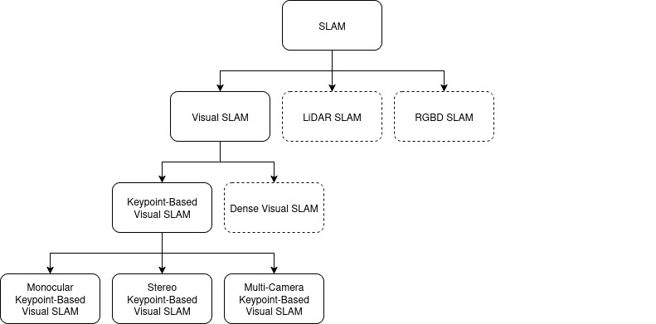
Figure 2: Overview of the relationships between popular SLAM modalities.
The first implementations of KV-SLAM appeared in the early 2000s [8][9], making the field relatively young. This can be attributed to the difficulty of estimating 3D geometries from 2D images, unlike LiDAR and RGB-D which are capable of direct 3D environmental measurements. However, due to the extremely low cost and wide availability of camera sensors, KV-SLAM has become a popular modality for robotics, AR/VR, and autonomous driving applications. This research ties into the structures and inner workings of KV-SLAM systems, so an overview of the concepts and techniques used in KV-SLAM is provided below.

2.1.1 Image Features
An image feature is the combination of a keypoint and a feature descriptor [10]. Keypoints are locations in an image designed to be invariant to lighting, scale, translation, and rotation, while descriptors are a data vector that acts as a unique fingerprint for a feature. Keypoints are located, and their descriptors generated, in a process called feature extraction.
Image features can be matched between frames using their descriptors. For many features such as SIFT [10], SURF [11], and ORB [12], the descriptor is a vector of floating-point values, calculated from pixel values surrounding the keypoint, which can be compared using a distance metric such as Euclidean distance or Hamming distance.
The purpose of feature extraction is to reduce the large input image data to a small set of easily detectable and trackable features, allowing the majority of the image data to be discarded. Figure 3 shows the output of the ORB feature extractor on two input images, and the matching features between the two images. The ability to match the same set of points across multiple viewpoints is core to how 3D map points are estimated from multiple 2D images.

2.1.2 Robust Estimation and RANSAC
Image feature matching is a noisy process, meaning the correspondences between features in different images will not always be correct. This is especially true when the environment contains repetitive patterns. To address this, robust estimation techniques are used to filter
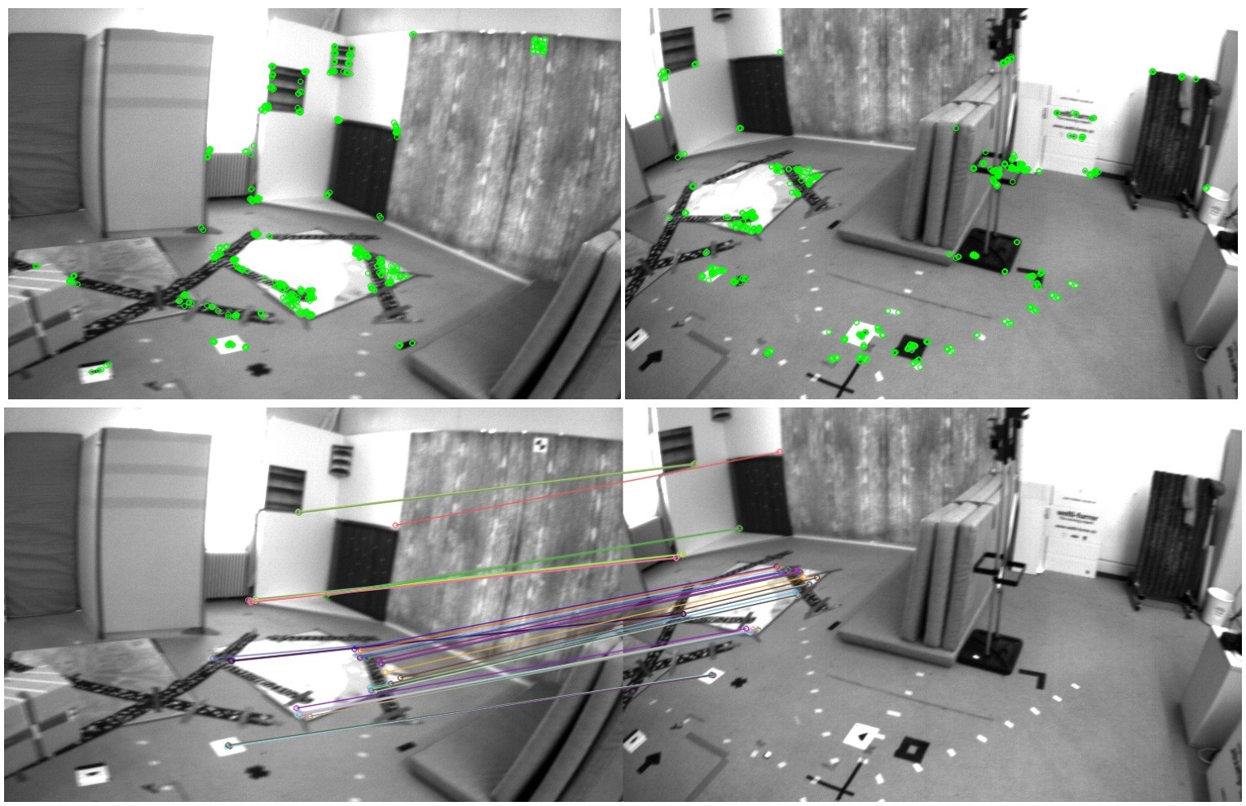
Figure 3: (Top) ORB features extracted from two frames of the EuRoC MAV V1 03 dataset [13]. (Bottom) Corresponding ORB feature matches between the two frames.
outliers from the data. In the context of KV-SLAM, the most common robust estimation technique is Random Sample Consensus (RANSAC) [14].
RANSAC is an iterative algorithm that estimates model parameters from a dataset containing outliers. It works by randomly selecting a subset of the data, fitting the model to this subset, and then counting the number of inliers that fit the model within a certain threshold. The process is repeated until a model is found that matches a sufficient number of inliers, or a maximum number of iterations is reached.
Figure 4 provides a visual representation of the RANSAC process. If one were to sample linear data with a noisy sensor that sometimes produces outliers, the output may look like the left-most plot of the figure. As can be seen, the best-fit line is severely skewed by the outliers. By iteratively selecting a random sample of the input data, fitting the model to this sample, and counting the number of inliers, RANSAC can find a solution that explains a high proportion of the observations.
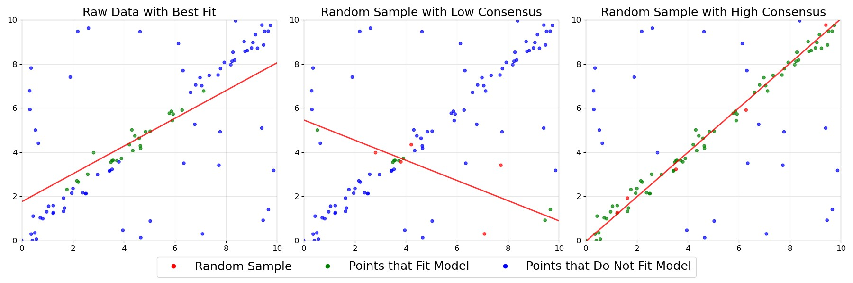
Figure 4: A demonstration of how RANSAC determines model parameters through iterative random sampling and model application.
It should be noted that RANSAC requires a low proportion of outliers in the data to be effective, as it relies on randomly selecting a set of inliers for model fitting. For that reason, preprocessing steps that reduce the number of potential outliers in sample data are useful for improving the speed and effectiveness of RANSAC.

2.1.3 Tracking and Mapping
In the context of KV-SLAM, tracking refers to the process of estimating the real-time position and orientation of the camera, while mapping refers to the process of generating a 3D map of the environment. Methods such as the eight-point algorithm can be used to simultaneously calculate the transformation and depths between two images taken from different viewpoints using their 2D-2D feature correspondences [15][16]. This is primarily used for map initialization, before any 3D map points have been established. Once a set of
3D map points has been established, tracking can be achieved using the Perspective-n-Point (PnP) algorithm [14], with mapping utilizing triangulation to generate new map points [9].
Incorrect 2D-2D and 2D-3D correspondences degrade the performance of the tracking and mapping processes. To account for outliers in the correspondences, RANSAC is used to estimate the transformations and 3D depths on a subset of the matches with the goal of finding a transformation that maximizes the number of correspondence inliers.
In the context of this research, the 2D-3D correspondences between an image and the map may contain more outliers when the map contains a significant number of outdated map points. If this conjecture is correct, an improvement in the speed and robustness of the RANSAC process should be observed after the implementation of the proposed viewpoint-based MPR method.

2.1.4 Loop Closure and Relocalization
Loop closure is a technique used to correct drift during large-scale KV-SLAM operations [17]. The process works by recognizing when the system has entered a previously visited place, usually by detecting visual similarity between this place and the current image. Due to noise inherent to the system, the current position estimate may not match the position estimate from the previous visitation. The drift error is the difference between the previous and current position estimates, and can be propagated through the historical trajectory estimations, re-aligning the two positions. Figure 5 shows how loop closure identifies a previously visited place and corrects the trajectory to remove accumulated drift.
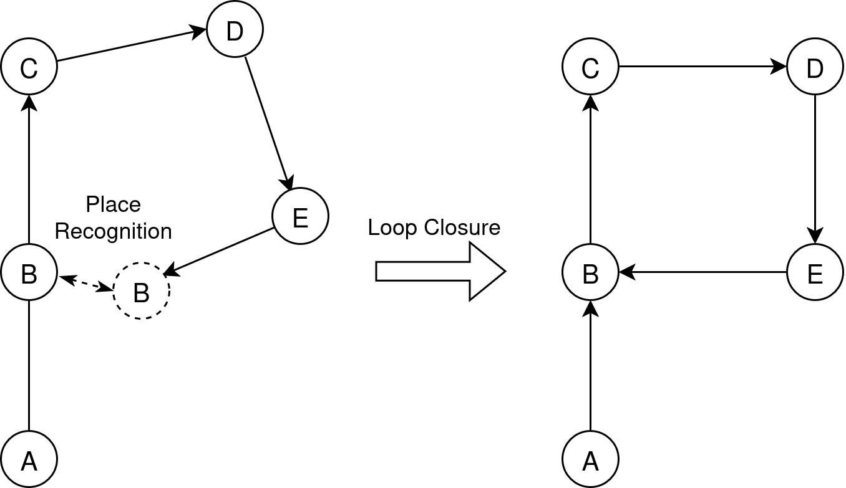
Figure 5: An example of how loop closure can correct drift by constraining the trajectory based on detected loops.
Relocalization is used when the SLAM system is ”lost,” meaning a map of the environment exists but the location of the camera within this map is unknown. This can happen for many reasons such as traversing an area with low visual texture, dim lighting, or temporary obstruction of the camera by a moving object. To recover, the SLAM system looks for positions within the map that are visually similar to the current image. If a strong candidate position is found, the system attempts to find a valid pose for the image in the map using PnP and RANSAC.
Both of these operations rely on the ability to recognize visual similarity between the current image and the map. As the image data is discarded, visual similarity must be recognized another way. In KV-SLAM systems, this is commonly accomplished using a bag-of-words model, which represents the map’s feature descriptors as a collection of visual words, allowing the system to recognize previously visited places based on the presence of these words in the current image’s feature descriptors [18].
For this research, the existence of outdated map points in the map may cause the bagof-words model to produce false positives or negatives, leading to incorrect relocalization or loop closure detections. Removing these outdated features from the map and from the bag-of-words model should improve the performance of these operations, as the system will no longer attempt to match against outdated features.

2.1.5 Map Reuse
Map reuse is core to this research, as it is what allows SLAM to operate in the episodic operating model. By loading a previously generated map into the SLAM system, the system can operate in a known coordinate frame and maintain a consistent map of the environment. In the episodic operating model, the system is expected to operate in the same environment over long periods of time. By reusing a previously generated map, updating it with new observations, and removing outdated observations, the system can maintain a map that is up-to-date with the last observed state of the world while preserving as much previously collected data as possible.

2.2 ORB-SLAM3
ORB-SLAM3 is a KV-SLAM implementation that is popular in research contexts due to its performance, open-source codebase, and use of methods and techniques that are well documented and widely understood. Figure 6 shows a simplified diagram of the internal processes of ORB-SLAM3. The system supports a variety of input modalities including monocular and stereo cameras, RGB-D cameras, and IMU data. It splits work across multiple threads, allowing it to perform tracking, mapping, loop closure, relocalization, and optimization concurrently.
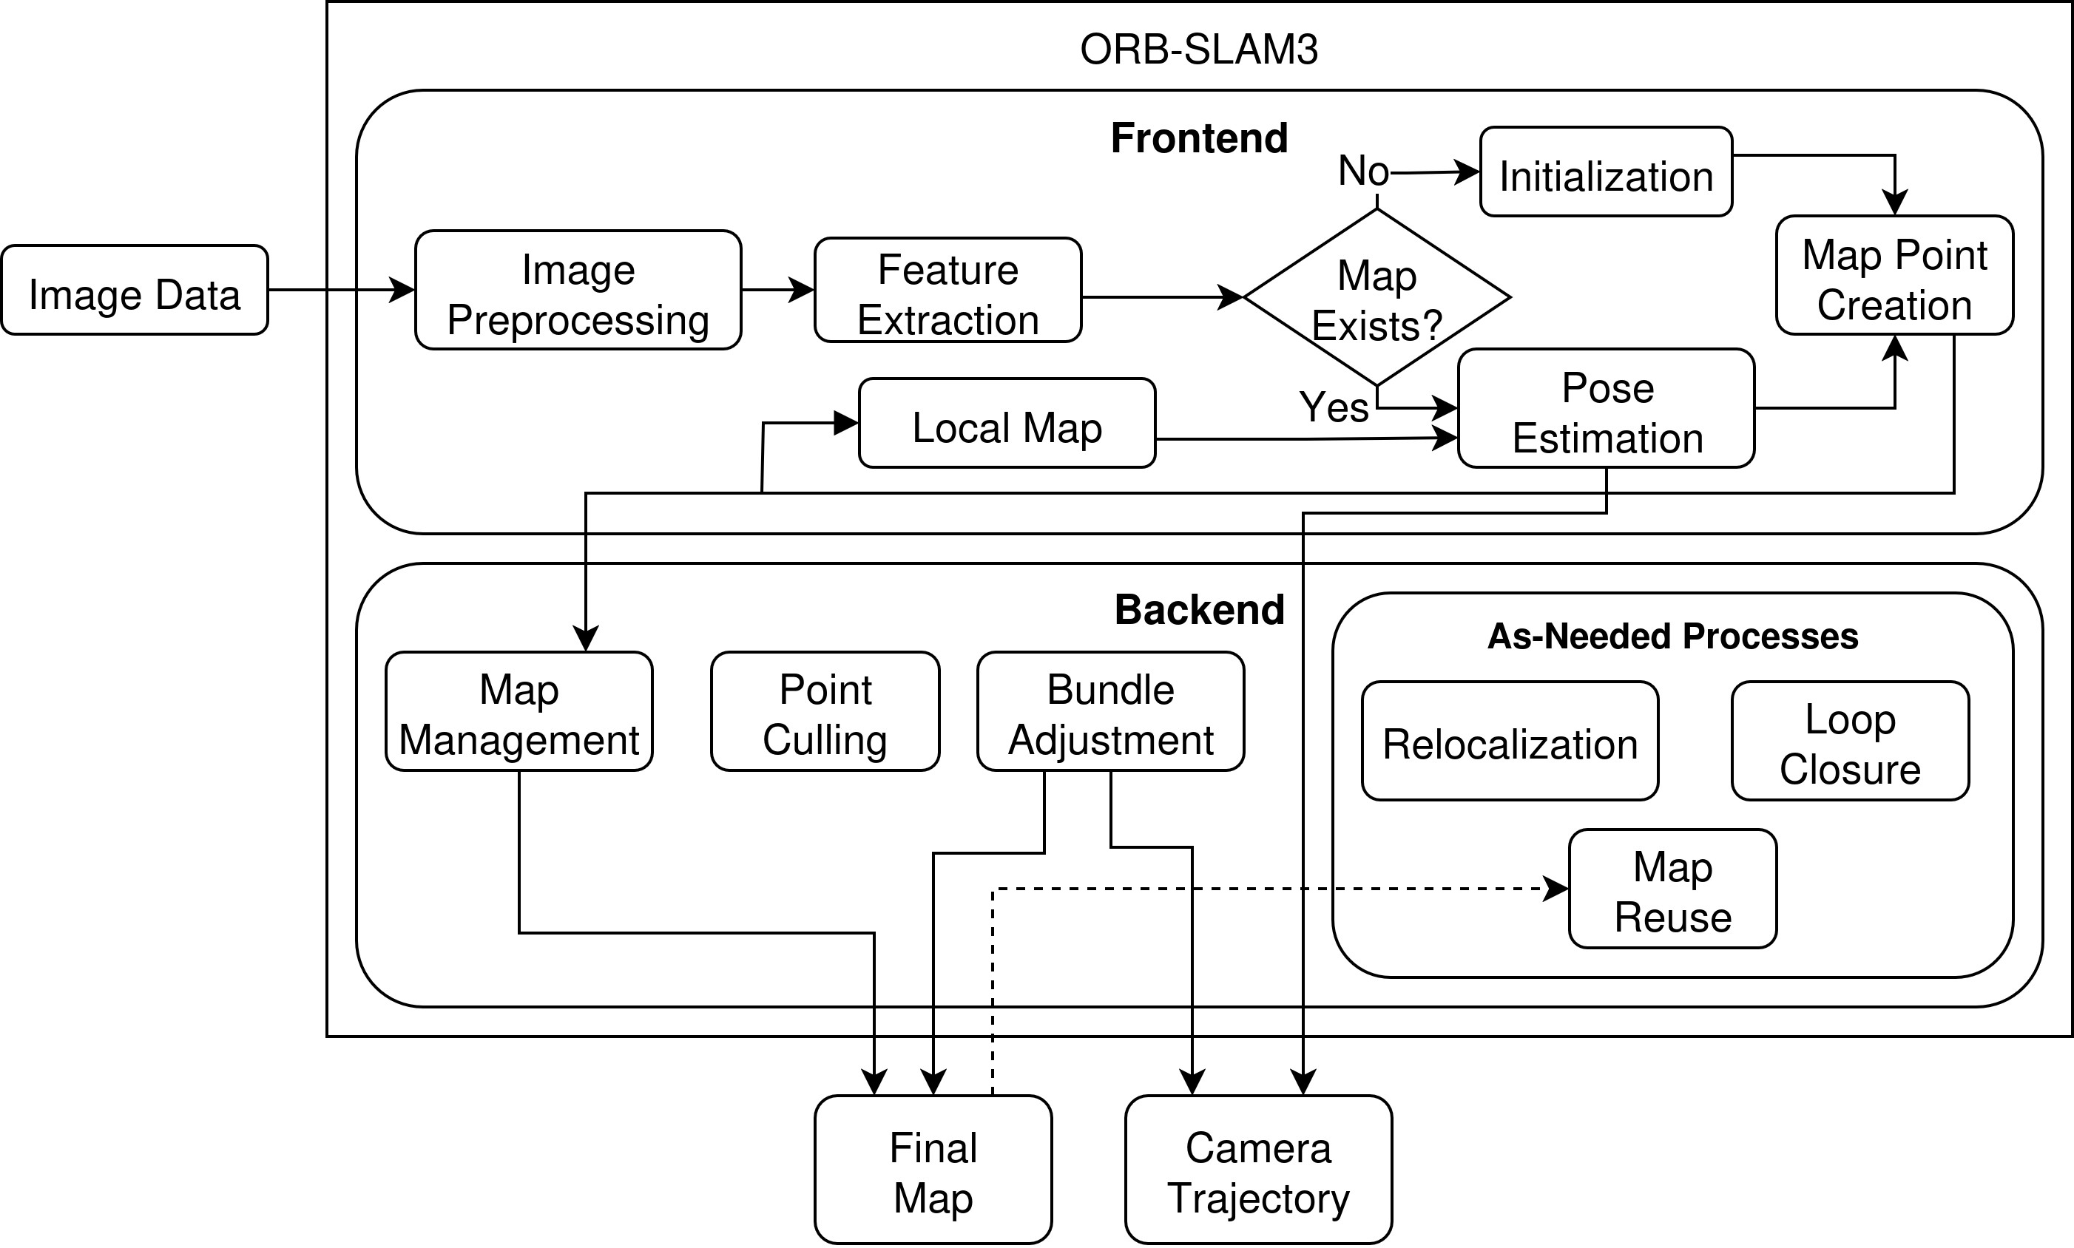
Figure 6: A simplified diagram of the inputs, outputs, and subprocesses of ORB-SLAM3.

3 Related Work
The episodic operating model which is used for this thesis falls under the umbrella of Lifelong SLAM. The term lifelong SLAM has varied definitions throughout the literature, but for simplicity, this research adopts the definition provided by Shi et al. [19], describing lifelong SLAM as the ability for a robot to generate, maintain, and localize within a map of a particular environment over an extended period of time. Unlike the standard SLAM operating model, lifelong SLAM operating models are expected to perform without the assumption of a static environment. This research falls under the topic of map maintenance, but has downstream effects on other operations related to lifelong SLAM.
Several research topics fall under lifelong SLAM, with those relevant to the work presented in this thesis discussed below. This research directly impacts the KV-SLAM map, so the downstream effects on other aspects of lifelong SLAM performance will be discussed at the end.

3.1 Place Recognition over Long Time Horizons
As previously discussed, place recognition refers to the ability to determine when an agent has entered a previously visited area. In KV-SLAM, this is commonly achieved using a bag-of-words approach over binary feature descriptors extracted from camera images [20]. However, these features can vary significantly over time due to changes in lighting, weather, scene layout, or viewpoint. Chen et al. [21] proposed using deep learning to identify features that are invariant to conditions and viewpoint, but they are still sensitive to geometric changes.
Milford et al. improved robustness to time-of-day and weather variation by matching sequences of whole-image comparisons rather than relying on a single image or feature-based matches. However, this approach requires alignment between the image sequence and the reference trajectory, effectively requiring similar speed and direction of travel. Naseer et al. [22] relaxed this constraint by computing a full probability distribution over possible locations, removing the need for trajectory alignment. Both of these approaches are sensitive to viewpoint variation, and can fail when the camera trajectory differs significantly from previously observed trajectories.
Learning-based methods like NetVLAD [23] assign global descriptors to places rather than features, increasing robustness to viewpoint, conditions, and dynamic clutter. HF-Net [24] extends this idea by utilizing global descriptors for large-scale place recognition and local learned features for refinement. The negative aspects of learning-based approaches tend to be their computational load, requiring significantly higher capability than methods that do not require a neural network.
While the methods discussed here do allow for place recognition to succeed despite significant visual and geometric changes, in general place recognition is most effective when the internal scene representation matches the true environment. To accomplish this, the system must be able to identify and correct discrepancies between the map and the current sensor readings.

3.2 Change Detection for Map Maintenance
Change detection in SLAM refers to identifying discrepancies between current sensor observations and the existing map. This functionality supports operations like relocalization and place recognition by acting as the mechanism through which outdated map data is identified so it can be updated. The implementation of change detection depends heavily on sensor modality and map representation.
Girardeau-Montaut et al. [25] implemented point cloud change detection for laser scans of industrial sites using iterative closest point (ICP) [26, 27] to align scans, with Hausdorff distance [28] used to identify areas of change. Lin et al. [29] extended this to stereo visual SLAM in their system PPCA-VINS, which detects changes between a prior point cloud and current point measurements. The method of aligning point clouds and measuring disparity is effective, but requires both point clouds to be of similar scale and density to achieve optimal alignment. Additionally, these methods do not attempt to model global point observability, meaning features that still exist could be erroneously deleted.
Many modern methods utilize a learning-based approach to align and detect changes in dissimilar data types. Larsen et al. [30]

3.3 Dynamic Rejection
Dynamic rejection is the process of identifying dynamic objects within a scene and rejecting image features that fall on them. This requires either tracking object motion to verify the object is dynamic, or performing image segmentation and semantic identification to categorize objects as either dynamic or static. It can also be accomplished without strict object identification using methods that detect movement in images (e.g., optical flow) or in point clouds.
3.4 Lifelong SLAM
La´zaro et al. [31] implemented map updates for ... Mielle et al. [32] ...
3.5 Map Point Observability
Derner et al. [33] ... Berrio et al. [34, 35] ... Alcantarilla et al. [36] ...

4 Implementation

4.1 Definitions and Functions
Future sections explore the mathematical basis and implementation of the proposed system.
To provide a common reference, useful definitions and constructs are defined here.

Definitions
d_{min} and d_{max}: The minimum and maximum distances at which a map point may be
considered visible to the camera.
v: A viewpoint in the domain v ∈ S² × [d_{min},d_{max}] → R³.
o: An observation of a map point defined as o = (v,s), where v is the viewpoint and s ∈ {0.0,1.0} indicates whether the point was seen (1.0) or not seen (0.0) from v.
O^{n}: A vector of n observations in the form {o₀,...,o_{n}}.
P(E): The probability that the map point exists.
P(S,v): The probability that the map point is visible from a given viewpoint v.
ε_{neg}: The probability of a false negative (not observing a map point when it is actually
observable).
ε_{pos}: The probability of a false positive (observing a map point when it is actually
unobservable).
α: The damping coefficient applied to updates of P(E).
ρ_{t}: The estimated overall observability of the map point at time t.
η: The damping coefficient applied to updates of ρ.
β: The feedback propagated from the Bayesian update step back to the observability model, calculated as P^{ˆ}(E)_{t} − P^{ˆ}(E)_{t−1}.
KNN: An instance of the KNN observability model, used as the initial observability model during development. The Discrete Boundary model replaced the KNN model in the final system.
EPE: An instance of the existence probability estimator.
VBEE: An instance of the viewpoint-based existence estimator, which contains both an existence probability estimator and an observability model.
θ_{KNN}: A vector of parameters specific to the observability model. This notation is retained from the initial KNN-based development for consistency with the pseudocode. In the form {θ_{KNN,1},...,θ_{KNN,n}}, where n is the number of parameters.
θ_{EPE}: A vector of parameters for the existence probability estimator in the form
{εneg,εpos}.
θ_{VBEE}: A vector of parameters for the viewpoint-based existence estimator in the form {KNN,P^{ˆ}(E)₀,α,ρ₀,η}.

Functions
VBEE.Initialize(θ_{VBEE},θ_{KNN},θ_{EPE}): Initializes the viewpoint-based existence estimator.
VBEE.Update(o): Updates the estimator with a new observation o, returning the updated existence probability Pˆ(E).
VBEE.Query(): Queries the estimator for the current estimate of the map point’s existence probability Pˆ(E).
KNN.Initialize(θ_{KNN}): Initializes the KNN model with parameters θ_{KNN}.
KNN.Estimate(v): Returns the KNN model’s estimated probability of seeing the map point from viewpoint v, given the point exists: Estimate(v) = Pˆ(S,v|E).
KNN.Integrate(o,β): Integrates a new observation o into the KNN model’s internal representation, using feedback β to adjust for the direction and magnitude of the change in existence probability.
EPE.Initialize(θ_{EPE}): Initializes the existence probability estimator with parameters
θEPE.
EPE.Update(o,P^{ˆ}(E)_{t},P^{ˆ}(S,v|E)): Updates the map point’s existence probability P^{ˆ}(E)_{t+1} based on o, the prior estimate Pˆ(E)t, and the current observability model estimate Pˆ(S,v|E).

4.2 Method Overview
To achieve the goal of estimating and refining the probability of a 3D feature’s existence. The estimation uses Bayesian methods to integrate prior knowledge of 3D positions where the feature is and is not visible and new observations of the feature to determine a new probability of the feature’s existence. Due to the focus of this research on KV-SLAM, the 3D features discussed are 3D visual map points.

4.2.1 The Observability Model
The goal of the observability model is to estimate whether a point in 3D space is visible from another point in 3D space based on previous observations. These historical observations are made up of the observer’s viewpoint, and whether the point of interest was visible from that location. In the context of KV-SLAM, these points of interest are visual landmarks
Map points are conceptualized as static, infinitesimally small points in 3D Euclidean space. Let the observability of a map point p from a viewpoint v = {θ,ϕ,d} ∈ [0,2π) × 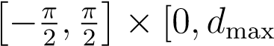) be represented by
observable_{p}(v) : V → {0,1},
which returns 1 if p is observed from v and 0 otherwise. An observation of point p is then defined as o_{p} = (v,s), where s ∈ {0,1} denotes whether the point was seen. A set of n
observations is O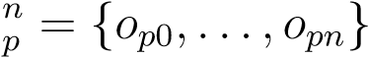.
For illustrative purposes, later figures may use a simplified 2D representation v^{2D} = {θ,d}.
Figure 7 shows an example of such a plot.
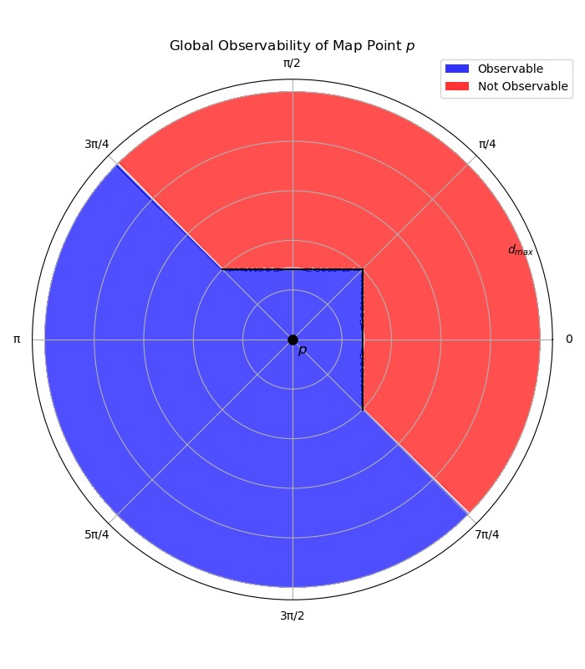
Figure 7: A 2D representation of the global observability of a map point p near two orthogonal obstructions.
Constructing the exact global observability surface would require infinite observations across the full domain of viewpoints, which is infeasible. To satisfy the constant-size requirement in section 1.3, the observability model maintains a finite, bounded representation.
The model serves two roles: 1. Estimating P(S,v|E) from a given viewpoint. 2. Integrating new observations into its internal representation.
The objective is to minimize the total error between the model estimate and the true
observability:
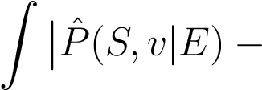 observable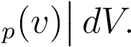

4.2.2 Existence Probability Estimator
The probability of existence P(E) is updated with each new observation using Bayesian inference. Let P(E)_{t} denote the prior probability of existence before the observation, and P(E)_{t+1} the posterior after incorporating it.
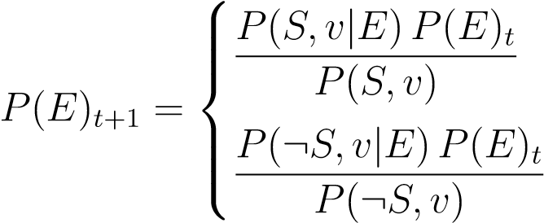
if s = 1,
if s = 0.
The marginal likelihood is
P(S,v) = P(S,v|E)P(E)_{t} + P(S,v|¬E)(1 − P(E)_{t}).
False matches are possible when the map point does not exist. Let
ε_{pos} = P(S,v|¬E) ≈ 0,
representing the false positive rate. Assuming the model provides an estimate Pˆ(S,v|E) ≡ m(v), the update simplifies to
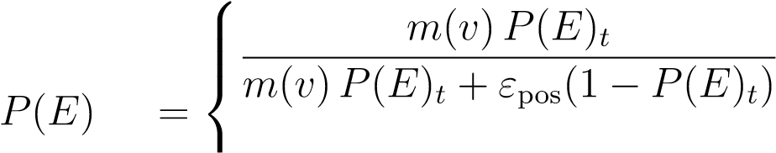 if s = 1,
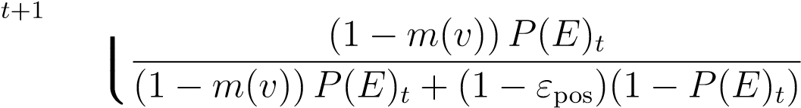 if s = 0.

4.2.3 The Existence Estimation Framework
The existence estimation framework combines an observability model with a Bayesian existence probability estimator. A high-level view is shown in Figure 8.
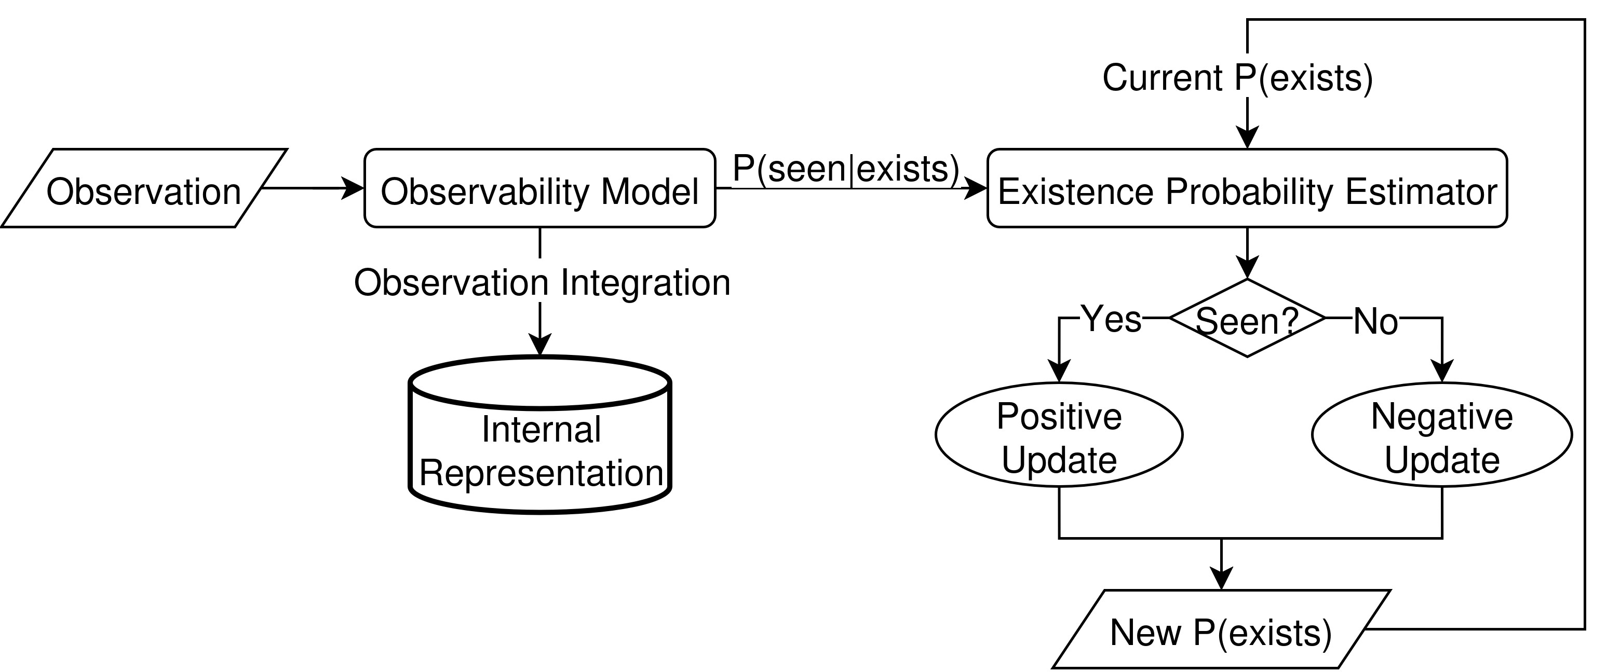
Figure 8: A flowchart representing the flow of data through the proposed existence estimation framework.
The observability model estimates P(S,v|E), the probability of observing a map point from viewpoint v given that the point exists, using historical observations. This estimate is then used by the existence probability estimator to update the existence probability P(E) of the map point in a Bayesian manner. After the update, the new observation o is integrated into the model’s internal representation, with feedback β from the existence probability update used to adjust the strength of integration.

4.2.4 Overall Observability
The update above is overly sensitive in cases where a map point has historically been highly observable. For instance, if m(v) = 1, then a single negative observation (s = 0) would drive P(E)_{t+1} close to zero. To reduce this sensitivity, a damping coefficient α ∈ [0,1] is applied:
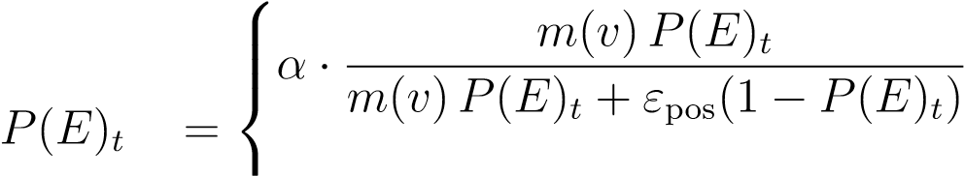 if s = 1,
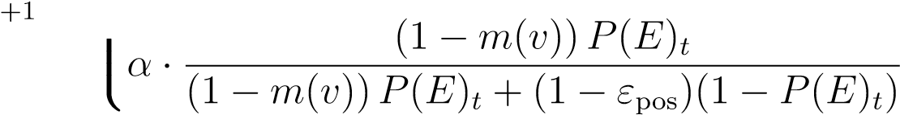 if s = 0.
To further improve robustness, the model incorporates an overall observability parameter ρ, defined as the proportion of viewpoints from which the point has historically been observable.
This is adaptively updated using
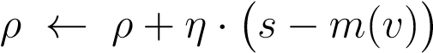,
where η controls the adaptation rate. In effect, ρ moderates the influence of each observation, ensuring that negative evidence in highly observable regions has more weight than in rarely observable ones.

4.3 System Implementation
This section describes the implementation of the existence estimation framework described in section 4.2. Implementation details of the observability models, the Bayesian updater, and the Viewpoint-Based Existence Estimator library are provided. Pseudocode implementations of key functions are included to illustrate the implementation details of the framework.

4.3.1 Existence Estimation Framework Implementation
The viewpoint-based existence estimation framework is implemented as a C++ library called libvbee. This library facilitates the integration of VBEE into KV-SLAM systems, providing observability estimation and existence probability estimation. The library provides the VBEE class, which configures the observability model and provides functions for updating and querying the existence probability of a map point. Pseudocode for the initialization, update, and query functions is provided below.
The initialization function in Algorithm 1 sets up the VBEE instance with the specified parameters, initializing the observability model and the existence probability estimator.

Algorithm 1 VBEE Initialization: VBEE.Initialize(θ_{VBEE},θ_{KNN},θ_{EPE})

Require: θ_{VBEE}: VBEE Parameters
Require: θ_{KNN}: KNN Parameters
Require: θ_{EPE}: Existence Probability Estimator Parameters global p e,α,ρ,η ← θ_{VBEE} global knn ← KNN.Initialize(θ_{KNN}) global epe ← EPE.Initialize(θ_{EPE})

The update function in Algorithm 2 integrates a new observation, determining an updated existence probability based on the observation and the observability model estimate. The observability model is updated with feedback, and the overall observability is updated based on the difference between the observation’s state and the model estimate.

Algorithm 2 VBEE Update: VBEE.Update(o)

Require: o: New Observation
Ensure: Pˆ(E): Updated Existence Probability
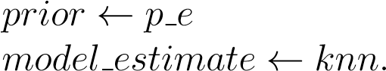Estimate(o.v)
posterior ← epe.Update(o,prior,model estimate)
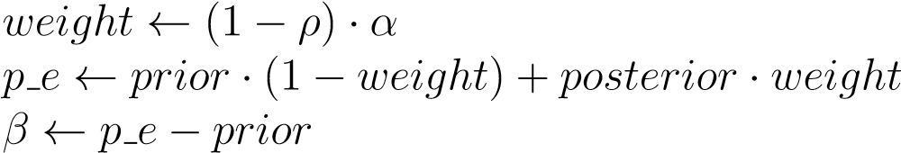
knn.Update(o,β)
ρ ← ρ + η · (o.s − model estimate) return p e

The query function simply returns the current existence probability P(E).

4.3.2 Observability Models
Two methods were explored for modeling observability. An initial K-Nearest Neighbors approach was developed as a baseline, estimating observability from a representative set of previous observations. The limitations of this approach motivated the development of the Discrete Boundary model, which exploits the geometric structure of visibility to estimate the boundary in all directions from which the map point transitions from visible to obscured. The Discrete Boundary model is the primary observability model used in the final system.

KNN Model
The KNN model was the first observability model explored in this research. While it was ultimately replaced by the Discrete Boundary model, its development informed several design decisions carried forward into the final system. The KNN model was the first observability model explored in this research. While it was ultimately replaced by the Discrete Boundary model, its development informed several design decisions carried forward into the final system. The KNN model estimates P(S,v|E) as the ratio of positive observations within the k nearest neighbors of the query viewpoint. The model maintains a finite buffer of n observations. The angular distance between viewpoints is also considered, as distant observations may be irrelevant. Finally, the model incorporates feedback from the existence probability estimator to decide whether or not to integrate a new observation.
The parameter vector is:
θKNN = {k,n,τangle,τβ}
where k is the number of neighbors to consider, n is the maximum number of stored observations, τ_{angle} is the maximum angular distance for neighbors, and τ_{β} is the minimum feedback magnitude required for integration.
The estimation function is shown in Algorithm 3, returning the ratio of positive neighbors, or 0.5 if no neighbors are found.

Algorithm 3 KNN Estimate(v)

Require: O_{prev}: Stored observations
Require: k, τ_{angle}: KNN parameters
Ensure: Pˆ(S,v|E): Estimated probability of observation function Estimate()(v) candidates ← [ ] for all o ∈ O_{prev} do if ∆θ(o.v,v) < τ_{angle} then add o to candidates

end if
end for sort candidates by distance to v neighbors ← first min(k,length(candidates)) if neighbors is empty then return 0.5
end if seen count ← sum of o.s in neighbors return seen count/length(neighbors)
endfunction
The update function (Algorithm 4) integrates new observations. If the buffer is not full, the observation is added. If the feedback magnitude is below τ_{β}, the observation is ignored.
Otherwise, the observation replaces the nearest inconsistent stored observation.
Algorithm 4 KNN Update(o,β)

Require: O_{prev}: Stored observations
Require: n, τ_{β}: Parameters function Update()(o,β) if length(O_{prev}) < n then add o return

end if if |β| < τ_{β} then return end if if o.s = 1 then
replace nearest not-seen observation with o
else replace nearest seen observation with o

end if end function

The accuracy and performance of the KNN model are evaluated in section ??. As discussed there, the KNN model exhibited poor predictive performance, motivating the development of the Discrete Boundary model described below.

Discrete Boundary Model
The KNN model is simple to implement and use, but its treatment of observations as interchangeable samples ignores the geometric structure of visibility. If a map point can be observed from a distance d, then it is guaranteed that it can be observed from a distance ¡ d along the same vector. The Discrete Boundary Model establishes a set of ”bins” surrounding the map point, each tied to a unique direction vector. Each bin stores the radial distance to the furthest positive observation, and the closest negative observation. For each query, the bin whose direction vector is nearest to the queried viewpoint’s direction vector is selected. If a query falls within the confirmed visible region of a bin, it is scored with P(S,v|E) = 1. If it falls beyond the maximum observed distance, it is scored with P(S,v|E) = 0. If the query falls within an ambiguous region where the maximum observed distance exceeds the minimum non-observed distance, the score is determined by a per-bin ambiguous counter, described below.
For simplicity, this implementation uses 20 bins, with direction vectors corresponding to the centroids of each face of an icosahedron with a virtex in the +Z direction and a face in the +X direction. This provides a consistent tiling of the sphere, so each bin covers equal angular area.
Integrating a new observation into this model first requires the selection of the appropriate bin. This can be done by identifying the direction vector with the lowest cosine angle to the vector from the map point to the viewpoint. If the observation is positive and the distance is further than that bin’s current max observation distance, the max observation distance is updated to the distance between the observation and the map point. Similarly, if the observation is negative and the distance is closer than the current min non-observation distance, the bin is again updated. Bins are initialized to have 0 max observation distance and infinite minimum non-observation distance.
Because the domain of viewpoints is downsampled into a finite number of bins, it is possible for negative observations to occur at distances closer than the maximum positive distance due to environmental geometry. If a negative observation occurs at a distance less than the maximum positive distance, an ambiguous region is created. Each bin maintains an integer ambiguous counter initialized to k (a neutral midpoint) in the range [0, 2k]. When an observation falls within the ambiguous region, the counter is incremented for positive observations and decremented for negative observations. The counter is then mapped to the range [0.5 - ambiguous_range/2, 0.5 + ambiguous_range/2] to produce a P(S,v|E) estimate for queries in the ambiguous region.
Querying this model is done first by identifying the bin for the given viewpoint. If the query distance is within the bin's maximum observed distance, two sub-cases are evaluated: if the distance is also less than the minimum non-observed distance, the query returns 1.0; otherwise, the query falls in the ambiguous region, and the mapped ambiguous counter value is returned. If the query distance exceeds the maximum observed distance, the query returns 0.0.

4.3.3 Existence Probability Estimator
The Existence Probability Estimator (EPE) updates the probability P(E) of a map point’s existence. It is initialized with θ_{EPE} = {ε_{neg},ε_{pos}}. The update function takes an observation, the prior P(E)t, and the observability model estimate Pˆ(S,v|E) as inputs, and computes the posterior
P(E)_{t+1} with a Bayesian update. Algorithm 5 shows the implementation.
Algorithm 5 Bayesian Update Step

Require: Observation o = (v,s)
Require: Prior P^{ˆ}(E)_{t} ∈ [0,1]
Require: Model estimate Pˆ(S,v|E) if o.s = 1 then
Pˆ S,v E ε Pˆ E

else
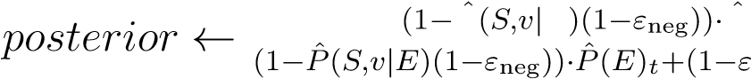
P E P(E)_{t}
pos)(1−P^{ˆ}(E)_{t})

end if return posterior

4.4 Dataset Creation
Two datasets were created to test the isolated performance of the VBEE library, and the integrated performance of VBEE with ORB-SLAM3 respectively The first dataset referred to as the Observability Scenarios Dataset, consists of a set of points, each with their own unique observability properties. These points can be queried to determine if a point can be seen from a given viewpoint, allowing the full VBEE pipeline to be exercised without a SLAM implementation. The second dataset known as the Episodic Visual SLAM Dataset is a stereo visual SLAM dataset in the style of the EuRoC MAV SLAM dataset, but with extensions for episodic operation. This section details the construction and intention behind these datasets.

4.5 Observability Scenarios Dataset
The observability scenarios dataset is intended to represent the domain of observability scenarios which may apply to map points seen during SLAM operations. A map point’s observability can be represented as the union of three sets of viewpoints: Viewpoints from which the map point is visible, viewpoints from which the map point is not visible (obstructed), and viewpoints which are inaccessible to the observer (e.g. under a floor or inside a wall). These three sets cover the domain of viewpoints for a map point and represent the unique observability scenario for that map point.
For the creation of the observability scenarios dataset, rather than classifying specific viewpoints into specific sets, the proportional sizes of these sets are defined, and a generative process is used to create a scenario matching these proportional sizes. The process of generating an observability scenario for a desired parameterization is shown in Algorithm 6. This algorithm randomly generates inaccessible and obstructed areas around a central point, then samples random viewpoints to estimate the relative proportions of each set. If the proportional set sizes match the desired proportions within a defined tolerance, the observability scenario is returned. Otherwise, the number of inaccessible and obstructed areas are adjusted and regenerated until a valid solution is found.

Algorithm 6 GenerateObservabilityScenario

function GenerateObservabilityScenario end function

The final dataset consists of observability scenarios generated for all pairings of 5% inaccessible to 95% inaccessible and 5% obstructed to 95% obstructed in 5% increments, giving a total of 361 unique observability scenarios. A subset of cutaways from the dataset is shown in Figure 9.
Figure 9: 2D cutaways of examples from the Observability Scenarios Dataset
4.5.1 Static Episodic Visual SLAM Dataset

4.5.2 Changing Episodic Visual SLAM Datasets
To evaluate VBEE performance in a real-world SLAM system, a stereo visual dataset was created consisting of a series of trajectories through a household environment. No dynamic changes occur during the recording of a single trajectory, but environmental changes are introduced between trajectories, matching the episodic run modality described in section 2.
Figure 10 shows example images from each trajectory at roughly the same location.
Figure 10: Example images from each trajectory of the episodic visual SLAM dataset
This dataset is intended to replicate realistic episodic SLAM operation in a household environment. Ground truth is difficult to obtain in large-scale 3D environments, so evaluation focuses on the SLAM system’s ability to maintain a consistent map across multiple trajectories. LibVBEE is integrated into ORB-SLAM3, and performance is evaluated by measuring its ability to identify and remove outdated map points while preserving map consistency across episodes.

4.6 ORB-SLAM3 Integration
This section covers the integration of libVBEE into ORB-SLAM3. As discussed in section 2.2, ORB-SLAM3 was selected due to its wide adoption, high performance, and inclusion of several SLAM extensions which can benefit from outdated map point culling.
The original intention was to perform VBEE operations on every image frame in real-time as it passed through the SLAM system. However, these operations are time-consuming and computationally expensive, which led to a reduction in frame throughput and localization accuracy. Instead, the decision was made to operate on keyframes rather than frames, and to move the VBEE operations to the ends of episodic runs, acting as a post-processing step rather than a real-time update.

4.6.1 Map Point
The Map Point class is modified to include a VBEE instance, allowing for observability based existence estimation on a per-map point basis. The Map Point class includes a merge method which is called when the SLAM system’s optimization operations identify that two map points likely represent the same visual feature. This method is modified to call the VBEE merge method to combine the VBEE instances of the two map points.

4.6.2 VBEE Post-Processing Operations
Run ends are determined by matching the current frame’s timestamp to a timestamp in the splits file provided by the episodic datasets. Figure ?? shows the pipeline of VBEE operations which take place at the ends of runs.
At the end of the run, several iterations of Global Bundle Adjustment are performed to minimize the global error of the map. This operation repositions keyframes and merges map points, which give the VBEE operations the greatest chance of success. Each keyframe from the most recent run is then processed in order of collection. For each keyframe, two groups of map points are generated: positive observations and negative observations. Positive observations are map points that the SLAM system observed within the keyframe, while negative observations are map points that could be projected onto the camera’s sensor based on the keyframe’s pose, but were not observed within the keyframe. For each positively observed map point, an update is submitted to its VBEE instance with a viewpoint of the keyframe’s position, and a seen status of 1. Similarly, for each negatively observed map point, an update is submitted with a seen status of 0.
After all new keyframes have been processed, map point culling begins. For each map point in the map, if its probability of existence is found to be less than the P(E) threshold, the map point is marked bad. Once marked bad, ORB-SLAM3 will perform the necessary operations to remove the map point from the map, and clean up any pointers to its instance.

4.6.3 RANSAC Integration
RANSAC is used for relocalization and loop closing in ORB-SLAM3. The base implementation selects map points with a uniform probability of selection. The integration of VBEE into the system allows the selection to instead be weighted by the map point’s probability of being seen P(S) from the given viewpoint. The conjecture is that by weighting for selection of map points with a high likelihood of being seen, the number of iterations required to fit a model to the data will be minimized.
For each map point, P(S) is calculated as follows:
P(S) = P(S|E)P(E) + P(S|¬E)P(¬E)
where P(S|E) is the observability model’s estimate from the current position, and P(S|¬E) is the false positive rate parameter. A selection is made from the pool of map points, with each map point’s probability of selection proportional to its probability of being seen. Instrumentation is added to the loop closing and relocalization methods to count the number of iterations the RANSAC process takes to find a solution.

4.7 Parameter Optimization
Before experimentation can take place on the SLAM system, the parameters of libVBEE must be tuned to optimize performance. Parameters are split between the VBEE framework and the observability model. The VBEE and model parameters are tightly coupled through feedback, making optimization difficult as the parameters of one system affect the other. As a solution, parameter optimization is performed in three phases. The first phase freezes the
VBEE parameters to reasonable values while optimizing the observability model parameters.
The second phase freezes the observability model parameters to the values obtained in Phase
1 while optimizing the VBEE parameters. The final phase fine-tunes both parameter sets simultaneously, ideally achieving stable performance for the system.

Phase 1 - Observability Model Tuning
The parameter tuning procedure described in this section was initially developed using the KNN observability model, and the notation θKNN is retained for consistency with the pseudocode. The insights gained from this tuning process informed the design and parameterization of the Discrete Boundary model used in the final system. The parameter tuning procedure described in this section was initially developed using the KNN observability model, and the notation θKNN is retained for consistency with the pseudocode. The insights gained from this tuning process informed the design and parameterization of the Discrete Boundary model used in the final system. The observability model has parameters θ_{KNN} = {k,n,τ_{angle},τ_{β}}, which are tuned to minimize the following objectives:
- n_{converge}: The number of observations necessary for the VBEE system to converge to a stable estimate of P(E)
- ϵ_{converge}: The observability model’s error after n_{converge} observations
- n_{adapt}: The number of observations necessary for the system to re-converge to a stable estimate of P(E) after changing the point’s observability
- ϵ_{adapt}: The observability model’s error after n_{adapt} observations
- t_{update}: The average time in ms needed to perform one estimation and one update
- size: The total storage in bytes needed to serialize one map point’s observability
In this first phase, the VBEE and EPE parameters are locked to the following values:
^{θ∗}_{VBEE} = {P^{ˆ}(E)₀ = 0.9,α = 0.1,ρ₀ = 0.5,η = 0.5}
The observability model parameters are optimized to minimize the objectives using the objective functions described below.
The function ObjectiveNConverge shown in Algorithm 7 determines the average number of observations needed for the system to converge to a stable Pˆ(E) for each observability scenario in the dataset. The system is considered converged when the standard deviation over the last w = 100 samples drops below σ_{converge} = 0.2. If the system does not converge within m_{max} = 1000 observations, the test is considered failed, and the optimization is penalized accordingly.

Algorithm 7 ObjectiveNConverge
Require: vbee: VBEE instance initialized with
Require: observability scenarios
1: function ObjectiveNConverge
2: all n convergences ← [ ]
3: for os in observability scenarios do
4: reset vbee
5: window ← Queue()
6: n converge ← −1
7: for i = 0 to m_{max} do
8: v ← random viewpoint
9: new Pˆ(E) ← VBEE.Update(o = (v,os.Query()(v)))
10: push new P^{ˆ}(E) onto window
11: if window size > w then
12: pop window
13: if std dev(window) < σ_{converge} then
14: n converge ← i
15: break

16: end if 17: end if 18: end for
19: if n converge = −1 then
20: | append 2 ∗ m_{max} to all n convergences
21: | else
22: | append i to all n convergences
23: | end if
24: | end for
25: return average all n convergences
26:
endfunction
The function ObjectiveEConverge shown in Algorithm 8 determines the average error between the observability model and the observability scenario after the system has converged across all observability scenarios. Model error is calculated as the sum of differences between
VBEE.Query() and the true observability from the dataset over j = 1000 random viewpoints. Once again, if the system does not converge to a stable probability estimate, the system is penalized.
Algorithm 8 ObjectiveEConverge
Require: vbee: VBEE instance initialized with
Require: observability scenarios function ObjectiveEConverge all e convergences ← [ ] for os in observability scenarios do reset vbee error ← 0 window ← Queue() for m_{max} times do
[Same as Algorithm 7, lines 8-13] if window size > w then pop window
if std dev(window) < σ_{converge} then for j times do v ← random viewpoint
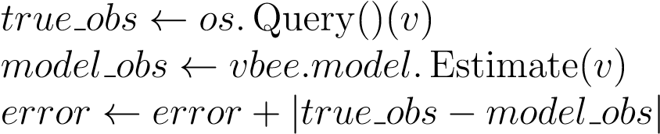

end for break end if end if
end for if error = 0 then append 1000 to all e convergences else append error to all e convergences

end if end for
return average all e convergences
endfunction
The functions ObjectiveNAdapt and ObjectiveEAdapt are implemented similarly but perform two convergence loops per scenario. Between the loops, the active scenario is replaced with a predetermined partner scenario selected to be significantly different from the original but with some observability overlap.
The function ObjectiveTUpdate, shown in Algorithm 9, determines the average time to perform VBEE.Update() for 1000 random observations, averaged for every scenario.
Algorithm 9 ObjectiveTUpdate
Require: vbee: VBEE instance initialized with
Require: observability scenarios function ObjectiveTUpdate all t updates ← [ ] for os in observability scenarios do reset vbee avg t update ← 0 for 1000 times do v ← random viewpoint t₀ ← current time in ms new Pˆ(E) ← VBEE.Update(o = (v,os.Query()(v)))
t₁ ← current time in ms avg t update ← avg t update + (t₁ − t₀)
end for append (avg t update/1000) to all t updates

end for
return average all t updates
endfunction
The function ObjectiveSize calculates the total size in bytes necessary to store all information required to reconstruct a serialized map point VBEE system in the same state as when it was serialized. This reconstruction requires:
- All parameter vectors θ_{VBEE},θ_{KNN},θ_{EPE}
- The current estimated existence probability Pˆ(E)
- The current observability ρ
- The list of observations from the observability model
The only item in this list with a size dependent on the parameter vectors is the observations list, which has a maximum capacity of n, provided in θ_{KNN}. All other sizes are not dependent on the input parameters. The serialization of an observation requires three floating-point values for the x, y, and z coordinates in the map point’s frame, and a boolean value for whether the observation is positive or negative. If a float is assumed to be four bytes in size and the boolean one byte, then ObjectiveSize can be implemented to simply return 5 ∗ n.
The final multi-objective function is shown in Algorithm 10. This function returns an

objective vector of six values, each related to one of the performance criteria defined previously. At this stage, the system is able to undergo multi-objective optimization to find values that minimize each of the six objectives.

Algorithm 10 Observability Model Objective Function

Require: ^{θ∗}_{VBEE},^{θ∗}_{EPE}: Static VBEE and EPE parameters function ObjectiveObservabilityModel(θ_{KNN}) vbee ← VBEE.Initialize(θ∗_{VBEE},θ_{KNN},θ∗_{EPE}) n_{converge} ← ObjectiveNConverge() reset vbee ϵ_{converge} ← ObjectiveEConverge() reset vbee n_{adapt} ← ObjectiveNAdapt() reset vbee ϵ_{adapt} ← ObjectiveEAdapt() reset vbee t_{update} ← ObjectiveTUpdate()
reset vbee size ← ObjectiveSize()
return (nconverge,ϵconverge,nadapt,ϵadapt,tupdate,size)

end function

The Python library Optuna [37] was selected to perform the multi-objective optimization of the system’s parameters. Optuna is a hyperparameter optimization framework that allows for the discovery of Pareto optimal [38] parameter sets.

Phase 2 - VBEE and EPE Tuning
In the second phase, the observability model parameters are frozen to the values obtained in Phase 1, and the VBEE and EPE parameters are tuned. The VBEE parameters θ_{VBEE} = {P^{ˆ}(E)₀,α,ρ₀,η} are tuned to minimize the same objectives as in Phase 1, while the EPE parameters θ_{EPE} = {ε_{neg},ε_{pos}} are tuned to minimize the following objectives:

4.8 Experimental Setup
This section describes the experiments conducted to evaluate the performance of the observability model and to determine the impact of libVBEE on SLAM systems. These experiments are defined here, and the results are presented in section ??.

Experiment 1: Observability Model Prediction Quality
The goal of this experiment is to determine whether the VBEE observability model can estimate the probability of map point visibility from a given viewpoint (assuming the map point still exists) based on historic observations, beyond what can be explained by viewpointagnostic prevalence statistics.
The experimental procedure begins by generating 200 random observability scenarios, which are distributed randomly throughout a 3D space to act as map points. The system is “trained” by selecting 10,000 random viewpoints. For each of these viewpoints, each map point is labeled as visible or not visible depending on whether the map point can be seen from the viewpoint based on the observability rules defined in Section 4.5. Additionally, each map point’s VBEE instance is updated with either a positive or a negative observation for each training viewpoint. From this training process, two prevalence-based priors are calculated: point prevalence and global prevalence. These are the ratios of positive to total observations on a per-point basis and across all map points respectively.
Two control models are used in this test. The first control model always returns the global prevalence, while the second control model always returns the point prevalence. The global prevalence model captures the average likelihood that a map point is visible, independent of viewpoint. The point prevalence model captures the average likelihood that a specific map point is visible, independent of viewpoint.
Following training, evaluation begins using a new set of 10,000 random viewpoints disjoint from those used for training. For each of these viewpoints, a ground truth value indicating whether each map point is visible is generated, along with a predicted visibility probability provided by each model. The VBEE observability model and prevalence scores are not updated. Instead, estimates are provided based strictly on the observations collected during training.
The Brier score was selected as the evaluation metric for comparisons between models. It measures mean squared error between predicted visibility probabilities and the binary visibility ground truth, penalizing confident, incorrect predictions more strongly than uncertain predictions. The Brier score for each model is calculated against the ground truth values, resulting in the following metrics:
- Brier_{gp} - Brier score for the global prevalence model
- Brier_{pp} - Brier score for the point prevalence model
- Brier_{vbee} - Brier score for the VBEE observability model
This experiment is run over 10 independent trials. For each trial, a new random seed is selected, and observability scenarios and viewpoints are regenerated. The resultant data from this experiment is shown in Section ??.
Experiment 2: VBEE Integrated SLAM Performance with Static Episodic Oper-

ations
The goal of this experiment is to quantify the effect that VBEE integration has on KV-SLAM tracking performance under static episodic operations.
Two configurations of ORB-SLAM3 are used: the control configuration with changes made only to support episodic operations and increased keyframe generation rate, and the VBEE integrated configuration discussed in Section 4.6. These systems are run on the static All Machine Halls dataset discussed in Section 4.4.
Each system is run using the EuRoC calibration provided by the ORB-SLAM3 repository which contains camera calibrations and SLAM system parameters which have been selected experimentally [39]. The VBEE integrated system is run with the optimized parameters selected in Section 4.7.
Two trajectory files are produced containing the frame trajectory and the keyframe trajectory respectively. The difference between these trajectories is discussed in Section 2.2, but put simply, the frame trajectory contains real-time, unoptimized pose estimates while the keyframe trajectory contains the final estimated poses of the keyframes after optimization. For each of these trajectories, the trajectory analysis tool evo is used to produce absolute and relative pose error statistics relative to the All Machine Halls ground truth. While evo returns several statistics for APE and RPE, the RMSE is selected as the primary measurement of trajectory error for comparison. Additional metrics are collected from the instrumentation added to ORB-SLAM3, resulting in the following being reported for each test:
- APE_{KF}^{RMSE} - APE RMSE for the keyframe trajectory • APE_{Frame}^{RMSE} - APE RMSE for the frame trajectory
- RPE_{KF}^{RMSE} - RPE RMSE for the keyframe trajectory
- RPE_{Frame}^{RMSE} - RPE RMSE for the frame trajectory
- n_{ve} - The number of VBEE eliminated points at the end of the test (0 for no VBEE
integration)
- p_{lf} - The percentage of frames where the tracking system is “lost”
- n_{r} - The number of successful relocalizations performed during the test
- n_{lc} - The number of successful loop closures performed during the test
Ten trials are performed for each system, with a different random seed for each trial.

Experiment 3: VBEE Integrated SLAM Performance with Changing Episodic Operations
The goal of this experiment is to evaluate whether VBEE integration improves tracking robustness and accuracy relative to the control system when previously observed map points become outdated, as is the case in changing episodic operations.
This experiment has a construction identical to Experiment 2 in terms of system configuration, parameters, and evaluation procedure, but is run on the changing All Days dataset described in Section 4.4, and evaluated against that dataset’s ground truth. The same metrics are reported as in Experiment 2:
- APEKFRMSE
- APE_{Frame}RMSE
- RPEKFRMSE
- RPE_{Frame}RMSE
- n_{ve}
- p_{lf}
- n_{r}
- n_{lc}
Ten trials are performed for each system with a different random seed for each trial.
Experiment 4: VBEE + RANSAC SLAM Performance with Changing Episodic

Operations
This experiment evaluates the extent to which VBEE integration combined with RANSAC weighting affects tracking robustness and accuracy relative to the control system and the unweighted VBEE integrated system under changing episodic conditions.
The configuration of the control and VBEE integrated systems are identical to Experiment
3, and because each trial is independent, the results for the control and VBEE integrated systems are reused, while the VBEE + RANSAC system is evaluated in new trials. The VBEE + RANSAC system is configured similarly to the VBEE integrated system from Experiment 3, but with RANSAC weighting enabled as discussed in Section ??. A new metric n_{ri} is added, representing the average number of RANSAC iterations needed to find sufficient inliers per successful RANSAC run. The metrics reported for each test are:
- APEKFRMSE
- APE_{Frame}RMSE
- RPEKFRMSE
- RPE_{Frame}RMSE
- n_{ve}
- p_{lf}
- n_{r}
- n_{lc}
- n_{ri}
Ten trials are performed on the VBEE + RANSAC system with a different random seed
for each trial.

5 Results

Experiment 1: Observability Model Prediction Quality
Table 1 shows the resultant Brier scores for each observability model split by trial. The mean and standard deviation are calculated across trials by model, and are shown in Table 2.
The mean difference between the VBEE observability model Brier scores and each baseline Brier score is shown in Table 3. Additionally, this table contains a 95% confidence interval computed using a paired t-distribution over the 10 trials, and a count of the number of trials in which the VBEE observability model “wins” against a baseline by achieving a lower Brier
score.
The same observability scenarios, training viewpoints and evaluation viewpoints are shared between models in the same trial. Therefore, the Brier scores are considered paired with a trial, giving the following formula for the mean difference between the VBEE observability model and a baseline b as
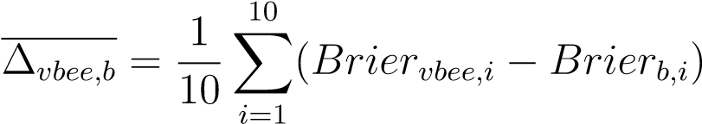
where Brier_{m,i} represents the Brier score for model m in trial i.
Trial | Brier_{gp} | Brier_{pp} | Brier_{vbee}
 |  | 
Table 1: Brier scores for three observability models across 10 independent trials
Model m | Brier_{m} | Std. Dev.
 | 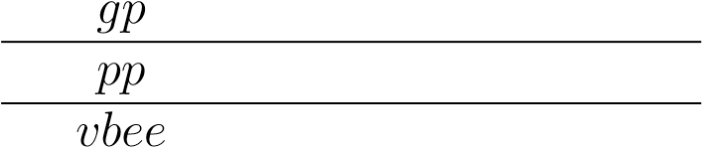
Table 2: Brier score averages and standard deviations by model
Baseline b | ∆vbee,b | 95% CI | Wins (out of 10)
Table 3: Pairwise comparisons of VBEE observability model Brier scores to baseline Brier scores

5.1 Experiment 2: VBEE Integrated SLAM Performance with Static Episodic Operations
Tables 4 and 5 show the resulting metrics collected for each of the 10 trials of Experiment 2 by the baseline SLAM system and the VBEE integrated SLAM system respectively.
Table 6 shows the per-metric means and standard deviations for the baseline and VBEE integrated SLAM systems, and compares the metrics between the two systems.
Trial | APEKFRMSE | APEFrameRMSE | RPEKFRMSE | RPEFrameRMSE | n_{ve} | p_{lf} | n_{r} | n_{lc}
 |  |  | 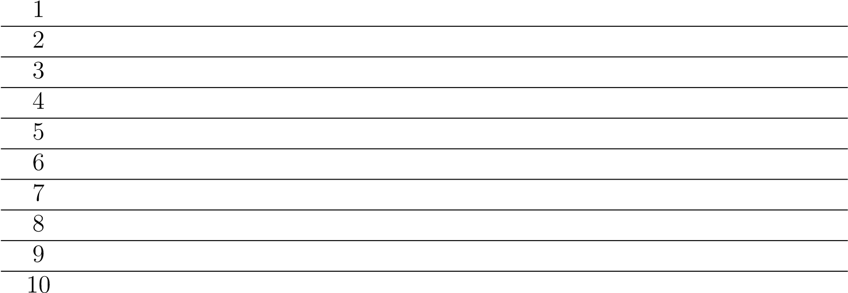
Table 4: Metrics from 10 independent trials of the baseline SLAM system run on the static All Machine Halls episodic dataset.
Trial | APEKFRMSE | APEFrameRMSE | RPEKFRMSE | RPEFrameRMSE | n_{ve} | p_{lf} | n_{r} | n_{lc}
 |  |  | 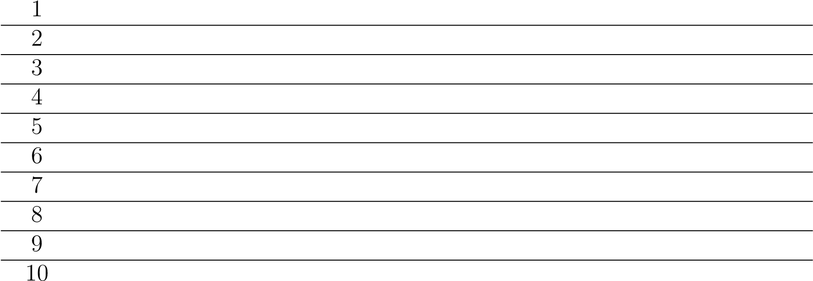
Table 5: Metrics from 10 independent trials of the VBEE integrated SLAM system run on the static All Machine Halls episodic dataset.
Metric | Baseline (µ ± σ) | VBEE Integrated (µ ± σ) | ∆(VBEE − Baseline)
 |  | 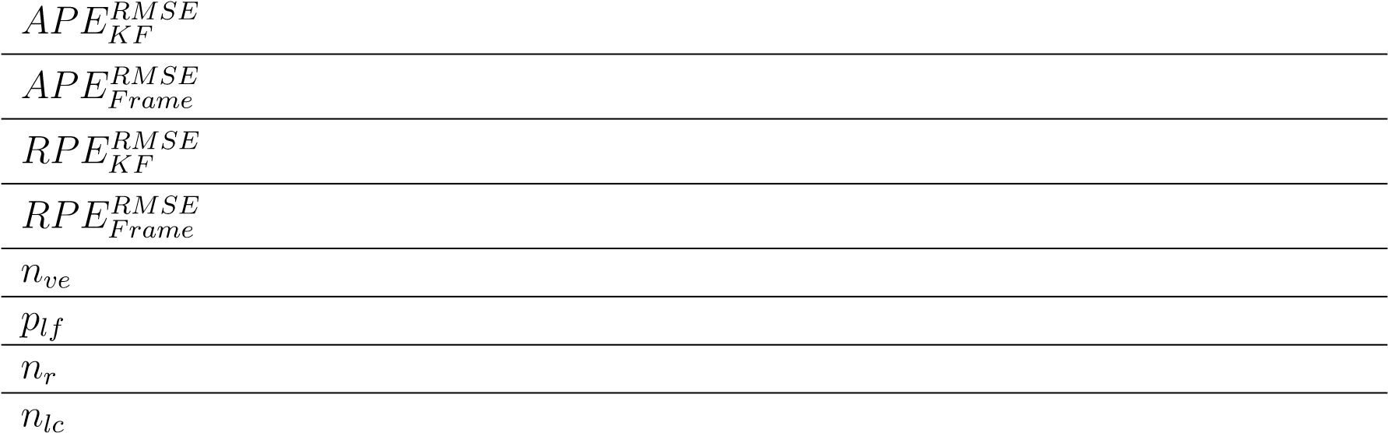
Table 6: Per-metric comparison between the baseline SLAM system and the VBEE integrated
SLAM system
5.2 Experiment 3: VBEE Integrated SLAM Performance with Changing Episodic Operations
Experiment 3 mirrors the structure of Experiment 2, but is evaluated with a different dataset. Therefore, the structure of data matches the previous section with Tables 7 and 8 showing the raw resultant metrics, and Table 9 showing the per-metric comparisons between the two systems.
Trial | APEKFRMSE | APEFrameRMSE | RPEKFRMSE | RPEFrameRMSE | n_{ve} | p_{lf} | n_{r} | n_{lc}
 |  |  | 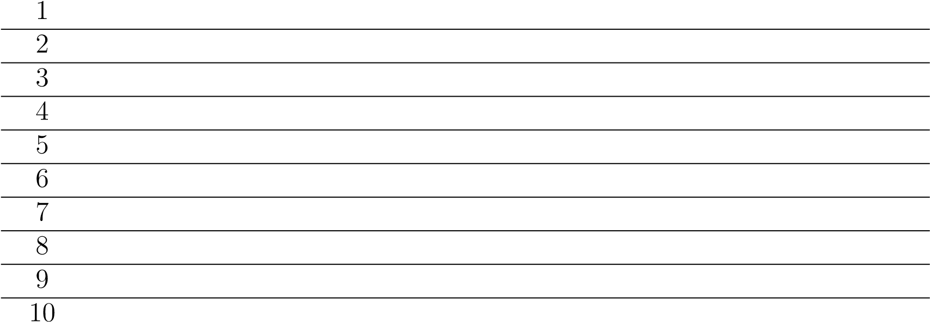
Table 7: Metrics from 10 independent trials of the baseline SLAM system run on the changing All Days episodic dataset.
Trial | APEKFRMSE | APEFrameRMSE | RPEKFRMSE | RPEFrameRMSE | n_{ve} | p_{lf} | n_{r} | n_{lc}
 |  |  | 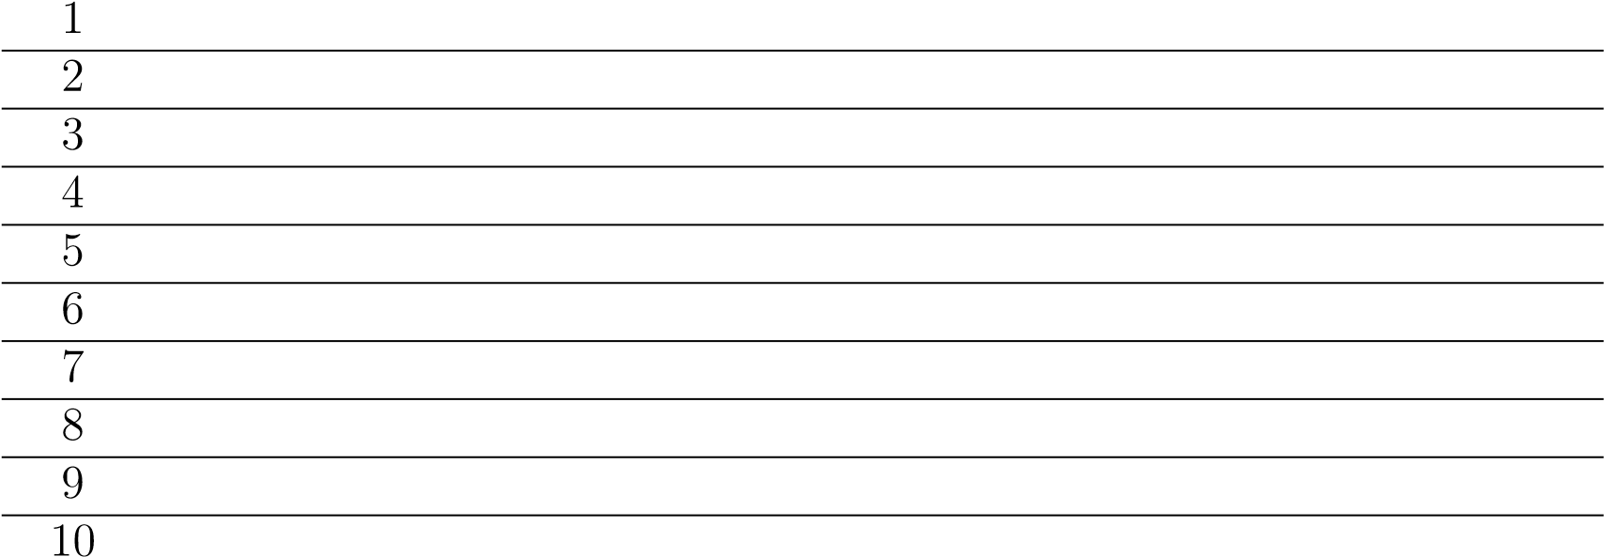
Table 8: Metrics from 10 independent trials of the VBEE integrated SLAM system run on the changing All Days episodic dataset.
Metric | Baseline (µ ± σ) | VBEE Integrated (µ ± σ) | ∆(VBEE − Baseline)
 |  | 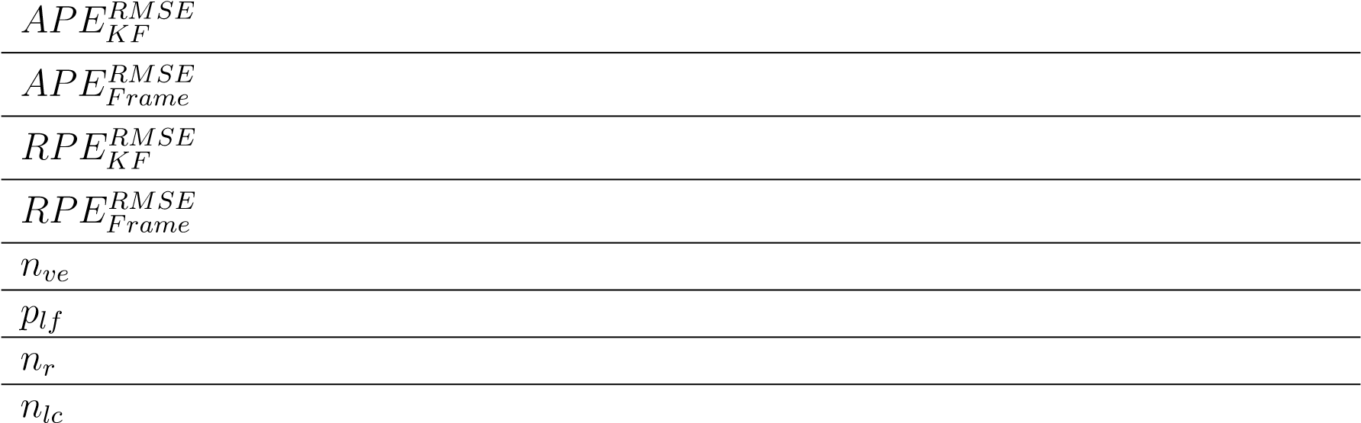
Table 9: Per-metric comparison between the baseline SLAM system and the VBEE integrated SLAM system
5.3 Experiment 4: VBEE + RANSAC SLAM Performance with Changing Episodic Operations
Table 10 shows the resulting metrics collected for each of the 10 trials of Experiment 4 by
the VBEE + RANSAC (VR) SLAM system.
Table 11 shows the per-metric means and standard deviations for the VBEE + RANSAC system, and pairwise comparisons between it and the systems tested in Experiment 3.
Trial | APEKFRMSE | APEFrameRMSE | RPEKFRMSE | RPEFrameRMSE | n_{ve} | p_{lf} | n_{r} | n_{lc}
 |  |  | 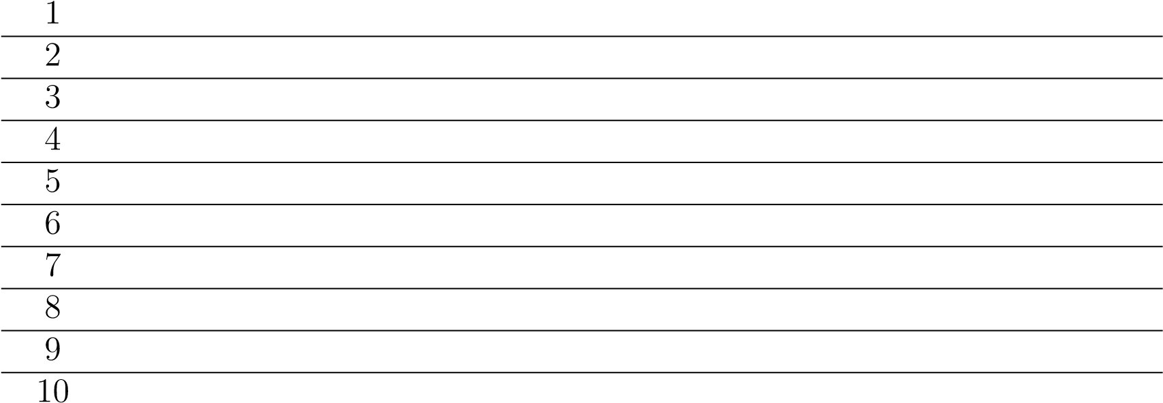
Table 10: Metrics from 10 independent trials of the VBEE + RANSAC SLAM system run on the changing All Days episodic dataset.
Metric | VR (µ ± σ) | ∆(VR − Baseline) | ∆(VR − VBEE)
 |  | 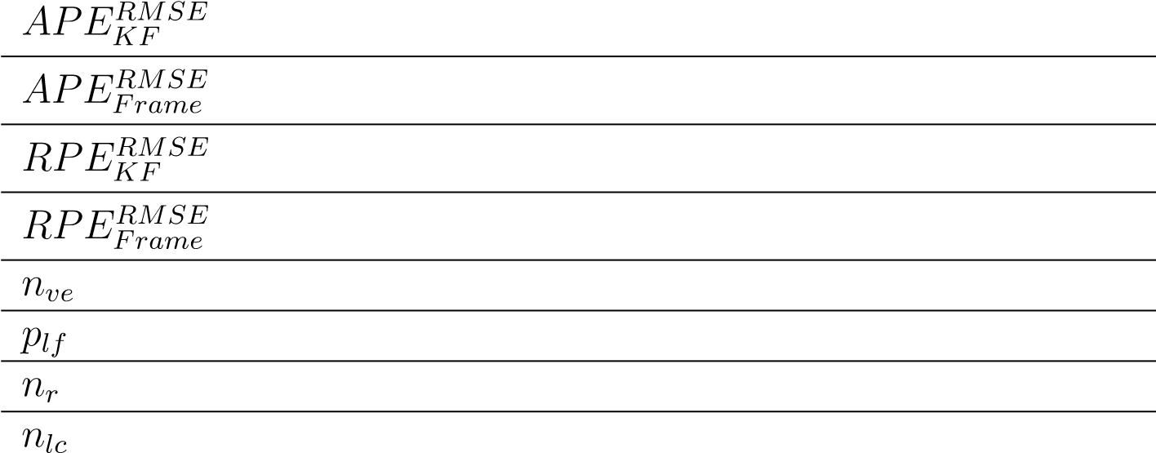
Table 11: Per-metric comparison between the VBEE + RANSAC SLAM system, the baseline
SLAM system, and VBEE integrated SLAM system

6 Future Work and Conclusions

6.1 Future Work
Performing the map point removal as part of an offline post-processing step is done for performance reasons. Projecting every map point into the camera’s frustum for every frame proved to be too significant of a load to run the system in real time. Optimizations were attempted making use of ORB-SLAM3’s co-observability graph to reduce the number of map points to project, but this still caused high computational load beyond what would be allowable for low-powered systems. This could be addressed by reimplementing the map backend using a data structure optimized for spacial searches such as a k-d tree. Selecting points that are likely to project into the camera’s frame would significantly reduce the number of points that need to be tested. Additionally, observability models that rely on spatial queries over past observations would benefit from this structure, as nearby observations would be fast to identify (O(log N) vs O(N)).
The methods of modeling global map point observability explored in this research are not comprehensive, and make no claims around being optimal in terms of accuracy or storage space. A deeper exploration into methods of encoding observability information may reveal significant improvements in both these areas. The discrete boundary model explored encoding maximum observability distance for a fixed number of bins, but issues arise when geometricly complex boundaries exist within a single bin, leading to ambiguity. Ideally, bins could be created or modified dynamically, allowing for a higher density of bins in geometricly complex areas, and lower density in uninteresting or unexplored areas.
If a discrete number of bins is desired for memory consistency and reduced complexity, the selection of bins using the fibonacci sphere may not be optimal. Other methods of descritizing the sphere could provide distinct advantages. For example, using icosahedron subdivisions or
HEALPix would provide uniform segmentation areas distributed evenly around the sphere.
Because 3D map points tend to lie on surfaces or corners, it is common for a map point to only be observable from a single hemisphere. If surface normals are estimated for each map point, bins could be concentrated around the surface normal, rather than wasting density on low likelyhood observability areas.
Online learning methods may also be useful for encoding global observability within a high dimensional vector representing a continuous shell around the map point rather than a finite set of bins. If properly implemented, this could allow map points to learn complex observability boundaries without the disadvantages of a discrete set of bins.
Treating map points as discrete elements matches the structure used by most KV-SLAM systems, but it ignores potential optimizations that could occur by considering similar observability in nearby map points. Two map points that are physically close to each other on the same surface will have nearly identical observability boundaries. If map points with similar observability boundaries could be identified, a single observability boundary could be defined for a group of map points instead of on an individual basis.
Finally, while the selected hyperparameters were selected through multivariate optimization, there may be more mathematically rigorous methods of selecting one or more of these values. The simulations used to select the values were limited in terms of applicability to real-world SLAM systems, and easily could have converged to local minima.

Bibliography
- Trey Smith et al. “ASTROBEE: A NEW PLATFORM FOR FREE-FLYING ROBOTICS ON THE INTERNATIONAL SPACE STATION”. In: ().
- Ryan Soussan et al. “AstroLoc: An Efficient and Robust Localizer for a Free-flying Robot”. In: 2022 International Conference on Robotics and Automation (ICRA). 2022 International Conference on Robotics and Automation (ICRA). May 2022, pp. 4106– 4112. doi: 10.1109/ICRA46639.2022.9811919.
- Roberto Carlino et al. “Lessons Learned from Astrobee Operations on the International Space Station”.
- Tom Zurales et al. Collaborative Sensing and Mapping for IVA Robots Phase II Final Report. Apr. 5, 2024.
- Paul Robinette, Ayanna M. Howard, and Alan R. Wagner. “Effect of Robot Performance on Human–Robot Trust in Time-Critical Situations”. In: IEEE Transactions on HumanMachine Systems 47.4 (Aug. 2017), pp. 425–436. issn: 2168-2305. doi: 10.1109/THMS.
2017.2648849.
- Saeid Nahavandi et al. “A Comprehensive Review on Autonomous Navigation”. In: ACM Computing Surveys 57.9 (Sept. 30, 2025), pp. 1–67. issn: 0360-0300, 1557-7341. doi: 10.1145/3727642.
- Randall Smith, Matthew Self, and Peter Cheeseman. “Estimating Uncertain Spatial
Relationships in Robotics*”. In: Machine Intelligence and Pattern Recognition. Ed. by John F. Lemmer and Laveen N. Kanal. Vol. 5. Uncertainty in Artificial Intelligence.
North-Holland, Jan. 1, 1988, pp. 435–461. doi: 10.1016/B978-0-444-70396-5.50042-
X.
- Stephen Se, David Lowe, and J.J. Little. “Mobile Robot Localization and Mapping with Uncertainty Using Scale-Invariant Visual Landmarks”. In: The International Journal of
Robotics Research 21 (Aug. 1, 2002), pp. 735–760. doi: 10.1177/027836402761412467.
- Davison. “Real-Time Simultaneous Localisation and Mapping with a Single Camera”.
In: Proceedings Ninth IEEE International Conference on Computer Vision. Ninth IEEE International Conference on Computer Vision. Oct. 2003, 1403–1410 vol.2. doi:
10.1109/ICCV.2003.1238654.
- D.G. Lowe. “Object Recognition from Local Scale-Invariant Features”. In: Proceedings of the Seventh IEEE International Conference on Computer Vision. The Seventh IEEE International Conference on Computer Vision. Vol. 2. Sept. 1999, 1150–1157 vol.2. doi:
10.1109/ICCV.1999.790410.
- Herbert Bay, Tinne Tuytelaars, and Luc Van Gool. “SURF: Speeded Up Robust Features”. In: Computer Vision – ECCV 2006. Ed. by Aleˇs Leonardis, Horst Bischof, and Axel Pinz. Berlin, Heidelberg: Springer, 2006, pp. 404–417. isbn: 978-3-540-33833-8. doi: 10.1007/11744023_32.
- Ethan Rublee et al. “ORB: An Efficient Alternative to SIFT or SURF”. In: 2011 International Conference on Computer Vision. 2011 International Conference on Computer Vision. Nov. 2011, pp. 2564–2571. doi: 10.1109/ICCV.2011.6126544.
- Michael Burri et al. “The EuRoC Micro Aerial Vehicle Datasets”. In: The International Journal of Robotics Research 35 (Jan. 25, 2016). doi: 10.1177/0278364915620033.
- Martin A. Fischler and Robert C. Bolles. “Random Sample Consensus: A Paradigm for Model Fitting with Applications to Image Analysis and Automated Cartography”.
In: Commun. ACM 24.6 (June 1, 1981), pp. 381–395. issn: 0001-0782. doi: 10.1145/ 358669.358692.
- H. C. Longuet-Higgins. “A Computer Algorithm for Reconstructing a Scene from Two Projections”. In: Nature 293.5828 (Sept. 1981), pp. 133–135. issn: 1476-4687. doi:
10.1038/293133a0.
- R.I. Hartley. “In Defense of the Eight-Point Algorithm”. In: IEEE Transactions on Pattern Analysis and Machine Intelligence 19.6 (June 1997), pp. 580–593. issn: 19393539. doi: 10.1109/34.601246.
- Mark Cummins and Paul Newman. “Probabilistic Appearance Based Navigation and Loop Closing”. In: Proceedings 2007 IEEE International Conference on Robotics and Automation. 2007 IEEE International Conference on Robotics and Automation. Apr. 2007, pp. 2042–2048. doi: 10.1109/ROBOT.2007.363622.
- Dorian Galvez-L´opez and Juan D. Tardos. “Bags of Binary Words for Fast Place Recognition in Image Sequences”. In: IEEE Transactions on Robotics 28.5 (Oct. 2012), pp. 1188–1197. issn: 1941-0468. doi: 10.1109/TRO.2012.2197158.
- Xuesong Shi et al. Are We Ready for Service Robots? The OpenLORIS-Scene Datasets for Lifelong SLAM. Mar. 14, 2020. doi: 10.48550/arXiv.1911.05603. arXiv: 1911.
05603 [cs]. url: http://arxiv.org/abs/1911.05603 (visited on 03/11/2025).
Pre-published.
- Carlos Campos et al. “ORB-SLAM3: An Accurate Open-Source Library for Visual,
Visual-Inertial and Multi-Map SLAM”. In: IEEE Transactions on Robotics 37.6 (Dec. 2021), pp. 1874–1890. issn: 1552-3098, 1941-0468. doi: 10.1109/TRO.2021.3075644. arXiv: 2007.11898[cs].
- Zetao Chen et al. “Deep Learning Features at Scale for Visual Place Recognition”. In: 2017 IEEE International Conference on Robotics and Automation (ICRA). 2017 IEEE International Conference on Robotics and Automation (ICRA). May 2017, pp. 3223– 3230. doi: 10.1109/ICRA.2017.7989366.
- Tayyab Naseer et al. “Vision-Based Markov Localization across Large Perceptual Changes”. In: 2015 European Conference on Mobile Robots (ECMR). 2015 European Conference on Mobile Robots (ECMR). Sept. 2015, pp. 1–6. doi: 10.1109/ECMR.2015.
7324181.
- Relja Arandjelovi´c et al. NetVLAD: CNN Architecture for Weakly Supervised Place
Recognition. May 2, 2016. doi: 10.48550/arXiv.1511.07247. arXiv: 1511.07247[cs]. url: http://arxiv.org/abs/1511.07247 (visited on 08/01/2025). Pre-published. [24] Paul-Edouard Sarlin et al. “From Coarse to Fine: Robust Hierarchical Localization at Large Scale”. In: Proceedings of the IEEE/CVF Conference on Computer Vision and Pattern Recognition. 2019, pp. 12716–12725.
- D Girardeau-Montaut et al. “CHANGE DETECTION ON POINTS CLOUD DATA ACQUIRED WITH A GROUND LASER SCANNER”. In: (2005).
- K. S. Arun, T. S. Huang, and S. D. Blostein. “Least-Squares Fitting of Two 3-D Point Sets”. In: IEEE Transactions on Pattern Analysis and Machine Intelligence PAMI-9.5 (Sept. 1987), pp. 698–700. issn: 1939-3539. doi: 10.1109/TPAMI.1987.4767965.
- P.J. Besl and Neil D. McKay. “A Method for Registration of 3-D Shapes”. In: IEEE Transactions on Pattern Analysis and Machine Intelligence 14.2 (Feb. 1992), pp. 239– 256. issn: 1939-3539. doi: 10.1109/34.121791.
- N. Aspert, D. Santa-Cruz, and T. Ebrahimi. “MESH: Measuring Errors between Surfaces Using the Hausdorff Distance”. In: Proceedings. IEEE International Conference on Multimedia and Expo. . IEEE International Conference on Multimedia and Expo. Vol. 1. Aug. 2002, 705–708 vol.1. doi: 10.1109/ICME.2002.1035879.
- Zihan Lin et al. “Point Cloud Change Detection With Stereo V-SLAM: Dataset, Metrics and Baseline”. In: IEEE Robotics and Automation Letters 7.4 (Oct. 2022), pp. 12443– 12450. issn: 2377-3766. doi: 10.1109/LRA.2022.3219018.
- Stefan Larsen et al. “Change Detection and Model Update Framework for Accurate Long-Term Localization”. In: ().
- Mar´ıa T. L´azaro, Roberto Capobianco, and Giorgio Grisetti. “Efficient Long-term
Mapping in Dynamic Environments”. In: 2018 IEEE/RSJ International Conference on
Intelligent Robots and Systems (IROS). 2018 IEEE/RSJ International Conference on Intelligent Robots and Systems (IROS). Oct. 2018, pp. 153–160. doi: 10.1109/IROS.
2018.8594310.
- Malcolm Mielle et al. “SLAM Auto-Complete: Completing a Robot Map Using an Emergency Map”. In: 2017 IEEE International Symposium on Safety, Security and
Rescue Robotics (SSRR). 2017 IEEE International Symposium on Safety, Security and Rescue Robotics (SSRR). Oct. 2017, pp. 35–40. doi: 10.1109/SSRR.2017.8088137.
- Erik Derner et al. “Change Detection Using Weighted Features for Image-Based Localization”. In: Robotics and Autonomous Systems 135 (Jan. 2021), p. 103676. issn: 0921-8890. doi: 10.1016/j.robot.2020.103676.
- Julie Stephany Berrio et al. “Updating the Visibility of a Feature-Based Map for Long-Term Maintenance”. In: 2019 IEEE Intelligent Vehicles Symposium (IV). 2019 IEEE Intelligent Vehicles Symposium (IV). June 2019, pp. 1173–1179. doi: 10.1109/ IVS.2019.8814189.
- Julie Stephany Berrio et al. Long-Term Map Maintenance Pipeline for Autonomous
Vehicles. Aug. 28, 2020. doi: 10.48550/arXiv.2008.12449. arXiv: 2008.12449[cs]. url: http://arxiv.org/abs/2008.12449 (visited on 07/29/2025). Pre-published. [36] Pablo F. Alcantarilla et al. “Learning Visibility of Landmarks for Vision-Based Localization”. In: 2010 IEEE International Conference on Robotics and Automation. 2010 IEEE International Conference on Robotics and Automation. May 2010, pp. 4881–4888. doi: 10.1109/ROBOT.2010.5509383.
- Takuya Akiba et al. Optuna: A Next-generation Hyperparameter Optimization Framework. July 25, 2019. doi: 10.48550/arXiv.1907.10902. arXiv: 1907.10902 [cs].
url: http://arxiv.org/abs/1907.10902 (visited on 08/12/2025). Pre-published.
- Yair Censor. “Pareto Optimality in Multiobjective Problems”. In: Applied Mathematics and Optimization 4.1 (Mar. 1, 1977), pp. 41–59. issn: 1432-0606. doi: 10.1007/ BF01442131.
- Raul Mur-Artal, J. M. M. Montiel, and Juan D. Tardos. “ORB-SLAM: A Versatile and
Accurate Monocular SLAM System”. In: IEEE Transactions on Robotics 31.5 (Oct. 2015), pp. 1147–1163. issn: 1552-3098, 1941-0468. doi: 10.1109/TRO.2015.2463671. arXiv: 1502.00956[cs].

A Appendices
A.1 Absolute and Relative Pose Error

A.2 Key Algorithm Implementations

Bayesian Update Implementation
def update(self, observation: Observation):
prior = self.p_exists
# Model estimation is clamped to [0.001, 0.999] to avoid division by zero or extreme values
model_estimation = clamp(self.model.predict(observation.viewpoint),
0.001, 0.999)
if observation.state == ObservationState.SEEN:
numerator = model_estimation * (1 - self.false_negative_rate) *
prior denominator = (model_estimation * (1 - self.false_negative_rate) *
prior) + ( self.false_positive_rate * (1 - prior)
)
posterior = numerator / denominator
else: numerator = (1 - (model_estimation * (1 - self.false_negative_rate
))) * prior denominator = (
(1 - (model_estimation * (1 - self.false_negative_rate))) *
prior
) + ((1 - self.false_positive_rate) * (1 - prior)) posterior = numerator / denominator
if posterior < 0 or posterior > 1:
raise ValueError(f"Posterior probability out of bounds: {posterior
}")
# If the estimated observability of the point is lower than the actual
, we increase the overall observability
# Otherwise we decrease it self.observability = clamp( self.observability
+ (
self.observability_update_factor
* (observation.state.value - model_estimation)
),
0.25,
0.75,
)
# The more observable the point is, the more we dampen the update
1
2
3
4
5
6
7
8
9
10
11
12
13
14
15
16
17
18
19
20
21
22
23
24
25
26
27
28
29
30
31
32
33
34
35
36
self.p_exists = clamp( self.p_exists
+ (posterior - prior) * (1 - self.observability) * self.
damping_coefficient,
0.001,
0.999, )
self.model.integrate(observation, abs(self.p_exists - prior), self. plot) return self.p_exists
37
38
39
40
41
42
43
44
45
46
47
48
Listing 1: Python Implementation of the Bayesian Update Step

Full Results

This metric was recorded in Experiment 3 as well, but is not relevant to that experiment

