Signal Shift
Product concept, specifications, and requirements for an Elata-native TypeScript mini-game

Summary
Signal Shift is a browser-based biometric arcade game for Elata. The player sorts falling signals into the correct zones while the game changes in real time based on webcam BPM and EEG or simulated EEG.

1. Product vision
Signal Shift is designed as a compact, playful app that demonstrates Elata’s biometric capabilities through a game loop rather than a passive dashboard. The experience should feel readable in under 30 seconds, fun in under 3 minutes, and distinctive enough to serve as a memorable ecosystem showcase.

2. Core concept
Area | Detail
Genre | Arcade / sorting / survival mini-game
Main loop | Falling signal fragments appear in lanes and the player routes them to the correct zone before the system destabilizes.
Key twist | Biometric input does not only display live values; it changes the behavior, pace, and feel of the game in real time.
Tone | Futuristic, playful, slightly chaotic, and easy to understand

3. Core gameplay loop
1. Signal fragments spawn at the top of the game field and move downward.
2. The player routes each fragment into one of three zones: Stabilize, Convert, or Discard.
3. Correct routing increases score and supports reactor stability. Incorrect routing or missed fragments increases instability or corruption.
4. Biometric state continuously modifies the game mode, spawn intensity, recovery mechanics, and event frequency.
5. The run ends when reactor stability reaches zero or the corruption threshold is exceeded.

4. Game entities and routing rules
Entity | Correct destination | Gameplay effect
Calm signal | Stabilize | Small score gain and stability recovery
Focus signal | Convert | Charges clarity meter and increases score
Noise signal | Discard | Prevents clutter and minor penalties
Glitch signal | Usually Discard or avoid | Wrong handling causes instability spike or event trigger

5. Biometric interaction model
The app should present live biometric panels, but those panels are secondary. The primary design goal is to make the player feel that their current state is shaping the game.
State source | Game reaction | Player feel
Webcam / BPM rises | Spawn pressure increases, pace quickens, short glitch events appear more often | The world feels urgent and unstable
Webcam / BPM settles | Pressure normalizes, event rate drops, timing becomes easier to read | The player regains control
EEG / simulated EEG focus improves | Clarity meter fills faster and recovery abilities become available | Focus is rewarded without making the game trivial
Very calm state | Gameplay becomes slower but trickier, with more ambiguity or hidden information | Calm creates a different style, not only an easier style
High-pressure state | Gameplay becomes faster and more chaotic, potentially with higher reward | Stress changes the character of the game rather than only punishing the player
Design guardrail: Signal Shift should feel like a closed-loop interactive experience, not a punitive stress simulator. Calm and pressure should create different play styles rather than a simple good-versus-bad scale.

6. Primary use cases
• A fun app-store mini-game that is easy to try without a long onboarding flow.
• A live Elata showcase proving that webcam and EEG signals can change gameplay in real time.
• A lightweight neurofeedback-style experience that makes biometric interaction more accessible to non-technical users.
• An intro app for first-time Elata users who want to understand what the sensors and SDK can do.

7. User experience goals
• The first 30 seconds should communicate the rules with almost no explanation.
• The user should always see a visible relationship between the game and the live biometric panel.
• The app should be playable with webcam plus simulated EEG so it remains demoable without special hardware.
• The game should feel surprising and playful, but not visually noisy to the point of confusion.

8. Screen-level specification
Screen | Purpose | Must include
Title | Fast entry and concept framing | Game name, one-line description, start button
Setup | Enable sensors and session options | Webcam start, simulated EEG toggle, status labels
Calibration | Capture baseline state | Short countdown, BPM preview, EEG preview, progress indicator
Gameplay | Main play surface | Game canvas, small camera window, right HUD, bottom telemetry strip
Results | Session summary and replay | Score, survival time, summary of dominant state, replay button

9. UI and layout requirements
• Main game canvas centered and dominant on screen.
• Small camera preview visible during active play.
• Bottom telemetry strip for BPM, focus, signal quality, and current event state.
• Right-side HUD for score, reactor stability, corruption, panic pressure, and clarity meter.
• Fullscreen-friendly layout that still works inside an iframe.

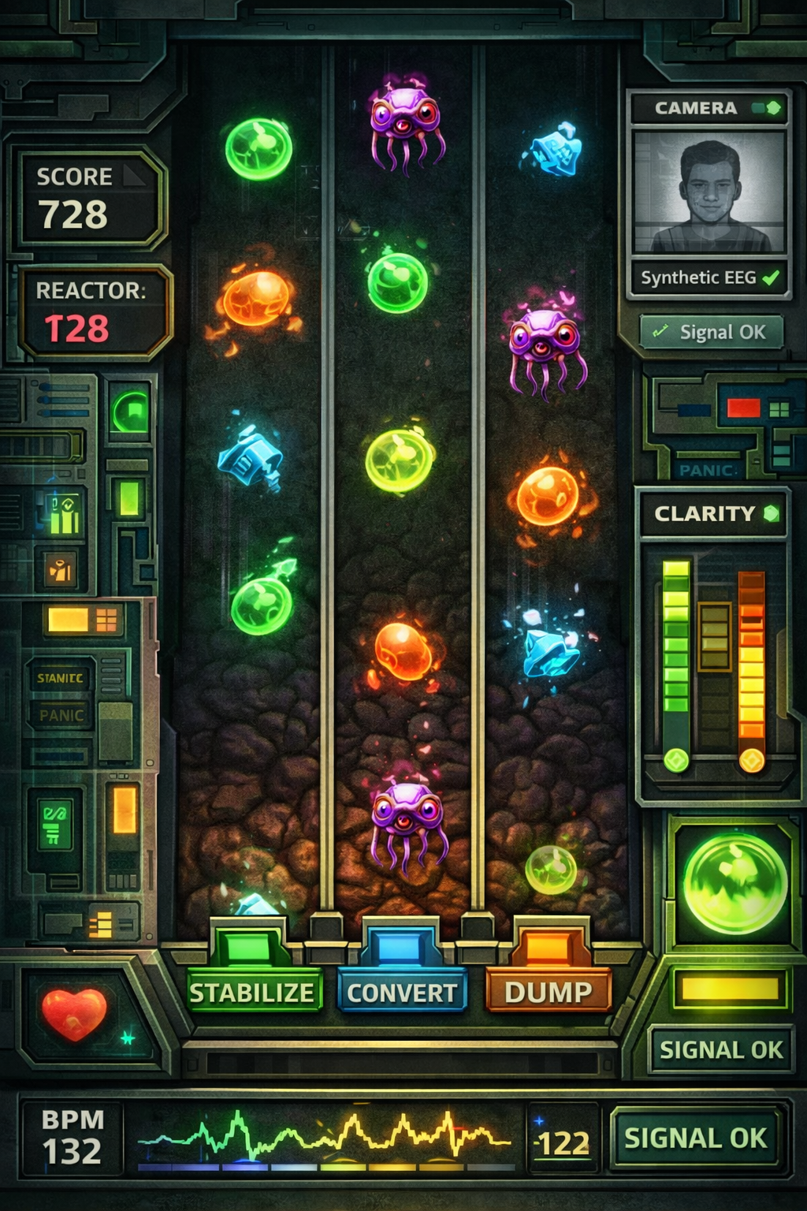
Concept gameplay mock showing the intended balance between game canvas, telemetry, and sensor visibility.

10. Functional requirements
Area | Detail
FR-1 | The app must be implemented in TypeScript.
FR-2 | The first playable MVP must run as a browser app without requiring a real EEG device.
FR-3 | The gameplay must use webcam BPM and EEG or simulated EEG as direct gameplay inputs, not only display metrics.
FR-4 | The app must support a calibration step to establish an approximate baseline state before a play session.
FR-5 | The gameplay must expose at least three distinct biometric state reactions: balanced, calm-tilted, and pressure-tilted.
FR-6 | The UI must keep the camera preview and live signal indicators visible during gameplay.
FR-7 | The player must be able to complete a run using standard keyboard controls on desktop.
FR-8 | The app must surface short dynamic events tied to biometric changes or state thresholds.
FR-9 | The results screen must summarize score and at least one state-related metric.
FR-10 | The MVP must remain small enough to ship as a focused proof of concept instead of a full game platform.

11. Technical requirements and constraints
Area | Detail
Language | TypeScript
Recommended frontend stack | React + Vite
Recommended rendering approach | Canvas-driven game area with React UI shell
State management | Lightweight store such as Zustand
Packaging goal | Static web build suitable for Elata upload
Testing assumption | Local development with webcam and simulated EEG first; real BLE EEG is optional later
The app should stay within proof-of-concept scope. Real hardware EEG support can be a later extension, but the initial version should be compelling using simulated EEG so it is easy to demo and iterate.

12. Non-goals for MVP
• No multiplayer or tournament logic in v1.
• No on-chain gameplay logic in v1.
• No wallet-dependent progression required for the first demo.
• No large content pipeline, handcrafted levels, or asset-heavy production scope.

13. Risks and mitigation
Risk | Why it matters | Mitigation
Biometric loop feels punitive | Players may feel punished rather than engaged | Use mode shifts and recovery tools, not only difficulty spikes
Sensor integration delays core gameplay | The project could stall before the game becomes fun | Build the full game loop first with mocked values
UI becomes too dashboard-heavy | The app may feel like a demo instead of a game | Keep 70% of attention on gameplay and 30% on telemetry
Scope expands too quickly | PoC may miss the submission window | Limit v1 to one core loop, one power, and a handful of events

14. MVP acceptance criteria
• A new user can start a session, calibrate, and play within roughly one minute.
• The game clearly changes when biometric state changes.
• Camera preview and telemetry are visible during the run.
• The app feels like an Elata-native mini-game rather than a plain technical dashboard.
• The build is stable enough to package as a self-contained browser app.

