ITEM LIST

**Wrench:**

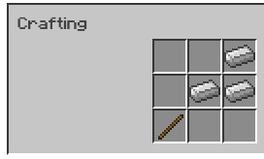

*Stick and 3 iron ingots.*

- Does 7 damage when swung with left click (acts like a sword).

- Shift-right click to open the GUI, GUI allows you to load the wrench with iron nuggets, ingots and blocks. Iron content is converted into its mb liquid equivalent. Wrench can hold 2,000 mb of liquid max.

- Left click on a Dispenser to add up to 250 mb of iron per swing. Once the Dispenser reaches 2,000 mb it upgrades to the next level. (To be implemented later.)

- Left click on a Sentry to reload it, at 2mb per bullet and 10mb per rocket. (The level 3 sentry has rockets). After a Sentry is completely reloaded, left clicking on the Sentry will add up to 250 mb of iron per whack. A Sentry at 2,000 mb of iron will upgrade to the next tier.

- Right clicking a teleporter will start a “link”. Right click a second teleporter to finish the link.  
- Can mine the dispenser and teleporter to break them almost instantly.

- Right clicking a sentry will drop it, preserving its metadata (current health, ammo count, upgrade progress, targeting parameters).

- Remember, left click will hurt mobs but not the sentry!

**Dispenser:**

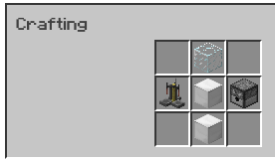

*Glass, 2 iron block, brewing stand and dispenser.*

- Block that’s 22 pixels tall.

- Gives Regeneration I to all mobs/players/etc in a 4 block radius around the dispenser.  
- Generates arrows at a rate of 1 arrow per 8 seconds, max of 64 inside the dispenser.

- Emits light at a level equal to glowstone.  
- Can place a hopper/item pipe/etc under the dispenser to automatically extract arrows.  
- Can be mined by a pickaxe or wrench.

- Comes in lv 1, lv 2 and lv 3. (To be discussed/implemented in the future)

**Teleporter:**

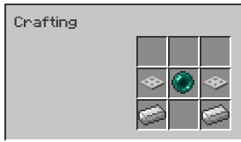

*2 iron trapdoor, 2 iron ingot, 1 ender pearl.*

- Emits light equal to glowstone.  
- Teleports entities standing on top of it for 1.2 seconds.

- 5 second delay until the next teleport action.

- Use the Wrench to link 2 teleporters together.

**Sentry Gun:**

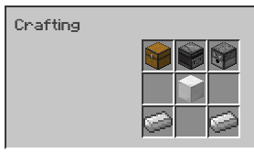

*Chest, Observer, Dispenser, Iron block, 2 iron ingot.*

- Autonomous defense turret. Has 12 hp and does 3 damage per bullet, at a rate of 1 bullet every 0.5 seconds.

- Detection range of 30 blocks.  
- Cannot detect “cloaked” entities (entities under the effects of a potion of invisibility) or entities wearing a mob/player head.

- Can be upgraded (to be discussed in the future)

- Right clicking a sentry with a wrench will drop it, preserving its metadata (current health, ammo count, upgrade progress, targeting parameters).

- Right Click with an empty hand to open GUI, GUI allows for the following to be changed:  
 - Attack all mobs or hostile mobs only.  
 - Attack players with the exception of the player that deployed it (can add players to exclude via

a whitelist)

- Holds 150 bullets, left clicking with a wrench adds bullets at a rate of 2mb per bullet.

- Drops an iron block when destroyed.

- Plays a sound every 10 seconds when idle.