DESIGN DIRECTION → TRACKED SPACES → BUILD WORK → PROOF

Cinematic consultation
Desktop + mobile build plan
  - Business consultation in the age of AI.
A working map of the globe-led hero and the five visual scroll chapters. Every space has an ID, a responsive treatment, its dependencies and a route to acceptance. This is a build plan, not a new positioning document.

Existing concept art • composition reference only • real text and controls will be rebuilt in the site
WHAT IS MAPPED | WORKING BASELINE
9 page scenes + shared shell + deferred homepage panel | /ai-consultation · TomaDev23/curious-labs-production
68 spaces · 10 artwork entries · 9 coded visuals | main at a49e6324c385bad24cf64d5314db241a67c6621e
11 interaction contracts · 18 work packages · 35 checks | 13 September 2026 · design plan v1.0 · implementation not started in this session

Start here. Read the page map, then the scene cards. Use the companion tracker to assign owners, advance desktop/mobile separately and attach proof. A finished-looking mockup is not a finished build.
01 / CONTROL AND READING ROUTE

How to use this plan
The design is intentionally dramatic. Its meaning stays business-first, its text stays editable, and its controls stay real. The latest visual approval permits stronger imagery; it does not automatically approve every animation, statement, face or button drawn by the image generator.
AUTHORITY | WHAT IT CONTROLS
SRC-01 · _FRAMING_LOCKED.md | Intent, voice, audiences and hard boundaries. Wins over earlier documents and image wording.
SRC-02 · COPY_DECK_v2.md | Working copy. Approved changes go back here; complete secondary labels and FAQ text as well.
SRC-03 · Owner answers | Service scope, process, delivery, spoken language, geography and reserved material.
REF-00–05 · Mockups | Composition, contrast, atmosphere and visual emphasis. They are not screenshots of an implemented design.
This plan + tracker | Proposed responsive design, asset briefs, tasks and tests. Measurements and budgets are proposals unless specifically labeled otherwise.

Three things must not get conflated
Direction approved means the owner likes the cinematic treatment. Artwork approved means a particular source and both crops are accepted. Scene verified means the actual page has passed desktop, phone, interaction and reduced-motion checks. These are different states.

A practical tracking example
SP-04-04 · Harness visual It belongs to SC-04, is built as VIS-03, is delivered in WP-09, and must pass QA-16 plus desktop/mobile scene checks. Save the evidence path in the tracker before marking it done.

Where to read
READING NEED | GO TO
Understand the page as a journey | Page map → responsive rules → scene cards SC-01–09
Prepare or request artwork | Artwork production → ART register → coded VIS register
Give an agent a bounded mission | WP work packages → component seams → QA criteria
Review progress without rereading everything | Tracker: Overview, Scenes, Spaces, Work, Decisions and QA

Baseline honesty: the reported 14,500px mobile height and below-fold capture blanking came from the pasted agent report. They were not independently re-measured here. New scene geometry is proposed; the page must still be checked in the owner’s actual browser.
02 / HERO + FIVE NARRATIVE SCROLL CHAPTERS

The complete page map
Five scrolls means five connected visual chapters after the hero—not a promise that the entire page occupies exactly five physical screens. On phones, each chapter gets its own composition rather than a squeezed desktop screenshot.
SCENE / CHAPTER | WHAT IT DOES | EXISTING ID / LINK | VISUAL
SC-01 · Opening | Earth hero | D1  #overview | REF-00
SC-02 · Scroll 1 · entry | Two audience doors | D2 · first half  #audiences | REF-01
SC-03 · Scroll 1 · difficulty | The three walls | D2 · second half  #audiences (subregion) | REF-01
SC-04 · Scroll 2 | What I actually do | D3  #contribution | REF-02
SC-05 · Scroll 3 | The person and this market | D4  #person | REF-03
SC-06 · Scroll 4 | Approach and deeper readings | D5 + R1–R4  #approach | REF-04
SC-07 · Scroll 5 · process | From conversation to agreed work | D7  #engagement | REF-05
SC-08 · Scroll 5 · reassurance | Questions before the conversation | D9  #questions | REF-05
SC-09 · Scroll 5 · close | Final horizon and contact | D8 + footer  #contact | REF-05

The sequence to preserve
One connected journey Earth hero → two doors → three walls → three consulting areas → the person / Cambodia → approach and deeper readings → engagement → questions → final horizon and contact.

Outside the main sequence
AREA | TREATMENT
SC-00 · Shared shell | Keep existing navbar, background, skip link, route and footer behavior. Clean up metadata with the copy pass.
D6 · Evidence | Omitted. It is not an empty design slot; approved real artifacts with Origin / Purpose / Meaning / Limit are required before adding it.
SC-10 · Homepage invitation | Tracked but deferred. Place before MoonSignalShowcase at the agreed seam after rechecking the source; do not replace the existing moon-led opening.

Proposed visual rhythm
Open sky → architectural doors → terrain and stone → asymmetric diagram → warm editorial city → illustrated reading entries → light rail → quiet questions → Earth horizon. Avoid repeating eyebrow + two-line title + glass-card grid at every stop.
03 / PROPOSED RESPONSIVE CONTRACT

Desktop and phone are two designs
The desktop version uses width, negative space and art scale. The phone version uses closer crops, concise surfaces and deliberate reveal controls. Required information stays available in both. These dimensions are starting specifications, not claimed measurements.
WIDTH / TEST VIEW | LAYOUT RULE
1440×900 · primary desktop | 12-column content grid; maximum 1320px; 24–32px gutters. Full-bleed art may extend beyond that content width.
1024×768 · small desktop | Reduce to 8 columns or stack when copy demands it. Do not preserve a 3-column composition at the expense of legibility.
768×1024 · tablet | Use intentional 2-column groups or full-width narrative. Touch interactions, not hover assumptions.
390×844 · primary phone | 20–24px side padding. 16–18px body text target. Direct controls at least 44×44px. Portrait or shallow landscape art, depending on the scene.
320×568 · narrow fallback | 16px side padding; single-column fallback for dense cards/readings. No horizontal document overflow or forced one-screen scenes.
1920×1080 · recommended extra check | Keep readable copy bounded; expand background art rather than stretching paragraphs.

A shorter reading surface, not missing information
Planning budget: roughly 6,500–8,500px, or 8–10 screens at 390×844, with readings and FAQ answers closed. Measure the real result before accepting it. Open content is allowed to grow. Never remove essential meaning or clip copy to satisfy a height target.

Layer contract
LAYER | RESPONSIBILITY
Atmosphere | Text-free raster art, shared starfield and local scrims. Does not carry an essential label or control.
Structure | HTML headings, paragraphs, lists, links, buttons and reading regions. The offer works before motion runs.
Explanatory visual | SVG/DOM for doors, monoliths, harness, paths and process. Labels remain readable real text.
Enhancement | Motion changes emphasis and depth, not whether the content can be reached. Static/reduced-motion state is complete.

Motion default Dramatic composition, normal vertical scrolling, manual swipe where useful. No phone pinning; optional desktop sticky contribution is a later, explicitly tested trial. Inline readings are the default, not unapproved bottom sheets.
OPENING / D1 / REF-00

SC-01 · Earth hero
Introduce the business advisor, the offer and the free first conversation. AI is a serious focus within the offer, not the consultant’s whole identity.
  REF-00 · visual only | DESKTOP 12-column content grid, maximum 1320px. Copy spans columns 1–6; globe occupies 6–12 behind a left-to-right dark scrim. Keep title, lead, invitation and actions visible from first render. A low metadata strip closes the scene.  PHONE One copy column. Use a separately approved crop: planet lower/right, dark upper half. Copy and actions come before optional art extent and metadata. Allow height to grow; never crop text to fit one screen.

Tracked spaces
SPACE | DESKTOP PLACEMENT | PHONE PLACEMENT
SP-01-01  Eyebrow + headline | Top-left; one h1. 6 columns. | Full width; natural line breaks.
SP-01-02  Advisor lead + invitation | Under heading; 45–65-word lead allowance. | Short visible lead; aim 5–7 lines at 390px, expand if approved meaning needs it.
SP-01-03  Primary + secondary actions | Inline: free conversation → #contact; approach → #approach. | Full-width actions, minimum 44px hit area.
SP-01-04  Earth atmosphere + protective scrim | Right/bottom, about half the scene. | Distinct mobile crop below/behind copy; no text in image.
SP-01-05  Personal delivery / place / spoken languages | Low horizontal strip. | Wrapping compact lines, never tiny compressed chips.
SP-01-06  Decorative quote / orbital labels | Omit until exact words are approved. | Omit; do not spend a phone screen on a slogan.
SP-01-07  Transition + section navigation | Quiet inline anchors after hero; globe fades into next scene. | Wrapping anchors; no second fixed bar covering content.

Assets: ART-01 | Visuals: VIS-08 | Motion: INT-01, INT-09, INT-11
Height targets: At 1440×900: 640–820px. At 390×844: 600–780px. Targets only; no fixed-height text containers.
Acceptance Full headline, lead and primary action are visible without scrolling to trigger animation. Planet crop leaves a quiet text area on both widths. No obsolete AI INTEGRATION wording survives in visible labels, page title or footer.
Hold / correction: No booking calendar, fake contact action, 18+ metric or portrait. Orbital slogan options remain unapproved; the globe can carry the mood without words.
Source: SRC-02 §1; SRC-01 §§1–6. Headline retained; lead still needs the planned copy pass. Code: Existing D1 in ConsultationContent.jsx; proposed HeroScene.jsx; review hero uses of ConsultationMotion.jsx.
SCROLL 1 · ENTRY / D2 · FIRST HALF / REF-01

SC-02 · Two audience doors
Let two co-equal company types recognize themselves in the same business-consultation offer.
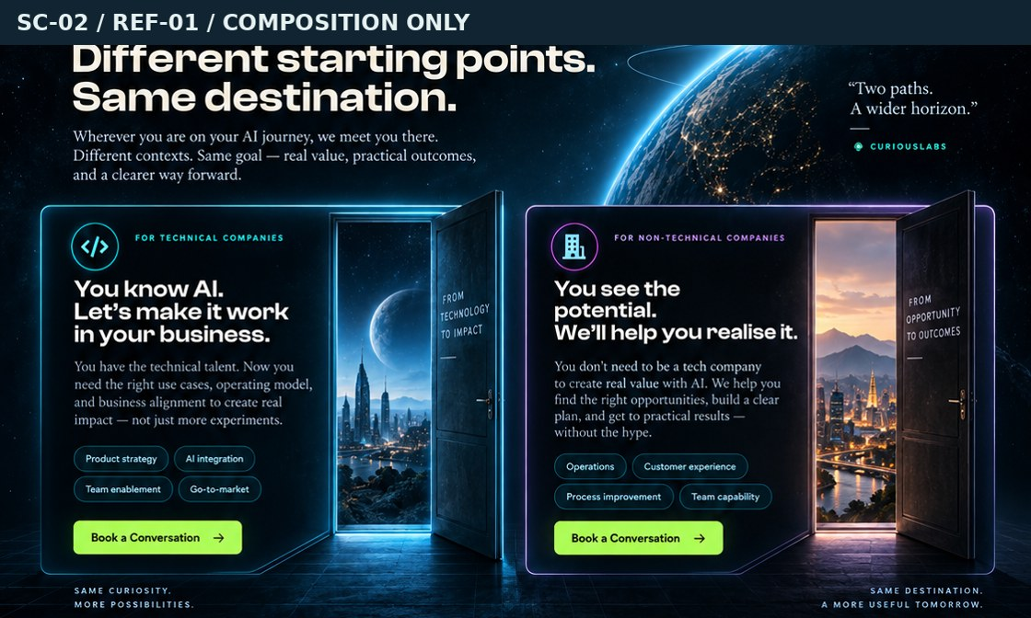  REF-01 · visual only | DESKTOP Equal 6/6 columns and matched card depth. Each door visual uses the outer third of its card; text uses the inner two-thirds. A single introduction spans the top. Read-more controls do something real; decoration is not a second offer.  PHONE Native horizontal two-item list, about 88% card width with the next edge showing. Both audience names remain visible in a compact index above it. Previous/next controls supplement swipe. At 320px or enlarged text, permit a stacked fallback.

Tracked spaces
SPACE | DESKTOP PLACEMENT | PHONE PLACEMENT
SP-02-01  Section heading + shared invitation | Full-width top band. | Before audience-name index.
SP-02-02  Technical-company copy | Left inner two-thirds. | First track item; essential meaning visible, not hidden on a flip side.
SP-02-03  Technical doorway / cyan vista | Outer right third of first door panel. | Shallower crop on right or top, text remains dominant.
SP-02-04  Non-technical-company copy | Right card inner two-thirds. | Second track item; not labeled as beginner-only.
SP-02-05  Business doorway / warm vista | Outer right third of second panel. | Match technical card’s crop depth and status.
SP-02-06  Detail links + track navigation | Optional “Discuss your situation” anchors; no booking UI. | Names + count + previous/next; all links must resolve.
SP-02-07  Ground plane + seam into walls | A shared perspective floor, then landscape transition. | Short seam; no empty spacer screen.

Assets: ART-02, ART-03 | Visuals: VIS-01, VIS-08 | Motion: INT-02, INT-09
Height targets: Desktop: 620–820px. Phone: 600–780px for the visible track. Both cards remain reachable.
Acceptance Technical companies means teams already shipping products, not anyone who uses computers. A non-technical business already using AI still recognizes itself. Both doors have equal visual weight and can be reached without dragging.
Hold / correction: Do not import Product strategy, Go-to-market, deployment promises, “You know AI,” or “We will help” from generated images. No speculative client history.
Source: SRC-01 §3; SRC-02 §2. Replace beginner-stage framing with technical / non-technical company framing after approval. Code: Existing D2 audience articles; proposed AudienceScene.jsx and DoorVisual.jsx.
SCROLL 1 · DIFFICULTY / D2 · SECOND HALF / REF-01

SC-03 · The three walls
Make trust, growing complexity and reliable execution recognizable without changing the offer into a reliability course.
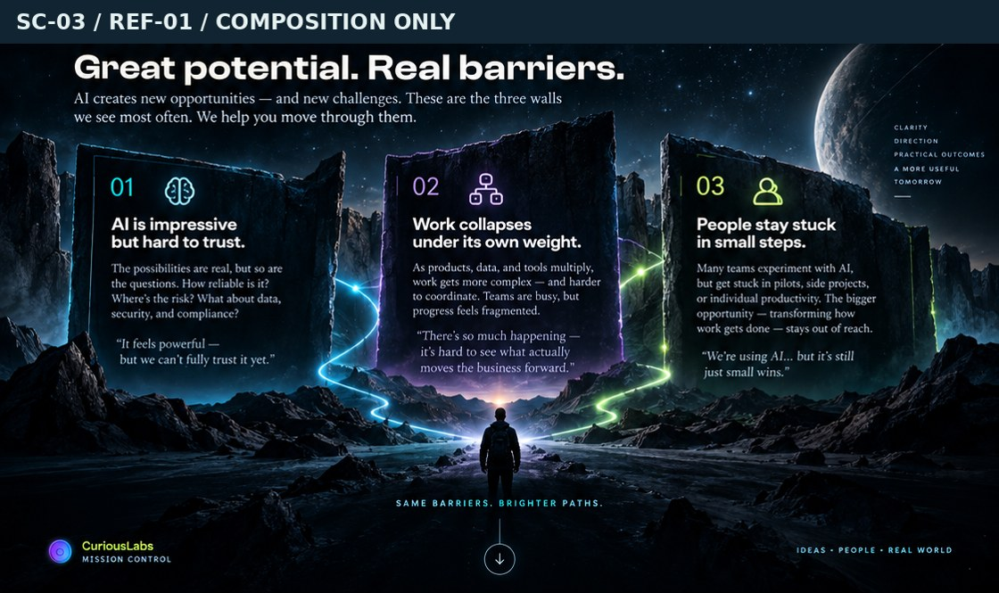  REF-01 · visual only | DESKTOP Heading on open sky; three 4-column monolith panels across the lower stage. Use real HTML over calm, dark surfaces; keep landscape behind, not inside every paragraph.  PHONE Compact heading followed by one user-swiped wall at a time. Keep all three labels in the track index. A tap reveals the response below the question. Stacked fallback at small widths or when text is enlarged.

Tracked spaces
SPACE | DESKTOP PLACEMENT | PHONE PLACEMENT
SP-03-01  Three-problem introduction | Across sky above monoliths. | Visible before the track.
SP-03-02  Trust monolith + response | One of three equal panels; no drawn text. | One track item; response opens by explicit button.
SP-03-03  Complexity monolith + response | One of three equal panels; no drawn text. | One track item; response opens by explicit button.
SP-03-04  Reliability monolith + response | One of three equal panels; no drawn text. | One track item; response opens by explicit button.
SP-03-05  Terrain and luminous path | Full-bleed lower stage behind the walls. | Portrait crop; keep foreground shallow.
SP-03-06  Response controls / track index | Explicit open/close, not hover-only flip. | Previous/next plus three topic names.
SP-03-07  Bridge into the consultation | One short sentence under stage. | One line or short paragraph; no additional large card.

Assets: ART-04 | Visuals: VIS-02 | Motion: INT-03, INT-11
Height targets: Desktop: 520–720px. Phone: 500–680px closed. Expanded responses add real document height.
Acceptance Front faces explain all three problems without needing a hover. Responses are not hidden exclusively on an inaccessible back face. “Every time” and any invented failure rates are absent.
Hold / correction: Latest picture says “stuck in small steps”; source deck says Reliability. Resolve in the copy pass, not by copying the image. Foreground explorer is unnecessary and should be omitted.
Source: SRC-02 §2; SRC-03 Q1. Labels: Trust / Complexity / Reliability. Larger-scope work belongs in the explanation; do not silently rename the third topic. Code: Existing StatTrio in ConsultationGraphs.jsx; proposed WallsScene.jsx. Preserve D2 relationship; subanchor #problems is optional, additive.
SCROLL 2 / D3 / REF-02

SC-04 · What I actually do
Explain the consulting act and the three areas it can draw on. The harness can be the visual center without becoming the page’s positioning.
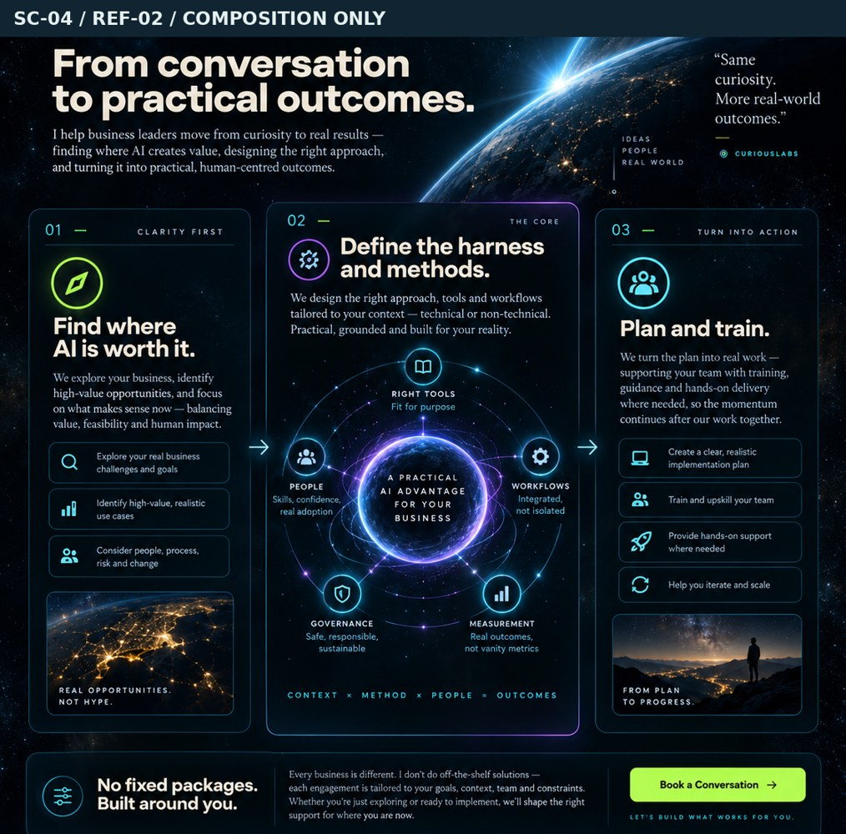  REF-02 · visual only | DESKTOP Open headline and intro, then left opportunity area, central harness, right plan/train. A single tailoring/delivery band below spans all columns. Keep no more than one scope statement.  PHONE Three compact areas in source order. The harness diagram is readable at full content width; its deeper explanation belongs in R1. No pinned stack in the default phone version. Do not make three poster-height cards.

Tracked spaces
SPACE | DESKTOP PLACEMENT | PHONE PLACEMENT
SP-04-01  Consulting act: problem → clarity | Open full-width headline + concise intro. | First, before methods.
SP-04-02  Area 1: where AI is worth it | Left 3 columns; compact copy. | First compact row.
SP-04-03  Area 2: harness and methods | Central 6-column heading + explanation. | Second row, stronger visual emphasis.
SP-04-04  Harness visual | Center, largest visual element. | Full content width; minimum readable labels. No rasterized labels.
SP-04-05  Area 3: plan and train | Right 3 columns. | Third compact row.
SP-04-06  Tailoring + delivery baseline | One full-width band below areas. | One compact explanation; expand formats only on request.
SP-04-07  Scope statement + discussion link | Single low-emphasis line with valid #contact link. | After delivery band; no repeated exclusions.
SP-04-08  Optional outcomes / decorative quote band | Omit unless separately approved and supported. | Omit; do not add another screen of vague claims.

Assets: No new raster required | Visuals: VIS-03, VIS-08 | Motion: INT-04, INT-09
Height targets: Desktop: 780–1040px. Phone: 850–1100px closed. Fit to approved copy, not a rigid viewport.
Acceptance All three area titles remain real text and visible in the primary path. The diagram labels use supported generic concepts, not invented named-method definitions. Visual emphasis on the harness does not replace the business-consulting introduction.
Hold / correction: No guaranteed outcomes strip, implementation/deployment menu, “measurement” score, governance certification or new product-development promise. Optional sticky emphasis is a separately tested experiment.
Source: SRC-02 §3; SRC-01 §4; SRC-03 Q4/Q9/Q10. Three areas, not packages. Report + one-to-one sessions baseline, then tailored. Code: Existing SUBJECTS and delivery band; proposed ContributionScene.jsx; reuse/rework HarnessGraph as HarnessSystem.jsx.
SCROLL 3 / D4 / REF-03

SC-05 · The person and this market
Connect business judgment, local knowledge and current AI practice as one personal package. Communicate direct delivery and spoken Khmer honestly.
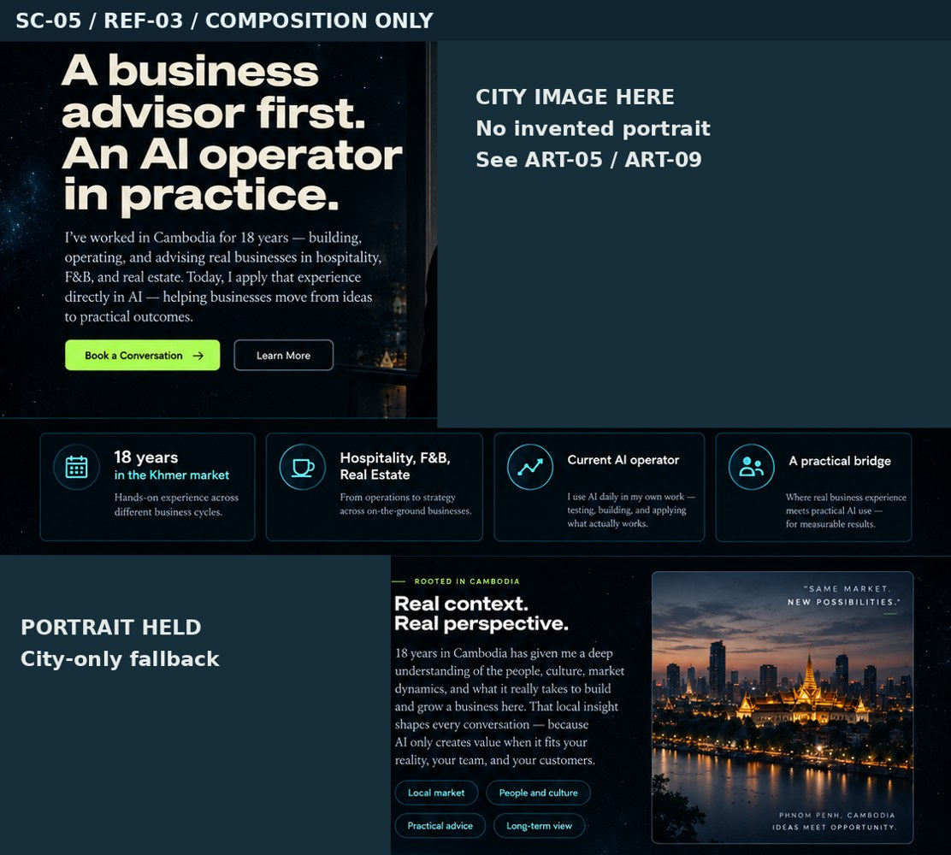  REF-03 · visual only | DESKTOP Lead copy left (5 columns), approved city visual right (7). A compact credibility band follows, then two narrative areas on market experience and language. Optional accurate regional inset is held, not required.  PHONE Lead and factual background first; then a shallow city crop; then compact credibility facts and language. Keep a route to R4. Do not preserve the mockup’s repeated portrait and map blocks just to fill space.

Tracked spaces
SPACE | DESKTOP PLACEMENT | PHONE PLACEMENT
SP-05-01  Business-first introduction | Left 5 columns. | Top, before city art.
SP-05-02  Approved city / future portrait space | Right 7 columns; person-free city by default. | Shallow crop after introduction.
SP-05-03  18 years / sectors / current AI facts | A compact 3–4-part strip, not oversized stats. | Two short columns or stacked facts; keep “18 years” exact.
SP-05-04  Market and operating experience | One editorial paragraph; hotels, restaurants, F&B, real estate. | Before AI-practice detail.
SP-05-05  Personal delivery + spoken Khmer | Paired with market paragraph; explain reasoning directly. | Full width; recipients include whoever needs the help.
SP-05-06  More about my experience | Link opens R4 and lands at it. | Same behavior; visible focus on return.
SP-05-07  Regional map / Cambodia-from-space inset | Optional accurate map only; otherwise collapse space. | Omit by default; region/travel stays text.

Assets: ART-05, ART-09 (held), ART-10 (held) | Visuals: VIS-08 | Motion: INT-06, INT-09, INT-11
Height targets: Desktop: 760–1080px. Phone: 820–1080px closed. No multiple full-screen portrait sequences.
Acceptance No fabricated face, silhouette, signature or public name stands in for the owner. Any image labeled Phnom Penh is verified and its usage rights recorded. Khmer refers to spoken explanation/training; written bilingual deliverables are not implied.
Hold / correction: Generated people in REF-03 are not approved assets. Replace with a verified person-free city scene until a real portrait is supplied. Remove unsupported factory-operating credentials and national-impact promises.
Source: SRC-01 §5; SRC-03 Q8/Q11/Q12. Eighteen years means residence/Khmer-market experience, not eighteen years of AI or a verified consultancy tenure. Code: Existing person block and #experience link; proposed PersonScene.jsx.
SCROLL 4 / D5 + R1–R4 / REF-04

SC-06 · Approach and deeper readings
Explain the operator perspective as supporting craft, then reward curiosity with four genuinely different deeper readings.
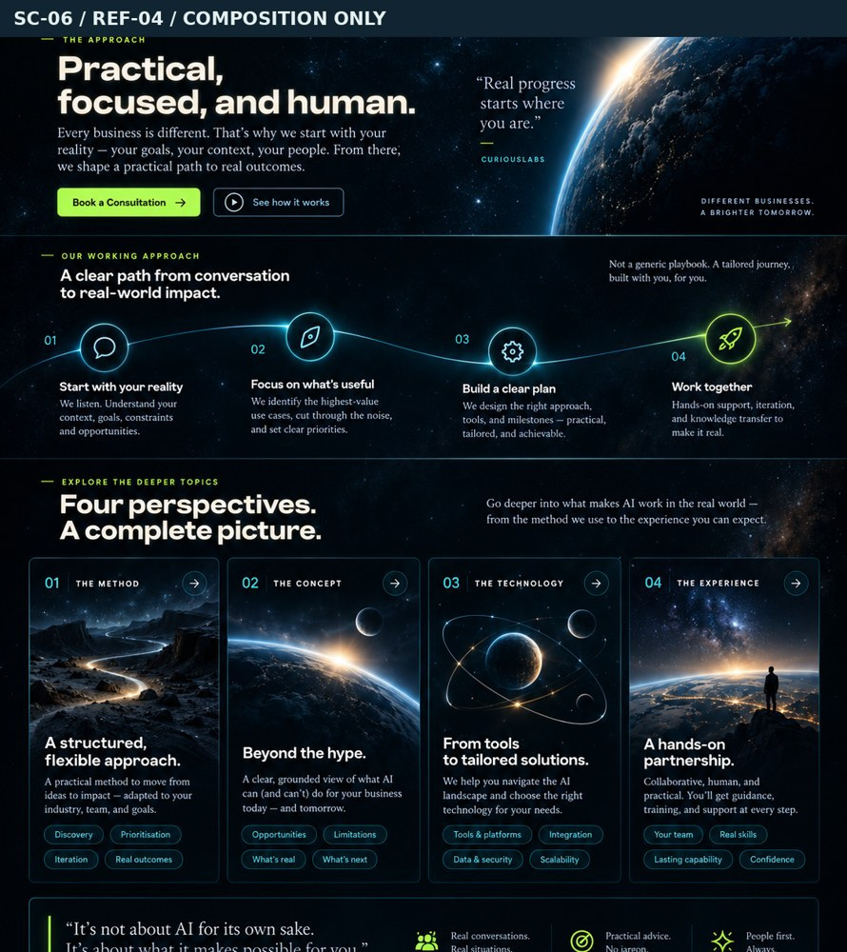  REF-04 · visual only | DESKTOP Opening statement and operator contrast above a luminous path. Four equal reading summaries across; expanded material stays in the document flow beneath its associated summary. Preserve reading identity and return path.  PHONE Short introduction, then a compact vertical/diagonal SVG rather than a tiny wide diagram. Reading summaries use two columns at 390px if readable and one column at 320px. Inline expansion is the default; a modal bottom sheet is not yet approved.

Tracked spaces
SPACE | DESKTOP PLACEMENT | PHONE PLACEMENT
SP-06-01  Approach headline + operator perspective | Open intro, not a full hero repetition. | Brief first block.
SP-06-02  Directed work / checking path | Wide luminous path with meaningful labels. | Compact vertical arrangement; no scaled-down illegible labels.
SP-06-03  Method reading: summary + full panel | One illustrated entry; panel opens in flow. | 2 columns if readable; 1 at 320px; panel full content width.
SP-06-04  Concept reading: summary + full panel | One illustrated entry; panel opens in flow. | 2 columns if readable; 1 at 320px; panel full content width.
SP-06-05  Technology reading: summary + full panel | One illustrated entry; panel opens in flow. | 2 columns if readable; 1 at 320px; panel full content width.
SP-06-06  Experience reading: summary + full panel | One illustrated entry; panel opens in flow. | 2 columns if readable; 1 at 320px; panel full content width.
SP-06-07  Close controls + in-page return behavior | Within each open topic. | Close never loses place or hides behind mobile browser UI.
SP-06-08  Approach horizon / chapter seam | Shallow art behind the introduction and transition. | Share/crop existing art; no duplicate tall mood block.

Assets: ART-06, ART-07, ART-08, ART-05 (reuse) | Visuals: VIS-04, VIS-05, VIS-07 | Motion: INT-05, INT-06, INT-09
Height targets: Desktop: 760–1020px closed. Phone: 780–1040px closed. Reading panels expand naturally; closed-page target excludes their length.
Acceptance Closed summaries already explain what each topic offers. Each opened topic adds information rather than repeating the operator sentence. All four hashes open their topic; close returns focus; multiple topics can remain open.
Hold / correction: The mockup’s generic four-step service journey is a composition reference, not a replacement for the operator-view content. Bottom sheets or single-open behavior need an explicit behavior change decision.
Source: SRC-02 §5; SRC-03 Q2–Q3/Q16. R1 method, R2 concept, R3 technology, R4 experience; no invented Maestro/Orchestrator/LEGIT detail. Code: Existing OperatorView, READINGS, native details and useConsultationPage.js; proposed ApproachScene.jsx + ReadingCard.jsx.
04 / READ-MORE CONTENT AND STATE CONTRACT

R1–R4 · What happens after a tap
The picture’s four reading cards are a visual invitation. The opened state must be designed as carefully as the closed state. Do not turn the same operator paragraph into four versions of “read more.”
READING | VISITOR QUESTION | WHAT THE OPENED PANEL ADDS | ASSETS
R1 / #method | What surrounds the prompt? | Context, stages, tools, handoffs and checks. Show how work is directed and reviewed. Use VIS-03 if it adds explanation rather than duplicating the contribution graphic. | ART-07 / VIS-03
R2 / #concept | What changes at a larger scope? | Contrast isolated requests with directing a whole undertaking. Explain relationships and decisions at a higher level. Not a bigger-prompt tutorial. | ART-06 / VIS-04
R3 / #technology | Where does trust need checking? | Describe useful capabilities and limitations in plain language. No ranking list, performance score or guarantee. Use a qualitative visual. | ART-08 / VIS-05
R4 / #experience | How do both sides connect? | Make the business-to-AI connection more specific than the biography summary, using only supplied facts. Do not invent a project result to add depth. | ART-05 / optional owner detail

Default states
STATE | DESKTOP + PHONE REQUIREMENT
Closed | Topic label, real question and illustration remain visible. Essential service meaning is already in the page.
Open | Associated content expands in normal document flow. Full-width phone reading area; no horizontal text scrolling. Multiple topics may remain open.
Direct link | Cold #method/#concept/#technology/#experience loads open the addressed topic and land below the navbar.
Close | Return focus to its own summary. Keep the visitor near the point where the topic was opened.
Reduced motion | Immediate state change; the same material is available. No animation-dependent explanation.
Optional future sheet | A modal bottom sheet changes the behavior contract: requires focus trap, Escape/close, background inertness, scroll restoration and deep-link/back handling. Not in the default build.

Content gate Maestro, Orchestrator mode, LEGIT and the planning principles remain undefined. The build can present supported introductory readings now; deeper named-method content needs the owner’s specification.
Implementation: preserve native details where practical. If tile layout requires a replacement, reproduce the existing hash, independent-open and focus behavior deliberately; do not assume the old hook will operate on new markup. [SRC-08]
SCROLL 5 · PROCESS / D7 / REF-05

SC-07 · From conversation to agreed work
Explain the real sequence and the distinction between the free discussion, proposal and paid deliverable.
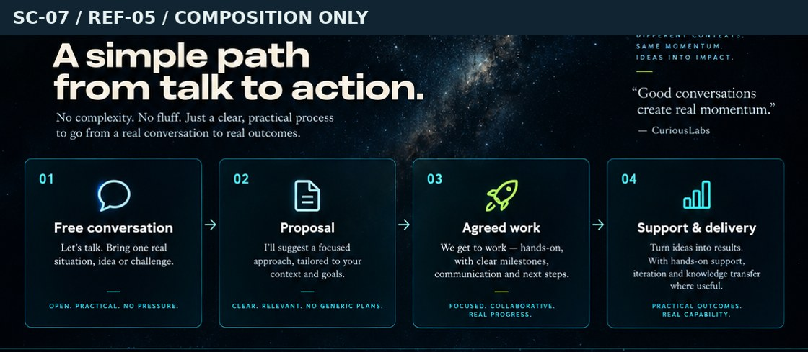  REF-05 · visual only | DESKTOP Horizontal rail: Discuss → Propose → Agree → Deliver. Each milestone has one short paragraph. Meeting summary belongs before proposal; report belongs to delivery.  PHONE A compact four-step list is visible to everyone. Richer step panels can use a native horizontal swipe track with previous/next buttons. Never require swiping to discover that agreement precedes work.

Tracked spaces
SPACE | DESKTOP PLACEMENT | PHONE PLACEMENT
SP-07-01  Engagement introduction | Above rail, brief. | Before compact step list.
SP-07-02  Discuss: free conversation | One rail milestone. | Listed name + reachable detailed panel.
SP-07-03  Propose: summary then scoped quote | One rail milestone. | Listed name + reachable detailed panel.
SP-07-04  Agree: contract and payment arrangements | One rail milestone. | Listed name + reachable detailed panel.
SP-07-05  Deliver: prepare materials, report and sessions | One rail milestone. | Listed name + reachable detailed panel.
SP-07-06  Luminous rail + document cues | Connects all four milestones. | Vertical/compact rail; rich panels optional swipe.
SP-07-07  Free / separately agreed boundary | Single sentence below rail. | Single compact statement, not another card stack.

Assets: No new raster required | Visuals: VIS-06 | Motion: INT-07
Height targets: Desktop: 420–560px. Phone: 430–590px closed. No pinned horizontal scrolling.
Acceptance The Agree milestone exists before preparation and delivery. No invented fee, service duration or deposit percentage is shown. Summary, proposal/quote and paid report are not presented as the same document.
Hold / correction: Do not copy the latest image’s “Agreed work → Support & delivery” simplification over the canonical process. “A few days” remains a soft intention, not a service deadline.
Source: SRC-02 §6; SRC-03 Q5/Q13. Free conversation → summary → scoped quote → confirmation/contract/payment → preparation/report/sessions/agreed support. Code: Existing FlowGraph; proposed EngagementScene.jsx and EngagementRail.jsx.
SCROLL 5 · REASSURANCE / D9 / REF-05

SC-08 · Questions before the conversation
Answer remaining practical concerns without repeating the whole page.
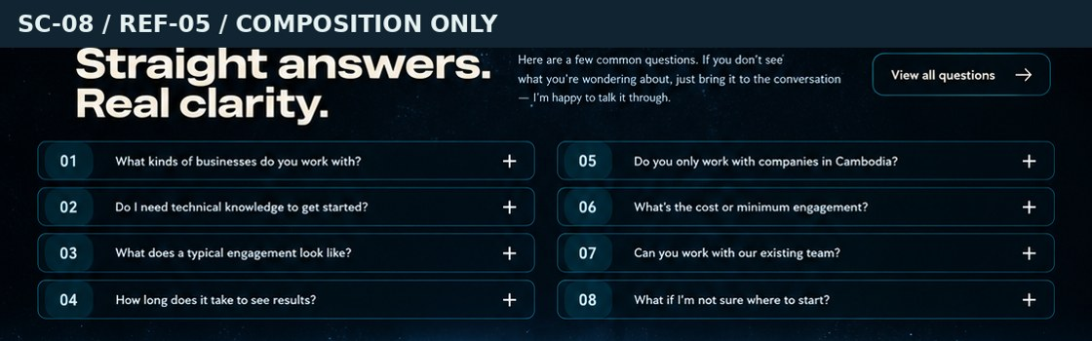  REF-05 · visual only | DESKTOP Grouped question summaries in two columns only when the reading order stays clear. Short answers open underneath. A real “all questions” control exposes the remaining set in the same page.  PHONE One column. Show a proposed first set of six high-value question titles; reveal the remaining questions with a labeled button. Each answer is an independent details element.

Tracked spaces
SPACE | DESKTOP PLACEMENT | PHONE PLACEMENT
SP-08-01  FAQ heading + short context | Editorial heading left, optional supporting sentence right. | Full width; no multi-line marketing preamble.
SP-08-02  Priority question summaries + answers | Grouped into logical columns. | First six titles proposed; independent expand/collapse.
SP-08-03  Remaining questions + reveal control | After initial groups, preserve all remaining entries. | “View all questions” exposes remaining items in place.
SP-08-04  Bridge to contact | One quiet #contact link. | No duplicate multi-step explanation.

Assets: No new raster required | Visuals: VIS-08 | Motion: INT-08, INT-09
Height targets: Desktop: 380–560px closed. Phone: 430–650px with the first six questions closed. Expanded content grows naturally.
Acceptance Every existing question is accounted for, retained or explicitly merged in the copy deck. Industry history and business-first hierarchy are corrected. “View all” is a real control and not a link to an invented resource page.
Hold / correction: The eight generated mockup questions are not an approved FAQ replacement. Do not publish guaranteed results timelines or a made-up minimum engagement.
Source: SRC-02 §7 plus all current QUESTION_GROUPS in SRC-04. Exact visible six and final answers require editorial approval; do not silently delete the rest. Code: Existing QUESTION_GROUPS and details; proposed QuestionsScene.jsx.
SCROLL 5 · CLOSE / D8 + FOOTER / REF-05

SC-09 · Final horizon and contact
End with an invitation into a real business conversation. Keep geography, spoken language and the pending-contact state honest.
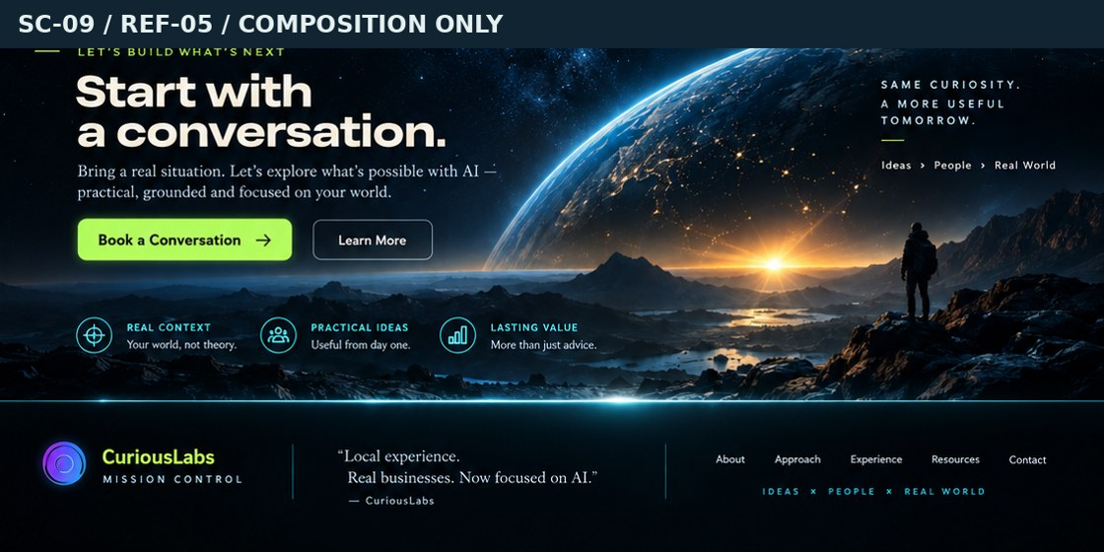  REF-05 · visual only | DESKTOP Copy on left, horizon low/right. In ready state, show actual messaging/email options with QR as secondary. In pending state, collapse the empty controls area into one clear, noninteractive status note.  PHONE Invitation and contact status first; then shallow horizon. In ready state, direct links precede QR. Never show a “Book” button without a booking service; no overlapping sticky action bar.

Tracked spaces
SPACE | DESKTOP PLACEMENT | PHONE PLACEMENT
SP-09-01  Final invitation + free boundary | Left half over dark sky. | First block; free versus separately agreed work stays clear.
SP-09-02  Earth-horizon return | Low/right, paired with opening art. | Shallow derivative crop, not a new full-screen poster.
SP-09-03  Pending contact state | One visible status note; no inert buttons. | Full width; collapse blank card spaces.
SP-09-04  Ready contact controls + QR | Approved Telegram / WhatsApp / email destinations only; QR secondary. | Direct taps first, QR secondary; Facebook only when supplied.
SP-09-05  Availability + spoken language | Below invitation. | Wrapping plain text, never clipped chips.
SP-09-06  Site footer / Home link | Existing shell footer, revised copy only. | Compact vertical stack.

Assets: ART-01 (reuse), ART-06 (optional reuse) | Visuals: VIS-08 | Motion: INT-09, INT-10, INT-11
Height targets: Desktop: 450–650px. Phone: 500–700px including a compact footer. Pending state may be shorter.
Acceptance Pending and ready states are tested separately; no dead icons or QR codes. Email copy/composer does not claim a message was sent or a meeting booked. Shared footer/nav match the site; no invented resources, signature or social accounts.
Hold / correction: No LinkedIn, calendar or destination copied from another page without approval. Contact is a launch blocker, not a reason to fabricate controls.
Source: SRC-02 §8; SRC-03 Q5/Q11/Q12/Q15. Phnom Penh/vicinity or online; regional travel by arrangement; destinations remain pending. Code: Existing D8 and shell footer; proposed ContactScene.jsx. Keep metadata cleanup in src/pages/ai-consultation.jsx.
05 / SC-00 AND DEFERRED SC-10

Shared spaces and the homepage seam
The cinematic pass belongs to the consultation page. It is not a navbar redesign, a new WebGL engine, a product-page rewrite or a repository-cleanup campaign.
SPACE | DESKTOP / SHARED RULE | PHONE RULE
SP-00-01  Existing navigation and skip link | Reuse MissionControlNavbar; do not copy mockup menu. | Existing mobile nav; skip link remains reachable.
SP-00-02  Shared cosmic background / section seams | One shared background, local overlays. | No new canvas or duplicate starfield.
SP-00-03  Global type / spacing / focus rules | Scoped .cl-consultation styles only. | 320px and text-resize fallback, visible focus.
SP-00-04  Page title / description / social metadata | Business-first approved wording; preserve noindex hold. | Same metadata; no duplicated implementation.
SP-00-05  Route and anchor integration | Preserve /ai-consultation and all canonical hashes. | Test cold deep links and browser Back.
SP-10-01  Homepage invitation panel | After existing moon-led opening, immediately before MoonSignalShowcase, per earlier seam; recheck before use. | Copy/action first; compact reused Earth crop.
SP-10-02  Homepage route links + regression | /ai-consultation and /ai-consultation#contact only; no product section replacement. | Existing home page still works and reads in order.

Preserve these links
/ai-consultation · #overview · #audiences · #contribution · #person · #approach · #engagement · #questions · #contact · #method · #concept · #technology · #experience

Implementation seams—not a mandatory file explosion
Keep ConsultationContent.jsx as the page composition. Extract scene modules when that makes the work easier to review. Reuse ConsultationIcons, the existing graph logic, and the shared background. The proposed names below are new seams, not a claim that those files already exist.
EXISTING | PROPOSED USE
ConsultationContent.jsx | Composition + scene order. Extract HeroScene, AudienceScene, WallsScene, ContributionScene, PersonScene, ApproachScene, EngagementScene, QuestionsScene, ContactScene as needed.
ConsultationGraphs.jsx | Retain or extract DoorVisual, MonolithVisual, HarnessSystem, OperatorPath and EngagementRail. Unique SVG IDs per instance.
consultation.css | All new selectors/tokens stay under .cl-consultation. A second scoped scene stylesheet is optional, not global :root.
ConsultationMotion.jsx / useConsultationPage.js | Adjust hero visibility and scene-specific motion; preserve hash/focus behavior and route cleanup.
src/pages/ai-consultation.jsx | Keep shell and noindex hold; update page metadata/footer with approved copy.

Homepage is deferred Recheck the source seam immediately before MoonSignalShowcase after the current moon-led opening. Use /ai-consultation and /ai-consultation#contact. No home edit until authorized; no duplicate hero orbital IDs.
06 / PRODUCTION RULES

Artwork: separate the picture from the page
The mockups are composition references, not production backgrounds. Do not use a screenshot with its headings, icons, face or buttons baked in. Every raster needs a clean image, a desktop crop and a phone crop.
STEP | DELIVERABLE | ACCEPTANCE
1 · Brief | ART ID + scene + reference + text-safe zone | Say what the image must not contain; identify whether it is fictional mood art or documentary place imagery.
2 · Source / create | Text-free master | No headings, logos, UI, fake consultant, signature or accidental client proof.
3 · Art-direct crops | Desktop and phone variants | Approve the two compositions independently. A centered desktop crop is not automatically the phone composition.
4 · Prepare files | Named exports + fallback + dimensions | Example: art-01-earth-desktop-1920.webp and art-01-earth-mobile-960.webp. These are proposed names, not existing assets.
5 · Integrate | Responsive picture/image + local scrim | Real text and controls remain on top; image bounds reserve their layout space; art failure has a readable fallback.
6 · Verify | Scene screenshots + approval record | Attach exact served files, source/rights, approved crops and the scene state evidence to the tracker.

Proposed load budgets—not benchmark results
Aim for a hero image at or below about 350KB on a phone and 600KB on desktop. Aim for secondary scene images at or below 200KB / 350KB respectively. A first-viewport image budget around 600KB and a mobile art total around 2.5MB are starting constraints, not measured site performance. Adjust only with documented visual/load evidence; do not reduce readability to meet a byte count.

Delivery naming and records
Serve assets from a consultation-only public directory, for example public/consultation/. Keep source masters and approvals outside the served bundle. Record dimensions, format, desktop/mobile file paths, source/rights, crop focal point, alt/caption decision, approver and date. Prefer reuse before creating a separate image for every panel.
What exists now Six reference mockups are included in the handoff pack. No new text-free art master, phone crop or finished scene has been generated or implemented in this task.
07 / ART-01–10

Artwork register · core scenes

ART-01 · Earth-at-night / Asia horizon
Core · Not started · SC-01; SC-09; SC-10 · REF-00; REF-05
DESKTOP SOURCE / CROP | PHONE SOURCE / CROP
2560×1440 starting master; web candidate 1920/2560 widths. | Separate 1080×1440 portrait crop; export 640/960 widths.

Text-safe zone: Dark left 50–55% on desktop; upper 55% on phone. Bright rim lower/right.
Production brief: Generate text-free mood art; no labels, borders, buttons, people or UI. Reuse as hero and final horizon; one source, separate crops.

ART-02 · Technical doorway vista
Core · Not started · SC-02 · REF-01
DESKTOP SOURCE / CROP | PHONE SOURCE / CROP
1000×1400 portrait source; crop into the outer third of door card. | 640×900 derivative; frame built as DOM, not baked typography.

Text-safe zone: Dark frame edge adjoining copy.
Production brief: Blue/cyan imagined city/space view; not a real office or client site. Door frame, glow and opening movement live in VIS-01.

ART-03 · Business doorway vista
Core · Not started · SC-02 · REF-01
DESKTOP SOURCE / CROP | PHONE SOURCE / CROP
1000×1400 portrait source paired with ART-02. | 640×900 derivative, equal prominence.

Text-safe zone: Copy-side edge remains dark.
Production brief: Warm/violet imagined business-city horizon, no factual location label. No people or company logos.

ART-04 · Three-walls terrain
Core · Not started · SC-03 · REF-01
DESKTOP SOURCE / CROP | PHONE SOURCE / CROP
2560×1200 landscape; clear midground for three DOM monoliths. | 1080×1440 alternative crop without tall empty foreground.

Text-safe zone: Text is on opaque monolith faces, not rock texture.
Production brief: Text-free rock terrain, small luminous path, no figures. The three walls remain real DOM/SVG shapes.

ART-05 · Verified Phnom Penh at night
Core · Not started · SC-05; SC-06 R4 · REF-03 composition only
DESKTOP SOURCE / CROP | PHONE SOURCE / CROP
2400×1600 source; subject matter and rights must be recorded. | 1080×1350 crop plus a short landscape phone cut.

Text-safe zone: Keep lights clear of any overlaid copy; use separate copy panel when necessary.
Production brief: Owner-supplied or licensed, verifiably Phnom Penh. No synthetic person pretending to be the consultant. Generated mood art must not be labeled documentary.
07 / ART-01–10

Artwork register · reuse, readings and held items

ART-06 · Dawn / Earth transition
Optional · Not started · SC-06 R2; SC-09 · REF-04; REF-05
DESKTOP SOURCE / CROP | PHONE SOURCE / CROP
Prefer derivative of ART-01; new 2400×1200 master only if distinct scene is needed. | 1080×1200 derivative; cap decorative vertical space.

Text-safe zone: Dark text zone above/left; sun below the reading line.
Production brief: Shallow chapter transition, not another redundant hero. Reuse before commissioning a new master.

ART-07 · Method reading / path through terrain
Optional · Not started · SC-06 R1 · REF-04
DESKTOP SOURCE / CROP | PHONE SOURCE / CROP
1200×800 source or derivative of ART-04. | 640×640 crop for reading summary.

Text-safe zone: No text in raster.
Production brief: A path illustrates sequence only; it must not suggest a defined proprietary method.

ART-08 · Technology reading / star field
Optional · Not started · SC-06 R3 · REF-04
DESKTOP SOURCE / CROP | PHONE SOURCE / CROP
Reuse shared space treatment; optional 1200×800 raster. | 640×640 derivative if used.

Text-safe zone: No labels; actual technology explanation remains HTML.
Production brief: Prefer a small live SVG orbital from VIS-05 over another large raster.

ART-09 · Real owner portrait
Deferred · Deferred · SC-05 · REF-03 is not likeness authority
DESKTOP SOURCE / CROP | PHONE SOURCE / CROP
Only after owner supplies/approves the photo and public identity. | Art-directed crop approved separately.

Text-safe zone: No synthesized stand-in, including a biography silhouette.
Production brief: Reserved slot has a city-only fallback and collapses gracefully.

ART-10 · Accurate regional map
Deferred · Deferred · SC-05 optional inset · REF-03 composition only
DESKTOP SOURCE / CROP | PHONE SOURCE / CROP
Approved, accurate geography and usage rights. | Omit by default.

Text-safe zone: Labels real HTML/SVG, verified boundaries.
Production brief: No generated national outline or unsubstantiated impact statistics.
No portrait substitute The earlier suggestion to use a silhouette in the biography is not adopted. Without an approved real portrait, use the person-free city composition or omit the photo space. Fictional imagery must not impersonate the consultant.
08 / VIS-01–09

Coded visual artifacts
These are reusable visual components, not nine new rendering engines. Prefer existing SVG/DOM and installed motion tools. Their words remain editable and their meaning remains available in the static state.
ID / VISUAL | DESKTOP DESIGN | PHONE / STATIC REQUIREMENT
VIS-01  Two doorway frames  SC-02 | Equal frames; simple 2D light/edge reveal; no WebGL door model. | Two names, reachable cards, same status on phone.
VIS-02  Three monoliths  SC-03 | Three legible fronts; light traces are decorative, not metrics. | Essential problem copy always visible; response opens explicitly.
VIS-03  Harness system  SC-04; SC-06 R1 | Use supported nodes: Context, Stages, Tools, Handoffs, Checks. Central work, no invented certifications or numerical reliability score. | Readable at 320px or replace radial layout with labeled vertical list.
VIS-04  Operator work path  SC-06 | Isolated requests versus directed, checked work. Labels describe concepts, not named methods. | Vertical alternative; static final state with reduced motion.
VIS-05  Technology / trust visual  SC-06 R3 | Qualitative explanation of trust and checking. No calibrated risk score or guarantee. | Readable paired statements rather than a tiny gauge.
VIS-06  Engagement rail  SC-07 | Discuss, Propose, Agree, Deliver. Distinct summary, quote and report cues. | All step names visible; detail panels optional swipe.
VIS-07  Four illustrated reading entries  SC-06 | One entry per R1–R4; expanded material adds depth. Preserve hashes and independent opening. | Two columns only while readable; full-width expansion.
VIS-08  Shared icons / UI marks  All | Reuse icon system, focus styles and directional arrows. No extra icon package. | Touch targets at least 44px by this plan’s acceptance target.
VIS-09  Chapter transitions  All | Scene-edge seams, optional short light wipe; never wipe away required text. | Static or subtle, no scroll interception.

The harness is the graphic center, not the sales headline
Within SC-04, VIS-03 can be larger than the side areas. The page still begins with business consultation and the person’s judgment. Keep the supported nodes—Context, Stages, Tools, Handoffs, Checks—and do not turn labels such as governance, measurement or security into new services or certifications.

Where an image is decorative
A decorative globe, light path or starfield does not need a second narrative competing with the copy. Omit it from the accessibility reading order. An explanatory diagram needs equivalent nearby HTML meaning, not a screenshot full of tiny text.
09 / INT-01–11

Interaction contracts · entry and depth

INT-01 · Hero readiness
DESKTOP | PHONE | REDUCED MOTION
Headline, intro, invitation and actions render fully visible. Decorative art may settle after them. | Same rule. No wait for scroll/IntersectionObserver. | Static art. All content present.

Check: Initial load, refresh, cold anchor return, reduced motion, slow asset load.

INT-02 · Two-door exploration
DESKTOP | PHONE | REDUCED MOTION
Subtle 2D light response on hover/focus; valid anchors or explicit detail controls only. | Native swipe/snap with named previous/next and visible two-name index; no vertical-scroll capture. | No animated door motion; manual navigation remains.

Check: Reach both doors by touch, mouse and keyboard; stacked 320px fallback.

INT-03 · Wall response
DESKTOP | PHONE | REDUCED MOTION
Explicit expand control reveals response. A visual flip may decorate the same state, not create duplicate accessible text. | Tap-to-expand; next/previous on track. No hover-only content. | Immediate open/close; static monoliths.

Check: Focus survives change; hidden face has no tab stops; all three topics reachable.

INT-04 · Harness emphasis
DESKTOP | PHONE | REDUCED MOTION
Draw connectors or highlight a node once. Optional short sticky contribution scene only after approval and fit checks. | No pinning. Diagram or readable list; explain selected node in HTML. | Final static network/list.

Check: Labels legible at 320px; effect paused offscreen; no invented method/metric.

INT-05 · Operator path
DESKTOP | PHONE | REDUCED MOTION
Short path draw as the art enters view; text is already readable. | Compact path, light progress only when appropriate. | Whole path visible immediately.

Check: No explanation depends on animation completion.

INT-06 · Deeper reading
DESKTOP | PHONE | REDUCED MOTION
Native inline details default. Open several topics; each full panel stays associated with its summary. | Inline drawer default. Bottom sheet is an unapproved alternative, not a second copy of the content. | Instant open/close; same information.

Check: Cold #method/#concept/#technology/#experience links, close-to-summary focus, keyboard and Back.
09 / INT-01–11

Interaction contracts · navigation and completion

INT-07 · Engagement sequence
DESKTOP | PHONE | REDUCED MOTION
Horizontal visual rail, ordered HTML list. No auto-advancing stages. | Four names visible; optional manual detail track with next/previous. | Static ordered list.

Check: Agree precedes Deliver; sequence visible without swiping; keyboard works.

INT-08 · Questions
DESKTOP | PHONE | REDUCED MOTION
Independent details; actual reveal-more button for additional questions. | Single column; no compressed two-column answers. | Instant state change.

Check: Every question remains available; “View all” works; no fabricated external resource.

INT-09 · Anchors / page movement
DESKTOP | PHONE | REDUCED MOTION
Keep existing canonical hashes and navbar offset. User scrolling cancels corrective deep-link movement. | Same, including orientation/browser toolbar changes. | No smooth travel.

Check: Cold deep links, existing #experience CTA, focus, keyboard and browser Back.

INT-10 · Contact pending → ready
DESKTOP | PHONE | REDUCED MOTION
Pending = explanation only. Ready = approved destinations plus optional QR. | Direct links first; QR secondary. Copy confirmation is specific and honest. | No change in functionality.

Check: No # dead links, unsupplied handles, hidden-but-focusable controls or false “sent/booked” notices.

INT-11 · Atmosphere / chapter motion
DESKTOP | PHONE | REDUCED MOTION
Local small parallax and edge wipes, never scroll hijack or text concealment. No new dependencies/3D. | Lower amplitude or static; normal vertical reading. | No parallax, pulsing, drawing, masks or sticky choreography.

Check: Check route cleanup, offscreen pause, no ongoing flashes, stable content dimensions.
The normal scroll always wins No auto-advancing carousel, blocking animation, wheel interception or mandatory pinned phone sequence. Richness comes from art scale, lighting, asymmetry and useful interaction—not a fight with the visitor’s scroll.
10 / PRESERVE MEANING WHILE CHANGING THE COMPOSITION

Copy gates before visual sign-off
This plan does not publish another copy deck. Every approved change belongs in COPY_DECK_v2.md and then in the relevant component. Image headings remain draft unless separately approved. These items track the known places where visual enthusiasm could otherwise create drift.
ITEM | SCENES | REQUIRED RESOLUTION
CP-01  Hero and audience entry | SC-01; SC-02 | Keep business-advisor-first and the junction. Both technical and non-technical companies are co-equal; not advanced vs beginner.
CP-02  First-person and scope | All | Replace fabricated agency “we”; consultation/planning/training is core. No automatic engineering, deployment, product strategy or go-to-market menu.
CP-03  Reliability and experience claims | SC-02; SC-03; SC-08 | Remove “every time,” unsupported factory operating history and implied prior AI engagements in every example industry.
CP-04  Person and local knowledge | SC-05 | Use 18 years exactly as residence/market experience, F&B and real estate, led hotels/restaurants, unnamed shareholding; no generated identity/signature.
CP-05  Method names and reading depth | SC-04; SC-06 | Keep only supported generic concepts. R1–R4 have distinct jobs; do not define Maestro, Orchestrator, LEGIT or planning principles.
CP-06  Engagement steps | SC-07 | Discuss → Propose → Agree → Deliver. Separate summary, quote and paid report. No fixed financial/service promises.
CP-07  Contact and language | SC-01; SC-09 | No Book calendar/LinkedIn or unsupplied channels. Spoken English/Khmer, not guaranteed bilingual written delivery.
CP-08  FAQ, titles and peripheral labels | SC-00; SC-08; SC-09 | Complete exact FAQ text in COPY_DECK_v2; bring metadata/footer/orbital labels into line. Preserve noindex until authorized.
CP-09  Artwork wording and proofs | All | Image slogans, “typical outcomes,” made-up quotes/logos and national-impact bands do not become approved copy. D6 remains omitted.

Copy ownership by scene
SC-01 → deck §1; SC-02/03 → §2; SC-04 → §3; SC-05 → §4; SC-06 and R1–R4 → §5; SC-07 → §6; SC-08 → §7 plus the full current FAQ; SC-09 → §8; SC-00 → approved metadata and footer wording.
No silent substitution The third wall is Reliability in the current source; “larger scope” is explanatory content pending refinement. The four engagement steps include agreement before delivery. Stronger visual approval changes neither fact.
11 / BOUNDED WORK PACKAGES

Build work · foundation and first scenes
Do not implement the whole picture in one unreviewable pass. Finish each scene in desktop and phone together, then add motion after the static meaning and geometry work. Owner roles below are implementation roles—not a public delivery team.
PACKAGE / DEPENDS | WORK | EXIT EVIDENCE
WP-01 · Pin baseline and copy holds  — | Record branch SHA, route, files, existing screenshots/measurements. Do not assume the 14,500px report was independently reproduced. | Baseline record; no code change.
WP-02 · Approve copy by scene  WP-01 | Resolve all CP items; keep COPY_DECK_v2 as source of truth. Geometry prototyping may proceed with labeled baseline copy. | Approved per-scene copy, including FAQ and metadata.
WP-03 · Approve reference-to-space mapping  WP-01 | Review SC-01–09, mobile transformations and omission decisions. Confirm visual direction without adopting image text. | Scene cards and DEC choices approved.
WP-04 · Art batch A: Earth / doors / walls  WP-03 | Prepare text-free ART-01–04 with separate desktop/mobile crops. | Approved masters, derivatives, rights/provenance records.
WP-05 · Art batch B: city / reading accents  WP-03 | Source verified ART-05; prefer reuse for ART-06–08. Keep portrait/map deferred. | Approved city and reading crops; no fictional identity.
WP-06 · Static semantic scene skeleton  WP-01; WP-03 | Refactor existing route in place; preserve D IDs/hashes, nav, footer, scope and native readings. | Every section visible without motion, desktop and phone.
WP-07 · Hero: visible-first + globe  WP-02 SC-01; WP-04; WP-06 | Install responsive art and scrim; remove content-gating reveal behavior only where needed. | SC-01 desktop + phone screenshots and first-load checks.
WP-08 · Two doors + three walls pilot  WP-02 SC-02/03; WP-04; WP-06 | Use these as the vertical slice for visual language and touch interactions. | SC-02/03 at 1440 and 390, all cards/expansions tested.
WP-09 · Contribution and harness  WP-02 SC-04; WP-06; WP-08 | Build asymmetric scene and lightweight VIS-03; no service-menu drift. | SC-04 default plus mobile and reduced-motion states.

First visual slice Two doors + three walls is the test scene for dramatic art and responsive controls. Review that slice before multiplying its pattern across the rest of the page.
11 / BOUNDED WORK PACKAGES

Build work · completion and release review
Do not implement the whole picture in one unreviewable pass. Finish each scene in desktop and phone together, then add motion after the static meaning and geometry work. Owner roles below are implementation roles—not a public delivery team.
PACKAGE / DEPENDS | WORK | EXIT EVIDENCE
WP-10 · Person and local context  WP-02 SC-05; WP-05; WP-06 | Editorial city scene; business background before AI detail; approved spoken-language wording. | SC-05 with city-only fallback and R4 link check.
WP-11 · Approach and all four readings  WP-02 SC-06; WP-05; WP-06 | Build VIS-04/05/07; preserve independent details and deep-link behavior. | R1–R4 closed/open/closed screenshots plus keyboard record.
WP-12 · Engagement, questions and contact  WP-02 SC-07/08/09; WP-06 | Canonical four steps; complete FAQ; honest contact pending state. | SC-07–09 verified with all primary in-page links.
WP-13 · Responsive / state pass  WP-07…WP-12 | Check 320/390/768/1024/1440, text resize, no overflow, deep links and contacts. | Viewport/state acceptance record, not just hero captures.
WP-14 · Motion and atmosphere pass  WP-13 | Add INT effects after static scenes pass; optional sticky trial only if DEC-02 approved. | Normal/reduced-motion parity; no hidden content.
WP-15 · Asset / load / regression pass  WP-13; WP-14 | Optimize served derivatives, check no art-load shift and no global style or homepage regressions. | QA evidence at representative widths and load conditions.
WP-16 · Real contact wiring  DEC-05; WP-12 | Only supplied destinations; test on desktop and phone. Facebook remains absent until supplied. | Ready contact state, QR validation if included.
WP-17 · Owner approval and release review  WP-02…WP-16 | Review copy, desktop, phone, reduced motion and QA evidence. Ask before any git/commit/push; no automatic publishing. | Explicit approval and release instruction.
WP-18 · Homepage invitation later  WP-17; DEC-07 | Reuse approved Earth/copy in the agreed seam; do not replace the existing opening or MoonSignal. | Homepage + destination regression review.

Repository rules Use the owner’s existing localhost:5173 session; do not start another server. PowerShell uses semicolons, not &&. No git commands, commits, pushes, deletion or publication without instruction. Review at a coherent checkpoint before an agreed build—not after every small tweak.
12 / QA-01–35 · ALL UNTESTED AT HANDOFF

Acceptance checks · content and layout
A scene is not verified because a screenshot looks plausible or a DOM measurement fits. Capture the real state, test the interaction, and attach a path or link to the evidence. Desktop and phone are independent gates.
CHECK | PASS CONDITION | SCOPE
QA-01  Source / scope | Record baseline SHA and inspect current tree before future edits; do not overwrite unpublished local work. | All
QA-02  Copy | Final scene wording matches approved COPY_DECK_v2 and locked hierarchy; CP-01–09 resolved. | All
QA-03  Claims | No fabricated portraits, signatures, case studies, factory history, performance figures or guarantees. | SC-02/03/05/08
QA-04  Initial visibility | Hero headline, lead, invitation, actions and meta visible without scrolling. | SC-01
QA-05  Desktop visual | Capture every scene at 1440×900 and confirm composition, crop and distinct rhythm. | All
QA-06  Phone visual | Capture every scene at 390×844; same information available, no tiny desktop diagrams. | All
QA-07  Narrow phone | 320×568: no horizontal document overflow, all touch controls readable/reachable. | All
QA-08  Tablet | 768×1024: intentionally stacked/two-column layouts, no half-desktop collisions. | All
QA-09  Small desktop | 1024×768: no heading/diagram/card overlap; wide art still has text-safe zone. | All
QA-10  Large desktop | 1920×1080: content stays bounded while art may bleed beyond it. | All
QA-11  Text enlargement | At 200% zoom/enlarged text, no clipped labels or locked scene heights; overflow transforms to stacked layout. | All
QA-12  Reading order | Keyboard and assistive order follow the narrative; only one h1, clear section landmarks. | All
QA-13  Focus | Visible focus on every control; close returns focus; hidden details contain no reachable hidden controls. | All
QA-14  Door track | Both audiences reachable by keyboard, touch and previous/next; vertical page scrolling never trapped. | SC-02
QA-15  Wall response | Each problem and response can be consumed without hover; no duplicate exposed front/back text. | SC-03
QA-16  Harness diagram | Nodes readable at 320px or replaced with equivalent labeled list; no false gauges. | SC-04
QA-17  All readings | Open/close R1–R4 individually and more than one at once; expanded panel adds distinct information. | SC-06
QA-18  Cold reading links | Direct load and refresh #method, #concept, #technology, #experience land/open correctly. | SC-06

12 / QA-01–35 · ALL UNTESTED AT HANDOFF

Acceptance checks · behavior and delivery
A scene is not verified because a screenshot looks plausible or a DOM measurement fits. Capture the real state, test the interaction, and attach a path or link to the evidence. Desktop and phone are independent gates.
CHECK | PASS CONDITION | SCOPE
QA-19  Section links | Direct load and click #overview/#audiences/#contribution/#person/#approach/#engagement/#questions/#contact. | All
QA-20  Navigation history | Back/forward and close do not strand focus or fight user scroll; titles clear navbar. | All
QA-21  Engagement order | Discuss/Propose/Agree/Deliver and three document types match Q13. | SC-07
QA-22  FAQ retention | Every baseline question is retained or explicitly approved as merged; reveal-all works. | SC-08
QA-23  Pending contacts | No dead icons, booking/calendar claims, QR placeholders or # links that pretend to contact. | SC-09
QA-24  Ready contacts | Approved email and messaging destinations work; copy feedback accurate; QR resolves to same destination. | SC-09
QA-25  Reduced motion | Full information, static final art, no parallax/path drawing/sticky sequence required. | All
QA-26  Art failure | Disable or fail a background request; content, layout, controls and contrast remain usable. | All
QA-27  Image provenance | Record approved source, generation or license, crops, dimensions, alt/caption choice. Verify any named place. | All artwork
QA-28  Load budget | Check hero prioritization, below-fold lazy loading, explicit image dimensions, and per-viewport transferred art. | All
QA-29  Runtime / cleanup | No new runtime errors; motion listeners/observers clean up on route changes; no extra dependencies or global tokens. | All
QA-30  Contrast / touch | Actual art-backed text remains legible. Target 4.5:1 body, 3:1 large text; controls at least 44×44px under this plan. | All
QA-31  Real phone | Owner/device check on Safari iOS and/or Android browser; label emulator-only checks accurately. | All
QA-32  Screenshot blanking | If capture blanks below fold, record capture failure, inspect viewport state and get real-browser evidence; JS dimensions alone cannot mark visual QA passed. | All
QA-33  Home regression | Existing homepage/product/nav unchanged. If shared backdrop is adjusted, verify / and /ai-consultation. | SC-00/10
QA-34  Metadata / publication | Page title, description, social preview and footer agree with approved copy; noindex remains until owner authorizes removal. | SC-00/09
QA-35  Owner review | Owner approves desktop, phone, key interactive states and open issues before any commit/push/release instruction. | All

Capture failures are not passes When below-fold screenshots blank, label the visual check blocked. Inspect live viewport state and obtain a real-browser capture or owner observation. JS dimensions support layout checks but do not prove that art, contrast or content painted correctly.
13 / WORKING CONTROL PAGE

Decisions, progress and next handoff
DECISION | WORKING DEFAULT / HOLD | IMPACT
DEC-01  Approved wording per scene  Pending | Use SRC-02 as working baseline; approve CP-01–09 before release. Image text is not authority. | Copy sign-off; do not restart positioning.
DEC-02  Dramatic motion / pinning  Proposed default | Dramatic imagery and local motion; no pinned scene initially. At most one short contribution sticky trial after static mobile passes. | No scroll hijacking or content hidden behind animation.
DEC-03  Reading drawer behavior  Proposed default | Inline, independent accessible readings on both layouts. Bottom sheets are optional later, not automatically approved. | Preserve hashes, keyboard and return-to-summary behavior.
DEC-04  Person imagery  Pending asset | Verified person-free city image now. Actual portrait only after explicit owner supply/approval. | Portrait absence does not block city-only design.
DEC-05  Contact destinations  Blocked | Owner supplies actual Telegram / WhatsApp / email. Facebook only when created. | Blocks live contact conversion and launch, not scene prototyping.
DEC-06  Regional map / national-impact band  Deferred | Omit generated geography and impact claims. Add only a sourced, approved map if it earns its space. | No reserved empty gap in the page.
DEC-07  Homepage invitation integration  Deferred | Do after the dedicated page is approved and separately authorized; preserve existing moon opening. | Recheck the MoonSignalShowcase seam before editing.
DEC-08  Mobile length / visible FAQ set  Proposed default | 8–10 screens at 390×844 closed is a planning budget, not a hard limit. Start with six FAQ titles and keep all others reachable. | No text clipping or hidden essential meaning to hit the number.

How the tracker is used
Scene IDs stay fixed. Assign a work owner. For each space, advance copy, artwork, desktop, mobile and QA independently. Use Notes for exceptions; use Evidence for the actual file or review receipt. Do not mark a reused component “done” until the new composition has been rechecked.
Working status vocabulary: Not started → In progress → For review → Approved / Done; Blocked and Deferred remain explicit. QA uses Not tested / Pass / Fail / Blocked / Not applicable. Optional held assets do not pretend to block the entire base design.
Definition of a completed scene Approved copy and artwork; no open mandatory dependency; desktop and mobile accepted; normal and reduced-motion behavior checked; evidence attached; owner review recorded. A visually approved mockup alone meets none of the implementation gates.

Next concrete action
Review the scene map and mobile transformations, then approve the first asset batch and the two-doors/three-walls vertical slice. Keep the copy pass moving scene by scene in parallel; do not restart the positioning.
14 / TRACEABILITY

Source and reference register
The three copy authorities were re-read in the requested order for this plan. The main branch read returned the same pinned commit. Reading/hash and motion files were also re-read. Other code descriptions use the explicit source review already present in this conversation; no browser or local-working-tree parity is claimed here.
SRC-01 · Locked intent and voice
Docs_v8/page_Consultation/_FRAMING_LOCKED.md
Meaning and boundaries. Wins over earlier documents and image text.
SRC-02 · Current copy deck
Docs_v8/page_Consultation/COPY_DECK_v2.md
Wording baseline, not blanket approval of every existing line. Corrections still need approval.
SRC-03 · Owner discovery answers
Docs_v8/page_Consultation/DISCOVERY_ANSWERS_Q1-Q18.md
Service, recipients, process, languages, geography and publication holds.
SRC-04 · Page content
src/components/consultation/ConsultationContent.jsx
Existing sections, FAQs and readings at the pinned cut; earlier source review in this conversation.
SRC-05 · Current visual components
src/components/consultation/ConsultationGraphs.jsx
StatTrio, OperatorView, HarnessGraph, TrustSpectrum and FlowGraph; source review in this conversation.
SRC-06 · Page CSS
src/components/consultation/consultation.css
Existing scoped styling; exact new geometry below is proposed, not measured.
SRC-07 · Page shell
src/pages/ai-consultation.jsx
Navbar, background, metadata, noindex and footer; source review in this conversation.
SRC-08 · Reading and hash behavior
src/components/consultation/useConsultationPage.js
Re-read for this plan: native details, deep links, focus return and user-scroll priority.
SRC-09 · Motion primitives
src/components/consultation/ConsultationMotion.jsx
Re-read for this plan: Reveal, Stagger, KineticHeading, Parallax and reduced-motion branches.
SRC-10 · Earlier integration handoff
Docs_v8/page_Consultation/NEXT_PASS_HANDOFF.md
Reference only for scope and homepage seam; not current copy authority.

Conversation basis
Owner approval: globe-led hero; later request for more dramatic lower-page scenes; latest request for a tracked desktop/mobile plan. Pasted design-agent observations are attributed reports, not independent tests. Earlier dossier/wireframe wording is subordinate to the locked framing. Old cleanup and contract-system uploads are not the authority for this page.
Artifact state: Word/Markdown plan and tracking workbook created locally. No repository file, source copy, dependency, branch, local server or live page was changed by this task.
15 / INDEX OF THE SUPPLIED MOCKUPS

The six visual references
These thumbnails identify the pictures behind the plan. The handoff pack contains the full reference files. They are not production artwork. Generated wording, figures and controls remain subject to the explicit holds in the scene cards.
REF-00 · Earth hero  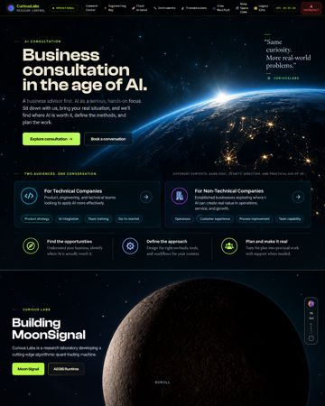  Opening globe, black negative space, cream type, lime action. Ignore generated copy and altered homepage placement. | REF-01 · Two doors and three walls  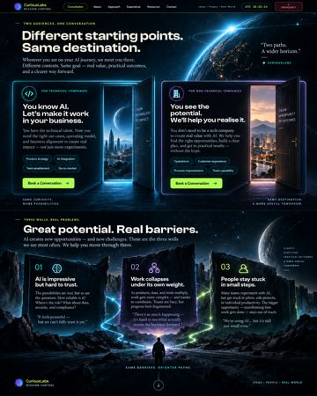  Equal cyan/warm doors; rocky monolith landscape. Ignore invented services and pronouns.
REF-02 · Three areas / harness centerpiece  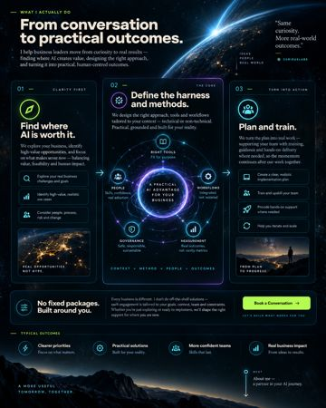  Larger center visual flanked by two narrower areas; tailoring band. Not a service menu. | REF-03 · Person / Cambodia  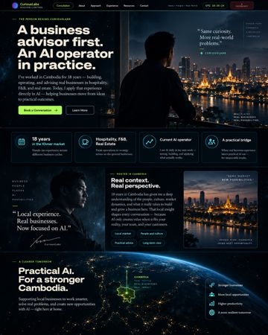  Editorial city composition and credibility bands only. Generated portraits, signatures and geographic map are NOT approved.
REF-04 · Approach / deeper reading  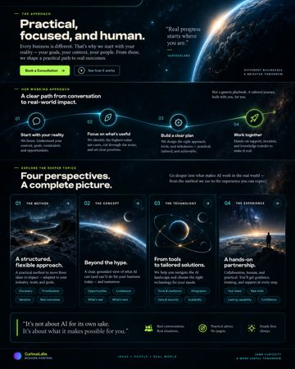  Luminous path and four illustrated reading entries. Image text does not define the methods. | REF-05 · Engagement / FAQ / final horizon  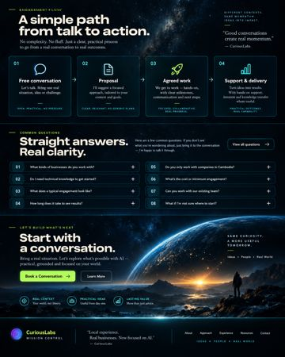  Connected steps, quiet questions, Earth-horizon close. Keep canonical agreement step; no booking controls.

