WORLDS AT A GLANCE
V05 | A short visual survey
6 comparisons / 18 quick choices / about 10-15 minutes (estimate).
Look at A and B. Some pages show world images; others show world organization.
For each row, replace [choose] with A, B, Same, or Not sure.
Same means no preference. Not sure means you cannot judge from the pictures.
Judge only what is shown. More rooms or more detail is not automatically better.
Structure pages: each box is a place; icons count people and large props. Boxes do not show walking routes.
Before you start
[ ] I am 18 or older.
[ ] I can understand these English questions.
[ ] I have read this page and agree to take part voluntarily.
If any of these is not true, please stop.
Have you worked on this system or seen its detailed results? [ ] No [ ] Yes [ ] Not sure
Your choices are used for research summaries. Do not enter your name. You may stop or withdraw by code through the inviter; withdrawal may not be possible after publication. Ask the inviter about storage, payment, and return arrangements.
Save this file and return it to the inviter. Fill only one Word / PDF / print copy.
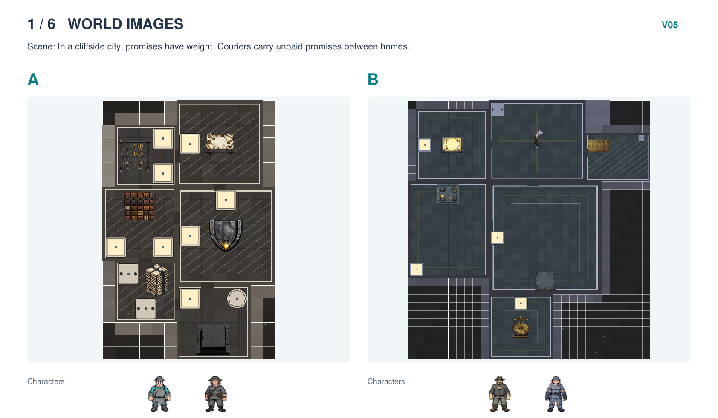
Which world would you rather explore? | [choose]
Which map is easier to read? | [choose]
Which characters fit their world better? | [choose]
Choices: A / B / Same / Not sure
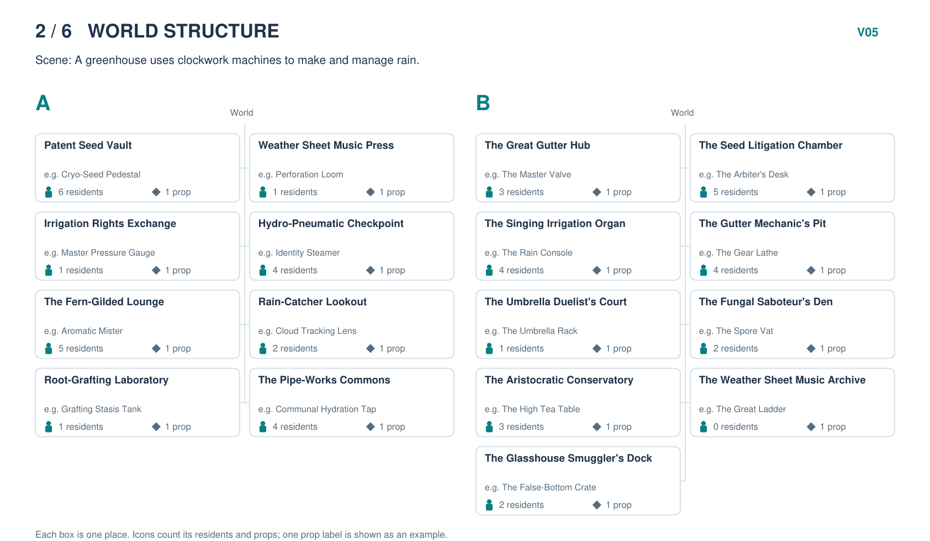
Which world would you rather explore? | [choose]
Which world is easier to understand? | [choose]
Which places fit the scene better? | [choose]
Choices: A / B / Same / Not sure
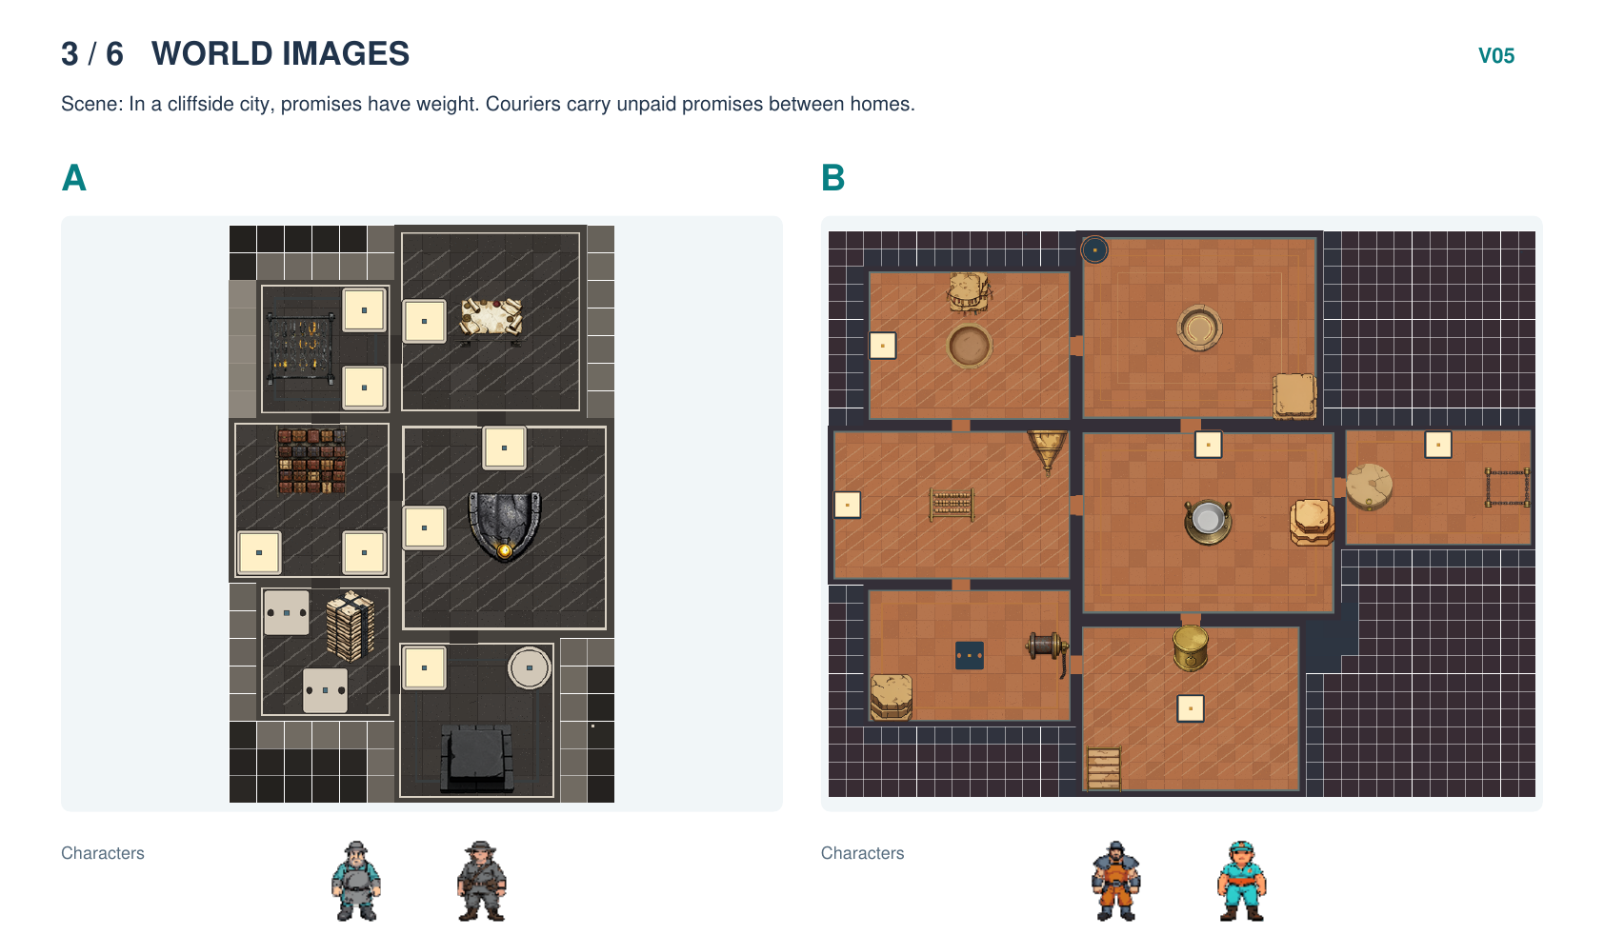
Which world would you rather explore? | [choose]
Which map is easier to read? | [choose]
Which characters fit their world better? | [choose]
Choices: A / B / Same / Not sure
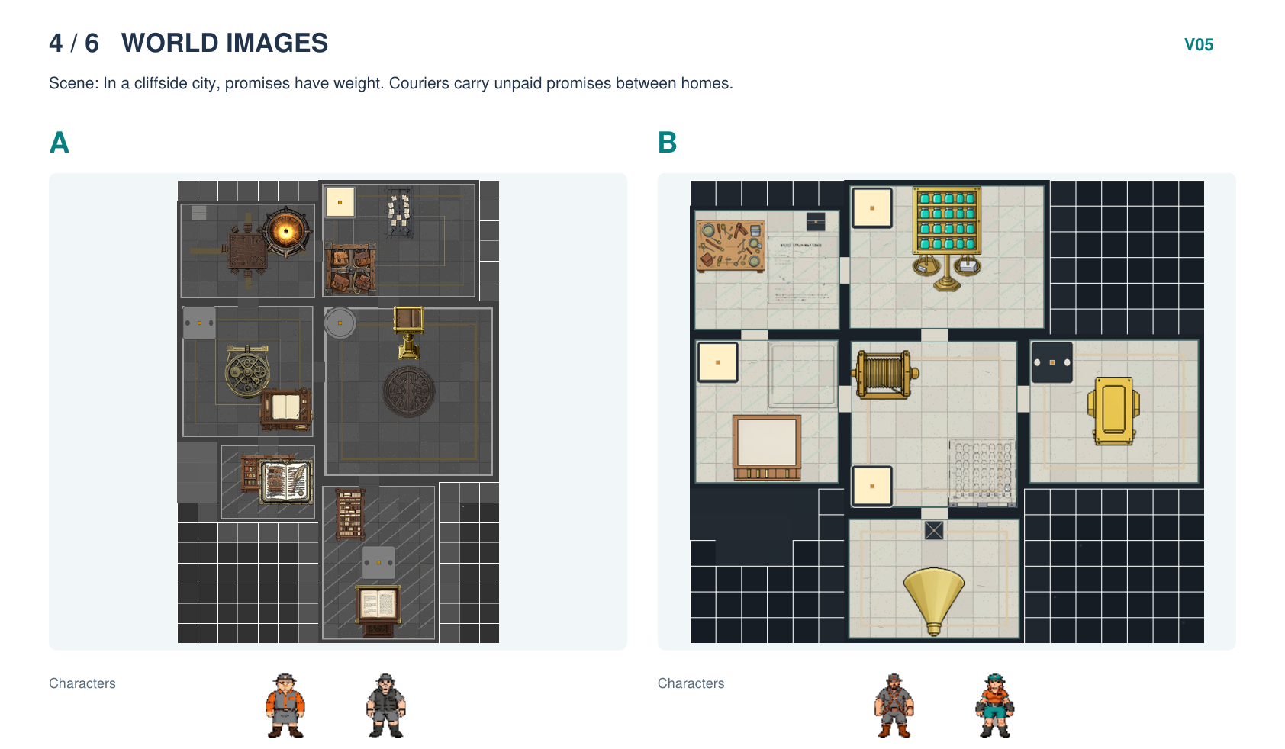
Which world would you rather explore? | [choose]
Which map is easier to read? | [choose]
Which characters fit their world better? | [choose]
Choices: A / B / Same / Not sure
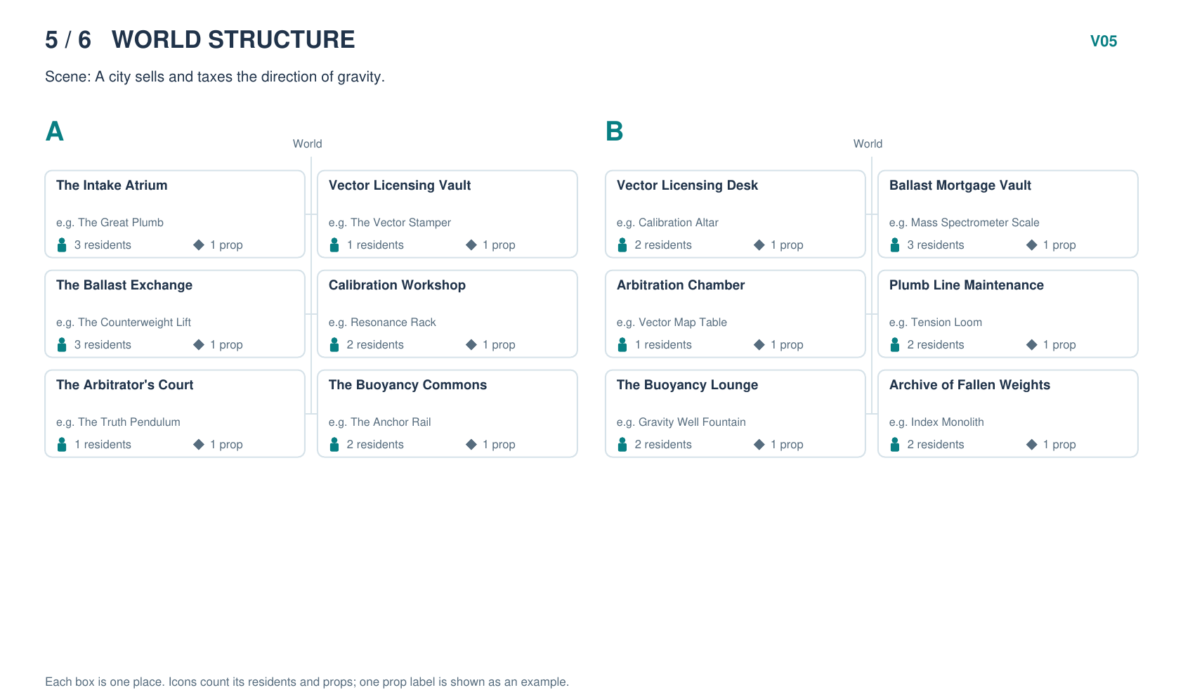
Which world would you rather explore? | [choose]
Which world is easier to understand? | [choose]
Which places fit the scene better? | [choose]
Choices: A / B / Same / Not sure
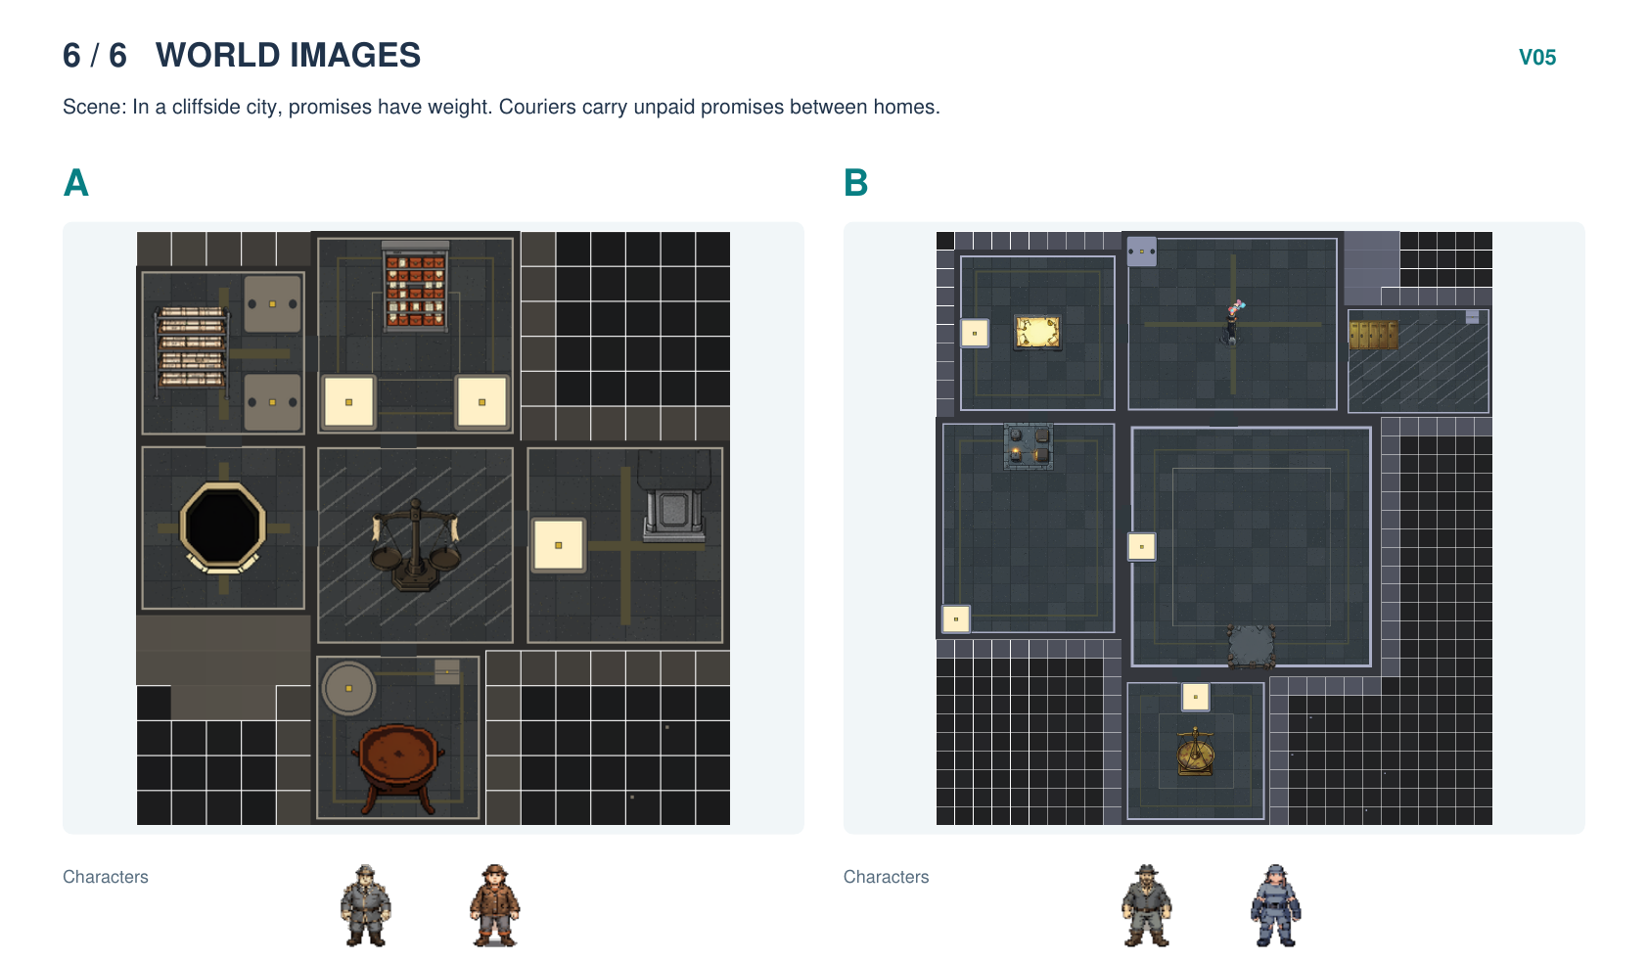
Which world would you rather explore? | [choose]
Which map is easier to read? | [choose]
Which characters fit their world better? | [choose]
Choices: A / B / Same / Not sure

