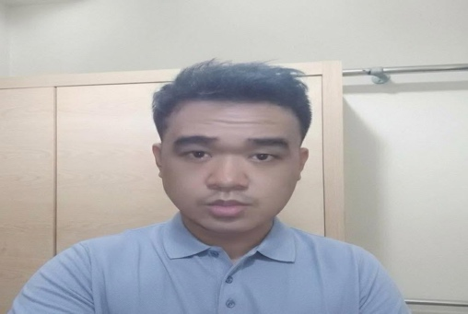
TAKAI MACUTO
Quezon City, Philippines
tam.azurin@gmail.com
09615969615

OVERVIEW  Experienced professional with a diverse background in customer service, technical support, training and digital marketing. Adept at providing exceptional service and assistance to customers, leveraging strong communication and problem-solving skills. Skilled in cross-training across multiple lines of business, ensuring comprehensive knowledge of campaign processes. Recognized for delivering engaging training sessions, fostering a collaborative learning environment, and contributing to team success. Possesses a strong work ethic, adaptability, and a customer-centric mindset. Proven ability to excel in fast-paced environments and contribute to organizational growth.  EDUCATION  Computer Secretarial  Anunciata Training and Formation Center, Quezon City – 2008 – 2011  SUMMARY QUALIFICATION  - Executive & Client Communication Support  - Documentation, Process & Project Follow-Up  - Cross-Functional Coordination Across Multiple Workstreams  - Digital Marketing Operations (Meta Ads, CRM, Campaign Reporting)  - Google Workspace & Remote Collaboration Tools (Slack, Zoom)  SKILLS  Ad Tech & Campaign Setup  Meta Pixel & CAPI  CRM Integrations (Salesforce, HubSpot, GoHighLevel, Shopify, WordPress)  GA4 & Google Tag Manager  Performance Analysis  Technical Troubleshooting  Client Communication  Process Documentation  Adobe Creative Suite  Git, MySQL (Foundational), Notion  CERTIFICATIONS  Meta Certified Professional  Meta Blueprint  Accenture Agentic AI Certification  CHARACTER REFERENCE  Ville Lloyd Mari – Foundever Team Leader  Phone#:09778279588  Email: stiles0721@gmail.com  Ryzel Nonirafa – Hewett Packard Team Lead  Phone#: 09157190983  Email: Ryzel121992@gmail.com  Mariel Elip – Team Leader – Telus  Phone#: 09688705135  Email: mariel.elip14@gmail.com | WORK EXPERIENCE  Sales Inside Analyst CL11 – Digital Marketing, Accenture,  Accenture Philippines - Project Meta, Quezon City January 2023| Currently  - Skilled in creating and managing Meta Ads campaigns from scratch, including campaign setup, audience targeting, performance analysis, reporting, and optimization across multiple ad objectives.  - Designed and implemented end-to-end lead nurturing workflows, integrating CRMs with email marketing platforms to increase engagement and conversion rates.  - Expert in Meta Pixel and Conversions API (CAPI) setup, configuration, and troubleshooting to ensure accurate event tracking and attribution.  - Proficient in deploying tracking pixels and conversion APIs across multiple platforms, including HubSpot, GoHighLevel, WordPress, Customer.io, and Stape.  - Advanced user of Google Tag Manager and GA4, building custom tags, triggers, and events for granular performance tracking and analytics.  - Built automated sales funnels and CRM workflows to optimize lead generation, nurturing, and revenue performance.Certified Meta Professional; Accenture Agentic AI certified.  Technical Support  Hewlett Packard (HP) via Foundever/Sitel, Philippines | October 2019 - January 2023  - Managed technical account relationships for US and Canadian B2B and B2C customers, providing hardware and software support with a high first-contact resolution rate.  - Delivered product configuration, installation, and maintenance guidance, ensuring optimal device performance and customer satisfaction.  - Drove incremental revenue through consultative upselling and cost-effective solution recommendations tailored to client needs.  Customer Service Associate - Financial Accounts  Telus International, Quezon City | August 2016 - March 2019  - Processed financial transactions and resolved complex account inquiries with strict confidentiality.  - Promoted banking products and services, contributing to customer engagement and retention targets.  Non-BPO Experience Sales Assistant  Lotte Confectionery Corp, Pasig City | March 2015 - August 2016  - Processed transactions and kept the sales floor organized and well-stocked.  - Facilitated monthly and quarterly physical inventory counts.  - Sold products B2B, recommending merchandise based on client needs.  - Computed sales prices, totaled purchases, and processed payments.  - Managed sales invoices.  Customer Service Associate – Smart Broadband  Smart Telecommunication, Quezon City | March 2014 – March 2015  - Address members' concerns and provide solutions.  - Respond to inquiries regarding OTC benefits.  - Assist members with placing orders for OTC items via telephone.  Data Lifter/Back Office  Imagenet Philippines Inc, Valero Tower Makati | July 2011 - March 2014  - Validating the medical information of patients  - Review data for deficiencies, correct any incompabilities & check output.  - Secure information by using data base backups,  - Prepare and manage correspondence, reports and documents  - Answer queries through telephone and email.
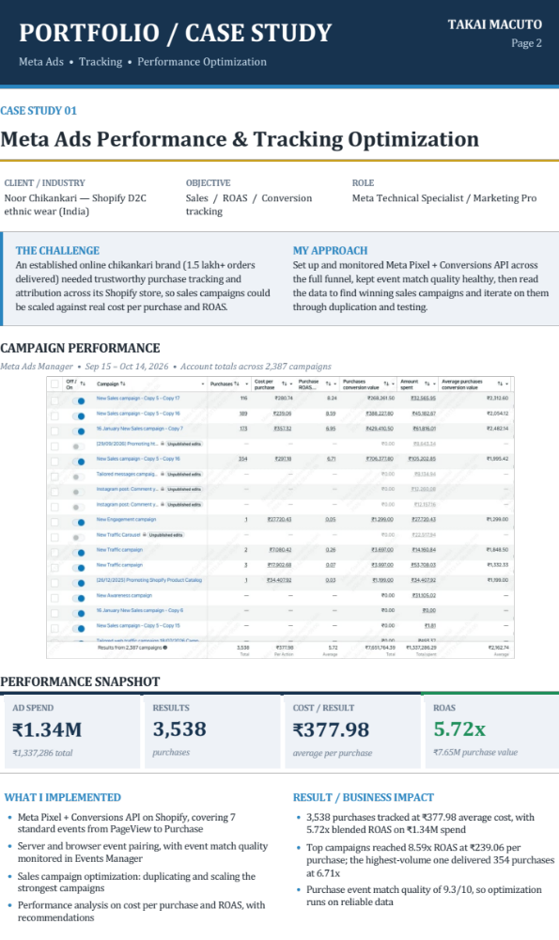

PORTFOLIO / CASE STUDY 1  TRACKING & RESULTS DETAIL  Events Manager • Funnel health • Top campaigns | TAKAI MACUTO  Page 3

CASE STUDY 01 • CONTINUED

EVENTS MANAGER — PIXEL + CONVERSIONS API
Dataset overview • Sep 11 – Oct 8, 2026 • event volume and event match quality (EMQ)
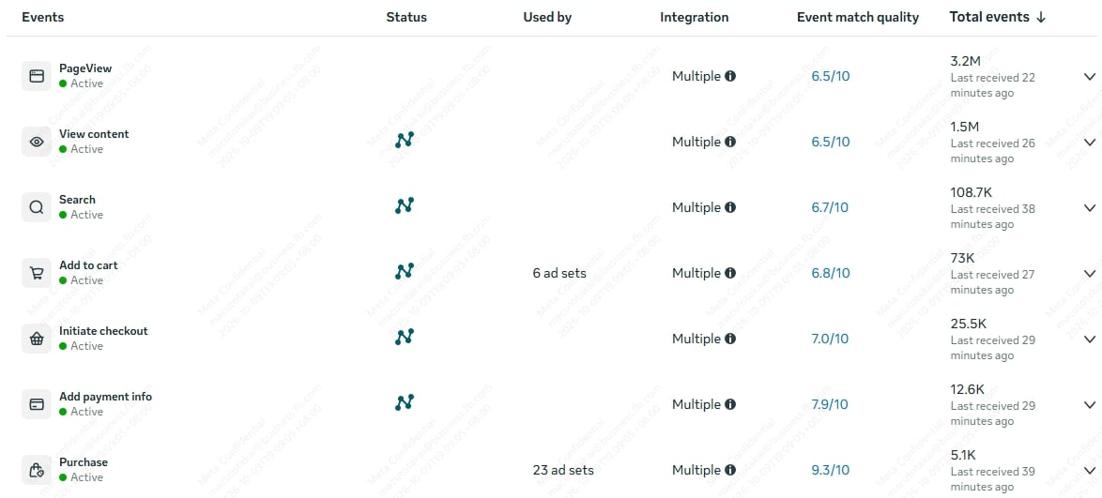

FULL-FUNNEL EVENT COVERAGE
Bar length is log-scaled so the whole funnel is readable. Score = event match quality (out of 10).
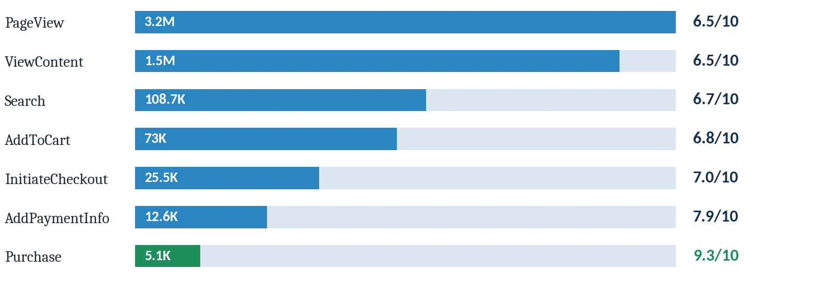

TOP SALES CAMPAIGNS (Sep 15 – Oct 14, 2026)
Campaign | Spend | Purchases | Cost / purchase | Purchase value | ROAS
Sales campaign A | ₹105,203 | 354 | ₹297.18 | ₹706,378 | 6.71x
Sales campaign B | ₹45,183 | 189 | ₹239.06 | ₹388,228 | 8.59x
Sales campaign C | ₹61,816 | 173 | ₹357.32 | ₹429,411 | 6.95x
Sales campaign D | ₹32,566 | 116 | ₹280.74 | ₹268,262 | 8.24x
Figures shown as reported in Meta Ads Manager (INR). Campaign names are generalized.
KEY TAKEAWAYS

- Reliable end-to-end tracking is what makes ROAS-based scaling decisions possible.
- Event match quality improves down the funnel, peaking at 9.3/10 on Purchase, the event the algorithm optimizes for.
- Campaigns were judged on cost per purchase and ROAS together, not volume alone.

PORTFOLIO / CASE STUDY 2  Meta Ads • Lead Generation • Conversion Tracking | TAKAI MACUTO  Page 4
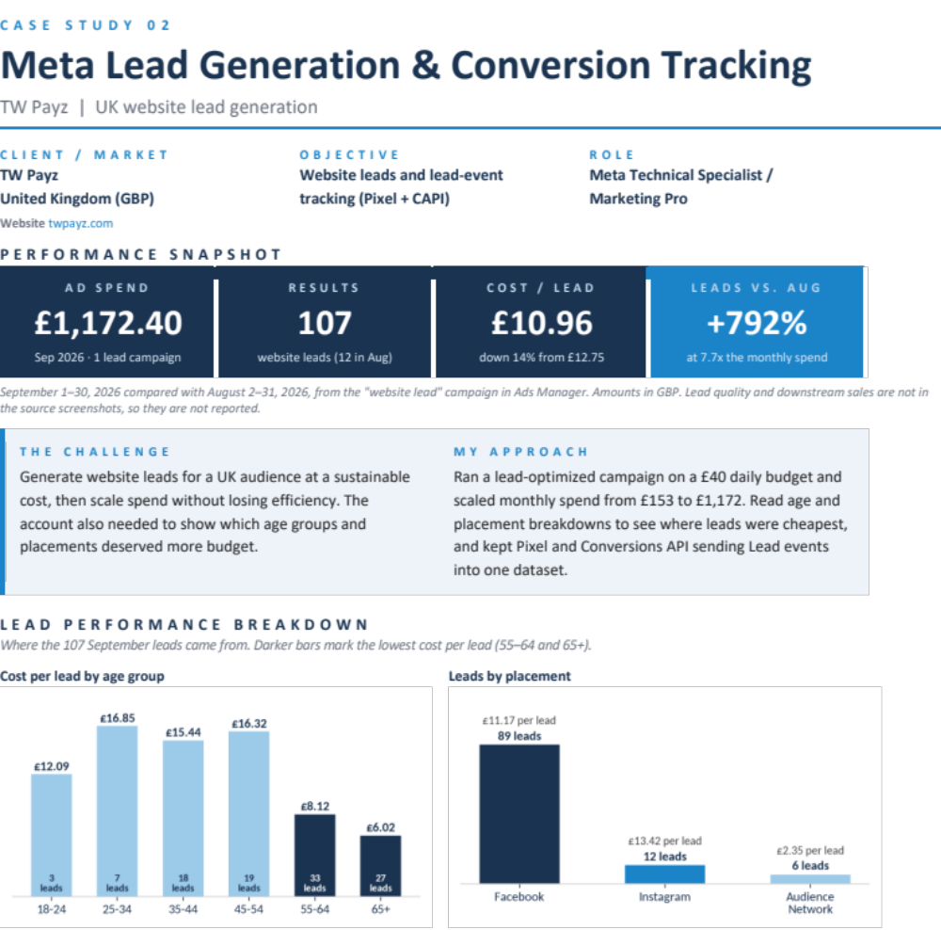

PORTFOLIO / CASE STUDY 2  Meta Ads • Lead Generation • Conversion Tracking | TAKAI MACUTO  Page 5
CAMPAIGN PERFORMANCE | META ADS MANAGER
Website lead campaign with age breakdown, Sep 2026 vs Aug 2026. Results, cost per lead and amount spent.
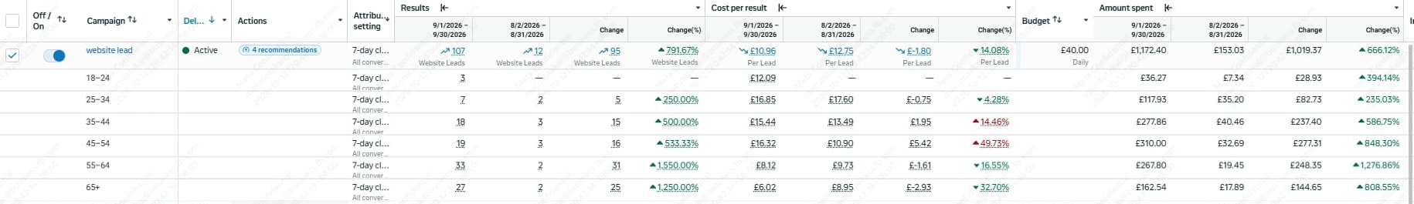
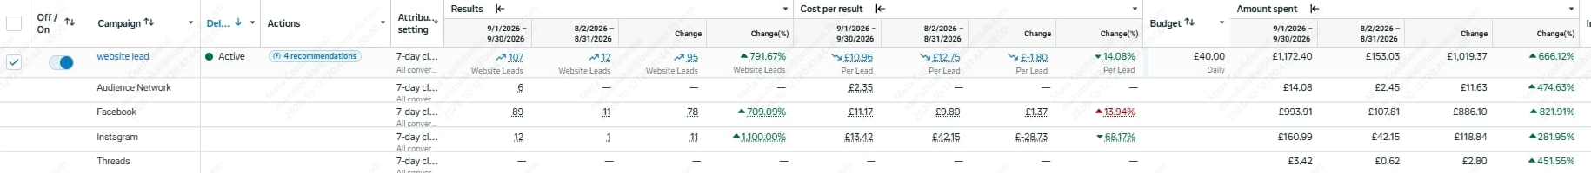
Placement breakdown for the same campaign: Facebook, Instagram, Audience Network and Threads.
TRACKING HEALTH | META EVENTS MANAGER
TW Payz dataset, Sep 14 – Oct 11, 2026. Conversions API and Meta Pixel connected.
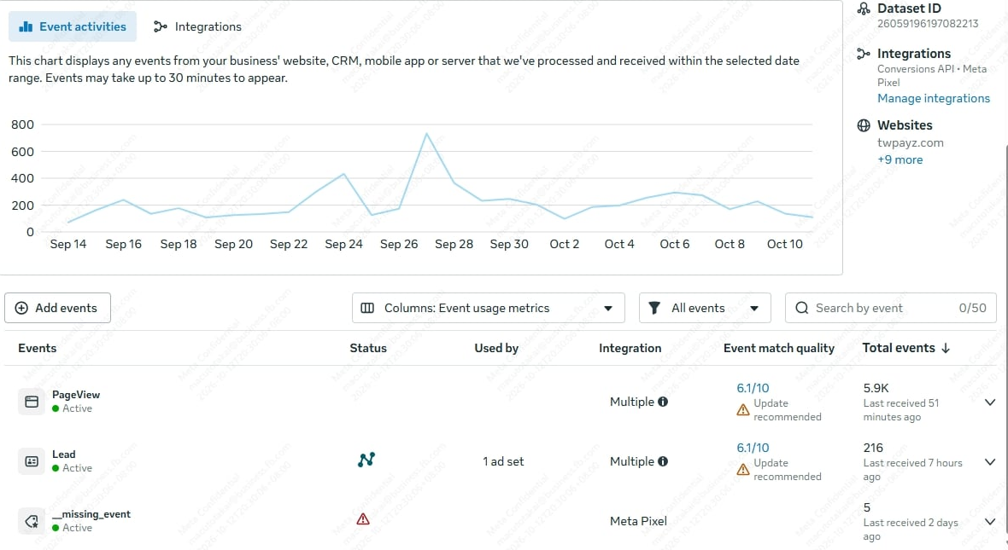 | WHAT I IMPLEMENTED  - Meta Pixel and Conversions API both connected to the TW Payz dataset, with Lead events active and used by an ad set  - Age and placement breakdowns to see where leads were cheapest as spend scaled  - Month-over-month comparison of leads, cost per lead and spend to judge each scale-up  NEXT OPTIMIZATION  - Lead Event Match Quality is 6.1/10 with an update recommended. Next step is passing more customer parameters through CAPI  - Clear the open diagnostic on the dataset (a stray missing-event entry)

RESULT / BUSINESS IMPACT
- 107 website leads in September at £10.96 each on £1,172.40 spend, against 12 leads at £12.75 in August (+792% leads, −14% cost per lead)
- Lowest cost per lead by age: 65+ at £6.02 and 55–64 at £8.12. Together they produced 60 of the 107 leads (56%) for £430.34, about £7.17 each
- Facebook delivered 89 leads at £11.17. Instagram delivered 12 leads at £13.42, down from £42.15 in August (−68%)
- Cost per lead rose in the 35–54 groups as spend scaled, so that is where the next testing effort should go
- Lead events flowing through Pixel and CAPI: 216 Lead events received in Events Manager, Sep 14 – Oct 11
Source: Meta Ads Manager (Sep 1–30, 2026 vs Aug 2–31, 2026) and Events Manager (Sep 14 – Oct 11, 2026). Figures are taken directly from the screenshots above.

PORTFOLIO / CASE STUDY 3  Meta Ads • Ecommerce • Conversion Tracking | TAKAI MACUTO  Page 4

CASE STUDY 03

E-commerce Tracking Setup & Campaign Scaling

CLIENT / INDUSTRY  DynamicScent — Shopify perfume e-commerce (India) | OBJECTIVE  Sales / ROAS / Conversion tracking | ROLE  Meta Technical Specialist / Marketing Pro

THE CHALLENGE  A Shopify perfume store needed accurate purchase tracking before scaling ad spend: standard events carrying customer (PII) and e-commerce parameters, confirmed as firing, so campaigns could optimize on real purchases. | MY APPROACH  Build the tracking layer first (Shopify custom pixel feeding Google Tag Manager), verify every event, then launch a simple CBO structure and scale it in controlled steps: new creative concepts every two weeks and budget increases capped at 20%.

CAMPAIGN PERFORMANCE
Meta Ads Manager • Oct 1 – Oct 14, 2026 • 4 conversion campaigns
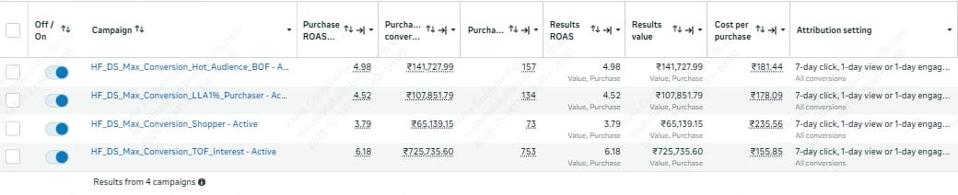

PERFORMANCE SNAPSHOT
AD SPEND  ₹187K  ≈ ₹186,901 total | RESULTS  1,117  purchases | COST / RESULT  ₹167.32  average per purchase | ROAS  5.57x  ₹1.04M purchase value
Totals calculated from the four campaign rows (spend = purchases × cost per purchase).

WHAT I IMPLEMENTED  - Shopify custom pixel feeding Google Tag Manager to track standard e-commerce events  - PII and e-commerce parameters added to GTM Tag events, improving data quality and matching  - Confirmed every event was firing correctly before any scaling  - Purchase conversion event from GTM connected to Google Ads  - Meta campaign launched with CBO, one ad set and 3 creatives  - Creative rotation and budget increases capped at 20% (see next page) | RESULT / BUSINESS IMPACT  - Advertiser was very happy with the results  - Significant results within the first two weeks of launch  - 1,117 purchases across 4 campaigns (Oct 1–14) at about ₹167 each, with ≈5.57x blended ROAS  - Best campaign: 753 purchases at ₹155.85 each and 6.18x ROAS  - Purchase and Add Payment Info events at 9.3/10 event match quality

PORTFOLIO / CASE STUDY 3  TRACKING & SCALING DETAIL  Events Manager • Funnel health • Creative & budget plan | TAKAI MACUTO  Case Study 03

CASE STUDY 03 • CONTINUED

EVENTS MANAGER — EVENT VOLUME & MATCH QUALITY
Dataset overview • Sep 16 – Oct 13, 2026 • event volume and event match quality (EMQ)
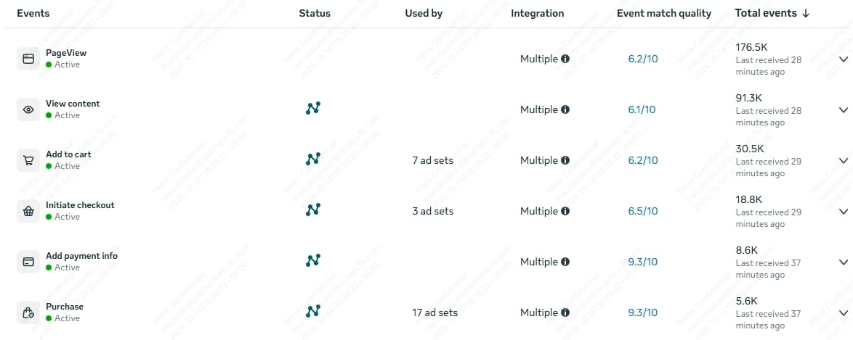

FULL-FUNNEL EVENT COVERAGE
Bar length is log-scaled so the whole funnel is readable. Score = event match quality (out of 10).
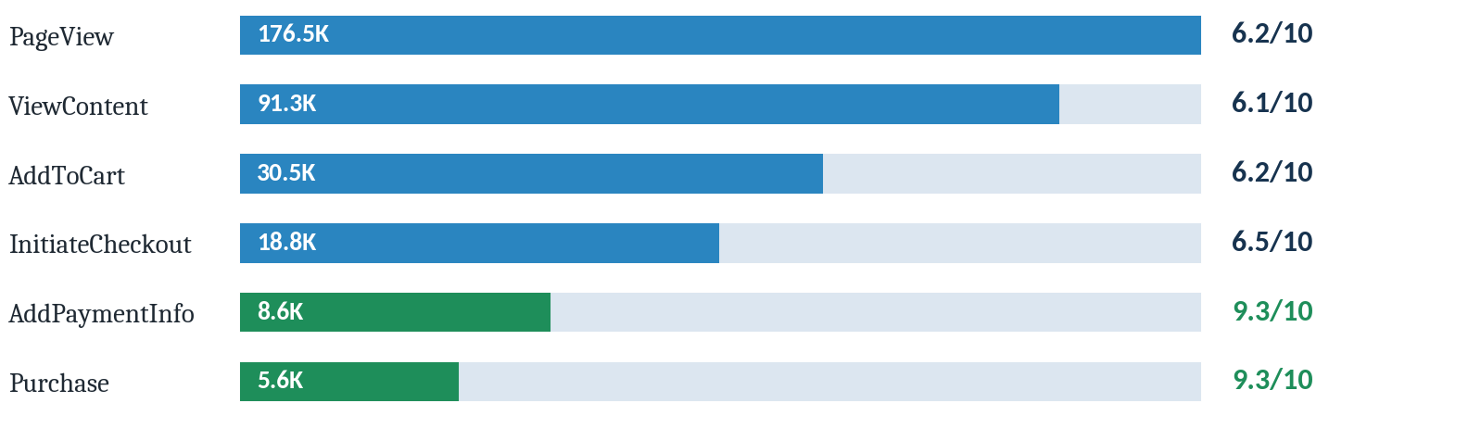

CAMPAIGN RESULTS (Oct 1 – Oct 14, 2026)
Campaign | Spend* | Purchases | Cost / purchase | Purchase value | ROAS
Interest (TOF) | ₹117,355 | 753 | ₹155.85 | ₹725,736 | 6.18x
Hot audience (BOF) | ₹28,486 | 157 | ₹181.44 | ₹141,728 | 4.98x
Lookalike 1% – purchasers | ₹23,864 | 134 | ₹178.09 | ₹107,852 | 4.52x
Shopper audience | ₹17,196 | 73 | ₹235.56 | ₹65,139 | 3.79x
Total (4 campaigns) | ₹186,901 | 1,117 | ₹167.32 | ₹1,040,455 | 5.57x
*Spend calculated as purchases × cost per purchase. Figures as reported in Meta Ads Manager (INR).
SCALING PLAN — CREATIVE ROTATION & BUDGET
 | STEP 1  Launch  CBO campaign, one ad set, 3 creatives. Tracking confirmed first. | WEEKS 1–2  Strong start  Advertiser saw significant results from the initial setup. | AFTER 2 WEEKS  +2 creatives (5)  New concepts: customer-review (UGC-style) and bundle-offer spotlight. | 2 WEEKS LATER  +5 creatives (10)  Gifting, all-day longevity demo, unboxing, scent-notes story, best-seller lineup.
Budget rule: every increase kept within 20%, so the campaign does not re-enter the learning phase. Creative volume was raised in step to avoid creative fatigue.

