Development of Banglar Heshel: A Comprehensive

Restaurant Management System

Tomal Mujumder
ID: 22103038

A Practicum in the Partial Fulfillment of the Requirements

for the Award of Bachelor of Computer Science and Engineering (BCSE)




Department of Computer Science and Engineering College of Engineering and Technology
IUBAT International University of Business Agriculture and Technology

Development of Banglar Heshel: A Comprehensive Restaurant Management System

Tomal Mujumder

A Practicum in the Partial Fulfillment of the Requirements for the Award of Bachelor of Computer Science and Engineering (BCSE)
The practicum has been examined and approved,

Prof. Dr. Utpal Kanti Das Chairman

Shahinur Alam
Co-supervisor, Coordinator and Assistant Professor

Toyeer-E-Ferdoush
Supervisor and Assistant Professor

Department of Computer Science and Engineering College of Engineering and Technology
IUBAT International University of Business Agriculture and Technology

Letter of Transmittal

14 January 2026 The Chair
Practicum Defense Committee
Department of Computer Science and Engineering
IUBAT International University of Business Agriculture and Technology 4 Embankment Drive Road, Sector 10, Uttara Model Town
Dhaka 1230, Bangladesh.

Subject: Letter of Transmittal.
Dear Sir,
With due respect, I submit my project report titled "Development of Banglar Heshel: A Comprehensive Restaurant Management System", completed as part of the practicum requirement for the Bachelor of Computer Science and Engineering (BCSE) degree. The project, conducted under the supervision of Soft-Tech Solutions, focuses on developing a full-stack web application that streamlines restaurant operations, online food ordering, table reservations, and inventory management using modern software architecture.
This work provided practical exposure to the MERN stack (MongoDB, Express.js, React.js, Node.js), Redux state management, SSLCommerz payment gateway integration, Cloudinary cloud storage, and Nodemailer email services, strengthening my full-stack development, database design, and problem-solving skills. I sincerely appreciate your time in reviewing this report and hope it meets the required academic and professional standards.
Yours sincerely,

Tomal Mujumder ID: 22103038

Organization’s Certificate

Place your organization’s certificate scanned copy here.

Student’s Declaration

I hereby declare that the project report entitled “Development of Banglar Heshel: A Comprehensive Restaurant Management System” is my original work and has been prepared by me in partial fulfillment of the requirements for the practicum. All sources of information and references used in this report have been properly acknowledged.
I confirm that the contents of this report are original and that no part of this work has been submitted previously for any degree or academic purpose. I have adhered to ethical guidelines in the collection and presentation of data and take full responsibility for the authenticity of this work.
I sincerely hope that this report meets the standards and expectations of the Practicum Defense Committee and respectfully submit it for review and evaluation.

Tomal Mujumder
ID: 22103038

Supervisor’s Certification

This is to certify that the project report entitled “Development of Banglar Heshel: A Comprehensive Restaurant Management System” has been prepared by Tomal Mujumder, ID: 22103038, in partial fulfillment of the requirements for the practicum.
I have reviewed the report and confirm that the work has been carried out under my supervision. All sources, references, and materials used in this report have been properly cited.
I hereby certify that the report meets the academic standards required by the Department of Computer Science and Engineering, IUBAT, and is suitable for submission and evaluation.

Toyeer-E-Ferdoush
Supervisor and Assistant Professor Department of Computer Science and Engineering
IUBAT International University of Business Agriculture and Technology

Abstract

This practicum report presents the design and implementation of "Banglar Heshel," a full-stack restaurant management system developed to modernize restaurant operations and customer service delivery. The project addresses critical challenges in traditional restaurant management including manual order processing, inefficient inventory tracking, limited customer engagement, and lack of digital payment integration. Built using the MERN stack (MongoDB, Express.js, React.js, Node.js), the system implements role-based architecture supporting three user types: Administrators, Managers, and Customers, each with tailored functionalities. Key features include secure authentication with OTP-based email verification, comprehensive menu management with multi-image uploads via Cloudinary, shopping cart and wishlist functionality, table reservation system with real-time availability, SSLCommerz payment gateway integration with unique token generation for order tracking, customer review and rating system (1-5 stars), inventory management with automated low-stock alerts, supplier and purchase order management, and analytics dashboards with sales visualizations using Recharts. The system employs JWT-based authentication, bcrypt password hashing, Redux state management, and RESTful API architecture to ensure security and scalability. Development followed the Incremental Process Model, allowing iterative refinement of authentication, ordering, payment, and management modules. The application successfully demonstrates how modern web technologies can digitize restaurant operations, reduce processing time, minimize errors, and enhance customer satisfaction through seamless online ordering and reservation experiences. Current limitations include internet dependency and sandbox payment testing. Future enhancements will include mobile application development, real-time order tracking, AI-powered menu recommendations, offline capabilities, and production deployment with live payment processing. This project showcases the effective application of full-stack development principles to solve real-world challenges in the hospitality industry.

Acknowledgments

I would like to take this opportunity to sincerely thank all those who supported and encouraged me throughout the completion of my practicum program and the preparation of the project report entitled “Development of Banglar Heshel: A Comprehensive Restaurant Management System.” First and foremost, I express my gratitude to Almighty for granting me the patience, strength, and perseverance necessary to complete this work. I am also thankful to the International University of Business, Agriculture and Technology (IUBAT) for providing an academic environment that fosters both personal and professional growth. I would like to pay special tribute to Late Prof. Dr. M. Alimullah Miyan, the Founder of IUBAT, whose visionary leadership opened new avenues for higher education in the non-government sector of Bangladesh. I also extend my sincere appreciation to the honorable Vice-Chancellor, Prof. Abdur Rab, for his continued leadership and guidance, which have greatly benefited the institution and its students. My heartfelt thanks go to Prof. Dr. Utpal Kanti Das, Professor and Chair, for his valuable advice and encouragement throughout this academic journey. Above all, I am deeply indebted to my supervisor, Toyeer-E-Ferdoush, Assistant Professor, Department of Computer Science and Engineering, IUBAT, for his constant guidance, constructive feedback, and encouragement, which were instrumental in shaping this work. Completing this practicum has enhanced my understanding of the subject matter, strengthened my technical skills, and provided valuable experience in research and report writing. I am truly grateful for the opportunity to work on this project, which has been both academically enriching and professionally rewarding.

Table of Contents

Letter of Transmittal iii
Organization’s Certificate iv
Student’s Declaration v
Supervisor’s Certification vi
Abstract vii
Acknowledgments viii
List of Figures xv
List of Tables xviii
Chapter 1. 1
Introduction 1
  - Background of the Study 2
  - Methodology 3
    - Primary Sources. 3
    - Secondary Sources. 4
  - Objectives 5
    - Broad Objective 5
    - Specific Objectives 5
  - Process Model 6
    - Reasons for Choosing the Incremental Process Model. 6
  - Feasibility Study 7
    - Technical Feasibility. 7
    - Economic Feasibility. 7
    - Operational Feasibility. 8
  - Structure of the Report 8
Chapter 2. 9
Organizational Overview 9
  - Organization Vision 10
  - Organization Mission 10
  - Organization Services 10
  - Organizational Structure 11
  - My Position in this Organization 12
  - Address of the Organization 12
Chapter 3. 13
Requirement Engineering 13
  - Requirement Analysis 14
  - Requirement Engineering 14
    - User and System Requirements 14
    - Functional Requirements 17
    - Non-Functional Requirements 18
  - Use Case Diagram of the System 20
Chapter 4. 22
Analysis 22
  - Software Analysis Pattern 23
  - Activity Diagrams 24
    - Activity Diagram for User Registration 24
    - Activity Diagram of Provider Verification 25
    - Activity Diagram of Booking Lifecycle 26
    - Activity Diagram of Service Creation 27
    - Activity Diagram of User Management 28
    - Activity Diagram of Review Submission 29
    - Activity Diagram of Report Generation 30
  - Swim-lane Diagrams 30
    - Swim-lane Diagram for User Registration 31
    - Swim-lane Diagram for Service Creation 31
    - Swim-lane Diagram for Booking Services 32
    - Swim-lane Diagram for Reschedule Services 32
    - Swim-lane Diagram for Provider Verification 33
    - Swim-lane Diagram for User Management 33
  - Sequence Diagrams 34
    - Sequence Diagram for Registration 34
    - Sequence Diagram for Login 34
    - Sequence Diagram for Booking Services 35
    - Sequence Diagram for Payment 35
    - Sequence Diagram for Provider Verification 36
    - Sequence Diagram for Service Creation 36
    - Sequence Diagram for Service Reschedule 37
  - Class Diagram of Neighbourly System 37
Chapter 5. 39
Project Management 39
  - Risk Identification 40
  - Risk Analysis 41
  - Risk Planning 42
  - The RMMM Plan 43
Chapter 6. 45
Project Planning 45
  - System Project Estimation 46
  - Function-Oriented Metrics 47
  - Identifying Complexity 47
    - Identifying Complexity of Transaction Functions 47
    - Identifying Complexity of Data Functions 48
    - Unadjusted Function Point Contribution 48
    - Unadjusted Function Point Contribution 49
    - Performance and Environmental Impact 50
    - Counting Adjusted Function Point 51
  - Project Schedule Chart (12- week timeframe) 51
  - Accounts Table 52
    - Personnel Cost 52
    - Expected Hardware Cost 52
    - Expected Software Cost 53
    - Expected Other Cost 53
  - Clarification of Academic vs. Industry Estimates 54
Chapter 7. 55
Design 55
  - Interface Design 56
    - Non-Logged in User Features 56
    - Provider Features 59
    - Users Features 61
    - Admin Features 63
  - Data Flow Diagram (DFD) 65
    - Context-Level DFD (Level 0) 66
    - DFD Level 1 67
    - DFD Level 2 68
  - Database Design 70
    - Normalization of Data Fields 71
    - Entity Relationship (ER) Model 71
    - Database Table Structure 73
  - ER Diagram for Neighbourly System 77
Chapter 8. 79
System Quality and Testing 79
  - System Quality Management 80
    - Software Quality Management Process 80
    - Software Test Cases 81
Chapter 9. 83
Ethical Consideration 83
  - Ethical Considerations in the Software Development Process 84
  - Sustainability in the Software Development Process 86
Chapter 10. 88
Conclusion 88
  - Brief Overview of the Project 89
  - Proposed System Benefits 89
  - Limitations of the Project 89
  - Practicum and Its Value 90
  - Future Plan 91
Bibliography 92

List of Figures

Figure 1.1: Incremental Process Model 6
Figure 2.1 Organizational Structure 11
Figure 3.1: Use Case Diagram 20
Figure 4.1: Clean Code Architecture in ASP .NET Core 23
Figure 4.2: Activity Diagram for User Registration 24
Figure 4.3: Activity Diagram of Provider Verification 25
Figure 4.4: Activity Diagram of Booking Lifecycle 26
Figure 4.5: Activity Diagram of Service Creation 27
Figure 4.6: Activity Diagram of User Management 28
Figure 4.7: Activity Diagram of Review Submission 29
Figure 4.8: Activity Diagram of Report Generation 30
Figure 4.9: Swim-lane Diagram for User Registration 31
Figure 4.10: Swim-lane Diagram for Service Creation 31
Figure 4.11: Swim-lane Diagram for Booking Services 32
Figure 4.12: Swim-lane Diagram for Reschedule Services 32
Figure 4.13: Swim-lane Diagram for Provider Verification 33
Figure 4.14: Swim-lane Diagram for User Management 33
Figure 4.15: Sequence Diagram for Registration 34
Figure 4.16: Sequence Diagram for Login 34
Figure 4.17: Sequence Diagram for Booking Services 35
Figure 4.18: Sequence Diagram for Payment 35
Figure 4.19: Sequence Diagram for Provider Verification 36
Figure 4.20: Sequence Diagram for Service Creation 36
Figure 4.21: Sequence Diagram for Service Reschedule 37
Figure 4.22: Class Diagram of Neighbourly System 38
Figure 6.1: Project Schedule Gantt Chart 51
Figure 7.1: Hero Section of Home Page 56
Figure 7.2: Featured Services in Home page 57

Figure 7.3: Search page 57
Figure 7.4: Service Details Page 57
Figure 7.5: Review Section in Service Details page 58
Figure 7.6: More services from same Provider 58
Figure 7.7: Similar Service Section 58
Figure 7.8: Providers Verification Request Form 59
Figure 7.9: Providers Dashboard 59
Figure 7.10: Provider Active Services Page 59
Figure 7.11: Providers booking page 60
Figure 7.12: Providers Payment History Page 60
Figure 7.13: Providers My Review Page 60
Figure 7.14: Providers Earning Report page 61
Figure 7.15: Users Dashboard 61
Figure 7.16: Users My booking page 61
Figure 7.17: SSLCommerz payment page 62
Figure 7.18: Users Payment History page 62
Figure 7.19: Users My Review page 62
Figure 7.20: Users Activity Report Page 63
Figure 7.21: Admin Dashboard 63
Figures 7.22: User Management 63
Figure 7.23: Provider Management 64
Figure 7.24: Service Category Management 64
Figure 7.25: Platform Analytics & Reports 64
Figure 7.26: Admin Audit Log 65
Figure 7.27: Context Level DFD (Level 0) 66
Figure 7.28: Level 1 DFD 67
Figure 7.29: DFD Level 2 Process 1 68
Figure 7.30: DFD Level 2 Process 2 68
Figure 7.31: DFD Level 2 Process 3 69
Figure 7.32: DFD Level 2 Process 4 69
Figure 7.33: DFD Level 2 Process 5 69

Figure 7.34: DFD Level 2 Process 6 70
Figure 7.35: DFD Level 2 Process 7 70
Figure 7.36: DFD Level 2 Process 8 70
Figure 7.37: ER Diagram of Neighbourly System 78
Figure 9.1: Sustainability Considerations in Software Development 87

List of Tables

Table 5.1: Risk Identification Table 40
Table 5.2: Risk Analysis Table 41
Table 5.3: Risk Planning Table 42
Table 5.4: Risk Mitigation, Monitoring, and Management Table 44
Table 6.1: Unadjusted Function Point Contribution (Transaction Function) 48
Table 6.2: Unadjusted Function Point Contribution (Data Function) 49
Table 6.3: Performance and Environmental Impact (GSC) 50
Table 6.4: Personal Cost 52
Table 6.5: Expected Hardware Cost 52
Table 6.6: Expected Software Cost 53
Table 6.7: Expected Other Cost 53
Table 7.1: ApplicationUser Table 73
Table 7.2: Service Table 73
Table 7.3: Booking Table 74
Table 7.4: ServiceCategory Table 74
Table 7.5: Review Table 74
Table 7.6: VerificationRequest Table 75
Table 7.7: Notification Table 75
Table 7.8: AuditLog Table 75
Table 7.9: ProviderTimeSlot Table 76
Table 7.10: RescheduleProposal Table 76
Table 7.11: ServiceBlock Table 77
Table 7.12: CategoryRequest Table 77
Table 8.1: Test Cases for the System 81

Chapter 1. Introduction

The contemporary food service industry is characterized by a paradigm shift towards digital transformation and on-demand convenience, fundamentally altering consumer behavior and restaurant operational methodologies. In an era where efficiency and seamless digital experiences are paramount, the traditional methods of restaurant management relying on manual order processing, paper-based reservation systems, physical inventory ledgers, and cash-dominant transactions have become increasingly inefficient and obsolete. "Banglar Heshel - A Comprehensive Restaurant Management System" represents a strategic response to this gap, engineered as a full-stack web-based platform during academic practicum. This system is designed to seamlessly connect customers seeking authentic Bengali cuisine and convenient dining experiences with comprehensive restaurant services including online ordering, table reservations, and real-time inventory management, all integrated within their immediate digital accessibility.
Developed leveraging the robust capabilities of the MERN stack (MongoDB, Express.js, React.js, Node.js) and adhering to the rigorous principles of modular architecture, Banglar Heshel integrates secure payment processing via SSLCommerz and harnesses cloud storage through Cloudinary and automated email services via Nodemailer to optimize operational workflows. The platform facilitates the entire restaurant service lifecycle, encompassing menu discovery, cart management, booking, secure payment processing with unique token generation, and review management. By digitizing traditional restaurant operations and providing a structured, secure framework for food service transactions, Banglar Heshel aims to empower local food businesses, reduce friction in service delivery, enhance inventory control, and provide unparalleled convenience to urban food enthusiasts. This report exhaustively details the project's inception, architectural design, implementation challenges, database schema, security implementations, and strategic implications for the digital restaurant management landscape.

Background of Study
The global landscape for restaurant technology and food service automation is currently undergoing an unprecedented expansion, catalyzed by rapid digital transformation, the ubiquitous proliferation of online ordering platforms, and a profound shift in consumer preference toward contactless, technology-driven dining experiences. Market analysis indicates that the global restaurant management software market size was valued at approximately USD 4.59 billion in 2023 and is projected to exceed USD 10.02 billion by 2030, growing at a compound annual growth rate (CAGR) of 11.8% (Grand View Research, 2023). This exponential growth is fueled by the increasing digitization of food ordering, delivery services, and inventory management systems, transforming how modern restaurants operate and interact with their customers.
Despite the dominance of major players in specific verticals like food delivery or point-of-sale systems, the comprehensive restaurant management ecosystem remains highly fragmented and operationally inefficient. Trust and quality assurance remain significant barriers; customers often struggle to find authentic cuisine with verified reviews and reliable service, while restaurant owners lack integrated digital infrastructure to manage inventory, reservations, payments, and customer relationships effectively within a single unified platform (McKinsey & Company, 2023). Traditional restaurant operations rely on disconnected systems for ordering, reservation management, and inventory tracking, while existing platforms often charge substantial commission fees that reduce profit margins for small and medium-sized establishments. Furthermore, the integration of data analytics and automated workflow management represents a shift toward "intelligent" restaurant operations, a key trend identified for 2025 and beyond, where real-time insights and personalized customer experiences become the competitive norm (Deloitte, 2024). Banglar Heshel addresses these gaps by offering a unified, comprehensive management platform that prioritizes operational efficiency and customer satisfaction. Unlike generic point-of-sale systems, it employs integrated role-based architecture to connect menu management, inventory control, payment processing, reservation workflows, and analytics dashboards within a cohesive ecosystem, reducing operational overhead and enhancing service quality for both restaurant staff and customers.

Methodology
The development of Banglar Heshel followed a rigorous, structured methodology that combined agile software development practices with user-centered design principles and iterative testing workflows. This approach ensured that the final product was not only technically robust and scalable but also aligned precisely with the operational realities and needs of restaurant owners, management staff, and customers. The methodology was divided into distinct phases of requirements gathering, system design, incremental development, testing, and deployment validation.

​Primary Sources

Primary data collection was instrumental in shaping the functional requirements and user experience design of the platform. This phase involved direct engagement with the target demographic to understand their immediate pain points and operational necessities.

Primary data collection was instrumental in shaping the functional requirements and user experience design of the platform. This phase involved direct engagement with the target demographic to understand their immediate pain points and operational necessities.

Direct Observation of Restaurant Operations: We conducted field observations of current offline methods for restaurant management, noting the friction points such as manual order taking leading to errors, inefficient inventory tracking causing stock shortages or wastage, paper-based reservation systems resulting in double bookings, and lack of integrated payment processing creating accounting discrepancies. This highlighted the necessity for a unified digital platform with automated workflows and real-time data synchronization.

Stakeholder Interviews: Structured interviews were conducted with potential users, ranging from restaurant owners and managers to front-line staff and regular customers, to understand their technological literacy, workflow preferences, and pain points. These insights directly influenced the design of the role-based dashboard system, the decision to implement intuitive menu management with drag-and-drop image uploads, and the simplified reservation workflow with email confirmations.

User Feedback Loops: During the development phase, iterative prototypes were tested with a focus group of restaurant staff and customers to refine the UI/UX. Particular attention was paid to the "Order Placement" flow, shopping cart functionality, and mobile responsiveness of the platform, ensuring that the payment process was seamless and the table reservation system was intuitive and non-intrusive (Nielsen Norman Group, 2023).

​Secondary Sources
Secondary research focused on establishing technical feasibility, adhering to architectural best practices, and understanding broader market trends in restaurant technology.
      - Technical Documentation: An extensive review of MongoDB database design patterns, Express.js middleware architecture, React.js component lifecycle documentation, Node.js server-side programming guides, SSLCommerz payment gateway integration documentation, Cloudinary API specifications, and Nodemailer SMTP configuration provided the technical backbone for the system's architecture. This ensured that the chosen technologies were compatible and capable of meeting performance benchmarks (MongoDB Documentation, 2024; React Documentation, 2024).
      - Market Research Reports: Reports from Grand View Research and Deloitte provided critical data on restaurant management software market size, growth trajectories (CAGR of 11.8%), and emerging trends like cloud-based operations, mobile ordering integration, and data analytics adoption. This data validated the business case for the project and informed the feature prioritization strategy, emphasizing inventory management, payment integration, and analytics dashboards (Grand View Research, 2023; Deloitte, 2024).
      - Academic Journals on Web Application Security: Research papers regarding authentication best practices, specifically JWT token security, bcrypt password hashing, and OTP-based verification systems, informed the design of the security modules. This ensured that the application would remain secure against common vulnerabilities like SQL injection, cross-site scripting (XSS), and unauthorized access, critical factors in maintaining user trust and data integrity (OWASP, 2024; IEEE Software Engineering, 2023).

Objectives
The project was driven by a strategic vision to create a scalable, secure, and community-focused platform that addresses the specific challenges of the hyperlocal economy.

​Broad Objective.
The broad objective of this practicum is to design, develop, and deploy "Neighbourly," a robust hyperlocal service marketplace that streamlines the connection between service seekers and providers through real-time geolocation, secure transactions, and AI-enhanced user experiences. The ultimate goal is to foster trust and stimulate economic activity within local communities by removing the technological barriers that currently exist in the service discovery process.

​Specific Objectives.
      - Implement a Clean Architecture Monolith: To build a maintainable and testable codebase using ASP.NET Core 8, ensuring a strict separation of concerns between the domain, infrastructure, and presentation layers. This architecture facilitates future scalability and ease of maintenance (NDepend, 2024).
      - Integrate Precision Geolocation Services: To utilize LocationIQ APIs for accurate address geocoding, reverse geocoding, and radius-based search functionality. This objective ensures "hyperlocal" relevance, allowing users to find providers within walking or short driving distances (LocationIQ Documentation, 2026).
      - Develop AI-Powered Features: To integrate the Hugging Face Inference API for intelligent text generation, assisting users in drafting service descriptions and providing automated responses. This enhances the user experience by reducing the effort required to post or respond to service requests (Huggingface.co, 2025).
      - Ensure Data Security and Privacy: To implement robust authentication and authorization mechanisms, utilizing ASP.NET Core Identity. This includes protecting sensitive user location data and personal identifiable information (PII) in strict compliance with ethical standards and regulations (FORTUNE, 2024).

      - Create a Responsive User Interface: To design a mobile-first frontend that allows seamless booking and management of services across various devices. Recognizing the dominance of smartphone usage in the target market, the interface must be touch-friendly and responsive to varying screen sizes (FORTUNE, 2024).

Process Model
The Incremental Process Model was selected as the optimal development methodology for Neighbourly. This model was chosen because the project required the integration of distinct, complex modules User Management, Geolocation, Booking Logic, and Payment Processing that could be developed, tested, and refined independently before integration into the final system.
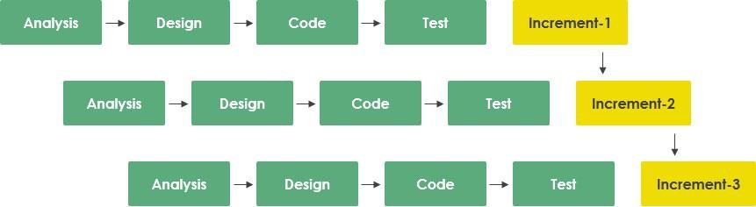
Figure 1.1: Incremental Process Model

Reasons for Choosing the Incremental Process Model.
The rationale for selecting the Incremental Process Model over other methodologies like Waterfall or pure Agile Scrum includes several key factors relevant to the practicum environment:
      - Risk Mitigation: By developing the core booking engine first, we could validate the primary value proposition and technical architecture before investing time in secondary, high-risk features like AI integration. This reduced the likelihood of project failure due to technical roadblocks in advanced features.
      - Flexibility: The incremental approach allowed for the incorporation of feedback from early testing phases (e.g., refining the search radius logic based on initial user data) into subsequent iterations without derailing the entire project schedule.

      - Parallel Development: The separation of the project into distinct increments (e.g., Increment 1: Authentication & Profile; Increment 2: Geolocation & Search; Increment 3: Booking & Payments) allowed for focused development sprints, ensuring that each component was robust before moving to the next.
      - Early Delivery of Functionality: A functional version of the product was available early in the lifecycle, facilitating early testing of critical paths like the "Book a Service" workflow. This allowed for continuous validation against user requirements (Shipturtle, 2025).

Feasibility Study
A comprehensive feasibility study was conducted to ensure the project's viability across technical, economic, and operational dimensions. This analysis confirmed that the project was not only achievable within the constraints of the practicum but also held significant potential for real-world application.

​Technical Feasibility.
The project is technically feasible, leveraging the mature and robust ASP.NET Core 8 ecosystem. This framework provides extensive support for web APIs, dependency injection, and security, which are essential for a scalable marketplace. The use of PostgreSQL (via Entity Framework Core) ensures scalable and reliable data storage, capable of handling complex relational data and spatial queries. Integration with LocationIQ relies on standard RESTful APIs, which are well-documented and widely supported in the.NET environment (location-iq, 2025). Furthermore, the Hugging Face API provides a serverless inference model, removing the need for heavy local GPU resources. This makes advanced AI features technically viable on standard hosting environments without requiring specialized hardware (Raza, 2025).

​Economic Feasibility.
The project demonstrates strong economic viability. The development phase utilized open-source frameworks (.NET Core, PostgreSQL) and free-tier services for APIs (LocationIQ, Hugging Face), significantly minimizing upfront development costs. The potential operational cost is low, primarily consisting of cloud hosting fees (e.g., Azure or AWS) which scale with

usage. Given the market projection of the hyperlocal sector reaching over USD 4 trillion by 2025 (FORTUNE, 2024), the potential return on investment (ROI) through commission-based revenue models or subscription fees for providers is substantial. The low barrier to entry and high scalability of the platform suggest a sustainable business model.

​Operational Feasibility.
Operationally, the system is designed to be self-sustaining with minimal manual intervention required for day-to-day activities. Automated workflows for booking confirmations, invoicing, and notifications reduce the administrative burden on the platform operator. The platform's user interface is designed for intuitive use, minimizing the need for extensive user training or support. The "Clean Architecture" ensures that the system is maintainable and adaptable to future changes in business logic or technology, ensuring long-term operational stability (NDepend, 2024).

Structure of the Report
The report is structured systematically into ten chapters to provide a comprehensive overview of the project. Following this Introduction, Chapter 2 provides an in-depth overview of FiroTech, the host organization. Chapter 3 details Requirement Engineering, outlining user and system needs. Chapter 4 covers Analysis, presenting detailed architectural diagrams including Activity, Swim-lane, and Class diagrams. Chapter 5 discusses Project Management and Risk mitigation strategies. Chapter 6 outlines Project Planning and Estimation metrics. Chapter 7 details System Design, including Interface, Data Flow, and Database design. Chapter 8 covers System Quality and Testing methodologies. Chapter 9 addresses Ethical Considerations in software development. Finally, Chapter 10 concludes the report with a summary of achievements and future work.

Chapter 2.

Organizational Overview

FiroTech Limited is a software development and logistics technology company. It provides Enterprise Resource Planning (ERP) solutions, custom software development, cloud computing, and mobile application development. The company has a particular focus on logistics and courier management systems. Its work combines practical problem-solving with innovative technology. FiroTech is based in Dhaka and is gradually expanding its services beyond the city. The team consists of experienced professionals and young developers, creating a balance of industry knowledge and fresh technical skills.

Organization Vision
The vision of FiroTech Limited is to establish itself as a recognized technology provider that supports business growth through reliable and scalable software. The organization seeks to contribute to the digital transformation of industries by offering practical and cost-effective solutions that simplify operations and improve efficiency.

Organization Mission
The mission of FiroTech Limited is to design and deliver software solutions that are tailored to client needs. The company emphasizes high-quality development, professional guidance, and long-term client support. In addition to serving organizations, FiroTech also focuses on developing new talent by providing interns and junior developers with hands-on learning opportunities. Through teamwork, continuous improvement, and a focus on usability, the company aims to contribute positively to the local technology community.

Organization Services
FiroTech Limited provides a range of services, including:
    - Custom Software Development: Development of software solutions designed for specific business requirements across industries.
    - Enterprise Resource Planning (ERP) Solutions: Implementation of ERP systems to integrate operations, increase efficiency, and support decision-making.
    - Cloud Computing Services: Cloud migration, secure storage, and system management for scalability and cost-effectiveness.

    - E-commerce Platform Development: Creation of e-commerce websites and mobile applications that support online transactions and business growth.
    - Product Development and Software Integration: Assistance in building new digital products and integrating them with existing systems.
    - Software Maintenance and Testing: Ongoing updates, performance monitoring, and security testing to ensure system reliability.
    - Training: Training programs for client teams to support the effective use and management of new systems.
    - Mobile App Development: Design and development of mobile applications for Android and iOS platforms.

Organizational Structure
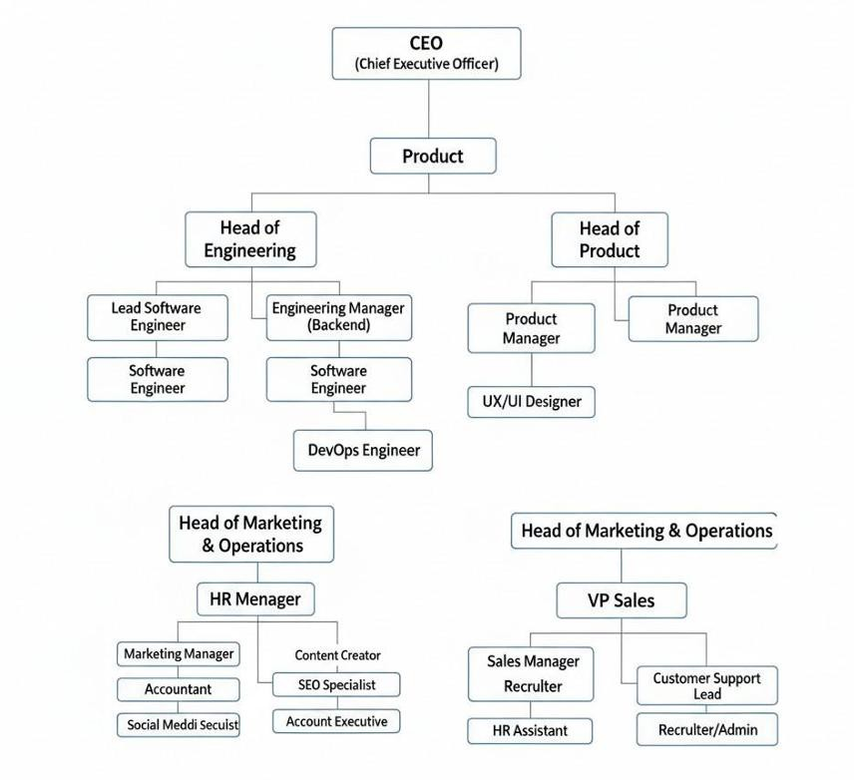
FiroTech Limited is a small but growing company. As a startup, it follows a simple organizational structure, as shown in Figure 2.1.
Figure 2.1 Organizational Structure

My Position in this Organization
I served as a Software Developer Intern within the Engineering Department. My responsibilities were integral to the development of the Neighbourly platform. I was tasked with assisting in full-stack development, specifically focusing on backend API architecture using ASP.NET Core, integrating third-party APIs such as LocationIQ for mapping and Hugging Face for AI features, and designing the relational database schema. I worked under the direct mentorship of the Engineering Manager, actively participating in daily stand-ups, code reviews, and sprint planning sessions, which provided invaluable exposure to professional software development workflows.[15]

Address of the Organization
FiroTech Finance and Software Solution
Uttara Eastern City, Udayan School Road, Behind Sector 4, Road 10, Uttara, Dhaka 1230, Bangladesh.15

Chapter 3.

Requirement Engineering

Requirement engineering was a pivotal phase in defining the scope, functionality, and user experience of Neighbourly. We employed a collaborative and iterative approach, engaging with various stakeholders to elicit, analyze, and validate requirements ensuring the final product effectively solved the identified market problems.

Requirement Analysis
The analysis phase focused on identifying the core problem: the lack of a centralized, trusted, and efficient platform for local services. We conducted a comparative analysis of competitor platforms (e.g., TaskRabbit, Thumbtack) and identified significant gaps in their localization capabilities and trust verification processes in the local context. The analysis confirmed the critical need for a system that prioritizes proximity—to reduce travel time and cost—and verified identity—to ensure safety. The "Hyperlocal" nature of the solution meant the system had to handle complex geospatial queries efficiently and provide real-time data to users.[2]

Requirement Engineering
The requirements were categorized into User, System, Functional, and Non-Functional requirements to ensure a holistic definition of the system.

User and System Requirements
his section maps high-level user needs to specific, testable system requirements.
- Authentication and Account Management: Users and Service Providers require a secure and distinct access mechanism to the platform.
  - The system shall provide a dual registration system, allowing actors to register specifically as a User or Service Provider.
  - The system shall enforce separate registration flows, including a multi-step wizard for detailed data collection.
  - The system shall require email confirmation before account activation to verify user identity.

  - The system shall support secure login using email and password with ASP.NET Core Identity integration.
  - The system shall allow users to reset their passwords via a secure email link or OTP.
  - The system shall enforce role-based access control (RBAC) covering Admin, Service Provider, and User roles.
- Profile and Location Services: Users need to find services relevant to their current location.
  - The system shall utilize browser geolocation APIs to automatically detect the user's current position.
  - The system shall integrate the LocationIQ API to provide address autocomplete functionality during profile creation and search.
  - The system shall support reverse geocoding to convert map coordinates into readable addresses.
  - The system shall store latitude and longitude for all users to enable proximity-based logic.
  - Service Providers shall be able to manage a comprehensive business profile, including business name, description, and service portfolio.
- Service Discovery and Search: Users must be able to verify details and find the specific help they need efficiently.
  - The system shall allow users to browse services by dynamically managed categories (e.g., Plumbing, Electrical).
  - The system shall provide a search bar allowing keyword-based queries for services.
  - The system shall sort search results based on geodesic distance between the user and the provider.
  - The system shall display service cards with key information, including Starting Price, Rating, Provider Name, and Distance.
  - The system shall implement AJAX-based pagination or a Load More mechanism to handle large lists of services without page reloads.

- Booking and Negotiation: Users and Service Providers need a structured process to agree on work terms and schedules.
  - The system shall enable users to initiate a booking request for a specific service.
  - The system shall implement a booking status lifecycle:
Pending➔Confirmed➔JobDone → Completed.
  - The system shall allow extensive rescheduling negotiation:
    - Users can propose a new time for a booking.
    - Service Providers can accept or reject the proposed time.
  - The system shall prevent double-booking of Service Providers for the same time slot.
  - The system shall provide a provider-facing endpoint (AdjustBookingTime) to modify confirmed booking times if necessary.
- Payments and Transactions: Users need a secure method to pay for services, and Service Providers need to track earnings.
  - The system shall integrate SSLCommerz for handling secure online payments.
  - The system shall process payments only when the job status is marked as JobDone.
  - The system shall generate automated PDF receipts for completed transactions.
  - The system shall maintain a comprehensive transaction history accessible to both Users and Service Providers.
  - The system shall ensure transactional integrity by updating booking status to
Completed only upon successful payment confirmation.
- Trust and Verification: The platform requires mechanisms to ensure safety and quality.
  - The system shall require Service Providers to upload verification documents (e.g., ID, License) before their services become visible.
  - The system shall provide an Admin interface to review and approve or reject verification requests.

  - The system shall allow Users to rate and review Service Providers (1–5 stars) after service completion.
  - The system shall calculate and display the average rating for each Service Provider.
  - ​The system shall allow Admins to block or unblock Users or Service Providers, removing their access and hiding their content.
- AI and Intelligent Features: Service Providers should be assisted in creating professional content.
  - The system shall integrate the Hugging Face Inference API to generate smart service descriptions.
  - The system shall use context-aware prompts based on provider business data to generate tailored text.
  - The system shall allow Service Providers to review and edit AI-generated content before saving.
8. Notifications: Users need real-time updates on their service requests.
  - The system shall trigger in-app notifications for key events, including booking requests, status changes, and payment requests.
  - The system shall track read and unread status for all notifications.
  - The system shall display a notification counter in the navigation bar

Functional Requirements
The core functionalities of the Neighbourly system include several key operational areas that together enable end-to-end service delivery on the platform.
      - User Authentication and Identity: The system provides secure registration, login, and logout functionality for all actors. It supports email verification and password recovery mechanisms to ensure account security. Role management is enforced to maintain strict separation of privileges among Users, Service Providers, and Administrators.

      - Profile Management: Users are able to update their personal details and profile pictures. Service Providers can manage detailed business profiles and upload required verification documents. Administrators have visibility into all user profiles and their corresponding verification statuses.
      - Service Management: Service Providers can create, read, update, and delete their service offerings. Each service includes a title, description, price, category, and images. AI-assisted tools are available to help providers generate and refine professional service descriptions.
      - Booking Management: The system supports complete booking lifecycle management, from initial request through completion. It provides rescheduling interfaces that allow users to propose new times and providers to accept or reject them. Booking statuses are tracked transparently, including Pending, Confirmed, In Progress, Completed, and Cancelled states.
      - Search and Discovery: The platform enables location-based search using geospatial queries, combined with category filtering and keyword-based search. Provider detail pages display reviews, ratings, and records of past work to assist users in decision-making.
      - Payment Processing: The system integrates with the SSLCommerz payment gateway to handle transactions securely. It supports both sandbox testing and production environments and generates verifiable digital receipts for completed payments.
      - Admin Administration: Administrators are provided with a dashboard that presents an overview of platform activity, including user counts and booking statistics. The system supports service provider verification workflows through document review, service category management, and user blocking and content moderation.
      - Audit and Compliance: The system logs critical actions such as user logins, payment processing, and data changes in an audit log. It ensures compliance with basic data protection standards through secure data storage practices.

Non-Functional Requirements
Non-functional requirements define system quality and performance standards.

      - Security: The system shall ensure secure handling of user data by hashing passwords using strong algorithms such as PBKDF2 and enforcing HTTPS for all communications. Role-based authorization shall restrict access to system resources, and all inputs shall be validated on both client and server sides to prevent common security attacks.
      - Performance: The system shall deliver responsive performance, with search results returned within acceptable time limits and main pages loading quickly under normal conditions. Time-consuming operations such as email delivery and AI content generation shall be processed asynchronously.
      - Scalability: The system shall be designed to support future growth by following Clean Architecture principles and using an optimized SQL Server database with appropriate indexing on frequently queried fields.
      - Reliability and Availability: The platform shall maintain high availability during business hours and ensure reliable operation through proper error handling and logging. All critical transactions shall follow ACID principles to maintain data consistency.
      - Usability: The user interface shall be responsive across all devices and follow basic accessibility guidelines. The system shall provide clear and immediate feedback for user actions to enhance usability.
      - Maintainability: The system shall follow standard C# coding practices with clear separation of concerns. Proper documentation shall be maintained to support future development and maintenance.

Use Case Diagram of the System
The Use Case diagram visualizes the high-level interactions between the actors (Seeker, Provider, Admin) and the system, defining the scope of the application.
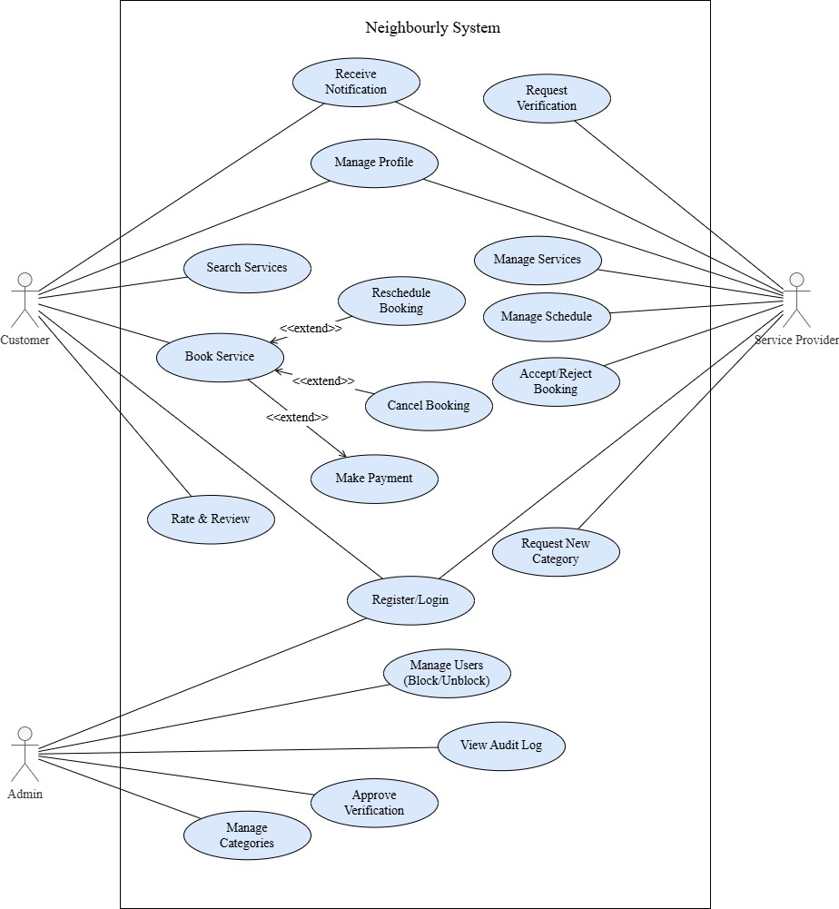
Figure 3.1: Use Case Diagram

- Actors: Service Seeker (User), Service Provider, Administrator.

Key Use Cases:

  - User: Register, Search Service, View Provider Profile, Book Service, Make Payment, Rate Provider.
  - Provider: Manage Profile, Set Availability, Accept Booking, Request Payment, Update Status.
  - Admin: Verify Users, Manage Disputes, View Reports, Manage Categories.

- Relationships: "Includes" relationships for Login (required for Booking) and Payment (required for Booking Confirmation). "Extends" relationships for functionality like "Cancel Booking" which extends the Booking use case.

Chapter 4. Analysis

This chapter presents the structural and behavioral analysis of the Neighbourly system using standard UML diagrams. These diagrams are employed to illustrate the overall system logic, data flow, component responsibilities, and interactions between objects. The analysis helps in understanding how different parts of the system collaborate to fulfill functional requirements and supports better system design, implementation, and maintenance.

Software Analysis Pattern
We adopted Clean Architecture (also known as Onion Architecture) for Neighbourly. This pattern organizes code into concentric circles of dependencies, ensuring that the core business logic (Domain) remains independent of external frameworks, databases, or UI. This promotes longevity and maintainability of the codebase.
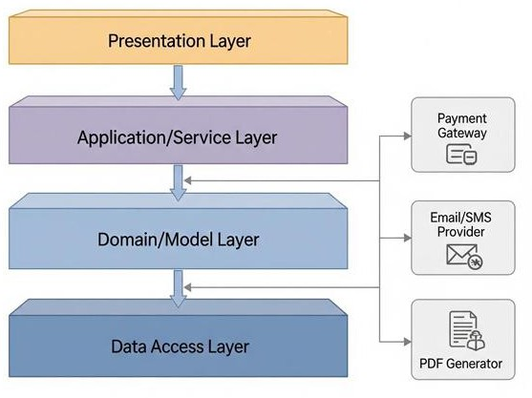
Figure 4.1: Clean Code Architecture in ASP .NET Core
- Domain Layer: The core of the system containing Enterprise Logic and Entities (User, Booking, Service). It has no external dependencies.
- Application Layer: Contains Use Cases, Interfaces, and DTOs (Data Transfer Objects). It depends only on the Domain layer and orchestrates the flow of data.

- Infrastructure Layer: Implements interfaces defined in the Application layer (e.g., Database access using EF Core, File System, External APIs like LocationIQ). It depends on the Application layer.
- Presentation Layer (Web API): The entry point for the application. It depends on the Application layer and handles HTTP requests/responses.

Activity Diagrams
Activity diagrams illustrate the dynamic nature of the system by modeling the flow of control from activity to activity.

​Activity Diagram for User Registration
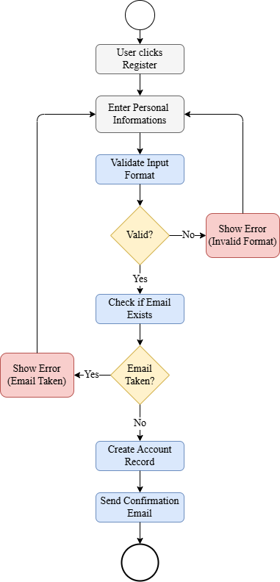
Figure 4.2: Activity Diagram for User Registration

​Activity Diagram of Provider Verification
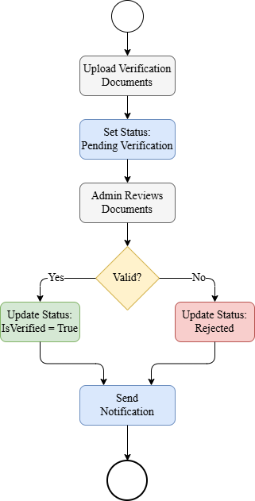
Figure 4.3: Activity Diagram of Provider Verification

​Activity Diagram of Booking Lifecycle
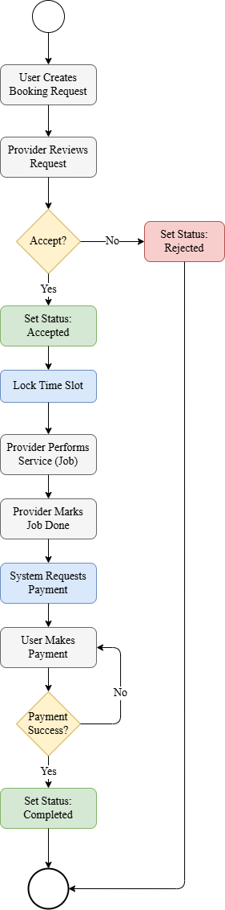
Figure 4.4: Activity Diagram of Booking Lifecycle

​Activity Diagram of Service Creation
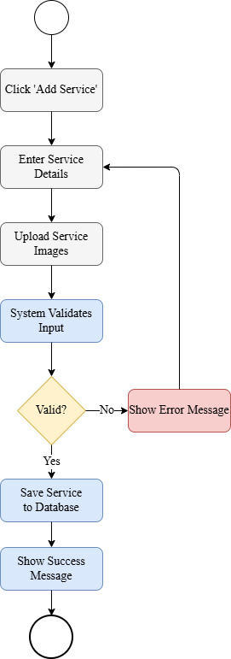
Figure 4.5: Activity Diagram of Service Creation

​Activity Diagram of User Management
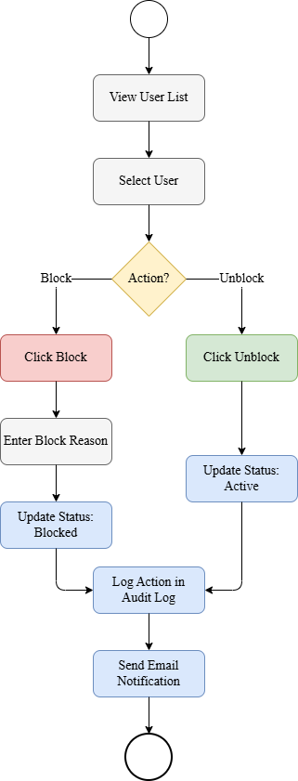
Figure 4.6: Activity Diagram of User Management

​Activity Diagram of Review Submission
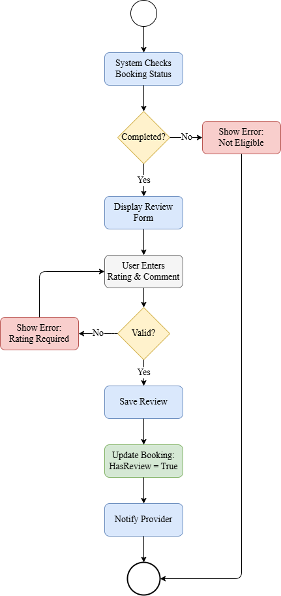
Figure 4.7: Activity Diagram of Review Submission

​Activity Diagram of Report Generation
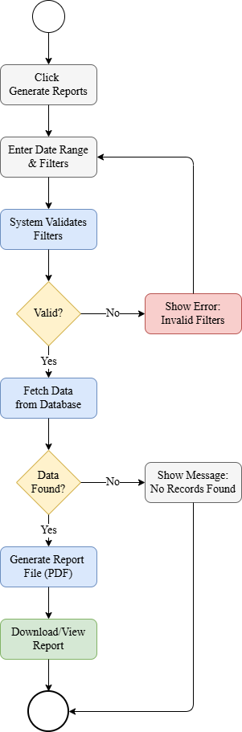
Figure 4.8: Activity Diagram of Report Generation

Swim-lane Diagrams
Swim-lane diagrams delineate specific responsibilities within a process, clarifying the interaction between the User, System, Database, and External Services.

​Swim-lane Diagram for User Registration
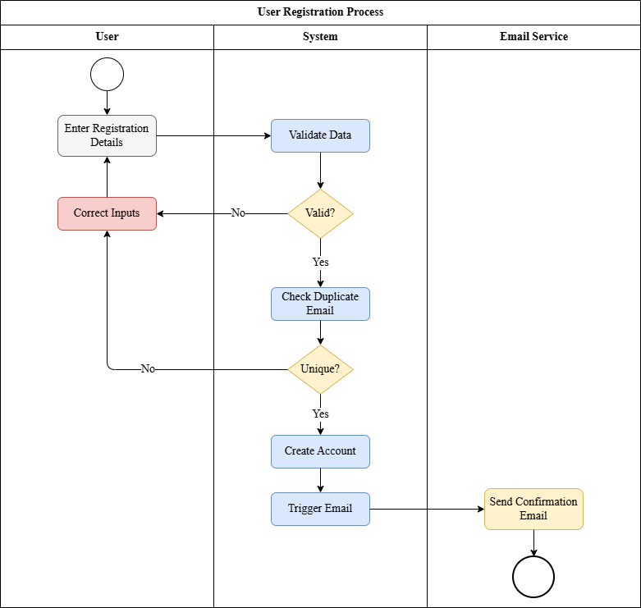
Figure 4.9: Swim-lane Diagram for User Registration

​Swim-lane Diagram for Service Creation
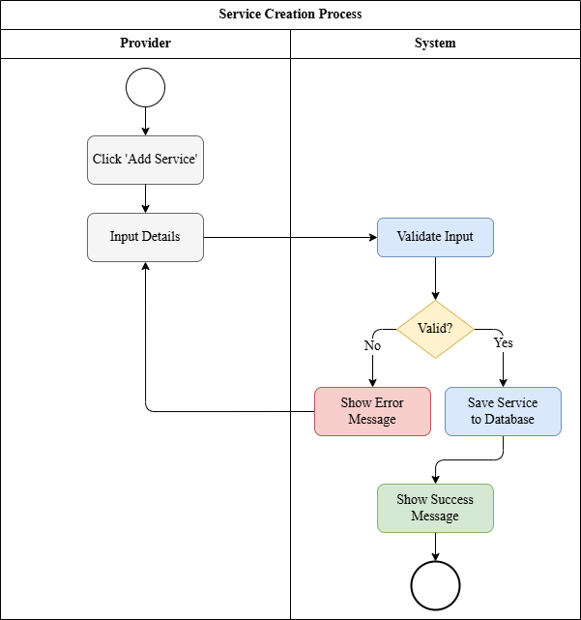
Figure 4.10: Swim-lane Diagram for Service Creation

​Swim-lane Diagram for Booking Services
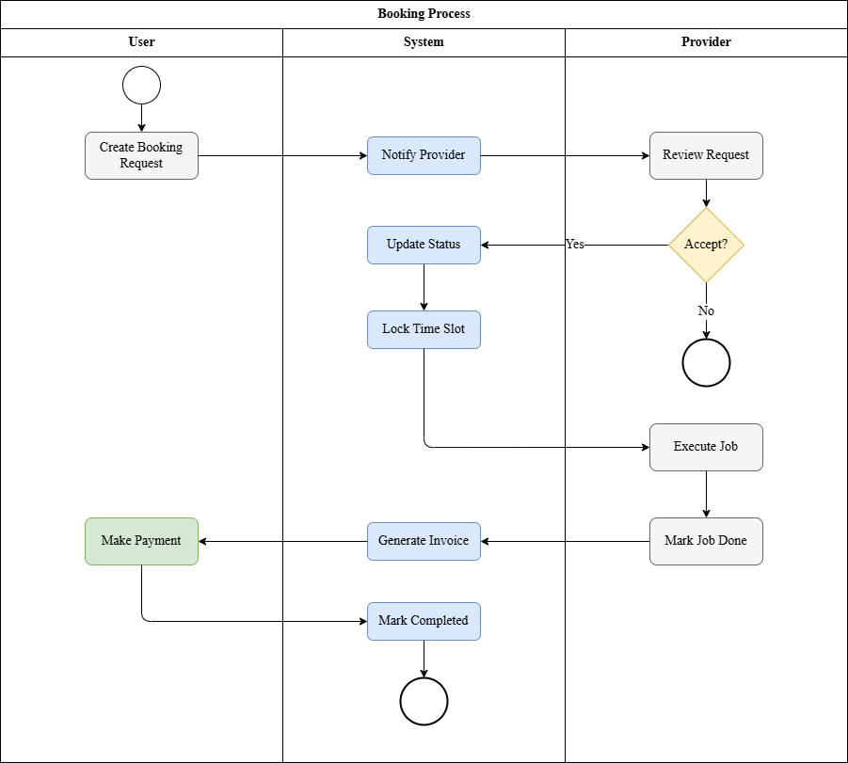
Figure 4.11: Swim-lane Diagram for Booking Services

​Swim-lane Diagram for Reschedule Services
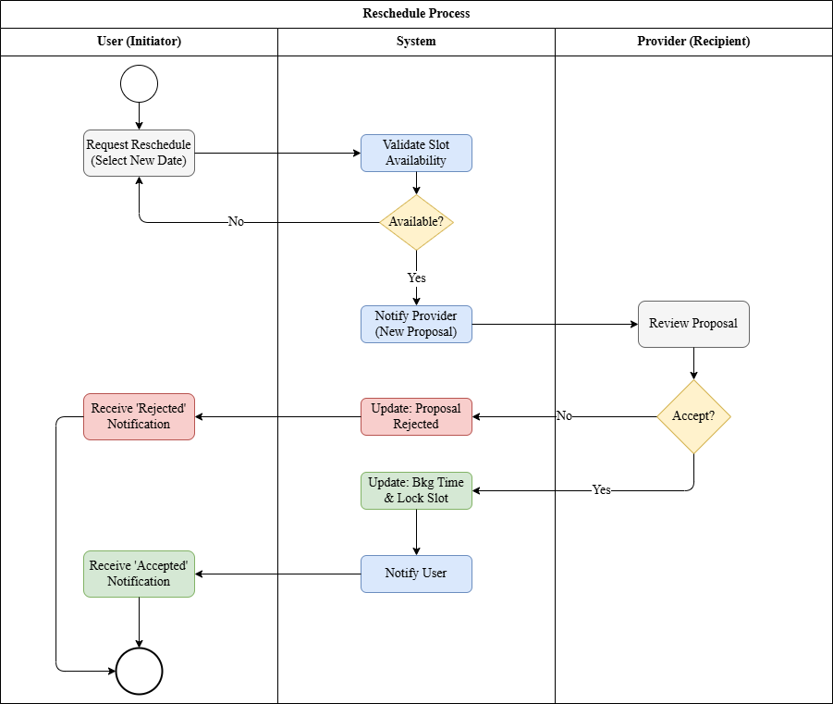
Figure 4.12: Swim-lane Diagram for Reschedule Services

​Swim-lane Diagram for Provider Verification
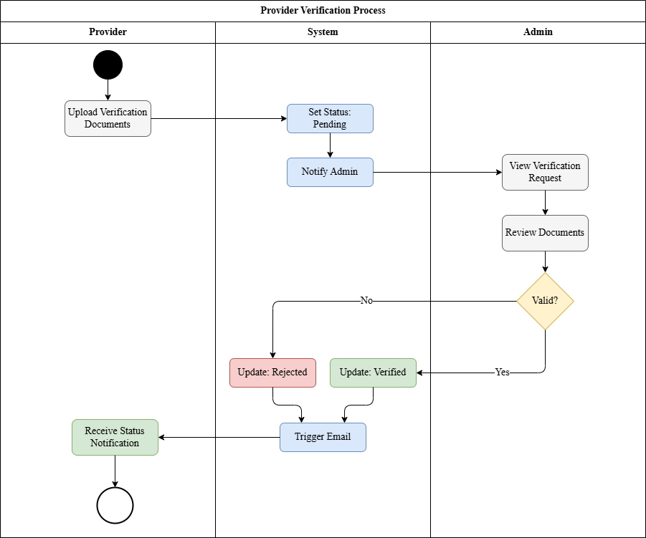
Figure 4.13: Swim-lane Diagram for Provider Verification

​Swim-lane Diagram for User Management
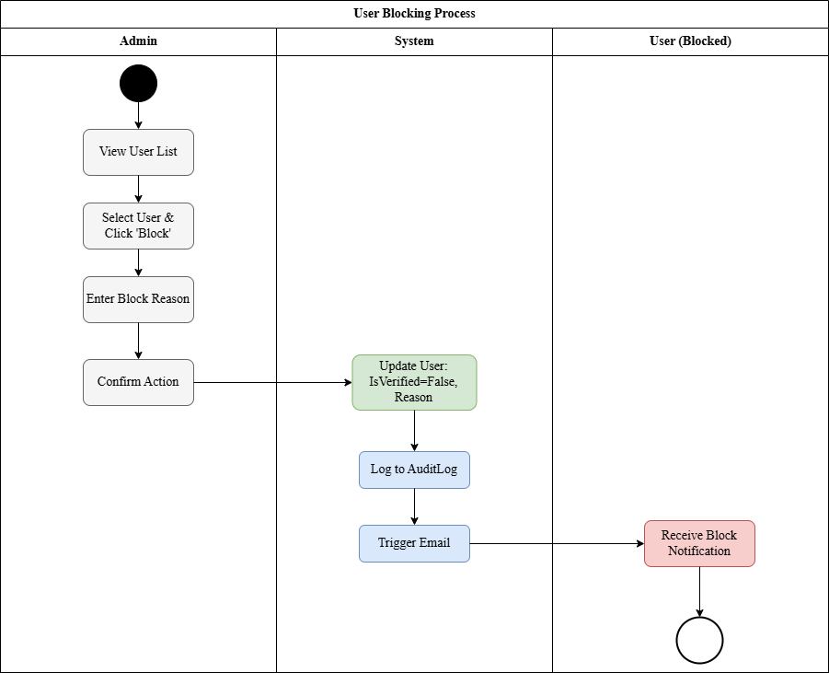
Figure 4.14: Swim-lane Diagram for User Management

Sequence Diagrams
Sequence diagrams capture the detailed interaction between objects over time for specific use cases.

​Sequence Diagram for Registration
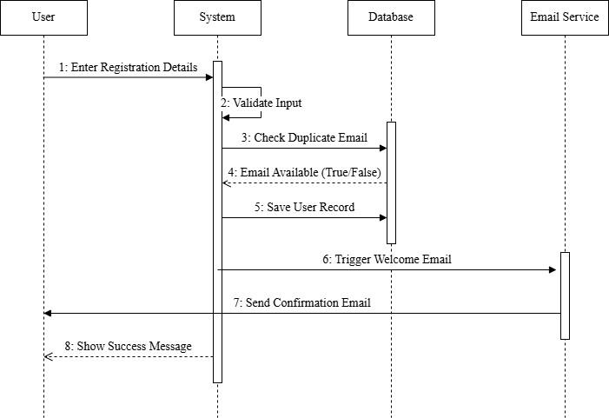
Figure 4.15: Sequence Diagram for Registration

​Sequence Diagram for Login
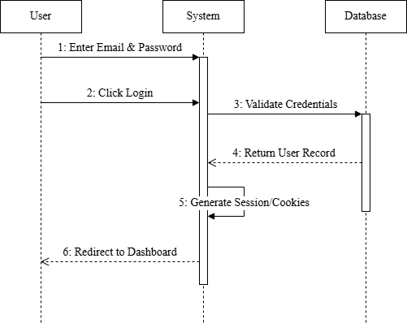
Figure 4.16: Sequence Diagram for Login

​Sequence Diagram for Booking Services
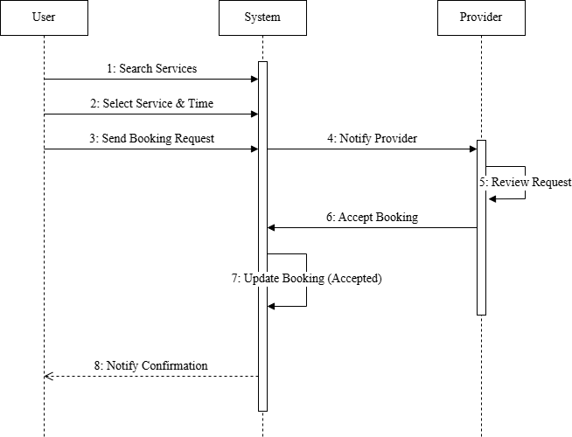
Figure 4.17: Sequence Diagram for Booking Services

​Sequence Diagram for Payment
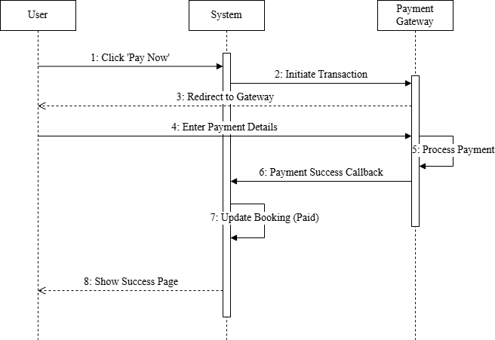
Figure 4.18: Sequence Diagram for Payment

​Sequence Diagram for Provider Verification
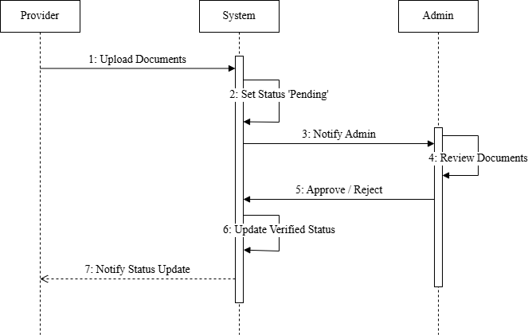
Figure 4.19: Sequence Diagram for Provider Verification

​Sequence Diagram for Service Creation
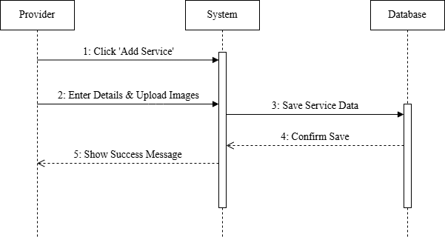
Figure 4.20: Sequence Diagram for Service Creation

​Sequence Diagram for Service Reschedule
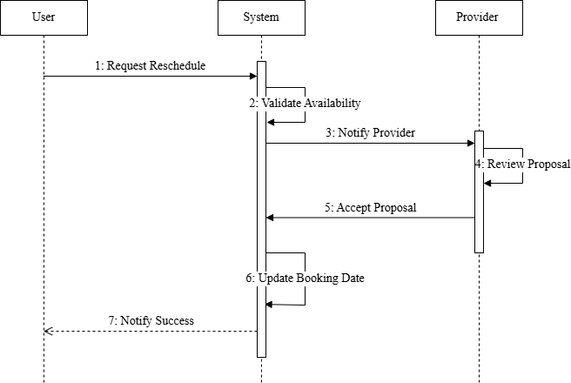
Figure 4.21: Sequence Diagram for Service Reschedule

Class Diagram of Neighbourly System
- The Class Diagram represents the static structure of the system, showing classes, attributes, operations, and relationships.
- User Class: UserId, Name, Email, PasswordHash, Location (GeoPoint), Role.
- Provider Class (inherits User): BusinessName, Services (List<Service>), Rating, IsVerified, Bio.
- Service Class: ServiceId, ProviderId, Name, Category, BasePrice, Description.
- Booking Class: BookingId, ProviderId, SeekerId, ServiceId, Status, ScheduledTime, TotalAmount.
- Review Class: ReviewId, BookingId, Rating (1-5), Comment, SentimentScore.

- Relationships: Provider has many Services; User makes many Bookings; Booking
has one Payment; Booking has one Review.
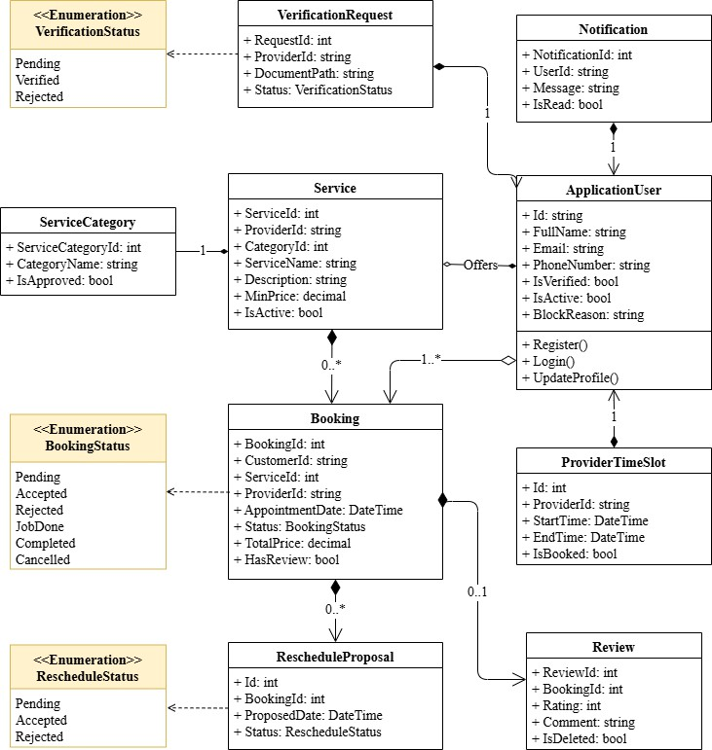
Figure 4.22: Class Diagram of Neighbourly System

Chapter 5.

Project Management

Effective project management was essential for the successful delivery of the Neighbourly platform. This chapter details the risk management strategies employed to ensure the project was completed on time, within budget, and to the specified quality standards. Given the system's reliance on external services (LocationIQ, Hugging Face, SSLCommerz) and real-time data, proactive risk management was critical. The following sections outline the risk identification, analysis, planning, and the comprehensive Risk Mitigation, Monitoring, and Management (RMMM) plan.

Risk Identification
The first step in our risk management process was identifying potential threats to the project's success. These risks were categorized into Technical, Operational, Schedule, and Security domains.
Table 5.1: Risk Identification Table

Risk ID | Risk Description | Category | Probability | Impact
R1 | LocationIQ API downtime or rate limiting causing search failures | Technical | Low | High
R2 | Delayed approval of Service Provider accounts creating a supply bottleneck | Operational | High | Medium
R3 | AI Service (Hugging Face) timeout or generating irrelevant descriptions | Technical | Medium | Medium
R4 | Integration errors with SSLCommerz payment gateway in production | Technical | Medium | High
R5 | Inaccurate browser geolocation data leading to poor search results | Technical | Medium | Medium
R6 | Scope creep due to new feature requests (e.g., chat, advanced maps) | Schedule | High | High

R7 | Data security vulnerability exposing user PII or location history | Security | Low | High
R8 | Deployment failures on cloud hosting environment | Operational | Medium | High

Risk Analysis
Following identification, each risk was analyzed to determine its probability and impact. This allowed us to calculate the Risk Exposure and assign a Priority level to focus our mitigation efforts effectively.
Table 5.2: Risk Analysis Table

Risk ID | Probability (P) | Impact (I) | Risk Exposure (P × I) | Priority
R1 | Low | High | Medium | 3
R2 | High | Medium | Medium-High | 2
R3 | Medium | Medium | Medium | 3
R4 | Medium | High | Medium-High | 2
R5 | Medium | Medium | Medium | 4
R6 | High | High | Very High | 1
R7 | Low | High | Medium | 3
R8 | Medium | High | Medium-High | 2

Risk Planning
For each identified risk, a specific response strategy was developed. This planning phase ensured that the team was prepared to act immediately should any risk materialize.
Table 5.3: Risk Planning Table

Risk ID | Planned Response / Mitigation Strategy
R1 | Implement client-side caching for location data and provide a manual address entry fallback if the API fails.
R2 | Develop a streamlined Admin Dashboard for quick verification and implement auto-reminders for admins.
R3 | Implement asynchronous processing for AI requests with default template description fallbacks on failure.
R4 | Utilize SSLCommerz Sandbox for extensive testing and implement robust transaction logging for debugging.
R5 | Use LocationIQ's address autocomplete to validate and correct browser-detected coordinates.
R6 | Adhere strictly to the "Phase 1" requirements document and defer extra features to a "V2.1" backlog.
R7 | Utilize ASP.NET Core Identity for secure authentication and implement strict input validation to prevent XSS/SQLi.
R8 | Set up a CI/CD pipeline for automated testing before deployment and maintain a local backup server.

The RMMM Plan
The Risk Mitigation, Monitoring, and Management (RMMM) plan provided a framework for ongoing risk oversight. Managing these risks was a continuous process throughout the development lifecycle of the Neighbourly system. By anticipating issues such as API dependencies and verification bottlenecks, we allocated resources efficiently to maintain steady progress.

Risk Mitigation
      - Incremental Development: Adopted an agile approach, delivering core features (User Auth, Search) first before complex integrations (Payment, AI).
      - External Service Abstraction: Wrapped third-party APIs (LocationIQ, Hugging Face) in service interfaces to allow easy swapping or mocking during testing.
      - Security First: Applied payment industry standards and GDPR principles early in the database design phase.

Risk Monitoring
      - Daily Standups: Discussed potential blockers and new risks daily.
      - Log Monitoring: Used Serilog to monitor API response times and error rates for external services.
      - User Feedback Loop: Monitored beta tester feedback regarding location accuracy and search relevance.

Risk Management
      - Fallback Provision: Maintained static default images and text in case dynamic assets failed to load.
      - Load Balancing plan: Prepared logic to limit AI requests if API rate limits were approached.
      - Documentation: Kept detailed API documentation to resolve integration issues quickly.

Table 5.4: Risk Mitigation, Monitoring, and Management Table

Risk ID | Category | Mitigation Strategy | Monitoring Method
R1 | Technical (API) | Implement Circuit Breaker pattern; allowing manual address override. | Monitor API error logs and latency metrics.
R2 | Operational | Create an "Urgent" queue in the Admin Panel for pending verifications > 24hrs. | Track verification turnaround time key performance indicators (KPIs).
R3 | Technical (AI) | Use background jobs (Hangfire) for AI tasks so UI doesn't freeze. | Monitor job success/failure rates in the background queue.
R4 | Technical (Payment) | Comprehensive unit tests for payment callback logic; Sandbox simulation. | Real-time alerts for failed payment IPN (Instant Payment Notification) requests.
R6 | Schedule | Weekly review of "Must-Have" vs "Nice-to-Have" features with stakeholders. | Burndown charts and velocity tracking in project management tools.
R7 | Security | Regular code reviews focusing on OWASP Top 10  vulnerabilities. | Automated security scanning and dependency checks.

Chapter 6.

Project Planning

To ensure successful execution, the Neighbourly project required a structured project plan. This involved defining project objectives, system scope, and critical milestones such as requirements analysis, system design, development, testing, and deployment. The plan also addresses resource allocation, budget estimation, and risk management strategies. Key deliverables include administrative features (managing categories, verification approval functions, reporting), service provider features (service listing optimization, booking management), and user features (geolocation search, service booking, secure payments). The system ensures a smooth interface with features like proximity-based sorting, AI-assisted descriptions, and secure role-based access.
The following activities of project planning were followed in this system:
    - Estimation of project effort and resources
    - Task prioritization based on dependencies and risks
    - Personnel requirements for development and testing
    - Estimation of project cost and schedule
    - Version control for proper code and document management

System Project Estimation
The accuracy of estimation in the Neighbourly System depends on:
- Estimating product size: Scope includes modules such as User/Provider Authentication, Service Management, Location-based Search, Booking Lifecycle (Request/Negotiate/Complete), Payment Gateway Integration, and Admin/Provider Dashboards.
- Effort, Calendar Time, and Cost: Time and cost are estimated considering system complexity (specifically geospatial logic and AI integration), number of modules, and skill requirements of the development team. This involves effort for clean architecture setup, frontend responsiveness, and API integrations.
- Consistency of requirements: Requirements are kept stable throughout development, focused on the core "Service Marketplace" value proposition.

Function-Oriented Metrics
The project estimation is based on function point analysis, which considers both data functions and transactional functions.

Data Functions
  - Internal Logical Files (ILF): Data maintained within the system, such as Users (ApplicationUser), Service Listings, Bookings, Reviews, Notifications, and Provider Verification Documents.
  - External Interface Files (EIF): Interfaces connecting to external services like LocationIQ (Geocoding), SSLCommerz (Payment), and Hugging Face (AI Inference).

Transactional Functions
  - External Inputs (EI): User actions such as registering, creating a service, searching for providers, placing a booking request, negotiating time, and processing payments.
  - External Outputs (EO): Booking confirmations, Digital Receipts, Verified Provider Badges, Admin Reports.
  - External Inquiries (EQ): Real-time queries such as checking provider availability, viewing service details, and filtered search results.

Identifying Complexity

​Identifying Complexity of Transaction Functions
      - Low complexity: Simple inputs such as user login, logout, viewing static pages, and profile updates.
      - Medium complexity: Service creation (requires image upload + AI generation), submitting verification requests, and keyword-based search.

      - High complexity: The Booking process (involves state changes: Pending -> Confirmed -> JobDone -> Paid), Secure Payments (SSLCommerz integration with callbacks), and Geo-spatial Search (sorting by distance).

​Identifying Complexity of Data Functions
      - Low complexity: Static data such as Service Categories or FAQ entries.
      - Medium complexity: User profiles (Basic info + Location data) and Review records.
      - High complexity: Service Listings (links to Provider, Location, Reviews, Images), Booking Records (links to User, Provider, Service, Payment, Status History).

​Unadjusted Function Point Contribution

Table 6.1: Unadjusted Function Point Contribution (Transaction Function)

Transaction Functions | FTRs | DETs | Complexity | UFP
User/Provider Registration (EI) | 2 | 15 | Average | 4
Authentication (Login/Reset) (EI) | 1 | 5 | Low | 3
Search Services (Geo-Location) (EQ) | 2 | 10 | High | 6
View Service Details (EQ) | 2 | 20 | High | 6
Create/Edit Service (EI) | 2 | 18 | Average | 4
Book Service (Negotiation) (EI) | 3 | 15 | High | 6
Process Payment (EO) | 2 | 12 | High | 7
Provider Verification (EI) | 2 | 8 | Average | 4

Manage Bookings (Provider) (EI) | 2 | 12 | Average | 4
Submit Review (EI) | 2 | 5 | Low | 3
Admin User Management (EI) | 1 | 8 | Low | 3
Generate Reports (EO) | 2 | 15 | Average | 5
Total (Transaction) |  |  |  | 55

​Unadjusted Function Point Contribution

Table 6.2: Unadjusted Function Point Contribution (Data Function)

Data Function (ILF/EIF) | FTRs | DETs | Complexity | UFP
tbl_Users (ILF) | 3 | 25 | High | 15
tbl_Services (ILF) | 4 | 20 | High | 15
tbl_Bookings (ILF) | 4 | 18 | High | 15
tbl_Categories (ILF) | 1 | 5 | Low | 7
tbl_VerificationRequest (ILF) | 2 | 10 | Average | 10
tbl_Reviews (ILF) | 2 | 8 | Low | 7
tbl_Notifications (ILF) | 1 | 6 | Low | 7
LocationIQ API (EIF) | 1 | 5 | Average | 7

SSLCommerz API (EIF) | 1 | 15 | Average | 7
Total (Data) |  |  |  | 90

​Performance and Environmental Impact

Table 6.3: Performance and Environmental Impact (GSC)

General System Characteristic | Rating
Data Communications | 4
Distributed Data Processing | 2
Performance (Geo-search latency) | 4
Heavily Used Configuration | 2
Transaction Rate | 3
Online Data Entry | 4
End-user Efficiency | 3
Online Update | 3
Complex Processing (Geospatial) | 4
Reusability | 3
Installation Ease | 3
Operational Ease | 3
Multiple Site | 2
Facilitate Change | 3

Total Degree of Influence (TDI) | 43

​Counting Adjusted Function Point
Function Point Calculation
      - UFP for Transaction = 55
      - UFP for Data = 90
      - Total UFP = 145
      - Value Adjustment Factor (VAF) = 0.65 + (0.01 × 43) = 1.08
      - Adjusted FP (AFP) = 145 × 1.08 = 156.6 (approx 157)
      - Effort = AFP × Productivity (Assumed C# productivity ≈ 14 FP/month for small teams) = 157 ÷ 14 ≈ 11.2 person-months
      - With a team of 4 members: Duration ≈ 11.2 ÷ 4 ≈ 2.8 months (approx 12 weeks)

Project Schedule Chart (12- week timeframe)
The Neighbourly system project follows a structured 12-week timeline running from October 23, 2025, to January 14, 2026, using a sequential, phase-based approach. The project begins with a 2-week Planning phase focused on requirements gathering, followed by a 2-week Design phase covering database structure and UI/UX architecture.
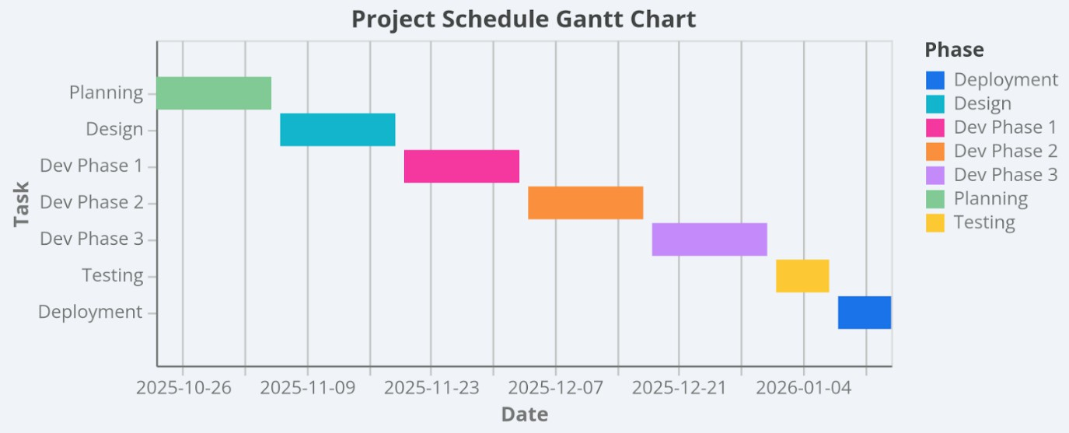
Figure 6.1: Project Schedule Gantt Chart

Development is carried out in three incremental 2-week phases: Phase 1 implements core Authentication and User Profiles, Phase 2 delivers Service Creation and Location-Based Sorting, and Phase 3 completes Booking Logic and Payment Integration. The schedule concludes with a 1-week Testing phase for validation and bug fixes, and a final 1-week Deployment phase for documentation and presentation, ensuring all dependencies are addressed.

Accounts Table
Project costs are estimated based on a standard development environment for a medium-scale academic/startup project.

​Personnel Cost
The largest portion of the budget is dedicated to personnel, as skilled manpower is essential for successful development and deployment.
Table 6.4: Personal Cost

Role | No. of Persons | Est. Cost (Monthly) | Duration | Total
Project Manager | 1 | 80,000 BDT | 3 Mos | 240,000 BDT
Backend Developer | 2 | 50,000 BDT | 3 Mos | 300,000 BDT
Frontend Developer | 1 | 45,000 BDT | 3 Mos | 135,000 BDT
Total Personnel |  |  |  | 675,000 BDT

​Expected Hardware Cost
To support development, testing, and hosting, certain hardware resources are required.

Table 6.5: Expected Hardware Cost

Item | Quantity | Unit Price | Total Cost

Development Laptops | 4 | (Existing Assets) | 0 BDT
Local Server (Testing) | 1 | 5,000 BDT | 5,000 BDT
Total Hardware |  |  | 5,000 BDT

​Expected Software Cost
Licensed software and development tools are also considered in the cost structure.

Table 6.6: Expected Software Cost

Item | Type | Cost
Visual Studio 2022 | IDE | Free (Community)
SQL Server Express | Database | Free
LocationIQ API | Geolocation | Free Tier
SSLCommerz Sandbox Account | Payment Gateway | Free
Azure/SmarterASP | Hosting | 3,000 BDT (3 month)
Domain Name | Web | 1,000 BDT
Total Software |  | 4,000 BDT

​Expected Other Cost
Other costs include miscellaneous but essential expenses.

Table 6.7: Expected Other Cost

Item | Description | Cost
Internet & Utility | High-speed connection | 6,000 BDT

Documentation | Printing & Binding | 2,000 BDT
Miscellaneous | Contingency fund | 5,000 BDT
Total Other |  | 13,000 BDT
Grand Total Estimated Project Cost: 697,000 BDT

Clarification of Academic vs. Industry Estimates
It is important to note that this budget represents an industry implementation scenario. In the context of this practicum report, the actual cost was close to zero because the project was completed as an academic exercise using free or personal resources. The detailed accounts table therefore illustrates what an organization might expect to spend if deploying the system commercially, while the student project itself required minimal financial investment.

Chapter 7. Designing

The design phase translated the requirements into detailed technical specifications, focusing on usability, data flow, and database integrity.

Interface Design
The User Interface (UI) follows a minimalist, mobile-first design language, acknowledging that most users will access the platform via smartphones. Key design principles include:
- Simplicity: Clear navigation menus for Dashboard, Reports, Search etc.
- Consistency: Uniform design across all modules (fonts, colors, buttons).
- Feedback: Confirmation pop-ups after booking, cancellation, payment etc.
- Accessibility: Mobile-friendly design adaptable to multiple screen sizes.

Non-Logged in User Features
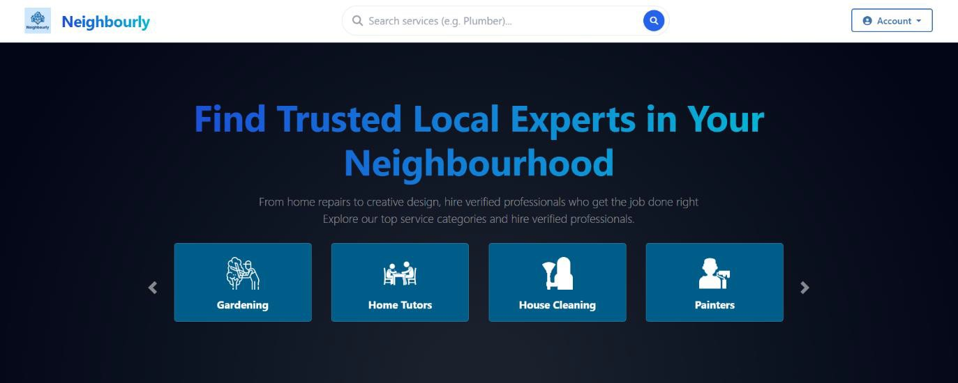
Hero Section: Hero Section in home page shows heading, sub-heading and a dynamic Category Carousal. Also, there are a Search bar and Account Drop Down button at the nav bar. So that users can easily Search for the services, and navigate to the Login/Register page.

Figure 7.1: Hero Section of Home Page
Featured Service: All the featured services show below the Hero Section. Initial two row of featured Service card shows. After Clicking Explore All Services button rest of the services shows up. Every service card loads via AJAX for a smooth user experience.

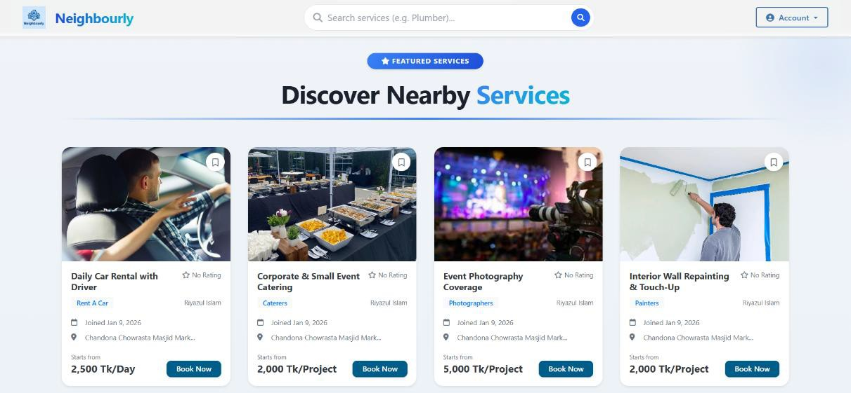
Figure 7.2: Featured Services in Home page
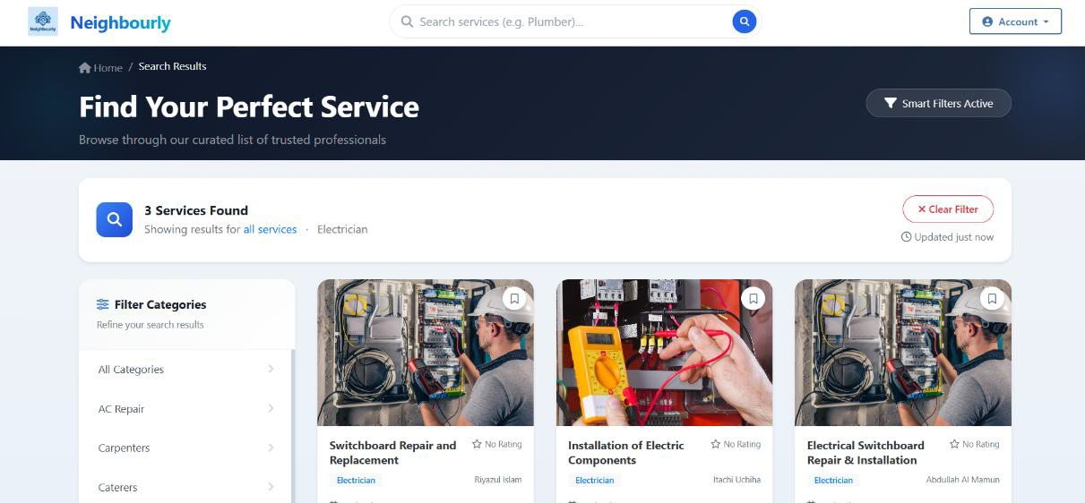
Figure 7.3: Search page
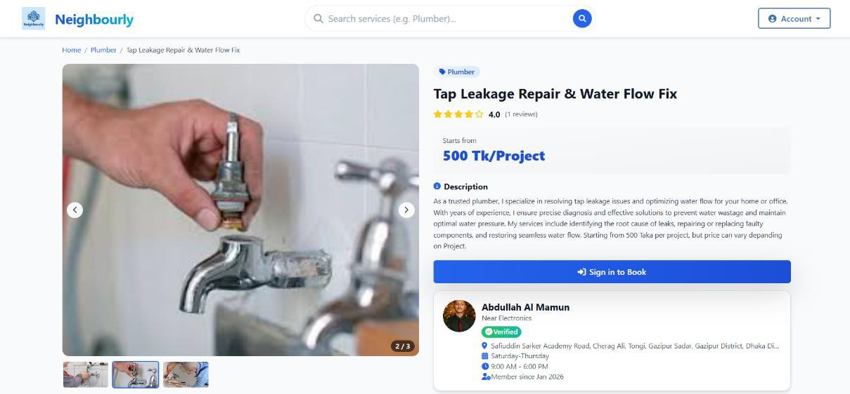
Figure 7.4: Service Details Page

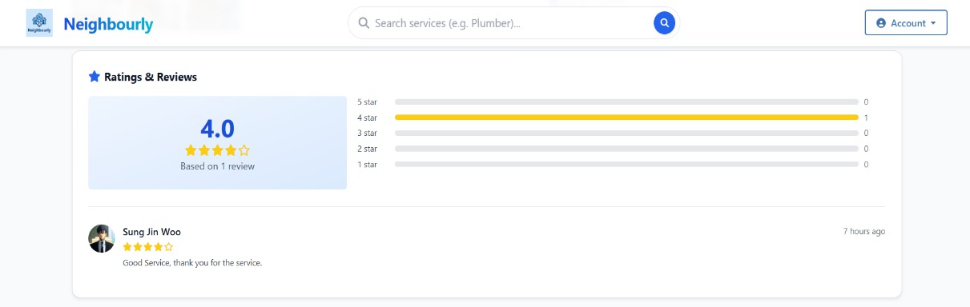
Figure 7.5: Review Section in Service Details page
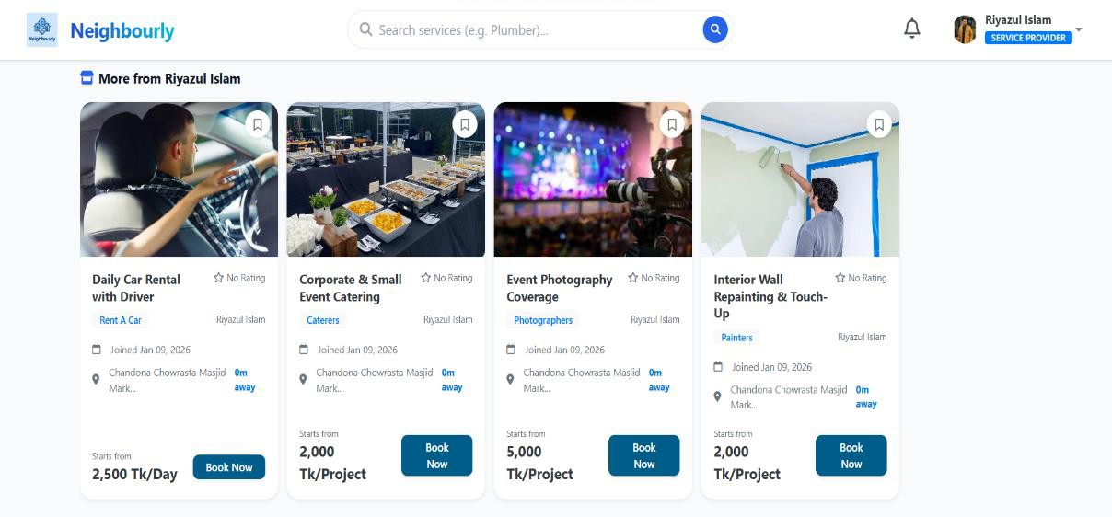
Figure 7.6: More services from same Provider
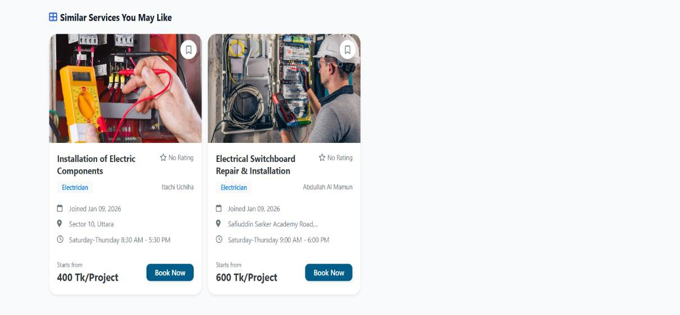
Figure 7.7: Similar Service Section

Provider Features
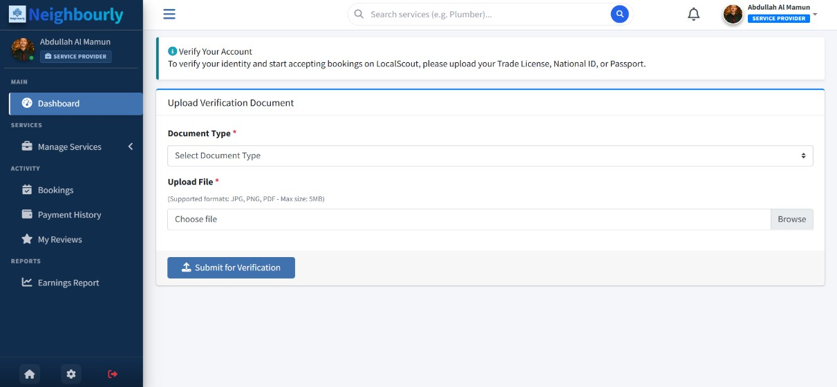
Figure 7.8: Providers Verification Request Form
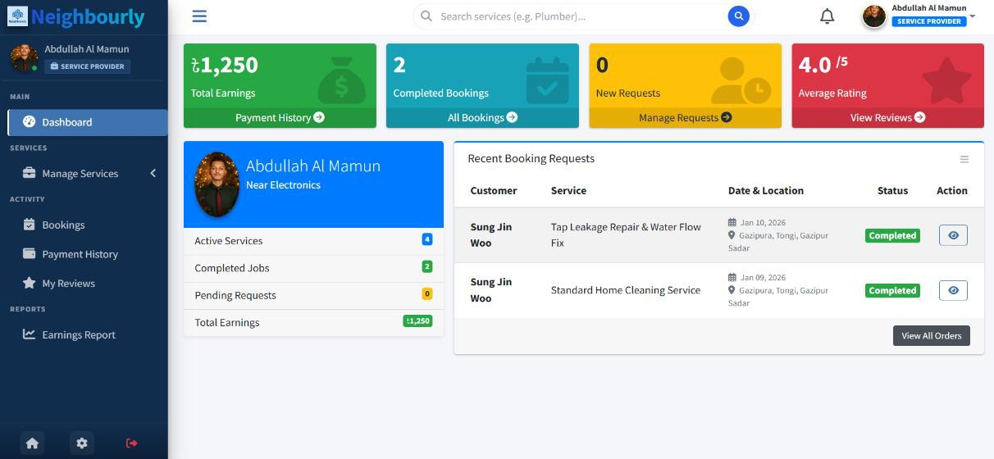
Figure 7.9: Providers Dashboard
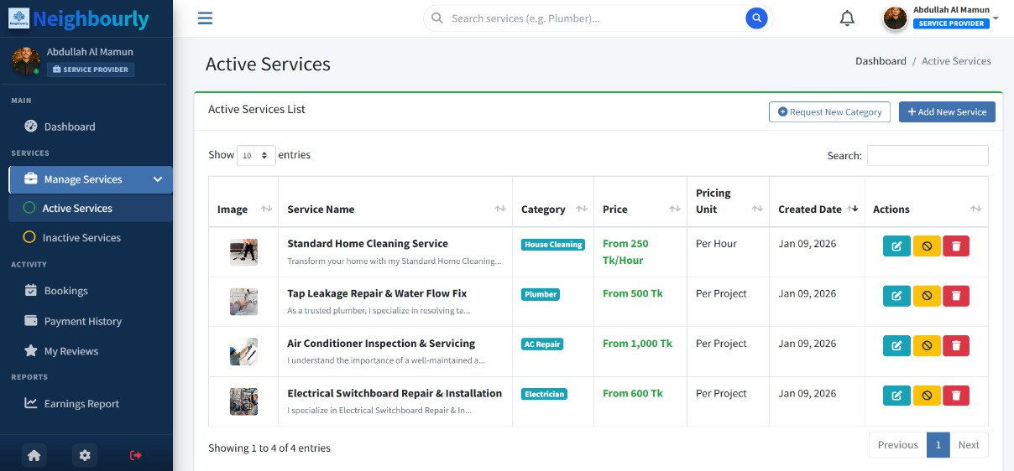
Figure 7.10: Provider Active Services Page

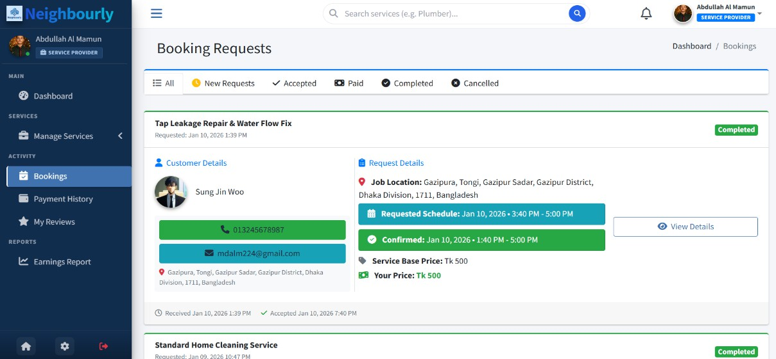
Figure 7.11: Providers booking page
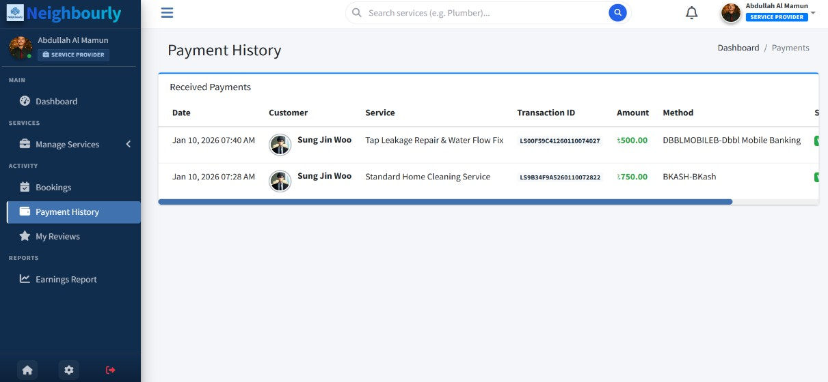
Figure 7.12: Providers Payment History Page
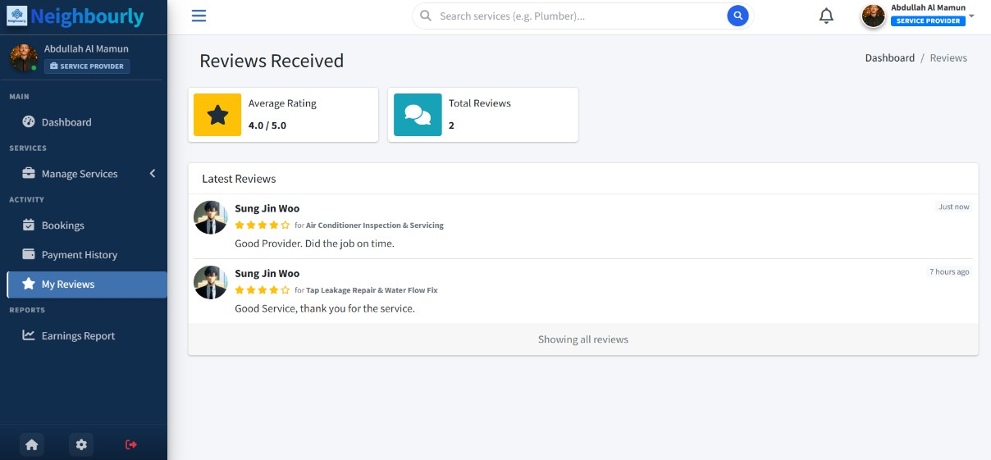
Figure 7.13: Providers My Review Page

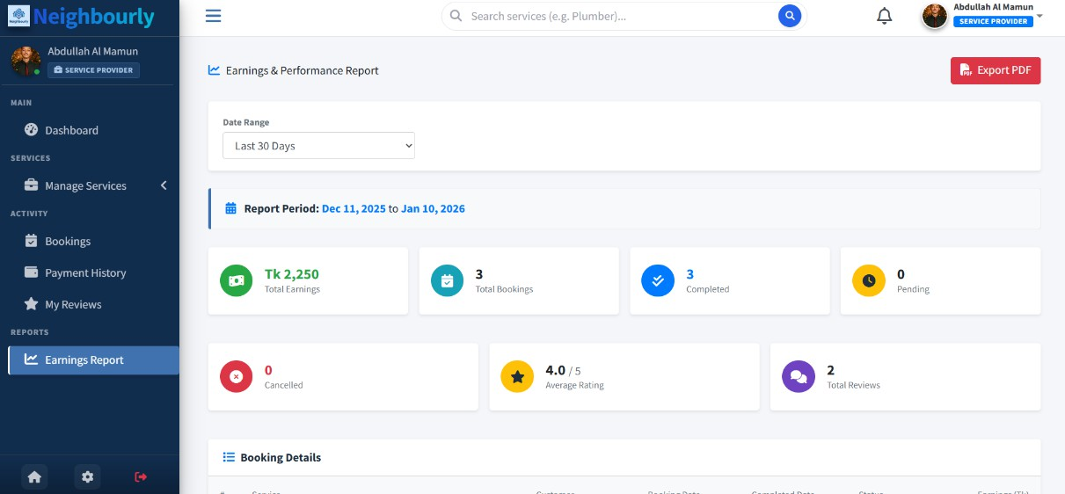
Figure 7.14: Providers Earning Report page

​Users Features
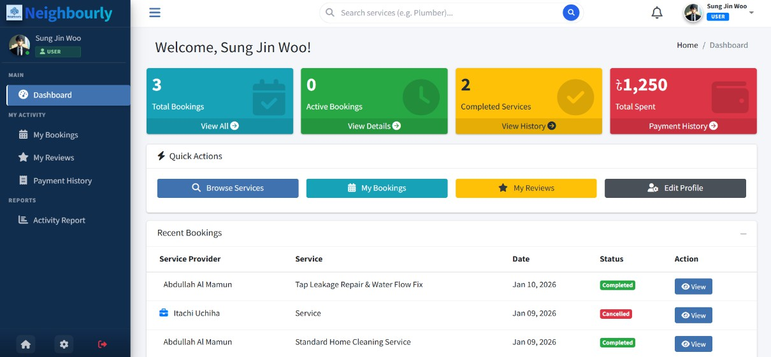
Figure 7.15: Users Dashboard
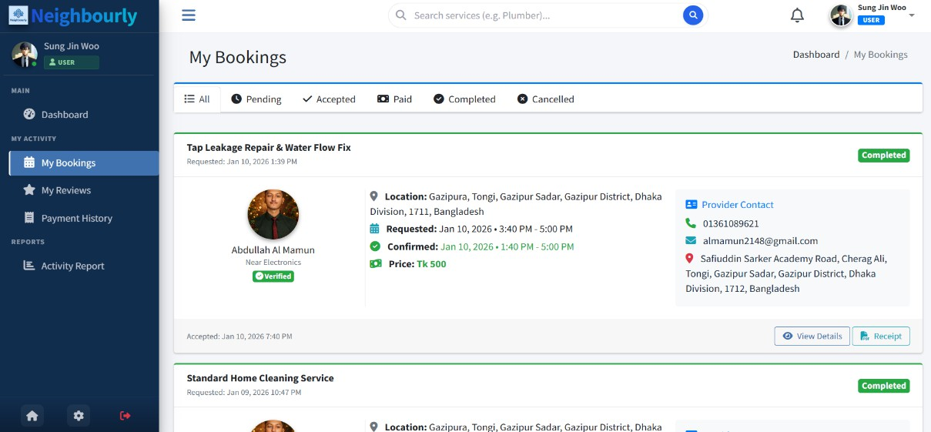
Figure 7.16: Users My booking page

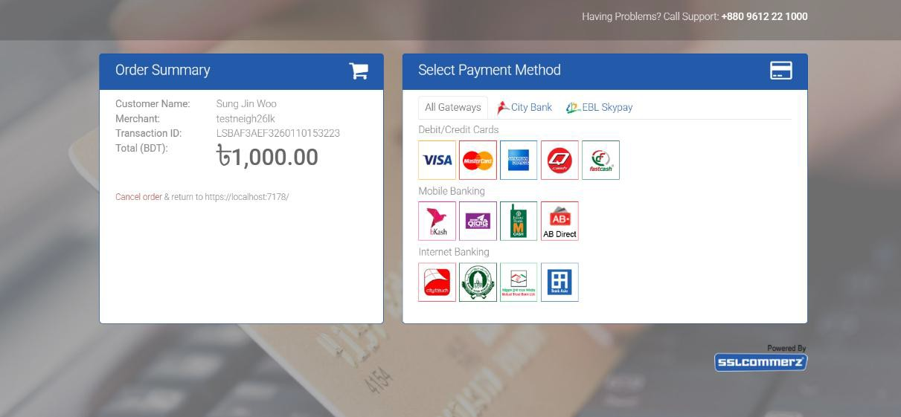
Figure 7.17: SSLCommerz payment page
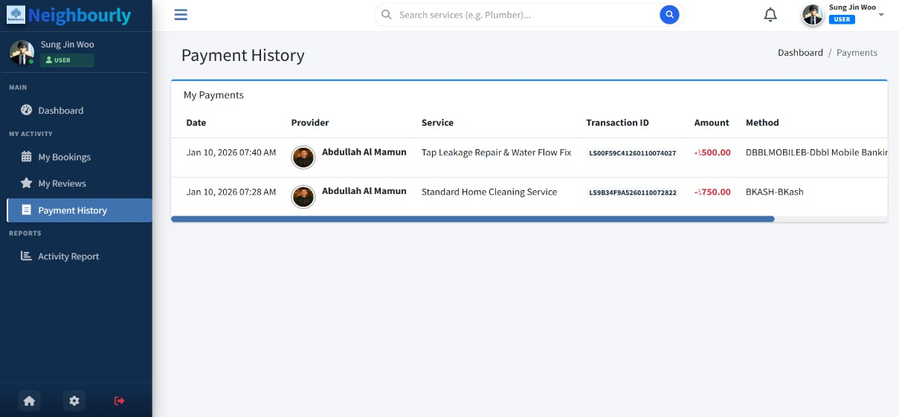
Figure 7.18: Users Payment History page
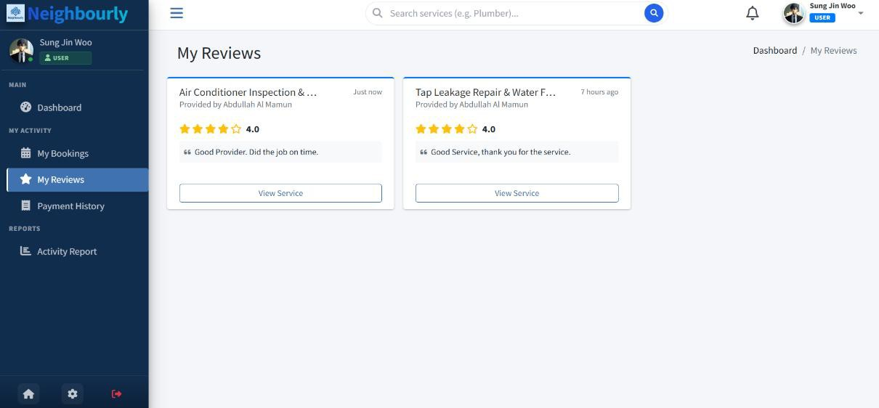
Figure 7.19: Users My Review page

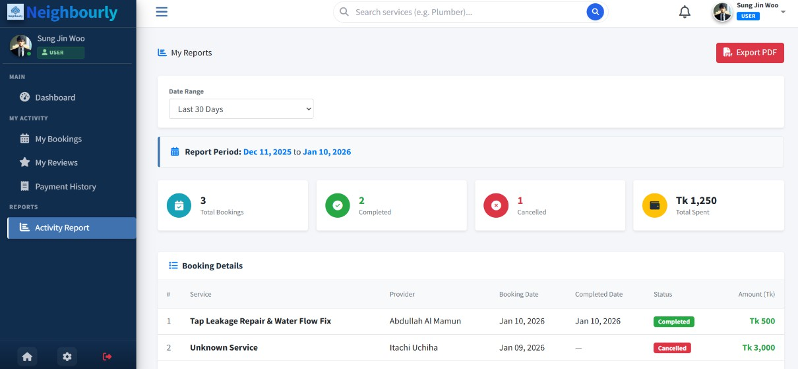
Figure 7.20: Users Activity Report Page

​Admin Features
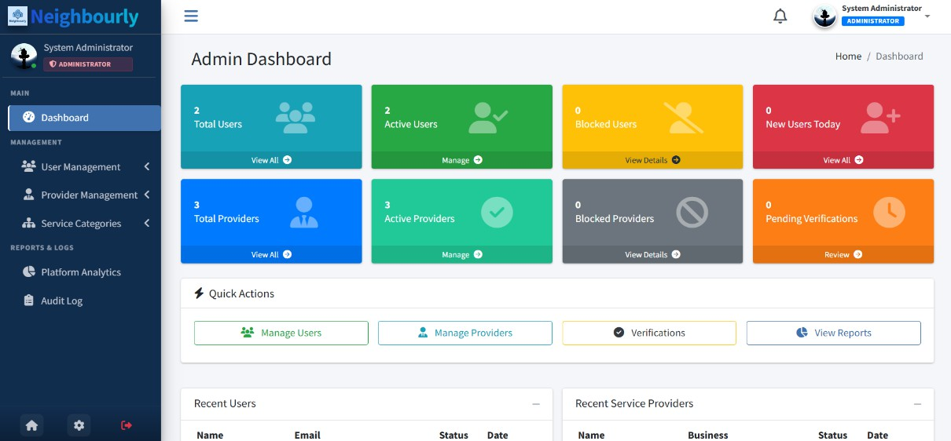
Figure 7.21: Admin Dashboard
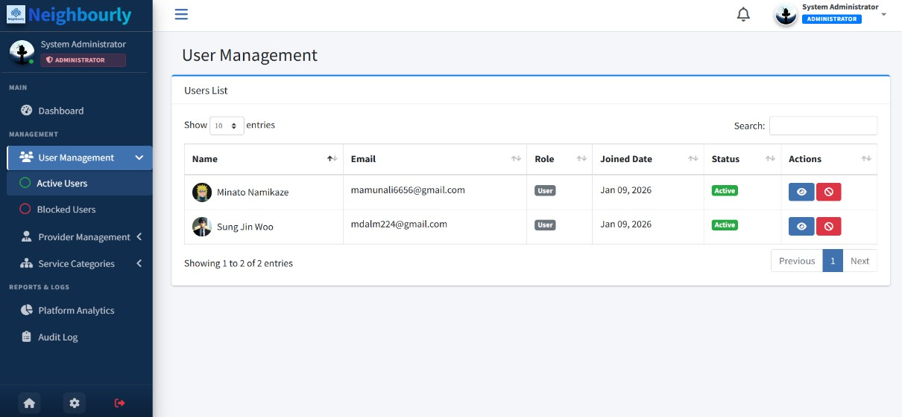
Figures 7.22: User Management

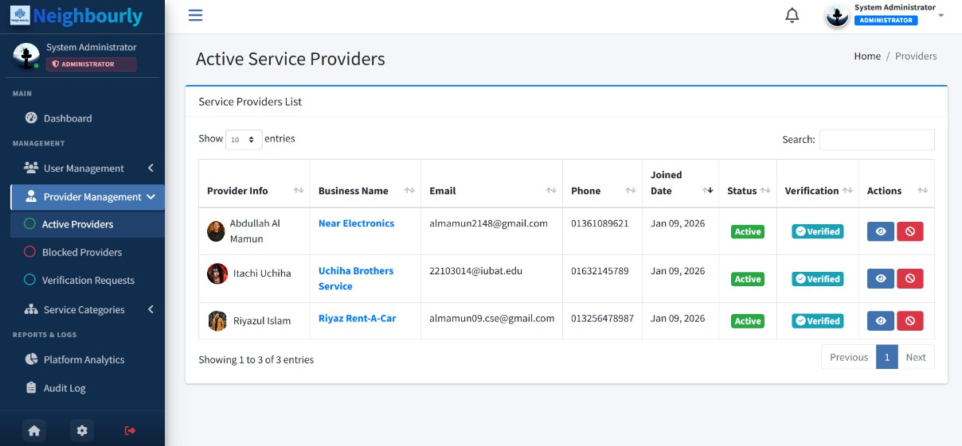
Figure 7.23: Provider Management
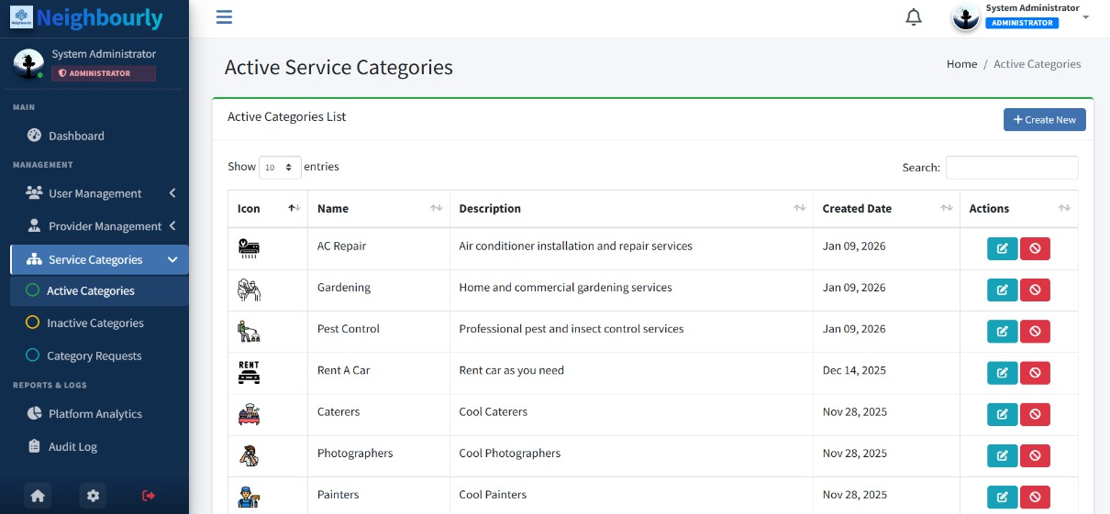
Figure 7.24: Service Category Management
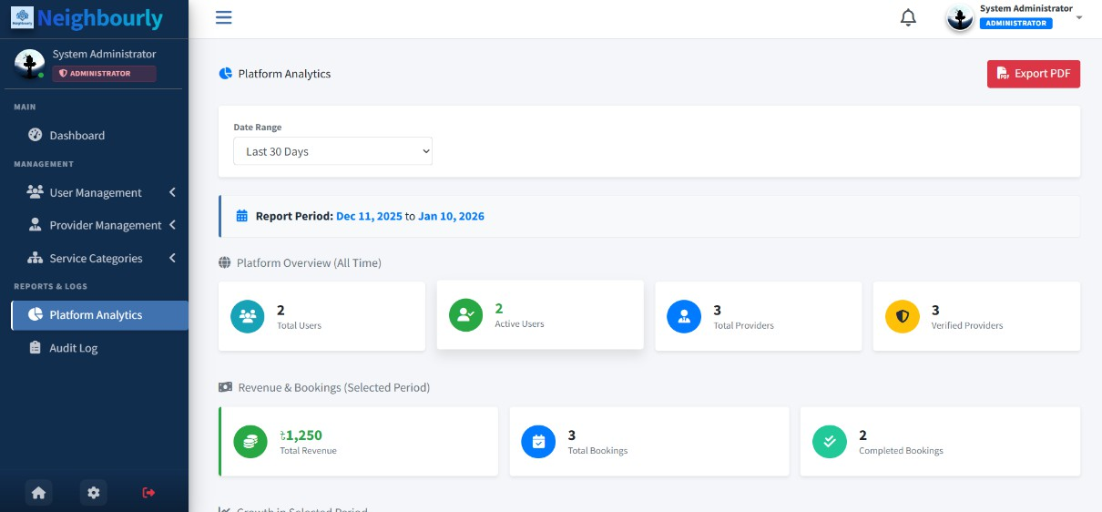
Figure 7.25: Platform Analytics & Reports

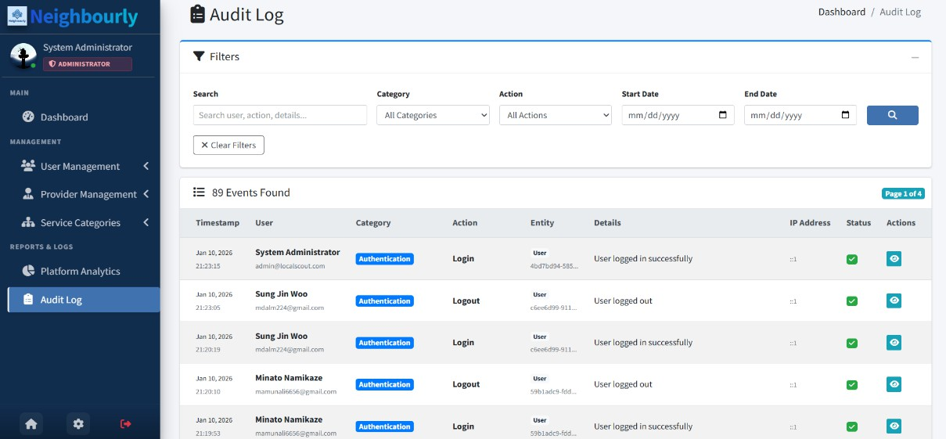
Figure 7.26: Admin Audit Log

Data Flow Diagram (DFD)
A Data Flow Diagram (DFD) is a graphical representation used to illustrate how data moves through an information system. It focuses on the flow of data between different system components rather than on program logic or technical implementation. DFDs help analysts and developers understand how data is received, processed, stored, and produced as output within the system.
A Data Flow Diagram is composed of four main elements: external entities, processes, data stores, and data flows. External entities represent users or external systems that interact with the system. Processes define the activities that transform input data into meaningful output. Data stores are repositories where data is saved for future use, such as databases or files. Data flows show the direction and type of data moving between entities, processes, and data stores.
DFDs are developed in multiple levels to provide increasing detail. The Context Diagram (Level 0) presents the entire system as a single process and shows its interaction with external entities. Level 1 and Level 2 DFDs further decompose the system into smaller, more detailed processes, making complex systems easier to understand.
Overall, Data Flow Diagrams are essential for system analysis and design, as they improve clarity, support requirement validation, and enhance communication among stakeholders.

​Context-Level DFD (Level 0)
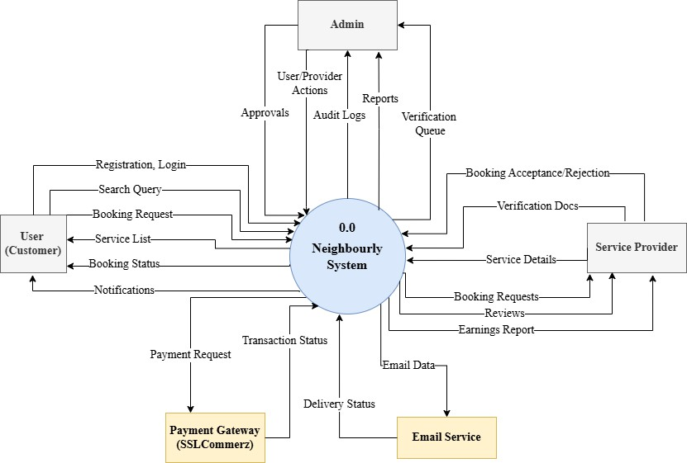
The Level 0 DFD represents the entire Neighbourly system as a single process interacting with external entities.

Figure 7.27: Context Level DFD (Level 0)

External Entities:
        - User: Sends registration data, search queries, booking requests, and payments. Receives service results, booking confirmations, and notifications.
        - Service Provider: Sends business details, service listings, verification docs, and booking responses. Receives booking requests and earnings reports.
        - Admin: Sends verification approvals and blocking commands. Receives system reports and usage stats.
        - Payment Gateway (SSLCommerz): Receives payment requests. Sends transaction status.
        - Map Service (LocationIQ): Receives coordinates/addresses. Sends geolocation data.

​DFD Level 1
The Level 1 DFD decomposes the main system into its primary sub-processes:
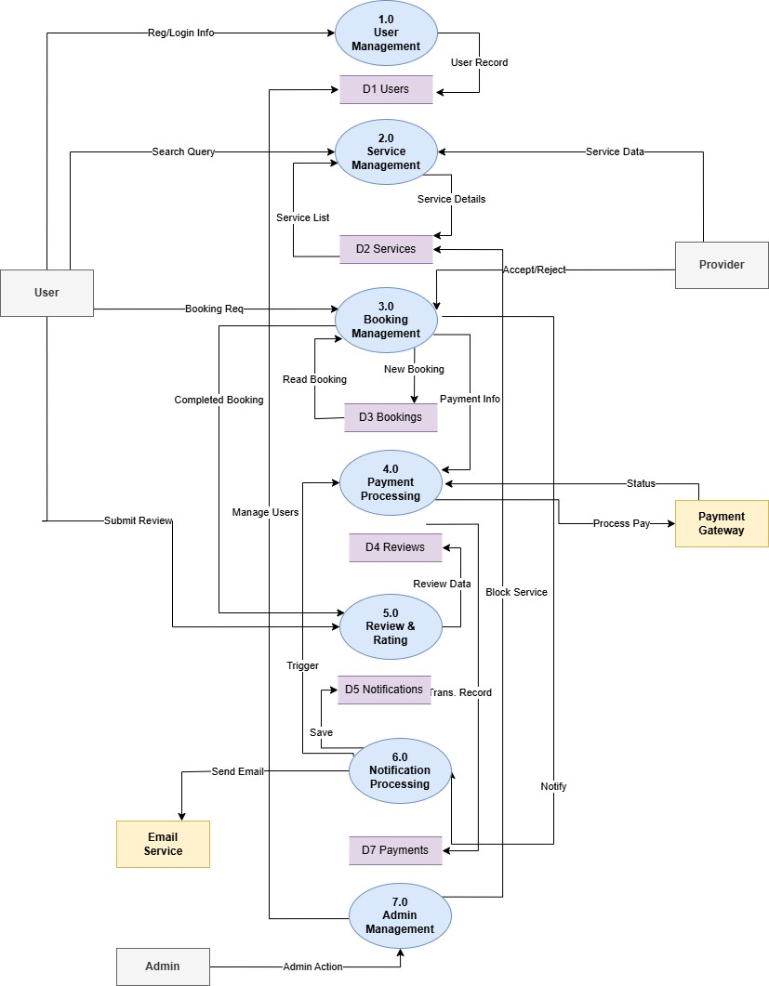
Figure 7.28: Level 1 DFD
      - 1.0 User Management: Handles user registration, login, and maintenance of user records.
      - 2.0 Service Management: Manages service listings, service details, and processes user search queries.

      - 3.0 Booking Management: Handles service booking requests, provider accept/reject actions, and booking status updates.
      - 4.0 Payment Processing: Processes payment information, interacts with the payment gateway, and records transaction status.
      - 5.0 Review & Rating: Manages user reviews and ratings after service completion and stores feedback data.
      - 6.0 Notification Processing: Generates and sends booking, payment, and review notifications through the email service.
      - 7.0 Admin Management: Oversees system administration, including user management, service control, and payment monitoring.

DFD Level 2
P2.1 Browse & Search Services: Allows users to search services using criteria and retrieves relevant service listings from the Services data store.
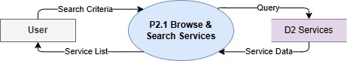
Figure 7.29: DFD Level 2 Process 1
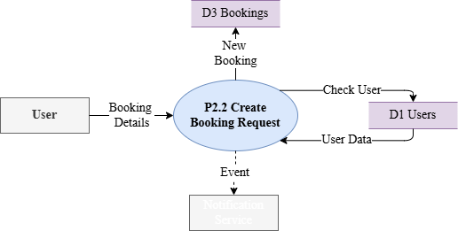
P2.2 Create Booking Request: Collects booking details from the user, validates user information, creates a new booking record, and triggers notification events.

Figure 7.30: DFD Level 2 Process 2

P2.3 Process Provider Response: Sends booking requests to providers, processes accept/reject responses, locks time slots, and updates booking status.
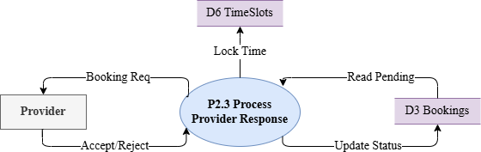
Figure 7.31: DFD Level 2 Process 3
P2.4 Handle Scheduling: Manages rescheduling requests, checks time slot availability, updates booking time, and returns updated status to users and providers
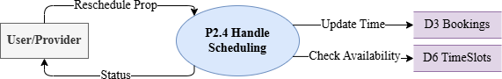
Figure 7.32: DFD Level 2 Process 4
P2.5 Process Payment: Retrieves booking details, processes payment through the payment gateway, marks bookings as paid, and stores payment receipts.
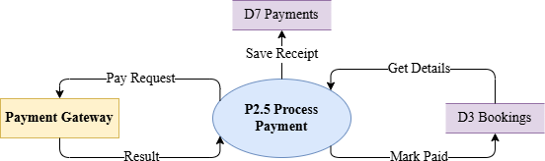
Figure 7.33: DFD Level 2 Process 5

P2.6 Manage Job Execution: Tracks job starts and completion by providers, retrieves job information, and updates booking execution status.
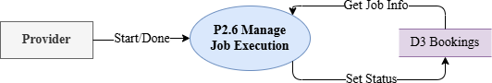
Figure 7.34: DFD Level 2 Process 6
P2.7 Handle Review Submission: Accepts review details from users, verifies completed bookings, saves reviews, and marks bookings as reviewed.
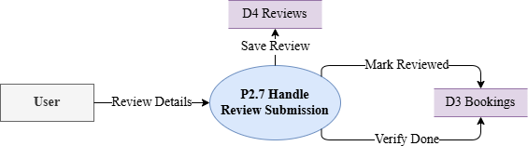
Figure 7.35: DFD Level 2 Process 7
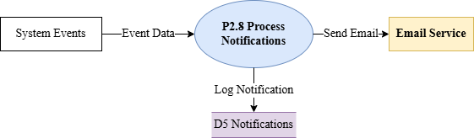
P2.8 Process Notifications: Processes system events, sends email notifications via the email service, and logs notification records.

Figure 7.36: DFD Level 2 Process 8

Database Design
Database design plays a critical role in ensuring that the Neighbourly Service Booking System is efficient, scalable, and reliable. The database is designed to manage users, service providers, services, bookings, payments, reviews, notifications, and administrative operations. A relational database approach is adopted to maintain data integrity, minimize redundancy, and support complex relationships between entities such as users, services, bookings, and time slots.

The design supports core system functionalities including service discovery, booking management, payment processing, scheduling, reviews, verification, and notifications.

​Normalization of Data Fields
To ensure data consistency and eliminate redundancy, the Neighbourly database is normalized up to the Third Normal Form (3NF).
- First Normal Form (1NF)
  - All tables contain atomic values.
  - No repeating groups or multivalued attributes exist.
  - Example: Image paths, working hours, and time slots are stored in separate fields or related tables instead of being embedded in a single column.
- Second Normal Form (2NF)
  - All non-key attributes fully depend on the primary key.
  - Example: In the Booking table, attributes such as status, negotiated price, and requested date depend entirely on BookingId.
- Third Normal Form (3NF)
  - Non-key attributes are independent of each other.
  - Example: User profile details (name, email, address) are stored only in the
ApplicationUser table and not duplicated in Booking or Service tables.
This normalization approach improves data integrity, reduces update anomalies, and enhances database maintainability.

​Entity Relationship (ER) Model
The ER model of the Neighbourly system defines key entities and their relationships as follows:
      - ApplicationUser: Represents both users and service providers. Stores personal information, location, verification status, and business details.

      - Service: Represents services offered by providers. Each service belongs to a specific service category and is associated with one provider.
      - ServiceCategory: Defines categories under which services are grouped (e.g., plumbing, cleaning).
      - Booking: Represents service bookings made by users. A booking links a user, a service, a provider, and selected time slots.
      - ProviderTimeSlot: Stores provider availability and ensures that booked slots are blocked during confirmed bookings.
      - Review: Stores user feedback and ratings for completed bookings.
      - Payment: Records payment transactions linked to bookings and users.
      - Notification: Stores system-generated notifications sent to users.
      - VerificationRequest: Manages provider verification submissions and admin review decisions.
      - CategoryRequest: Allows providers to request new service categories.
      - AuditLog: Tracks system activities for security and monitoring.
      - ServiceBlock & RescheduleProposal: Handle service blocking by admin and booking rescheduling workflows.
The relationships include:
      - One User to Many Bookings
      - One Provider to Many Services
      - One Booking to One Payment
      - One Booking to One Review
      - One Service to Many Bookings
      - One Provider to Many Time Slots

​Database Table Structure
The following tables represent the core schema of the system:

Table 7.1: ApplicationUser Table

Field | Type | Description
Id (PK) | NVARCHAR(450) | Unique user identifier (Identity)
FullName | NVARCHAR(MAX) | User's legal name
Email | NVARCHAR(256) | Unique email address
BusinessName | NVARCHAR(MAX) | Provider's business display name
Role | NVARCHAR(MAX) | User role (Admin, Provider, User)
Latitude | FLOAT | Location coordinate for search
Longitude | FLOAT | Location coordinate for search
IsVerified | BIT | Provider verification status
Table 7.2: Service Table

Field | Type | Description
ServiceId (PK) | UNIQUEIDENTIFIER | Unique service identifier
ServiceCategoryId (FK) | UNIQUEIDENTIFIER | Link to ServiceCategory
Id (FK) | NVARCHAR(450) | Link to Provider (ApplicationUser)
ServiceName | NVARCHAR(MAX) | Title of the service
MinPrice | DECIMAL(18,2) | Starting price for the service

IsActive | BIT | Visibility status
Table 7.3: Booking Table

Field | Type | Description
BookingId (PK) | UNIQUEIDENTIFIER | Unique booking reference
ServiceId (FK) | UNIQUEIDENTIFIER | Link to Service
UserId (FK) | NVARCHAR(450) | Link to Customer
ProviderId (FK) | NVARCHAR(450) | Link to Service Provider
Status | INT | Enum
NegotiatedPrice | DECIMAL(18,2) | Final agreed price
ConfirmedStartDateTime | DATETIME | Scheduled start time
Table 7.4: ServiceCategory Table

Field | Type | Description
ServiceCategoryId (PK) | UNIQUEIDENTIFIER | Unique category ID
CategoryName | NVARCHAR(MAX) | Name (e.g., Plumbing)
IconPath | NVARCHAR(MAX) | Path to category icon image
IsApproved | BIT | Admin approval status
Table 7.5: Review Table

Field | Type | Description
ReviewId (PK) | UNIQUEIDENTIFIER | Unique review ID

BookingId (FK) | UNIQUEIDENTIFIER | Link to completed booking
Rating | INT | Star rating (1-5)
Comment | NVARCHAR(MAX) | Text feedback
CreatedAt | DATETIME | Date of review
Table 7.6: VerificationRequest Table

Field | Type | Description
VerificationRequestId (PK) | UNIQUEIDENTIFIER | Unique request ID
ProviderId (FK) | NVARCHAR(450) | Link to Provider
DocumentPath | NVARCHAR(MAX) | Path to uploaded ID/License
Status | INT | Pending, Approved, Rejected
Table 7.7: Notification Table

Field | Type | Description
NotificationId (PK) | UNIQUEIDENTIFIER | Unique notification ID
UserId (FK) | NVARCHAR(450) | Recipient ID
Title | NVARCHAR(MAX) | Notification header
Message | NVARCHAR(MAX) | Notification body content
IsRead | BIT | Read/Unread status
Table 7.8: AuditLog Table

Field | Type | Description

AuditLogId (PK) | UNIQUEIDENTIFIER | Unique log ID
Action | NVARCHAR(MAX) | Description of activity
UserId | NVARCHAR(450) | User who performed action
IpAddress | NVARCHAR(MAX) | Source IP address
Timestamp | DATETIME | Time of occurrence
Table 7.9: ProviderTimeSlot Table

Field | Type | Description
TimeSlotId (PK) | UNIQUEIDENTIFIER | Unique slot ID
ProviderId (FK) | NVARCHAR(450) | Link to Provider
BookingId (FK) | UNIQUEIDENTIFIER | Link to Booking
StartDateTime | DATETIME | Slot start time
EndDateTime | DATETIME | Slot end time
Table 7.10: RescheduleProposal Table

Field | Type | Description
ProposalId (PK) | UNIQUEIDENTIFIER | Unique proposal ID
BookingId (FK) | UNIQUEIDENTIFIER | Link to Booking
ProposedBy | NVARCHAR(450) | Name of proposer
ProposedDate | DATETIME | Suggested new date
Status | INT | Pending, Accepted, Rejected

Table 7.11: ServiceBlock Table

Field | Type | Description
ServiceBlockId (PK) | UNIQUEIDENTIFIER | Unique block ID
ServiceId (FK) | UNIQUEIDENTIFIER | Link to blocked service
Reason | NVARCHAR(MAX) | Reason for blocking
UnblockAt | DATETIME | Automatic unblock time
Table 7.12: CategoryRequest Table

Field | Type | Description
CategoryRequestId (PK) | UNIQUEIDENTIFIER | Unique request ID
ProviderId (FK) | NVARCHAR(450) | Requester ID
RequestedCategoryName | NVARCHAR(MAX) | Suggested name
Status | INT | Approval status

ER Diagram for Neighbourly System
The Entity-Relationship (ER) Diagram of the Neighbourly system visually represents the database structure and the relationships between key entities. It shows how users interact with services, including service creation and booking processes. The diagram also illustrates how bookings are associated with payments and reviews, ensuring accurate tracking of transactions and feedback. Additionally, it represents administrative functions such as user verification and service blocking, which support system security and quality control. Overall, the ER Diagram provides a clear understanding of data organization and relationships within the Neighbourly system, supporting efficient database design and system implementation.

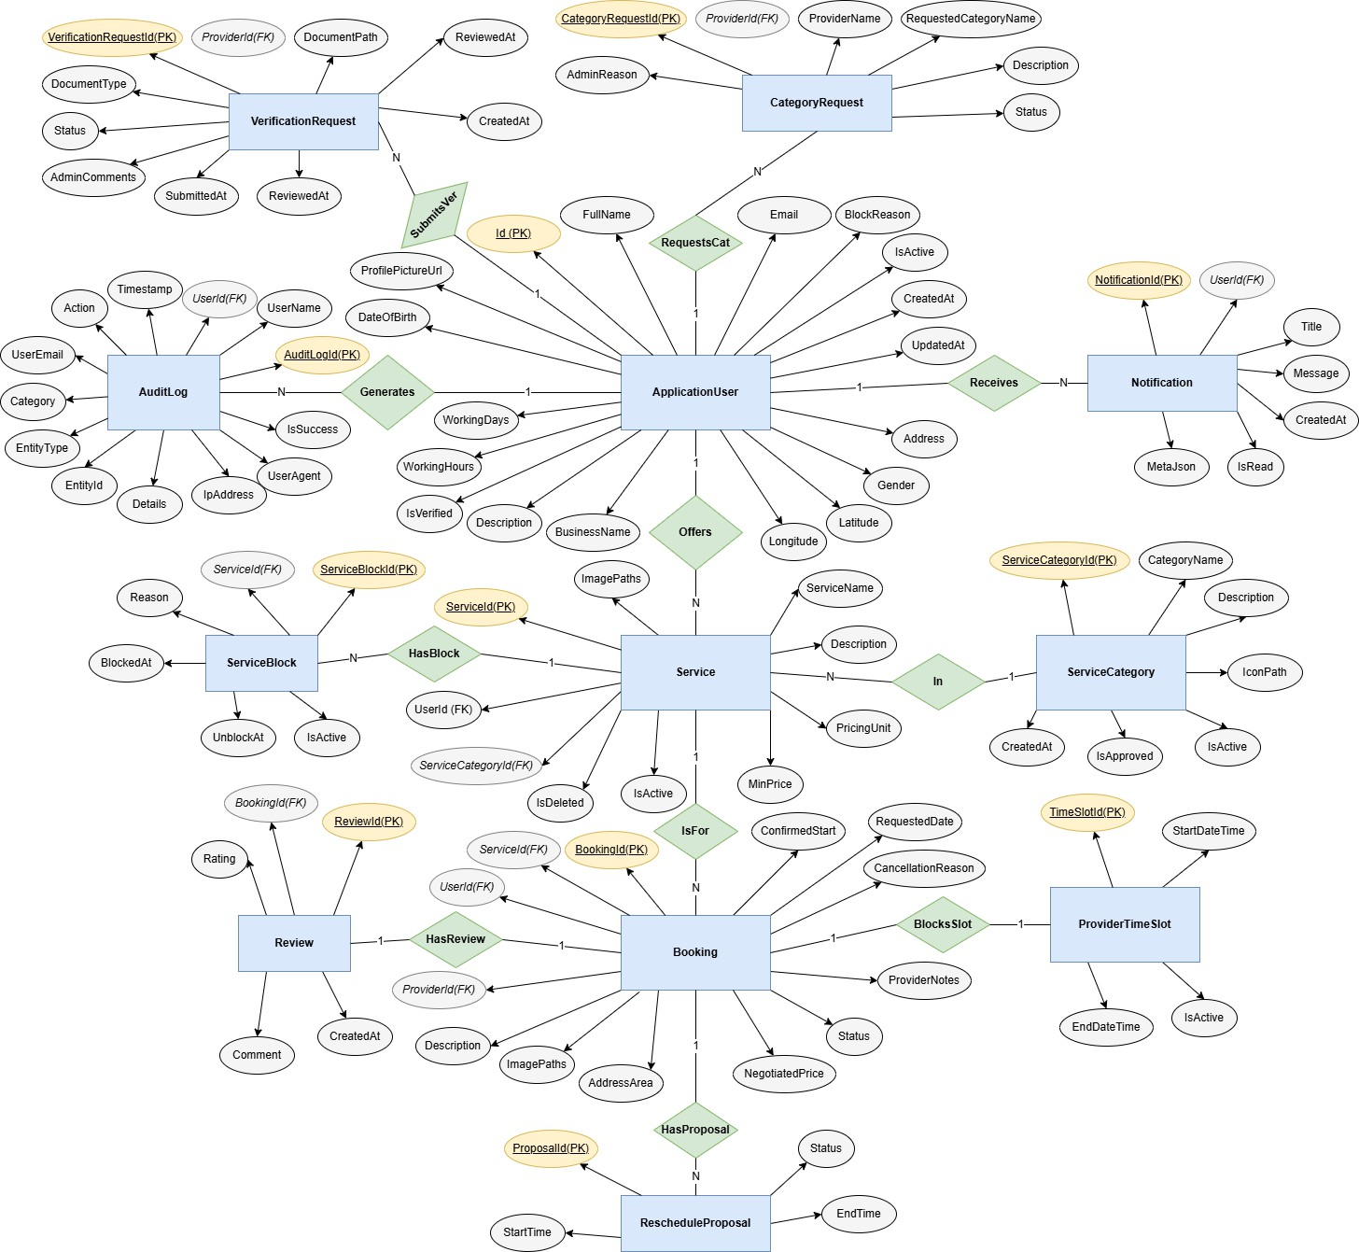
Figure 7.37: ER Diagram of Neighbourly System

Chapter 8.

System Quality and Testing

System Quality Management
System quality management ensures that the developed LocalScout System (Service Marketplace) meets its functional requirements, performance expectations, and user satisfaction goals. The quality of the system was managed throughout the project by applying structured testing methods, code reviews, and continuous validation of requirements.

​Software Quality Management Process
The quality management process followed these steps:
- Requirement Verification: All Service Seeker and Service Provider requirements (service listing, extensive search, booking management, payment processing, cancellation, refund, reporting, etc.) were documented and confirmed with stakeholders before development (Mramba and Kaijage, 2018).
- Design Validation: The database schema (Entity Relationship Diagram), interface design, and system architecture were validated to ensure consistency, normalization, and efficiency.
- Code Quality Assurance: Coding standards (C# naming conventions, SOLID principles) were maintained and peer reviews were performed to avoid logical errors, redundancy, and maintainability issues (Pressman and Maxim, 2014).
- Testing: Multiple types of testing, such as unit testing, integration testing, system testing, and user acceptance testing (UAT), were performed to verify the interaction between different modules (e.g., User, Booking, Service).
- Performance Evaluation: Load testing was carried out to ensure the system could handle multiple simultaneous users searching for services and booking appointments without failures.
- Error Monitoring Debugging: Bugs identified during testing (e.g., status transition errors, payment callback failures) were logged, categorized by severity, and fixed before final deployment.
- User Feedback Integration: End users (Seekers and Providers) and admin testers were involved to provide feedback on usability, which was integrated into the final version.

​Software Test Cases
The system was tested using multiple scenarios to ensure functionality, security, and reliability. Ghezzi et al. (2002). Some key test cases are listed below:
Table 8.1: Test Cases for the System

Test Case ID | Feature Tested | Input / Action | Expected Result | Status
TC1 | User Registration | Enter new username, email, password, select role (Seeker/Provider) | New user account created, confirmation message shown, redirected to login | Passed
TC2 | User Login | Enter valid username and password | Dashboard loads with appropriate options (Service Search for Seeker, Manage Services for Provider) | Passed
TC3 | Invalid Login | Enter wrong password or unregistered email | Error message displayed ("Invalid credentials") | Passed
TC4 | Service Booking | Select service category (e.g., Cleaner), choose provider, pick date/time, and confirm booking | Booking request created, status set to "PendingProviderReview", notification sent to provider | Passed
TC5 | Payment Gateway | Process payment for confirmed booking using SSLCommerz sandbox | Payment successful, validation ID received, Booking status updates to "PaymentReceived" | Passed

TC6 | Booking Cancellation | User cancels a confirmed booking before the cut-off time | Booking marked as "Cancelled", refund request initiated if applicable | Passed
TC7 | Admin Report Generation | Admin requests monthly transaction report | PDF/Excel report generated with accurate booking and commission details | Passed
TC8 | System Load Test | 100 users search for services simultaneously | System remains stable with no downtime; search results return within acceptable time | Passed
TC9 | Security Test (SQL Injection) | Try inserting malicious SQL in search or login fields | System blocks attempt, sanitizes input, and shows generic error | Passed
TC10 | Session Management | User logs out and presses back button | Session expired, requires re-login to access secured pages | Passed

Chapter 9.

Ethical Consideration

Ethical Considerations in the Software Development Process
Developing the Neighbourly platform involved navigating complex ethical landscapes, particularly given its nature as a location-based service connecting real-world individuals.
    - Data Privacy and Security In a hyper-local service marketplace, protecting user privacy is paramount. The system handles highly sensitive Personally Identifiable Information (PII), including precise home addresses, real-time geolocation coordinates (Latitude/Longitude), and identity verification documents (National IDs/Licenses). To ensure confidentiality and compliance with data protection standards:
      - Encryption: Passwords are hashed using ASP.NET Core Identity's strong hashing algorithms. All data in transit is encrypted via HTTPS.
      - Access Control: Strict Role-Based Access Control (RBAC) ensures that only authorized Admins can view verification documents, and Users can only see Provider details relevant to a booking.
      - Payment Security: Financial data is never stored locally. The integration with SSLCommerz ensures that sensitive card details are handled by a PCI-DSS compliant gateway.
      - Minimization: The system only requests location access when necessary for the search functionality. Sommerville (2016) Turban and Volonino (2010)
    - Intellectual Property The development of Neighbourly respected all intellectual property rights. The solution utilizes open-source technologies such as ASP.NET Core 8.0, Entity Framework Core, and Tailwind CSS, adhering strictly to their MIT or Apache
2.0 licenses. External APIs like LocationIQ and Hugging Face were integrated according to their Terms of Service, ensuring proper attribution and usage limits. The core business logic, database schema, and custom UI components remain the intellectual property of the development team and the client organization. Bass et al. (2012) Ghezzi et al. (2002)
    - User Impact The system significantly impacts the daily lives of local community members. For Service Providers, particularly freelancers and small business owners, the platform provides a critical source of income and visibility. For Users, it offers a convenient, stress-free way to solve household problems. The design prioritizes "Safety First"—features

like Provider Verification and the ability to block/report users were implemented to prevent harm. Accessibility best practices were followed in the UI design to ensuring the app is usable by elderly or non-technical users seeking help. Sommerville (2011b) Sommerville (2011a)
    - Bias and Fairness Neighbourly is designed to be a meritocratic platform.
      - Algorithm Neutrality: The search algorithms prioritize Proximity and Rating, ensuring that new providers in a local area have a fair chance of being discovered compared to established ones, provided they offer quality service.
      - AI Ethics: The "Smart Description" feature powered by Hugging Face is carefully prompted to generate professional, neutral content, avoiding gendered or biased language when describing services.
      - Fair Access: The platform does not discriminate based on the demographic or geographic background of the provider; anyone with valid skills and verification documents can join. Hevner and Chatterjee (2010)
    - Responsibility to Stakeholders The primary stakeholders are the Local Community (Customers), Service Professionals (Providers), and Platform Administrators.
      - Community: The team is responsible for delivering a functional, bug-free experience where bookings are reliable.
      - Providers: The system must accurately track bookings and earnings to ensure they are compensated fairly for their work.
      - Admins: The platform empowers admins with tools to maintain order (e.g., verifying docs, moderating disputes) effectively. Regular feedback loops with beta testers helped align the software functionality with these diverse stakeholder needs. Hevner and Chatterjee (2010)
    - Professional Responsibility The development team adhered to the ACM/IEEE Software Engineering Code of Ethics. This specifically meant:
      - Honesty: clearly communicating system limitations (e.g., location accuracy depends on browser hardware).

      - Competence: ensuring the payment and security modules were implemented using industry-standard best practices to prevent financial loss.
      - Maintenance: committing to resolving critical bugs (like potential booking conflicts) promptly to prevent user disruption. Hevner and Chatterjee (2010)

Sustainability in the Software Development Process
Sustainability is integrated into the core architecture of Neighbourly, addressing environmental, economic, and social dimensions.

Environmental Sustainability
      - Paperless Workflow: By digitizing the entire service lifecycle—from Booking requests to Digital Receipts and Invoices—Neighbourly significantly reduces paper waste involved in traditional contracting and billing.
      - Efficiency: The verification process is entirely digital, eliminating the need for physical mail or travel for document submission.
      - Server Optimization: Database queries are optimized using Entity Framework's specialized projection to fetch only necessary data, reducing CPU cycles and energy consumption in data centers.

Economic Sustainability
      - Gig Economy Support: The platform directly fosters the local economy by lowering the barrier to entry for skilled workers (plumbers, tutors, technicians), allowing them to start businesses with minimal overhead costs.
      - Cost Efficiency: For users, finding a local provider reduces need for long-distance travel, saving fuel and time costs.
      - Scalability: The modular "Clean Architecture" design allows the system to scale to new cities without complete redevelopment, ensuring long-term economic viability of the software asset itself. Pressman and Maxim (2014).

Social Sustainability

      - Trust Building: By implementing a verification and review system, Neighbourly builds social capital and trust between strangers in a community.
      - Inclusivity: The platform provides equal opportunity for independent workers who might not have the capital for traditional advertising store-fronts.
      - Employment: Long-term, the platform acts as an engine for local employment, helping skilled individuals find consistent work. Turban and Volonino (2010).
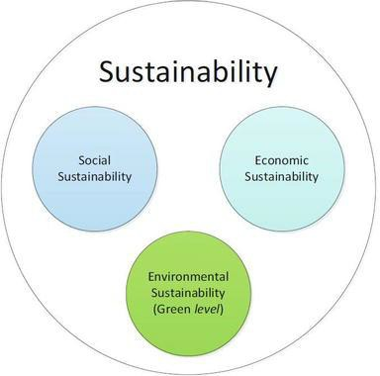
Figure 9.1: Sustainability Considerations in Software Development

Chapter 10. Conclusion

Brief Overview of the Project
The Neighbourly system was designed to provide a comprehensive digital marketplace for connecting local community members with skilled service providers. It serves as a modern bridge between demand and supply in the gig economy, replacing fragmented methods of finding help (like word-of-mouth or unverified directories) with a centralized, verified platform. By introducing features such as geolocation-based search, AI-powered service descriptions, negotiation-friendly booking workflows, and secure digital payments, the project aims to professionalize local services. On the administrative side, the system offers robust tools for provider verification and platform moderation, ensuring a safe ecosystem for all users.

Proposed System Benefits
The developed system offers a range of benefits for both End-Users and Service Providers:
    - Localized Convenience: Users can instantly find help (plumbers, electricians, tutors) within their specific vicinity using geolocation technology.
    - Economic Empowerment: Provides a professional platform for freelancers and small business owners to showcase their portfolios and earn income without high marketing costs.
    - Trust & Safety: The mandatory verification workflow and rating system ensures that users interact with legitimate, trusted professionals.
    - Operational Efficiency: Automated booking management, invoicing, and digital receipts reduce the administrative burden on providers.
    - Secure Transactions: Integration with SSLCommerz provides a regulated and secure environment for financial exchanges, minimizing fraud risk.
    - AI Assistance: Integration with Hugging Face lowers the barrier for providers to create professional-looking service listings by auto-generating content.

Limitations of the Project
While the system meets its primary objectives, several limitations remain, which highlight areas for improvement:

    - Browser-Based Location: The system relies on browser APIs for geolocation, which can vary in accuracy depending on the user's device hardware and network.
    - Internet Dependence: As a cloud-hosted web application, it requires a stable internet connection, which may limit accessibility in areas with poor 4G/Broadband coverage.
    - Payment Gateway Sandbox: The current implementation uses the SSLCommerz Sandbox environment; a live production deployment would require rigorous compliance auditing and legal agreements.
    - Lack of Native Mobile App: The system is a Responsive Web App (RWA), which lacks native mobile features like push notifications for real-time booking updates.
    - AI Rate Limits: The reliance on the free tier of the Hugging Face Inference API means the "Smart Description" feature could face rate limits under heavy load.
    - No Real-Time Chat: Communication is currently handled via Booking Notes and Reschedule Proposals; a live chat system is missing for immediate coordination.
These limitations emphasize that while the project demonstrates strong architectural principles and functional value, further refinement is needed for a commercial-grade launch.

Practicum and Its Value
The practicum offered meaningful real-world learning opportunities by connecting theoretical knowledge with practical application. The experience included:
    - Technical Mastery: Deepened expertise in the ASP.NET Core 8.0 ecosystem, Entity Framework Core, and Clean Architecture patterns.
    - Third-Party Integration: Gained practical experience integrating diverse external services such as LocationIQ (Maps), SSLCommerz (FinTech), and Hugging Face (AI).
    - Complex Logic Implementation: Solved challenging problems related to booking state machines, time-slot negotiation, and concurrency handling.
    - Professional Development: Reinforced the importance of code reviews, Git version control, and adhering to strict project documentation standards. Overall, the practicum

bridged the gap between academic concepts and industry-standard software engineering practices.

Future Plan
Future development of the system will focus on addressing the identified limitations and preparing it for larger-scale deployment. Planned improvements include:
    - Native Mobile Application: Developing cross-platform apps (using .NET MAUI or React Native) to leverage native push notifications and background location tracking.
    - Real-Time Chat Module: Implementing a WebSocket-based (SignalR) chat system to allow users and providers to communicate instantly within the app.
    - Advanced Recommendation Engine: Using Machine Learning to suggest services to users based on their past booking history and search patterns.
    - Multiple Payment Options: Expanding beyond SSLCommerz to include bKash, Nagad, and Stripe APIs for broader payment accessibility.
    - Infrastructure Scalability: Migrating the monolithic architecture to microservices (separating Auth, Booking, and Notification services) to handle thousands of concurrent users.
    - Enhanced AI Features: Implementing image recognition to automatically categorize portfolio photos uploaded by providers.
These enhancements will help transition Neighbourly from a functional prototype to a market-ready platform capable of serving a city-wide user base.

Bibliography

FORTUNE (2024). Hyperlocal Services Market Size, Share | Growth Report [2032]. [online] Fortunebusinessinsights.com
Folio3 (2025). A Guide to Hyperlocal Marketplaces and Ecommerce. [online] Folio3 Ecommerce.
Huggingface.co. (2025). Inference Providers. [online] Available at: https://huggingface.co/docs/inference-providers/en/index.
location-iq (2025). GitHub - location-iq/locationiq-csharp-client. [online] GitHub. Available at: https://github.com/location-iq/locationiq-csharp-client.
location-iq (2025). GitHub - location-iq/locationiq-csharp-client. [online] GitHub. Available at: https://github.com/location-iq/locationiq-csharp-client.
Mramba, B.P. and Kaijage, S.F. (2018). Design of an Interactive Mobile Application for Maternal, Neonatal and Infant Care Support for Tanzania. Journal of Software Engineering and Applications, 11(12), pp.569–584.
NDepend (2024). Clean Architecture in ASP.NET Core - NDepend Blog. [online] NDepend Blog. Available at: https://blog.ndepend.com/clean-architecture-for-asp-net-core-solution.
Raza, J. (2025). Building a Simple Text Generation App with Hugging Face Model APIs. [online] Medium. Available at: https://medium.com/@jhonraza/building-a-simple-text-generation-app-with-hugging-face-model-apis.
Shipturtle. (2025). Marketplace Trends for 2025 You Should Not Miss. [online] Available at: https://www.shipturtle.com/blog/online-marketplace-industry-trends.
www.rst.software. (n.d.). 6 common geolocation app development challenges and how to overcome them | RST Software. [online] Available at: https://www.rst.software/blog/6-common-geolocation-app-development-challenges-and-how-to-overcome-them.
Pressman, R. S. and Maxim, B. R. (2014), Software Engineering: A Practitioner’s Approach,
8th edn, McGraw-Hill Education, New York.

Ghezzi, C., Jazayeri, M. and Mandrioli, D. (2002), Fundamentals of Software Engineering, 2nd edn, Prentice Hall, Upper Saddle River.
Sommerville, I. (2011a), Requirements Engineering, 9th edn, Pearson.
Sommerville, I. (2011b), Requirements Engineering: From System Goals to UML Models to Software Specifications, Pearson Education, London.
Sommerville, I. (2016), Software Engineering, 10th edn, Pearson, Boston.
Bass, L., Clements, P. and Kazman, R. (2012), Software Architecture in Practice, 3rd edn, Addison-Wesley, Boston.
Turban, E. and Volonino, L. (2010), Information Technology for Management, 7th edn, John Wiley & Sons, Hoboken.
Hevner, A. R. and Chatterjee, S. (2010), Design Research in Information Systems: Theory and Practice, Springer, New York.

