To setup the program, you will need to define the group bounds in groups.xml, set the values correctly in info.xml, and create an RoiSet zip archive in ImageJ. Make sure you have Fiji and Python 3 installed.

To use the program, open your computer’s terminal and navigate to the folder where you have the program’s code installed. Then type
$ python3 main.py
at the prompt and press “Enter.”

The program follows these steps:
- Start Fiji
- Open your image sequence in Fiji as a stack
- Run the Enhance contrast tool in Fiji with the option “Equalize Histogram” enabled.
- Run the Median filter on the stack
- Run Subtract Background in Fiji on your images
- Register your image sequence using the SIFT plugin
- Create an 8-bit mask of your sequence using the RATS plugin
- Convert the 8-bit mask to 16-bit and multiply by 257 so that ON pixels in the mask are 2¹⁶-1
- Use ImageCalculator to AND the mask and the sequence
- Measure the Area, Mean, %Area, and Slice of the ROIs you defined in an RoiSet zip archive
- Save the information from step 10 to a csv file where you defined in the info.xml file
- Does some math to remove the non-data, zeroed out pixels from the averages
- Averages the sequences of averages into groups which are sequences of averages of averages
- Graph these groups
- Display the graph

You can save the graph if you want.
2¹⁶-1 is special because it is the largest possible unsigned integer that can be stored in 16 bits.

To create an RoiSet.zip
- Start Fiji
- Click Analyze
- Click Tools
- Click Roi Manager
- create a selection
- click “Add” in the Roi Manager
- Repeat 5 and 6 until all desired plants are selected
- In Roi Manager, click “More”
- Click “Save”
- Save the Roi Set as a zip archive.

To set up info.xml
- Use the one from the Github page as a starting point
- in the csv tag, replace the text with the fully qualified filename where you want the pipeline to save the csv file
- In the images tag, replace the text with the folder name of the images you want to operate on
- in the ROI_archive tag, replace the text with the filename of the RoiSet archive.
- In the ImageJ tag, enter the folder name of the folder that ImageJ is saved in
- The mask tag can safely be ignored for now, but in the future, defining it may allow you to save the mask used in the pipeline to remove noise

To set up groups.xml
- groups.xml follows a pattern
- each group of plants is represented by a group element, which has a number tag, a lower tag, and an upper tag, like so (try to ignore the bullets):
  - <group>
    - <number>23</number>
    - <lower>0</lower>
    - <upper>42</upper>
  - </group>
- The number element is a number, which may be used to identify groups in the future.
- The lower element is the index of the first plant in the group in the image sequence’s csv file.
- The upper element is the index of the last plant
- The index of a plant is the number it has if you count the number of plants between that plant and the first one, eg the first plant is 0, the thirtieth is 29, etc.

Be careful to use forward slashes (/) in info.xml, and not backslashes (\). Not doing so will cause the program to fail.

Potential edits you may need to make
- If you are on a Windows machine, make sure to edit Tomas_Plugin.py and replace the word linux in any instance of the string “ImageJ-linux64” with the string “win”
- If you are on a 32 bit machine, make sure to replace the 64 in the string previously with 32

The pipeline has been developed on a Debian 9 computer, so it may work better that way.
Also, running main.py from the command line seems generally faster than running it from a IDE or similar programs.

How xml works
All you need to know about xml for this to work is the following.
- xml elements are defined by the form <tag>value</tag>
- elements can contain other elements
- the part that says value, you edit, because that is the information
- the part that says tag, you do not edit, because that is how the program gets the information
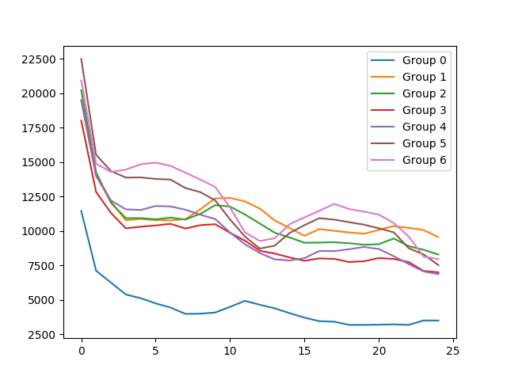
An example of what the program outputs as of June 18th, 2018:

