

Viatech Project Documentation

Contents

1. Introduction 3

2. Use cases 4

3. Architecture 5

3.1. Model-View-Controller 5

4. Implementation 6

4.1. Technology stack 6

4.2. Database 6

4.3. Cron service 7

5. Security 7

5.1. Authentication 7

5.2. Activation mail service 7

5.3. Google captcha 7

6. Deployment 7

1. Introduction

**Viatech** is an ecommerce website solution focused on minimalist design while still packing features such as detailed product filter, user statistics, modern feel and 3-button checkout all bundled in a friendly user experience package able to compete in the market with similar sites at ease.

**Viatech** focuses mostly on providing the best experience for the user and gives priority to quality rather than quantity of products in the electronics market. 3-button checkout allows the user to order the product much faster. User can filter items in various categories, read professionally written product description or look at the reviews left by other customers.

1. Use cases

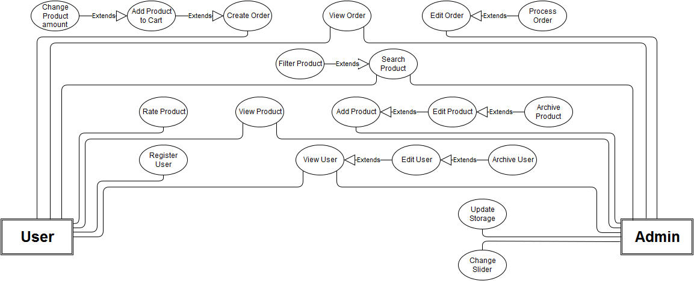

Roles:

* Admin
* User

1. Architecture

Application is implemented by using MVC architecture pattern.

* 1. Model-View-Controller

**Model–view–controller** (**MVC**) is a software architectural pattern mostly (but not exclusively) for implementing user interfaces on computers. It divides a given software application into three interconnected parts, so as to separate internal representations of information from the ways that information is presented to or accepted from the user.

1. Implementation
   1. Technology stack

HTML

CSS

JavaScript

jQuery

PHP

* 1. Database

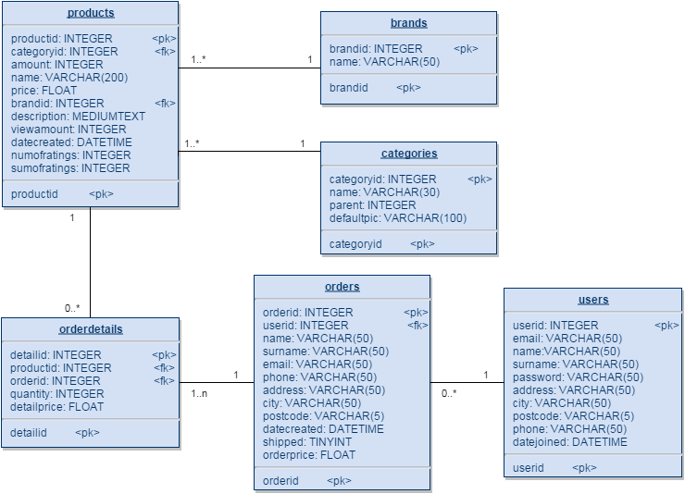

Image – Physical database model

* 1. Cron service

1. Security
   1. Authentication

Authentication of client is performed by using password hashing method. Password hashing is one of the most basic security considerations in designing any application that accepts passwords from users. Without hashing, any passwords that are stored in your application's database can be stolen if the database is compromised, and then immediately used to compromise the application. For our purposes of password hashing is used **MD5 hashing algorythm**.

* 1. Activation mail service
  2. Google captcha

1. Deployment