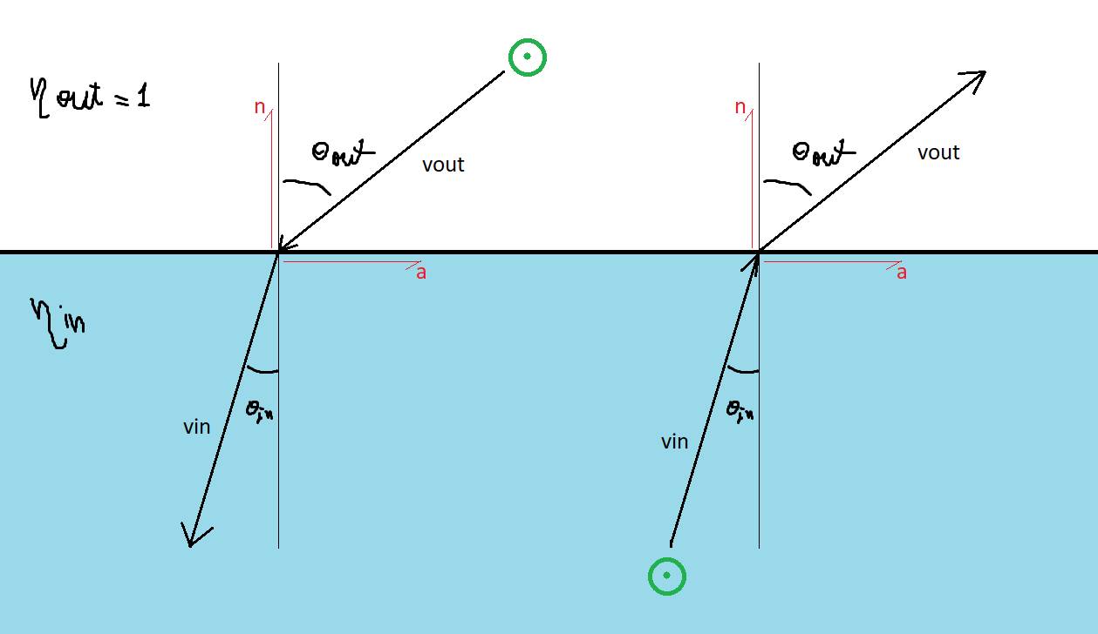

Ray going from the outside to the inside of the material:

$$v_{in}=α⋅v_{out}+β⋅n$$

$$\frac{\sin{θ_{out}}}{\sin{θ_{in}}}=η_{in}$$

$$\frac{\left\|n×v_{out}\right\|}{\left\|n×v_{in}\right\|}=η_{in}$$

$$\left\|n×v_{in}\right\|=\frac{\left\|n×v_{out}\right\|}{η_{in}}$$

$$α=\frac{1}{η_{in}}$$

$$v_{in}^{2}=1→$$

$$β^{2}+2αβ⋅v_{out}⋅n+α^{2}-1=0$$

$$β=-\left(α⋅v_{out}⋅n\right)-\sqrt{{\left(α⋅v_{out}⋅n\right)}^{2}+\left(1-α^{2}\right)}$$

Ray going from the inside to the outside:

$$v_{out}=α⋅v_{in}+β⋅n$$

$$\frac{\sin{θ_{out}}}{\sin{θ_{in}}}=η_{in}$$

$$\frac{\left\|n×v_{out}\right\|}{\left\|n×v_{in}\right\|}=η_{in}$$

$$\left\|n×v_{out}\right\|=η_{in}\left\|n×v_{in}\right\|$$

$$α=η_{in}$$

$$v_{out}^{2}=1→$$

$$β^{2}+2αβ⋅v_{in}⋅n+α^{2}-1=0$$

$$β=-\left(α⋅v_{in}⋅n\right)+\sqrt{{\left(α⋅v_{in}⋅n\right)}^{2}+\left(1-α^{2}\right)}$$