Approximate Event Occurance Counting Using Probabilistic Counters – Use Case of Text Files
Tomás Oliveira Costa <89016>, tomascosta@ua.pt

Abstract – This article’s main objective is to give an approximate count of words in a book, using different probabilistic counters and an exact counter for measure comparison. On this work we focus on the half probability counter and the decreasing probability logarithmic counter.

I. Introduction
The problem of the approximate counters is very relevant, since it provides a way to give close estimates to exact counters, but in a much more efficient way. There’s several types of probabilistic counters, but for this work we focus on:
- ½ probability counter
- Logarithmic with descending probability

II. Description of the problem
The goal is to read a book (text file) and count the occurrences for each distinct word. This can be done in one of three ways: the exact counter, the “half” counter and the “log” counter. These provide different values, but should all be approximate to the exact counter.

A. Counter with half probability

The “half” counter should have at each increment the probability of ½ to increment (a balanced coin throw), and at the end of the counting we will have about ½ of the counter increments of the exact counter. To estimate the number of words with this counter, we simply multiply counter increments by 2.

B. Counter with decreasing logarithmic probability
The “log” counter is cumulative, in the way that the probability of incrementing the counter keeps decreasing as the counter increments, therefore, several increments of the counter make it less likely to be incremented.
Afterwards we use the next formula to estimate the number of words:
(base^k - base + 1 ) / ( base-1 )

Given that the k is the counter value and our base for this work is the square root of 2 (√2)

III. Project Structure
For this project to have a standardized structure, the following folder were created:
- Code
- Report
- Texts
These folders represent the folders for the python scripts, the written reports and the example texts, respectively.
Which leads to this following figure:

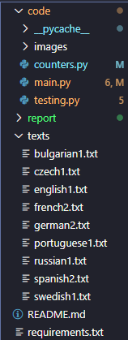

IV. Description of the Solution
Given the short length of the solution in lines of code (LOC), the project was created to be very modular and readable, therefore, the code is divided in a main script and a counters class.
Three counter classes were inherited from one Counter.class, which was contained the methods that were common between all of them.
This class is very simple in processing, and it has 2 main stages: Tokenizing and Indexing.

Tokenizing is the step of reading the text and generating tokens, which are the “words”, already filtered that we will later add to our dictionary.
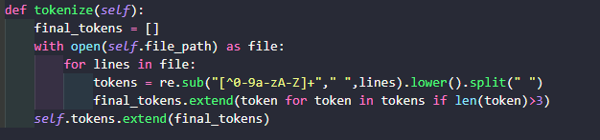

After tokenizing, we can now index, and this is where each counter will vary.

Indexing the exact counter
The indexing for the exact counter is very trivial, for each token, we add it to the dictionary and increment the counter value by 1. These are the exact measures and are only used for comparison.

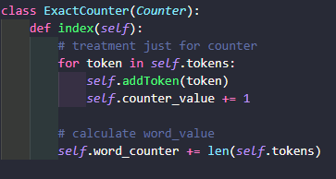

Indexing the half counter
As for the half counter, we do an interesting trick, which is to create an array of 0s or 1s with a 1/2 probability each and then we iterate the array and only had the token if the value was 1. To get the estimated word values, we only need to get the sum of all elements of the array and then multiply by 2 (our probability inversed).

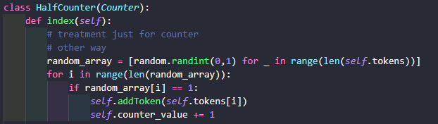

Indexing the log counter
This counter is the most efficient, or the one that was providing the best results, since it doesn’t really increment the counter by as much as the other two did, but still provides really good results when it comes to estimating words.
For this counter we take into account the probability of past increments and then decide based on a new calculated probability if we should increment of not.

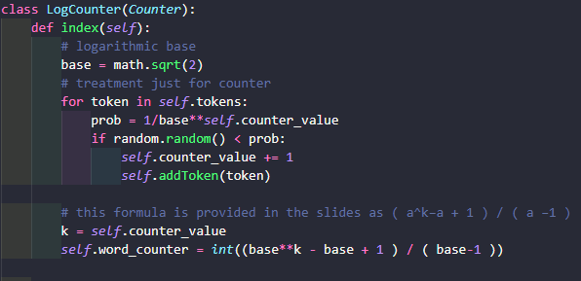

V. Testing tools and analysis
Execuçao de cada um, com params de teste
Correr o testing py para comparar entre eles

VI. Results and discussion
Log counter melhor, mais close e mais eficient

VII. Conclusions
How prob counters area good measure for it

References
Use the Style “referencia” to the references. Example:
[1] M. T. Rose and K. McCloghrie, "Structure and Identification of Management Information for TCP/IP-based Internets", RFC 1155, DDN Network Information Center, SRI International, May 1990.

