Project
Credit cards

1. Business Context
2. Dashboard Objective
3. Target Audience
4. Dashboard Structure
5. Metrics and KPIs
6. Visual Analysis
7. Key Insights
8. Business Recommendations
9. Data Quality and Limitations

Alejandro Tomas De Franco

- Business Context
This project analyzes credit card transaction data in order to understand customer spending behavior, credit usage patterns, and transaction distribution across different merchant categories and geographic regions.
The dataset includes information such as transaction amounts, card types, merchant categories, geographic location, and customer age segmentation.
The analysis aims to transform raw transactional data into actionable insights to support decision-making in a banking context.

2. Dashboard Objective
The objective of this dashboard is to analyze credit card transaction activity by identifying spending patterns, customer segmentation, and credit usage trends.
It aims to answer key business questions such as:
- Which merchant categories concentrate the highest spending?
- Which customer segments generate the highest transaction volume?
- How are transactions distributed over time and across regions?

3. Target Audience
This dashboard is designed for data analysts, product managers, and banking professionals responsible for monitoring credit card portfolio performance.
It can also be used by marketing and strategy teams to identify segmentation opportunities and business growth potential.

4. Dashboard Structure
The dashboard is structured into three main sections:
- Introduction: provides context and explains the purpose of the analysis.
- Overview: presents a high-level view of key metrics and business performance.
- Customer Analysis: offers a deeper analysis of customer behavior, including spending by age group, average transaction value, and credit usage.
This structure enables a logical flow from general insights to more detailed analysis.

- Metrics and KPIs
The main metrics used in the dashboard are:
- Total Transactions: total number of transactions
- Total Amount: total spending amount
- Average Ticket: average transaction value
- Average Credit Limit: average credit limit available
The main KPI is:
- Fraud Rate: percentage of fraudulent transactions, calculated as:
fraud transactions / total transactions
These indicators are critical as they provide insight into both transaction volume and transaction quality.

- Visual Analysis
Each visualization was included with a specific analytical purpose:
- Monthly transactions: shows the evolution of transaction volume over time.
- Spending by category: identifies the merchant categories with the highest spending.
- Card type distribution: shows the usage share of each card type.
- Geographic map: visualizes the regional distribution of transactions.
- Spending by age group: highlights the most relevant customer segments.
- Credit usage: indicates how intensively customers use their available credit.

- Key Insights
The analysis of transaction data reveals clear patterns in customer behavior.
First, spending is mainly concentrated in specific merchant categories such as restaurants, subscriptions, and entertainment, indicating that these industries capture a significant portion of credit card usage.
Second, customers in the older age segment (56+) generate the highest total spending, suggesting that this group either has greater purchasing power or uses credit cards more frequently.
Additionally, the average transaction value remains relatively consistent across different card types (Visa, Mastercard, and Amex), indicating that the card issuer does not significantly influence transaction size.
Regarding credit usage, the percentage of credit limit utilization is relatively similar across age groups, suggesting consistent behavior in how customers use their available credit.
Finally, the geographic distribution shows that certain provinces concentrate a higher volume of transactions, likely linked to higher population density or economic activity.

- Business Recommendatio
Based on the analysis, the following actionable recommendations are proposed:
- Focus marketing efforts on high-value customer segments
Since the 56+ age group generates the highest total spending, targeted campaigns should be developed for this segment, including exclusive benefits, loyalty programs, or adjusted credit limits.
- Build partnerships with high-performing merchant categories
Categories such as restaurants and subscriptions show the highest spending levels. Strategic partnerships, discounts, or promotions could increase card usage in these areas.
- Improve customer segmentation strategies
As spending behavior varies across age groups, segmenting customers more effectively can help personalize offers, improve customer experience, and increase retention.
- Explore geographic expansion opportunities
Regions with higher transaction volumes could be prioritized for business expansion, targeted campaigns, or increased financial services presence.
- Strengthen fraud monitoring systems
Although the fraud rate is relatively low, continuous monitoring and improvement of fraud detection systems is recommended to mitigate potential risks.

Dashboard Imagens:
KPYs
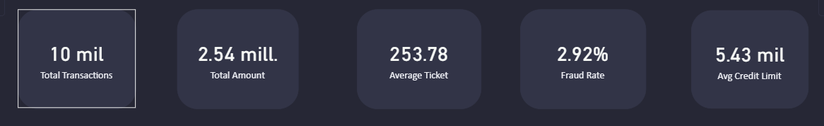

Monthly Transaction Volume
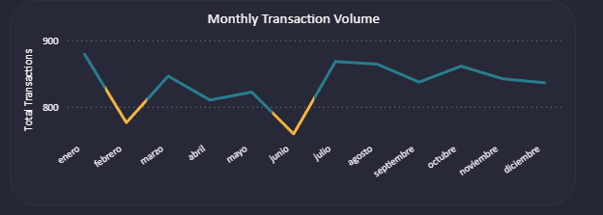

Spending by Merchant Category
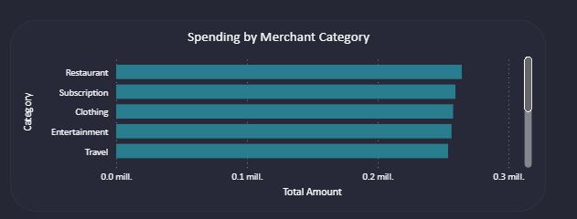

Map Distribution
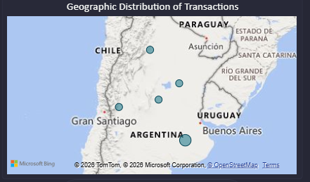

Card Usage Distribution
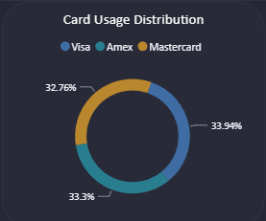

Total Amount by Age Group: 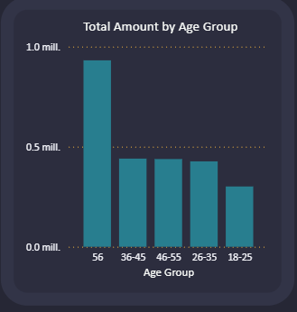
Average Credit Usage by Age Group: 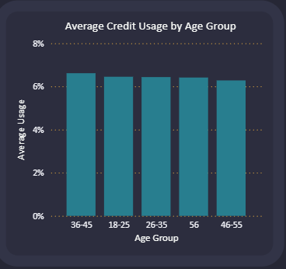
Average Ticket by Card Type: 