authogar.com
Análisis de https://www.authogar.com/
Generado: 2026-08-17T18:21:20.265Z

authogar.com
- URL: https://www.authogar.com/
- URL final: https://www.authogar.com/
- HTTP 200 · estrategia de espera: networkidle · carga 8376 ms · análisis total 38.1 s
- Elementos analizados: 2985 · nodos DOM: 3080 · profundidad máx: 29
- Rol en el proyecto: sitio del cliente — Authogar
- Capturas: desktop full · mobile full · popup inicial

0. Recorrido del análisis y popups
Overlays detectados al entrar: 9
Elemento | Tipo | Tamaño | position | z-index | Tapa viewport | Form | Texto
div#_icommktmodal5ee860a8-e220-481b-b7ea-058f4dbd0d6e.icommktmodalwrapper._icommkt | newsletter | 1440x900 | fixed | 999999 | sí | sí | Authogar News! Suscribite y aprovechá 🔥 Enterate antes que nadie de nuestras promos y llevate eso que siempre soñaste!
div._icommktmodalcontainer.icommktmodalcustom5ee860a8-e220-481b-b7ea-058f4dbd0d6e | modal | 800x293 | relative | auto | no | sí | Authogar News! Suscribite y aprovechá 🔥 Enterate antes que nadie de nuestras promos y llevate eso que siempre soñaste!
div._icommktmodal._icommktmodalimagebackground | modal | 800x293 | relative | auto | no | sí | Authogar News! Suscribite y aprovechá 🔥 Enterate antes que nadie de nuestras promos y llevate eso que siempre soñaste!
div._icommktmodal_inside | modal | 800x293 | static | auto | no | sí | Authogar News! Suscribite y aprovechá 🔥 Enterate antes que nadie de nuestras promos y llevate eso que siempre soñaste!
div._icommktmodalimagewrapper._icommktmodalimagewrappercustom5ee860a8-e220-481b- | modal | 800x293 | absolute | 1 | no | no | —
img._icommktmodalimage.icommktmodalimagecustom_5ee860a8-e220-481b-b7ea-058f4dbd0d6 | modal | 800x293 | static | auto | no | no | —
div._icommktmodalcontentwrapper._icommktmodalcontentwrappercustom5ee860a8-e220-4 | modal | 800x293 | relative | 2 | no | sí | Authogar News! Suscribite y aprovechá 🔥 Enterate antes que nadie de nuestras promos y llevate eso que siempre soñaste!
form._icommktmodal_form | modal | 704x99 | static | auto | no | sí | Suscribirme
div._icommktmodalbackground.icommktmodalbackgroundsubscription | newsletter | 1440x900 | fixed | 999998 | sí | no | —

Cierres ejecutados: [class*="close" i][class*="modal" i]
Overlays visibles después del cierre: 0

Errores de consola (20)
Failed to load resource: the server responded with a status of 404 ()
Failed to load resource: the server responded with a status of 404 ()
Failed to load resource: the server responded with a status of 404 ()
Failed to load resource: the server responded with a status of 404 ()
Failed to load resource: the server responded with a status of 404 ()
requestStorageAccess: Permission denied.
[GSI_LOGGER]: FedCM get() rejects with TypeError: Failed to execute 'get' on 'CredentialsContainer': Failed to read the 'identity' property from 'CredentialRequestOptions': Failed to read the 'mode' p
Failed to load resource: the server responded with a status of 404 ()
Failed to load resource: the server responded with a status of 404 ()
Failed to load resource: the server responded with a status of 404 ()
Failed to load resource: the server responded with a status of 404 ()
Failed to load resource: the server responded with a status of 404 ()
requestStorageAccess: Permission denied.
Failed to load resource: the server responded with a status of 404 ()
Failed to load resource: the server responded with a status of 404 ()
Failed to load resource: the server responded with a status of 404 ()
Failed to load resource: the server responded with a status of 404 ()
Failed to load resource: the server responded with a status of 404 ()
Failed to load resource: the server responded with a status of 404 ()
[GSI_LOGGER]: FedCM get() rejects with TypeError: Failed to execute 'get' on 'CredentialsContainer': Failed to read the 'identity' property from 'CredentialRequestOptions': Failed to read the 'mode' p

Traza paso a paso
214ms navegando (networkidle, 60s)
8377ms cargado HTTP 200 → https://www.authogar.com/
8513ms buscando popups / banners de cookies
8539ms overlay detectado (9): newsletter:div#__icommkt_modal_5ee860a8-e220-481b-b7ea-058f4dbd0d6e.__icommkt_modal_wrapper.__icommkt | modal:div.__icommkt_modal_container.__icommkt_modal_custom_5ee860a8-e220-481b-b7ea-058f4dbd0d6e | modal:div.__icommkt_modal.__icommkt_modal_image_background | modal:div.__icommkt_modal_inside
8622ms click cerrar → [class*="close" i][class*="modal" i]
9446ms overlays visibles luego de cerrar: 0
9853ms scroll completo (lazy-load + animaciones de scroll)
12030ms extrayendo: meta y SEO
12053ms extrayendo: stack tecnológico
12153ms extrayendo: tipografía, paleta y espaciado
12282ms extrayendo: estructura y layout
12331ms extrayendo: inventario de componentes
12507ms extrayendo: accesibilidad
12541ms extrayendo: animaciones
12594ms extrayendo: CSSOM y media queries
12642ms extrayendo: performance timing
12650ms recortando 15 componentes y zonas
15502ms recortes guardados: 15/15
15504ms screenshot desktop 1440 fullPage
16784ms probando breakpoint 360x844
19188ms probando breakpoint 390x844
20454ms probando breakpoint 768x1024
21750ms probando breakpoint 1024x900
23042ms probando breakpoint 1280x900
24515ms probando breakpoint 1440x900
25758ms probando breakpoint 1920x900
27023ms contexto mobile 390x844 (touch) + screenshot fullPage

1. Meta, SEO y datos estructurados
Campo | Valor
title | Authogar (8 car.)
description | Authogar (8 car.)
viewport | width=device-width, initial-scale=1
lang / dir / charset | es-AR / null / utf-8
favicon | https://authogar.vtexassets.com/arquivos/Favicon_authogar.svg
og:image | —
canonical | https://www.authogar.com/
robots | Authogar
theme-color | —
generator | vtex.render-server@8.180.1
manifest (PWA) | —
hreflang | —
JSON-LD | WebSite, ItemList
meta tags | 18
peso del HTML | 3509 KB

Open Graph / Twitter completos
Campo | Valor
og:type | website
og:title | Authogar
og:url | https://www.authogar.com/
og:description | Authogar

2. Stack tecnológico
Tecnología | Detectado
react | sí
next | no
vue | no
angular | no
jquery | no
tailwind | sí
bootstrap | no
wordpress | no

Otras detecciones: VTEX · Google Tag Manager · Google Analytics · Meta Pixel · Clarity · reCAPTCHA · Service Worker
Assets | Cantidad
scripts externos | 54
scripts inline | 22
hojas de estilo externas | 36
tags &lt;style> | 5
hosts de scripts | 14

Hosts que sirven scripts
Host
scripts.clarity.ms
scripts.icommkt.online
www.clarity.ms
www.googletagmanager.com
www.gstatic.com
activity-flow.vtex.com
io.vtex.com.br
connect.facebook.net
capi-automation.s3.us-east-2.amazonaws.com
www.google.com
authogar.vtexassets.com
www.authogar.com
tracker.metricool.com
accounts.google.com

3. Estructura y layout
Landmark | Cantidad
header | 0
nav | 1
footer | 0
main | 0
aside | 1
section | 46
article | 24
search | 0

Métrica | Valor
display:grid | 4
display:flex | 1268
position:sticky | 1
position:fixed | 7
position:absolute | 86
elementos con cursor:pointer | 1768
alto de página | 6610px (7.3 viewports)
overflow horizontal @1440 | no
background del body | #ffffff
nodos DOM / profundidad máx / media | 3080 / 29 / 18.2
elemento más profundo | a.vtex-rich-text-0-x-link.vtex-rich-text-0-x-link--title-banner-home
caracteres de texto visible | 5780

max-width de contenedores (más frecuentes)
max-width | Usos
1296px | 61
100px | 56
fit-content | 48
331px | 24
1536px | 13
410px | 6

padding lateral de contenedores
padding izq / der | Usos
0px / 0px | 143
15px / 15px | 56
4px / 4px | 12
20px / 20px | 1

z-index en uso
z-index | Usos
11 | 43
1 | 6
2 | 6
5 | 4
999 | 3
2147483647 | 2
1000 | 1
9999 | 1

Anatomía sección por sección (orden de scroll)
# | Elemento | Encabezado | Alto | Vh | display | Cols | Padding | Fondo | Hijos | Img | Links | Btn | Cards
1 | div.vtex-sticky-layout-0-x-container.vtex-sticky-layout-0-x-container--sticky-header.z-999 | — | 137px | 0.15 | block | — | 0px | transparente | 5 | 3 | 12 | 3 | 4
2 | img.vtex-store-components-3-x-imageElement.vtex-store-components-3-x-imageElement--wssp-fi | — | 57px | 0.06 | inline | — | 0px | transparente | 0 | 0 | 0 | 0 | 0
3 | div.vtex-slider-layout-0-x-sliderTrack.vtex-slider-layout-0-x-sliderTrack--hero.flex | — | 280px | 0.31 | flex | 9 | 0px | transparente | 9 | 2 | 2 | 0 | 0
4 | div.authogar-components-0-x-wrapperCategorySliderDesktop | Hogar y Tecnología: | 235px | 0.26 | flex | 2 | 0px | #efeff0 | 2 | 18 | 18 | 2 | 0
5 | div.vtex-slider-layout-0-x-sliderTrack.vtex-slider-layout-0-x-sliderTrack--home-brands.fle | — | 67px | 0.07 | flex | 29 | 0px | transparente | 29 | 11 | 11 | 0 | 0
6 | div.authogar-components-0-x-wrapperCategorySliderDesktop | Deporte y Moda: | 235px | 0.26 | flex | 2 | 0px | #efeff0 | 2 | 18 | 18 | 2 | 0
7 | div.vtex-slider-layout-0-x-sliderTrack.vtex-slider-layout-0-x-sliderTrack--home-brands.fle | — | 67px | 0.07 | flex | 27 | 0px | transparente | 27 | 11 | 11 | 0 | 0
8 | div.flex.mt0.mb0 | PS5 PlayStation 5 Slim + Astro Bot y Gran Turismo 7 Digital | 640px | 0.71 | flex | 2 | 0px | transparente | 2 | 25 | 5 | 2 | 65
9 | div.flex.mt0.mb0 | — | 160px | 0.18 | flex | 3 | 20px 0px | transparente | 3 | 3 | 3 | 0 | 0
10 | div.flex.mt0.mb0 | Tablet TCL TAB A1 Plus 12.2" 128GB 6GB Space Blue + Teclado | 639px | 0.71 | flex | 2 | 0px | transparente | 2 | 28 | 5 | 2 | 80
11 | div.flex.mt0.mb0 | — | 365px | 0.41 | flex | 2 | 0px | transparente | 2 | 3 | 6 | 0 | 0
12 | div.flex.mt0.mb0 | Zapatillas Nike Vomero 18 Ver. Hombre | 612px | 0.68 | flex | 2 | 0px | transparente | 2 | 24 | 5 | 2 | 80
13 | div.flex.mt0.mb0 | — | 365px | 0.41 | flex | 2 | 0px | transparente | 2 | 3 | 8 | 0 | 0
14 | div.flex.mt0.mb0 | Zapatillas Vans U Knu Skool Cel. Hombre | 612px | 0.68 | flex | 2 | 0px | transparente | 2 | 24 | 5 | 2 | 80
15 | section#slider-items-4pudh1k.w-100.flex.items-center | — | 120px | 0.13 | flex | 3 | 0px | transparente | 3 | 2 | 2 | 2 | 0
16 | div.flex.mt0.mb0 | Rack Para Colgar Tables 1,80M Tono Olmo Finlandes/Everest 1407-Coe | 641px | 0.71 | flex | 2 | 0px | transparente | 2 | 26 | 5 | 2 | 80
17 | div.flex.mt0.mb0 | Termotanque Coppens 120L Multigas De Pie | 639px | 0.71 | flex | 2 | 0px | transparente | 2 | 24 | 5 | 2 | 62
18 | div.flex.mt0.mb0 | — | 223px | 0.25 | flex | 1 | 16px 0px 40px | transparente | 1 | 2 | 2 | 0 | 0
19 | div | — | 267px | 0.3 | block | — | 0px | transparente | 1 | 10 | 21 | 1 | 0
20 | div.authogar-minicart-0-x-drawer.authogar-minicart-0-x-closed.right-0 | — | 900px | 1 | flex | 1 | 0px | #ffffff | 1 | 0 | 0 | 1 | 0

Capas sticky / fixed
Elemento | position | z-index | Tamaño | top | bottom | Fondo | Rol inferido
div | sticky | 1000 | 1440x137 | 0px | auto | — | otro
a.vtex-store-link-0-x-link.vtex-store-link-0-x-link--wspp-fixed | fixed | 9999 | 56x57 | 843.359px | 0px | — | otro
div.authogar-minicart-0-x-drawer.authogar-minicart-0-x-closed.right-0 | fixed | 999 | 460x900 | 0px | 0px | #ffffff | otro

Grillas CSS reales
Elemento | grid-template-columns | rows | gap | Items
div.vtex-flex-layout-0-x-flexCol.ml0.mr0 | 161.078px 178.109px | 26.0938px 26.0938px 26.0938px | normal | 5
div.vtex-flex-layout-0-x-flexCol.ml0.mr0 | 329.781px | 27px 26.0938px 29px | normal | 3
div.vtex-flex-layout-0-x-flexCol.ml0.mr0 | 265.75px 222.797px | 26.0938px 26.0938px 26.0938px | normal | 6

Elementos que exceden el viewport @1440
Elemento | Ancho
div.vtex-slider-layout-0-x-sliderTrack.vtex-slider-layout-0-x-sliderTrack--hero.flex | 11664px
div.vtex-slider-layout-0-x-sliderTrack.vtex-slider-layout-0-x-sliderTrack--home-brands.fle | 3854px
div.vtex-slider-layout-0-x-sliderTrack.vtex-slider-layout-0-x-sliderTrack--home-brands.fle | 3588px
div.vtex-slider-layout-0-x-sliderTrack.vtex-slider-layout-0-x-sliderTrack--carrusel-produc | 6480px
div.vtex-slider-layout-0-x-sliderTrack.vtex-slider-layout-0-x-sliderTrack--carrusel-produc | 9072px
div.vtex-slider-layout-0-x-sliderTrack.vtex-slider-layout-0-x-sliderTrack--carrusel-produc | 5508px
div.vtex-slider-layout-0-x-sliderTrack.vtex-slider-layout-0-x-sliderTrack--carrusel-produc | 5184px
div.vtex-slider-layout-0-x-sliderTrack.vtex-slider-layout-0-x-sliderTrack--large-banner.fl | 7776px
div.vtex-slider-layout-0-x-sliderTrack.vtex-slider-layout-0-x-sliderTrack--carrusel-produc | 5832px
div.vtex-slider-layout-0-x-sliderTrack.vtex-slider-layout-0-x-sliderTrack--carrusel-produc | 6156px

4. Tipografía
font-family (top 5 por uso real)
font-family | Usos
NotoSans, sans-serif | 2080
Agrandir | 504
"Noto Sans", sans-serif | 130
Neulis | 65
NotoSans | 57

font-size (top 8)
font-size | Usos
16px | 2215
12px | 284
22px | 170
14px | 123
11px | 65
32px | 14
24px | 12
0px | 5

font-weight (top 5)
font-weight | Usos
400 | 2337
700 | 390
600 | 121
500 | 40

line-height (top 5)
line-height | Usos
18.4px | 2114
normal | 571
16px | 74
11px | 65
14px | 38

letter-spacing
letter-spacing | Usos
0.64px | 65
0.15px | 3
0.13px | 2

text-transform
text-transform | Usos
uppercase | 118
capitalize | 65
lowercase | 21

Escala tipográfica real por elemento
Elemento | size | weight | line-height | letter-spacing | familia | color
body | 16px | 400 | 18.4px | normal | NotoSans | #000000
h2 | 32px | 700 | normal | normal | Neulis | #00249c
h3 | 16px | 700 | 18.4px | normal | NotoSans | #3f3f40
p | 14px | 400 | 21px | 0.13px | NotoSans | #00249c
a | 16px | 400 | 18.4px | normal | NotoSans | #0000ee
button | 16px | 400 | 18.4px | normal | -apple-system | #000000
input | 16px | 400 | normal | normal | Agrandir | #4d6b78

Consistencia: 6 familias distintas · 8 tamaños · 4 pesos · 8 line-heights → escala acotada

Fuentes cargadas (document.fonts)
Fuente
NotoSans 400 normal (loaded)
NotoSans 500 normal (loaded)
Agrandir 200 normal (unloaded)
Agrandir 400 normal (loaded)
Agrandir 700 normal (loaded)
Agrandir 800 normal (unloaded)
Neulis 400 normal (loaded)
Neulis 500 normal (loaded)
Neulis 700 normal (loaded)
Montserrat 500 normal (unloaded)
Montserrat 700 normal (unloaded)

font-size — lista extendida
font-size (top 20)
font-size | Usos
16px | 2215
12px | 284
22px | 170
14px | 123
11px | 65
32px | 14
24px | 12
0px | 5

5. Paleta de color
Colores de texto (top 8)
color | Usos
#000000 | 1899
#0000ee | 257
#00249c | 254
#4e4e4e | 178
#4d6b78 | 109
#3f3f40 | 87
#ffffff | 53
#0083c7 | 37

Backgrounds (top 8, sin transparentes)
background | Usos
#ffffff | 99
#d9e1f2 | 65
#f9f6f4 | 54
#00249c (0.80) | 36
#d6fc52 | 24
#efeff0 | 18
#00249c (0.60) | 6
#ddd6d0 | 6

Colores de borde (top 5)
border-color | Usos
#bababa | 65
#e0e0e0 | 36
#e8e8e8 | 24
#ddd6d0 | 7
#f5f5f5 | 6

Gradientes
background-image | Usos
linear-gradient(90deg, rgb(224, 224, 224), rgb(224, 224, 224) 50%, rgb(232, 232, 232) 60%, rgb(224, 224, 224) 65%, rgb(2 | 1

Amplitud: 12 colores de texto distintos · 13 de fondo · 8 de borde

Paleta extendida (top 20 de cada grupo)
Texto
color | Usos
#000000 | 1899
#0000ee | 257
#00249c | 254
#4e4e4e | 178
#4d6b78 | 109
#3f3f40 | 87
#ffffff | 53
#0083c7 | 37
#979899 | 8
#f71963 | 3
#0f3e99 | 2
#727273 | 1

Fondos
background | Usos
#ffffff | 99
#d9e1f2 | 65
#f9f6f4 | 54
#00249c (0.80) | 36
#d6fc52 | 24
#efeff0 | 18
#00249c (0.60) | 6
#ddd6d0 | 6
#00249c | 4
#000000 | 1
#d7dcde | 1
#e0e0e0 | 1
#f2eff3 | 1

6. Sistema de espaciado y superficie
border-radius (top 6)
border-radius | Usos
4px | 68
12px | 64
0px 0px 12px 12px | 36
10px | 20
6px | 19
20px | 7

box-shadow (top 5)
box-shadow | Usos
rgba(0, 0, 0, 0.15) 0px 0px 2px 0px | 54
rgb(128, 128, 128) 0px 0px 5px 0px | 1
rgba(0, 0, 0, 0.11) 0px 3px 6px 0px | 1

gap (top 6)
gap | Usos
2px | 43
24px | 30
4px | 24
12px | 12
16px | 5
40px | 4

padding (top 8)
padding | Usos
0px 2px | 65
1px 2px | 65
22px 15px | 56
8px 0px 0px | 48
0px 4px | 36
15px 0px 0px | 36
12px 0px 8px | 24
16px 5px | 24

margin (top 8)
margin | Usos
4px 0px 0px | 24
0px 68px | 12
0px 72px | 8
0px 4px | 7
20px 0px 24px | 6
0px 0px 10px | 3
0px 0px 16px | 3
0px 0px 0px 8px | 2

border-width
border-width | Usos
1px | 140
2px | 2

Amplitud: 16 radios · 3 sombras · 7 gaps · 32 paddings distintos

7. Inventario de componentes
Componente | Cantidad
buttons | 32
links | 145
forms | 1
inputs | 4
images | 238
svg | 26
videosEmbeds | 2
modals | 1
tables | 0
carousels | 548
cards | 447
lists | 2
accordions | 0
tabs | 0
breadcrumbs | 0
pagination | 8
badges | 23
icons | 27
ratings | 83
prices | 284
addToCart | 3
search | 1
newsletter | 0
social | 2
skeletons | 0
banners | 636

Variantes de botón (agrupadas por firma de estilo)
Usos | Ejemplos | Fondo | Texto | Radio | Padding | Size | Weight | Borde | Sombra | Tamaño típico
14 | Previous Slide / Next Slide / Previous Slide | rgb(249, 246, 244) | rgb(0, 0, 0) | 10px | 5px | 16px | 400 | 0px rgb(0, 0, 0) | rgba(0, 0, 0, 0.15) 0px 0px 2px 0px | 53x80
6 | Dot 1 of 7 / Dot 3 of 7 / Dot 4 of 7 | rgb(221, 214, 208) | rgb(0, 0, 0) | 100% | 4px | 16px | 400 | 1px rgb(221, 214, 208) | — | 10x10
4 | Buscar Productos / Previous Slide / Next Slide | rgba(0, 0, 0, 0) | rgb(0, 0, 0) | 0px | 0px | 16px | 400 | 0px rgb(0, 0, 0) | — | 28x14
4 | button.authogar-components-0-x-arrow.authogar-components-0-x-leftArrow / button.authogar-components-0-x-arrow.authogar-components-0-x-rightArrow / button.authogar-components-0-x-arrow.authogar-components-0-x-leftArrow | rgb(249, 246, 244) | rgb(0, 0, 0) | 8px | 11px | 16px | 400 | 0px rgb(0, 0, 0) | rgba(0, 0, 0, 0.15) 0px 0px 2px 0px | 38x52
1 | MI CUENTA | rgba(0, 0, 0, 0) | rgb(0, 36, 156) | 4px | 0px | 16px | 500 | 1px rgba(0, 0, 0, 0) | — | 30x42
1 | button.vtex-button.bw1.ba | rgba(0, 0, 0, 0) | rgb(15, 62, 153) | 4px | 0px | 0px | 500 | 1px rgba(0, 0, 0, 0) | — | 34x40
1 | Dot 2 of 7 | rgb(0, 36, 156) | rgb(0, 0, 0) | 20px | 4px | 16px | 400 | 1px rgb(221, 214, 208) | — | 16x10
1 | button.authogar-minicart-0-x-closeIconButton.pa4.pointer | rgba(0, 0, 0, 0) | rgb(0, 0, 0) | 0px | 12px | 16px | 400 | 0px rgb(0, 0, 0) | — | 54x58

Variantes de card
Usos | Ejemplos | Fondo | Radio | Sombra | Padding | Borde | Tamaño típico
24 | PS5 PlayStation 5 Slim + Astro Bot y Gra / Lavarropas Drean 6Kg 800Rpm Inverter Bla / Combo Desayuno Smartlife: Cafetera + Pav | rgba(0, 0, 0, 0) | 0px | — | 16px 5px | 0px rgb(0, 0, 0) | 311x524

Variantes de input
Usos | Ejemplos | Fondo | Radio | Padding | Alto | Size | Borde
1 | Busca en Authogar | rgb(255, 255, 255) | 1px | 0px 0px 0px 16px | 36px | 16px | 0px rgb(186, 186, 186)

Links
Métrica | Valor
total | 145
internos | 132
externos | 9
anclas (#) | 3
tel: / mailto: | 0 / 1
javascript: | 0
rel=nofollow | 2
target=_blank | 32
sin texto ni aria-label | 0

Dominios externos más enlazados
Host | Usos
api.whatsapp.com | 2
forms.gle | 1
g.page | 1
online.fliphtml5.com | 1
qr.afip.gob.ar | 1
servicios1.afip.gov.ar | 1
www.hotsale.com.ar | 1
www.pcisecuritystandards.org | 1

Imágenes
Métrica | Valor
total | 238
loading=lazy / eager / sin atributo | 23 / 74 / 141
con srcset o &lt;picture> | 0
sobredimensionadas (>2x del tamaño mostrado) | 82
sin width/height declarados (riesgo de CLS) | 235
decorativas (alt="") | 36
formatos | png: 127 · sin-extensión: 72 · svg: 23 · jpg: 15 · jpeg: 1

Detalle de imágenes (muestra)
src | Host | Mostrada | Natural | Sobredim. | loading | srcset | alt | object-fit | radio
graphql/images/fec4d629-160e-49fc-84b9-2549b2052edd___5ac3e7d19e75b00589b6776e398eb9a0.png | authogar.vtexassets.com | 240x54 | 5744x1282 | sí | lazy | no | Authogar.com | fill | 0px
https://authogar.vtexassets.com/arquivos/open-menu-icon.svg | authogar.vtexassets.com | 24x24 | 24x24 | no | lazy | no | (falta) | fill | 0px
— | www.authogar.com | 0x0 | 0x0 | no | lazy | no | (falta) | cover | 4px
ssets-builder/authogar.theme/0.5.132/img/wssp-fixed___317c70ad063bdeb1eb82d1eced3a5a85.svg | authogar.vtexassets.com | 56x57 | 56x57 | no | eager | no | (vacío/decorativa) | fill | 0px
graphql/images/40588aa0-395c-438e-9fbf-6bdf0684417b___4ec097c4531837f4535e8b0cd13f4f24.jpg | authogar.vtexassets.com | 1280x280 | 1280x280 | no | eager | no | (vacío/decorativa) | contain | 40px
graphql/images/2c09589b-d750-4a56-b16b-9b88dcb64422___8ee7d985ff3350dc2019cb6eab6ca269.jpg | authogar.vtexassets.com | 1280x280 | 1280x280 | no | eager | no | (vacío/decorativa) | contain | 40px
graphql/images/f1ddc46c-de06-4893-b717-bb8b1cf46c74___0dca06ed6c3f9297ede9de6ea1696d15.png | authogar.vtexassets.com | 100x100 | 100x100 | no | (default) | no | Categoría CELULARES | contain | 0px
graphql/images/2360cc8c-0039-4216-a146-b44f0beeedd3___941134768359993b1531483afcf1c409.png | authogar.vtexassets.com | 100x100 | 100x100 | no | (default) | no | Categoría TELEVISIÓN | contain | 0px
graphql/images/99a72f61-5e46-4abf-a5ed-59ff5cbd8c4b___d2397b1ee7f5472a1a2dcb08c02f28aa.png | authogar.vtexassets.com | 100x100 | 100x100 | no | (default) | no | Categoría REFIGERACIóN | contain | 0px
graphql/images/3f551109-8152-4738-921d-56e08639ec8c___483aaf8141ea96c9e826aeec632d2c65.png | authogar.vtexassets.com | 100x100 | 100x100 | no | (default) | no | Categoría LAVADO | contain | 0px
graphql/images/eec15193-f0b6-4c3c-ae12-53da2bcd923d___1545fa0c70fa42f8cac1ba26e4acd5e1.png | authogar.vtexassets.com | 100x100 | 100x100 | no | (default) | no | Categoría COCCIÓN | contain | 0px
graphql/images/1ce9658c-6d74-4d01-a6e5-9950e12ef0f1___94603817b30f7f89575fe960726febd9.png | authogar.vtexassets.com | 92x100 | 454x492 | sí | (default) | no | Categoría CALEFACCION | contain | 0px
graphql/images/3485ac81-8133-4a81-835c-a0b415ff6a42___66151689789ed4bbda69351e2fa1a852.png | authogar.vtexassets.com | 100x100 | 300x300 | sí | (default) | no | Categoría AGUA CALIENTE | contain | 0px
graphql/images/80dca950-ff90-401e-b7ad-9a0085e44d19___dac2ed6964a6863269e9258e41462636.png | authogar.vtexassets.com | 100x100 | 100x100 | no | (default) | no | Categoría FREIDORAS | contain | 0px
graphql/images/2a764e77-d8c3-4f03-b96a-d07a195329f9___5982161bf9dfd45004fa022764ad65dc.png | authogar.vtexassets.com | 100x100 | 100x100 | no | (default) | no | Categoría PEQ. ELECTROS | contain | 0px
graphql/images/f64c8453-7eec-45e7-b63d-537c0089a0f8___4b38d2d36c72b50b426d0708d0373e6b.png | authogar.vtexassets.com | 100x100 | 100x100 | no | (default) | no | Categoría AUDIO | contain | 0px
graphql/images/6926f53e-4fb8-4b8f-aa5b-6875278092af___30ee519c3c4fa1361adf93ace8709297.png | authogar.vtexassets.com | 100x93 | 417x388 | sí | (default) | no | Categoría INFORMÁTICA | contain | 0px
graphql/images/64a00c83-43e4-4140-a1cf-1069b664f669___8b878809400cb5e7d4e3b2bf52b5ba02.png | authogar.vtexassets.com | 100x100 | 100x100 | no | (default) | no | Categoría AIRES ACOND. | contain | 0px
graphql/images/6e96fa88-a4ed-49c6-9e8d-9c1059288824___b8d3cf9ef673b9907e1c1cb370338e47.png | authogar.vtexassets.com | 100x100 | 100x100 | no | (default) | no | Categoría CUIDADO PERSONAL | contain | 0px
graphql/images/e4a2952d-5440-474e-8de0-bce50f8fc6c2___1e3008fb0398e682231de144f345f020.png | authogar.vtexassets.com | 100x100 | 100x100 | no | (default) | no | Categoría COLCHONES | contain | 0px

Formularios
Form 1: `form.dn` → GET (mismo) · submit: — · novalidate: no
Campo | Tipo | name | placeholder | Requerido | autocomplete | pattern
input | text | account | — | no | — | —
input | text | credential | — | no | — | —

Carruseles / sliders
Elemento | Librería | Slides | Tamaño | Flechas | Dots | Autoplay
div.vtex-flex-layout-0-x-flexRow.vtex-flex-layout-0-x-flexRow--hero-slider-row | custom/desconocido | 39 | 1440x344 | sí | sí | no
div.flex.mt0.mb0 | custom/desconocido | 38 | 1296x344 | sí | sí | no
section#slider-items-pew6a00.w-100.flex.items-center | custom/desconocido | 36 | 1296x344 | sí | sí | no
div.w-100.vtex-slider-layout-0-x-sliderTrackContainer.vtex-slider-layout-0-x-sliderTrackCo | custom/desconocido | 23 | 1296x280 | no | no | no
div.vtex-slider-layout-0-x-sliderTrack.vtex-slider-layout-0-x-sliderTrack--hero.flex | custom/desconocido | 22 | 11664x280 | no | no | no
div.vtex-slider-layout-0-x-slide.vtex-slider-layout-0-x-slide--hero.vtex-slider-layout-0-x | custom/desconocido | 1 | 1296x280 | no | no | no
div.vtex-slider-layout-0-x-slideChildrenContainer.vtex-slider-layout-0-x-slideChildrenCont | custom/desconocido | 0 | 1296x280 | no | no | no
div.vtex-slider-layout-0-x-slide.vtex-slider-layout-0-x-slide--hero.vtex-slider-layout-0-x | custom/desconocido | 3 | 1296x280 | no | no | no

Navegación principal
Métrica | Valor
elemento | nav.vtex-menu-2-x-menuContainerNav.vtex-menu-2-x-menuContainerNav--mas-menu
links totales | 4
ítems de primer nivel | 4
position del header | static
tiene hamburguesa | no
tiene buscador | no

Ítem | href | Items de submenú | Mega menú
Revista Authogar | /revista | 0 | no
Deporte y Moda | /home-deportes | 0 | no
Zapatillas | /deporte-y-moda/zapatillas/?order= | 0 | no
Promo 12 Sin Interés | /507?map=productClusterIds&order=OrderByBestDiscountDESC | 0 | no

Videos / iframes / embeds
Tag | Host | Tamaño | title | lazy | autoplay | muted | controls
iframe | www.google.com | 256x60 | reCAPTCHA | no | no | no | no
iframe | www.authogar.com | 0x0 | — | no | no | no | no

Recortes de componentes y zonas
Carrusel Footer Header Primera sección / hero Navegación Botón variante 1 Botón variante 2 Botón variante 3 Botón variante 4 Botón variante 5 Botón variante 6 Botón variante 7 Botón variante 8 Card variante 1 Input variante 1
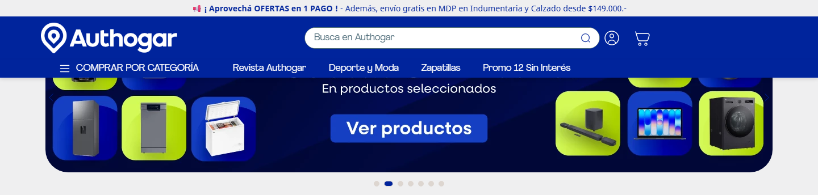
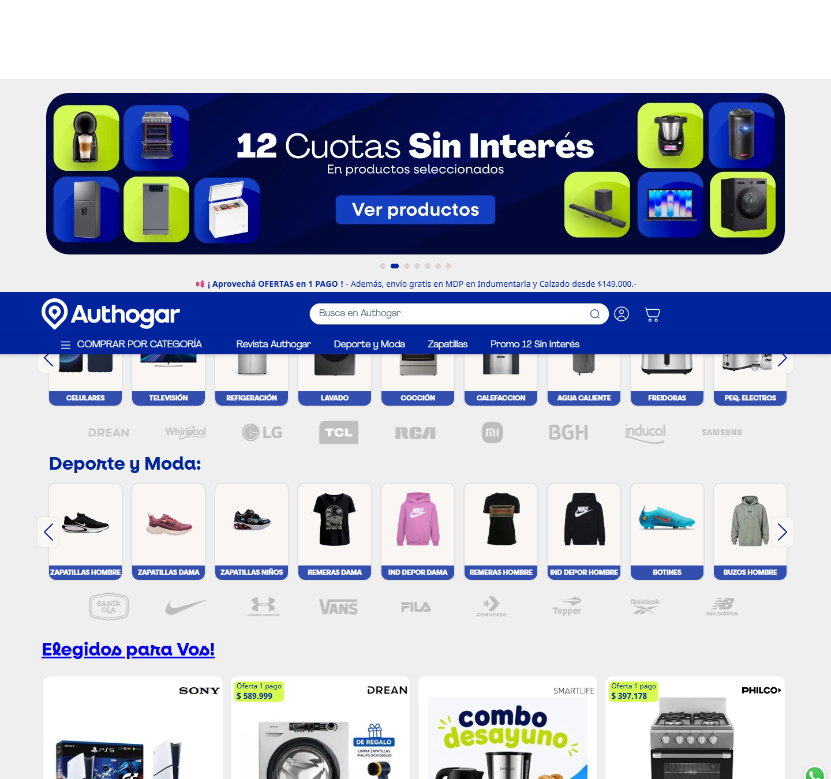
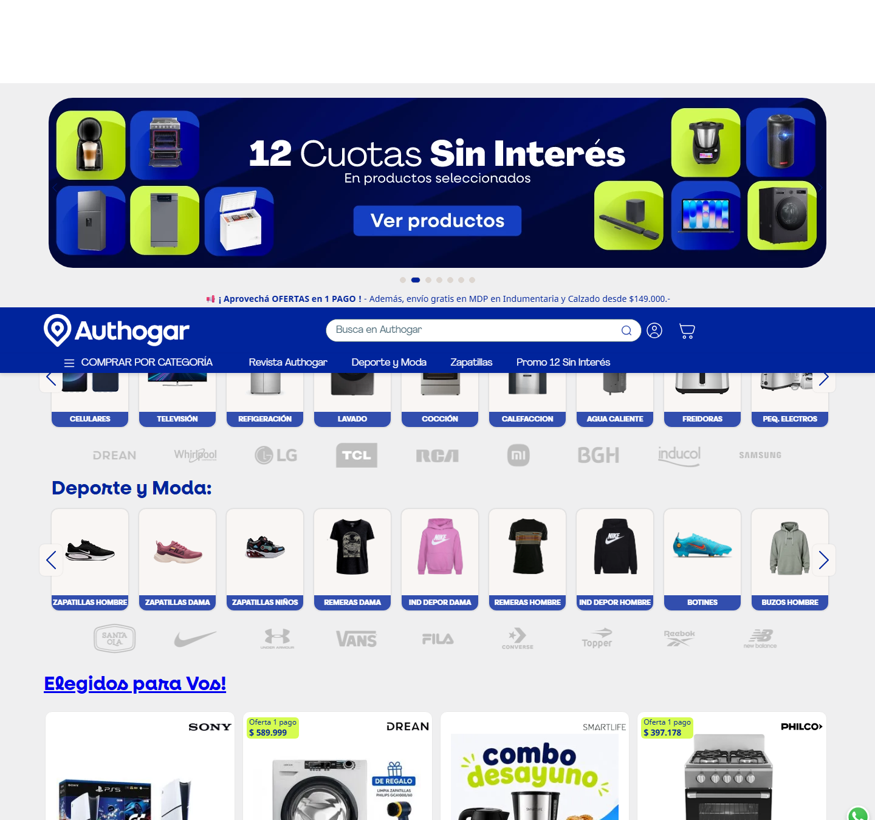




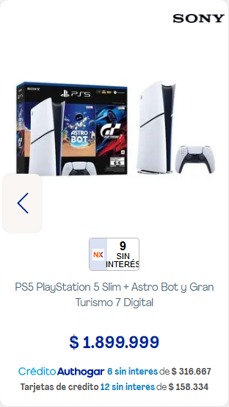

8. Accesibilidad
Métrica | Valor
imágenes sin alt | 5 de 239
imágenes con alt="" (decorativas) | 37
cantidad de h1 | 0
jerarquía h1/h2/h3/h4/h5/h6 | 0 / 2 / 24 / 0 / 0 / 0
saltos de jerarquía | el primer heading es h2, no h1
elementos con aria-label | 302
inputs sin label asociado | 3 de 4
botones sin nombre accesible | 6
links sin nombre accesible | 34
foco visible removido (outline:none) | 182
tabindex positivo | 0
skip link | no
iframes sin title | 1
tablas sin th | 0
media con autoplay | 0
landmarks | navigation
problemas de lang | ninguno

Contraste WCAG AA: 3 combinaciones por debajo del mínimo
Ratio | Mínimo | Color | Fondo | Size | Weight | Elemento | Texto
1.73 | 4.5 | #000000 | #00249c | 16px | 400 | label#downshift-0-label.vtex-store-components-3-x-visuallyHidden | Busca en Authogar
4.14 | 4.5 | #0083c7 | #ffffff | 12px | 700 | strong.authogar-components-0-x-interestFreeTextStrong | 6 sin interés
4.19 | 4.5 | #979899 | #00249c | 0px | 400 | span.vtex-login-2-x-label.t-action--small.pl4 | Mi cuenta

Inputs sin label (muestra)
Input
input[text] name=account ph=—
input[text] name=credential ph=—
textarea[text] name=g-recaptcha-response ph=—

Imágenes sin alt (muestra)
src
https://authogar.vtexassets.com/arquivos/open-menu-icon.svg
img.lazyload.vtex-render-runtime-8-x-lazyload
.5.132/img/footer/location-icon___612e84a1cedce2253bd1333faedc078b.svg
me/0.5.132/img/footer/mail-icon___0e8d6bc2e4d87b7965ab8a0c22e7666a.svg
5.132/img/footer/client-support___2cd3575847ae83a66983802ce2d19a07.svg

Outline de encabezados
Nivel | Texto | Visible | font-size
h2 | Hogar y Tecnología: | sí | 32px
h2 | Deporte y Moda: | sí | 32px
h3 | PS5 PlayStation 5 Slim + Astro Bot y Gran Turismo 7 Digital | sí | 16px
h3 | Lavarropas Drean 6Kg 800Rpm Inverter Blanco Lcfdr0608Lb | sí | 16px
h3 | Combo Desayuno Smartlife: Cafetera + Pava + Tostadora | sí | 16px
h3 | Cocina Philco 50cm Multigas Plata phcn50p | sí | 16px
h3 | Tablet TCL TAB A1 Plus 12.2" 128GB 6GB Space Blue + Teclado | sí | 16px
h3 | Tablet Lenovo 10" Kids Bumper Case 4Gb/64Gb | sí | 16px
h3 | Tablet X-View ProTab 10" 4GB/64GB | sí | 16px
h3 | Consola Level Up Super Drive Mini + 2 Joystick | sí | 16px
h3 | Zapatillas Nike Vomero 18 Ver. Hombre | sí | 16px
h3 | Zapatillas Nike Journey Run Neg. Mujer | sí | 16px
h3 | Zapatillas Nike Revolution 8 Neg. Mujer | sí | 16px
h3 | Zapatillas Run Defy Neg/Roj. Hombre | sí | 16px
h3 | Zapatillas Vans U Knu Skool Cel. Hombre | sí | 16px
h3 | Zapatillas Vans W Filmore Neg Mujer | sí | 16px
h3 | Zapatillas Vans W Brooklyn Ls Neg. Mujer | sí | 16px
h3 | Zapatillas Vans Caldrone Hombre | sí | 16px
h3 | Rack Para Colgar Tables 1,80M Tono Olmo Finlandes/Everest 1407-Coe | sí | 16px
h3 | Alacena Tables 1.20m Tono Olmo Finlandes/Everest 82301-Coe | sí | 16px
h3 | Box Tables Juvenil Tono Nevado/Everest 6440 Nce | sí | 16px
h3 | Placard Puertas Corredizas Tono Venecia 124X184X53Cm 3171 | sí | 16px
h3 | Termotanque Coppens 120L Multigas De Pie | sí | 16px
h3 | Lavarropa Carga Frontal Tcl Inverter 11 KG 1400 RPM Gris | sí | 16px
h3 | Cocina Morelli 55Cm Presenza Espejada Acero Inox. | sí | 16px
h3 | Heladera C/Freezer Drean 277L Blanca Hdr280F50B | sí | 16px

Roles y atributos ARIA en uso
role
role | Usos
group | 215
none presentation | 88
button | 7
presentation | 3
combobox | 1
listbox | 1

atributos aria-*
atributo | Usos
aria-label | 302
aria-hidden | 212
aria-roledescription | 101
aria-controls | 23
aria-atomic | 10
aria-live | 10
aria-labelledby | 2
aria-current | 1
aria-expanded | 1
aria-haspopup | 1

9. Animaciones y efectos
Métrica | Valor
elementos con transition activa | 57
elementos con animation | 1
elementos con transform | 28
elementos con will-change | 3
elementos con filter | 0
elementos con backdrop-filter | 0
@keyframes definidos | 30
soporta prefers-reduced-motion | sí
pistas de animación al scroll | 1 elementos con opacity:0 inline (pre-reveal)

Propiedades animadas por transition
propiedad | Usos
all | 44
transform | 12
-webkit-transform | 7
opacity | 1
right | 1

Duraciones de transition
duración | Usos
0.3s | 43
0.25s, 0.25s | 7
0.4s | 4
0.5s | 2
0.18s, 0.12s | 1

Easings
timing-function | Usos
ease-out | 50
ease | 7

animation-name en uso
animation | Usos
vtex-render-runtime-8-x-slide | 1

Propiedades que cambian en :hover
propiedad | Usos
background-color | 91
color | 86
border-left-color | 71
border-bottom-color | 70
border-right-color | 70
border-top-color | 70
background-attachment | 24
background-clip | 24
background-image | 24
background-origin | 24

Muestra de transiciones
Elemento | Propiedad | Duración | Easing | Delay
div | transform, opacity | 0.18s, 0.12s | ease-out | 0s, 0s
div.authogar-components-0-x-contColumnCategories2 | all | 0.5s | ease | 0s
img.lazyload.vtex-render-runtime-8-x-lazyload | all | 0.5s | ease | 0s
div.vtex-slider-layout-0-x-paginationDot.vtex-slider-layout-0-x-paginationDot--hero.bg-mut | transform, -webkit-transform | 0.25s, 0.25s | ease-out | 0s, 0s
div.vtex-slider-layout-0-x-paginationDot.vtex-slider-layout-0-x-paginationDot--hero.vtex-s | transform, -webkit-transform | 0.25s, 0.25s | ease-out | 0s, 0s
div.vtex-slider-layout-0-x-paginationDot.vtex-slider-layout-0-x-paginationDot--hero.bg-mut | transform, -webkit-transform | 0.25s, 0.25s | ease-out | 0s, 0s
div.vtex-slider-layout-0-x-paginationDot.vtex-slider-layout-0-x-paginationDot--hero.bg-mut | transform, -webkit-transform | 0.25s, 0.25s | ease-out | 0s, 0s
div.vtex-slider-layout-0-x-paginationDot.vtex-slider-layout-0-x-paginationDot--hero.bg-mut | transform, -webkit-transform | 0.25s, 0.25s | ease-out | 0s, 0s
div.vtex-slider-layout-0-x-paginationDot.vtex-slider-layout-0-x-paginationDot--hero.bg-mut | transform, -webkit-transform | 0.25s, 0.25s | ease-out | 0s, 0s
div.vtex-slider-layout-0-x-paginationDot.vtex-slider-layout-0-x-paginationDot--hero.bg-mut | transform, -webkit-transform | 0.25s, 0.25s | ease-out | 0s, 0s
div.authogar-components-0-x-sliderContainer | transform | 0.4s | ease | 0s
div.authogar-components-0-x-textContainerCategory | all | 0.3s | ease-out | 0s

Muestra de animaciones
Elemento | Nombre | Duración | Iteraciones | Easing | Dirección | Estado
div.vtex-render-runtime-8-x-slide | vtex-render-runtime-8-x-slide | 1.5s | infinite | linear | normal | running

@keyframes declarados
bounce, flash, pulse, rubberBand, shake, headShake, swing, tada, wobble, jello, heartBeat, bounceIn, bounceInDown, bounceInLeft, bounceInRight, bounceInUp, bounceOut, bounceOutDown, bounceOutLeft, bounceOutRight, bounceOutUp, fadeIn, fadeInDown, fadeInDownBig, fadeInLeft, fadeInLeftBig, fadeInRight, fadeInRightBig, fadeInUp, fadeInUpBig

10. Responsive
Veredicto: responsive: 3 transición(es) de layout detectadas, sin overflow horizontal
- Breakpoints medidos: 360, 390, 768, 1024, 1280, 1440, 1920
- Breakpoints declarados en CSS: 300, 320, 370, 400, 481, 500, 600, 640, 650, 680, 700, 720, 768, 784, 800, 850, 940, 1024, 1025, 1100, 1130, 1156, 1200, 1260, 1280, 1296, 1300, 1328, 1366, 1400, 1540
- Hamburguesa (selector conocido) visible en: nunca
- Candidato por heurística (botón con ícono arriba) en: 360, 390, 768, 1024, 1280, 1440, 1920 → button.vtex-button.bw1.ba (verificar a mano)
Ancho | Alto pág. | Vh | Overflow X | Visibles | Ocultos | Burger | Links nav | Header | h1 | body | Container | Cards/fila | Img vis. | Fixed
360 | 5671px | 6.7 | no | 3099 | 84 | no | 0 | 137px | 24px | 16px | 360px | 12 | 168 | 4
390 | 5726px | 6.8 | no | 3099 | 84 | no | 0 | 137px | 24px | 16px | 390px | 12 | 168 | 4
768 | 5910px | 5.8 | no | 2479 | 84 | no | 0 | 137px | 24px | 16px | 768px | 2 | 103 | 4
1024 | 6050px | 6.7 | no | 2479 | 84 | no | 0 | 137px | 24px | 16px | 1024px | 2 | 103 | 4
1280 | 6609px | 7.3 | no | 2874 | 120 | no | 4 | 137px | 32px | 16px | 1280px | 12 | 204 | 4
1440 | 6610px | 7.3 | no | 2874 | 120 | no | 4 | 137px | 32px | 16px | 1440px | 8 | 204 | 4
1920 | 6610px | 7.3 | no | 2874 | 120 | no | 4 | 137px | 32px | 16px | 1920px | 8 | 204 | 4
390 (touch) | 5740px | 6.8 | no | 3109 | 72 | no | 0 | 137px | 24px | 16px | 390px | 12 | 178 | 3

Transiciones de layout entre breakpoints
De → a | Cambios detectados
390px → 768px | cards por fila 12 → 2 · alto de página 6.8 → 5.8 viewports
1024px → 1280px | cards por fila 2 → 12 · links de nav visibles 0 → 4 · h1 24px → 32px
1280px → 1440px | cards por fila 12 → 8

Tap targets chicos en mobile (< 36px)
Ancho | Chicos | Total
360px | 78 | 146
390px | 75 | 146

11. CSS: hojas, media queries y tokens
Campo | Valor
stylesheets | 41
accessible | 40
crossOrigin | 1
totalRules | 6471
styleRules | 5992
mediaRules | 289
keyframeRules | 178
fontFaceRules | 11
supportsRules | 0
importRules | 0
importantCount | 276
customPropertyDeclarations | 10
inlineStyleAttributes | 589
approxCssBytes | 508840

Chequeo | Valor
media queries distintas | 51
breakpoints inferidos | 300, 320, 370, 400, 481, 500, 600, 640, 650, 680, 700, 720, 768, 784, 800, 850, 940, 1024, 1025, 1100, 1130, 1156, 1200, 1260, 1280, 1296, 1300, 1328, 1366, 1400, 1540
soporta dark mode (prefers-color-scheme) | no
estilos de impresión | no
queries de hover/pointer | no
selector más largo | .vtex-login-2-x-accessCodeOptionBtn, .vtex-login-2-x-accountOptions, .vtex-login-2-x-accountOptionsSectionTitle, .vtex-login-2-x-arrowUp, .vtex-login-2-x-backBu

Media queries más usadas
condición | Usos
(max-width: 1024px) | 200
(max-width: 1025px) | 17
(max-width: 640px) | 14
(max-width: 1400px) | 3
(max-width: 1540px) | 3
(max-width: 1296px) and (min-width: 1025px) | 2
only screen and (max-width: 49rem) | 2
screen and (max-width: 1025px) | 2
screen and (max-width: 700px) | 2
screen and (min-width: 1300px) | 2
screen and (prefers-contrast: more) | 2
(max-width: 1024px) and (max-width: 1024px) | 1
(max-width: 1025px) and (max-width: 1024px) | 1
(max-width: 1025px) and (max-width: 650px) | 1
(max-width: 1200px) | 1
(max-width: 1260px) | 1
(max-width: 1328px) | 1
(max-width: 1366px) | 1
(max-width: 370px) | 1
(max-width: 481px) | 1

Breakpoints por declaración
declaración | Usos
max-width: 1024px | 204
max-width: 1025px | 22
max-width: 640px | 15
min-width: 1025px | 4
max-width: 1400px | 3
max-width: 1540px | 3
max-width: 600px | 3
max-width: 700px | 3
max-width: 768px | 3
max-width: 1296px | 2
max-width: 49rem | 2
max-width: 500px | 2
max-width: 850px | 2
min-width: 1300px | 2
max-width: 1100px | 1
max-width: 1130px | 1
max-width: 1200px | 1
max-width: 1260px | 1
max-width: 1328px | 1
max-width: 1366px | 1

@font-face
Familia | Weight | Style | font-display | Formato | Host
NotoSans | 400 | normal | (no declarado) | ttf | authogar.vtexassets.com
NotoSans | 500 | normal | (no declarado) | ttf | authogar.vtexassets.com
Agrandir | 200 | normal | (no declarado) | ttf | authogar.vtexassets.com
Agrandir | 400 | normal | (no declarado) | ttf | authogar.vtexassets.com
Agrandir | 700 | normal | (no declarado) | ttf | authogar.vtexassets.com
Agrandir | 800 | normal | (no declarado) | ttf | authogar.vtexassets.com
Neulis | 400 | normal | (no declarado) | otf | authogar.vtexassets.com
Neulis | 500 | normal | (no declarado) | otf | authogar.vtexassets.com
Neulis | 700 | normal | (no declarado) | otf | authogar.vtexassets.com
Montserrat | 500 | normal | (no declarado) | ttf | authogar.vtexassets.com
Montserrat | 700 | normal | (no declarado) | ttf | authogar.vtexassets.com

Hojas de estilo cargadas
Hoja | Host | Reglas | media
raphql/v1/style/authogar.theme@0.5.129$style.common.min.css?v=1&workspace=master | authogar.vtexassets.com | 1124 | —
graphql/v1/style/authogar.theme@0.5.129$style.small.min.css?v=1&workspace=master | authogar.vtexassets.com | 573 | screen and (min-width: 20em)
phql/v1/style/authogar.theme@0.5.129$style.notsmall.min.css?v=1&workspace=master | authogar.vtexassets.com | 1145 | screen and (min-width: 40em)
graphql/v1/style/authogar.theme@0.5.129$style.large.min.css?v=1&workspace=master | authogar.vtexassets.com | 573 | screen and (min-width: 64em)
raphql/v1/style/authogar.theme@0.5.129$style.xlarge.min.css?v=1&workspace=master | authogar.vtexassets.com | 572 | screen and (min-width: 80em)
s-graphql/v1/fonts/989db2448f309bfdd99b513f37c84b8f5794d2b5?v=1&workspace=master | authogar.vtexassets.com | 0 | —
s.com/_v/public/assets/v1/npm/animate.css@3.7.0/animate.min.css?workspace=master | authogar.vtexassets.com | 90 | —
blished/vtex.render-runtime@8.136.2/public/react/common.min.css?workspace=master | authogar.vtexassets.com | 60 | —
ed/vtex.store-components@3.178.5/public/react/Container.min.css?workspace=master | authogar.vtexassets.com | 1 | —
ts/v1/published/vtex.styleguide@9.146.16/public/react/0.min.css?workspace=master | authogar.vtexassets.com | 1 | —
d/vtex.admin-pages@4.59.2/public/react/HighlightOverlay.min.css?workspace=master | authogar.vtexassets.com | 10 | —
ets/v1/published/vtex.flex-layout@0.21.6/public/react/0.min.css?workspace=master | authogar.vtexassets.com | 3 | —
ar.components@0.0.53/public/react/CategorySliderDesktop.min.css?workspace=master | authogar.vtexassets.com | 18 | —
s/v1/published/vtex.rich-text@0.16.1/public/react/index.min.css?workspace=master | authogar.vtexassets.com | 1 | —
/v1/published/authogar.components@0.0.53/public/react/2.min.css?workspace=master | authogar.vtexassets.com | 49 | —
d/authogar.components@0.0.53/public/react/PrecioContado.min.css?workspace=master | authogar.vtexassets.com | 4 | —
tex.store-components@3.178.5/public/react/DiscountBadge.min.css?workspace=master | authogar.vtexassets.com | 1 | —
product-summary@2.92.1/public/react/ProductSummaryImage.min.css?workspace=master | authogar.vtexassets.com | 16 | —
onents@0.0.53/public/react/InstallmentsBanksProductCard.min.css?workspace=master | authogar.vtexassets.com | 13 | —
/published/vtex.store-components@3.178.5/public/react/3.min.css?workspace=master | authogar.vtexassets.com | 1 | —
.components@0.0.53/public/react/InstallmentsProductCard.min.css?workspace=master | authogar.vtexassets.com | 18 | —
blished/vtex.store-components@3.178.5/public/react/Logo.min.css?workspace=master | authogar.vtexassets.com | 2 | —
ts/v1/published/vtex.styleguide@9.146.16/public/react/1.min.css?workspace=master | authogar.vtexassets.com | 3 | —
published/vtex.styleguide@9.146.16/public/react/Spinner.min.css?workspace=master | authogar.vtexassets.com | 1 | —
/published/vtex.store-components@3.178.5/public/react/4.min.css?workspace=master | authogar.vtexassets.com | 5 | —

Distribución de profundidad de selectores
niveles
niveles | Usos
1 | 4612
2 | 782
3 | 253
4 | 150
6 | 58
5 | 57
8 | 57
7 | 23

12. Performance y red
Métrica | Valor
TTFB | 19 ms
DNS / TCP / TLS | 46 / 25 / 14 ms
respuesta del documento | 32 ms
DOM interactive | 1816 ms
DOMContentLoaded | 1816 ms
load | 4251 ms
protocolo | h2
first-paint / first-contentful-paint | 1360 / 1360 ms
LCP | —
CLS | 0.0337
HTML decodificado | 3403 KB

Recursos (intercepción de red) | Cantidad | KB
document | 3 | 0
stylesheet | 42 | 90
script | 73 | 2093
image | 317 | 3777
font | 9 | 1217
fetch | 213 | 11
xhr | 8 | 0
media | 0 | 0
other | 2 | 675
ping | 6 | 0

Total | Valor
requests | 673
peso declarado | 7863 KB
status | 2xx: 661 · 4xx: 16
redirecciones | 0
304 not modified | 0
hosts de terceros | 19
requests fallidos | 9
tiempo total de carga | 8376 ms

Hosts por cantidad de requests
Host | Requests | KB | Tercero
authogar.vtexassets.com | 404 | 4913 | sí
www.authogar.com | 205 | 11 | no
www.gstatic.com | 10 | 2111 | sí
www.google.com | 7 | 0 | sí
g.clarity.ms | 7 | 0 | sí
af-origin.vtex.com | 4 | 0 | sí
api.icommkt.online | 4 | 0 | sí
www.googletagmanager.com | 3 | 503 | sí
analytics.google.com | 3 | 0 | sí
io.vtex.com.br | 2 | 0 | sí
connect.facebook.net | 2 | 173 | sí
www.clarity.ms | 2 | 1 | sí
tracker.metricool.com | 2 | 0 | sí
accounts.google.com | 2 | 0 | sí
fonts.gstatic.com | 2 | 78 | sí
www.google-analytics.com | 2 | 0 | sí
capi-automation.s3.us-east-2.amazonaws.com | 1 | 63 | sí
activity-flow.vtex.com | 1 | 0 | sí
sp.vtex.com | 1 | 0 | sí
ad.doubleclick.net | 1 | 0 | sí

Recursos más lentos
URL | Tipo | ms | KB | Host
ql/images/eba8b02a-bab9-48d7-a1c2-c377e1eb6242___1d7a688e38feebcd81fbe88c46f9ccb5.jpg | img | 1165 | 0 | authogar.vtexassets.com
ql/images/00f5611e-53bc-4a58-89c6-d2ad33c552f5___01154141db094bcd87207287ee345f2b.jpg | img | 1158 | 0 | authogar.vtexassets.com
ql/images/6044fba9-d6df-4e2f-b7eb-d125b077b74d___61ad2734022bcbd010d77e86767bae3e.jpg | img | 1158 | 0 | authogar.vtexassets.com
ql/images/6a2fe317-9170-4758-a7bd-4102a558199a___544d159deff3134dec19f8cc9121489c.jpg | img | 1149 | 0 | authogar.vtexassets.com
ql/images/8b9dfb75-b551-4bf3-9741-83d2dcec02d5___b23a8861e61506dfed37cf08d05626ba.jpg | img | 1141 | 0 | authogar.vtexassets.com
ql/images/caaf2369-f6f4-4076-bc7c-888253da2fdb___7f1aeccde8877a02e2a51e529939fc36.jpg | img | 1141 | 0 | authogar.vtexassets.com
ql/images/60dddb58-d8f1-4f0e-8986-00319eb8a887___508e420c0b9b3813d8207c8e222eff38.png | img | 1119 | 0 | authogar.vtexassets.com
ql/images/4ad2ed62-c4fc-4151-a30d-b7824c87bab7___a7bb76ca490d17a8aa2eb2b2d9c41c3c.jpg | img | 1118 | 0 | authogar.vtexassets.com
ql/images/5e5044dc-a410-41d0-a628-447096c6f217___59074f884906fce50327ca11b803b545.jpg | img | 1113 | 0 | authogar.vtexassets.com
ql/images/c4c14e35-7e55-4fdd-89cf-5a60063a3096___5524d21137109d1bd96c19b69f341d30.jpg | img | 1105 | 0 | authogar.vtexassets.com
ql/images/e47c5eed-0cf8-4d34-97c4-fe3132b6a75e___9f4b1d53d6e4f727dc7acf623f916006.jpg | img | 1054 | 0 | authogar.vtexassets.com
-builder/authogar.theme/0.5.132/img/footer/pci___efeaf80f31740c087156b05542d20b7a.png | img | 1051 | 0 | authogar.vtexassets.com

Requests fallidos
URL | Tipo | Error
https://sp.vtex.com/event-api/v1/authogar/event | fetch | net::ERR_ABORTED
8395334~118897920~118897930~119318177~120315470~120385423&tft=1786990718168&tfd=2973&fmt=8 | fetch | net::ERR_ABORTED
/ccm/s/collect?auid=137859266.1786990718&gtm=45He68d0v9128889544za200zd9128889544xea&fmt=8 | fetch | net::ERR_ABORTED
&dl=https%3A%2F%2Fwww.authogar.com%2F&dt=Authogar&en=pageview&fv=1&nsi=1&ss=1&tfd=3702 | fetch | net::ERR_ABORTED
1&seg=0&dl=https%3A%2F%2Fwww.authogar.com%2F&dt=Authogar&en=pageview&fv=1&_ss=1&tfd=3974 | fetch | net::ERR_ABORTED
%2F%2Fwww.authogar.com%2F&dt=Authogar&en=scroll&epn.percentscrolled=90&et=6980&tfd=10850 | fetch | net::ERR_ABORTED
%2F%2Fwww.authogar.com%2F&dt=Authogar&en=scroll&epn.percentscrolled=90&et=6714&tfd=15696 | fetch | net::ERR_ABORTED
sid=1786990718&sct=1&seg=0&dl=https%3A%2F%2Fwww.authogar.com%2F&dt=Authogar&_s=3&tfd=15854 | fetch | net::ERR_ABORTED
hcn50p~k3dimension4~v3available&ep.itemlistname=List%20of%20products&_et=12806&tfd=29528 | fetch | net::ERR_ABORTED

