vital.com.ar
Análisis de https://www.vital.com.ar/
Generado: 2026-08-17T19:38:33.670Z

vital.com.ar
- URL: https://www.vital.com.ar/
- URL final: https://www.vital.com.ar/
- HTTP 200 · estrategia de espera: networkidle · carga 10486 ms · análisis total 59.0 s
- Elementos analizados: 883 · nodos DOM: 1407 · profundidad máx: 17
- Rol en el proyecto: referencia (competencia) — Vital
- Capturas: desktop full · mobile full · breakpoints: 360px 390px 768px 1024px 1280px 1440px 1920px

Páginas analizadas
# | Tipo | URL | Origen | Estado | Elementos | Botones | Cards | Alto | Overflow X
1 | Home | / | entrada | ✓ | 883 | 20 | 0 | 5569px | no
2 | Contacto / sucursales | /contactos/ | nav | ✓ | 355 | 8 | 1 | 1228px | no
3 | Institucional | /empresas/ | nav | ✓ | 371 | 6 | 0 | 2049px | no
4 | Ayuda / legales | /ayudaresvital/ | sitemap | ✓ | 205 | 6 | 3 | 1310px | no
5 | Página interna | /obras/s_t/ | sitemap | ✓ | 341 | 7 | 1 | 900px | no
6 | Página | /ofertas/ | nav | ✓ | 594 | 15 | 0 | 2846px | no
7 | Contacto / sucursales | /sucursales/ | nav | ✓ | 747 | 18 | 17 | 2211px | no
8 | Ayuda / legales | /terminos-condiciones | footer | ✓ | 330 | 6 | 0 | 3363px | no
9 | Ayuda / legales | /terminos-y-condiciones-giftcard/ | sitemap | ✓ | 422 | 6 | 1 | 3056px | no
10 | Ayuda / legales | /terminos-y-condiciones-giftcard-salon/ | sitemap | ✓ | 428 | 6 | 1 | 3440px | no

El detalle completo que sigue corresponde al home. Las demás páginas están resumidas al final, en "Páginas adicionales".

0. Recorrido del análisis y popups
Sin popups ni banners de cookies detectados al entrar.

Traza paso a paso
885ms navegando (networkidle, 60s)
10486ms cargado HTTP 200 → https://www.vital.com.ar/
10486ms scroll completo (lazy-load + animaciones de scroll)
12576ms extrayendo: meta y SEO
12595ms extrayendo: stack tecnológico
12673ms extrayendo: tipografía, paleta y espaciado
12777ms extrayendo: estructura y layout
12828ms extrayendo: inventario de componentes
13076ms extrayendo: accesibilidad
13121ms extrayendo: animaciones
13181ms extrayendo: CSSOM y media queries
13243ms extrayendo: performance timing
13254ms recortando 16 componentes y zonas
19454ms recortes guardados: 15/16
19461ms screenshot desktop 1440 fullPage
20521ms probando breakpoint 360x844
22121ms probando breakpoint 390x844
23330ms probando breakpoint 768x1024
27192ms probando breakpoint 1024x900
28688ms probando breakpoint 1280x900
34764ms probando breakpoint 1440x900
40549ms probando breakpoint 1920x900
41738ms contexto mobile 390x844 (touch) + screenshot fullPage

1. Meta, SEO y datos estructurados
Campo | Valor
title | Supermayorista Vital - El mayorista de tu ahorro (48 car.)
description | Encontrá las mejores marcas, productos, promociones y descuentos todas las semanas a precios mayoristas. ¡En Vital todos pueden comprar! (136 car.)
viewport | width=device-width, initial-scale=1.0
lang / dir / charset | es / null / utf-8
favicon | https://www.vital.com.ar/wp-content/uploads/2020/10/cropped-favicon-vital-150x150.png?x54230
og:image | —
canonical | https://www.vital.com.ar/
robots | index, follow, max-image-preview:large, max-snippet:-1, max-video-preview:-1
theme-color | —
generator | —
manifest (PWA) | —
hreflang | —
JSON-LD | CollectionPage, BreadcrumbList, WebSite, Organization
meta tags | 13
peso del HTML | 440 KB

Resource hints (preload/preconnect)
Hint
preconnect → fonts.googleapis.com
preconnect → fonts.gstatic.com

Open Graph / Twitter completos
Campo | Valor
og:locale | es_ES
og:type | website
og:title | Supermayorista Vital
og:description | Encontrá las mejores marcas, productos, promociones y descuentos todas las semanas a precios mayoristas. ¡En Vital todos pueden comprar!
og:url | https://www.vital.com.ar/
og:site_name | Supermayorista Vital
twitter:card | summarylargeimage

2. Stack tecnológico
Tecnología | Detectado
react | no
next | no
vue | no
angular | no
jquery | sí
tailwind | sí
bootstrap | sí
wordpress | sí

Otras detecciones: Swiper · AOS · Google Fonts · Google Tag Manager · Google Analytics · Meta Pixel · Hotjar · Clarity · reCAPTCHA
Assets | Cantidad
scripts externos | 515
scripts inline | 15
hojas de estilo externas | 2
tags &lt;style> | 4
hosts de scripts | 14

Hosts que sirven scripts
Host
snap.licdn.com
www.youtube.com
scripts.clarity.ms
cdn.inspectlet.com
connect.facebook.net
static.hotjar.com
www.google-analytics.com
www.googletagmanager.com
www.clarity.ms
www.gstatic.com
www.google.com
script.hotjar.com
www.vital.com.ar
vitalar.my.site.com

3. Estructura y layout
Landmark | Cantidad
header | 1
nav | 1
footer | 1
main | 1
aside | 0
section | 12
article | 0
search | 0

Métrica | Valor
display:grid | 1
display:flex | 89
position:sticky | 0
position:fixed | 6
position:absolute | 41
elementos con cursor:pointer | 464
alto de página | 5569px (6.2 viewports)
overflow horizontal @1440 | no
background del body | #ffffff
nodos DOM / profundidad máx / media | 1407 / 17 / 10.4
elemento más profundo | rect.[object.SVGAnimatedString]
caracteres de texto visible | 1570

max-width de contenedores (más frecuentes)
max-width | Usos
33.3333% | 12
1100px | 11
58.3333% | 2
66.6667% | 2
41.6667% | 1

padding lateral de contenedores
padding izq / der | Usos
15px / 15px | 11
8px / 8px | 10
24px / 24px | 4
4px / 4px | 2
15px / 0px | 1

z-index en uso
z-index | Usos
1 | 7
10 | 7
2000000000 | 5
100000 | 1
1001 | 1
999 | 1

Anatomía sección por sección (orden de scroll)
# | Elemento | Encabezado | Alto | Vh | display | Cols | Padding | Fondo | Hijos | Img | Links | Btn | Cards
1 | div#home-slider.swiper-container.swiper-container-initialized.swiper-container-horizontal | — | 618px | 0.69 | block | — | 0px | transparente | 4 | 7 | 7 | 0 | 0
2 | div.d-flex.flex-column.flex-sm-row | — | 267px | 0.3 | flex | 3 | 0px | transparente | 3 | 3 | 3 | 0 | 0
3 | img.img-fluid.lazy.loaded | — | 70px | 0.08 | inline | — | 0px | transparente | 0 | 0 | 0 | 0 | 0
4 | div.container | ¡Nuestras ofertas mayoristas destacadas! | 375px | 0.42 | block | — | 0px 15px | transparente | 2 | 4 | 4 | 0 | 0
5 | div.row.mx-n4 | — | 419px | 0.47 | flex | 2 | 0px | transparente | 2 | 3 | 3 | 0 | 0
6 | h3.h1.text-center.fw600 | — | 48px | 0.05 | block | — | 0px | transparente | 0 | 0 | 0 | 0 | 0
7 | figure.flex-column.px-0.aos-init | — | 508px | 0.56 | block | — | 0px | transparente | 2 | 1 | 3 | 1 | 0
8 | figure.flex-column.px-0.aos-init | — | 508px | 0.56 | block | — | 0px | transparente | 2 | 1 | 3 | 1 | 0
9 | figure.flex-column.px-0.aos-init | — | 508px | 0.56 | block | — | 0px | transparente | 2 | 1 | 3 | 1 | 0
10 | figure.flex-column.px-0.aos-init | — | 508px | 0.56 | block | — | 0px | transparente | 2 | 1 | 3 | 1 | 0
11 | figure.flex-column.px-0.aos-init | — | 508px | 0.56 | block | — | 0px | transparente | 2 | 1 | 3 | 1 | 0
12 | figure.flex-column.px-0.aos-init | — | 508px | 0.56 | block | — | 0px | transparente | 2 | 1 | 3 | 1 | 0
13 | figure.flex-column.px-0.aos-init | — | 508px | 0.56 | block | — | 0px | transparente | 2 | 1 | 3 | 1 | 0
14 | figure.flex-column.px-0.aos-init | — | 508px | 0.56 | block | — | 0px | transparente | 2 | 1 | 3 | 1 | 0
15 | figure.flex-column.px-0.aos-init | — | 508px | 0.56 | block | — | 0px | transparente | 2 | 1 | 3 | 1 | 0
16 | figure.flex-column.px-0.aos-init | — | 508px | 0.56 | block | — | 0px | transparente | 2 | 1 | 3 | 1 | 0
17 | figure.flex-column.px-0.aos-init | — | 508px | 0.56 | block | — | 0px | transparente | 2 | 1 | 3 | 1 | 0
18 | figure.flex-column.px-0.aos-init | — | 508px | 0.56 | block | — | 0px | transparente | 2 | 1 | 3 | 1 | 0
19 | div.container | — | 288px | 0.32 | block | — | 0px 15px | transparente | 3 | 0 | 7 | 1 | 0
20 | section.home-atributo-marcas.bg-blue-100.pt-5 | — | 72px | 0.08 | block | — | 48px 0px 24px | #eff7fe | 1 | 0 | 0 | 0 | 0
21 | section.home-medios-de-pago.py-4 | — | 160px | 0.18 | block | — | 24px 0px | #f8f9fa | 1 | 21 | 0 | 0 | 0

Capas sticky / fixed
Elemento | position | z-index | Tamaño | top | bottom | Fondo | Rol inferido
a#wa-fixed.whatsapp.d-inline-block.rounded-circle | fixed | 100000 | 70x70 | 810px | 20px | #4dc247 | chat
button#embeddedMessagingConversationButton.embeddedMessagingConversationButton | fixed | auto | 56x56 | 819px | 25px | #1a1b1e | otro

Grillas CSS reales
Elemento | grid-template-columns | rows | gap | Items
div.grid-folletos | 346px 346px 346px | 524.094px 524.094px 524.094px 524.094px | 16px | 12

4. Tipografía
font-family (top 5 por uso real)
font-family | Usos
Roboto, sans-serif | 720
Montserrat, sans-serif | 91
sans-serif | 5

font-size (top 8)
font-size | Usos
16px | 680
14px | 65
12px | 44
20px | 13
0px | 5
12.8px | 4
40px | 3
10px | 1

font-weight (top 5)
font-weight | Usos
400 | 783
500 | 16
300 | 12
600 | 4
700 | 1

line-height (top 5)
line-height | Usos
24px | 461
30.4px | 216
21px | 65
normal | 36
14.4px | 12

letter-spacing
sin datos
text-transform
sin datos
Escala tipográfica real por elemento
Elemento | size | weight | line-height | letter-spacing | familia | color
body | 16px | 400 | 24px | normal | Roboto | #212529
h1 | 40px | 500 | 48px | normal | Montserrat | #003d9e
h2 | 40px | 600 | 48px | normal | Montserrat | #003d9e
h3 | 40px | 600 | 48px | normal | Montserrat | #003d9e
h4 | 40px | 600 | 48px | normal | Montserrat | #003d9e
h5 | 20px | 500 | 24px | normal | Montserrat | #003d9e
h6 | 12px | 500 | 14.4px | normal | Montserrat | #ffffff
a | 16px | 400 | 24px | normal | Roboto | #003d9e
button | 16px | 400 | 24px | normal | Roboto | #000000
input | 16px | 400 | 24px | normal | Roboto | #000000
small | 12.8px | 400 | 19.2px | normal | Roboto | #6c757d

Consistencia: 3 familias distintas · 9 tamaños · 5 pesos · 11 line-heights → escala acotada

Fuentes cargadas (document.fonts)
Fuente
Roboto 400 normal (loaded)
Roboto 500 normal (loaded)
Roboto 700 normal (unloaded)
Montserrat 400 normal (loaded)
Montserrat 600 normal (loaded)
Montserrat 700 normal (loaded)
Montserrat 900 normal (unloaded)
swiper-icons 400 normal (loaded)

font-size — lista extendida
font-size (top 20)
font-size | Usos
16px | 680
14px | 65
12px | 44
20px | 13
0px | 5
12.8px | 4
40px | 3
10px | 1
32px | 1

5. Paleta de color
Colores de texto (top 8)
color | Usos
#ffffff | 293
#212529 | 224
#003d9e | 204
#343a40 | 41
#495057 | 29
#f8f9fa | 12
#000000 | 7
#6c757d | 4

Backgrounds (top 8, sin transparentes)
background | Usos
#ffffff | 15
#000000 (0.75) | 12
#134b95 | 12
#003d9e | 5
#000000 | 4
#ed1c24 | 4
#4dc247 | 3
#eff7fe | 2

Colores de borde (top 5)
border-color | Usos
#f8f9fa | 12
#adb5bd | 9
#003d9e | 6
#ed1c24 | 3
#001d85 | 1

Amplitud: 10 colores de texto distintos · 11 de fondo · 10 de borde

Paleta extendida (top 20 de cada grupo)
Texto
color | Usos
#ffffff | 293
#212529 | 224
#003d9e | 204
#343a40 | 41
#495057 | 29
#f8f9fa | 12
#000000 | 7
#6c757d | 4
#28a745 | 1
#ed1c24 | 1

Fondos
background | Usos
#ffffff | 15
#000000 (0.75) | 12
#134b95 | 12
#003d9e | 5
#000000 | 4
#ed1c24 | 4
#4dc247 | 3
#eff7fe | 2
#1a1b1e | 1
#e9ecef | 1
#f8f9fa | 1

6. Sistema de espaciado y superficie
border-radius (top 6)
border-radius | Usos
50% | 26
4.8px | 21
800px | 15
12px | 8
30px | 2
100% | 1

box-shadow (top 5)
box-shadow | Usos
rgba(0, 0, 0, 0.15) 0px 2px 10px 0px | 12
rgba(0, 0, 0, 0.15) 0px 8px 16px 0px | 6
rgba(0, 0, 0, 0.25) 0px 0px 8px 0px | 5
rgba(0, 0, 0, 0.25) 0px 0px 5px 1px | 2
rgba(0, 0, 0, 0.075) 0px 2px 4px 0px | 1

gap (top 6)
gap | Usos
7px | 21
6px | 20
8px | 12
4px | 10
10px | 2
16px | 2

padding (top 8)
padding | Usos
0px 2px 1px | 41
0px 8px | 33
0px 15px | 19
8px | 17
4px 24px | 12
18px 5px | 11
4px 8px | 10
24px 0px | 7

margin (top 8)
margin | Usos
0px 0px 16px | 25
0px 162.5px | 9
-22px 0px 0px | 6
0px 8px 0px 0px | 6
0px -15px | 5
0px 10px 0px 0px | 5
0px 6px | 5
0px 0.03125px 0px 0.015625px | 4

border-width
border-width | Usos
1px | 12
2px | 12
4px | 12

Amplitud: 7 radios · 8 sombras · 6 gaps · 27 paddings distintos

7. Inventario de componentes
Componente | Cantidad
buttons | 20
links | 85
forms | 1
inputs | 21
images | 85
svg | 33
videosEmbeds | 5
modals | 15
tables | 0
carousels | 69
cards | 0
lists | 7
accordions | 0
tabs | 0
breadcrumbs | 0
pagination | 6
badges | 1
icons | 33
ratings | 3
prices | 0
addToCart | 0
search | 0
newsletter | 0
social | 19
skeletons | 0
banners | 14

Variantes de botón (agrupadas por firma de estilo)
Usos | Ejemplos | Fondo | Texto | Radio | Padding | Size | Weight | Borde | Sombra | Tamaño típico
12 | Ver folleto / Ver folleto / Ver folleto | rgba(0, 0, 0, 0) | rgb(248, 249, 250) | 800px | 4px 24px | 20px | 300 | 2px rgb(248, 249, 250) | — | 152x42
1 | Sumate al canal de WhatsApp | rgb(77, 194, 71) | rgb(255, 255, 255) | 30px | 8px 24px | 16px | 400 | 0px rgb(255, 255, 255) | — | 291x40
1 | Acceso a comerciantes | rgb(237, 28, 36) | rgb(255, 255, 255) | 800px | 6px 12px | 16px | 500 | 1px rgb(237, 28, 36) | — | 194x38
1 | VER TODOS LOS PRODUCTOS | rgb(237, 28, 36) | rgb(255, 255, 255) | 800px | 6px 24px | 16px | 500 | 1px rgb(237, 28, 36) | — | 264x38
1 | Suscribirme | rgb(237, 28, 36) | rgb(255, 255, 255) | 800px | 4px 32px | 16px | 500 | 1px rgb(237, 28, 36) | — | 204x20
1 | Hola, ¿tiene alguna pregunta? Chateemos. | rgb(26, 27, 30) | rgb(0, 0, 0) | 50% | 0px | 16px | 400 | 0px rgb(0, 0, 0) | rgba(45, 45, 45, 0.5) 2px 2px 5px 0px | 56x56

Variantes de card
sin datos
Variantes de input
Usos | Ejemplos | Fondo | Radio | Padding | Alto | Size | Borde
6 | Nombre* / Apellido* / CUIT/DNI* | rgb(255, 255, 255) | 12px | 6px 12px | 35px | 14px | 1px rgb(173, 181, 189)
1 | select-one | rgba(0, 0, 0, 0) | 4px | 6px 32px 6px 4px | 32px | 12px | 0px rgb(0, 61, 158)
1 | Prefijo | rgb(255, 255, 255) | 12px | 6px 24px 6px 36px | 35px | 14px | 1px rgb(173, 181, 189)
1 | 00NDn00000dbbLf | rgb(255, 255, 255) | 12px | 6px 24px 6px 12px | 35px | 14px | 1px rgb(173, 181, 189)

Links
Métrica | Valor
total | 85
internos | 47
externos | 25
anclas (#) | 13
tel: / mailto: | 0 / 0
javascript: | 0
rel=nofollow | 0
target=_blank | 24
sin texto ni aria-label | 6

Dominios externos más enlazados
Host | Usos
wa.me | 13
www.whatsapp.com | 2
comisionistas.vital.com.ar | 1
proveedores.vital.com.ar | 1
servicios1.afip.gov.ar | 1
tiendaonline.vital.com.ar | 1
www.argentina.gob.ar | 1
www.facebook.com | 1
www.instagram.com | 1
www.linkedin.com | 1

Imágenes
Métrica | Valor
total | 71
loading=lazy / eager / sin atributo | 27 / 0 / 44
con srcset o &lt;picture> | 17
sobredimensionadas (>2x del tamaño mostrado) | 16
sin width/height declarados (riesgo de CLS) | 50
decorativas (alt="") | 23
formatos | sin-extensión: 26 · jpg: 25 · png: 13 · svg: 4 · jpeg: 2 · gif: 1

Detalle de imágenes (muestra)
src | Host | Mostrada | Natural | Sobredim. | loading | srcset | alt | object-fit | radio
— | www.vital.com.ar | 0x0 | 0x0 | no | (default) | no | (vacío/decorativa) | fill | 0px
— | www.vital.com.ar | 0x0 | 0x0 | no | (default) | no | (vacío/decorativa) | fill | 0px
ps://www.vital.com.ar/wp-content/themes/vital/dist/images/logo-vital-sin-slogan.svg?x54230 | www.vital.com.ar | 90x40 | 300x134 | sí | (default) | no | Vital | fill | 0px
https://www.vital.com.ar/wp-content/themes/vital/dist/images/header/login-icon.svg?x54230 | www.vital.com.ar | 30x35 | 132x150 | sí | (default) | no | Usuario | fill | 0px
https://www.vital.com.ar/wp-content/themes/vital/dist/images/header/marker.svg?x54230 | www.vital.com.ar | 14x20 | 15x20 | no | (default) | no | Pin | fill | 0px
s://www.vital.com.ar/wp-content/uploads/2026/08/banners_almacen-desktop-copia-3.jpg-2.jpeg | www.vital.com.ar | 1425x573 | 2428x977 | no | (default) | no | marcas propias | fill | 0px
https://www.vital.com.ar/wp-content/uploads/2026/08/frescos-desktop-copia.png | www.vital.com.ar | 1425x574 | 1822x734 | no | (default) | no | delicias del mundo | fill | 0px
/www.vital.com.ar/wp-content/uploads/2026/08/BANNER-WEB-14-al-17_frescos-desktop-copia.jpg | www.vital.com.ar | 1425x573 | 2428x977 | no | (default) | no | frescos | fill | 0px
https://www.vital.com.ar/wp-content/uploads/2026/08/BANNER-WEB-14-al-17_non-food-.jpg | www.vital.com.ar | 1425x573 | 2428x977 | no | (default) | no | nonfood | fill | 0px
w.vital.com.ar/wp-content/uploads/2026/08/BANNER-WEB-14-al-17_almacen-desktop-copy-2-1.jpg | www.vital.com.ar | 1425x574 | 1821x733 | no | (default) | no | almacen | fill | 0px
s://www.vital.com.ar/wp-content/uploads/2026/08/banners_almacen-desktop-copia-3.jpg-2.jpeg | www.vital.com.ar | 1425x573 | 2428x977 | no | (default) | no | marcas propias | fill | 0px
https://www.vital.com.ar/wp-content/uploads/2026/08/frescos-desktop-copia.png | www.vital.com.ar | 1425x574 | 1822x734 | no | (default) | no | delicias del mundo | fill | 0px
https://www.vital.com.ar/wp-content/uploads/2025/04/Card_1.jpg | www.vital.com.ar | 453x267 | 453x267 | no | lazy | sí | Ofertas | fill | 0px
https://www.vital.com.ar/wp-content/uploads/2025/04/Card_2.jpg | www.vital.com.ar | 453x267 | 453x267 | no | lazy | sí | Sucursales | fill | 0px
https://www.vital.com.ar/wp-content/uploads/2025/05/Card_3.jpg | www.vital.com.ar | 453x267 | 453x267 | no | lazy | sí | Landing Vinos | fill | 0px
https://www.vital.com.ar/wp-content/uploads/2021/02/ezgif-2-686d9073d02d.gif?x54230 | www.vital.com.ar | 99x70 | 198x140 | no | (default) | no | (vacío/decorativa) | fill | 0px
https://www.vital.com.ar/wp-content/uploads/2026/08/DESTACADOS-FOOD-01-1.jpg?x54230 | www.vital.com.ar | 325x261 | 503x404 | no | lazy | no | (vacío/decorativa) | fill | 4.8px
https://www.vital.com.ar/wp-content/uploads/2026/08/DESTACADOS-FOOD-02-2.jpg | www.vital.com.ar | 327x263 | 503x404 | no | (default) | no | (vacío/decorativa) | fill | 4.8px
https://www.vital.com.ar/wp-content/uploads/2026/08/DESTACADOS-FOOD-03-2.jpg | www.vital.com.ar | 327x263 | 503x404 | no | (default) | no | (vacío/decorativa) | fill | 4.8px
https://www.vital.com.ar/wp-content/uploads/2026/08/DESTACADOS-FOOD-04-2.jpg | www.vital.com.ar | 327x263 | 503x404 | no | (default) | no | (vacío/decorativa) | fill | 4.8px

Formularios
Form 1: `form#newsletterForm.custom-form` → POST https://webto.salesforce.com/servlet/servlet.WebToLead?encoding=UTF-8&orgId=00DDn000002Ey8t · submit: Suscribirme · novalidate: sí
Campo | Tipo | name | placeholder | Requerido | autocomplete | pattern
input | hidden | captcha_settings | — | no | — | —
input | hidden | oid | — | no | — | —
input | hidden | retURL | — | no | — | —
input | hidden | recordType | — | no | — | —
input | hidden | Campaign_ID | — | no | — | —
input | hidden | lead_source | — | no | — | —
input | text | first_name | Nombre* | no | — | —
input | text | last_name | Apellido* | no | — | —
input | number | 00NDn00000aYe5l | CUIT/DNI* | no | — | —
input | email | email | Correo electrónico* | no | — | —
input | text | — | Prefijo | no | — | —
input | hidden | 00NUZ000001U20b | — | no | — | —
input | tel | newsletterTelefono | Celular/WhatsApp* | no | — | —
input | hidden | mobile | — | no | — | —
input | text | 00NUZ000002lKa2 | Cumpleaños | no | — | —
select | select | 00NDn00000dbbLf | — | no | — | —
input | checkbox | newsletterNotifications_checkbox | — | no | — | —
input | hidden | 00NUZ000004RcIE | — | no | — | —
input | hidden | 00NUZ000009iS1q | — | no | — | —
textarea | text | g-recaptcha-response | — | no | — | —

Carruseles / sliders
Elemento | Librería | Slides | Tamaño | Flechas | Dots | Autoplay
section.home-slider | custom/desconocido | 7 | 1425x618 | sí | sí | no
div#home-slider.swiper-container.swiper-container-initialized.swiper-container-horizontal | Swiper | 7 | 1425x618 | sí | sí | no
div.swiper-wrapper | Swiper | 7 | 1425x574 | sí | no | no
div.swiper-slide.swiper-slide-duplicate | Swiper | 0 | 1425x573 | no | no | no
img.img-fluid.swiper-lazy.swiper-lazy-loaded | Swiper | 0 | 1425x573 | no | no | no
div.swiper-slide | Swiper | 0 | 1425x574 | no | no | no
img.img-fluid.swiper-lazy.swiper-lazy-loaded | Swiper | 0 | 1425x574 | no | no | no
div.swiper-slide.swiper-slide-prev | Swiper | 0 | 1425x573 | no | no | no

Navegación principal
Métrica | Valor
elemento | nav#navigation.site-nav.position-relative
links totales | 10
ítems de primer nivel | 6
position del header | relative
tiene hamburguesa | sí
tiene buscador | no

Ítem | href | Items de submenú | Mega menú
Ofertas | https://www.vital.com.ar/ofertas/ | 0 | no
Sucursales | https://www.vital.com.ar/sucursales/ | 0 | no
Nuestras Marcas | https://www.vital.com.ar/nuestras-marcas/ | 0 | no
Nosotros | https://www.vital.com.ar/empresas/ | 3 | no
Ventas Corporativas | — | 2 | no
Contacto | https://www.vital.com.ar/contactos/ | 0 | no

Footer
Campo | Valor
columns | 0
links | 9
headings | 0
socialLinks | 5
height | 121
background | #000000 (0.00)
hasNewsletter | false
paymentIcons | 0

Videos / iframes / embeds
Tag | Host | Tamaño | title | lazy | autoplay | muted | controls
iframe | www.google.com | 182x47 | reCAPTCHA | no | no | no | no
iframe | www.vital.com.ar | 0x0 | — | no | no | no | no
iframe | — | 0x0 | _hjSafeContext | no | no | no | no
iframe | www.google.com | 300x150 | el desafío de recaptcha caduca dentro de dos minutos | no | no | no | no
iframe | vitalar.my.site.com | 0x0 | — | no | no | no | no

Recortes de componentes y zonas
Carrusel Footer Primer formulario Header Primera sección / hero Navegación Botón variante 1 Botón variante 3 Botón variante 4 Botón variante 5 Botón variante 6 Input variante 1 Input variante 2 Input variante 3 Input variante 4
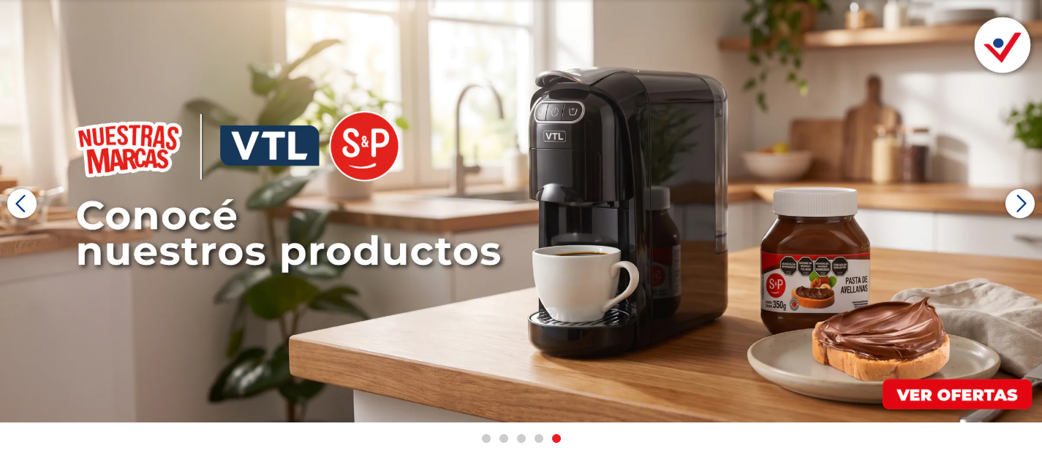
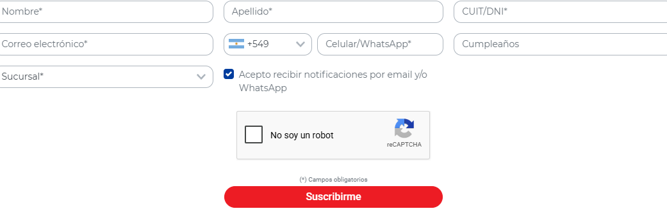
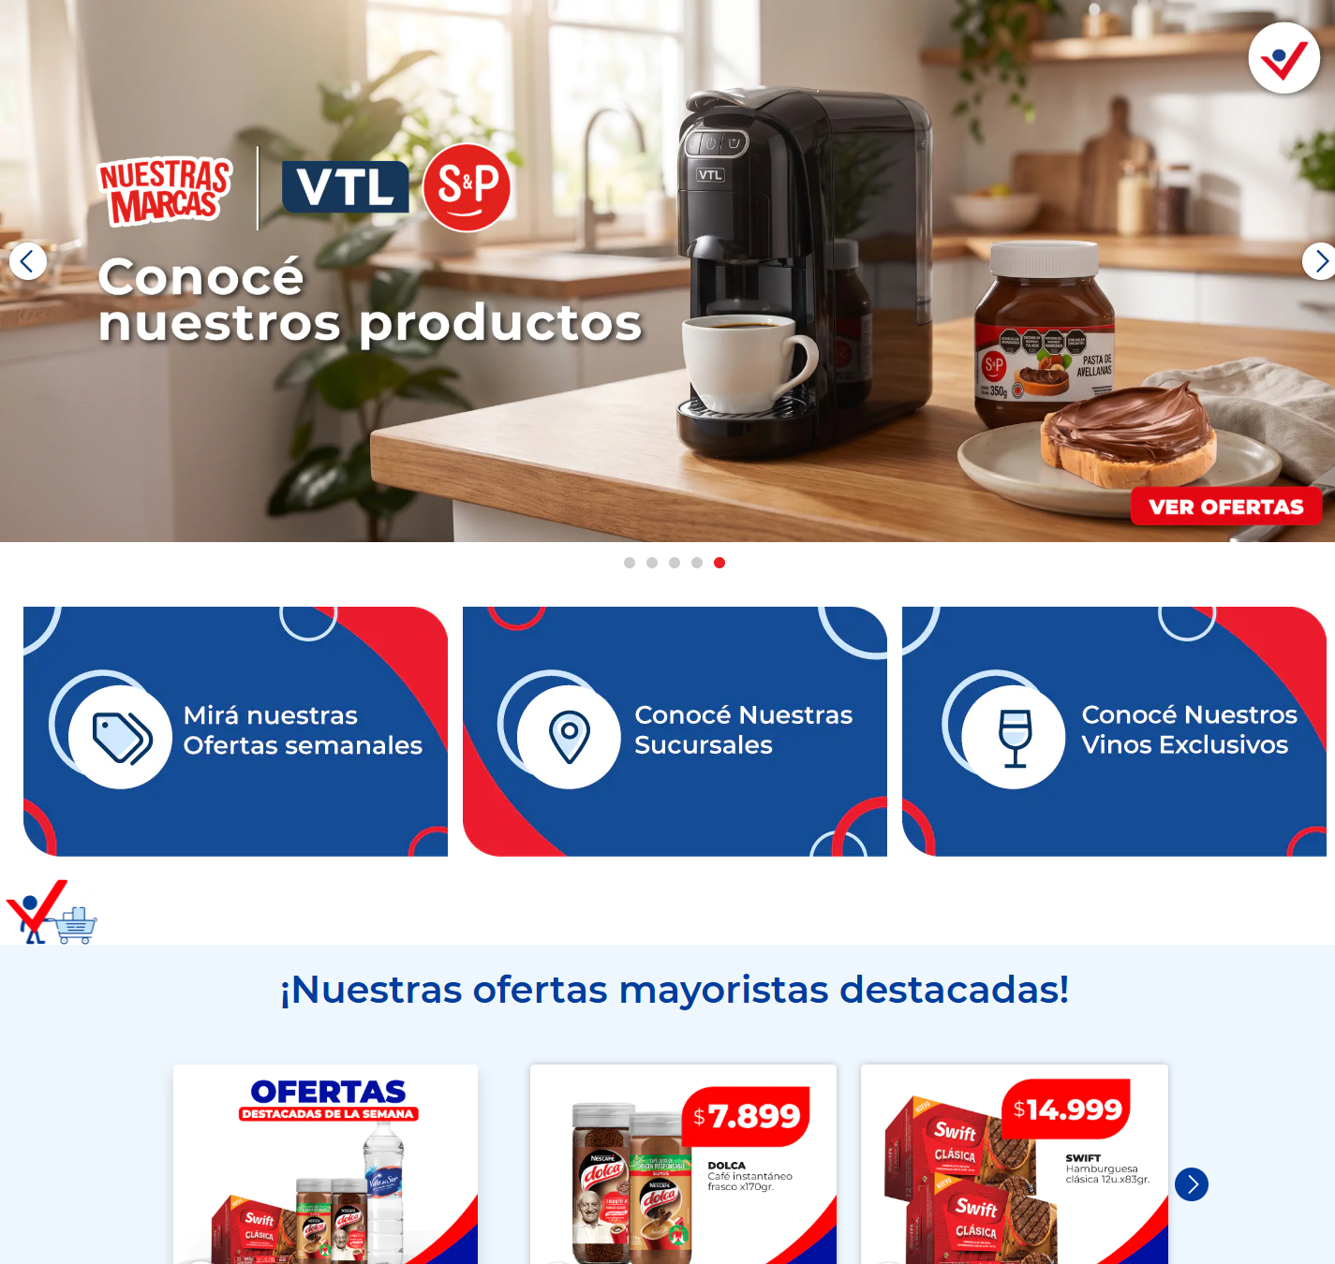









8. Accesibilidad
Métrica | Valor
imágenes sin alt | 0 de 71
imágenes con alt="" (decorativas) | 23
cantidad de h1 | 1
jerarquía h1/h2/h3/h4/h5/h6 | 1 / 2 / 1 / 1 / 1 / 12
saltos de jerarquía | salto h3 → h6 en "¡Ahorrá y disfrutá!" · salto h2 → h5 en "Medios de pago"
elementos con aria-label | 1
inputs sin label asociado | 9 de 11
botones sin nombre accesible | 2
links sin nombre accesible | 11
foco visible removido (outline:none) | 125
tabindex positivo | 0
skip link | no
iframes sin title | 2
tablas sin th | 0
media con autoplay | 0
landmarks | banner, navigation, main, contentinfo
problemas de lang | ninguno

Contraste WCAG AA: 2 combinaciones por debajo del mínimo
Ratio | Mínimo | Color | Fondo | Size | Weight | Elemento | Texto
4.38 | 4.5 | #ffffff | #ed1c24 | 14px | 500 | button#login_button.login-button.btn.btn-primary | Acceso a comerciantes
4.38 | 4.5 | #ffffff | #ed1c24 | 16px | 500 | a.btn.btn-primary.rounded-pill | VER TODOS LOS PRODUCTOS

Inputs sin label (muestra)
Input
input[text] name=first_name ph=Nombre*
input[text] name=last_name ph=Apellido*
input[number] name=00NDn00000aYe5l ph=CUIT/DNI*
input[email] name=email ph=Correo electrónico*
input[text] name=— ph=Prefijo
input[tel] name=— ph=Celular/WhatsApp*
input[text] name=00NUZ000002lKa2 ph=Cumpleaños
select[text] name=00NDn00000dbbLf ph=—
textarea[text] name=g-recaptcha-response ph=—

Outline de encabezados
Nivel | Texto | Visible | font-size
h1 | Supermercado Mayorista Vital | no | 40px
h2 | ¡Nuestras ofertas mayoristas destacadas! | sí | 40px
h3 | ¡Mirá las ofertas de esta semana! | sí | 40px
h6 | ¡Ahorrá y disfrutá! | sí | 12px
h6 | Ofertas de semana | 17.08 al 23.08 | sí | 12px
h6 | Ofertas de semana | 17.08 al 23.08 | sí | 12px
h6 | Ofertas de semana | 17.08 al 23.08 | sí | 12px
h6 | Delicias del mundo | 17.08 al 23.08 | sí | 12px
h6 | Especial de nonfood | 17.08 al 23.08 | sí | 12px
h6 | Especial de frescos | 17.08 al 23.08 | sí | 12px
h6 | Especial nuestras marcas | 17.08 al 23.08 | sí | 12px
h6 | Ofertas fin de semana | 14.08 al 17.08 | sí | 12px
h6 | Ofertas fin de semana | 14.08 al 17.08 | sí | 12px
h6 | Ofertas fin de semana | 14.08 al 17.08 | sí | 12px
h6 | Ofertas fin de semana | 14.08 al 17.08 | sí | 12px
h4 | ¡Conocé nuestras marcas! | sí | 40px
h2 | ¿Querés recibir las ofertas antes que nadie? | sí | 32px
h5 | Medios de pago | sí | 20px

Roles y atributos ARIA en uso
role
role | Usos
button | 1
presentation | 1

atributos aria-*
atributo | Usos
aria-hidden | 2
aria-label | 1

9. Animaciones y efectos
Métrica | Valor
elementos con transition activa | 76
elementos con animation | 2
elementos con transform | 35
elementos con will-change | 0
elementos con filter | 0
elementos con backdrop-filter | 0
@keyframes definidos | 11
soporta prefers-reduced-motion | sí
pistas de animación al scroll | AOS: 25 elementos · Locomotive/data-scroll · clases de reveal/animate: 18 · 3 elementos con opacity:0 inline (pre-reveal)

Propiedades animadas por transition
propiedad | Usos
opacity | 39
transform | 25
border-color | 24
box-shadow | 24
background-color | 15
color | 15
all | 1
visibility | 1

Duraciones de transition
duración | Usos
0.4s | 25
0.15s, 0.15s, 0.15s, 0.15s | 15
0.25s | 12
0.2s | 12
0.15s, 0.15s | 9
0.3s | 1

Easings
timing-function | Usos
ease | 51
ease-in-out | 24
linear | 1

animation-name en uso
animation | Usos
gif_home | 2

Propiedades que cambian en :hover
propiedad | Usos
color | 23
background-color | 14
text-decoration-color | 8
text-decoration-line | 8
text-decoration-style | 8
text-decoration-thickness | 8
border-bottom-color | 7
border-left-color | 7
border-right-color | 7
border-top-color | 7

Muestra de transiciones
Elemento | Propiedad | Duración | Easing | Delay
header.site-header.bg-white.shadow-sm | all | 0.5s | ease | 0s
button#login_button.login-button.btn.btn-primary | color, background-color, border-color, box-shadow | 0.15s, 0.15s, 0.15s, 0.15s | ease-in-out | 0s, 0s, 0s, 0s
select#sucurselect.form-control.custom-select.bg-transparent | border-color, box-shadow | 0.15s, 0.15s | ease-in-out | 0s, 0s
div#home-slider-dots.swiper-pagination.swiper-pagination-clickable.swiper-pagination-bulle | opacity | 0.3s | ease | 0s
div.aos-init.aos-animate | opacity, transform | 0.4s | ease | 0s
div.aos-init.aos-animate | opacity, transform | 0.4s | ease | 0.1s
div.aos-init.aos-animate | opacity, transform | 0.4s | ease | 0.2s
section.home-carrusel-ofertas.bg-blue-100.py-4 | opacity, transform | 0.4s | ease | 0s
section.home-carrusel-nonfood.py-4.mb-4 | opacity, transform | 0.4s | ease | 0s
section.folletos-home.py-4.aos-init | opacity, transform | 0.4s | ease | 0s
figure.flex-column.px-0.aos-init | transform | 0.4s | ease | 0s
div.overlay.d-flex.justify-content-center | opacity | 0.2s | ease | 0s

Muestra de animaciones
Elemento | Nombre | Duración | Iteraciones | Easing | Dirección | Estado
img.img-fluid.lazy.loaded | gif_home | 15s | infinite | linear | normal | running
img.img-fluid.lazy | gif_home | 15s | infinite | linear | normal | running

@keyframes declarados
spin, blink, swiper-preloader-spin, load, gif_home, flip, floating, ring, star-blinker-1, star-blinker-2, comics

10. Responsive
Veredicto: responsive: 3 transición(es) de layout detectadas, sin overflow horizontal
- Breakpoints medidos: 360, 390, 768, 1024, 1280, 1440, 1920
- Breakpoints declarados en CSS: 576, 767, 768, 992, 1200, 1400, 1800
- Hamburguesa (selector conocido) visible en: 360, 390 — umbral ≈ 390px
Ancho | Alto pág. | Vh | Overflow X | Visibles | Ocultos | Burger | Links nav | Header | h1 | body | Container | Cards/fila | Img vis. | Fixed
360 | 10811px | 12.8 | no | 810 | 73 | sí | 10 | 163px | 40px | 16px | 345px | — | 59 | 3
390 | 11429px | 13.5 | no | 810 | 73 | sí | 10 | 163px | 12px | 16px | 375px | — | 59 | 3
768 | 4297px | 4.2 | no | 814 | 69 | no | 5 | 139px | 40px | 16px | 720px | — | 59 | 2
1024 | 4911px | 5.5 | no | 814 | 69 | no | 5 | 101px | 40px | 16px | 960px | — | 59 | 2
1280 | 5411px | 6 | no | 814 | 69 | no | 5 | 101px | 40px | 16px | 1100px | — | 59 | 2
1440 | 5506px | 6.1 | no | 814 | 69 | no | 5 | 101px | 40px | 16px | 1100px | — | 59 | 2
1920 | 5698px | 6.3 | no | 814 | 69 | no | 5 | 101px | 40px | 16px | 1100px | — | 59 | 2
390 (touch) | 7925px | 9.4 | no | 811 | 71 | no | 10 | 163px | 40px | 16px | 390px | — | 49 | 4

Transiciones de layout entre breakpoints
De → a | Cambios detectados
360px → 390px | h1 40px → 12px
390px → 768px | desaparece hamburguesa (menú completo) · links de nav visibles 10 → 5 · h1 12px → 40px · header 163px → 139px · columnas de grid [1] → [3] · alto de página 13.5 → 4.2 viewports
768px → 1024px | header 139px → 101px · alto de página 4.2 → 5.5 viewports

Tap targets chicos en mobile (< 36px)
Ancho | Chicos | Total
360px | 46 | 98
390px | 45 | 98

11. CSS: hojas, media queries y tokens
Campo | Valor
stylesheets | 6
accessible | 5
crossOrigin | 1
totalRules | 3281
styleRules | 2911
mediaRules | 328
keyframeRules | 33
fontFaceRules | 8
supportsRules | 1
importRules | 0
importantCount | 866
customPropertyDeclarations | 67
inlineStyleAttributes | 39
approxCssBytes | 285905

Chequeo | Valor
media queries distintas | 11
breakpoints inferidos | 576, 767, 768, 992, 1200, 1400, 1800
soporta dark mode (prefers-color-scheme) | no
estilos de impresión | sí
queries de hover/pointer | no
selector más largo | div.wpcf7 .wpcf7-form .wpcf7-text:disabled, .custom-form .wpcf7-text:disabled, div.wpcf7 .wpcf7-form .wpcf7-number:disabled, .custom-form .wpcf7-number:disabled

Media queries más usadas
condición | Usos
only screen and (max-width: 767px) | 155
only screen and (min-width: 768px) | 125
(min-width: 576px) | 12
(min-width: 1200px) | 8
(min-width: 992px) | 8
(min-width: 768px) | 7
(prefers-reduced-motion: reduce) | 6
(min-width: 1400px) | 3
only screen and (min-width: 992px) | 2
(min-width: 1800px) | 1
print | 1

Breakpoints por declaración
declaración | Usos
max-width: 767px | 155
min-width: 768px | 132
min-width: 576px | 12
min-width: 992px | 10
min-width: 1200px | 8
min-width: 1400px | 3
min-width: 1800px | 1

@font-face
Familia | Weight | Style | font-display | Formato | Host
Roboto | 400 | normal | swap | woff2, woff | www.vital.com.ar
Roboto | 500 | normal | swap | woff2, woff | www.vital.com.ar
Roboto | 700 | normal | swap | woff2, woff | www.vital.com.ar
Montserrat | 400 | normal | swap | woff2, woff | www.vital.com.ar
Montserrat | 600 | normal | swap | woff2, woff | www.vital.com.ar
Montserrat | 700 | normal | swap | woff2, woff | www.vital.com.ar
Montserrat | 900 | normal | swap | woff2, woff | www.vital.com.ar
swiper-icons | 400 | normal | (no declarado) | woff | —

Hojas de estilo cargadas
Hoja | Host | Reglas | media
(inline &lt;style>) | www.vital.com.ar | 1474 | —
(inline &lt;style>) | www.vital.com.ar | 1 | —
(inline &lt;style>) | www.vital.com.ar | 2 | —
(inline &lt;style>) | www.vital.com.ar | 63 | —
https://www.vital.com.ar/wp-content/cache/minify/d721c.css?x54230 | www.vital.com.ar | 1371 | all
my.site.com/ESWIntegracionChatbotPR1734526289417/assets/styles/bootstrap.min.css | vitalar.my.site.com | (cross-origin) | —

Distribución de profundidad de selectores
niveles
niveles | Usos
1 | 1006
2 | 765
3 | 527
4 | 231
8 | 190
5 | 100
6 | 54
7 | 38

12. Performance y red
Métrica | Valor
TTFB | 323 ms
DNS / TCP / TLS | 128 / 327 / 165 ms
respuesta del documento | 169 ms
DOM interactive | 3772 ms
DOMContentLoaded | 3792 ms
load | 6156 ms
protocolo | http/1.1
first-paint / first-contentful-paint | 1344 / 1344 ms
LCP | —
CLS | 0.1525
HTML decodificado | 382 KB

Recursos (intercepción de red) | Cantidad | KB
document | 5 | 39
stylesheet | 6 | 109
script | 53 | 1899
image | 99 | 3542
font | 7 | 166
fetch | 29 | 0
xhr | 14 | 0
media | 0 | 0
other | 2 | 341
ping | 1 | 0

Total | Valor
requests | 229
peso declarado | 6097 KB
status | 2xx: 203 · 3xx: 14
redirecciones | 14
304 not modified | 0
hosts de terceros | 19
requests fallidos | 25
tiempo total de carga | 10486 ms

Hosts por cantidad de requests
Host | Requests | KB | Tercero
www.vital.com.ar | 118 | 3821 | no
www.google.com | 21 | 0 | sí
vitalar.my.site.com | 17 | 53 | sí
o.clarity.ms | 9 | 0 | sí
analytics.google.com | 8 | 0 | sí
www.gstatic.com | 7 | 1434 | sí
px.ads.linkedin.com | 5 | 0 | sí
www.googletagmanager.com | 2 | 360 | sí
static.hotjar.com | 2 | 0 | sí
snap.licdn.com | 2 | 39 | sí
www.google-analytics.com | 2 | 20 | sí
connect.facebook.net | 2 | 226 | sí
www.youtube.com | 2 | 9 | sí
fonts.gstatic.com | 2 | 78 | sí
c.clarity.ms | 2 | 0 | sí
vitalar.my.salesforce-scrt.com | 2 | 0 | sí
www.clarity.ms | 1 | 1 | sí
ad.doubleclick.net | 1 | 0 | sí
scripts.clarity.ms | 1 | 0 | sí
cdn.inspectlet.com | 1 | 0 | sí

Recursos más lentos
URL | Tipo | ms | KB | Host
https://www.vital.com.ar/wp-content/uploads/2026/08/amba.jpg?x54230 | img | 3186 | 94 | www.vital.com.ar
https://www.vital.com.ar/wp-content/uploads/2026/08/aviso-fds-tronador.jpg?x54230 | img | 3164 | 125 | www.vital.com.ar
com.ar/wp-content/uploads/2026/08/17-23-ago_quilmes-pilar-salta-1-768x1024.jpg?x54230 | img | 3064 | 139 | www.vital.com.ar
https://www.vital.com.ar/wp-content/uploads/2026/08/aviso-fds-talar-mdq.jpg?x54230 | img | 3052 | 125 | www.vital.com.ar
https://www.vital.com.ar/wp-content/uploads/2026/08/aviso-fds-resto-2.jpg?x54230 | img | 3051 | 130 | www.vital.com.ar
https://www.vital.com.ar/wp-content/uploads/2026/08/1-5-768x1024.jpg?x54230 | img | 3008 | 106 | www.vital.com.ar
//www.vital.com.ar/wp-content/uploads/2026/08/Marca-Propia_tapa-1-768x1024.jpg?x54230 | img | 2963 | 82 | www.vital.com.ar
s://www.vital.com.ar/wp-content/uploads/2026/08/17-23-ago_resto-2-768x1024.jpg?x54230 | img | 2870 | 141 | www.vital.com.ar
https://www.vital.com.ar/wp-content/uploads/2026/08/1-4-768x1024.jpg?x54230 | img | 2822 | 90 | www.vital.com.ar
://www.vital.com.ar/wp-content/uploads/2026/08/DELICIAS-DEL-MUNDO-768x1024.jpg?x54230 | img | 2816 | 143 | www.vital.com.ar
/www.vital.com.ar/wp-content/uploads/2026/08/17-23-ago_malvinas-1-768x1024.jpg?x54230 | img | 2699 | 136 | www.vital.com.ar
https://www.vital.com.ar/wp-content/uploads/2026/08/DESTACADOS-FOOD-01-1.jpg?x54230 | img | 2451 | 24 | www.vital.com.ar

Requests fallidos
URL | Tipo | Error
tag_exp=115938466~115938468~118897920~118897930~120385422&tft=1786994951883&tfd=1572&fmt=8 | fetch | net::ERR_ABORTED
t/ccm/s/collect?auid=1614238913.1786994952&gtm=45He68d0v831179693za200zd831179693xea&fmt=8 | fetch | net::ERR_ABORTED
FF5QU5RTktYX1pMYVRna1ZfbkMxcVgxVXR6VWx3YXV2MTNTVmpreTVndWtTdEY5YnFqb3FYegwICWIICAAQABgAIAA | fetch | net::ERR_ABORTED
ital%20-%20El%20mayorista%20de%20tu%20ahorro&en=pageview&fv=2&nsi=1&ss=2&_c=1&tfd=2790 | fetch | net::ERR_ABORTED
elBannerprincipal=0&ep.Departamentoslidehomeprincipal=deliciasdelmundo&et=6&tfd=2814 | fetch | net::ERR_ABORTED
VhlWmIycU9Feld5QkRzLUJmaEQ4d0xhM2pmZU16bF94VGJGOGRBMV9PVWttUlFqQUpNakJGegwICWIICAAQABgAIAA | fetch | net::ERR_ABORTED
0pKLXZfNTJTVm44eUc5emJrRkxmR2RydXlxWlUteF8tZzROZDVWcUg2cHk5bmlhUGRaZlR5egwICWIICAAQABgAIAA | fetch | net::ERR_ABORTED
TBuc2oxMl9jNG9BcEUxY3JqUFptcU01TmxzbjA2MVNJLTJfaDN0N0I3dnlWLUM0N0U2MFYzegwICWIICAAQABgAIAA | fetch | net::ERR_ABORTED
https://px.ads.linkedin.com/wa/?medium=fetch&fmt=g | fetch | net::ERR_ABORTED
https://7s-d309b5b93ece4e188e0aa4e9c7906f0f.ecs.us-west-1.on.aws/events?cee=no | fetch | net::ERR_ABORTED
ciondelBannerprincipal=1&ep.Departamentoslidehomeprincipal=frescos&_et=3547&tfd=6375 | fetch | net::ERR_ABORTED
UhTUkV3b1pMQXp5ekZodWJaNXJJMG9RZkd4N3RFUnVFcjhmSzdSdFJNb3gxbHNCcHIzZVpregwICWIICAAQABgAIAA | fetch | net::ERR_ABORTED
ciondelBannerprincipal=2&ep.Departamentoslidehomeprincipal=nonfood&_et=3337&tfd=9729 | fetch | net::ERR_ABORTED
UtzMFZzdXN0TzRvUjI1QTk3UmNxWHdacF9abE0yMGwxRkh3RkR4NU9NZzlRTVlWS1BJSlg1egwICWIICAAQABgAIAA | fetch | net::ERR_ABORTED
iondelBannerprincipal=3&ep.Departamentoslidehomeprincipal=almacen&_et=2536&tfd=13053 | fetch | net::ERR_ABORTED
com.ar%2F&dt=Supermayorista%20Vital%20-%20El%20mayorista%20de%20tu%20ahorro&_s=5&tfd=13053 | fetch | net::ERR_ABORTED
0JWT056anAtT3JNa3pDeDVzajJDNmF0Q2lhb0ZheXY2dWF3YXl4aGhWQVNjSG1UUDdQSy1HegwICWIICAAQABgAIAA | fetch | net::ERR_ABORTED
https://www.vital.com.ar/wp-content/uploads/2024/09/medios-de-pago_efectivo.png?x54230 | image | net::ERR_ABORTED
https://www.vital.com.ar/wp-content/uploads/2024/09/medios-de-pago_modo.png?x54230 | image | net::ERR_ABORTED
https://www.vital.com.ar/wp-content/uploads/2020/10/mercadopago-150x150.png?x54230 | image | net::ERR_ABORTED
https://www.vital.com.ar/wp-content/uploads/2020/10/visa-150x150.png?x54230 | image | net::ERR_ABORTED
https://www.vital.com.ar/wp-content/uploads/2020/10/mastercard-150x150.png?x54230 | image | net::ERR_ABORTED
ww.vital.com.ar/wp-content/uploads/2024/09/medios-de-pago_modo-cuenta-dni-dolar.png?x54230 | image | net::ERR_ABORTED
https://www.vital.com.ar/wp-content/uploads/2024/09/medios-de-pago_cuenta-dni.png?x54230 | image | net::ERR_ABORTED
https://www.vital.com.ar/wp-content/uploads/2020/10/americanexpress-150x150.png?x54230 | image | net::ERR_ABORTED

13. Lighthouse (con throttling)
Perfil desktop · Lighthouse 12.8.2 · 2026-08-17T19:35:54.088Z
Categoría | Puntaje
performance | 44/100
accessibility | 88/100
best-practices | 52/100
seo | 92/100

Métrica | Valor | Puntaje
Largest Contentful Paint | 5.3 s | 7
First Contentful Paint | 0.7 s | 96
Cumulative Layout Shift | 0.504 | 16
Total Blocking Time | 130 ms | 93
Speed Index | 3.9 s | 11
Time to Interactive | 5.4 s | 34
Initial server response time was short | Root document took 320 ms | 100
Avoid enormous network payloads | Total size was 5,287 KiB | 50
Avoids an excessive DOM size | 766 elements | 100

Oportunidades de mejora que reporta Lighthouse
Auditoría | Ahorro estimado
Reduce unused JavaScript | 520 ms · 701 KB
Initial server response time was short | 217 ms
Eliminate render-blocking resources | 154 ms
Properly size images | 100 ms · 1126 KB
Reduce unused CSS | 10 ms · 24 KB
Enable text compression | 23 KB

Auditorías de accesibilidad falladas (4)
Auditoría | Elementos
Background and foreground colors do not have a sufficient contrast ratio. | 4
Heading elements are not in a sequentially-descending order | 2
Links do not have a discernible name | 11
Select elements do not have associated label elements. | 1

14. Páginas adicionales

14.1 Contacto / sucursales — https://www.vital.com.ar/contactos/
Campo | Valor
title | Contacto - Supermayorista Vital
h1 | 1 (jerarquía 1/1/0)
HTTP / carga | 200 · 11564 ms
elementos / nodos DOM | 355 / 417
alto de página | 1228px (1.4 viewports)
secciones de primer nivel | 2
componentes | 8 botones · 1 cards · 1 forms · 27 inputs · 17 imágenes
accesibilidad | 0 img sin alt · 13/15 inputs sin label · 4 fallos de contraste
responsive | responsive: 2 transición(es) de layout detectadas, sin overflow horizontal
requests / peso | 126 · 6372 KB
LCP / CLS | — / 0.1484
overlays al entrar | 0

Capturas: desktop · mobile · 360px 390px 768px 1024px 1280px 1440px 1920px
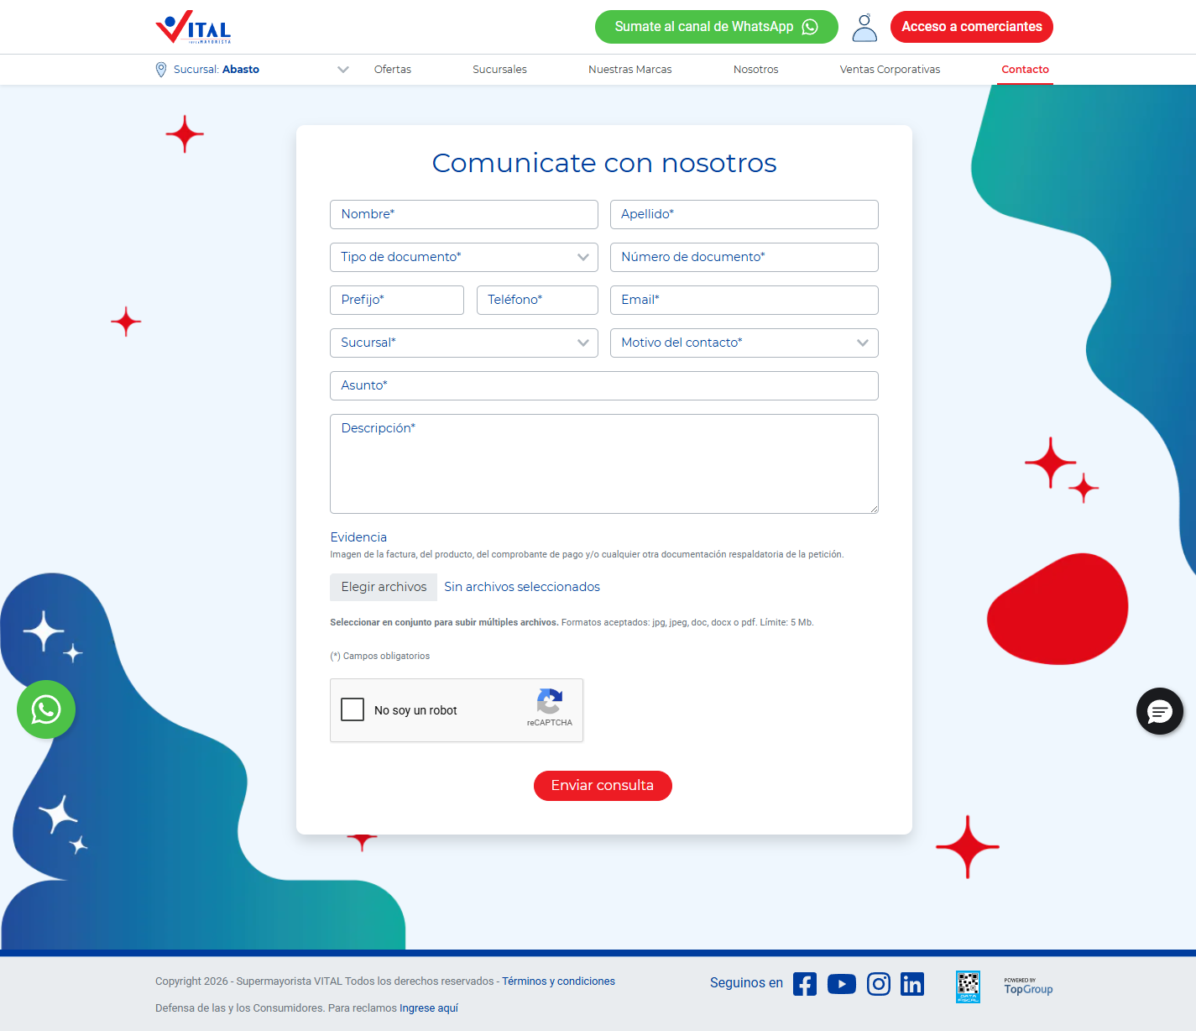
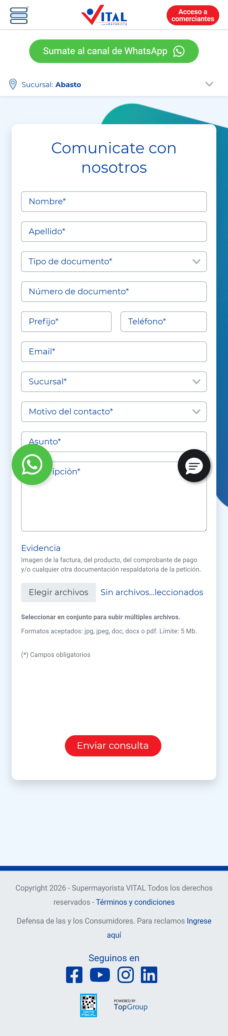
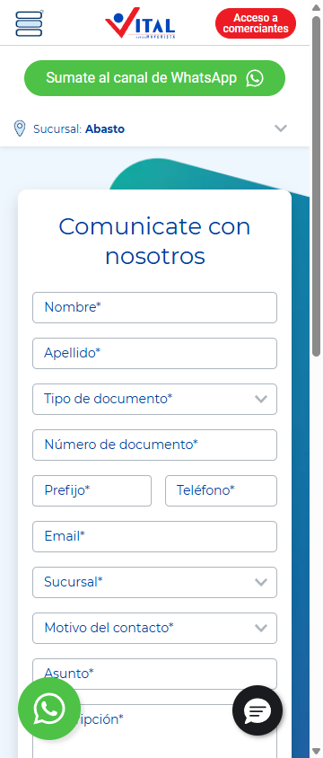
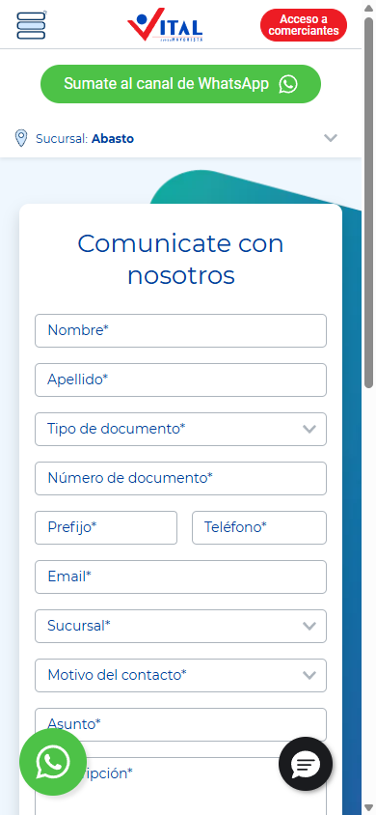
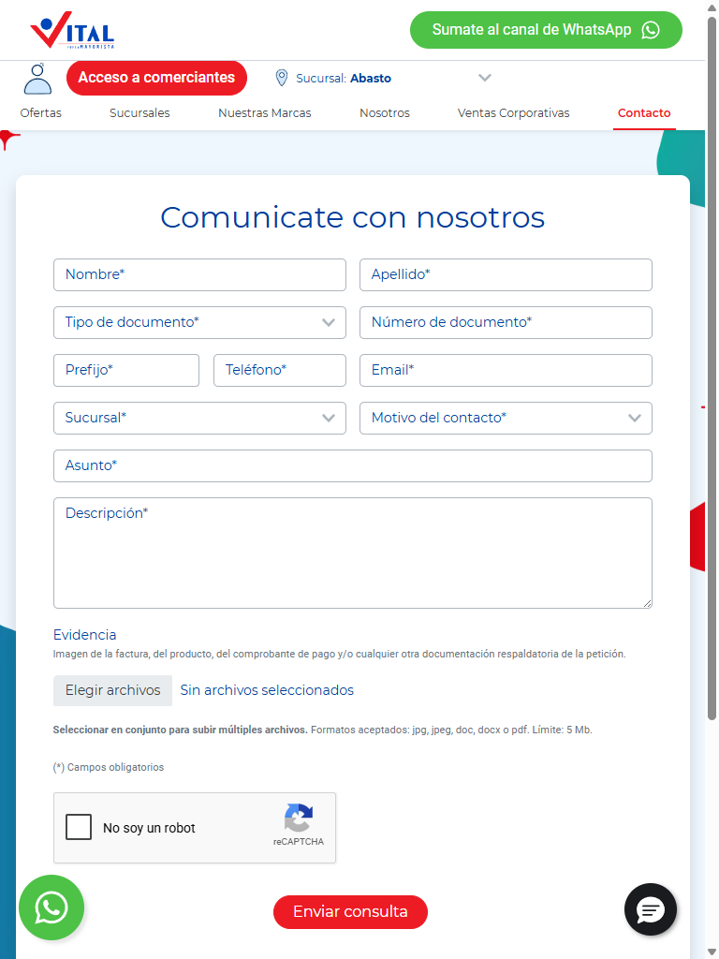
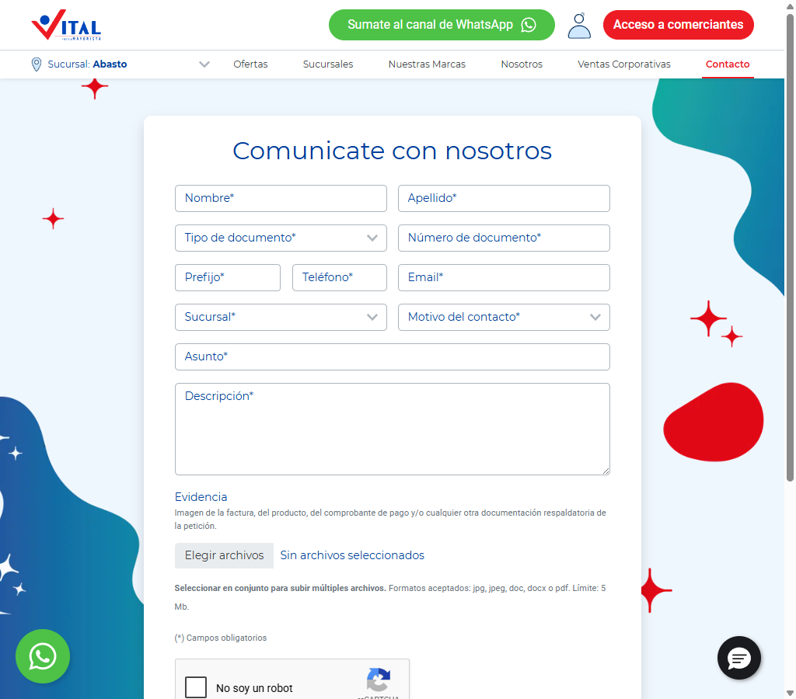
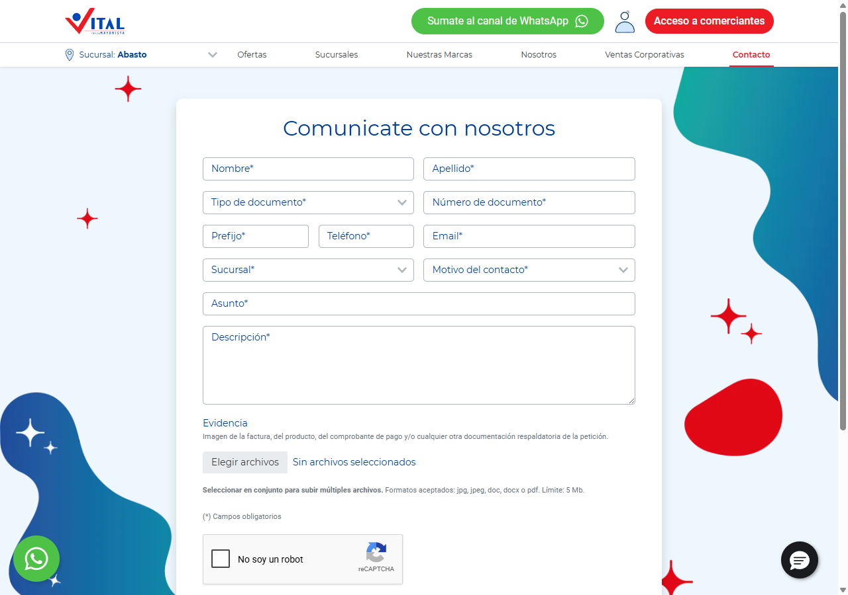
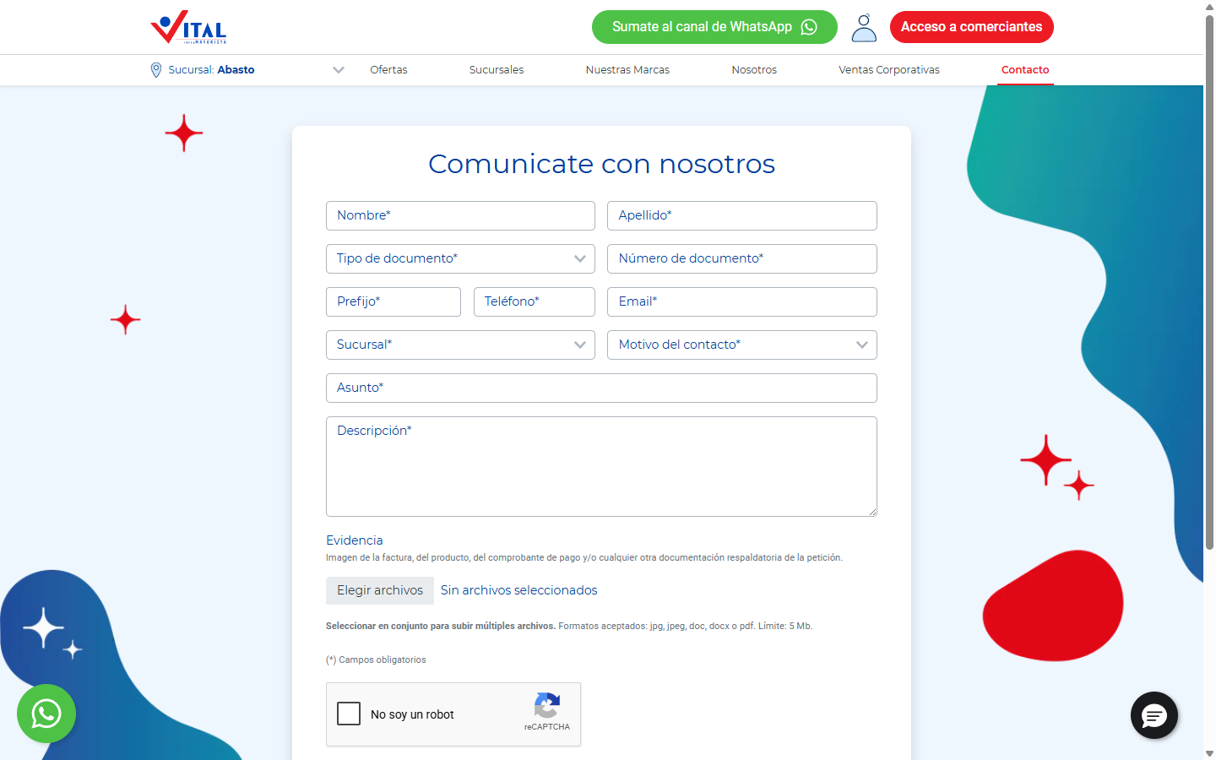
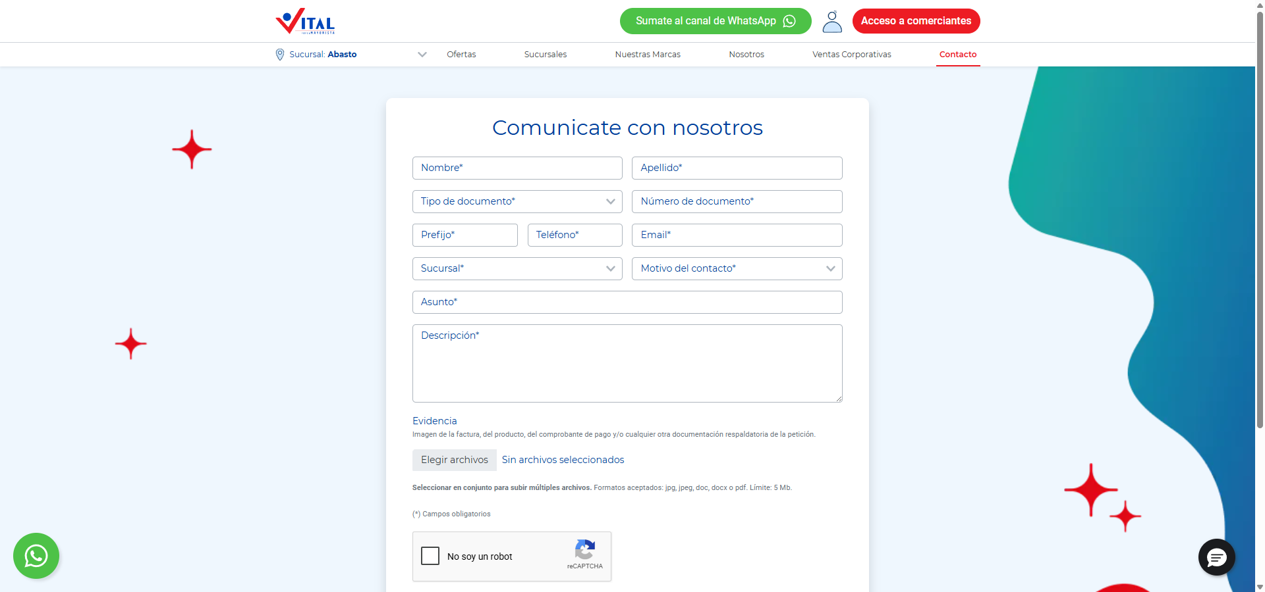
Estructura de la página
# | Elemento | Encabezado | Alto | display | Cols | Img | Links | Btn | Items
1 | div.bg-white.py-4.px-md-5 | Comunicate con nosotros | 845px | block | — | 9 | 0 | 2 | 9
2 | div.col-md-6.col-lg-auto.m-3 | — | 73px | block | — | 1 | 1 | 0 | 0

Formularios
- POST → https://webto.salesforce.com/servlet/servlet.WebToCase?encoding=UTF-8 · submit "Enviar consulta" · campos: captcha_settings, orgid, retURL, recordType, fuente, 00NUZ0000006HEH, 00NUZ000000Xmib, 00NUZ000000Xmic, 00NDn00000I9DRy, 00NDn00000CYdnc, company, 00NUZ000001GFnJ, phone, phoneShown, email, 00NDn00000CYJBG, 00NDn00000CYe8p, 00NDn00000I82us, subject, descripcion-visible, archivo, archivo-id, archivo-url, archivo-folder, description

Traza del análisis de Contacto / sucursales
1055ms navegando (networkidle, 60s)
11564ms cargado HTTP 200 → https://www.vital.com.ar/contactos/
11565ms scroll completo (lazy-load + animaciones de scroll)
12851ms extrayendo: meta y SEO
13572ms extrayendo: stack tecnológico
13604ms extrayendo: tipografía, paleta y espaciado
13685ms extrayendo: estructura y layout
13699ms extrayendo: inventario de componentes
13759ms extrayendo: accesibilidad
13775ms extrayendo: animaciones
13790ms extrayendo: CSSOM y media queries
13931ms extrayendo: performance timing
13945ms recortando 15 componentes y zonas
17778ms recortes guardados: 15/15
17958ms screenshot desktop 1440 fullPage
18837ms probando breakpoint 360x844
19832ms probando breakpoint 390x844
20681ms probando breakpoint 768x1024
21484ms probando breakpoint 1024x900
22304ms probando breakpoint 1280x900
23179ms probando breakpoint 1440x900
24015ms probando breakpoint 1920x900
24871ms contexto mobile 390x844 (touch) + screenshot fullPage

14.2 Institucional — https://www.vital.com.ar/empresas/
Campo | Valor
title | La Empresa - Supermayorista Vital
h1 | 0 (jerarquía 0/4/4)
HTTP / carga | 200 · 8789 ms
elementos / nodos DOM | 371 / 441
alto de página | 2049px (2.3 viewports)
secciones de primer nivel | 7
componentes | 6 botones · 0 cards · 1 forms · 21 inputs · 29 imágenes
accesibilidad | 0 img sin alt · 9/11 inputs sin label · 3 fallos de contraste
responsive | responsive: 2 transición(es) de layout detectadas, sin overflow horizontal
requests / peso | 137 · 2636 KB
LCP / CLS | — / 0.1674
overlays al entrar | 0

Capturas: desktop · mobile · 360px 390px 768px 1024px 1280px 1440px 1920px
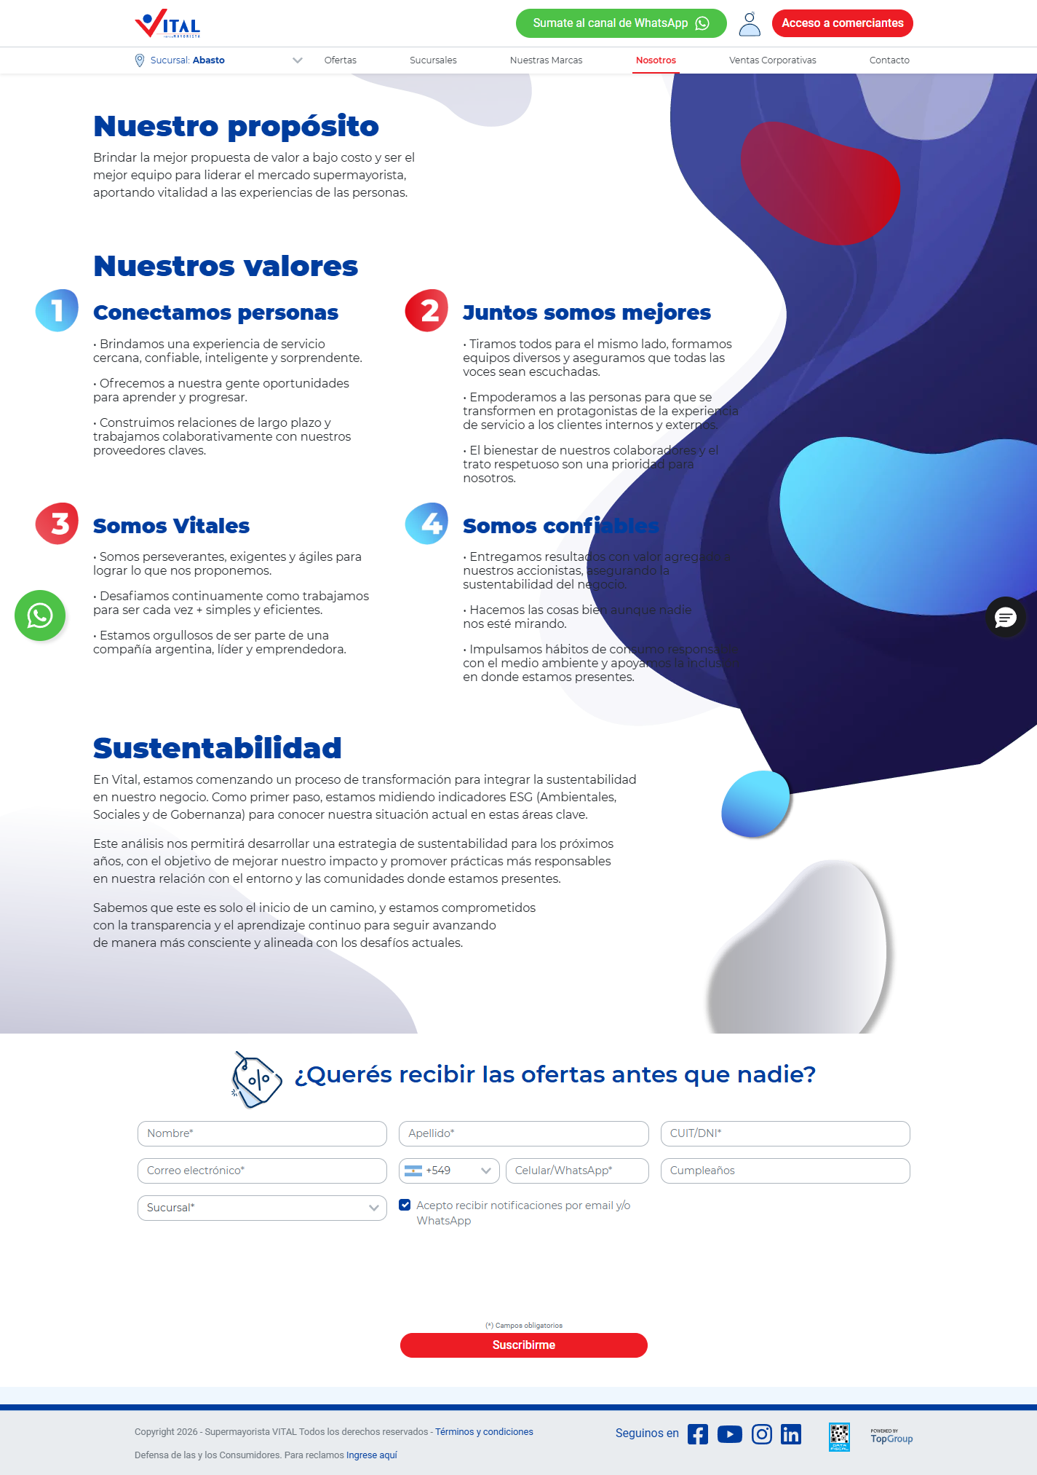
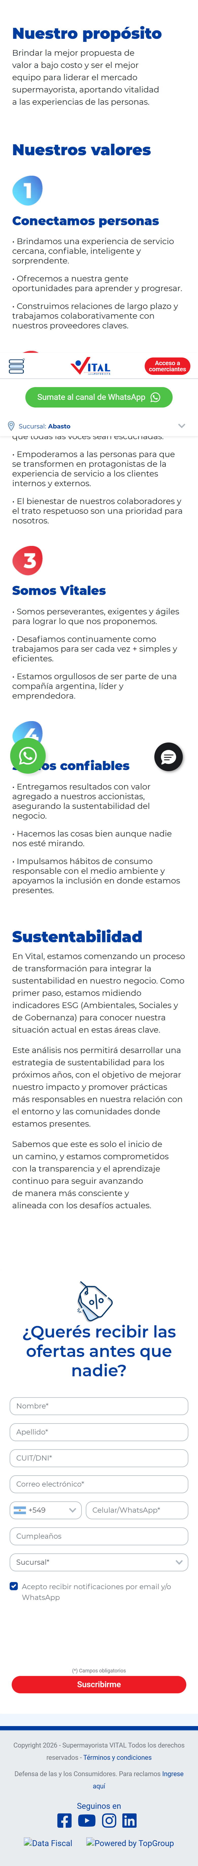


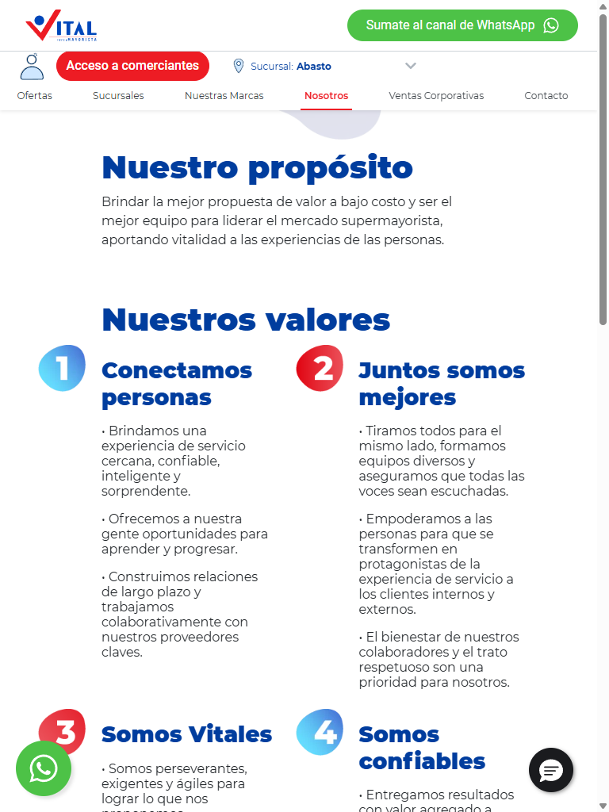
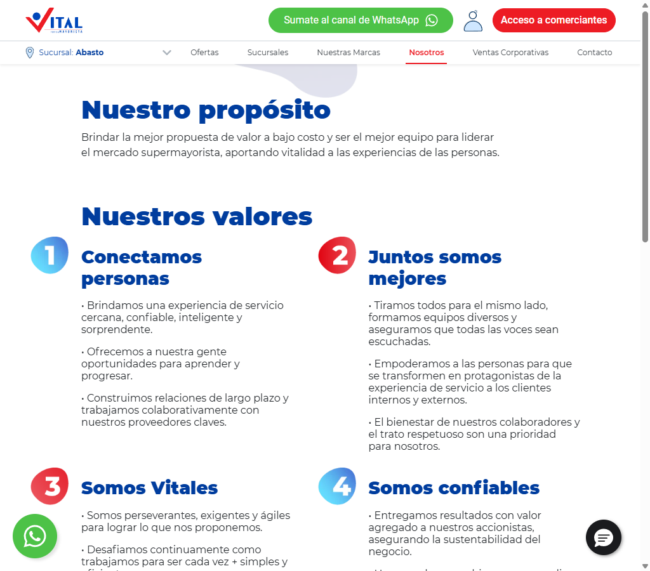
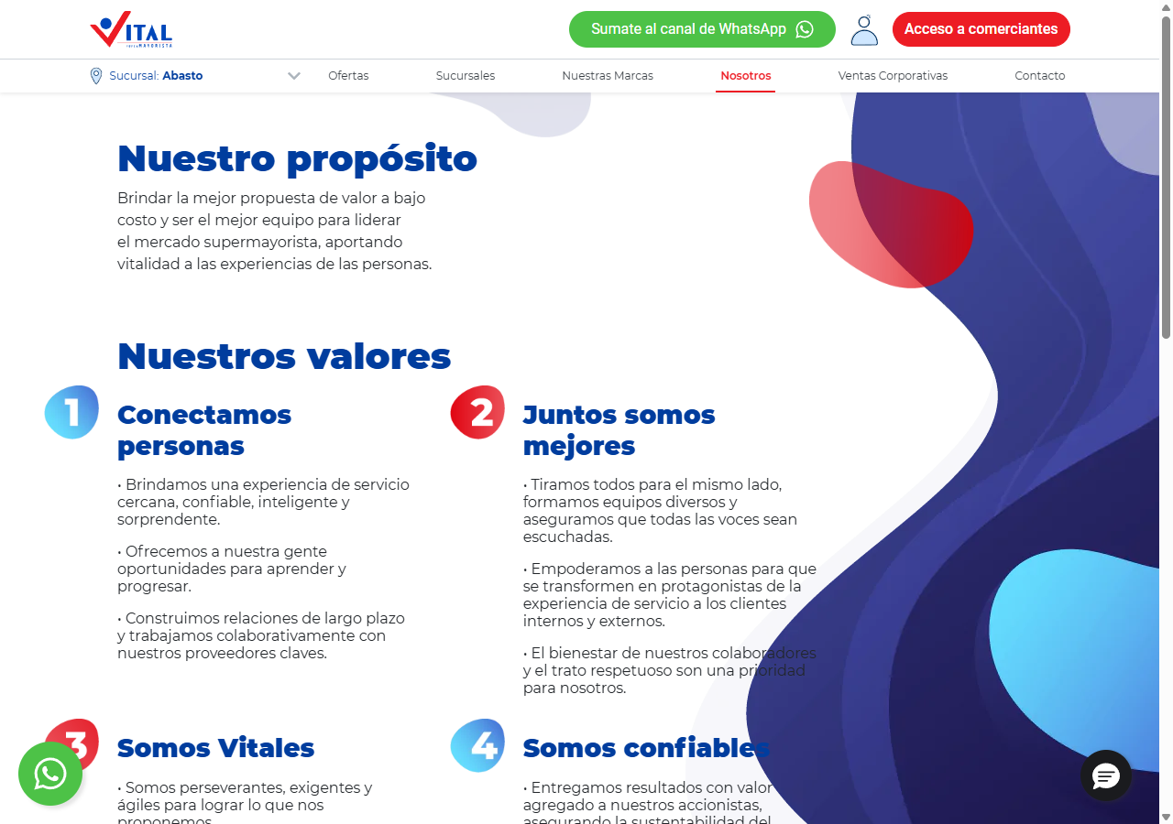
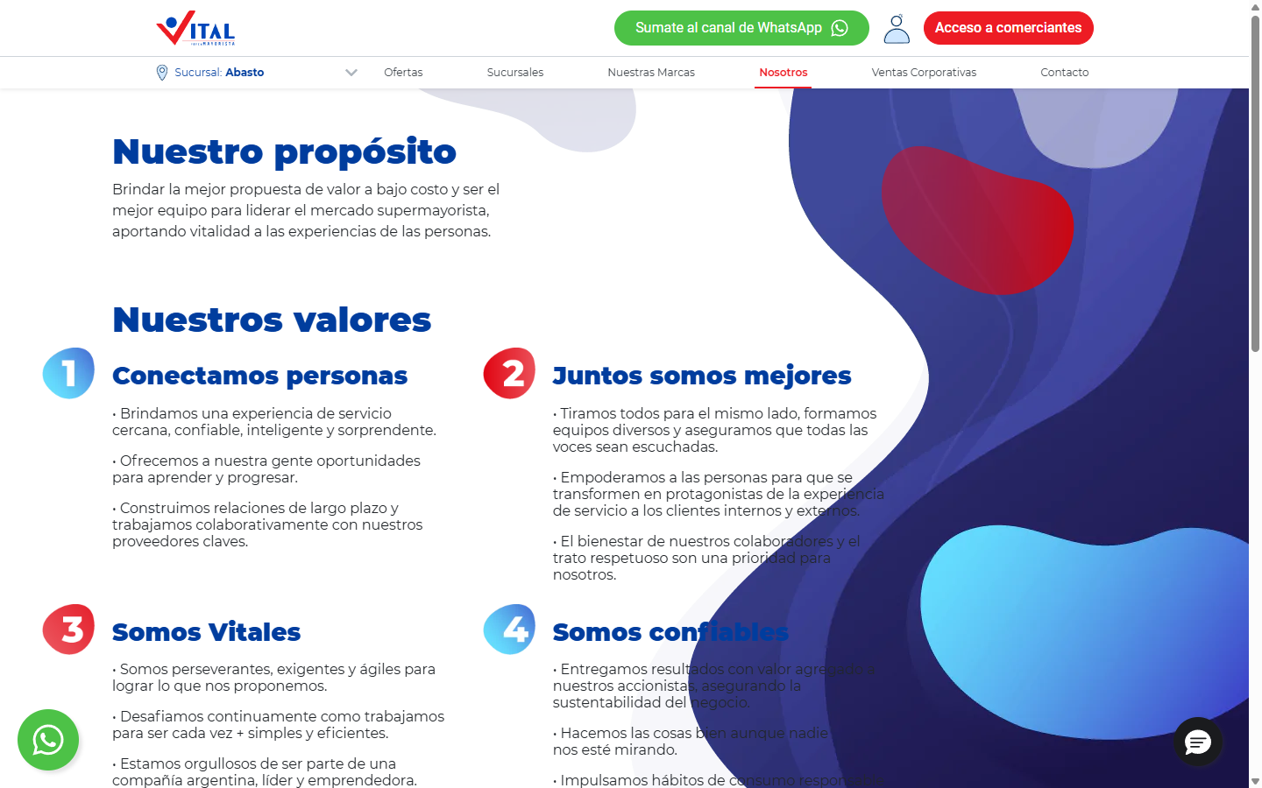
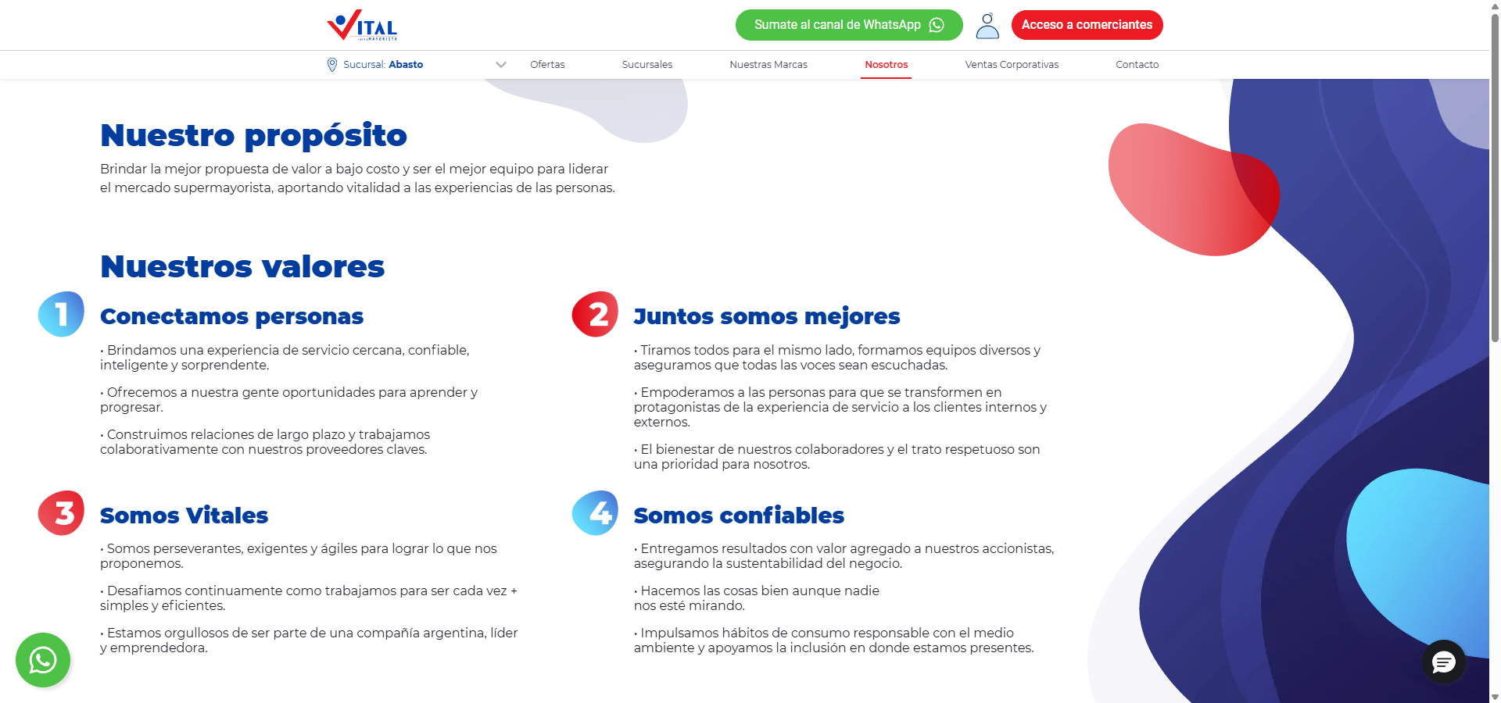
Estructura de la página
# | Elemento | Encabezado | Alto | display | Cols | Img | Links | Btn | Items
1 | img.img-fluid | — | 1199px | inline | — | 0 | 0 | 0 | 0
2 | img.img-fluid | — | 580px | inline | — | 0 | 0 | 0 | 0
3 | img.img-fluid | — | 139px | inline | — | 0 | 0 | 0 | 0
4 | img.img-fluid | — | 170px | inline | — | 0 | 0 | 0 | 0
5 | img.img-fluid | — | 101px | inline | — | 0 | 0 | 0 | 0
6 | img.img-fluid | — | 310px | inline | — | 0 | 0 | 0 | 0
7 | div.container-fluid | Nuestro propósito | 1174px | block | — | 4 | 0 | 0 | 12

Formularios
- POST → https://webto.salesforce.com/servlet/servlet.WebToLead?encoding=UTF-8&orgId=00DDn000002Ey8t · submit "Suscribirme" · campos: captchasettings, oid, retURL, recordType, CampaignID, leadsource, firstname, lastname, 00NDn00000aYe5l, email, text, 00NUZ000001U20b, newsletterTelefono, mobile, 00NUZ000002lKa2, 00NDn00000dbbLf, newsletterNotificationscheckbox, 00NUZ000004RcIE, 00NUZ000009iS1q, g-recaptcha-response

Traza del análisis de Institucional
381ms navegando (networkidle, 60s)
8789ms cargado HTTP 200 → https://www.vital.com.ar/empresas/
8789ms scroll completo (lazy-load + animaciones de scroll)
10093ms extrayendo: meta y SEO
10109ms extrayendo: stack tecnológico
10130ms extrayendo: tipografía, paleta y espaciado
10167ms extrayendo: estructura y layout
10187ms extrayendo: inventario de componentes
10216ms extrayendo: accesibilidad
10230ms extrayendo: animaciones
10256ms extrayendo: CSSOM y media queries
10302ms extrayendo: performance timing
10320ms recortando 13 componentes y zonas
12823ms recortes guardados: 13/13
13420ms screenshot desktop 1440 fullPage
13788ms probando breakpoint 360x844
14632ms probando breakpoint 390x844
15433ms probando breakpoint 768x1024
16477ms probando breakpoint 1024x900
17321ms probando breakpoint 1280x900
21493ms probando breakpoint 1440x900
30389ms probando breakpoint 1920x900
32952ms contexto mobile 390x844 (touch) + screenshot fullPage

14.3 Ayuda / legales — https://www.vital.com.ar/ayudaresvital/
Campo | Valor
title | Landing Bahia Blanca - Supermayorista Vital
h1 | 0 (jerarquía 0/1/1)
HTTP / carga | 200 · 9884 ms
elementos / nodos DOM | 205 / 261
alto de página | 1310px (1.5 viewports)
secciones de primer nivel | 1
componentes | 6 botones · 3 cards · 0 forms · 1 inputs · 9 imágenes
accesibilidad | 0 img sin alt · 0/1 inputs sin label · 2 fallos de contraste
responsive | responsive: 2 transición(es) de layout detectadas, sin overflow horizontal
requests / peso | 103 · 1561 KB
LCP / CLS | — / 0.4189
overlays al entrar | 0

Capturas: desktop · mobile · 360px 390px 768px 1024px 1280px 1440px 1920px
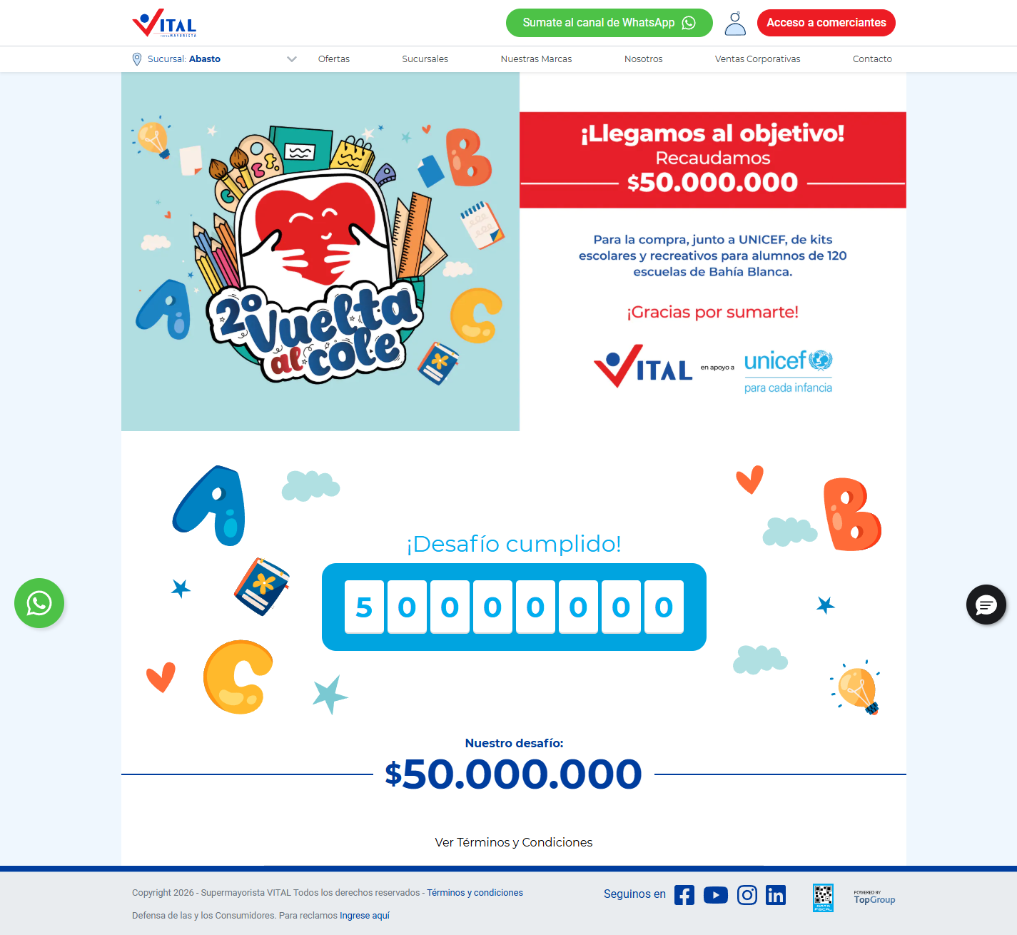



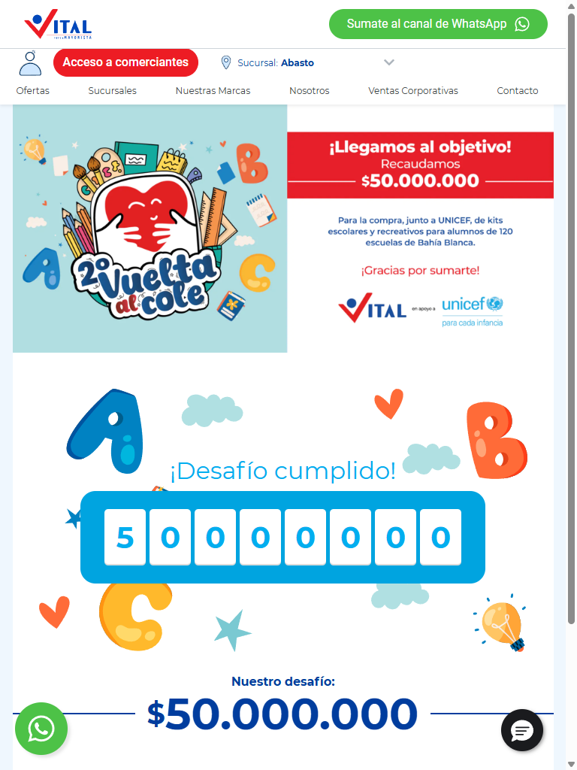
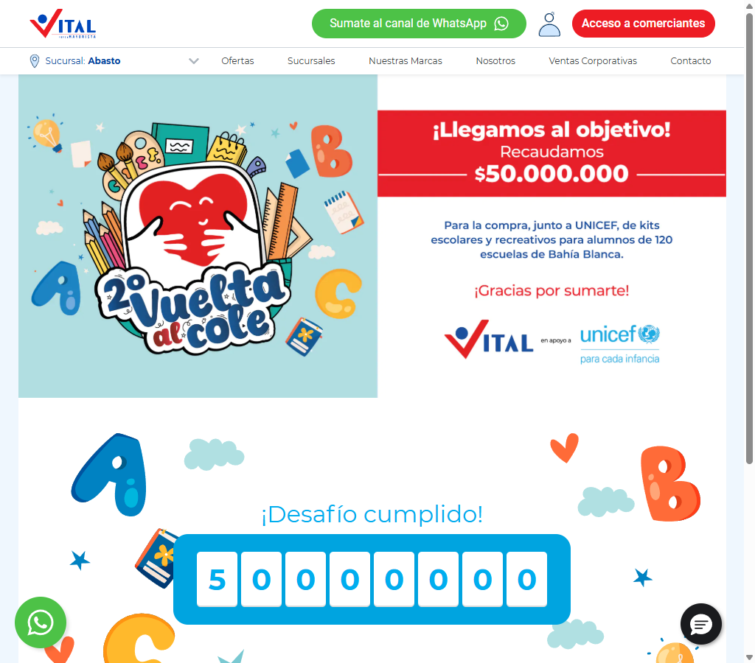
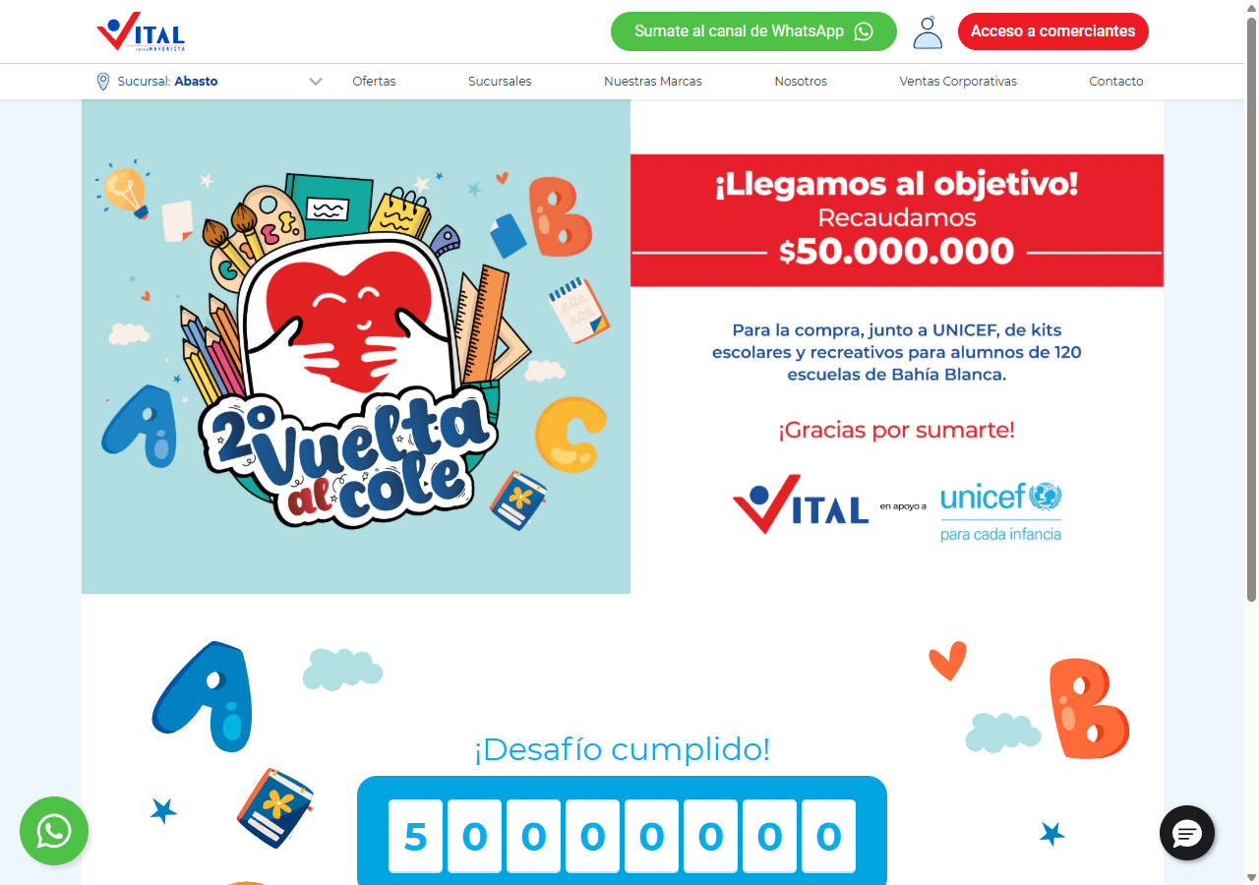
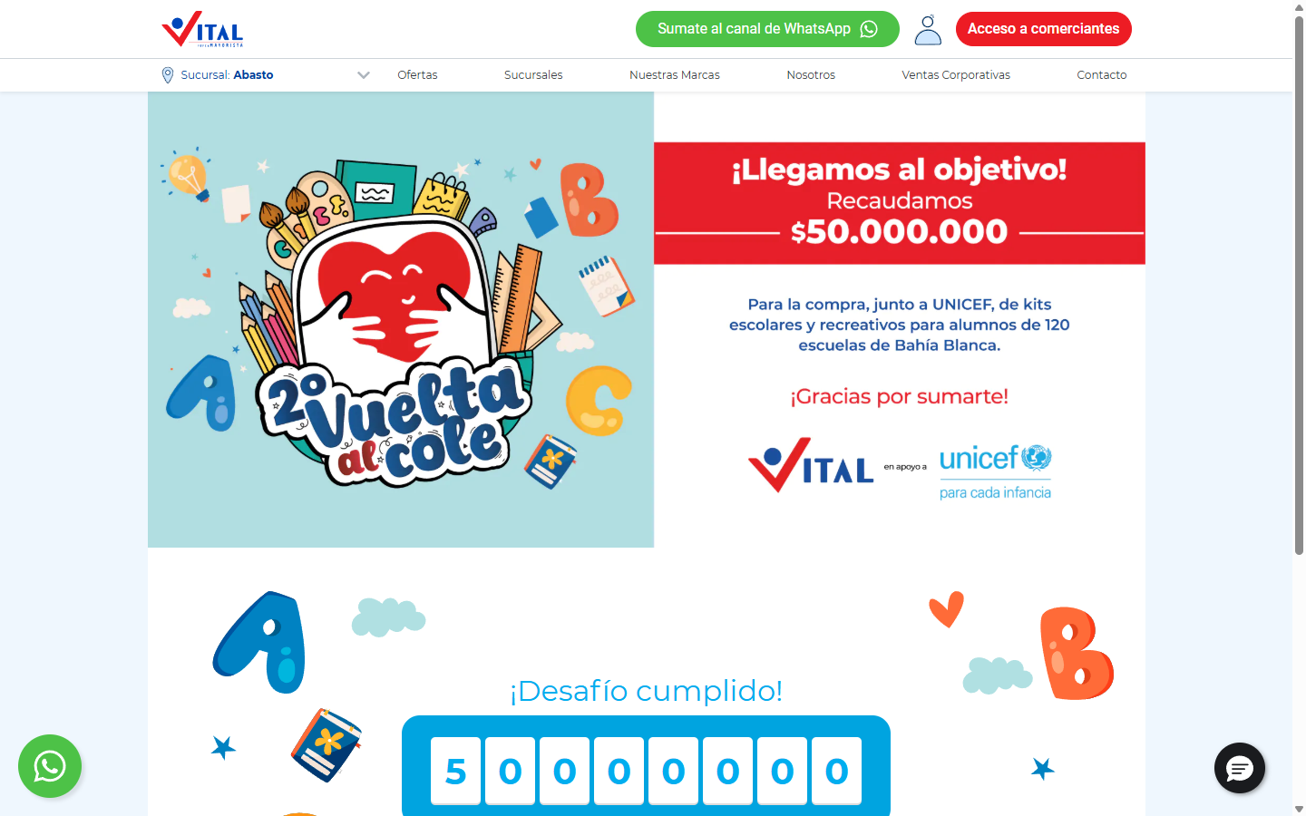
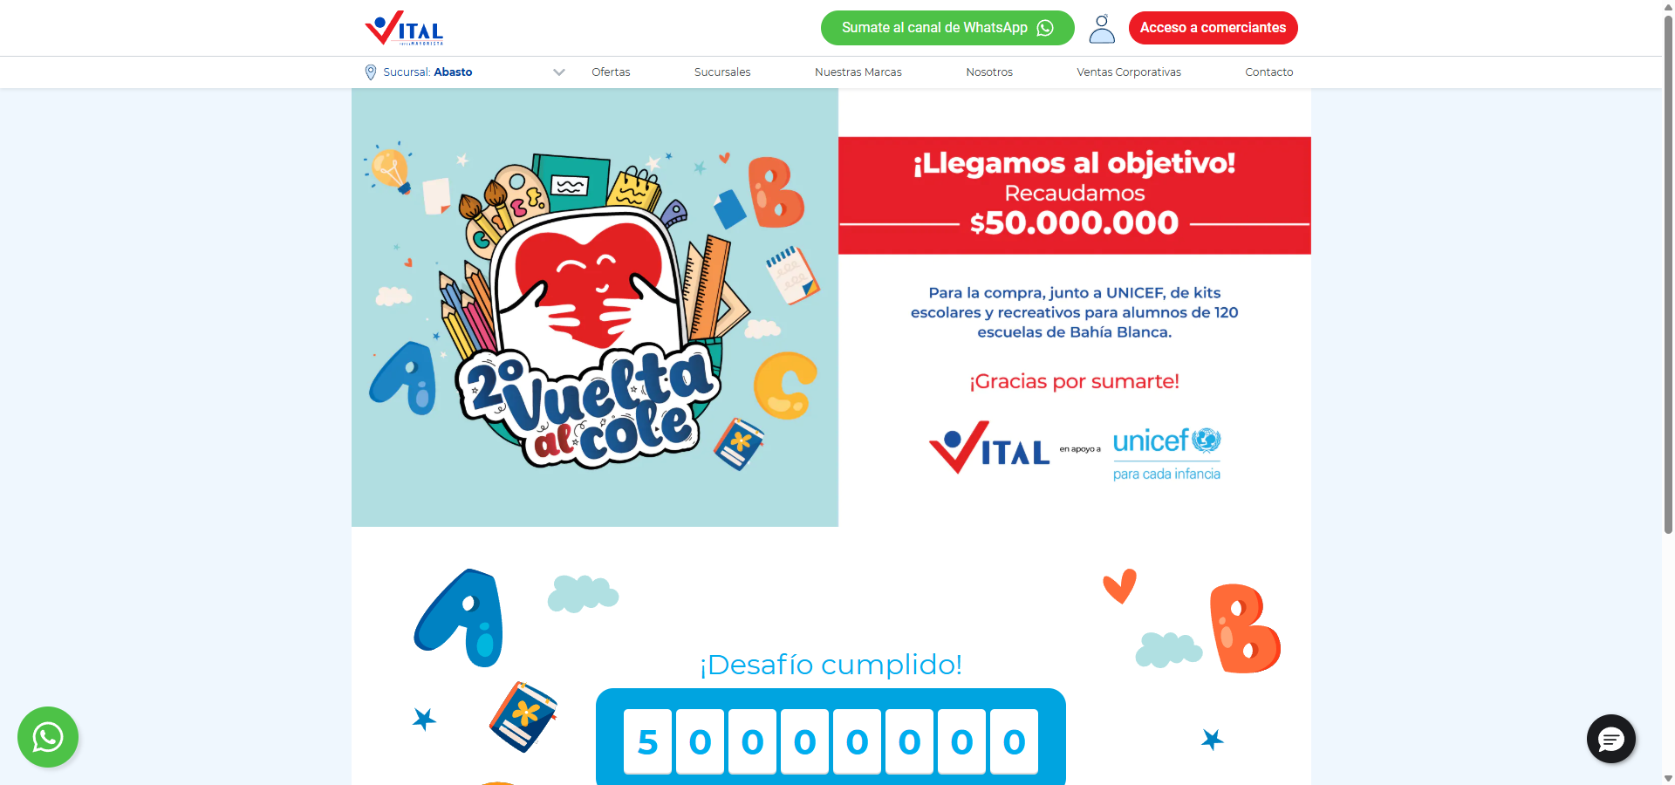
Estructura de la página
# | Elemento | Encabezado | Alto | display | Cols | Img | Links | Btn | Items
1 | div.container.bg-white.px-0 | ¡Desafío cumplido! | 1112px | block | — | 1 | 0 | 1 | 3

Traza del análisis de Ayuda / legales
371ms navegando (networkidle, 60s)
9884ms cargado HTTP 200 → https://www.vital.com.ar/ayudaresvital/
9884ms scroll completo (lazy-load + animaciones de scroll)
11071ms extrayendo: meta y SEO
11117ms extrayendo: stack tecnológico
11130ms extrayendo: tipografía, paleta y espaciado
11200ms extrayendo: estructura y layout
11247ms extrayendo: inventario de componentes
11280ms extrayendo: accesibilidad
11292ms extrayendo: animaciones
11305ms extrayendo: CSSOM y media queries
11349ms extrayendo: performance timing
11357ms recortando 9 componentes y zonas
14114ms recortes guardados: 9/9
14427ms screenshot desktop 1440 fullPage
14643ms probando breakpoint 360x844
15638ms probando breakpoint 390x844
16548ms probando breakpoint 768x1024
17388ms probando breakpoint 1024x900
18608ms probando breakpoint 1280x900
19961ms probando breakpoint 1440x900
20873ms probando breakpoint 1920x900
21759ms contexto mobile 390x844 (touch) + screenshot fullPage

14.4 Página interna — https://www.vital.com.ar/obras/s_t/
Campo | Valor
title | Sin título - Supermayorista Vital
h1 | 1 (jerarquía 1/1/2)
HTTP / carga | 200 · 7815 ms
elementos / nodos DOM | 341 / 498
alto de página | 900px (1 viewports)
secciones de primer nivel | 1
componentes | 7 botones · 1 cards · 1 forms · 21 inputs · 20 imágenes
accesibilidad | 0 img sin alt · 9/11 inputs sin label · 0 fallos de contraste
responsive | el layout no cambia entre breakpoints: probablemente no sea responsive (o sea fluido sin media queries)
requests / peso | 121 · 2564 KB
LCP / CLS | — / 0.0274
overlays al entrar | 0

Capturas: desktop · mobile · 360px 390px 768px 1024px 1280px 1440px 1920px
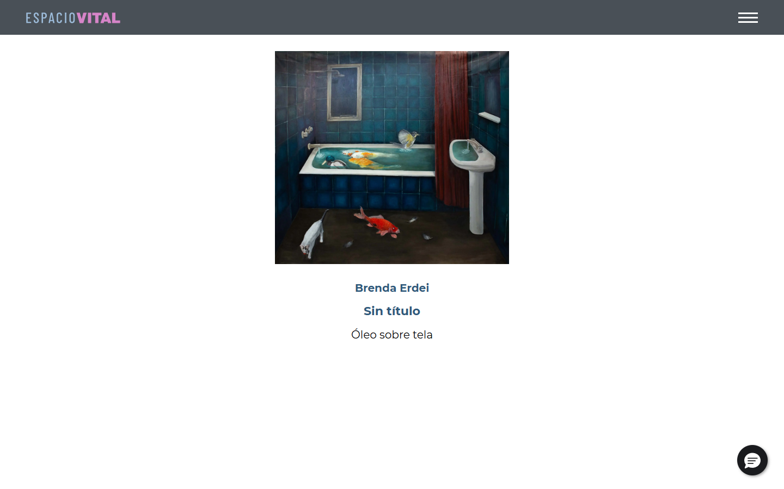
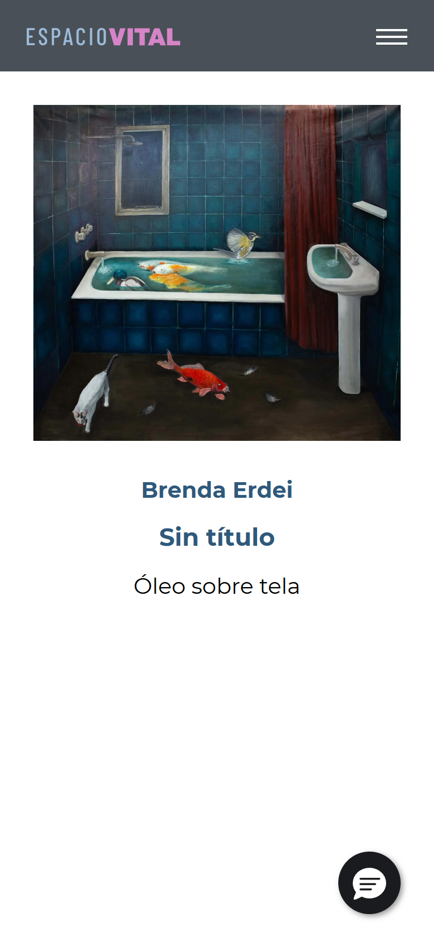
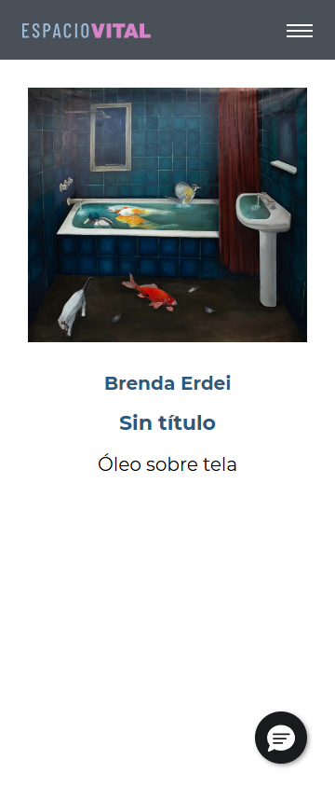
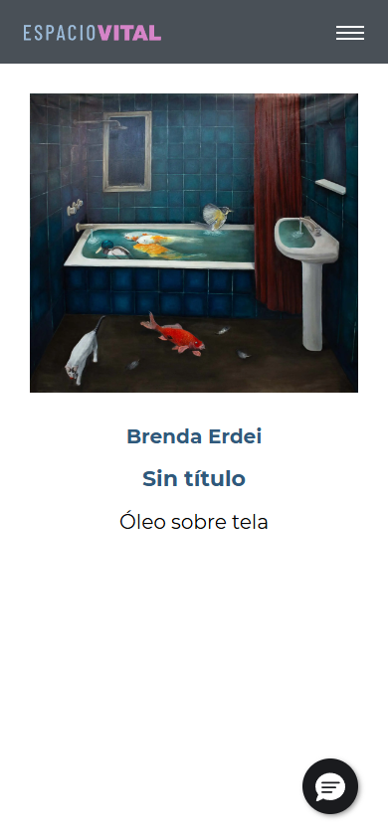
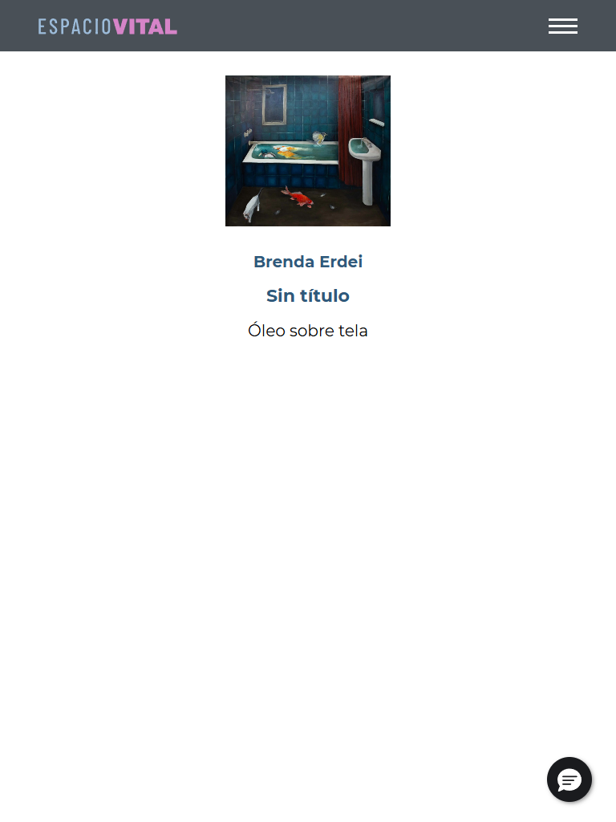
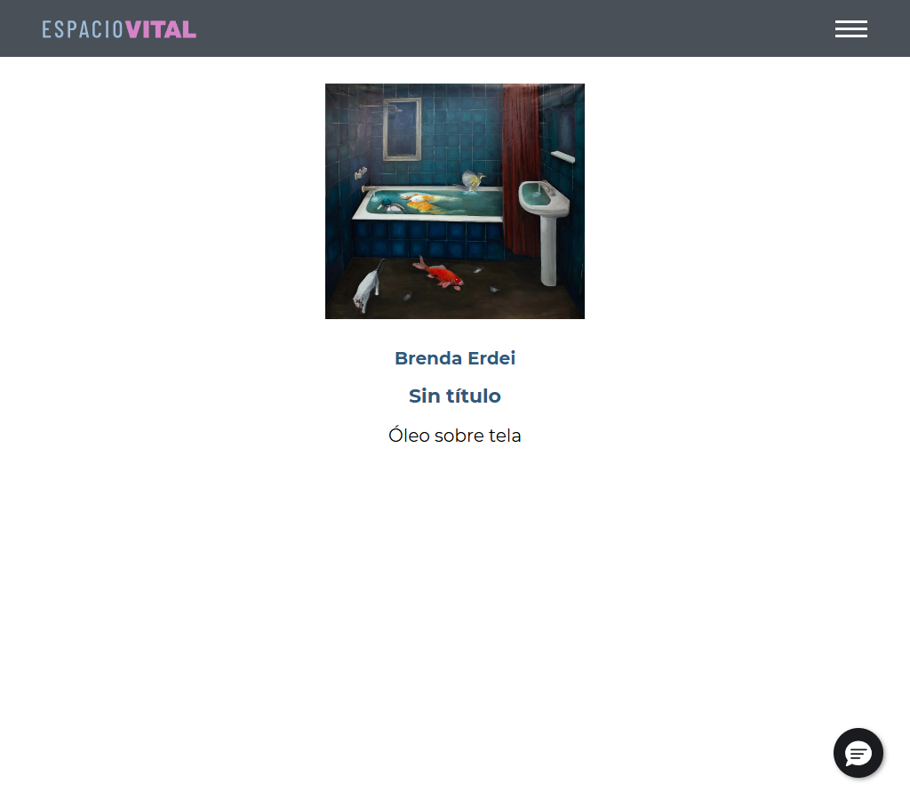
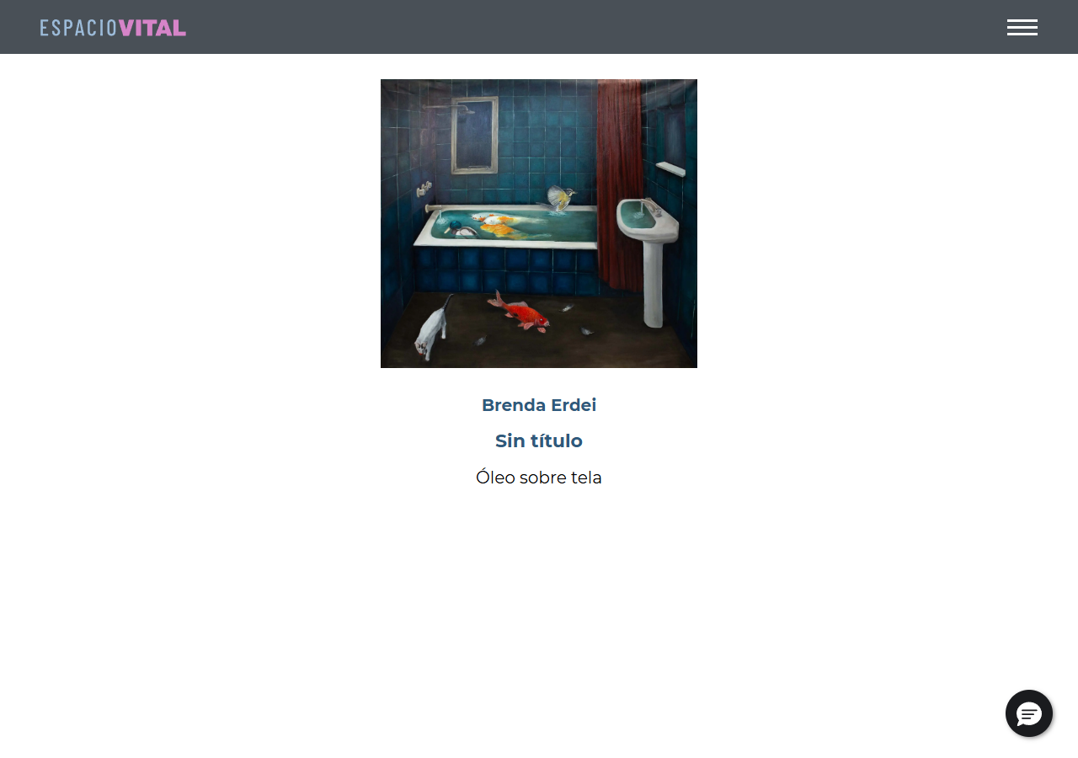
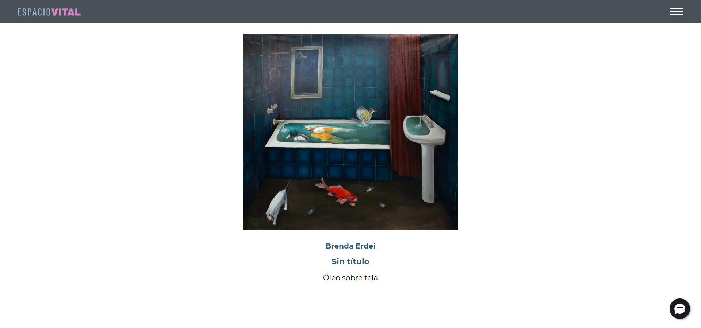
Estructura de la página
# | Elemento | Encabezado | Alto | display | Cols | Img | Links | Btn | Items
1 | div.obra-container.d-flex.flex-column | Brenda Erdei | 558px | flex | 4 | 1 | 0 | 0 | 0

Formularios
- POST → https://webto.salesforce.com/servlet/servlet.WebToLead?encoding=UTF-8&orgId=00DDn000002Ey8t · submit "Suscribirme" · campos: captchasettings, oid, retURL, recordType, CampaignID, leadsource, firstname, lastname, 00NDn00000aYe5l, email, text, 00NUZ000001U20b, newsletterTelefono, mobile, 00NUZ000002lKa2, 00NDn00000dbbLf, newsletterNotificationscheckbox, 00NUZ000004RcIE, 00NUZ000009iS1q, g-recaptcha-response

Traza del análisis de Página interna
406ms navegando (networkidle, 60s)
7815ms cargado HTTP 200 → https://www.vital.com.ar/obras/s_t/
7816ms scroll completo (lazy-load + animaciones de scroll)
8969ms extrayendo: meta y SEO
8975ms extrayendo: stack tecnológico
8990ms extrayendo: tipografía, paleta y espaciado
9035ms extrayendo: estructura y layout
9045ms extrayendo: inventario de componentes
9075ms extrayendo: accesibilidad
9086ms extrayendo: animaciones
9105ms extrayendo: CSSOM y media queries
9142ms extrayendo: performance timing
9149ms recortando 4 componentes y zonas
9887ms recortes guardados: 3/4
9889ms screenshot desktop 1440 fullPage
10118ms probando breakpoint 360x844
11392ms probando breakpoint 390x844
12178ms probando breakpoint 768x1024
12980ms probando breakpoint 1024x900
13826ms probando breakpoint 1280x900
14734ms probando breakpoint 1440x900
15900ms probando breakpoint 1920x900
17296ms contexto mobile 390x844 (touch) + screenshot fullPage

14.5 Página — https://www.vital.com.ar/ofertas/
Campo | Valor
title | Ofertas - Supermayorista Vital
h1 | 1 (jerarquía 1/2/0)
HTTP / carga | 200 · 10660 ms
elementos / nodos DOM | 594 / 651
alto de página | 2846px (3.2 viewports)
secciones de primer nivel | 2
componentes | 15 botones · 0 cards · 1 forms · 21 inputs · 38 imágenes
accesibilidad | 0 img sin alt · 9/11 inputs sin label · 3 fallos de contraste
responsive | responsive: 2 transición(es) de layout detectadas, sin overflow horizontal
requests / peso | 141 · 3537 KB
LCP / CLS | — / 0.1939
overlays al entrar | 0

Capturas: desktop · mobile · 360px 390px 768px 1024px 1280px 1440px 1920px


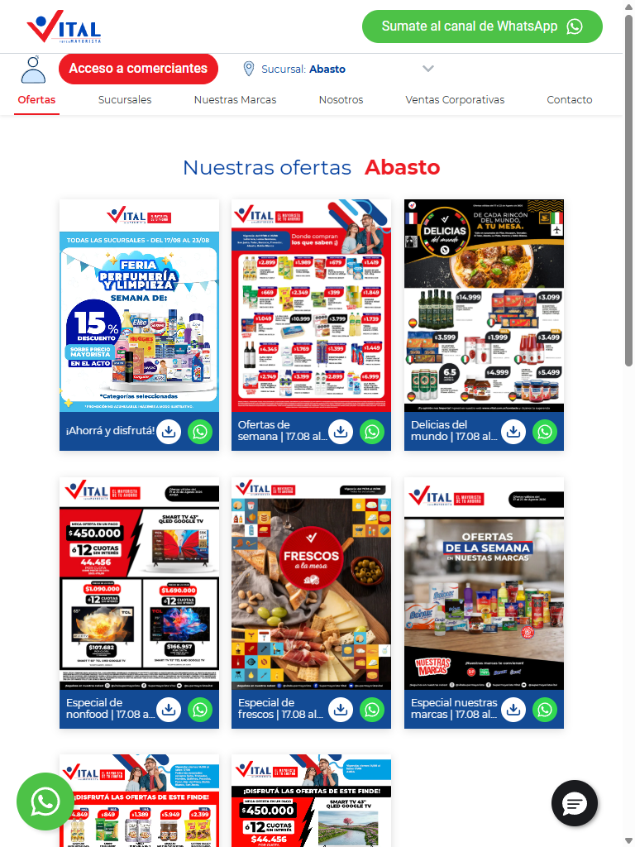
Estructura de la página
# | Elemento | Encabezado | Alto | display | Cols | Img | Links | Btn | Items
1 | div.container | Nuestras ofertas Abasto | 1616px | block | — | 11 | 25 | 8 | 2
2 | div.swiper-wrapper | — | 278px | flex | 4 | 4 | 4 | 0 | 0

Formularios
- POST → https://webto.salesforce.com/servlet/servlet.WebToLead?encoding=UTF-8&orgId=00DDn000002Ey8t · submit "Suscribirme" · campos: captchasettings, oid, retURL, recordType, CampaignID, leadsource, firstname, lastname, 00NDn00000aYe5l, email, text, 00NUZ000001U20b, newsletterTelefono, mobile, 00NUZ000002lKa2, 00NDn00000dbbLf, newsletterNotificationscheckbox, 00NUZ000004RcIE, 00NUZ000009iS1q, g-recaptcha-response

Traza del análisis de Página
413ms navegando (networkidle, 60s)
10660ms cargado HTTP 200 → https://www.vital.com.ar/ofertas/
10661ms scroll completo (lazy-load + animaciones de scroll)
12216ms extrayendo: meta y SEO
12223ms extrayendo: stack tecnológico
12258ms extrayendo: tipografía, paleta y espaciado
12312ms extrayendo: estructura y layout
12327ms extrayendo: inventario de componentes
12369ms extrayendo: accesibilidad
12377ms extrayendo: animaciones
12395ms extrayendo: CSSOM y media queries
12439ms extrayendo: performance timing
12456ms recortando 15 componentes y zonas
17867ms recortes guardados: 15/15
18594ms screenshot desktop 1440 fullPage
20483ms probando breakpoint 360x844
21482ms probando breakpoint 390x844
22288ms probando breakpoint 768x1024
23269ms probando breakpoint 1024x900
24285ms probando breakpoint 1280x900
25344ms probando breakpoint 1440x900
26416ms probando breakpoint 1920x900
30968ms contexto mobile 390x844 (touch) + screenshot fullPage

14.6 Contacto / sucursales — https://www.vital.com.ar/sucursales/
Campo | Valor
title | Sucursales - Supermayorista Vital
h1 | 1 (jerarquía 1/1/1)
HTTP / carga | 200 · 7763 ms
elementos / nodos DOM | 747 / 804
alto de página | 2211px (2.5 viewports)
secciones de primer nivel | 2
componentes | 18 botones · 17 cards · 1 forms · 21 inputs · 63 imágenes
accesibilidad | 0 img sin alt · 9/11 inputs sin label · 4 fallos de contraste
responsive | responsive: 2 transición(es) de layout detectadas, sin overflow horizontal
requests / peso | 152 · 3694 KB
LCP / CLS | — / 0.1477
overlays al entrar | 0

Capturas: desktop · mobile · 360px 390px 768px 1024px 1280px 1440px 1920px


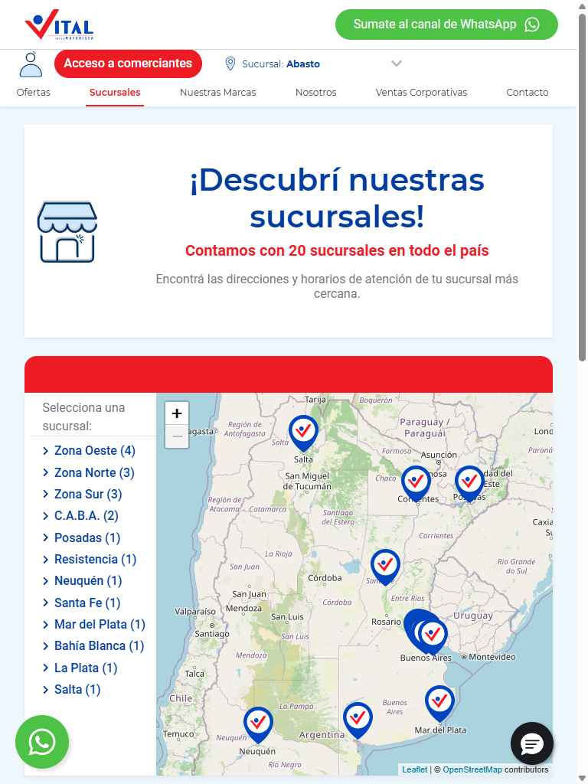
Estructura de la página
# | Elemento | Encabezado | Alto | display | Cols | Img | Links | Btn | Items
1 | div.container | ¡Descubrí nuestras sucursales! | 783px | block | — | 36 | 24 | 3 | 32
2 | div.swiper-wrapper | — | 548px | flex | 8 | 8 | 24 | 8 | 0

Formularios
- POST → https://webto.salesforce.com/servlet/servlet.WebToLead?encoding=UTF-8&orgId=00DDn000002Ey8t · submit "Suscribirme" · campos: captchasettings, oid, retURL, recordType, CampaignID, leadsource, firstname, lastname, 00NDn00000aYe5l, email, text, 00NUZ000001U20b, newsletterTelefono, mobile, 00NUZ000002lKa2, 00NDn00000dbbLf, newsletterNotificationscheckbox, 00NUZ000004RcIE, 00NUZ000009iS1q, g-recaptcha-response

Traza del análisis de Contacto / sucursales
278ms navegando (networkidle, 60s)
7763ms cargado HTTP 200 → https://www.vital.com.ar/sucursales/
7763ms scroll completo (lazy-load + animaciones de scroll)
9326ms extrayendo: meta y SEO
9333ms extrayendo: stack tecnológico
9357ms extrayendo: tipografía, paleta y espaciado
9422ms extrayendo: estructura y layout
9441ms extrayendo: inventario de componentes
9481ms extrayendo: accesibilidad
9492ms extrayendo: animaciones
9510ms extrayendo: CSSOM y media queries
9546ms extrayendo: performance timing
9556ms recortando 18 componentes y zonas
17155ms recortes guardados: 17/18
17672ms screenshot desktop 1440 fullPage
19945ms probando breakpoint 360x844
21300ms probando breakpoint 390x844
22094ms probando breakpoint 768x1024
26077ms probando breakpoint 1024x900
27371ms probando breakpoint 1280x900
28326ms probando breakpoint 1440x900
29467ms probando breakpoint 1920x900
30548ms contexto mobile 390x844 (touch) + screenshot fullPage

14.7 Ayuda / legales — https://www.vital.com.ar/terminos-condiciones
Campo | Valor
title | Términos y Condiciones - Supermayorista Vital
h1 | 1 (jerarquía 1/1/0)
HTTP / carga | 200 · 10027 ms
elementos / nodos DOM | 330 / 387
alto de página | 3363px (3.7 viewports)
secciones de primer nivel | 29
componentes | 6 botones · 0 cards · 1 forms · 21 inputs · 19 imágenes
accesibilidad | 0 img sin alt · 9/11 inputs sin label · 2 fallos de contraste
responsive | responsive: 2 transición(es) de layout detectadas, sin overflow horizontal
requests / peso | 125 · 2577 KB
LCP / CLS | — / 0.1488
overlays al entrar | 0

Capturas: desktop · mobile · 360px 390px 768px 1024px 1280px 1440px 1920px
Estructura de la página
# | Elemento | Encabezado | Alto | display | Cols | Img | Links | Btn | Items
1 | h1.my-3 | — | 48px | block | — | 0 | 0 | 0 | 0
2 | strong | — | 91px | inline | — | 0 | 0 | 0 | 0
3 | p.wp-block-paragraph | — | 120px | block | — | 0 | 0 | 0 | 0
4 | p.wp-block-paragraph | — | 96px | block | — | 0 | 0 | 0 | 0
5 | p.wp-block-paragraph | — | 96px | block | — | 0 | 0 | 0 | 0
6 | p.wp-block-paragraph | — | 48px | block | — | 0 | 0 | 0 | 0
7 | p.wp-block-paragraph | — | 48px | block | — | 0 | 0 | 0 | 0
8 | p.wp-block-paragraph | — | 72px | block | — | 0 | 0 | 0 | 0
9 | p.wp-block-paragraph | — | 96px | block | — | 0 | 0 | 0 | 0
10 | p.wp-block-paragraph | — | 96px | block | — | 0 | 0 | 0 | 0
11 | p.wp-block-paragraph | — | 48px | block | — | 0 | 0 | 0 | 0
12 | p.wp-block-paragraph | — | 120px | block | — | 0 | 0 | 0 | 0
13 | p.wp-block-paragraph | — | 48px | block | — | 0 | 0 | 0 | 0
14 | p.wp-block-paragraph | — | 72px | block | — | 0 | 0 | 0 | 0
15 | p.wp-block-paragraph | — | 72px | block | — | 0 | 0 | 0 | 0

Formularios
- POST → https://webto.salesforce.com/servlet/servlet.WebToLead?encoding=UTF-8&orgId=00DDn000002Ey8t · submit "Suscribirme" · campos: captchasettings, oid, retURL, recordType, CampaignID, leadsource, firstname, lastname, 00NDn00000aYe5l, email, text, 00NUZ000001U20b, newsletterTelefono, mobile, 00NUZ000002lKa2, 00NDn00000dbbLf, newsletterNotificationscheckbox, 00NUZ000004RcIE, 00NUZ000009iS1q, g-recaptcha-response

Traza del análisis de Ayuda / legales
247ms navegando (networkidle, 60s)
10027ms cargado HTTP 200 → https://www.vital.com.ar/terminos-condiciones/
10027ms scroll completo (lazy-load + animaciones de scroll)
11616ms extrayendo: meta y SEO
11621ms extrayendo: stack tecnológico
11633ms extrayendo: tipografía, paleta y espaciado
11667ms extrayendo: estructura y layout
11684ms extrayendo: inventario de componentes
11705ms extrayendo: accesibilidad
11722ms extrayendo: animaciones
11738ms extrayendo: CSSOM y media queries
11784ms extrayendo: performance timing
11790ms recortando 13 componentes y zonas
14957ms recortes guardados: 13/13
15797ms screenshot desktop 1440 fullPage
16095ms probando breakpoint 360x844
17320ms probando breakpoint 390x844
19361ms probando breakpoint 768x1024
20242ms probando breakpoint 1024x900
21093ms probando breakpoint 1280x900
22044ms probando breakpoint 1440x900
23045ms probando breakpoint 1920x900
24012ms contexto mobile 390x844 (touch) + screenshot fullPage

14.8 Ayuda / legales — https://www.vital.com.ar/terminos-y-condiciones-giftcard/
Campo | Valor
title | Términos y Condiciones GiftCard - Supermayorista Vital
h1 | 1 (jerarquía 1/1/0)
HTTP / carga | 200 · 8294 ms
elementos / nodos DOM | 422 / 481
alto de página | 3056px (3.4 viewports)
secciones de primer nivel | 5
componentes | 6 botones · 1 cards · 1 forms · 21 inputs · 19 imágenes
accesibilidad | 0 img sin alt · 9/11 inputs sin label · 2 fallos de contraste
responsive | responsive: 2 transición(es) de layout detectadas, sin overflow horizontal
requests / peso | 122 · 2546 KB
LCP / CLS | — / 0.1491
overlays al entrar | 0

Capturas: desktop · mobile · 360px 390px 768px 1024px 1280px 1440px 1920px
Estructura de la página
# | Elemento | Encabezado | Alto | display | Cols | Img | Links | Btn | Items
1 | h1.my-3 | — | 48px | block | — | 0 | 0 | 0 | 0
2 | ol.wp-block-list | — | 192px | block | — | 0 | 0 | 0 | 2
3 | p.wp-block-paragraph | — | 120px | block | — | 0 | 0 | 0 | 0
4 | ul.wp-block-list | — | 648px | block | — | 0 | 0 | 0 | 5
5 | tbody | — | 1012px | table-row-group | — | 0 | 0 | 0 | 0

Formularios
- POST → https://webto.salesforce.com/servlet/servlet.WebToLead?encoding=UTF-8&orgId=00DDn000002Ey8t · submit "Suscribirme" · campos: captchasettings, oid, retURL, recordType, CampaignID, leadsource, firstname, lastname, 00NDn00000aYe5l, email, text, 00NUZ000001U20b, newsletterTelefono, mobile, 00NUZ000002lKa2, 00NDn00000dbbLf, newsletterNotificationscheckbox, 00NUZ000004RcIE, 00NUZ000009iS1q, g-recaptcha-response

Traza del análisis de Ayuda / legales
265ms navegando (networkidle, 60s)
8294ms cargado HTTP 200 → https://www.vital.com.ar/terminos-y-condiciones-giftcard/
8294ms scroll completo (lazy-load + animaciones de scroll)
9772ms extrayendo: meta y SEO
9781ms extrayendo: stack tecnológico
9797ms extrayendo: tipografía, paleta y espaciado
9844ms extrayendo: estructura y layout
9879ms extrayendo: inventario de componentes
9906ms extrayendo: accesibilidad
9919ms extrayendo: animaciones
9933ms extrayendo: CSSOM y media queries
9973ms extrayendo: performance timing
9981ms recortando 14 componentes y zonas
14458ms recortes guardados: 14/14
15260ms screenshot desktop 1440 fullPage
15523ms probando breakpoint 360x844
16371ms probando breakpoint 390x844
19230ms probando breakpoint 768x1024
20035ms probando breakpoint 1024x900
20864ms probando breakpoint 1280x900
21760ms probando breakpoint 1440x900
22618ms probando breakpoint 1920x900
23490ms contexto mobile 390x844 (touch) + screenshot fullPage

14.9 Ayuda / legales — https://www.vital.com.ar/terminos-y-condiciones-giftcard-salon/
Campo | Valor
title | Términos y Condiciones GiftCard Salón - Supermayorista Vital
h1 | 1 (jerarquía 1/1/0)
HTTP / carga | 200 · 7533 ms
elementos / nodos DOM | 428 / 487
alto de página | 3440px (3.8 viewports)
secciones de primer nivel | 3
componentes | 6 botones · 1 cards · 1 forms · 21 inputs · 19 imágenes
accesibilidad | 0 img sin alt · 9/11 inputs sin label · 2 fallos de contraste
responsive | responsive: 3 transición(es) de layout detectadas, sin overflow horizontal
requests / peso | 121 · 2546 KB
LCP / CLS | — / 0.1508
overlays al entrar | 0

Capturas: desktop · mobile · 360px 390px 768px 1024px 1280px 1440px 1920px
Estructura de la página
# | Elemento | Encabezado | Alto | display | Cols | Img | Links | Btn | Items
1 | h1.my-3 | — | 48px | block | — | 0 | 0 | 0 | 0
2 | ul.wp-block-list | — | 1416px | block | — | 0 | 0 | 0 | 9
3 | tbody | — | 1012px | table-row-group | — | 0 | 0 | 0 | 0

Formularios
- POST → https://webto.salesforce.com/servlet/servlet.WebToLead?encoding=UTF-8&orgId=00DDn000002Ey8t · submit "Suscribirme" · campos: captchasettings, oid, retURL, recordType, CampaignID, leadsource, firstname, lastname, 00NDn00000aYe5l, email, text, 00NUZ000001U20b, newsletterTelefono, mobile, 00NUZ000002lKa2, 00NDn00000dbbLf, newsletterNotificationscheckbox, 00NUZ000004RcIE, 00NUZ000009iS1q, g-recaptcha-response

Traza del análisis de Ayuda / legales
255ms navegando (networkidle, 60s)
7533ms cargado HTTP 200 → https://www.vital.com.ar/terminos-y-condiciones-giftcard-salon/
7533ms scroll completo (lazy-load + animaciones de scroll)
9140ms extrayendo: meta y SEO
9145ms extrayendo: stack tecnológico
9156ms extrayendo: tipografía, paleta y espaciado
9192ms extrayendo: estructura y layout
9204ms extrayendo: inventario de componentes
9227ms extrayendo: accesibilidad
9233ms extrayendo: animaciones
9249ms extrayendo: CSSOM y media queries
9280ms extrayendo: performance timing
9287ms recortando 14 componentes y zonas
12354ms recortes guardados: 14/14
13210ms screenshot desktop 1440 fullPage
13535ms probando breakpoint 360x844
14324ms probando breakpoint 390x844
15108ms probando breakpoint 768x1024
15951ms probando breakpoint 1024x900
16803ms probando breakpoint 1280x900
17735ms probando breakpoint 1440x900
18575ms probando breakpoint 1920x900
19493ms contexto mobile 390x844 (touch) + screenshot fullPage

