# This is a very basic template of Word document with few bookmarks where we want to insert Plots

Some information about bookmarks in MS Word (for MS Word 2013)

## Making bookmarks visible

To make the bookmarks visible go to Options > Advanced > there to “Show document content” section and check the checkbox “Show bookmarks” there

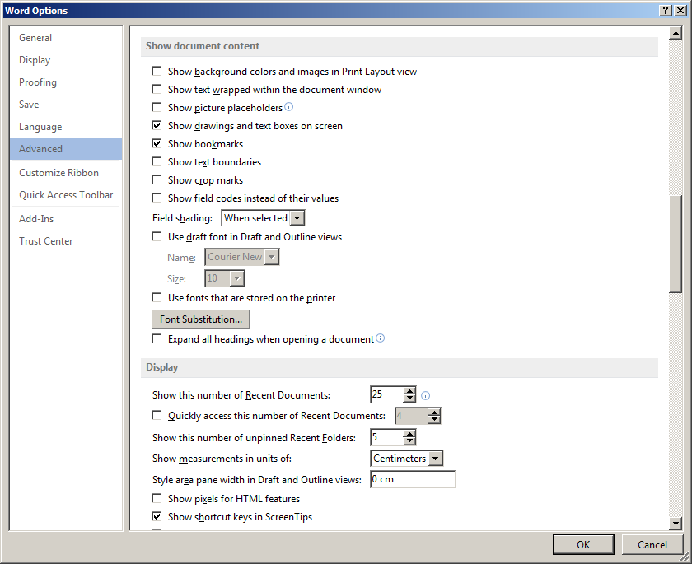

## Inserting a new bookmark

Go to INSERT panel > Bookmark

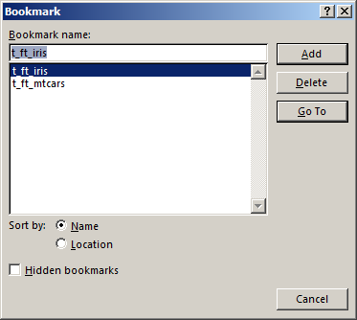

Below are two bookmarks, first is named p_plot1, second p_plot2

