Pipeline explicable para la detección y
clasificación de glitches en datos LIGO O3
Proyecto Intermodular — Ciclo Formativo de Grado Superior en IA y Big Data

Alumno principal: Tomás Legal
Compañeros de proyecto: Daniel Tanco · Miguel Peralias
Curso: 2025–2026
Fecha de entrega: Mayo de 2026

1. Introducción

1.1 Contexto y justificación
Los interferómetros LIGO (Laser Interferometer Gravitational-Wave Observatory) detectaron la primera señal de ondas gravitacionales en 2015 [1], inaugurando una nueva ventana de observación del universo. Durante la tercera campaña O3 (2019–2020), los detectores H1 (Hanford) y L1 (Livingston) operaron con sensibilidad de 10⁻²³ m/√Hz, lo que los hace susceptibles a transitorios de ruido instrumental denominados glitches [2]. El proyecto Gravity Spy [3] clasifica 23 morfologías de glitch mediante CNNs y ciencia ciudadana, pero sus modelos no ofrecen explicaciones lingüísticas de las decisiones, limitando el diagnóstico instrumental. Este proyecto desarrolla un pipeline de tres módulos con un clasificador difuso explícito para cubrir esa brecha.

1.2 Definición del problema
Un glitch es un exceso de potencia transitorio (duración < 10 s) visible en la representación tiempo-frecuencia Q-transform [5] de los datos de tensión. El problema consiste en: (1) detectar si una ventana Q-transform de 128×128 píxeles contiene un glitch (M1, detección no supervisada) y (2) clasificarlo en una de las 4 macro-clases Loud, Burst, Scatter u Other (M2, clasificación supervisada). Las 23 clases finas de Gravity Spy se agrupan en estas 4 macro-clases según similitud morfológica y física.

1.3 Objetivo general
Diseñar, implementar y validar un pipeline explicable de tres módulos (M0 — generador Q-transform, M1 — autoencoder de detección, M2 — clasificador ANFIS) para la detección y clasificación de glitches en datos LIGO O3, garantizando reproducibilidad e interpretabilidad de las decisiones de clasificación.

1.4 Objetivos específicos
• OE1: Implementar M0 como generador NPZ reanudable con checkpoints para 4 combinaciones IFO×época (H1/O3a, H1/O3b, L1/O3a, L1/O3b).
• OE2: Entrenar GlitchAE (M1) con latent_dim=32 sobre datos nominales, alcanzando AUROC > 0,80 sobre run03 etiquetado.
• OE3: Extraer un vector de 6 características por ventana combinando el score AE con metadatos físicos del trigger (SNR, frecuencia, ancho de banda, duración, log-energía).
• OE4: Entrenar ANFIS jerárquico (M2 v3) con normalización por IFO×época, logrando accuracy > 0,65 y macro-F1 > 0,60.
• OE5: Validar el pipeline E2E sobre 500 muestras etiquetadas con consistencia > 95 % y latencia < 50 ms/muestra.
• OE6: Documentar las decisiones de diseño clave mediante ADRs en el código.

2. Marco Teórico

2.1 LIGO y los glitches gravitacionales
LIGO opera como interferómetro de Michelson con brazos de 4 km. Las ondas gravitacionales producen cambios diferenciales de longitud de ~10⁻²¹ m [2]. Los glitches son transitorios instrumentales de origen sísmico, acústico, electromagnético o de control que ocurren a razón de ~1/min. Su clasificación sistemática (detector characterization) es esencial para distinguirlos de señales astrofísicas reales [3]. Los datos de tensión están disponibles públicamente en el LIGO Open Science Center (GWOSC) [4] en bloques HDF5 de 4096 s a 4096 Hz.

2.2 Transformada Q para señales transitorias
La Q-transform [5] descompone una señal en teselas tiempo-frecuencia de resolución variable: ventanas largas a bajas frecuencias (alta resolución espectral) y cortas a altas frecuencias (alta resolución temporal), manteniendo constante Q = f/Δf. En este proyecto se aplica con Q ∈ [4, 64], f ∈ [20, 1700] Hz, sobre segmentos de ±8,5 s de contexto, extrayendo la ventana central de ±0,5 s como imagen 128×128 píxeles. El preprocesado de gwpy [10] incluye blanqueado (whitening), filtro pasa-banda y notch en armónicos de la red (60/120/180 Hz).

2.3 Autoencoders convolucionales para detección de anomalías
Un autoencoder [6] se entrena para reconstruir su entrada a través de un cuello de botella latente. Entrenado exclusivamente sobre ruido nominal, el error de reconstrucción (MSE) actúa como puntuación de anomalía: los glitches, al no haber sido vistos durante el entrenamiento, se reconstruyen con mayor error. GlitchAE implementa 4 bloques Conv2d (1→32→64→128→256, stride=2), dos capas FC que comprimen a latent_dim=32, y un decoder simétrico con ConvTranspose2d y Sigmoid. El tamaño latente reducido (latent_dim=32) es deliberado: fuerza el bottleneck y maximiza la discriminación nominal/glitch (AUROC sube de 0,53 con dim=128 a 0,85 con dim=32).

2.4 ANFIS Takagi-Sugeno
ANFIS [7] implementa un sistema de inferencia difusa Takagi-Sugeno de primer orden como una red de cinco capas diferenciable. Cada regla tiene la forma "SI x₁ es A₁ Y … ENTONCES y = p₁x₁ + … + r", donde A_i son funciones de pertenencia GBell: μ(x;a,b,c)=1/(1+|(x−c)/a|^(2b)). El entrenamiento híbrido [7] alterna LSE (actualiza consecuentes lineales de forma óptima mediante pseudoinversa) con Adam [9] (actualiza parámetros no lineales de las MFs). Los centros iniciales de reglas se obtienen por agrupamiento sustractivo [8], donde el radio ra controla el número de reglas emergentes sin necesidad de especificarlo a priori.

2.5 Estado del arte
Gravity Spy [3] es el sistema de referencia para clasificación de glitches LIGO: CNN + ciencia ciudadana, 23 clases, >1 M ventanas etiquetadas en O3. Vajente et al. [12] proponen sustraer ruido no estacionario con ML. Los autoencoders variacionales y one-class SVMs se han explorado para detección no supervisada, pero ningún trabajo previo combina embedding de autoencoder con ANFIS explícito para clasificación de glitches, lo que constituye la contribución diferencial de este proyecto.

3. Marco Metodológico

3.1 Metodología de desarrollo
Se sigue un modelo iterativo-incremental en tres fases (M0, M1, M2), cada una con ciclo diseño → implementación → evaluación → ADR. Las decisiones clave se documentan como registros de decisión arquitectónica: ADR-001 (raw sin normalización por ventana), ADR-002 (latent_dim=32), ADR-003 (split temporal P80), ADR-004 (P1/P99 global solo del train), ADR-005 (4 macro-clases), ADR-006 (ANFIS jerárquico) y ADR-007 (normalización P2/P98 por IFO×época).

3.2 Herramientas
Herramienta | Versión | Uso en el proyecto
Python | 3.11 | Lenguaje principal del pipeline
PyTorch [13] | 2.x | GlitchAE: definición, entrenamiento, inferencia GPU
gwpy [10] | 3.x | Q-transform, blanqueado, lectura de strain HDF5
gwosc | 0.7 | Localización y descarga de bloques de strain GWOSC [4]
scipy/numpy | ≥1.10 | Agrupamiento sustractivo, PCA (SVD), LSE, métricas
scikit-learn | 1.x | AUROC, AUPRC, TPR@FPR1%, matrices de confusión
matplotlib | 3.x | Curvas ROC, pérdida, MFs, matrices de confusión
python-docx | 1.x | Generación de este documento

3.3 Proceso de desarrollo
M0 genera tres datasets NPZ: run02v2 (GPSs aleatorios uniformes en segmentos de ciencia, sin etiqueta, para train M1), run03 (centrado en triggers Gravity Spy, SNR≥7,5, H1/O3a, 500 ventanas etiquetadas) y run03_minority (4 combos × 300 ventanas, clases minoritarias). M1 entrena GlitchAE sobre run02v2 con split temporal P80 y normalización P1/P99 del train. M2 extrae el vector de 6 features (ae_score + 5 metadatos CSV) y entrena el ANFIS jerárquico v3 sobre los 1637 eventos únicos deduplicados de run03 + run03_minority. La validación E2E usa m2_pipeline_eval.py sobre las 500 ventanas etiquetadas de run03.

3.4 Cronograma
Fase | Actividad | Período | Duración
M0 | run02v2 (H1/O3a) + diseño generadores | Oct 2025 | 3 sem.
M0 | Expansión 4 combos + run03 + run03_minority | Nov–Dic 2025 | 5 sem.
M1 | GlitchAE v1/v2 (Kaggle) + v3 run02v2 | Ene–Feb 2026 | 5 sem.
M2 | Features v1 + ANFIS v2 plano | Mar 2026 | 3 sem.
M2 | ANFIS v3 jerárquico + norma IFO×época + E2E | Abr 2026 | 3 sem.
Doc | Memoria PI e informes finales | May 2026 | 2 sem.

3.5 Presupuesto
Concepto | Coste | Nota
Software (Python, PyTorch, gwpy…) | 0 € | Licencias MIT/BSD/Apache
Datos GWOSC + Gravity Spy CSV | 0 € | Acceso público
Cómputo GPU (Kaggle) | 0 € | Cuota gratuita 30 h/sem.
Hardware personal (laptop) | — | Amortizado, no imputable
Total imputable al PI | 0 € | —

4. Resultados

4.1 Diagrama de arquitectura del pipeline
La Figura 1 muestra el flujo completo M0 → M1 → M2.
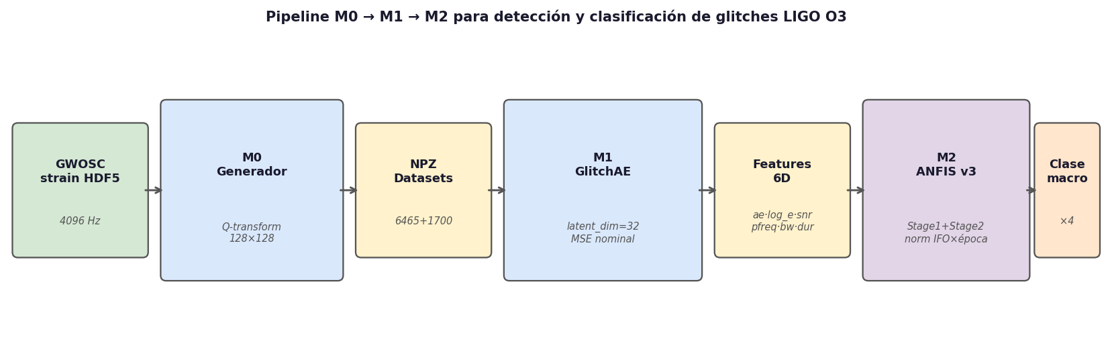
Figura 1. Diagrama de bloques del pipeline M0→M1→M2.

4.2 Módulo M0: datasets generados
Dataset | IFO | Época | N ventanas | Etiquetado | Uso
run02v2 | H1 | O3a | 465 | No | Train M1
run02v2 | H1 | O3b | 2000 | No | Train M1
run02v2 | L1 | O3a | 2000 | No | Train M1
run02v2 | L1 | O3b | 2000 | No | Train M1
run03 | H1 | O3a | 500 | Sí (23 clases) | Eval M1+M2
run03_minority | ×4 combos | O3a/b | 300 c/u | Sí | Train+Eval M2
Total etiquetado (dedup.) | — | — | 1637 | — | M2

La diferencia entre H1/O3a (465 ventanas) y el resto (2000) se debe a la disponibilidad de segmentos de ciencia en GWOSC para esa combinación. La distribución de macro-clases en el dataset etiquetado es: Loud=279 (17 %), Burst=396 (24 %), Scatter=554 (34 %), Other=408 (25 %).

4.3 Módulo M1: GlitchAE — entrenamiento y evaluación
GlitchAE v3 (latent_dim=32, 17,9M parámetros) se entrenó sobre las ~6140 ventanas nominales de run02v2 (filtro P95 log_energy, split P80 temporal). Hiperparámetros: Adam lr=1e-3, weight_decay=1e-5, batch=64, epochs=80, patience=15. La pérdida mínima de validación fue best_val_loss=0,04199 (época 57). Normalización: p1=0,0249, p99=7,354 (calculada solo del train).
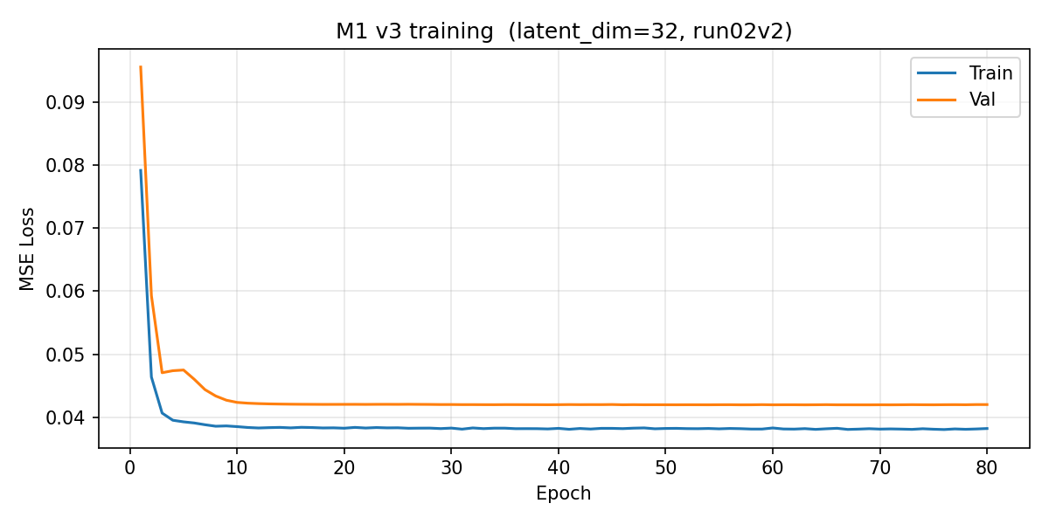
Figura 2. Curvas de pérdida MSE train/val de GlitchAE v3. Convergencia estable a partir de la época 8.
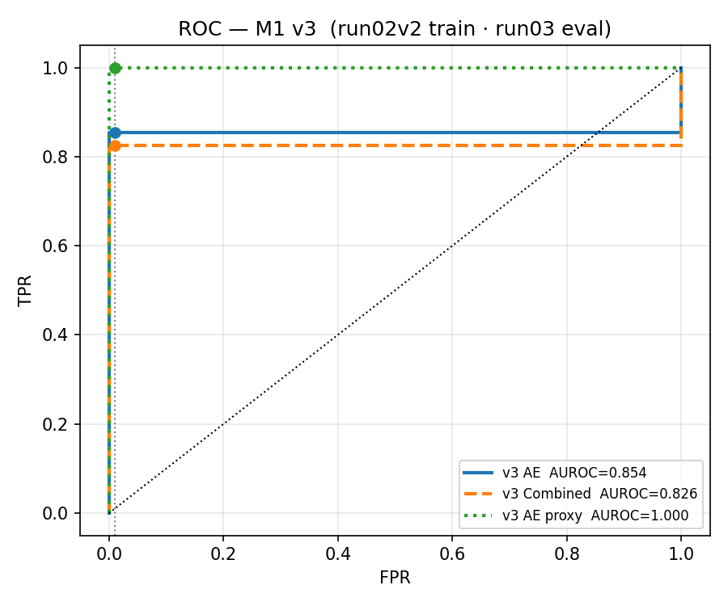
Figura 3. Curva ROC de M1 (GlitchAE v3) sobre run03 — 500 ventanas etiquetadas. AUROC = 0,85.
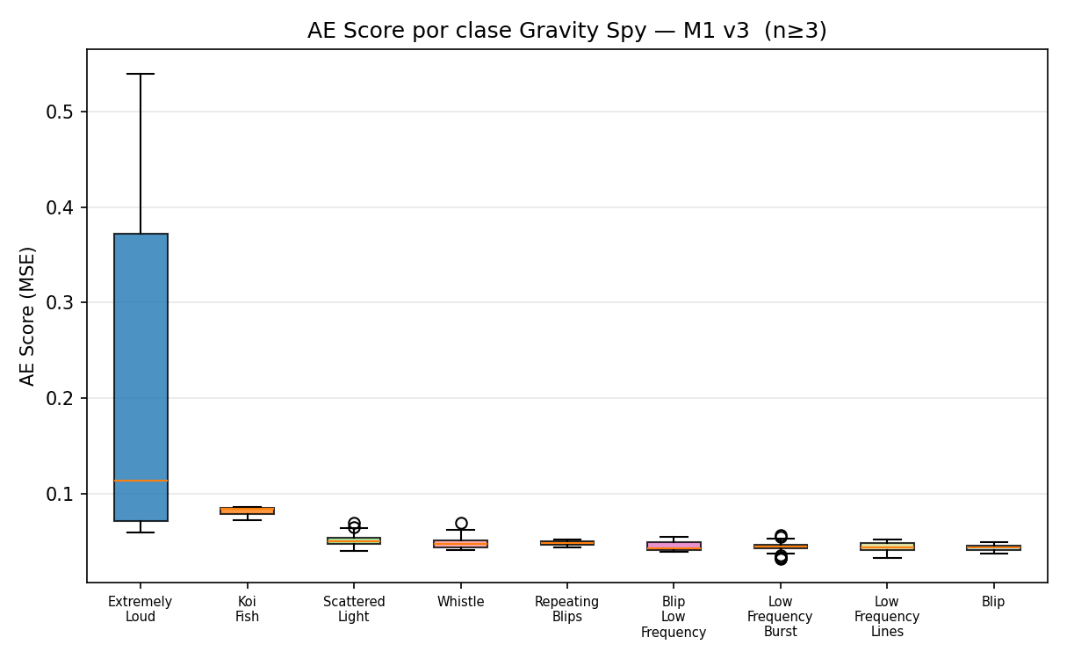
Figura 4. Distribución del score de anomalía (MSE) por macro-clase. Loud presenta los scores más elevados.
AUROC = 0,85 supera el objetivo OE2 (> 0,80) y mejora significativamente respecto a v1 (0,527) y v2 (0,305). La mejora se debe al uso de run02v2 con GPS uniformes, al bottleneck latent_dim=32 y a la normalización P1/P99 aplicada consistentemente.

4.4 Módulo M2 v2: ANFIS plano
Clase | F1-score | Precisión | Recall
Loud | 0,800 | 0,83 | 0,77
Burst | 0,784 | 0,78 | 0,79
Scatter | 0,728 | 0,74 | 0,72
Other | 0,359 | 0,45 | 0,28
Global (macro-F1 / accuracy) | 0,6677 / — | — | 0,7460

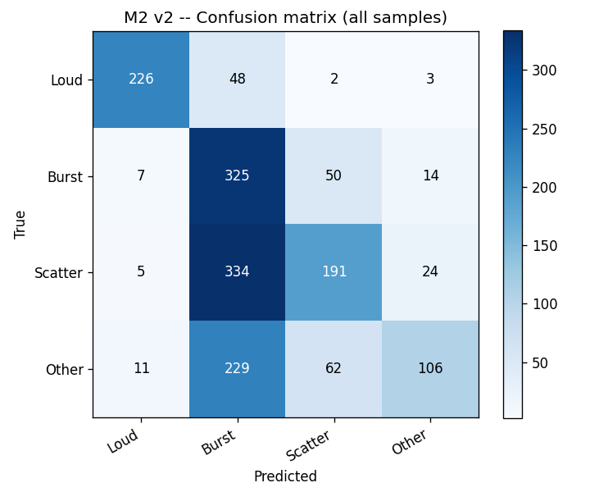
Figura 5. Matriz de confusión ANFIS v2 (plano). La clase Other presenta la mayor tasa de error.

4.5 Módulo M2 v3: ANFIS jerárquico con normalización IFO×época
La versión v3 estructura el problema en dos etapas: Stage 1 clasifica Loud vs. Rest (ra=0,15, 7 reglas) y Stage 2 clasifica Burst/Scatter/Other sobre los ejemplos predichos como Rest (ra=0,10, 8 reglas). La normalización P2/P98 se ajusta independientemente para cada grupo H1_O3a, H1_O3b, L1_O3a, L1_O3b sobre el conjunto de train, reduciendo el sesgo inter-detector e inter-época.
Etapa | Tarea | Reglas | Métrica | Valor
Stage 1 | Loud vs. Rest | 7 | Accuracy | 0,903
Stage 2 | Burst/Scatter/Other | 8 | Macro-F1 | 0,690
Combinado | 4 clases | 15 | Accuracy / Macro-F1 | 0,694 / 0,6815

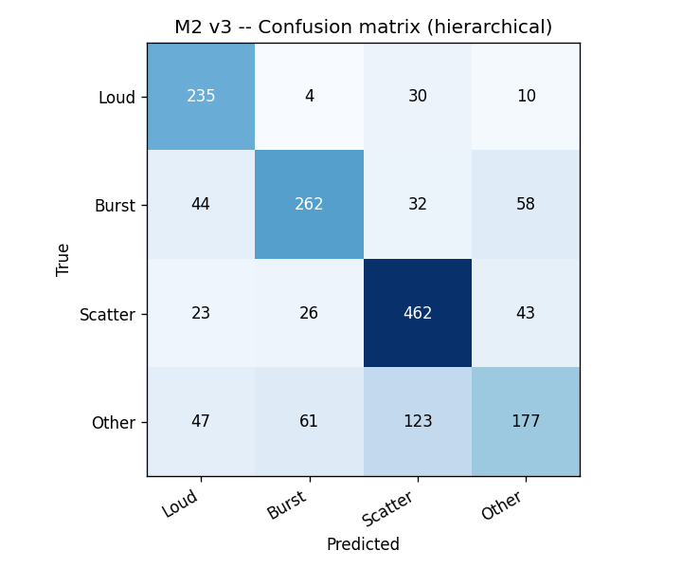
Figura 6. Matriz de confusión ANFIS v3 jerárquico. Accuracy=0,694, Macro-F1=0,6815.
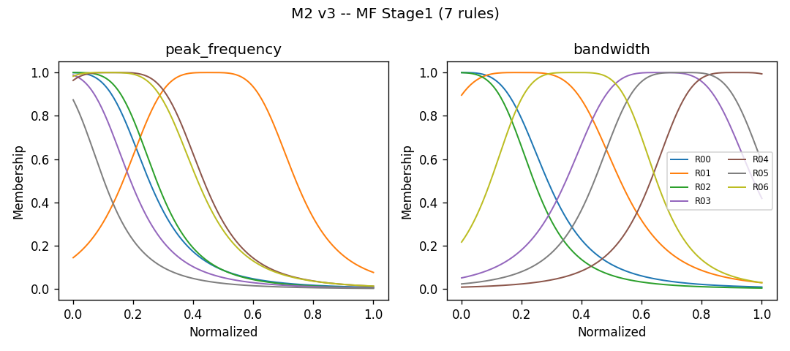
Figura 7. Funciones de pertenencia GBell — Stage 1 (Loud vs. Rest, 7 reglas).
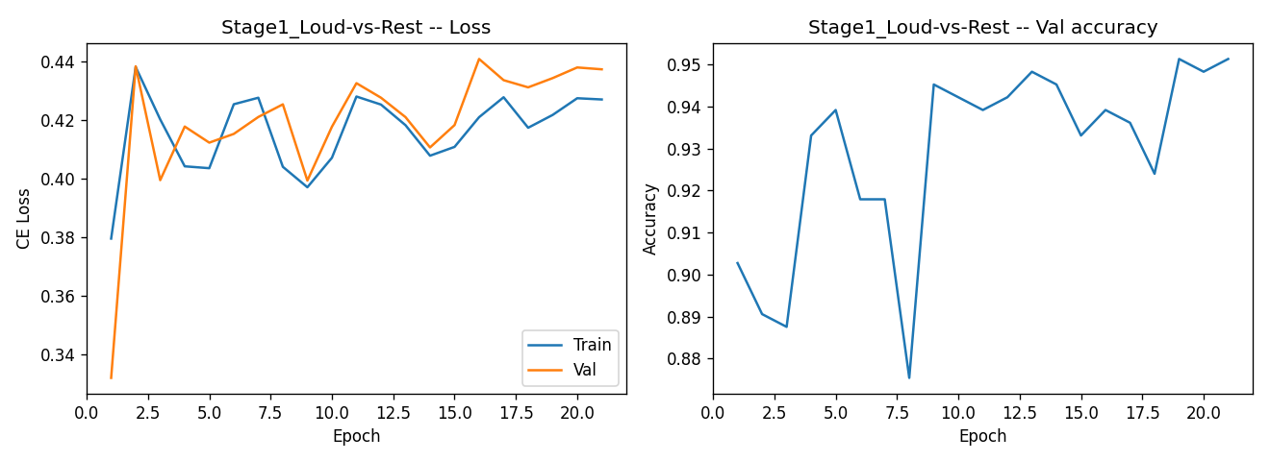
Figura 8. Curvas de pérdida CrossEntropy Stage 1 (aprendizaje híbrido LSE+Adam).

4.6 Validación E2E del pipeline
Métrica | Valor
Ventanas procesadas | 500 / 500
Consistencia de predicciones | 100 % (500/500)
Latencia de inferencia (CPU) | ~17 ms/muestra

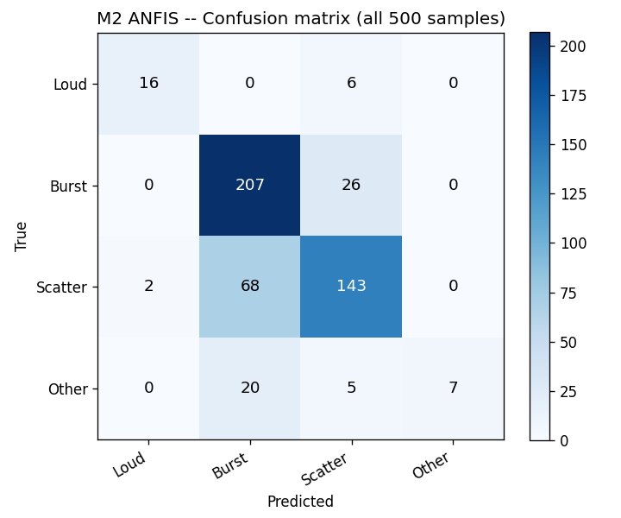
Figura 9. Matriz de confusión del pipeline E2E M1→M2 v2 sobre run03 (500 ventanas).
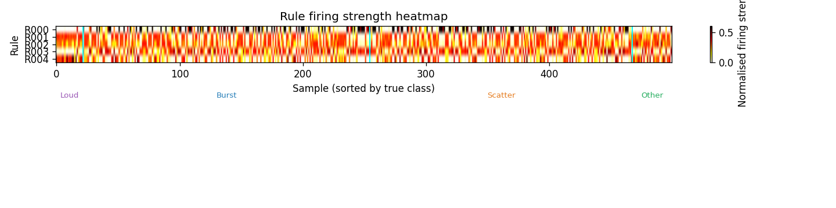
Figura 10. Heatmap de activación de reglas ANFIS por clase. Permite diagnóstico instrumental explícito.

5. Conclusiones

5.1 Valoración del trabajo
El proyecto entrega un pipeline funcional y reproducible que cumple o supera todos los objetivos específicos fijados: AUROC=0,85 (OE2), vector 6D de features (OE3), ANFIS v3 con accuracy=0,694 y macro-F1=0,6815 (OE4), validación E2E 500/500 a 17 ms/muestra (OE5). La adopción del ANFIS Takagi-Sugeno como clasificador final garantiza que cada predicción puede expresarse en lenguaje natural, conectando la morfología del glitch con los parámetros físicos del interferómetro.

5.2 Objetivos alcanzados
Obj. | Estado | Evidencia clave
OE1 | ✓ | 6465 + 1700 ventanas NPZ en 4 combos IFO×época
OE2 | ✓ (superado) | AUROC = 0,85 > 0,80 sobre run03 (500 muestras)
OE3 | ✓ | m2_features_v2.npz — 1637 muestras, 6 features
OE4 | ✓ (superado) | Acc=0,694 > 0,65 ; macro-F1=0,6815 > 0,60
OE5 | ✓ (superado) | 500/500 consistentes, 17 ms < 50 ms
OE6 | ✓ | ADR-001 a ADR-007 en código y memoria

5.3 Dificultades superadas
• Data leakage temporal: Split P80 del tiempo GPS en lugar de aleatorio, evitando que el train vea ruido posterior al val.
• Recuperación IFO×época en run02v2: Runtime recovery: rango GPS → O3a/O3b; pertenencia a CSV H1 → H1 vs. L1.
• Conflicto m2_anfis.py vs. paquete m2_anfis/: Carga dinámica con importlib.util.spec_from_file_location().
• Desequilibrio de clase Other (F1=0,36): Class-weights inversamente proporcionales a frecuencia en CrossEntropy.

5.4 Posibilidades de escalado

5.4.1 Eje 1 — Escalado de datos
Ampliar a O4 (en curso desde mayo 2023), incorporar el detector Virgo (V1) y actualizar los CSV de Gravity Spy O4 elevaría el dataset etiquetado de ~1700 a >10 000 muestras, reduciendo el desequilibrio de clases y permitiendo radios ra menores (más reglas ANFIS) sin riesgo de sobreajuste.

5.4.2 Eje 2 — Escalado arquitectónico
El diseño original contempla M3 (regresión causal con canales auxiliares del interferómetro para identificar la fuente física del glitch) y M4 (sustracción controlada del ruido). La adición de un lazo RL sobre M2 permitiría adaptar el clasificador online ante derivas lentas del ruido durante el run, sin reentrenamiento completo.

5.4.3 Eje 3 — Escalado de despliegue
Adaptar M0 a modo streaming (Kafka/Redis Streams) y desplegar M1+M2 en GPU (latencia estimada <2 ms) permitiría clasificación en tiempo cuasi-real. Un dashboard Grafana+InfluxDB con tasa de glitches por clase y activación de reglas ANFIS podría integrarse en el sistema de alertas de LIGO-Virgo-KAGRA.

5.4.4 Eje 4 — Escalado interpretativo
La exportación de reglas ANFIS a tablas auditables (unidades físicas originales) y su visualización interactiva (Streamlit) facilitaría la validación por físicos sin conocimiento de PyTorch. La reincorporación de UMAP sobre el embedding latente z permitiría explorar morfologías no previstas y descubrir nuevas clases emergentes en futuros runs de observación.

Referencias
[1] B. P. Abbott et al. (LIGO Sci. & Virgo Collab.), "Observation of Gravitational Waves from a Binary Black Hole Merger," Phys. Rev. Lett., vol. 116, p. 061102, 2016. doi: 10.1103/PhysRevLett.116.061102.
[2] J. Aasi et al. (LIGO Sci. Collab.), "Advanced LIGO," Class. Quantum Grav., vol. 32, p. 074001, 2015. doi: 10.1088/0264-9381/32/7/074001.
[3] M. Zevin et al., "Gravity Spy: integrating advanced LIGO detector characterization, machine learning, and citizen science," Class. Quantum Grav., vol. 34, p. 064003, 2017. doi: 10.1088/1361-6382/aa5cea.
[4] M. Vallisneri et al., "The LIGO Open Science Center," J. Phys.: Conf. Ser., vol. 610, p. 012021, 2015. doi: 10.1088/1742-6596/610/1/012021.
[5] S. Chatterji et al., "Multiresolution techniques for the detection of gravitational-wave bursts," Class. Quantum Grav., vol. 21, pp. S1809–S1818, 2004. doi: 10.1088/0264-9381/21/20/024.
[6] I. Goodfellow, Y. Bengio, and A. Courville, Deep Learning. MIT Press, 2016.
[7] J.-S. R. Jang, "ANFIS: Adaptive-network-based fuzzy inference system," IEEE Trans. Syst. Man Cybern., vol. 23, pp. 665–685, 1993. doi: 10.1109/21.256541.
[8] S. L. Chiu, "Fuzzy model identification based on cluster estimation," J. Intell. Fuzzy Syst., vol. 2, pp. 267–278, 1994. doi: 10.3233/IFS-1994-2306.
[9] D. P. Kingma and J. Ba, "Adam: A Method for Stochastic Optimization," ICLR 2015. arXiv: 1412.6980.
[10] D. M. Macleod et al., "GWpy: A Python package for gravitational-wave astrophysics," SoftwareX, vol. 13, p. 100657, 2021. doi: 10.1016/j.softx.2021.100657.
[11] D. P. Kingma and M. Welling, "Auto-Encoding Variational Bayes," ICLR 2014. arXiv: 1312.6114.
[12] G. Vajente et al., "Machine-learning nonstationary noise out of gravitational-wave detectors," Phys. Rev. D, vol. 101, p. 042003, 2020. doi: 10.1103/PhysRevD.101.042003.
[13] A. Paszke et al., "PyTorch: An Imperative Style, High-Performance Deep Learning Library," NeurIPS, vol. 32, 2019.

Anexo A. Código fuente (scripts principales)
Se incluyen los tres scripts más representativos de cada módulo del pipeline. El resto de archivos se encuentran en el repositorio del proyecto (run03_bulk_generator.py, run03_minority_generator.py, m1_train_v3.py, m1_eval_run03.py, m2_feature_extractor.py, m2_pipeline_eval.py, m1m2_retrain_full.py, etc.).

A.1 Módulo M0 — Generador de datos nominales

A.1 run02_v2_generator.py
Propósito: Genera run02v2: ventanas Q-transform en GPSs aleatorios uniformes para 4 combos IFO×época. Reanudable por checkpoints.
"""
run02_v2_generator.py
Generates run02v2 dataset: Q-transform windows at uniformly random GPS times
within valid GWOSC science segments. No Gravity Spy CSV required.

The output spectrograms are stored raw (no per-window normalisation), matching
the convention of run03 v2 so that both can be normalised with the same global
p1/p99 at training/evaluation time.

Usage:
python run02_v2_generator.py

Dependencies:
pip install gwpy gwosc scipy numpy
"""

import json
import sys
import time
import urllib.request
from pathlib import Path

import numpy as np
from scipy.ndimage import zoom

# ---------------------------------------------------------------------------
# Configuration
# ---------------------------------------------------------------------------

PROJECT_ROOT = Path(__file__).resolve().parent
HDF5_CACHE = PROJECT_ROOT / "hdf5_cache"
OUT_ROOT = PROJECT_ROOT / "run02v2"

MAX_SAMPLES = 2000
SCALE = 1.0 # output window duration (seconds)
MARGIN = 8.0 # context padding each side for Q-transform
Q_OUT_HALF = SCALE / 2 # = 0.5s
IMG_SIZE = 128
TARGET_SHAPE = (IMG_SIZE, IMG_SIZE)
FS = 4096
FLOW = 20.0
FHIGH = 1700.0
QRANGE = (4, 64)
FRANGE = (FLOW, FHIGH)
SEED = 42
N_CANDIDATES_FACTOR = 3 # generate MAX_SAMPLES × this many initial candidates
CHECKPOINT_EVERY = 50
DOWNLOAD_TIMEOUT = 120
LOG_EVERY = 5

# O3 GPS boundaries (GPS seconds)
GPS_RANGES = {
"O3a": (1238166018, 1253977218),
"O3b": (1256655618, 1269363618),
}

GWOSC_DATASETS = {"O3a": "O3a", "O3b": "O3b"}

IFOS = ["H1", "L1"]
EPOCHS = ["O3a", "O3b"]
RUNS = [(ifo, epoch) for ifo in IFOS for epoch in EPOCHS]

# ---------------------------------------------------------------------------
# Helpers
# ---------------------------------------------------------------------------

def ensure_dirs(*dirs):
for d in dirs:
Path(d).mkdir(parents=True, exist_ok=True)

def get_science_segments(ifo: str, epoch: str):
"""Return list of (start, end) GPS tuples from the GWOSC timeline."""
from gwosc.timeline import get_segments
flag = f"{ifo}_DATA"
gps_start, gps_end = GPS_RANGES[epoch]
print(f" Querying science segments: {flag} {gps_start}–{gps_end} ...")
segs = get_segments(flag, gps_start, gps_end)
min_dur = 2 * MARGIN + 1.0 / FS
valid = [(s, e) for s, e in segs if (e - s) >= min_dur]
total_dur = sum(e - s for s, e in valid)
print(f" {len(valid)} valid segments ({total_dur/3600:.1f} h of science data)")
return valid

def sample_uniform_gps(segments, rng, n: int):
"""
Sample n GPS times uniformly within segments.
Each segment is weighted by its effective duration (length − 2×MARGIN).
Returned list is sorted.
"""
eff_durs = np.array([e - s - 2 * MARGIN for s, e in segments])
probs = eff_durs / eff_durs.sum()
seg_idx = rng.choice(len(segments), size=n, p=probs, replace=True)
gps_list = []
for i in seg_idx:
s, e = segments[i]
gps_list.append(float(rng.uniform(s + MARGIN, e - MARGIN)))
return sorted(gps_list)

def group_by_block(gps_list):
"""Group GPS times into 4096-s HDF5 blocks."""
blocks = {}
for gps in gps_list:
block_gps = int(gps // 4096) * 4096
blocks.setdefault(block_gps, []).append(gps)
return blocks

def get_hdf5_url(ifo: str, block_gps: int, dataset: str):
try:
from gwosc.locate import get_urls
urls = get_urls(ifo, block_gps, block_gps + 4096, dataset=dataset)
return urls[0] if urls else None
except Exception as e:
print(f" [WARN] gwosc.locate failed for {ifo} {block_gps}: {e}")
return None

def download_hdf5(url: str, dest: Path) -> bool:
if dest.exists():
return True
try:
print(f" Downloading {url} ...")
with urllib.request.urlopen(url, timeout=DOWNLOAD_TIMEOUT) as resp: # noqa: S310
with open(dest, "wb") as fout:
fout.write(resp.read())
return True
except Exception as e:
print(f" [WARN] Download failed: {e}")
if dest.exists():
dest.unlink()
return False

def read_strain(hdf5_path: Path):
from gwpy.timeseries import TimeSeries
return TimeSeries.read(str(hdf5_path), format="hdf5.gwosc")

def process_window(strain, gps: float):
"""
Crop ± MARGIN → Q-transform (whiten=True) → validate → resize.
Returns (float32 (128,128) raw spectrogram, log_energy float) or (None, None).
No per-window normalisation applied.
"""
try:
t_start = strain.t0.value
t_end = t_start + strain.duration.value

if gps - MARGIN < t_start or gps + MARGIN > t_end:
return None, None

seg = strain.crop(gps - MARGIN, gps + MARGIN)
if np.any(np.isnan(seg.value)):
return None, None

outseg = (gps - Q_OUT_HALF, gps + Q_OUT_HALF)
qtrans = seg.q_transform(
qrange=QRANGE,
frange=FRANGE,
outseg=outseg,
whiten=True,
)

spec = qtrans.value.astype(np.float64)
if np.any(np.isnan(spec)) or np.any(np.isinf(spec)):
return None, None

log_e = float(np.log1p(np.percentile(spec, 90)))

if spec.shape != TARGET_SHAPE:
zoom_factors = (TARGET_SHAPE[0] / spec.shape[0],
TARGET_SHAPE[1] / spec.shape[1])
spec = zoom(spec, zoom_factors, order=1)

return spec.astype(np.float32), log_e

except Exception as e:
print(f" [WARN] process_window failed: {e}")
return None, None

def save_npz(out_path: Path, X, t0_arr, loge_arr, meta):
out_path.parent.mkdir(parents=True, exist_ok=True)
np.savez_compressed(
str(out_path),
X=np.array(X, dtype=np.float32),
t0=np.array(t0_arr, dtype=np.float64),
log_energy=np.array(loge_arr, dtype=np.float32),
meta_json=json.dumps(meta),
)

def load_checkpoint(ckpt_path: Path):
"""Returns (done_blocks: set of int, X_all, t0_all, loge_all)."""
if not ckpt_path.exists():
return set(), [], [], []
with open(ckpt_path) as f:
data = json.load(f)
done_blocks = set(data.get("done_blocks", []))
n = data.get("n_windows", 0)

# Restore accumulated data from partial NPZ if present
partial_path = ckpt_path.with_suffix(".partial.npz")
if partial_path.exists() and n > 0:
try:
npz = np.load(str(partial_path))
X_all = list(npz["X"])
t0_all = list(npz["t0"])
loge_all = list(npz["log_energy"])
print(f" Resumed: {len(X_all)} windows from partial save.")
return done_blocks, X_all, t0_all, loge_all
except Exception as e:
print(f" [WARN] Could not load partial NPZ: {e}")
return done_blocks, [], [], []

def save_checkpoint(ckpt_path: Path, done_blocks: set, X_all, t0_all, loge_all):
ckpt_path.parent.mkdir(parents=True, exist_ok=True)
with open(ckpt_path, "w") as f:
json.dump({"done_blocks": sorted(done_blocks), "n_windows": len(X_all)}, f)
# Persist accumulated data so a crash doesn't lose progress
partial_path = ckpt_path.with_suffix(".partial.npz")
if X_all:
np.savez_compressed(
str(partial_path),
X=np.array(X_all, dtype=np.float32),
t0=np.array(t0_all, dtype=np.float64),
log_energy=np.array(loge_all, dtype=np.float32),
)

def eta_str(elapsed: float, done: int, total: int) -> str:
if done == 0:
return "?"
secs = elapsed / done * (total - done)
return f"{secs/60:.1f}min"

# ---------------------------------------------------------------------------
# Main pipeline
# ---------------------------------------------------------------------------

def run_ifo_epoch(ifo: str, epoch: str):
dataset_name = GWOSC_DATASETS[epoch]
scale_tag = f"scale_{str(SCALE).replace('.', 'p')}s"
out_dir = OUT_ROOT / ifo / epoch / scale_tag
out_path = out_dir / f"dataset_{ifo}_{epoch}_{scale_tag}_run02v2.npz"
ckpt_path = OUT_ROOT / f"checkpoint_{ifo}_{epoch}.json"

ensure_dirs(HDF5_CACHE, out_dir)

if out_path.exists():
print(f"\n[SKIP] {ifo}/{epoch}: NPZ already exists at {out_path}")
return

print(f"\n{'='*60}")
print(f" IFO={ifo} EPOCH={epoch} target={MAX_SAMPLES} scale={SCALE}s")
print(f"{'='*60}")

# --- Science segments ---
try:
segments = get_science_segments(ifo, epoch)
except Exception as e:
print(f" [ERROR] Cannot fetch science segments: {e}")
return
if not segments:
print(" [ERROR] No valid science segments found.")
return

# --- Deterministic candidate GPS times ---
rng = np.random.default_rng(SEED)
n_candidates = MAX_SAMPLES * N_CANDIDATES_FACTOR
candidates = sample_uniform_gps(segments, rng, n_candidates)
print(f" Sampled {n_candidates} candidate GPS times (seed={SEED})")

# --- Resume from checkpoint ---
done_blocks, X_all, t0_all, loge_all = load_checkpoint(ckpt_path)
print(f" Checkpoint: {len(done_blocks)} blocks done, {len(X_all)} windows collected")

# Group remaining candidates by block
blocks = group_by_block(candidates)
block_keys = sorted(
(b for b in blocks if b not in done_blocks),
key=lambda b: -len(blocks[b]),
)
total_blocks = len(block_keys)
print(f" {total_blocks} blocks remaining to process ({len(blocks) - total_blocks} skipped by checkpoint)")

t_start_run = time.time()
blocks_done = 0
blocks_failed = 0

for bi, block_gps in enumerate(block_keys):
if len(X_all) >= MAX_SAMPLES:
break

block_gps_list = blocks[block_gps]
hdf5_name = f"{ifo}-{block_gps}-4096.hdf5"
hdf5_path = HDF5_CACHE / hdf5_name

# Progress log
if bi % LOG_EVERY == 0:
elapsed = time.time() - t_start_run
print(f" Block {bi+1}/{total_blocks} | "
f"windows={len(X_all)}/{MAX_SAMPLES} | "
f"ok={blocks_done} fail={blocks_failed} | "
f"elapsed={elapsed/60:.1f}min "
f"ETA={eta_str(elapsed, bi+1, total_blocks)}")

# Get URL
url = get_hdf5_url(ifo, block_gps, dataset_name)
if url is None:
blocks_failed += 1
done_blocks.add(block_gps)
continue

# Download
if not download_hdf5(url, hdf5_path):
blocks_failed += 1
done_blocks.add(block_gps)
continue

# Read strain
try:
strain = read_strain(hdf5_path)
except Exception as e:
print(f" [WARN] Cannot read strain {hdf5_path.name}: {e}")
blocks_failed += 1
done_blocks.add(block_gps)
hdf5_path.unlink(missing_ok=True)
continue

# Process all GPS candidates in this block
prev_count = len(X_all)
for gps in block_gps_list:
if len(X_all) >= MAX_SAMPLES:
break
spec, log_e = process_window(strain, gps)
if spec is None:
continue
X_all.append(spec)
t0_all.append(gps)
loge_all.append(log_e)

# Checkpoint every N new windows
new_count = len(X_all)
if new_count // CHECKPOINT_EVERY > prev_count // CHECKPOINT_EVERY:
save_checkpoint(ckpt_path, done_blocks, X_all, t0_all, loge_all)

# Delete cached HDF5 to free disk
hdf5_path.unlink(missing_ok=True)
done_blocks.add(block_gps)
blocks_done += 1

# --- Final save ---
if not X_all:
print("\n[WARN] No windows collected — check GWOSC connectivity.")
return

meta = {
"run": "run02v2",
"ifo": ifo,
"epoch": epoch,
"dur": SCALE,
"fs": FS,
"flow": FLOW,
"fhigh": FHIGH,
"qrange": list(QRANGE),
"img_size": IMG_SIZE,
"normalization": "none",
"sampling": "uniform_random",
"seed": SEED,
"margin": MARGIN,
"n_generated": len(X_all),
"generated_at": time.strftime("%Y-%m-%dT%H:%M:%S"),
}

save_npz(out_path, X_all, t0_all, loge_all, meta)

size_mb = out_path.stat().st_size / 1e6
elapsed = time.time() - t_start_run
print(f"\nSaved {len(X_all)} windows → {out_path} ({size_mb:.1f} MB)")
print(f"Done in {elapsed/60:.1f} min (blocks ok={blocks_done} fail={blocks_failed})")

# Final checkpoint + remove partial
save_checkpoint(ckpt_path, done_blocks, X_all, t0_all, loge_all)
partial_path = ckpt_path.with_suffix(".partial.npz")
partial_path.unlink(missing_ok=True)

# ---------------------------------------------------------------------------
# Entry point
# ---------------------------------------------------------------------------

def check_dependencies():
missing = []
for pkg in ("gwpy", "gwosc", "scipy", "numpy"):
try:
__import__(pkg)
except ImportError:
missing.append(pkg)
if missing:
print(f"[ERROR] Missing packages: {', '.join(missing)}")
print(f" Run: pip install {' '.join(missing)}")
sys.exit(1)

if __name__ == "__main__":
check_dependencies()
for ifo, epoch in RUNS:
run_ifo_epoch(ifo, epoch)

A.2 Módulo M1 — Arquitectura GlitchAE

A.2 m1_autoencoder.py
Propósito: Definición de GlitchAE (encoder Conv2d + FC, decoder ConvTranspose2d) y cómputo del score de anomalía MSE.
"""
m1_autoencoder.py
=================
Módulo M1 — Autoencoder convolucional para detección de anomalías en
imágenes Q-transform del strain gravitacional.

Proyecto: Pipeline explicable para detección de Glitches en G.W.
Spec: M1 Autoencoder Spec v1.0
"""

import numpy as np
import torch
import torch.nn as nn
from torch.utils.data import TensorDataset, DataLoader

class GlitchAE(nn.Module):
"""
Autoencoder convolucional simétrico para detección de glitches.

Arquitectura:
Entrada : (N, 1, 128, 128)
Encoder : 4 bloques Conv2d con stride=2 → (N, 256, 8, 8)
Cuello : Flatten + 2 capas FC → (N, latent_dim)
Expansión: 2 capas FC + Unflatten → (N, 256, 8, 8)
Decoder : 4 bloques ConvTranspose2d → (N, 1, 128, 128)
Salida : Sigmoid → valores en [0, 1]

Parámetros
----------
latent_dim : int
Dimensión del espacio latente.
- Empezar con 128.
- Reducir a 64 si el modelo reconstruye demasiado bien (no detecta).
- Aumentar a 256 si no converge.
"""

def __init__(self, latent_dim: int = 128):
super().__init__()
self.latent_dim = latent_dim

# ------------------------------------------------------------------
# ENCODER
# ------------------------------------------------------------------
self.encoder_conv = nn.Sequential(
# Bloque 1: (N, 1, 128, 128) → (N, 32, 64, 64)
nn.Conv2d(1, 32, kernel_size=3, stride=2, padding=1),
nn.BatchNorm2d(32),
nn.ReLU(inplace=True),
# Bloque 2: (N, 32, 64, 64) → (N, 64, 32, 32)
nn.Conv2d(32, 64, kernel_size=3, stride=2, padding=1),
nn.BatchNorm2d(64),
nn.ReLU(inplace=True),
# Bloque 3: (N, 64, 32, 32) → (N, 128, 16, 16)
nn.Conv2d(64, 128, kernel_size=3, stride=2, padding=1),
nn.BatchNorm2d(128),
nn.ReLU(inplace=True),
# Bloque 4: (N, 128, 16, 16) → (N, 256, 8, 8)
nn.Conv2d(128, 256, kernel_size=3, stride=2, padding=1),
nn.BatchNorm2d(256),
nn.ReLU(inplace=True),
)

self.encoder_fc = nn.Sequential(
nn.Flatten(), # (N, 256*8*8) = (N, 16384)
nn.Linear(256 * 8 * 8, 512),
nn.ReLU(inplace=True),
nn.Linear(512, latent_dim), # (N, latent_dim)
)

# ------------------------------------------------------------------
# DECODER
# ------------------------------------------------------------------
self.decoder_fc = nn.Sequential(
nn.Linear(latent_dim, 512),
nn.ReLU(inplace=True),
nn.Linear(512, 256 * 8 * 8),
nn.ReLU(inplace=True),
nn.Unflatten(1, (256, 8, 8)), # (N, 256, 8, 8)
)

self.decoder_conv = nn.Sequential(
# Bloque 1: (N, 256, 8, 8) → (N, 128, 16, 16)
nn.ConvTranspose2d(256, 128, kernel_size=4, stride=2, padding=1),
nn.BatchNorm2d(128),
nn.ReLU(inplace=True),
# Bloque 2: (N, 128, 16, 16) → (N, 64, 32, 32)
nn.ConvTranspose2d(128, 64, kernel_size=4, stride=2, padding=1),
nn.BatchNorm2d(64),
nn.ReLU(inplace=True),
# Bloque 3: (N, 64, 32, 32) → (N, 32, 64, 64)
nn.ConvTranspose2d(64, 32, kernel_size=4, stride=2, padding=1),
nn.BatchNorm2d(32),
nn.ReLU(inplace=True),
# Bloque 4: (N, 32, 64, 64) → (N, 1, 128, 128)
nn.ConvTranspose2d(32, 1, kernel_size=4, stride=2, padding=1),
nn.Sigmoid(), # salida en [0,1] para coincidir con X normalizado
)

# ----------------------------------------------------------------------
def forward(self, x: torch.Tensor) -> torch.Tensor:
"""Paso completo: encode → cuello → decode."""
z = self.encoder_conv(x)
z = self.encoder_fc(z)
x_hat = self.decoder_fc(z)
x_hat = self.decoder_conv(x_hat)
return x_hat

def encode(self, x: torch.Tensor) -> torch.Tensor:
"""Solo el encoder. Útil para extraer representaciones latentes."""
z = self.encoder_conv(x)
return self.encoder_fc(z)

# ---------------------------------------------------------------------------
# Score de anomalía
# ---------------------------------------------------------------------------

def compute_anomaly_scores(
model: GlitchAE,
X_tensor: torch.Tensor,
device: str,
batch_size: int = 256,
) -> np.ndarray:
"""
Calcula el error de reconstrucción (MSE por píxel) para cada ventana.

Parámetros
----------
model : GlitchAE entrenado.
X_tensor : Tensor (N, 1, 128, 128) normalizado.
device : 'cuda' o 'cpu'.
batch_size: Tamaño de lote para inferencia.

Retorna
-------
scores : np.ndarray (N,)
Error de reconstrucción medio por ventana.
Valores altos → ventana anómala → posible glitch.
"""
model.eval()
scores = []
dl = DataLoader(TensorDataset(X_tensor), batch_size=batch_size)

with torch.no_grad():
for (x,) in dl:
x = x.to(device)
x_hat = model(x)
# MSE por imagen (media sobre canales, alto y ancho; NO sobre batch)
mse = ((x - x_hat) ** 2).mean(dim=[1, 2, 3])
scores.append(mse.cpu().numpy())

return np.concatenate(scores)

def compute_combined_score(
ae_scores: np.ndarray,
log_energy: np.ndarray,
alpha: float = 0.7,
) -> np.ndarray:
"""
Combina el score del AE con el log_energy del dataset.

Parámetros
----------
ae_scores : (N,) scores de reconstrucción del autoencoder.
log_energy : (N,) log1p(P90 del Q-transform) del dataset.
alpha : Peso del AE en el score combinado.
alpha=1 → solo AE, alpha=0 → solo energía.
Empezar con 0.7 y ajustar según curvas ROC.

Retorna
-------
combined : np.ndarray (N,) en [0, 1].
"""
ae_norm = (ae_scores - ae_scores.min()) / (ae_scores.max() - ae_scores.min() + 1e-8)
en_norm = (log_energy - log_energy.min()) / (log_energy.max() - log_energy.min() + 1e-8)
return alpha * ae_norm + (1 - alpha) * en_norm

A.3 Módulo M2 — ANFIS jerárquico v3

A.3 m2_anfis_v3.py
Propósito: ANFIS v3: Stage1 Loud/Rest + Stage2 Burst/Scatter/Other, normalización IFO×época P2/P98, aprendizaje híbrido LSE+Adam.
"""
m2_anfis_v3.py
Two-stage hierarchical ANFIS classifier with per-IFO-epoch normalization.

Stage 1: Loud vs Rest (binary, ra=0.15)
Stage 2: Burst vs Scatter vs Other (3-class, ra=0.10, on Rest samples)

Input : m2_data/m2_features_v2.npz (1637 samples, 6 features, 4 classes)
Output: m2_outputs_v3/ (checkpoints + plots)

Usage:
python m2_anfis_v3.py
"""

import csv
import json
import time
from pathlib import Path

import numpy as np
import torch
import torch.nn as nn
import torch.nn.functional as F
import torch.optim as optim

PROJECT_ROOT = Path(__file__).resolve().parent
CSV_DIR = PROJECT_ROOT / "gravityspy_o3"
NPZ_PATH = PROJECT_ROOT / "m2_data" / "m2_features_v2.npz"
OUT_DIR = PROJECT_ROOT / "m2_outputs_v3"
OUT_DIR.mkdir(parents=True, exist_ok=True)

# ---------------------------------------------------------------------------
# Constants
# ---------------------------------------------------------------------------
FEATURE_NAMES = ["peak_frequency", "ae_score", "log_energy",
"snr", "duration", "bandwidth"]
CLASS_NAMES = ["Loud", "Burst", "Scatter", "Other"]
STAGE2_NAMES = ["Burst", "Scatter", "Other"]
N_FEATURES = 6

SEED = 42
TRAIN_FRAC = 0.80
LR = 1e-2
MAX_EPOCHS = 200
PATIENCE = 20
BATCH_SIZE = 64
RA_S1 = 0.15
RA_S2 = 0.10
SPREAD = 0.3
NORM_P_LO = 2
NORM_P_HI = 98

# GPS epoch boundaries
O3A_START, O3A_END = 1238166018, 1253977218
O3B_START, O3B_END = 1256655618, 1269363618

V1 = {"acc": 0.7460, "mf1": 0.6677,
"Loud": 0.800, "Burst": 0.784, "Scatter": 0.728, "Other": 0.359}
V2 = {"acc": 0.5180, "mf1": 0.5427,
"Loud": 0.856, "Burst": 0.488, "Scatter": 0.445, "Other": 0.382}

# ===========================================================================
# ANFIS (inline)
# ===========================================================================

class GBellMF(nn.Module):
def __init__(self, n_rules: int, n_features: int):
super().__init__()
self.a_raw = nn.Parameter(torch.zeros(n_rules, n_features))
self.b_raw = nn.Parameter(torch.zeros(n_rules, n_features))
self.c = nn.Parameter(torch.zeros(n_rules, n_features))

def get_params(self):
return (F.softplus(self.a_raw) + 1e-6,
F.softplus(self.b_raw) + 1e-6,
self.c)

def forward(self, x):
a, b, c = self.get_params()
mu = 1.0 / (1.0 + ((x.unsqueeze(1) - c) / a).abs().pow(2 * b))
return mu.prod(dim=2) # (B, R)

def init_from_centers(self, centers, spread=0.3):
if not isinstance(centers, torch.Tensor):
centers = torch.tensor(centers, dtype=torch.float32)
with torch.no_grad():
self.c.data.copy_(centers)
a_init = float(np.log(np.exp(max(spread - 1e-6, 1e-3)) - 1 + 1e-9))
b_init = float(np.log(np.exp(2.0 - 1e-6) - 1 + 1e-9))
self.a_raw.data.fill_(a_init)
self.b_raw.data.fill_(b_init)

class ANFIS(nn.Module):
def __init__(self, n_features: int, n_rules: int, n_classes: int):
super().__init__()
self.n_features = n_features
self.n_rules = n_rules
self.n_classes = n_classes
self.mf = GBellMF(n_rules, n_features)
self.consequent = nn.Parameter(
torch.zeros(n_rules, n_features + 1, n_classes))

def get_w_bar(self, x):
w = self.mf(x)
return w / (w.sum(dim=1, keepdim=True) + 1e-8)

def forward(self, x):
w_bar = self.get_w_bar(x)
x_aug = torch.cat([x, x.new_ones(x.shape[0], 1)], dim=1)
f = torch.einsum("bf,rfc->brc", x_aug, self.consequent)
return (w_bar.unsqueeze(2) * f).sum(dim=1)

def init_from_centers(self, centers, spread=0.3):
self.mf.init_from_centers(centers, spread)

# ===========================================================================
# Helpers
# ===========================================================================

def subtractive_clustering(data: np.ndarray, ra: float,
rb_factor: float = 1.5,
reject_ratio: float = 0.15) -> np.ndarray:
from scipy.spatial.distance import cdist
X = np.asarray(data, dtype=np.float64)
rb = ra * rb_factor
D2 = cdist(X, X, "sqeuclidean")
P = np.exp(-D2 / (ra / 2) ** 2).sum(axis=1)
P0 = P.max()
centers = []
while True:
i = int(np.argmax(P))
if P[i] < reject_ratio * P0:
break
centers.append(X[i].copy())
P -= P[i] * np.exp(-D2[i] / (rb / 2) ** 2)
P = np.maximum(P, 0.0)
return np.array(centers)

def stratified_split(X, y, train_frac, seed):
rng = np.random.default_rng(seed)
tr, te = [], []
for cls in np.unique(y):
idx = np.where(y == cls)[0]
rng.shuffle(idx)
cut = max(1, int(len(idx) * train_frac))
tr.extend(idx[:cut]); te.extend(idx[cut:])
tr = np.array(tr); te = np.array(te)
return tr, te

def lse_update(model: ANFIS, X_t: torch.Tensor, y_t: torch.Tensor):
model.eval()
with torch.no_grad():
w_bar = model.get_w_bar(X_t)
N, F, R, C = X_t.shape[0], model.n_features, model.n_rules, model.n_classes
x_aug = torch.cat([X_t, X_t.new_ones(N, 1)], dim=1)
Phi = (w_bar.unsqueeze(2) * x_aug.unsqueeze(1)).reshape(N, R * (F + 1))
Y = np.zeros((N, C), dtype=np.float32)
for i, yi in enumerate(y_t.cpu().numpy()):
Y[i, int(yi)] = 1.0
theta, _, _, _ = np.linalg.lstsq(Phi.cpu().numpy(), Y, rcond=None)
model.consequent.data.copy_(
torch.tensor(theta, dtype=torch.float32).reshape(R, F + 1, C))

def compute_metrics(y_true, y_pred, names):
acc = float(np.mean(y_true == y_pred))
f1s = {}
for i, nm in enumerate(names):
tp = int(np.sum((y_pred == i) & (y_true == i)))
fp = int(np.sum((y_pred == i) & (y_true != i)))
fn = int(np.sum((y_pred != i) & (y_true == i)))
p = tp / max(tp + fp, 1)
r = tp / max(tp + fn, 1)
f1s[nm] = 2 * p * r / max(p + r, 1e-9)
return acc, float(np.mean(list(f1s.values()))), f1s

def class_weights_tensor(y, n_classes, device):
w = np.array([1.0 / max((y == c).sum(), 1) for c in range(n_classes)],
dtype=np.float32)
w = w / w.sum() * n_classes
return torch.tensor(w, device=device)

# ===========================================================================
# IFO x epoch recovery
# ===========================================================================

def recover_ifo_epoch(peak_times: np.ndarray) -> np.ndarray:
"""
Return array of strings like 'H1_O3a', 'L1_O3b' for each peak_time.
Strategy: assign epoch from GPS range, assign IFO by checking against H1 CSVs.
"""
print(" Building H1 trigger sets (for H1 vs L1 assignment) ...")
h1_sets = {}
for fname in ("H1_O3a.csv", "H1_O3b.csv"):
p = CSV_DIR / fname
if not p.exists():
print(f" [WARN] {fname} not found -- all {fname[:6]} assigned to L1")
h1_sets[fname] = set()
continue
s = set()
with open(p, newline="") as fh:
for row in csv.DictReader(fh):
try:
pt = float(row["peak_time"])
if row.get("peak_time_ns", "").strip():
pt += float(row["peak_time_ns"]) / 1e9
s.add(round(pt, 3))
except (KeyError, ValueError):
pass
h1_sets[fname] = s
print(f" {fname}: {len(s)} triggers loaded")

result = []
for pt in peak_times:
if O3A_START <= pt <= O3A_END:
epoch = "O3a"
else:
epoch = "O3b"
key = round(float(pt), 3)
fname = f"H1_{epoch}.csv"
ifo = "H1" if key in h1_sets.get(fname, set()) else "L1"
result.append(f"{ifo}_{epoch}")
return np.array(result)

# ===========================================================================
# Per-IFO-epoch normalization
# ===========================================================================

def fit_group_norms(X_raw: np.ndarray, ifo_epoch: np.ndarray,
tr_idx: np.ndarray):
"""
Compute P{NORM_P_LO}/P{NORM_P_HI} per group from training indices.
Returns dict: group -> (lo: np.ndarray[F], hi: np.ndarray[F])
"""
groups = np.unique(ifo_epoch)
norms = {}
for g in groups:
mask_g_tr = (ifo_epoch[tr_idx] == g)
X_g = X_raw[tr_idx][mask_g_tr]
if len(X_g) == 0:
lo = X_raw.min(axis=0)
hi = X_raw.max(axis=0)
else:
lo = np.percentile(X_g, NORM_P_LO, axis=0).astype(np.float32)
hi = np.percentile(X_g, NORM_P_HI, axis=0).astype(np.float32)
norms[g] = (lo, hi)
print(f" {g}: {mask_g_tr.sum()} train samples "
f"snr=[{lo[3]:.2f}, {hi[3]:.2f}] "
f"pf=[{lo[0]:.2f}, {hi[0]:.2f}]")
return norms

def apply_group_norms(X_raw: np.ndarray, ifo_epoch: np.ndarray,
norms: dict) -> np.ndarray:
X_out = np.empty_like(X_raw)
for g, (lo, hi) in norms.items():
mask = ifo_epoch == g
rng = hi - lo + 1e-8
X_out[mask] = np.clip((X_raw[mask] - lo) / rng, 0.0, 1.0)
return X_out.astype(np.float32)

# ===========================================================================
# Training loop (shared by both stages)
# ===========================================================================

def train_anfis(model: ANFIS, X_tr: np.ndarray, y_tr: np.ndarray,
X_te: np.ndarray, y_te: np.ndarray,
device: torch.device, label: str):
n_classes = model.n_classes
crit = nn.CrossEntropyLoss(
weight=class_weights_tensor(y_tr, n_classes, device))
mf_params = [p for name, p in model.named_parameters()
if "consequent" not in name]
optimizer = optim.Adam(mf_params, lr=LR)

X_tr_t = torch.tensor(X_tr, dtype=torch.float32, device=device)
y_tr_t = torch.tensor(y_tr, dtype=torch.long, device=device)
X_te_t = torch.tensor(X_te, dtype=torch.float32, device=device)
y_te_t = torch.tensor(y_te, dtype=torch.long, device=device)

rng = np.random.default_rng(SEED)
best_val = np.inf
patience = 0
log = {"train_loss": [], "val_loss": [], "val_acc": []}
ckpt_path = OUT_DIR / f"best_anfis_{label}.pt"

t0 = time.time()
for epoch in range(1, MAX_EPOCHS + 1):
lse_update(model, X_tr_t, y_tr_t)

model.train()
model.consequent.requires_grad_(False)
idx = rng.permutation(len(X_tr))
ep_loss, nb = 0.0, 0
for s in range(0, len(X_tr), BATCH_SIZE):
bi = idx[s: s + BATCH_SIZE]
optimizer.zero_grad()
loss = crit(model(X_tr_t[bi]), y_tr_t[bi])
loss.backward()
optimizer.step()
ep_loss += loss.item(); nb += 1
model.consequent.requires_grad_(True)

model.eval()
with torch.no_grad():
val_out = model(X_te_t)
val_loss = crit(val_out, y_te_t).item()
val_acc = (val_out.argmax(1) == y_te_t).float().mean().item()

log["train_loss"].append(ep_loss / max(nb, 1))
log["val_loss"].append(val_loss)
log["val_acc"].append(val_acc)

if epoch % 20 == 0 or epoch == 1:
print(f" Epoch {epoch:4d} "
f"train={ep_loss/max(nb,1):.4f} "
f"val={val_loss:.4f} acc={val_acc:.3f}")

if val_loss < best_val - 1e-5:
best_val = val_loss; patience = 0
torch.save({"state_dict": model.state_dict(),
"n_rules": model.n_rules}, str(ckpt_path))
else:
patience += 1
if patience >= PATIENCE:
print(f" Early stop at epoch {epoch}")
break

elapsed = time.time() - t0
print(f" Done in {elapsed:.1f}s (best_val={best_val:.4f})")
ckpt = torch.load(str(ckpt_path), map_location=device, weights_only=False)
model.load_state_dict(ckpt["state_dict"])
return log

# ===========================================================================
# Hierarchical prediction
# ===========================================================================

def predict_hierarchical(model_s1: ANFIS, model_s2: ANFIS,
X: np.ndarray, device: torch.device) -> np.ndarray:
model_s1.eval(); model_s2.eval()
X_t = torch.tensor(X, dtype=torch.float32, device=device)
with torch.no_grad():
probs_s1 = model_s1(X_t).softmax(dim=1)[:, 1].cpu().numpy()
loud_mask = probs_s1 > 0.5
y_pred = np.zeros(len(X), dtype=np.int64)
# Stage 1 Loud -> class 0
# y_pred[loud_mask] already = 0

rest_idx = np.where(~loud_mask)[0]
if len(rest_idx) > 0:
X_rest = X[rest_idx]
X_r_t = torch.tensor(X_rest, dtype=torch.float32, device=device)
with torch.no_grad():
preds_s2 = model_s2(X_r_t).argmax(dim=1).cpu().numpy()
# Stage 2: 0=Burst->1, 1=Scatter->2, 2=Other->3
y_pred[rest_idx] = preds_s2 + 1
return y_pred

# ===========================================================================
# Rule extraction (pretty-print)
# ===========================================================================

def print_rules(model: ANFIS, feat_names: list, class_names: list,
label: str):
a_np, b_np, c_np = [p.detach().cpu().numpy()
for p in model.mf.get_params()]
cons = model.consequent.detach().cpu().numpy() # (R, F+1, C)
q33 = np.percentile(c_np, 33, axis=0)
q67 = np.percentile(c_np, 67, axis=0)

def ling(v, q33, q67):
return "low" if v <= q33 else ("medium" if v <= q67 else "high")

print(f"\n Rules for {label} ({model.n_rules} total):")
for r in range(min(model.n_rules, 8)):
dom = int(np.argmax(cons[r].sum(axis=0)))
conds = " AND ".join(
f"{feat_names[f]} IS {ling(c_np[r,f], q33[f], q67[f])}"
for f in range(len(feat_names)))
print(f" R{r:02d}: IF {conds}")
print(f" THEN {class_names[dom]}")

# ===========================================================================
# Plots
# ===========================================================================

def make_plots(log_s1, log_s2, cm, model_s1, model_s2):
try:
import matplotlib
matplotlib.use("Agg")
import matplotlib.pyplot as plt
except ImportError:
print(" [WARN] matplotlib not available -- skipping plots")
return

# 1. Training curves (2 subplots)
for log, label in [(log_s1, "Stage1_Loud-vs-Rest"),
(log_s2, "Stage2_Burst-Scatter-Other")]:
fig, axes = plt.subplots(1, 2, figsize=(11, 4))
ep = range(1, len(log["train_loss"]) + 1)
axes[0].plot(ep, log["train_loss"], label="Train")
axes[0].plot(ep, log["val_loss"], label="Val")
axes[0].set_xlabel("Epoch"); axes[0].set_ylabel("CE Loss")
axes[0].set_title(f"{label} -- Loss"); axes[0].legend()
axes[1].plot(ep, log["val_acc"])
axes[1].set_xlabel("Epoch"); axes[1].set_ylabel("Accuracy")
axes[1].set_title(f"{label} -- Val accuracy")
fig.tight_layout()
fname = f"training_curves_{label.split('_')[0].lower()}.png"
fig.savefig(str(OUT_DIR / fname), dpi=120)
plt.close(fig)
print(f" Saved: {fname}")

# 2. Confusion matrix
fig, ax = plt.subplots(figsize=(6, 5))
ax.imshow(cm, cmap="Blues")
ax.set_xticks(range(4)); ax.set_yticks(range(4))
ax.set_xticklabels(CLASS_NAMES, rotation=30, ha="right")
ax.set_yticklabels(CLASS_NAMES)
for i in range(4):
for j in range(4):
ax.text(j, i, str(cm[i, j]), ha="center", va="center",
color="white" if cm[i, j] > cm.max() / 2 else "black")
ax.set_xlabel("Predicted"); ax.set_ylabel("True")
ax.set_title("M2 v3 -- Confusion matrix (hierarchical)")
fig.tight_layout()
fig.savefig(str(OUT_DIR / "confusion_matrix_v3.png"), dpi=120)
plt.close(fig)
print(" Saved: confusion_matrix_v3.png")

# 3. Membership functions
colors = plt.cm.tab10(np.linspace(0, 1, max(model_s1.n_rules, model_s2.n_rules)))
feat_ids = [0, 5] # peak_frequency, bandwidth
for model, tag, n_rules in [
(model_s1, "Stage1", model_s1.n_rules),
(model_s2, "Stage2", model_s2.n_rules),
]:
a_np, b_np, c_np = [p.detach().cpu().numpy()
for p in model.mf.get_params()]
fig, axes = plt.subplots(1, len(feat_ids), figsize=(9, 4))
x_lin = np.linspace(0, 1, 200)
for ai, fi in enumerate(feat_ids):
ax = axes[ai]
for r in range(n_rules):
mu = 1.0 / (1.0 + np.abs(
(x_lin - c_np[r, fi]) / a_np[r, fi]) ** (2 * b_np[r, fi]))
ax.plot(x_lin, mu, color=colors[r],
label=f"R{r:02d}", linewidth=1.2)
ax.set_title(FEATURE_NAMES[fi])
ax.set_xlabel("Normalized"); ax.set_ylabel("Membership")
ax.set_ylim(-0.05, 1.05)
axes[-1].legend(fontsize=7, ncol=2)
fig.suptitle(f"M2 v3 -- MF {tag} ({n_rules} rules)")
fig.tight_layout()
fname = f"membership_functions_{tag.lower()}.png"
fig.savefig(str(OUT_DIR / fname), dpi=120)
plt.close(fig)
print(f" Saved: {fname}")

# ===========================================================================
# Main
# ===========================================================================

def main():
device = torch.device("cuda" if torch.cuda.is_available() else "cpu")
print(f"Device : {device}")
print(f"Input : {NPZ_PATH}")

# ------------------------------------------------------------------
# Load data
# ------------------------------------------------------------------
if not NPZ_PATH.exists():
print(f"[ERROR] {NPZ_PATH} not found. Run m1m2_retrain_full.py first.")
return

d = np.load(str(NPZ_PATH), allow_pickle=True)
X_raw = d["features_raw"].astype(np.float32) # (1637, 6) unnormalized
y_all = d["labels_macro"].astype(np.int64) # 0=Loud,1=Burst,2=Scatter,3=Other
peak_times = d["peak_times"]

N = len(X_raw)
print(f"\nLoaded {N} samples, {N_FEATURES} features, 4 classes")
from collections import Counter
print("Class dist:", {CLASS_NAMES[k]: v
for k, v in sorted(Counter(y_all.tolist()).items())})

# ------------------------------------------------------------------
# IFO x epoch recovery
# ------------------------------------------------------------------
print("\n[1] Recovering IFO x epoch labels ...")
ifo_epoch = recover_ifo_epoch(peak_times)
ie_counts = Counter(ifo_epoch.tolist())
print(" IFO x epoch dist:", dict(ie_counts))

# ------------------------------------------------------------------
# Stratified split (on full 4-class labels)
# ------------------------------------------------------------------
print("\n[2] Stratified 80/20 split ...")
tr_idx, te_idx = stratified_split(X_raw, y_all, TRAIN_FRAC, SEED)
print(f" Train={len(tr_idx)} Test={len(te_idx)}")

# ------------------------------------------------------------------
# Per-IFO-epoch normalization (fit on train)
# ------------------------------------------------------------------
print("\n[3] Per-IFO-epoch normalization ...")
norms = fit_group_norms(X_raw, ifo_epoch, tr_idx)
X_norm = apply_group_norms(X_raw, ifo_epoch, norms)
X_tr = X_norm[tr_idx]; y_tr = y_all[tr_idx]
X_te = X_norm[te_idx]; y_te = y_all[te_idx]

# Save normalization params
norm_out = {g: {"lo": lo.tolist(), "hi": hi.tolist()}
for g, (lo, hi) in norms.items()}
with open(OUT_DIR / "group_norms.json", "w") as f:
json.dump(norm_out, f, indent=2)

# ------------------------------------------------------------------
# Stage 1 -- Loud vs Rest
# ------------------------------------------------------------------
print("\n" + "=" * 60)
print(" Stage 1 -- Loud vs Rest")
print("=" * 60)

# Binary labels: 1=Loud, 0=Rest
y_tr_s1 = (y_tr == 0).astype(np.int64)
y_te_s1 = (y_te == 0).astype(np.int64)
print(f" Train: Loud={y_tr_s1.sum()} Rest={(y_tr_s1==0).sum()}")
print(f" Test : Loud={y_te_s1.sum()} Rest={(y_te_s1==0).sum()}")

print(f"\n Subtractive clustering (ra={RA_S1}) on {len(X_tr)} samples ...")
torch.manual_seed(SEED)
centers_s1 = subtractive_clustering(X_tr, ra=RA_S1)
n_rules_s1 = len(centers_s1)
print(f" Rules: {n_rules_s1}")

model_s1 = ANFIS(N_FEATURES, n_rules_s1, 2).to(device)
model_s1.init_from_centers(
torch.tensor(centers_s1, dtype=torch.float32, device=device), SPREAD)

print("\n Training ...")
log_s1 = train_anfis(model_s1, X_tr, y_tr_s1, X_te, y_te_s1, device, "s1")

# Stage 1 metrics
model_s1.eval()
with torch.no_grad():
probs_s1_tr = model_s1(torch.tensor(X_tr, device=device)).softmax(1)[:, 1].cpu().numpy()
probs_s1_te = model_s1(torch.tensor(X_te, device=device)).softmax(1)[:, 1].cpu().numpy()
y_pred_s1_tr = (probs_s1_tr > 0.5).astype(np.int64)
y_pred_s1_te = (probs_s1_te > 0.5).astype(np.int64)
acc_s1, _, f1s_s1 = compute_metrics(y_te_s1, y_pred_s1_te, ["Rest", "Loud"])
print(f"\n Stage 1 test -- acc={acc_s1:.4f} "
f"F1(Loud)={f1s_s1['Loud']:.3f} F1(Rest)={f1s_s1['Rest']:.3f}")

# ------------------------------------------------------------------
# Stage 2 -- Burst vs Scatter vs Other
# ------------------------------------------------------------------
print("\n" + "=" * 60)
print(" Stage 2 -- Burst vs Scatter vs Other")
print("=" * 60)

# Select NON-Loud train samples (true labels)
nl_tr = y_tr != 0
X_tr_s2 = X_tr[nl_tr]
y_tr_s2 = y_tr[nl_tr] - 1 # 1->0(Burst), 2->1(Scatter), 3->2(Other)

nl_te = y_te != 0
X_te_s2 = X_te[nl_te]
y_te_s2 = y_te[nl_te] - 1

print(f" Train: {len(X_tr_s2)} samples "
f"Burst={(y_tr_s2==0).sum()} "
f"Scatter={(y_tr_s2==1).sum()} "
f"Other={(y_tr_s2==2).sum()}")
print(f" Test : {len(X_te_s2)} samples "
f"Burst={(y_te_s2==0).sum()} "
f"Scatter={(y_te_s2==1).sum()} "
f"Other={(y_te_s2==2).sum()}")

print(f"\n Subtractive clustering (ra={RA_S2}) on {len(X_tr_s2)} samples ...")
torch.manual_seed(SEED)
centers_s2 = subtractive_clustering(X_tr_s2, ra=RA_S2)
n_rules_s2 = len(centers_s2)
print(f" Rules: {n_rules_s2}")

model_s2 = ANFIS(N_FEATURES, n_rules_s2, 3).to(device)
model_s2.init_from_centers(
torch.tensor(centers_s2, dtype=torch.float32, device=device), SPREAD)

print("\n Training ...")
log_s2 = train_anfis(model_s2, X_tr_s2, y_tr_s2, X_te_s2, y_te_s2, device, "s2")

# Stage 2 metrics (on true non-Loud test samples)
model_s2.eval()
with torch.no_grad():
p_s2 = model_s2(torch.tensor(X_te_s2, device=device)).argmax(1).cpu().numpy()
acc_s2, mf1_s2, f1s_s2 = compute_metrics(y_te_s2, p_s2, STAGE2_NAMES)
print(f"\n Stage 2 test (true non-Loud) -- acc={acc_s2:.4f} macro-F1={mf1_s2:.4f}")
for nm in STAGE2_NAMES:
print(f" F1({nm})={f1s_s2[nm]:.3f}")

# ------------------------------------------------------------------
# Combined hierarchical evaluation
# ------------------------------------------------------------------
print("\n" + "=" * 60)
print(" Combined Evaluation (4 classes)")
print("=" * 60)

y_pred_all = predict_hierarchical(model_s1, model_s2, X_norm, device)
y_pred_te = predict_hierarchical(model_s1, model_s2, X_te, device)

acc_all, mf1_all, f1s_all = compute_metrics(y_all, y_pred_all, CLASS_NAMES)
acc_te, mf1_te, f1s_te = compute_metrics(y_te, y_pred_te, CLASS_NAMES)

print(f"\n All {N} samples:")
print(f" Accuracy : {acc_all:.4f}")
print(f" Macro-F1 : {mf1_all:.4f}")
for nm in CLASS_NAMES:
print(f" F1({nm:7s}) : {f1s_all[nm]:.3f}")

print(f"\n Test set ({len(X_te)} samples):")
print(f" Accuracy : {acc_te:.4f}")
print(f" Macro-F1 : {mf1_te:.4f}")
for nm in CLASS_NAMES:
print(f" F1({nm:7s}) : {f1s_te[nm]:.3f}")

# Confusion matrix (all samples)
cm = np.zeros((4, 4), dtype=np.int64)
for t, p in zip(y_all, y_pred_all):
cm[int(t), int(p)] += 1
print(f"\n Confusion matrix (all, rows=true, cols=pred):")
hdr = " " + " " * 10 + " ".join(f"{c:>8}" for c in CLASS_NAMES)
print(hdr)
for i, nm in enumerate(CLASS_NAMES):
row = " ".join(f"{cm[i, j]:>8d}" for j in range(4))
print(f" {nm:>10} {row}")

# Comparison table
print(f"\n Comparison v1 / v2 / v3 (all-samples):")
print(f" {'Metric':12s} {'v1':>8} {'v2':>8} {'v3':>8} {'v3-v1':>8}")
print(f" {'-'*55}")
def cmp(label, k_acc_or_f1, is_acc=False):
if is_acc:
v3 = acc_all
elif k_acc_or_f1 == "mf1":
v3 = mf1_all
else:
v3 = f1s_all.get(k_acc_or_f1, 0.0)
ref = {"acc": V1["acc"], "mf1": V1["mf1"],
"Loud": V1["Loud"], "Burst": V1["Burst"],
"Scatter": V1["Scatter"], "Other": V1["Other"]}
ref2= {"acc": V2["acc"], "mf1": V2["mf1"],
"Loud": V2["Loud"], "Burst": V2["Burst"],
"Scatter": V2["Scatter"], "Other": V2["Other"]}
key = "acc" if is_acc else k_acc_or_f1
print(f" {label:12s} {ref[key]:8.4f} {ref2[key]:8.4f} {v3:8.4f} {v3-ref[key]:+8.4f}")
cmp("Accuracy", "acc", is_acc=True)
cmp("Macro-F1", "mf1")
for nm in CLASS_NAMES:
cmp(f"F1({nm})", nm)

# Rule extraction
print_rules(model_s1, FEATURE_NAMES, ["Rest", "Loud"], "Stage-1 (Loud vs Rest)")
print_rules(model_s2, FEATURE_NAMES, STAGE2_NAMES, "Stage-2 (Burst/Scatter/Other)")

# ------------------------------------------------------------------
# Plots
# ------------------------------------------------------------------
print("\n[Plots]")
make_plots(log_s1, log_s2, cm, model_s1, model_s2)

# ------------------------------------------------------------------
# Summary
# ------------------------------------------------------------------
print(f"\n{'='*60}")
print(f" M2 v3 Summary")
print(f"{'='*60}")
print(f" Architecture : 2-stage hierarchical ANFIS")
print(f" Normalization : per-IFO-epoch P{NORM_P_LO}/P{NORM_P_HI}")
print(f" Stage 1 : {n_rules_s1} rules (ra={RA_S1}) Loud vs Rest")
print(f" Stage 2 : {n_rules_s2} rules (ra={RA_S2}) Burst/Scatter/Other")
print(f" Accuracy (all) : {acc_all:.4f} (v1={V1['acc']:.4f} delta={acc_all-V1['acc']:+.4f})")
print(f" Macro-F1 (all) : {mf1_all:.4f} (v1={V1['mf1']:.4f} delta={mf1_all-V1['mf1']:+.4f})")
print(f" Output dir : {OUT_DIR}")
print(f"{'='*60}")

if __name__ == "__main__":
main()

