# Introduction

Perception relies on a transformation of external sensory inputs into higher-level templates. In other words, instead of representing the overwhelming range of sensory inputs in a one-to-one fashion, the neural system maps inputs onto a limited set of perceptual categories.

For instance, listening to a rhythmic acoustic stimulus often gives rise to perception of a periodic pulse-like meter. Importantly, a particular meter template can be activated with sensory inputs spanning a range of physical properties. For instance, the same rhythm can be performed by different instruments and each note can be given a different pitch, yet, the neural system may generalize across these variations and still elicit perception of the same meter[1]. Moreover, the system can go beyond the temporal structure of the stimulus. In sum, meter perception involves a transformation from spectro-temporally complex sensory signals into an invariant periodic representation.

To study the transformation from rhythm to meter, it is crucial to have a method that can measure periodic recurrence at different processing stages, from input to output. In other words, we need to quantify periodic recurrence in a variety of continuous signals, with high levels of sensitivity and specificity. To this end, a large amount of previous studies have adopted the frequency-tagging approach.

# Frequency tagging

Frequency-tagging is based on the fact that periodic recurrence in a signal can be identified in the frequency domain as narrow-band peaks of energy centered at the frequency corresponding to 1/period and its harmonics. This can be illustrated with an example of a seamlessly repeated rhythmic pattern, as shown in Figure 1. Figure 2 illustrates how taking the FFT of the signal yields energy at narrow peaks centered at frequencies corresponding to 1 / pattern duration Hz and harmonics. The distribution of energy across these peaks depends on the shape of the signal *within* the repeated rhythmic cycle. For instance, the signal may contain 3 repetitions of a feature evenly spanning the pattern cycle, thus creating a faster level of periodic recurrence nested within the repeating cycle of the rhythmic pattern. In such case, the frequencies corresponding to 1 / (pattern duration / 3) Hz and harmonics would stand out in the spectrum compared to the other harmonics elicited by the rhythmic pattern repetition. To quantify the prominence of particular harmonics, all the peaks in the spectrum can be normalized by z-scoring, and mean z-score at the harmonics of interest can be calculated. As shown in Figure 2, z-scores capture the gradual transformation from a cyclic signal without prominent nested periodic recurrence towards a signal where this nested recurrence is particularly pronounced. Using z-scored magnitudes ensures that the result is invariant to the scale and offset of the spectrum. This is particularly critical when analyzing physiological signals where the scale (or gain) may vary due to the attenuation of the underlying tissue and the recording apparatus, while the spectrum can be offset by broadband noise.

Thus, the frequency-tagging approach objectively isolates the feature of interest, i.e., the periodic recurrence at a certain level, from the analyzed signal.

Moreover, frequency tagging makes no assumptions about the particular shape of the response or latency. This is illustrated in Figure 2 and 3, whereby unitary events with different shapes are used to assemble signals based on the same temporal arrangement (i.e. an identical rhythmic pattern). Irrespective of the shape of the unitary event, the gradual transformation that enhances a specific periodicity nested within the rhythmic pattern cycle leads to a selective increase of FFT magnitudes at the harmonics linked to the nested periodicity.

While frequency-tagging has an extraordinary sensitivity to periodic recurrence, it has rather low specificity. The reason is that the mean z-scored magnitude at harmonics of interest changes depending on the shape of the unitary event, even when the periodic recurrence itself remains constant. This is illustrated in Figure 4, where the same rhythmic pattern is assembled from a unitary event waveform corresponding to a square wave. Depending on the duty cycle of the square wave, the mean z-score at harmonics quantifying the recurrence at a level nested within the pattern repetition period changes. To address this issue, we propose an alternative method based on autocorrelation (periodicity tagging).

# Autocorrelation

The autocorrelation approach relies on the fact that a signal with strong recurrence at a particular period will be highly correlated with a time-lagged version of itself, as long as the lag corresponds to a multiple of that period.

One way to capture this self-similarity would be to directly take the value of Pearson’s correlation between the original and circularly shifted version of the signal (i.e. lagged exactly by the period of interest). The advantage of Pearson’s correlation is the fact that it is normalized, hence robust to offset and scale in the time domain (see Figure 5). However, as illustrated in Figure 6, the raw correlation coefficient is sensitive to the unitary event shape similarly to frequency tagging.

To achieve invariance against the unitary event shape, the correlation at the lag of interest must be expressed relative to correlation values at other lags. In fact, this can be achieved by picking at least two additional lags, and using them to express the correlation at the lag of interest as a z-score. This method works even when the correlations are taken from the non-normalized autocorrelation function calculated using the Fast Fourier Transform (see Figures 2 and 5). The approach of first computing the whole autocorrelation function and subsequently extracting its values at the lag of interest has another advantage. Namely, it opens a possibility to account for broadband noise, particularly the aperiodic (1/f-like) component typical for electrophysiological neural activity.

# Accounting for 1/f noise

The power and exponent of physiological noise affect the autocorrelation estiamte and this may significantly bias the estimate of periodic recurrence. One recently proposed approach to account for 1/f-like noise is to directly model it from the spectrum of the signal. The model is parameterized with an offset and exponent of the 1/f activity. If the features required for the subsequent analyses are calculated from the FFT spectrum, the estimated 1/f component can be directly subtracted from the spectrum and the subsequent analysis performed on the residuals. In our case, the aim is to get an estimate of autocorrelation values. To this end, the estimated 1/f component can be used to normalize the magnitude of complex Fourier coefficients before they are used to compute the autocorrelation function. This can be done by dividing the complex Fourier coefficient at each frequency bin by the magnitude of the estimated 1/f component at that exact frequency bin. The results are illustrated in Figure 7.

The 1/f-like noise must be also accounted for when using frequency-tagging. This can be easily performed by estimating the noise level from the bins surrounding each frequency bin in the spectrum. This estimate based on the local neighborhood is robust when the noise is broadband, even if it has a higher 1/f exponent. Subtracting the estimated noise level from each frequency bin effectively removes the broadband noise component, and only narrow peaks are retained in the resulting spectrum. The magnitude of these peaks captures how much they stand out from the noise level (see Figure 7).

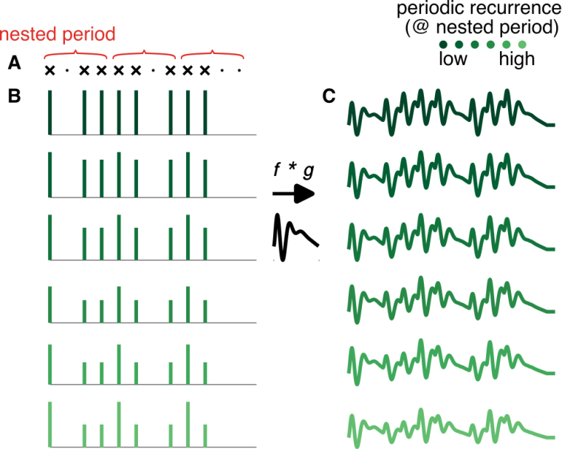

**Figure 1**. Generating signals corresponding to a repeated rhythmic pattern with various amounts of periodic recurrence nested within the pattern cycle. (**A**) One cycle of a rhythmic pattern comprising 12 equally-spaced grid points that can either contain an event (shown as “x”) or not (shown as “.”). (**B**) Rhythmic pattern projected into real time series with Dirac impulses placed at the positions of events. The amplitudes of the individual impulses can create periodic recurrence nested within the pattern cycle, as shown in red on the top. The prominence of this nested recurrence is gradually increased from top row to the bottom. (**C**) The impulse time series are convolved with a unitary kernel (middle). The resulting signal retains the level of periodic recurrence generated by the amplitude variations of impulses shown in B.

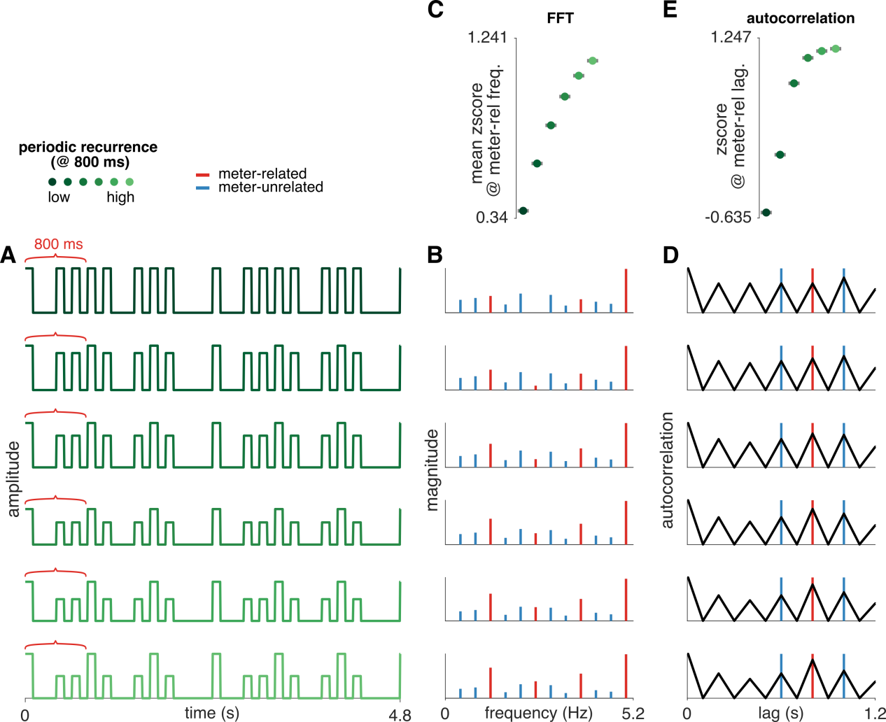

**Figure 2**. Sensitivity of FTT and autocorrelation to the level of periodic recurrence in a continuous signal. (**A**) Two out of sixteen cycles of a repeating pattern are shown. The pattern is generated as illustrated with Figure $, using a square wave kernel and time interval between successive grid points equal to 200 ms. Thus, the duration of one rhythm cycle is 12 * 200 = 2400 ms. Within the pattern cycle, a nested periodicity spanning 4 grid points, i.e. 4 * 200 = 800 ms is created by periodically enhancing the amplitude of every 4th event in the pattern. (**B**) FFT of the corresponding time-domain signal on the left. The spectra contain energy at the frequency corresponding to the inverse of pattern repetition period (1 / 2400 ms = 0.416 Hz) and harmonics. Meter-related frequencies in red capture the prominence of the nested periodic recurrence. These are tagged as 1 / 800 ms = 1.25 Hz and harmonics. As shown in panel **C**, the prominence of meter-related frequencies in contrast to meter-unrelated frequencies grows as periodic recurrence at 800 ms is increased in the signal. (**D**) Autocorrelation function of the corresponding time-domain signal on the left. Lag corresponding to the periodic level at 800 ms nested within the pattern cycle is highlighted in red. Two lags in blue were used for normalization. These lags are not multiples of 800 ms but correspond to multiples of the time interval between successive grid points which were used to generate the rhythmic pattern (3 x200 = 600 ms and 5 x 200 = 1000 ms). The autocorrelation values across the three lags are z-scored and the z-score for the 800-ms lag is taken as a measure of periodicity nested within the pattern cycle, spanning 4 grid points. Panel **E** shows that the z-scored autocorrelation at 800 ms grows as periodic recurrence at this rate is gradually increased in the signal.

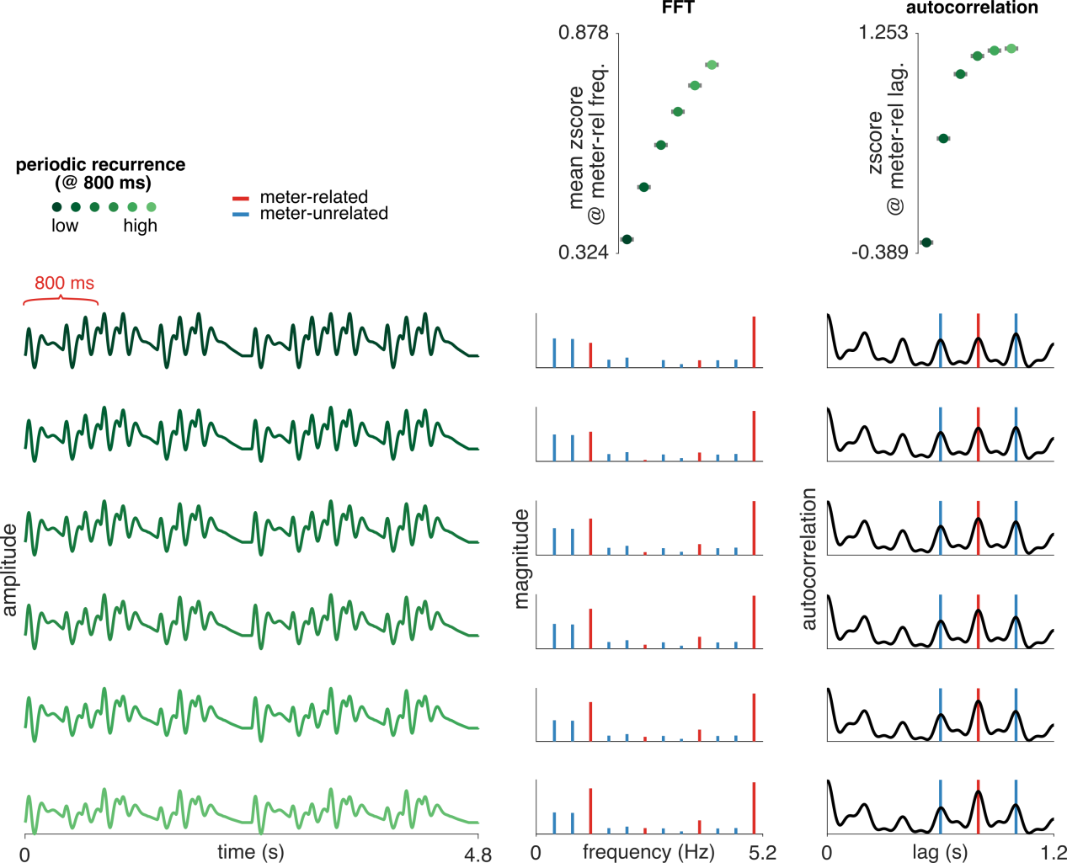

**Figure 3**. Sensitivity of FTT and autocorrelation to the level of periodic recurrence in a continuous signal. Same as Figure $, but using a unitary event kernel with a more complex shape.

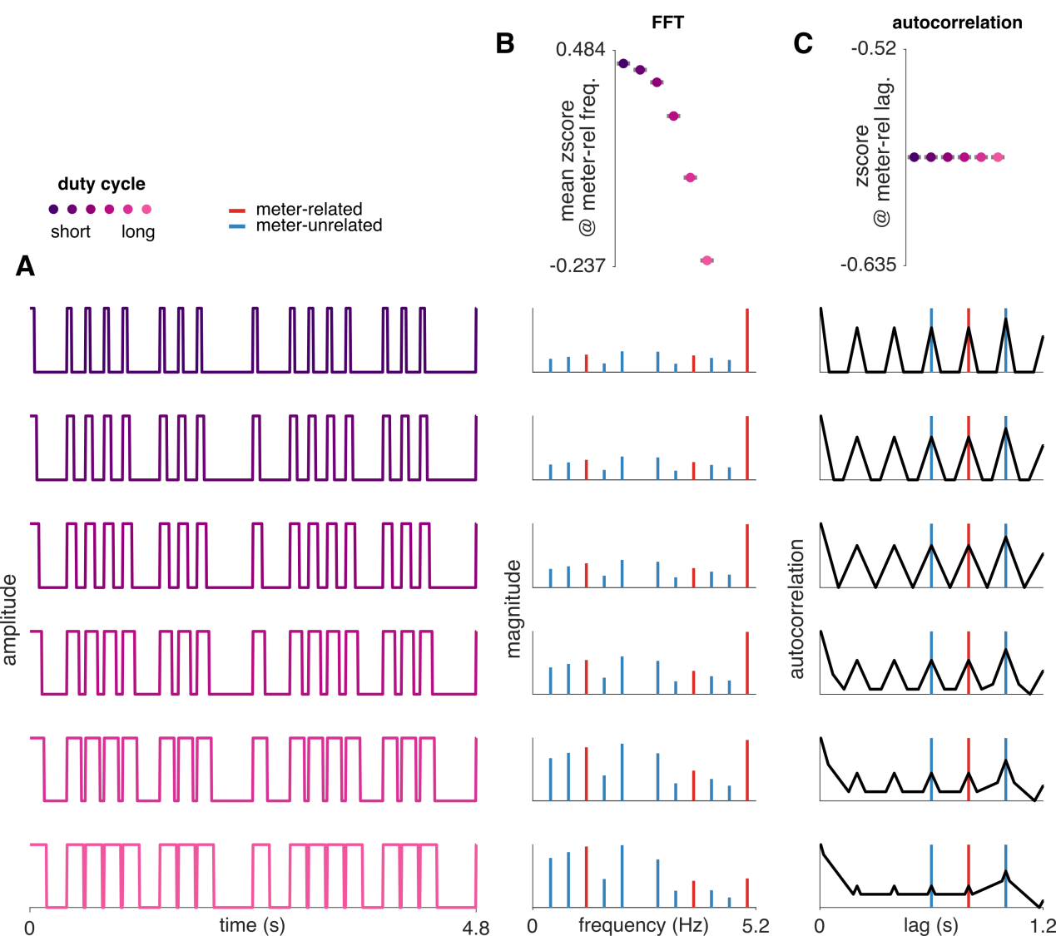

**Figure 4**. Effect of unitary event shape on measures of periodic recurrence. (**A**) A rhythmic pattern was used to construct a continuous signal as described in Figure $. The kernel used to generate the signal was a square wave with an increasing duty cycle across conditions. Importantly, the periodic recurrence at the levels nested within the pattern repetition period was constant. (**B**) The mean z-scored FFT magnitude at harmonics of a nested period spanning 4 grid points (see Figure $) is biased by the duty cycle. (**C**) The z-scored value taken from the autocorrelation function remains invariant across different duty cycles.

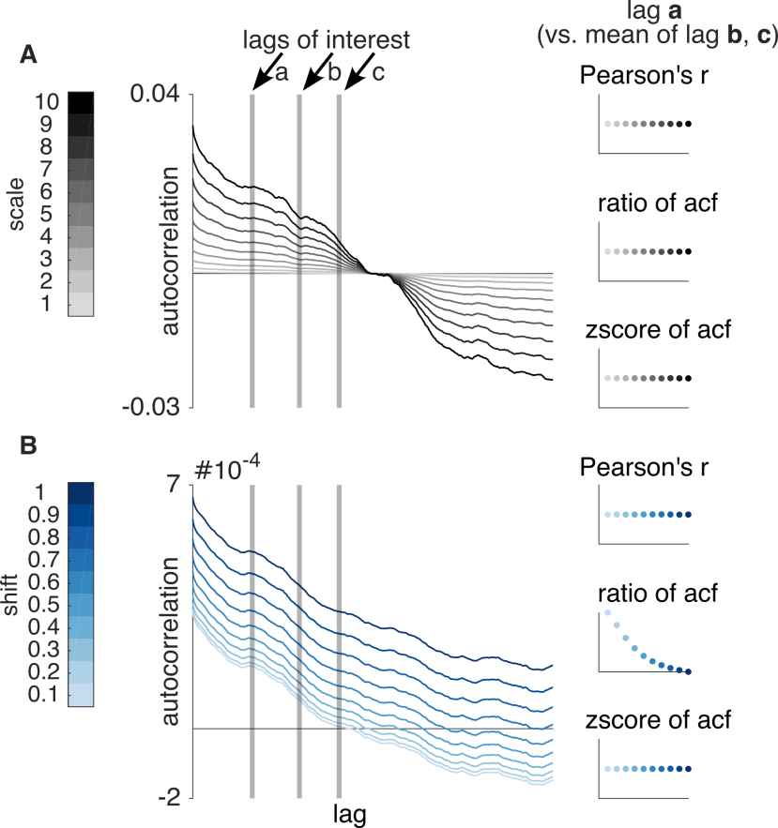

**Figure 5**. Bias of autocorrelation values by shift and scale of the time-domain signal. (**A**) An identical random signal was multiplied by a different constant in the time domain to change its scale. Pearson’s correlation of the signal with a version of itself delayed by a lag “*a*” remains constant across scales. The same is observed when taking the autocorrelation function value at lag “*a*” and dividing by the mean value at lags “*b*” and “*c*”. Similarly, z-scoring the autocorrelation values across lags “*a*”, “*b*”, and “*c*”, and then taking the z-score value at the lag “*a”* is invariant to scale. (**B**) Random signal analyzed after adding a constant in the time domain to change its shift (or offset). While Pearson’s correlation and z-score at lag “*a*” remain invariant to the magnitude of the shift, the ratio of autocorrelation values at “*a”* / mean of “*b*” and “*c*” is biased.

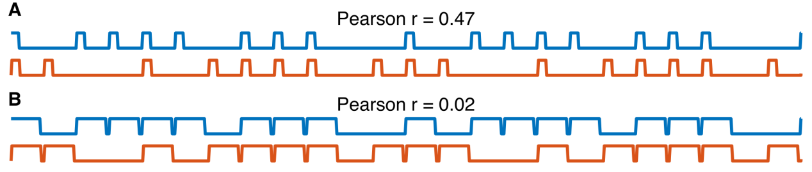

**Figure 6**. Pearson’s correlation is affected by the shape of the unitary event. An identical rhythmic pattern was used to generate a continuous signal using a square wave with a short (A) or long (B) duty cycle as a unitary event. The original signal is shown in blue, and a version cyclically shifted by 4 events is shown in orange. The Pearson correlation of the original and shifted signal significantly changes depending on the duty cycle of the unitary response.

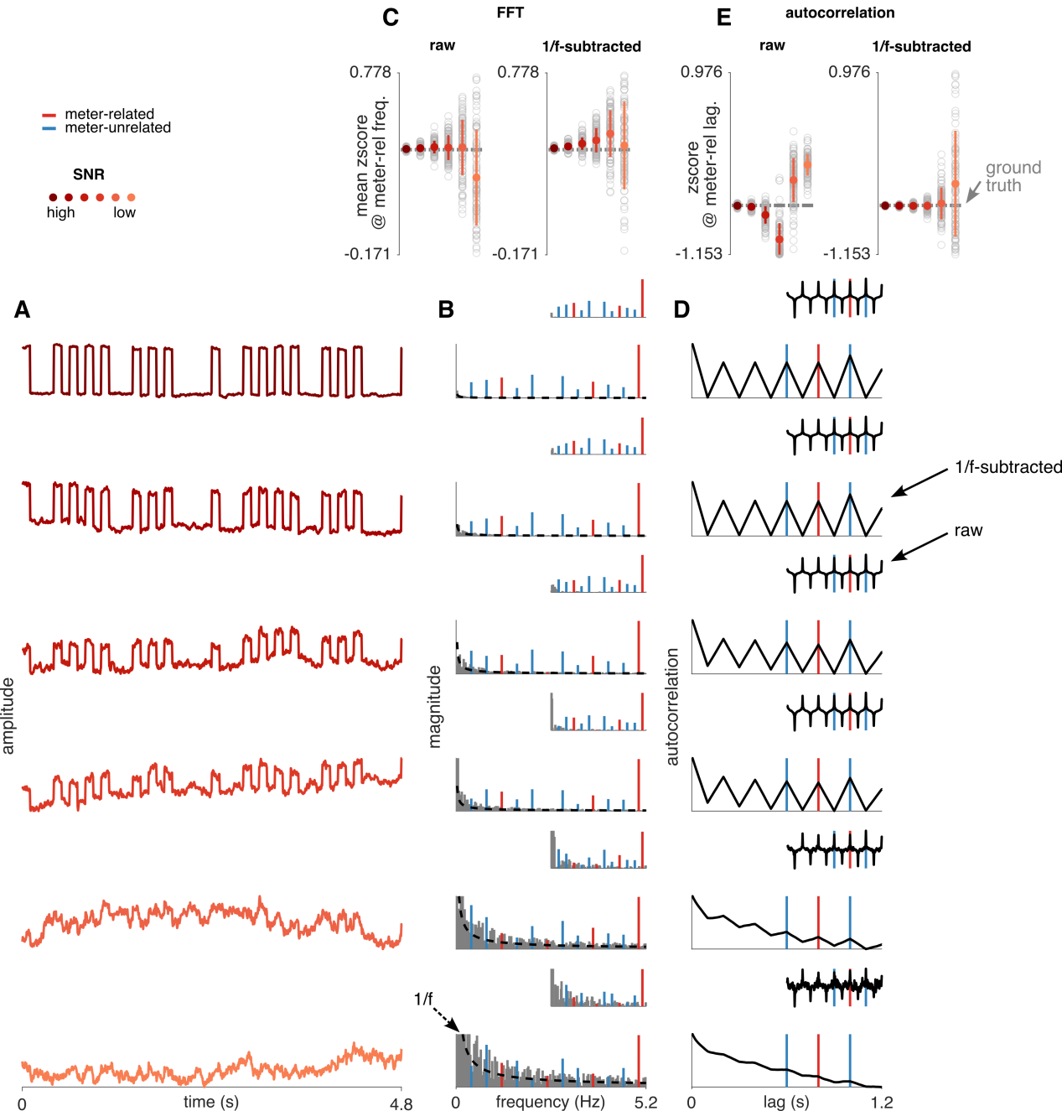

**Figure 7**. Accounting for 1/f-like noise. (**A**) 1/f noise with various amplitudes was added to identical time-domain signals. The signals were generated as described in Figure $ and $. The noise had an exponent of -1.5. (**B**) FFT of the corresponding signals on the left. The insets show spectra normalized by subtracting the mean magnitude at bins 2 to 5 on both sides of each frequency bin. The fit of the 1/f noise is shown as a dashed black line. Note that this fit was not used to normalize the spectra, but to obtain a normalized estimate of the autocorrelation function (shown in the insets of panel D). (**C**) The signal and noise were generated 100 times, and the mean z-score at meter-related frequencies (corresponding to harmonics of 1 / 800 ms) was calculated each time. The resulting values are shown as grey points, with the mean and standard deviation in color. The variance and bias of the estimate grows with the magnitude of the added noise. (**D**) Autocorrelation function of the corresponding signals on the left. The autocorrelation after normalizing by the estimated 1/f noise model is shown as an inset. (**E**) Relative prominence of the lag at 800 ms is shown as z-scores. Note that using noise with larger amplitude increases the bias and variance of the estimated z-score across 100 repetitions. However, normalizing the autocorrelation mitigates this issue unless the noise has very large amplitude (and thus cancels out most of the signal).

# Intracerebral data

Only electrodes responsive during listening (evaluated separately for each rhythm) were used.

We used meter-related lags 0.4, 0.8 s, and meter-unrelated lags 0.2, 0.6, 1.0 s. All the conclusions from the simulations above hold for such a selection of frequencies.

## Chang atlas (Jacques labeling)

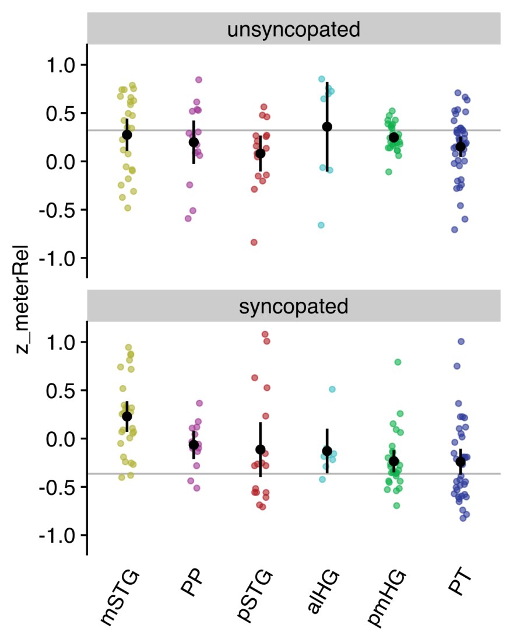

**pmHG**

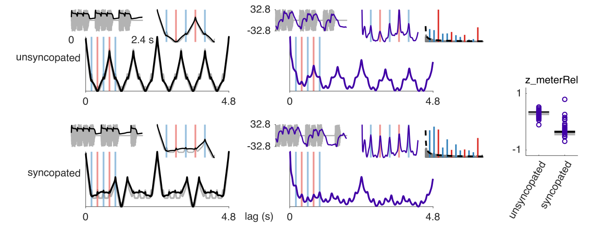

**PT**

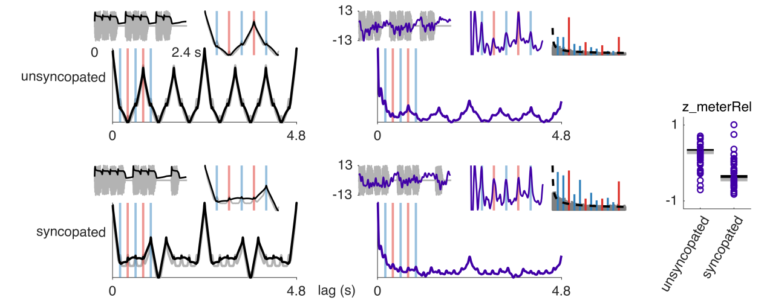

**pSTG**

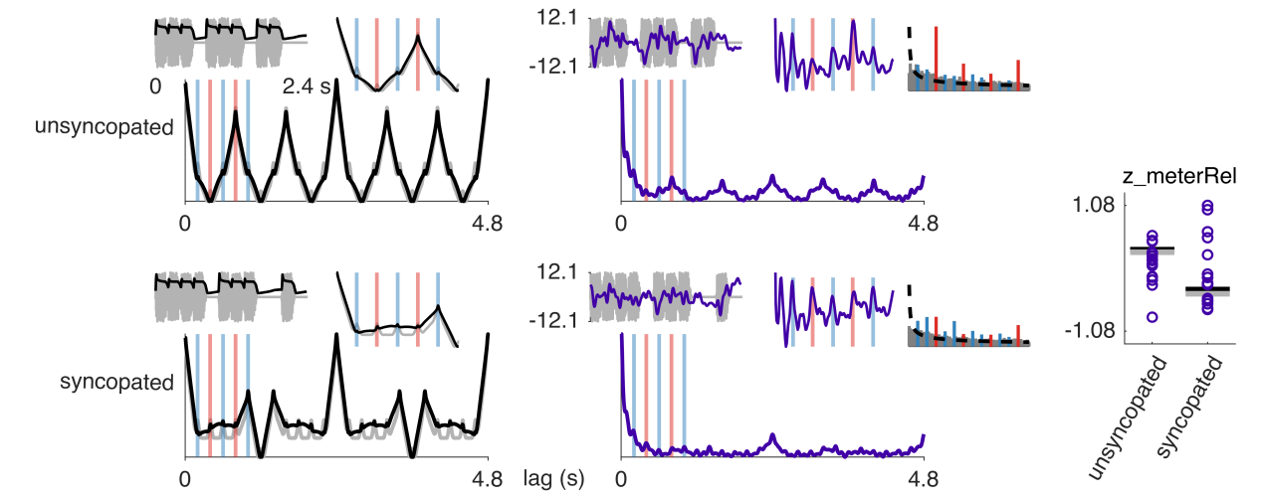

**alHG**

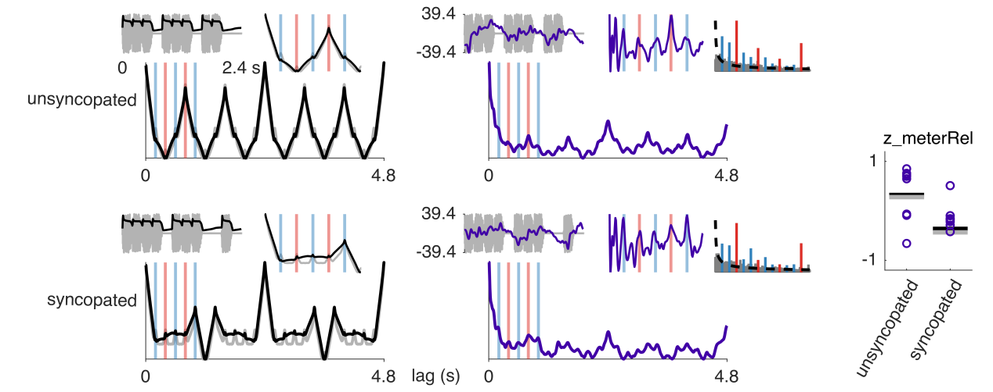

**PP**

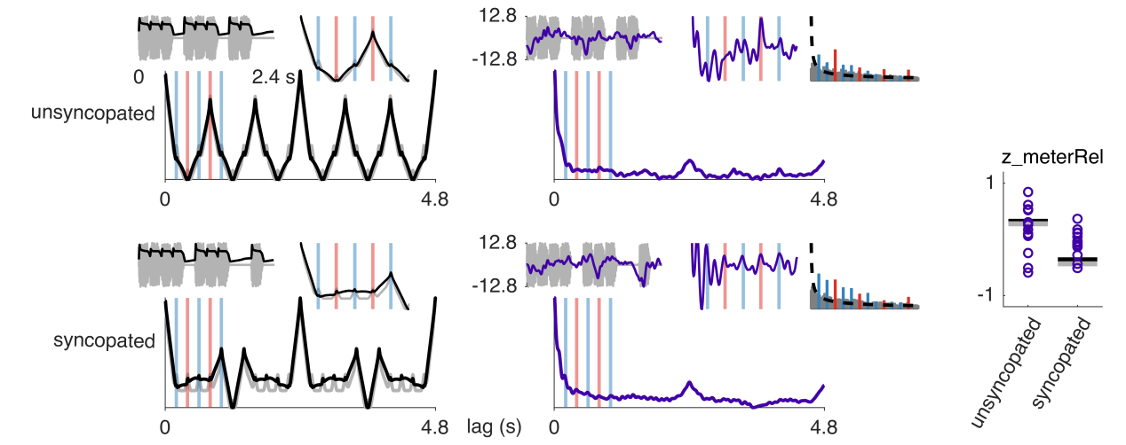

**mSTG**

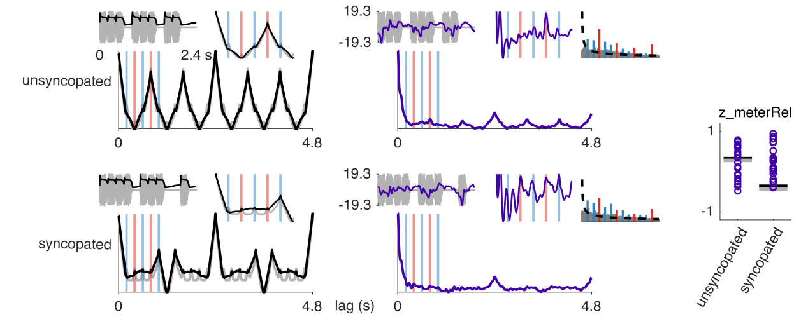

## Desikan-Killiany (automatic labeling)

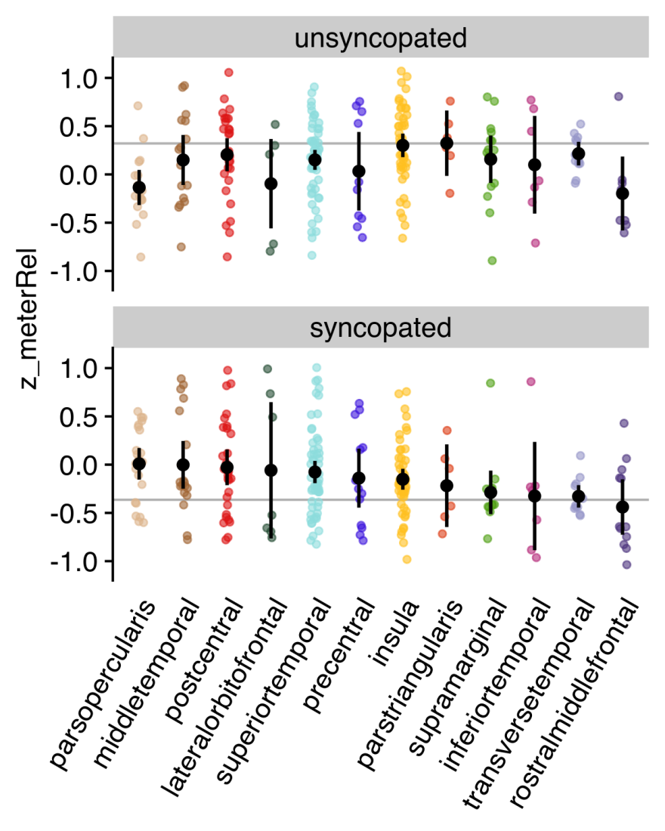

1. The “same” meter means that the periods of the individual pulse levels constituting the meter have the same nesting relations.