# Relationship between measures of rhythmic degradation in the rhythmic stimulus

In the current set of simulations, we used rhythmic sequences from the study of Lenc et al. (2020). Please see that paper for additional details about the construction and properties of these sequences.

First, we analyzed the rhythmic sequences. For each trial and segment, we calculated syncopation score based on Povel & Essens (PE; grouping by 4 events) and Longuet-Higgins & Lee (LHL; {2,4} meter) algorithm (Longuet-Higgins and Lee 1984; Povel and Essens 1985). This was done for 5 different phases, by circularly shifting the segmented window by -2, -1, 0, 1, and 2 events. Across these phases, minimum syncopation score, and the range of syncopation scores (max - min) were taken. While minimum syncopation score measures rhythmic degradation with respect to a given meter by assuming that the induced meter follows the “path of least resistance”, the range of syncopation scores shows the stability of the induced meter across phases. Because syncopation scores depend on the contrast between the number of sounds on- vs. off-beat, and because the total number of sounds was fixed here, it is unsurprising that the two measures are correlated. As the number of on-beat sounds decreases, the sound events are placed off-beat to retain the total number of sounds. At a certain point, sounds are equally distributed across on- and off-beat positions. This is the highest level of degradation that can be achieved when constructing rhythmic sequences on an isochronous grid. Moving even more sounds to off-beat positions would result in consistent accumulation of sounds at positions favoring other beat phase than the one assumed, and slowly decreasing the syncopation score for this other beat phase.

Moreover, we calculated DFT of the grid-representation for each segment (representing silences as 0s and sounds as 1s), and took the mean magnitude at frequencies with periods corresponding to 2 and 4 events (see Amiot 2016; Chiu 2018 for a similar approach). This approach is similar to LHL in the sense that multiple pulses can be taken into account, as opposed to just one pulse (e.g. PE). At the same time, the phase relations between the pulses are not fixed (as in LHL), which can be seen as a downside, as only pulse-sets in relation of inclusion can constitute a meter. At the same time, the fact that “best” phase of each pulse is directly estimated by the transform, no phase-shifting of the rhythmic input is required during analysis. This measure closely correlated with the PE and LHL syncopation scores.

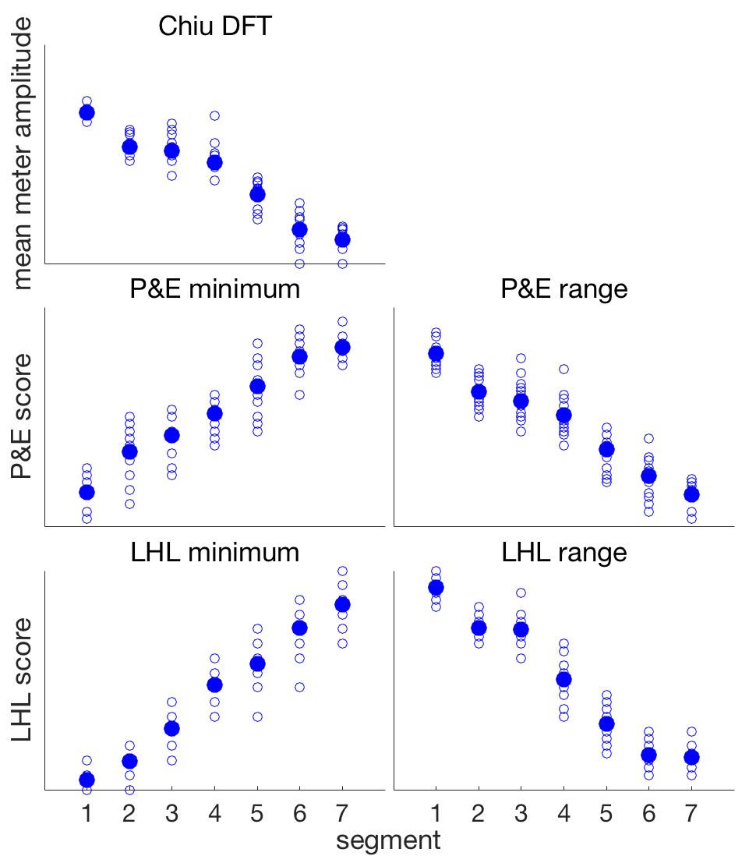

**Figure 1**. Different measures of degradation shown over successive segments, as the sequences changed from regular to degraded. Empty circles represent individual trials and full circles represent means across 15 trials.

# SIMULATION

# Methods

To assess the sensitivity of different frequency-domain measures to degradation of the rhythmic input, we simulated EEG response to the 15 sequences in 20 participants, and analyzed the response separately for each segment. The simulation was based on an assumption that the brain is a LTI system driven by onsets (acoustic edges) in the auditory input.

We simulated three conditions. In the *“no-emphasis” condition* the neural response was faithfully tracking the input. In the *“consistent-emphasis” condition*, the neural response was emphasized at time-points corresponding to pulse with period of two events (even when no sound event was present in the input at these time-points). Across trials the emphasized pulse was consistently aligned to the first event in the input. Finally, in the *“random-emphasis” condition*, the beat alignment with respect to the input was randomly selected for each trial. The neural emphasis was simulated with three different levels of prominence (0.05, 0.1, 0.3).

The internal representation of the rhythmic sequence was converted into a simulated EEG response by convolving it with an ERP-like impulse response (see e.g. van Diepen and Mazaheri 2018).

## Frequency-domain analyses

*FFT time average*. The simulated EEG response for each segment was averaged in the time-domain across trials, and transformed into the frequency domain using FFT. Mean amplitude at neighboring FFT bins 2 - 3 on each side were subtracted to separate signal and noise in the frequency-domain.

*FFT frequency average*. The EEG response for each segment was first transformed into the frequency domain separately for each trial, and FFT magnitudes were averaged across trials. Mean amplitude at neighboring FFT bins 2 - 3 on each side were subtracted to separate signal and noise in the frequency-domain.

*ITPC*. The EEG was transformed into the frequency domain separately for each trial, the phase angle was estimated from complex Fourier coefficients, and vector average was taken across trials. The resulting vector length represents inter-trial phase coherence (ITPC).

The estimates used for all three measures above were extracted from FFT bins centered at three meter-related frequencies (1.25, 2.5, 5 Hz), corresponding to periods of 4, 2, and 1 events respectively. For some analyses, the estimates across the three meter-related frequencies were averaged.

# Results

## Amplitude but not ITPC is sensitive to stimulus degradation

First, we discuss only the no-emphasis condition, shown *in green* *in* *the top row* across Figures 2, 3, 4, and 5.

For this condition, the measures of mean magnitude at meter-related frequencies gradually decreased as the degradation in the input progressed (Figure 2). However, ITPC did not show clear decreasing trend, but was similar across segments. This is because as long as there is a beat phase favored in the stimulus by consistently having more sound events at this phase, the FFT phase estimate will be identical across trials.

Importantly, the effect on FFT magnitudes was present irrespective of how the data was averaged across trials (in the time-domain, or magnitudes in the frequency-domain). This shows that as long as the phase favored in the stimulus is kept constant across trials (as revealed in the ITPC), the averaging method does not change the comparison across different levels of input degradation.

Further insight can be achieved by looking at the individual meter-related frequencies to see how they contribute to the averaged values analyzed above. As shown in the top row of Figure 3, the ITPC at 5 Hz was constantly 1 across segments (note that the green line overlaps with purple). However, ITPC at 2.5 Hz was constant at 1, and only decreased in the last two segments (see Figure 4). This can be explained by very small (practically zero) magnitude at 2.5 Hz in these segments, making the phase estimates random across trials. For 1.25 Hz, the magnitude was near zero in most segments, as shown in Figure 5. Consequently, the ITPC is low across segments for this frequency. Together, this shows that there is no systematic way that ITPC can be related to rhythmic degradation, and thus ITPC does not represent a sensitive measure of temporal regularity or rhythmicity.

## Consistent neural emphasis increases magnitude at meter-related frequencies but has little effect on ITPC

Next, we analyzed the consistent-emphasis condition, which is showed across figures in yellow. Figure 2 shows that consistent on-beat emphasis resulted in increased FFT magnitude averaged across meter-related frequencies, when compared to no-emphasis condition (in green). This was the case in all segments, irrespective of input degradation. Mean ITPC at meter-related frequencies was not affected by neural emphasis when there was considerable energy at meter frequencies in the input (segments 1 to 6). In the last segment, consistent emphasis slightly increased ITPC, but only when the emphasis was stronger (row 2 and 3 or Figure 2). This can be explained by looking at individual meter-related frequencies. While ITPC at 1.25 and 5 Hz was not affected consistent emphasis at all, 2.5 Hz alone seemed to be driving the result at meter-related frequencies (see Figures 3,4,5). This makes sense, at the neural emphasis was at the exact frequency (corresponding to period of 2 events). Thus, in case of very small amplitude at 2.5 Hz in the input (in segments 6 and 7), the consistent neural emphasis of sufficient prominence can “take over” the phase estimates, making ITPC equal to 1.

## Effect of random neural emphasis on FFT magnitude

Next, we examined the effect of brain emphasis at the beat period when the alignment of this emphasis varied randomly across trials.

When averaging across trials in the time domain, random emphasis yielded greater magnitude at meter-related frequencies than no emphasis across all segments (Figure 2, left column). At the same time, this increase was always smaller than the one yielded by consistent emphasis.

Similar results were observed when FFT magnitudes were averaged across trials (Figure 2, middle column). However, the advantage of consistent over random emphasis disappeared for the most degraded segments (6 and 7). This result can be better understood by looking at individual meter-related frequencies. At 1.25 Hz, the emphasis had no effect (Figure 5), thus this frequency did not contribute to the effect at all. At 2.5 Hz (Figure 4), only consistent emphasis lead to increased magnitude in segments 1 to 5, but for the two most degraded segments, the random emphasis yielded equivalent magnitude increase (when compared to no-emphasis condition). This can be explained by the fact that in segments 1-5 the input prefers a particular phase at 2.5 Hz. However, in random-emphasis condition, there are trials where the neural emphasis is anti-phase to the input-preferred phase (approximately half the trials). Thus, the destructive interference for these trials cancels out the magnitude increase that is otherwise observed in the condition where the phases of input and neural emphasis are consistently aligned. However, when there is almost no amplitude at 2.5 Hz in the input (segments 6 and 7), there is also no preferred phase. Thus the phase of the neural emphasis becomes irrelevant as long as FFT magnitudes are averaged across trials. When averaging across trials in the time-domain, the contribution of neural emphasis at 2.5 Hz cancels out, but the second harmonic of this emphasis (at 5 Hz) remains increased. This can be seen in Figure 3, which shows that consistent and random emphasis resulted in comparably increased magnitude at 5 Hz across all segments.

Taken together, this explains the effects observed for averaged magnitude at meter-related frequencies (Figure 2). In the first five segments, the increase due to random emphasis is driven solely by 5 Hz (second harmonic of beat frequency). In these segments, the consistent condition yields greater increase due to additional contribution of 2.5 Hz. In the last two segments, the analysis method matters. While time-domain averaging remains sensitive to consistency of the emphasis, frequency-domain averaging results in equivalent magnitude increase for consistent and random emphasis.

## Effect of random neural emphasis on ITPC

As shown in Figure 2, random emphasis resulted in decrease of mean ITPC across meter-related frequencies for segments with high degradation. In fact, this decrease happened earlier when the neural emphasis was more prominent (Figure 2 row 2 and 3). This effect was solely driven by 2.5 Hz, as ITPC at 1.25 and 5 Hz was completely independent on neural emphasis (see Figures 3,4,5). This effect can be explained by interplay between the magnitude at 2.5 Hz in the input and in the neural emphasis. If the input has large amplitude at 2.5 Hz relative to the neural emphasis, the phase estimate for each trial will be dominated by the stimulus. And because the stimulus is phase-consistent across trials, the estimated ITPC will be close to 1. In the current dataset, this is the case for segments 1 to 5. However, when the magnitude at 2.5 Hz in the stimulus is low relative to the neural emphasis, the phase estimate will be dominated by the consistency of the neural emphasis. This will lead in high ITPC for consistent-emphasis and low ITPC for random-emphasis condition. In the current data, this can be observed in the more degraded segments.

## Lower signal-to-noise ratio has similar effect on ITPC as smaller magnitude of the input.

…



**Figure 2**. No noise, 1.25, 2.5, 5 Hz averaged. Subtracted FFT bins 2 to 3.



**Figure 3**. 5 Hz only.



**Figure 4**. 2.5 Hz only.



**Figure 5**. 1.25 Hz only.

# References

Amiot E. 2016. Music through Fourier space. Cham, Switzerland: Springer International Publishing.

Chiu MG. 2018. Form as meter: metric forms through Fourier space.

Lenc T, Keller PE, Varlet M, Nozaradan S. 2020. Neural and Behavioral Evidence for Frequency-Selective Context Effects in Rhythm Processing in Humans. Cereb Cortex Commun. 1:1–15.

Longuet-Higgins HC, Lee CS. 1984. The rhythmic interpretation of monophonic music. Music Percept. 1:424–440.

Povel D-J, Essens PJ. 1985. Perception of temporal patterns. Music Percept. 2:411–440.

van Diepen RM, Mazaheri A. 2018. The Caveats of observing Inter-Trial Phase-Coherence in Cognitive Neuroscience. Sci Rep. 8:2990.