**Carbon flow web model for Beagle Channel**

We developed a carbon flow model for the pelagic ecosystem of the Beagle Channel (BC) in a spring situation, focusing on two contrasting sites: the inner (western) and outer (eastern) channel. The former one receives an important terrestrial input from mountain rivers, runoff, and glacial melting; in spring there is a halocline around 50-80 m depth caused by the seasonal increase in freshwater inputs related to ice- and snow-melting processes (Giesecke et al. 2021). The outer channel receives less saline and colder waters coming from the inner BC through the Mackinlay pass that overlie saltier and warmer SAAW entering from the east. This generates a two-layer structure system with a shallow and sharp pycnocline. Due to its shallow bottom depths (mostly <40 m), the entire water column is frequently mixed by currents and wind action. Both total chlorophyll concentration and diatom biomass are lower here than in the inner BC (Iachetti et al. 2021).

We applied the Linear Inverse Modelling (LIM) methodology to estimate the carbon flows among the different compartments of the model.

The structure of the model is the same for both sites, comprising 10 compartments and 5 externals (Figure 1). The number of constraints might vary due to data availability.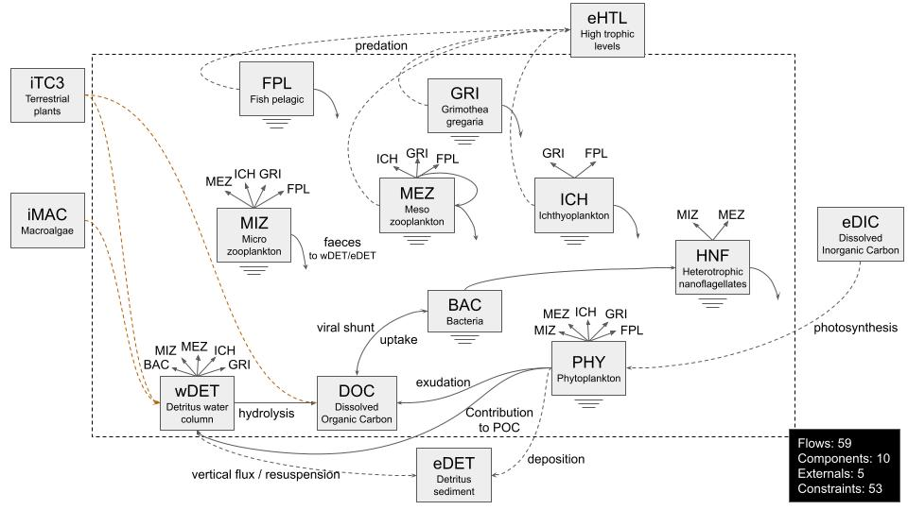

Figure 1. Conceptual diagram of the model, including compartments, externals and principal carbon flows and processes. The case for the inner BC is shown.

To date, we were able to build both models for the inner and outer sections of the BC, and gather sufficient data to obtain realistic but preliminary results for the inner BC (Figure 2).

Figure 2. Carbon flow estimations of the inner section of the Beagle Channel in a spring situation.

**References**

Giesecke, R., Martín, J., Pinones, A., Höfer, J., Garcés-Vargas, J., Flores-Melo, X., Alarcón, E., Durrieu de Madron, X., Bourrin, F., González, H.E., 2021. General hydrography of the Beagle Channel, a subantarctic interoceanic passage at the southern tip of South Ame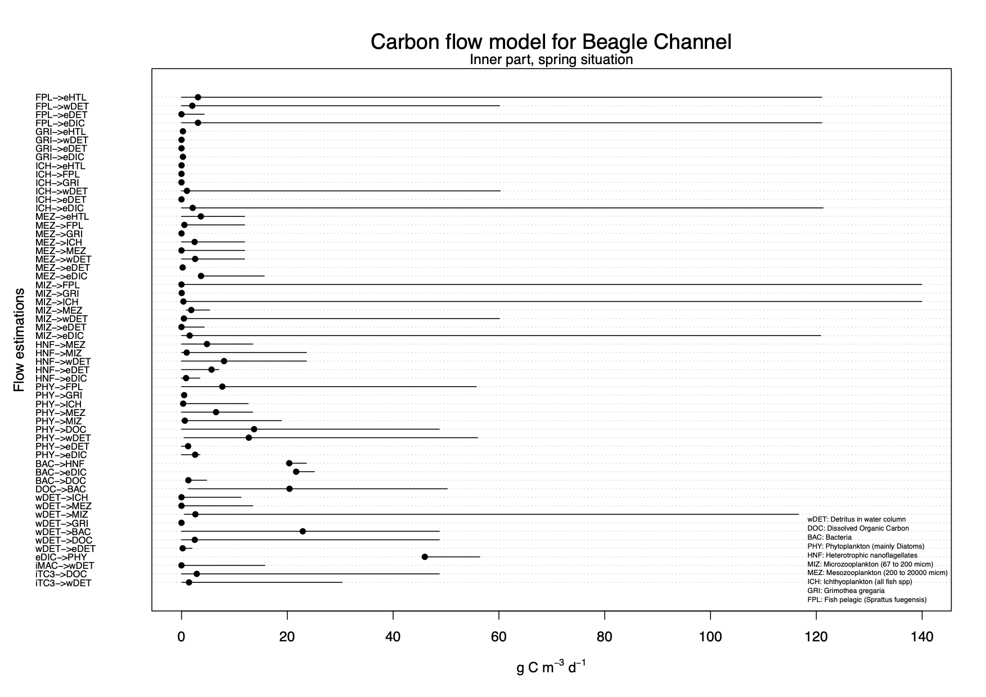rica. Front. Mar. Sci. 8, 621822 https://doi.org/10.3389/ fmars.2021.621822.

Iachetti, C.M., Lovrich, G., Alder, V.A., 2021. Temporal variability of the physical and chemical environment, chlorophyll and diatom biomass in the euphotic zone of the Beagle Channel (Argentina): evidence of nutrient limitation. Prog. Oceanogr. 195, 102576 https://doi.org/10.1016/j.pocean.2021.102576.