First Prompt
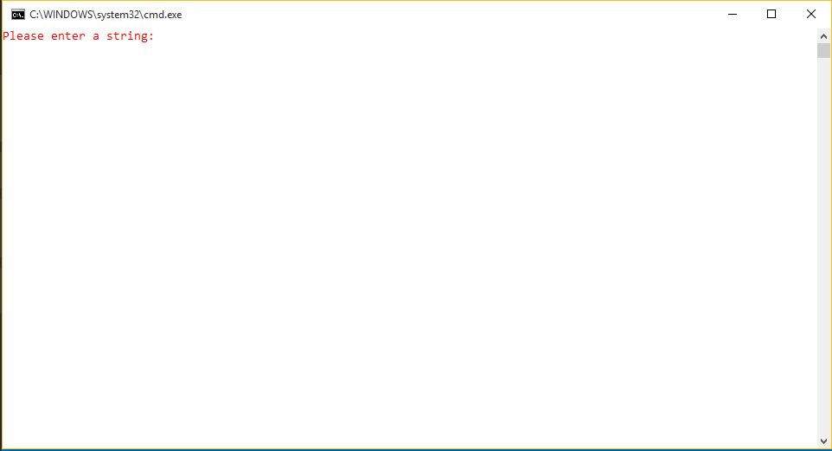
After Input
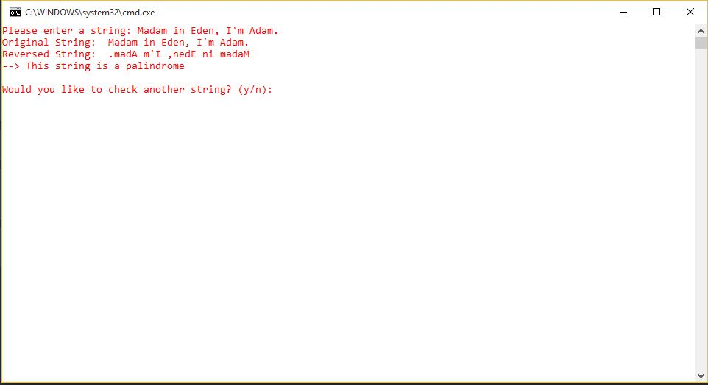

After Pressing 'Y' or 'y'
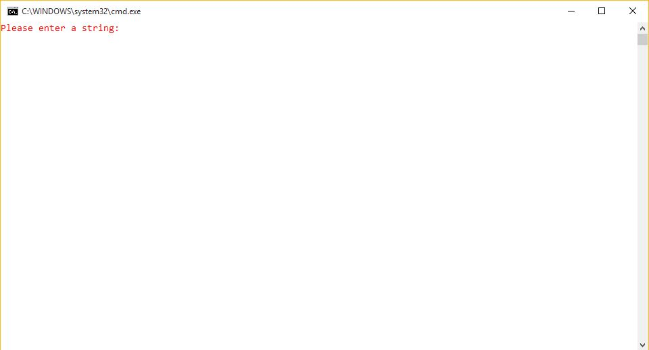
After 2nd Input
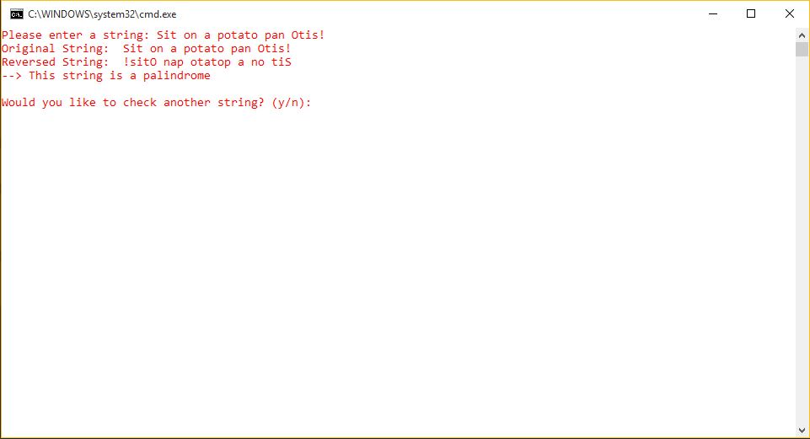

Not a Palindrome and Invalid Input
[Pressing anything but 'Y' or 'y' or 'N' or 'n' (Here 7x)]
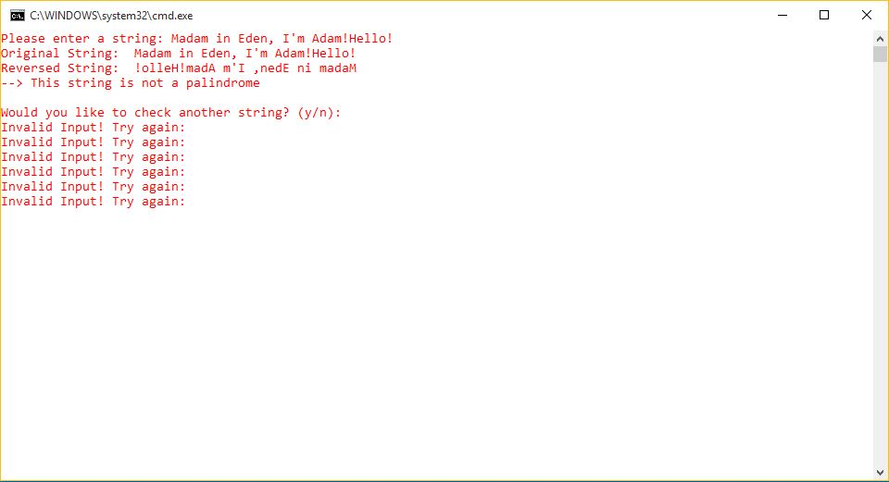
After Pessing 'N' or 'n'
