Assets MAP

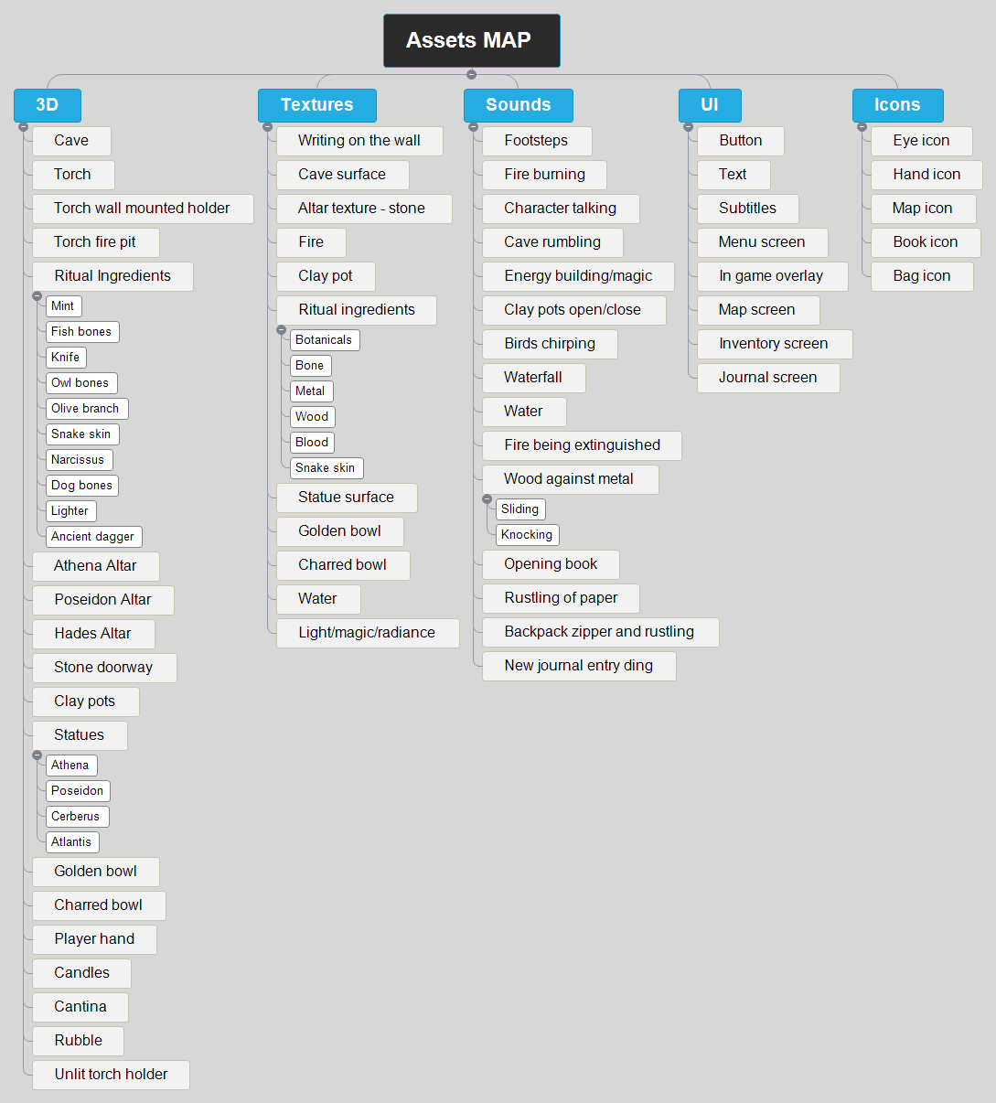

3D

Cave

Torch

Torch wall mounted holder

Torch fire pit

Ritual Ingredients

Mint

Fish bones

Knife

Owl bones

Olive branch

Snake skin

Narcissus

Dog bones

Lighter

Ancient dagger

Athena Altar

Poseidon Altar

Hades Altar

Stone doorway

Clay pots

Statues

Athena

Poseidon

Cerberus

Atlantis

Golden bowl

Charred bowl

Player hand

Candles

Cantina

Rubble

Unlit torch holder

Textures

Writing on the wall

Cave surface

Altar texture - stone

Fire

Clay pot

Ritual ingredients

Botanicals

Bone

Metal

Wood

Blood

Snake skin

Statue surface

Golden bowl

Charred bowl

Water

Light/magic/radiance

Sounds

Footsteps

Fire burning

Character talking

Cave rumbling

Energy building/magic

Clay pots open/close

Birds chirping

Waterfall

Water

Fire being extinguished

Wood against metal

Sliding

Knocking

Opening book

Rustling of paper

Backpack zipper and rustling

New journal entry ding

UI

Button

Text

Subtitles

Menu screen

In game overlay

Map screen

Inventory screen

Journal screen

Icons

Eye icon

Hand icon

Map icon

Book icon

Bag icon

# 3D

## Cave

## Torch

## Torch wall mounted holder

## Torch fire pit

## Ritual Ingredients

### Mint

### Fish bones

### Knife

### Owl bones

### Olive branch

### Snake skin

### Narcissus

### Dog bones

### Lighter

### Ancient dagger

## Athena Altar

## Poseidon Altar

## Hades Altar

## Stone doorway

## Clay pots

## Statues

### Athena

### Poseidon

### Cerberus

### Atlantis

## Golden bowl

## Charred bowl

## Player hand

## Candles

## Cantina

## Rubble

## Unlit torch holder

# Textures

## Writing on the wall

## Cave surface

## Altar texture - stone

## Fire

## Clay pot

## Ritual ingredients

### Botanicals

### Bone

### Metal

### Wood

### Blood

### Snake skin

## Statue surface

## Golden bowl

## Charred bowl

## Water

## Light/magic/radiance

# Sounds

## Footsteps

## Fire burning

## Character talking

## Cave rumbling

## Energy building/magic

## Clay pots open/close

## Birds chirping

## Waterfall

## Water

## Fire being extinguished

## Wood against metal

### Sliding

### Knocking

## Opening book

## Rustling of paper

## Backpack zipper and rustling

## New journal entry ding

# UI

## Button

## Text

## Subtitles

## Menu screen

## In game overlay

## Map screen

## Inventory screen

## Journal screen

# Icons

## Eye icon

## Hand icon

## Map icon

## Book icon

## Bag icon