In game overlay UI Design

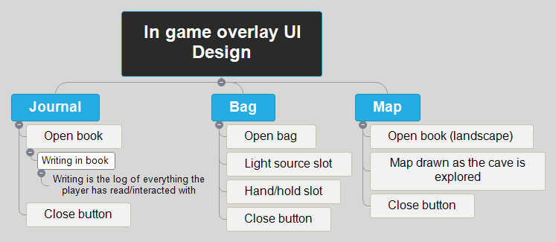

Journal

Open book

Writing in book

Close button

Bag

Open bag

Light source slot

Hand/hold slot

Close button

Map

Open book (landscape)

Map drawn as the cave is explored

Close button

# Journal

## Open book

### Writing in book

#### Writing is the log of everything the player has read/interacted with

## Close button

# Bag

## Open bag

## Light source slot

## Hand/hold slot

## Close button

# Map

## Open book (landscape)

## Map drawn as the cave is explored

## Close button