Aardvark:
DIY Fine Particulate Mask v0.4 (Current)
By Tomato Masks
Authors: Parsian Asgari, Allan Fernandes

Disclaimer
This is a ‘Do It Yourself’ open source mask and we are not liable or responsible in regards to its performance or characteristics or how it is used. Build and use this at your own risks.

NOTE: This is not a respirator.
WARNING: Masks can be dangerous to people with respiratory or heart problems.

Objective 2
Background 3
Filtration Mechanisms 3
Inertial Impaction 3
Diffusion 3
Electrostatic attraction 3
Design Requirements 3
Materials 4
Design 5
Fabrication 6
Operation 7
Testing 8
References 9

Objective
The objective here is to use available peer reviewed publication to design a mask that can be built at home with readily available materials and tools.

There is evidence that homemade masks may help with reducing the likelihood of infection but not eliminate the risk.1 The goal here is not to eliminate the chance of inhaling fine particulates, droplets and aerosol but provide an extra layer of protection to:

- Provide an extra barrier on the user’s face to reduce the chance of them touching their face
- Reduce propagation of particulates from cough and sneeze
- Through filtration, reduce the chance of inhaling some of the particles.
- To provide the best possible homemade solution as a last resort where alternatives are not accessible or reserved for frontline workers.

Background
The filtering systems used by respirators and masks have the ability to filter diverse particle sizes while maintaining breathability. Respirator filter design is always a tradeoff between breathability and filtration performance.

Filtration Mechanisms
There are three mechanisms involved in the filtration process of respirators and masks. These are inertial impaction, diffusion, and electrostatic attraction2:

Inertial Impaction
Particles with a diameter of 1 µm and larger have higher inertia due to their mass2. Such particles are less likely to change path as they propagate along the airstream. As airstream flows through filtering material, complex airflow patterns are formed and that increases the need for maneuverability of particles in order to fall through the gaps. High inertial particles have lower tendency to change direction as a result, they impact the fibres of the filter2.

Diffusion
Particles with a diameter of 0.1µm and smaller, have lower inertial and prone to influence by other particle interactions such as gas molecules. The momentum transfer leads to Brownian motion which increases the chance of collisions with the filter material’s fibres2.

Electrostatic Attraction
Statically charged filters use electrostatic force to attract flowing particles of various sizes2. Many respirators use permanently charged fibres to entrap particles. The mechanism reduces the need for dense and thick filtration.

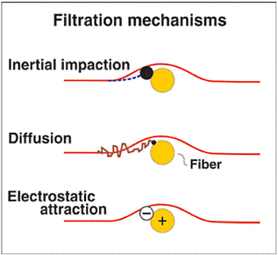
Figure 1: Filtration Mechanisms2

Efficacy of Homemade Masks

The efficacy of masks depends on filtering efficiency as well as its airtightness. Filtration depends on many factors such as the size of the particles, their velocity, filter material structure and composition. Despite the filter material’s capability to block fine particulates, goodness of fit of masks is also important as aerosols can find their way through gaps where the mask fails to seal the face.1

Filtration efficiency is a balance often comes at a cost of breathability. More dense materials tend to be less breathable and that has led to development of electrostatic filters.

Since homemade masks are made with accessible items, materials and tools and no testing mechanisms are there to validate their performance, homemade masks should not be used as a respirator. Homemade masks should be only used as a last resort as they provide little protection.1

Design Requirements
- Minimal tool and materials:
  - This mask needs to be manufacturable with most commonly found household items
  - Multiple options for materials should be available where possible.
- This mask should be as accessible as possible:
  - Easily constructible
  - Easy instructions to follow
  - Lowest possible material requirement
- This mask should provide the best possible fit and be as snug as possible.

Material Research
There are a few materials that can be used for filter and overall construction. The HEPA filters used by HVAC systems can be bought with PM 0.3 ratings. However, as such filters are not widely available and are expensive, alternative materials should also be pursued. Luckily, Cambridge University has done a study where they have ranked different household items in terms of their filtering capabilities.

In their research, Davies A et al,1 characterized a range of household materials and compared them with the material from a surgical mask from (Mo ¨lnlycke Health Care Barrier face mask 4239, EN14683 class I).

Filter Characterization
The researchers used circular cut outs of the materials and mounted them without any tension inside an airtight casing where the only entry point is through the material. They tested aerosol transport across each material. Through utilization of Henderson apparatus, the researchers delivered aerosols at a rate of 30L/min using the method of Wilkes et al,3 which is equivalent of 3 to 6 times per minute the ventilation of human at rest or doing light work but is less than 0.1 the flow of an average cough.1

In order to track filter material’s efficiency, the Cambridge University researchers used an apparatus to introduce the following microorganisms into the aerosol:

- Bacillus atrophaeus with size ranges of 0.95 -1.25 µm
- Bacteriophage MS2 with a diameter of 0.023 µm

Using the apparatus, these microorganisms were later collected from the aerosol prior to the passage and after the passage. They would then analyze the samples and compare the results with a control setup where no filters were present. They repeated the process 9 times per each filter material.1

Filter Efficiency
Davies A et al, then defined Filter Efficiency (FE) as the percent difference between colony-forming units (cfu) for upstream and downstream1 as:

Filter Breathability
The breathability was evaluated through measurement of the pressure drop across either side of the filter casing while clean aerosol was delivered. The pressure was measured using a manometer (P200UL, Digitron).1

Filter Performance
Davies et al study showed that all materials that were tested have some capability to block the microbial aerosols. However, across the board, the materials performed 10% worse for Bacteriophage MS2. Those materials that performed really well suffered from breathability with the exception of the surgical mask that was used as a control. In the study, double layering of some materials was also tested1:

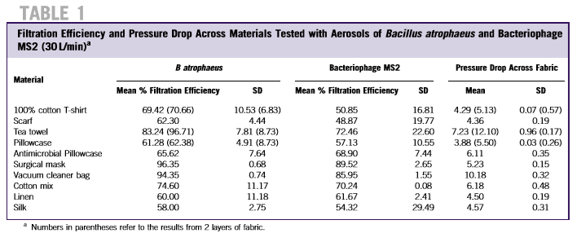
Source: Davies et al

All materials were clean and unused before. Due to the relatively decent filtering and breathability of 100% cotton, the authors concluded that this material is the best choice for homemade masks.1

Design
As per Davies et al study, it was decided to utilize 100% cotton as the main filtering material for this design. In order to meet the design requirements, several prototypes were built, and refinements were made iteratively.

The current design consists of an inner layer and an outer layer, all made out of 100% cotton fabric.

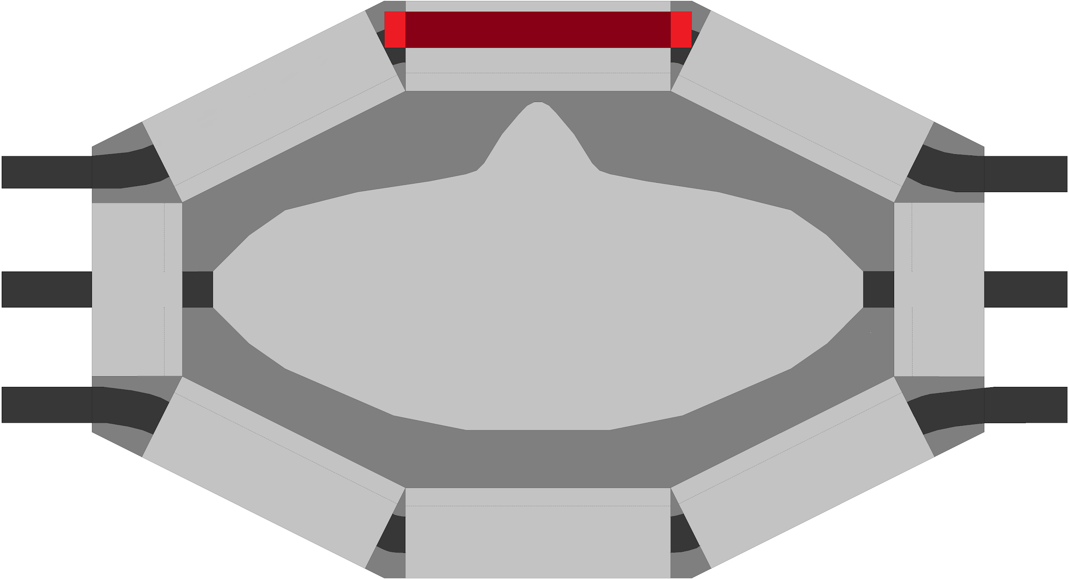
Fig 2: Concept - 100% Cotton Fine Particulate Mask

Inner Layer
An adjustable inner layer helps with the mask’s fitting to the shape of the face. The layer provides a tighter fit in conjunction with the outer layer. This layer has a pair of elastic bands made from 100% cotton. In addition, this layer acts as housing to hold an additional filter.

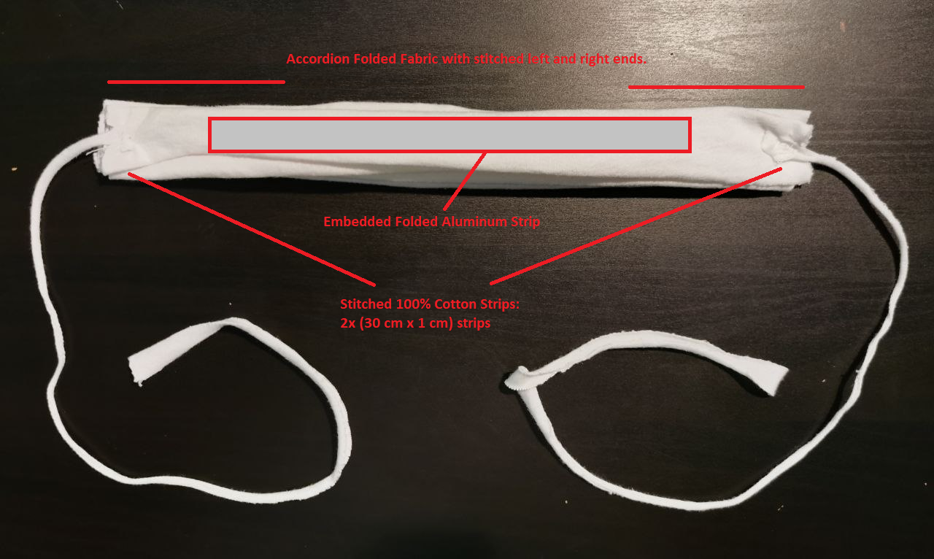
Fig 3a: Inner Layer -Top View (Red box: folded aluminum foil with size of 21 cm x 1 cm )

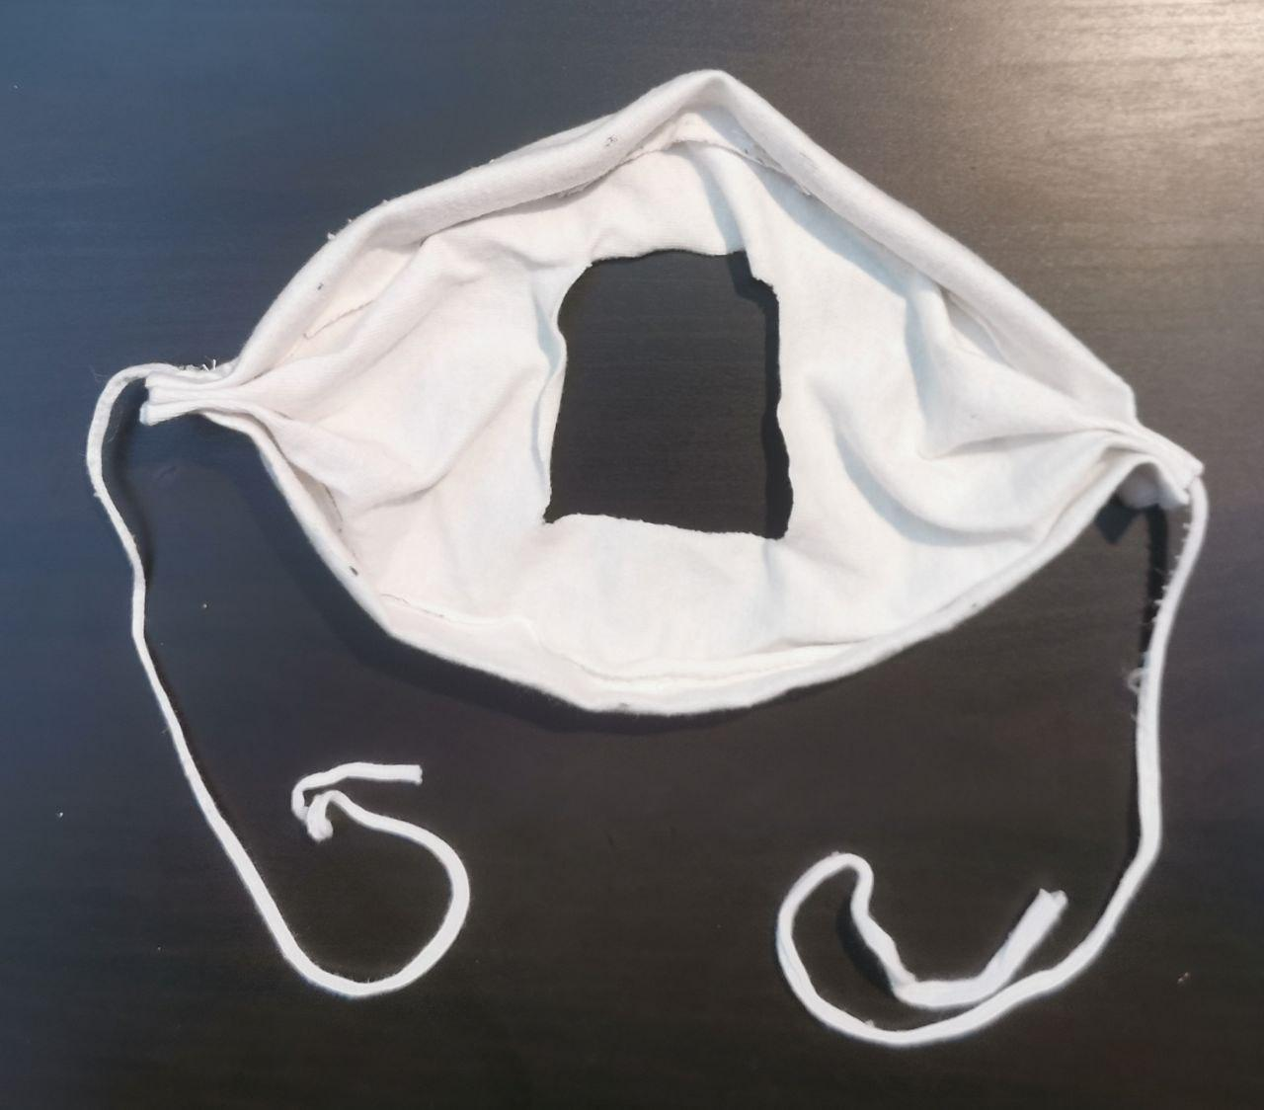
Fig 3b: Expanded Inner Layer - Inside View

Outer Layer
The main filtering is done through the outer layer. The outer layer helps to further close the gaps left by the first layer and also stabilizes the inner layer. The outer layer has two embedded elastic bands that enable tighter fitting.

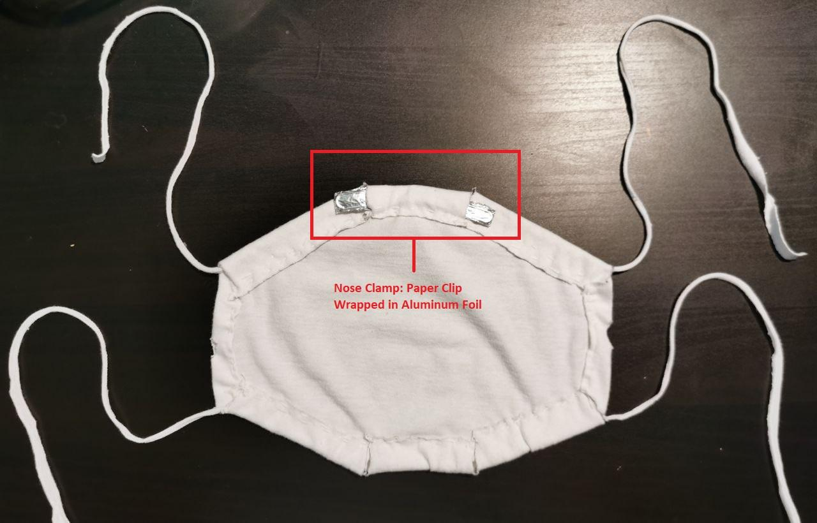
Fig 4: Outer Layer

Integrated Layers
The two layers are integrated via passing inner layer straps through two embedded holes in the outer layer. These straps then act as the middle bands of the mask.

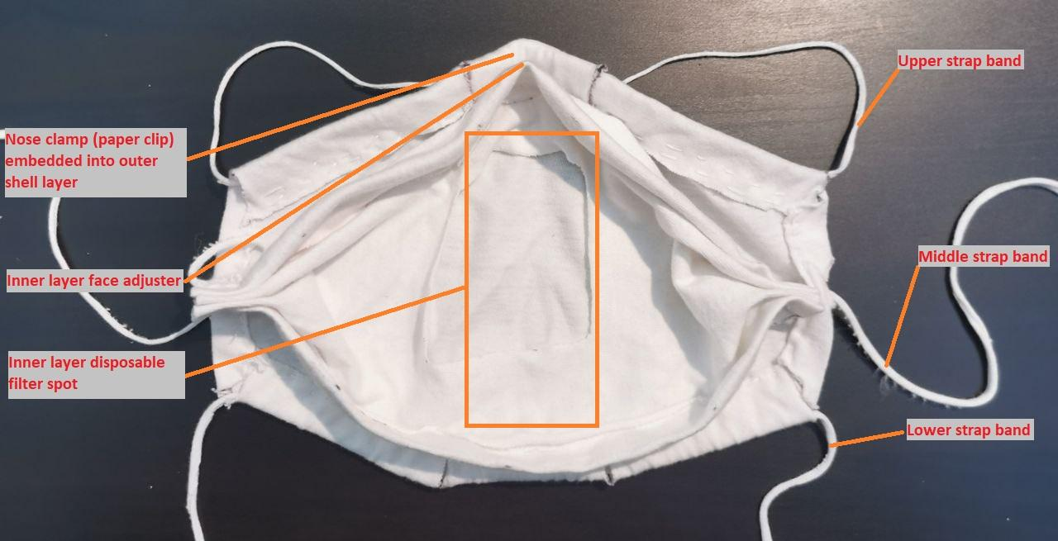
Fig 5: Actual 100% Cotton Fine Particulate Mask

Fabrication

Overview
The building instructions are broken down into:

- Preparation:
  - Size Selection
  - Materials
  - Tools
  - Layout
  - Fitting mechanisms
- Inner layer fabrication
- Outer layer fabrication
- Total Assembly
- Filter Installation

Preparation

Size Selection
Refer to Appendix 1 & Appendix 2 to identify the appropriate size for the mask you are building.

Materials

- 100% Cotton Fabric
  - Use an old (or new) 100% cotton clothing such as a shirt, t-shirt or button shirt:
    - 2x rectangles (29.7 cm x 21.0 cm: A4 size paper)
    - 2x strips (30 cm x 1 cm) (see Preparation section)
    - 2x strips (60 cm x 1 cm) (see Preparation section)

- Aluminum foil: A4 paper size (29.7 cm x 21.0 cm)
- Paper clips or alternatives such:
  - wires
  - Christmas ornament hangers (make sure to wrap it in aluminum foil)
  - aluminum can: cut strips (make sure to cover the edges)
  - folder fastener
  - twist ties
- Additional filter material such as:
  - Paper towel
  - Microfiber (better alternative than paper towel)
  - PM0.3 HEPA filter (Ideal but rare)
  - Surgical mask
- Optional:
  - elastic bands (2x 30 cm long strips + 2 x 60 cm long strips)
  - Shoelaces (2x 30 cm long strips + 2 x 60 cm long strips)

Tools
- Sewing needle and strand (Optional: If sewing machine is available, then use sewing machine)
- Scissors

Fitting Mechanism

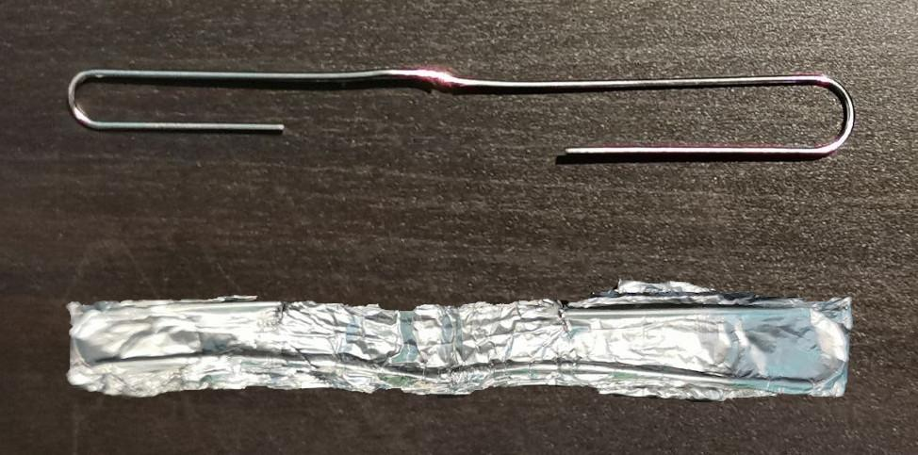1. Expand a large paper clip as shown above and wrap it in aluminum foil. Alternatively, use a piece of wire about 10-15 cm long. | 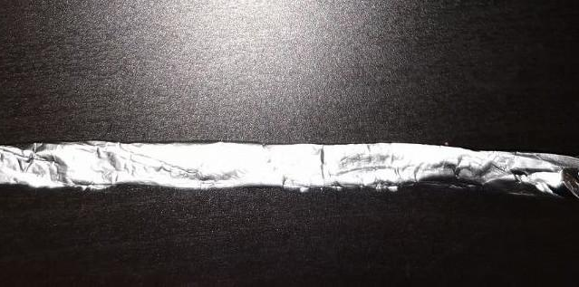2. Roll an A4 size paper (29.7 cm x 21.0 cm) aluminum foil along the height. The end result should be 0.8 cm - 1.0 cm thick and 21.0 cm long. This will be embedded into the fabric of the mask’s inner layer to assist with facial fitting.
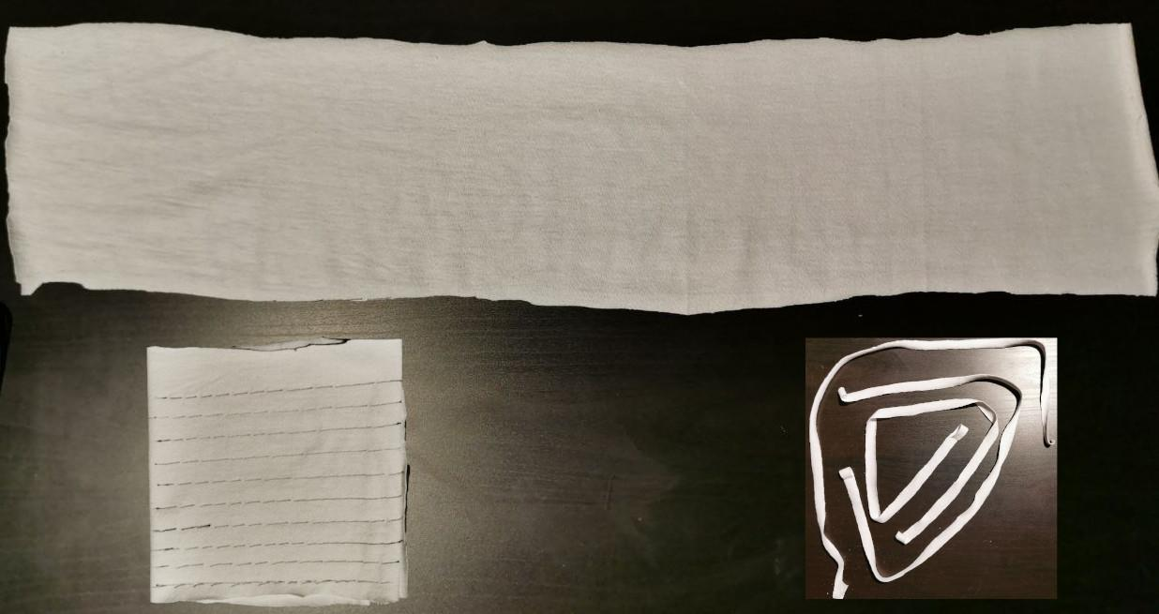
3. Cut a 60 cm x 6 cm rectangle from a 100% cotton fabric. Fold it along its length so that you end up with a 10 cm x 6 cm square. Use a ruler to draw parallel lines across its length with 1 cm gaps. These lines will be used as a guide for cutting. Once cuttings are done, you will end up with uniform strips each 60 cm length and 1 cm thick. Cut one or two of them in half to have one or two pairs of 30 cm x 1 cm strips.

Inner Layer
Proceed to Appendix 1.1 and select a size for the inner layer then proceed with the following steps:

0. This is the desired outcome | 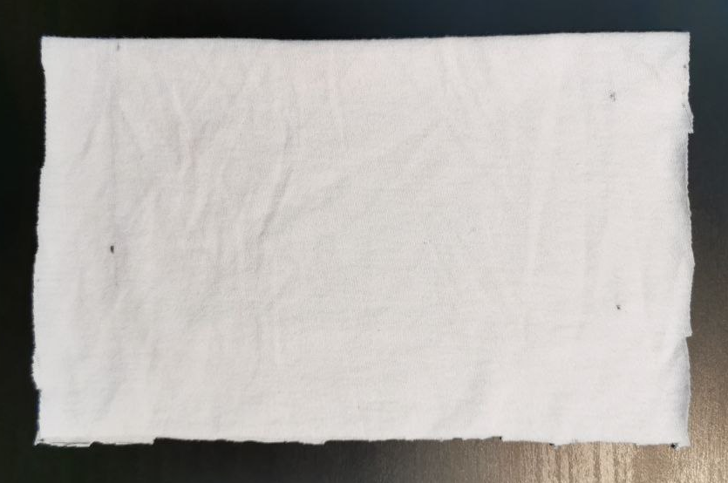  1. Cut the 100% cotton fabric into a rectangle based on the selected size (e.g. Large: 27 cm x 21 cm)
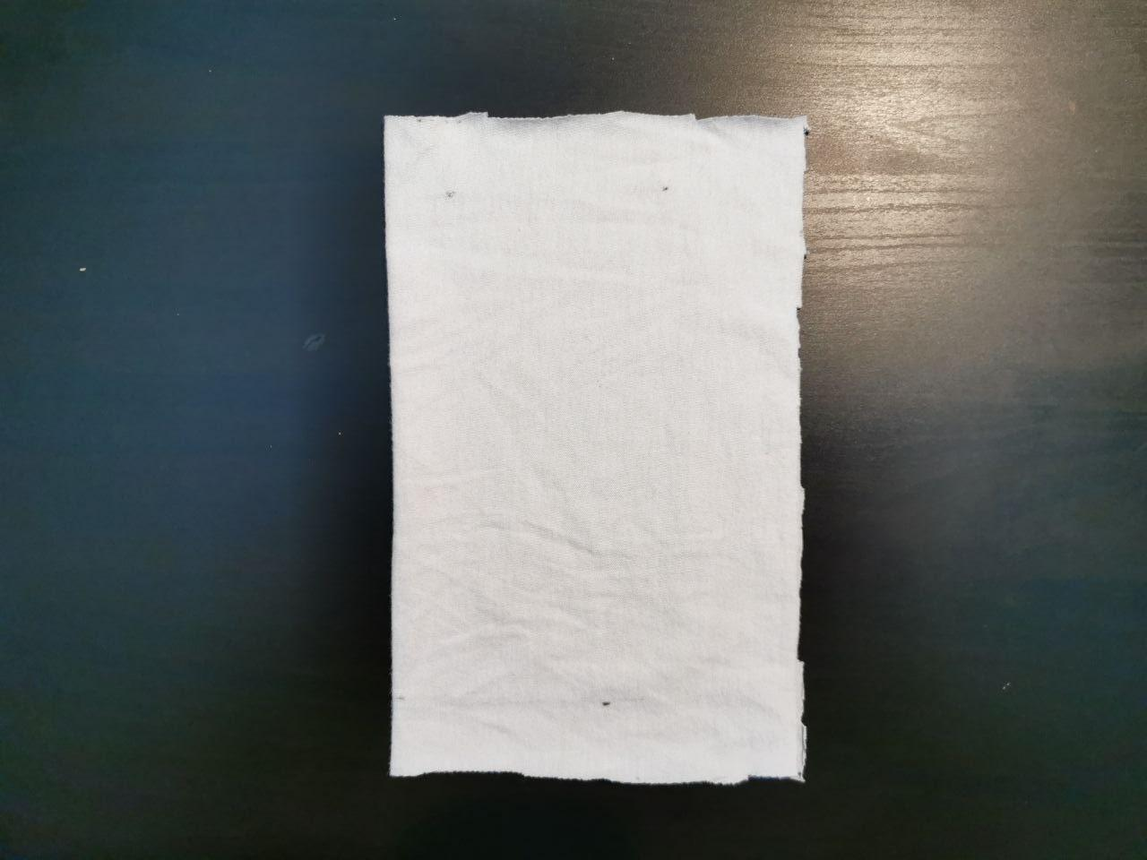  2. Fold the rectangle in half along the length | 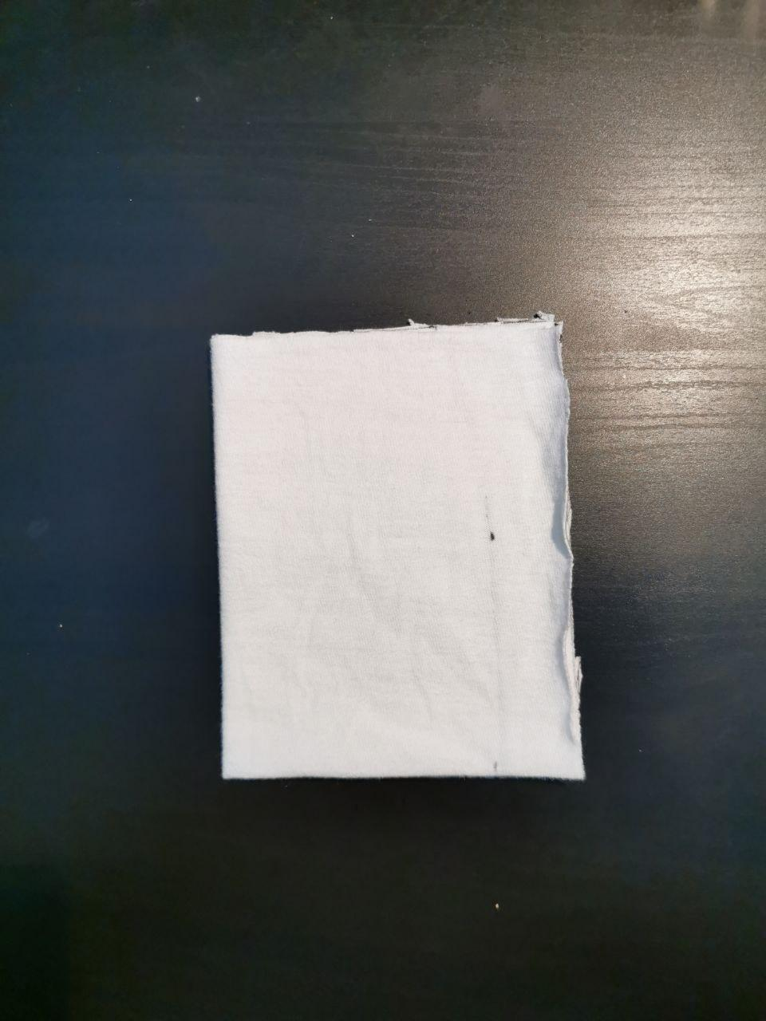  3. Fold the rectangle in half again along the height
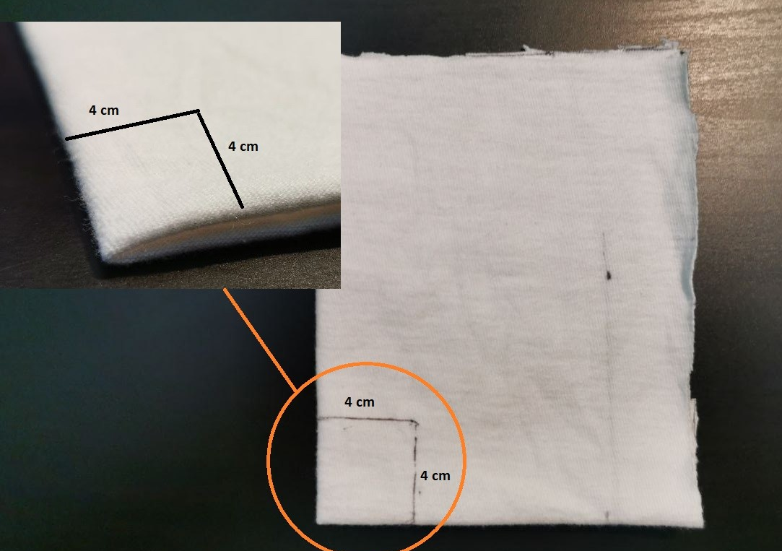  4. Mark a 4 cm x 4 cm square at the corner where the sides are folded. | 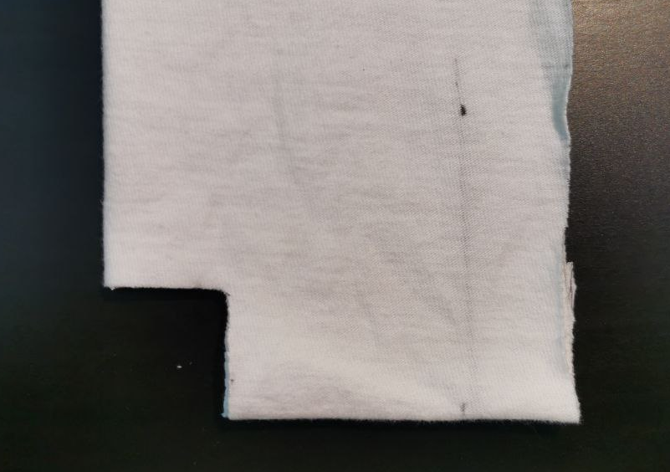  5. Cut the square with a pair of scissors.
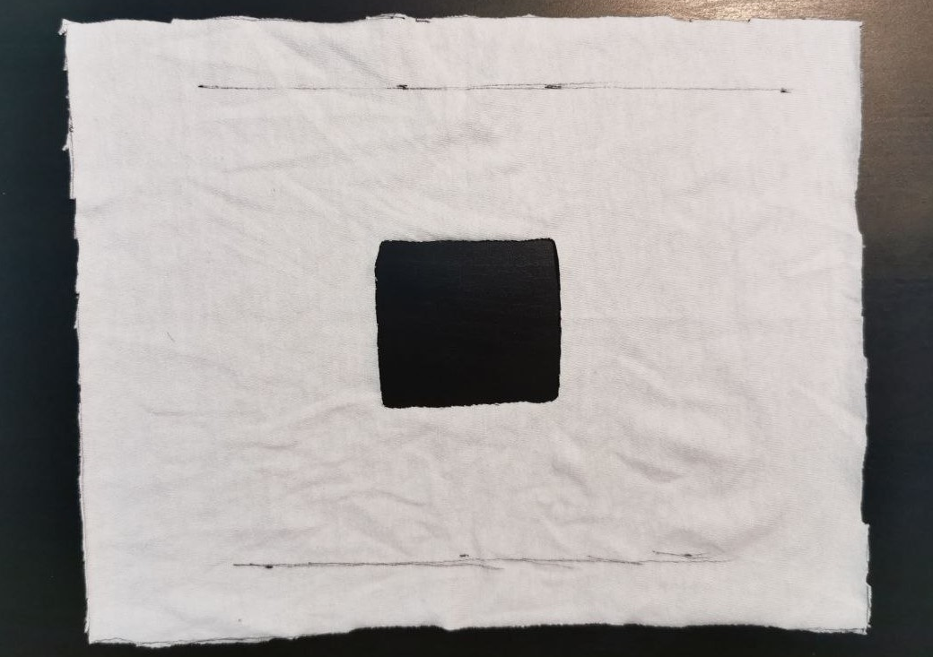  6. Unfold the fabric and the result should be a square shaped hole. | 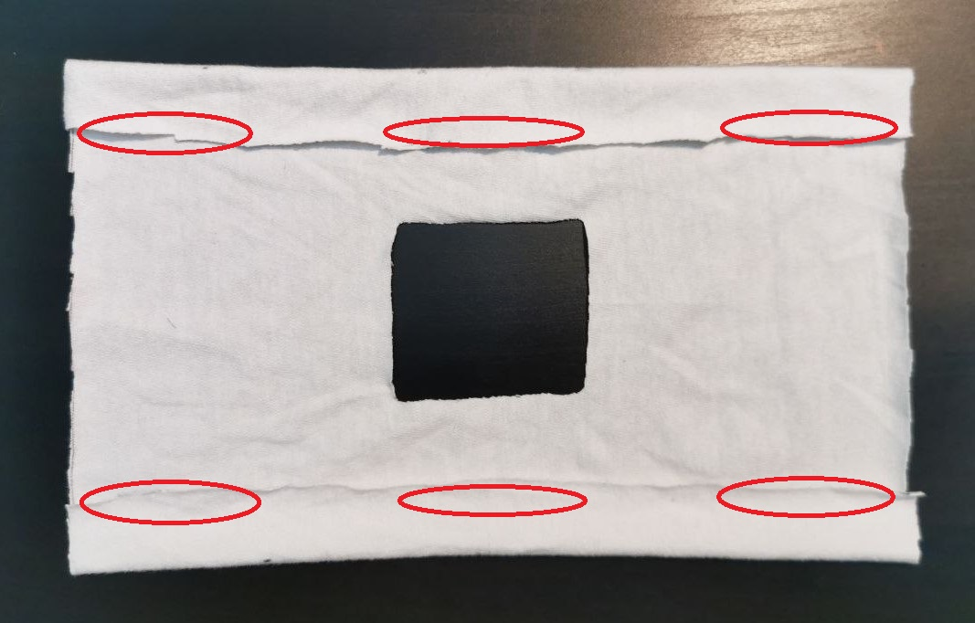  7. Sew the designated areas (~ 3-4 cm sew line is sufficient).
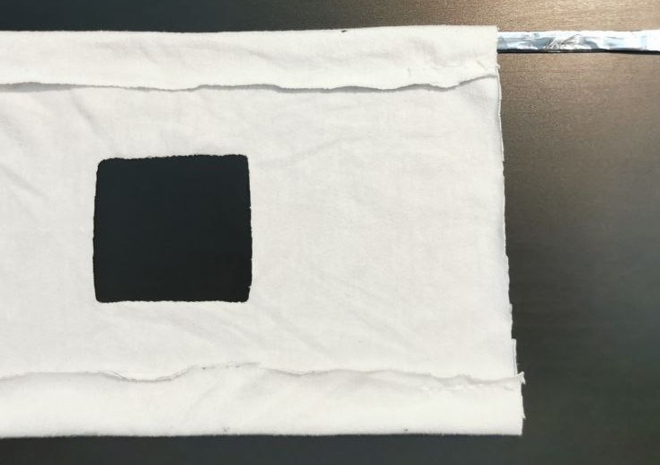  8. Insert the folded aluminum bar from either top corners. | 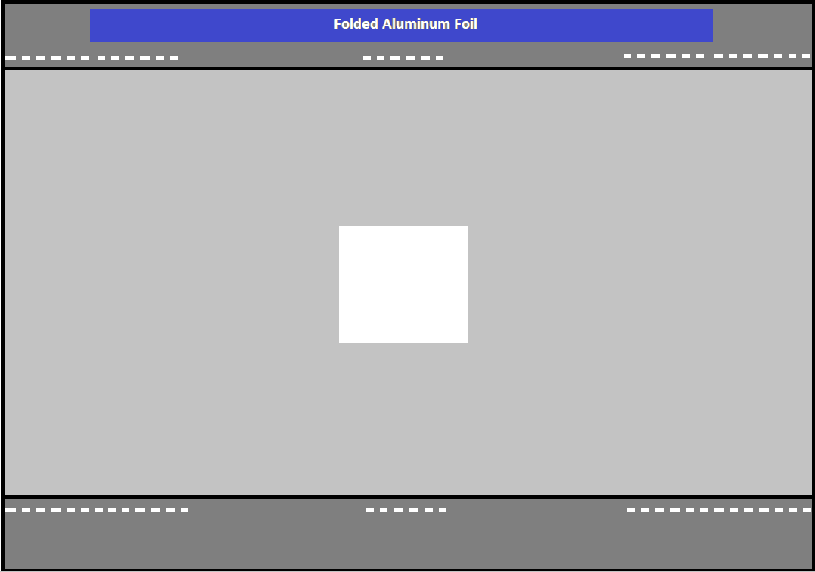  8.1. Centre the folded aluminum bar as shown above.

9. In this step, the fabric needs to be folded like an Accordion as shown below.

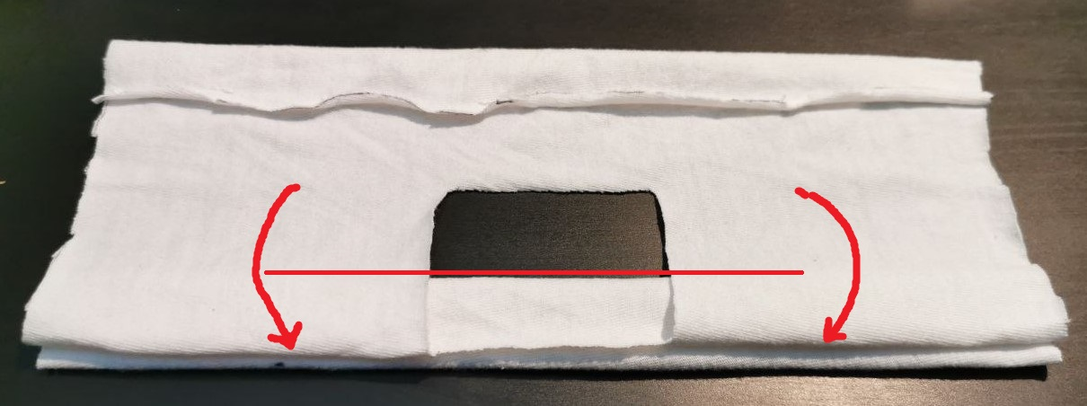
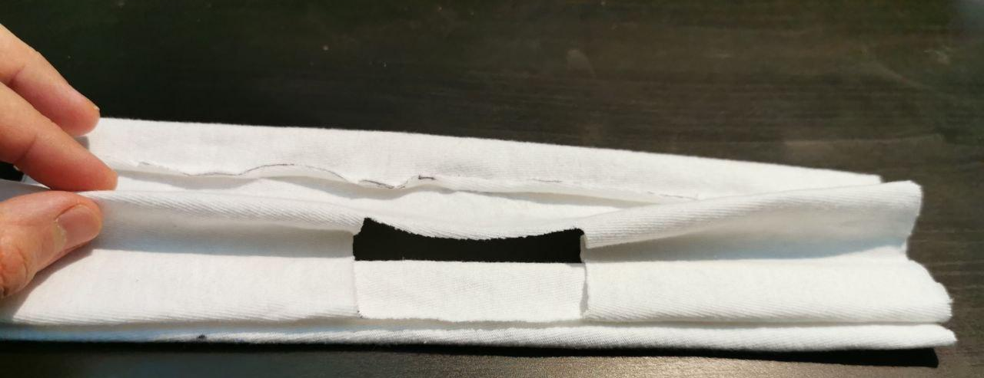
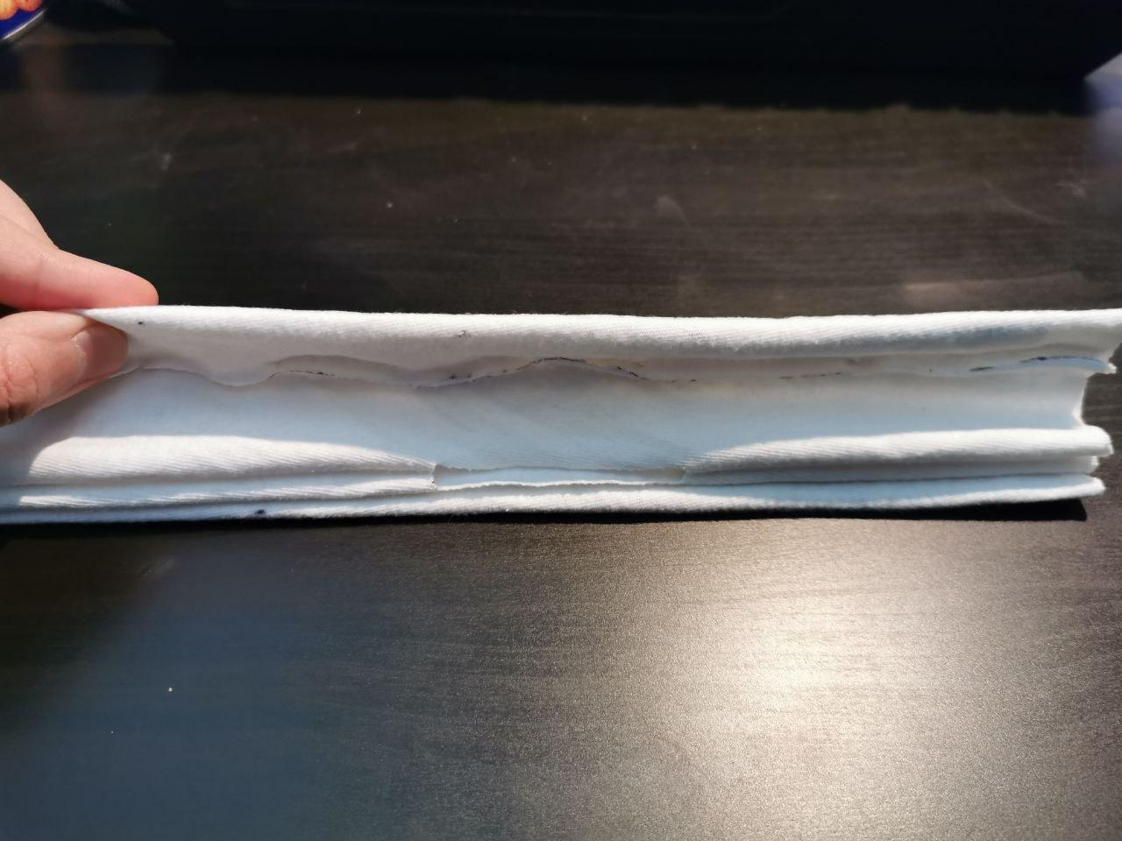
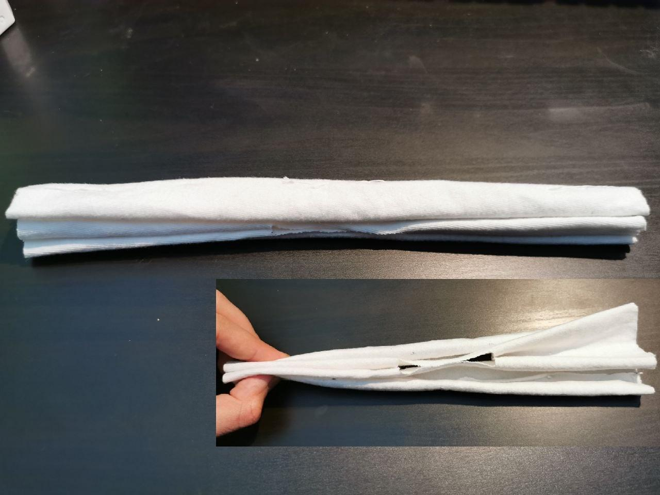
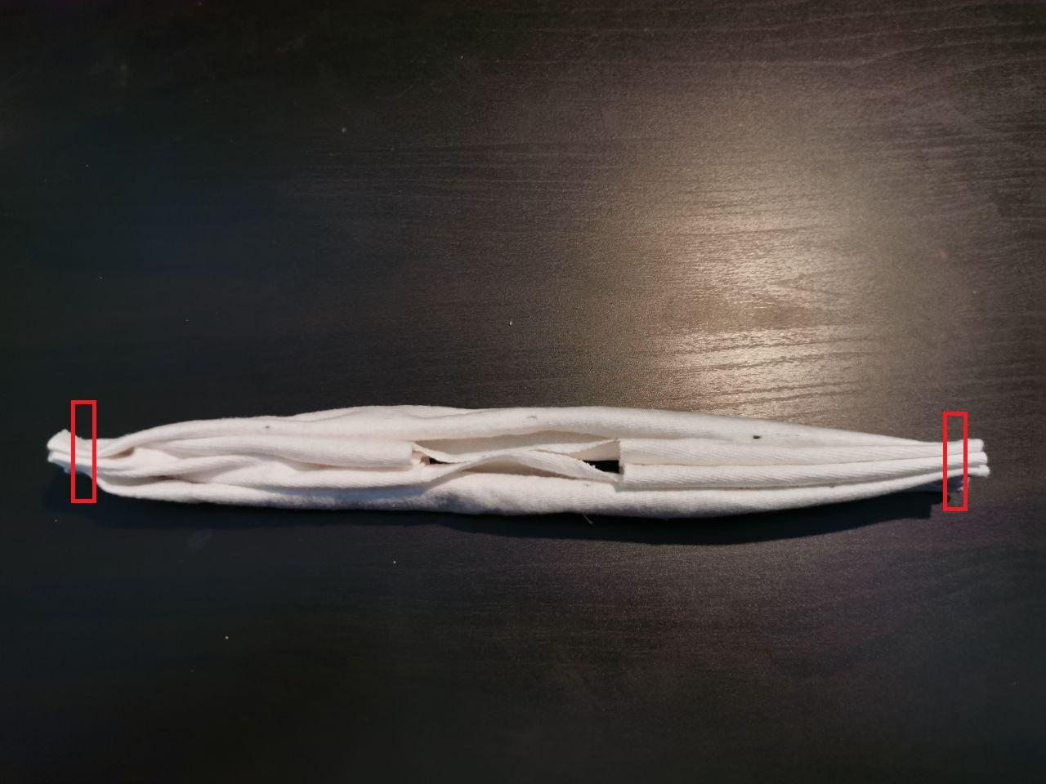  10. Sew both ends of the folded fabric as shown. | 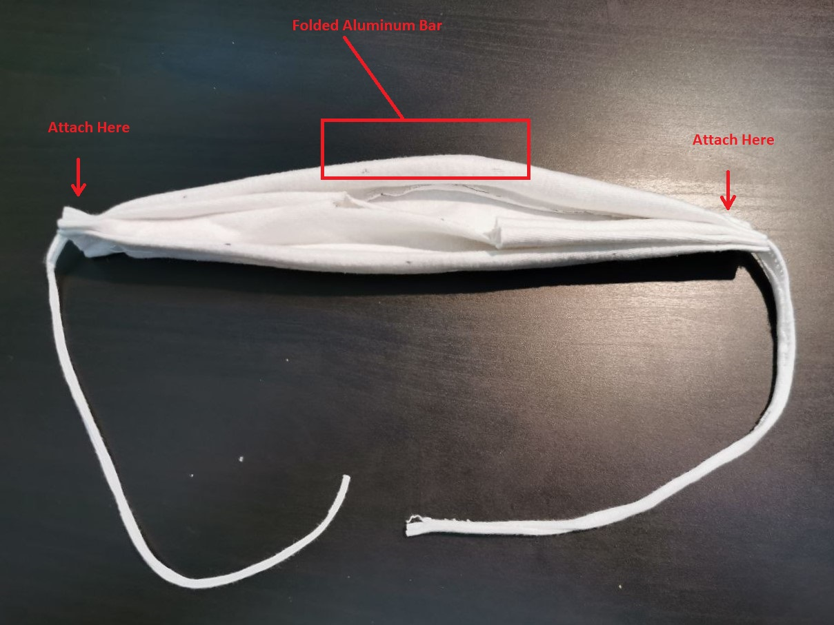  11. Attach a 1 cm x 30 cm strip to both left and right end. Attach the strips on the top of the rim as shown above.

12. Expand the inner layer by pulling the top and bottom rims. This is the expected result for the mask’s inner layer. Later, a disposable filter will be placed inside this layer to cover the square hole.

Outer Layer
In this segment, there are two options:

- Use a provided stencil under Appendix 2, as a guide to cut the fabric (requires printer). If you are using this option, skip to step 9.
- Use layouts from Appendix 1.2 and draw the layout onto fabric manually and then use it as a guide to cut. In this case, proceed from step 1.

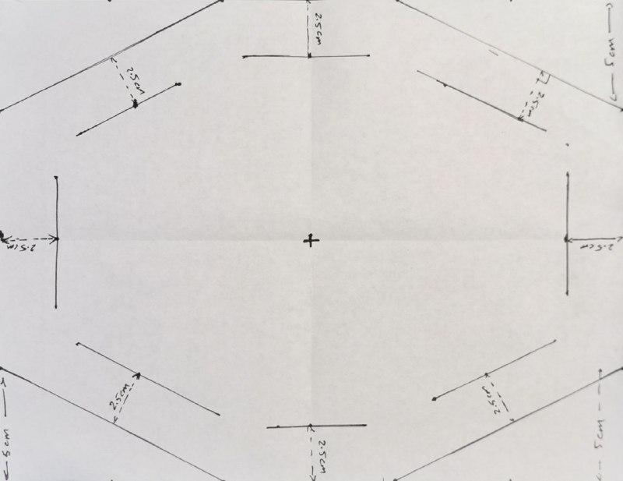1. Draw the desired pattern from Appendix 1.2 onto a paper (e.g. letter size). You should have an outer hexagon pattern and an inner hexagon pattern with a gap of 2-2.5 cm. | 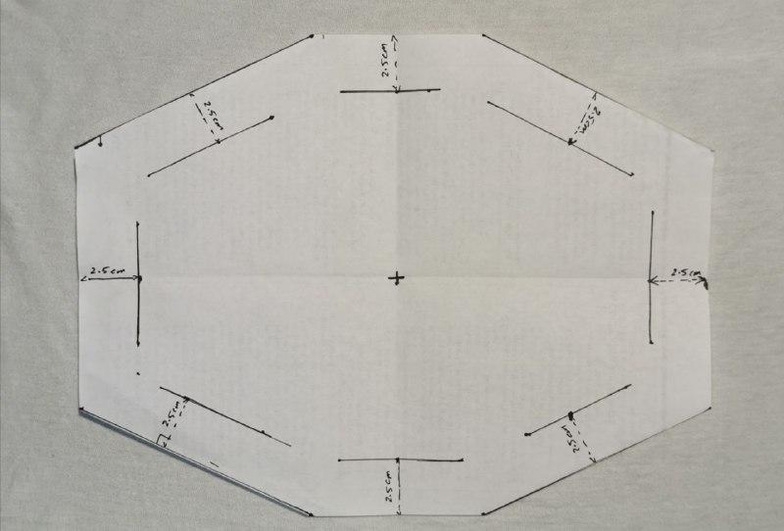2. Cut out the excess as shown above. The idea here is to fold the outer hexagon inward along the inner hexagon’s sides. This will create a loop to pass through elastic strands.
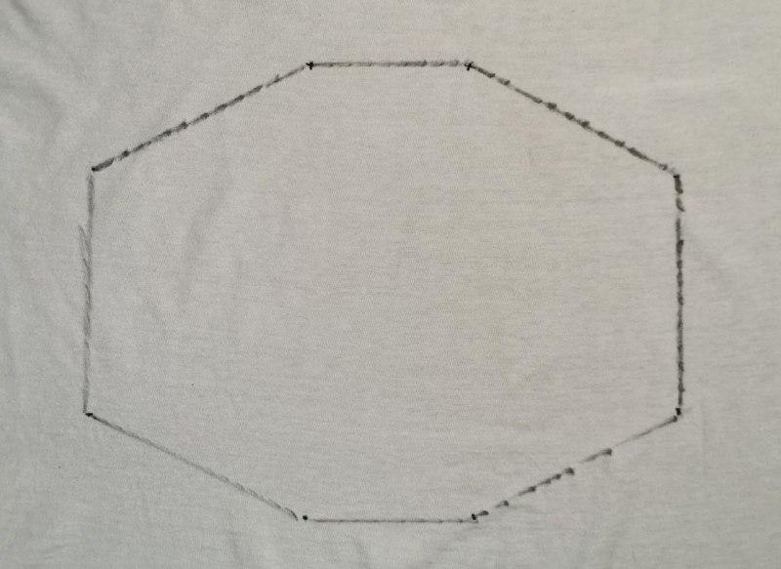3. Trace the outer hexagon onto the 100% cotton fabric. Use the cutted paper as a guide by placing the cut out onto the fabric and draw around it using a marker. | 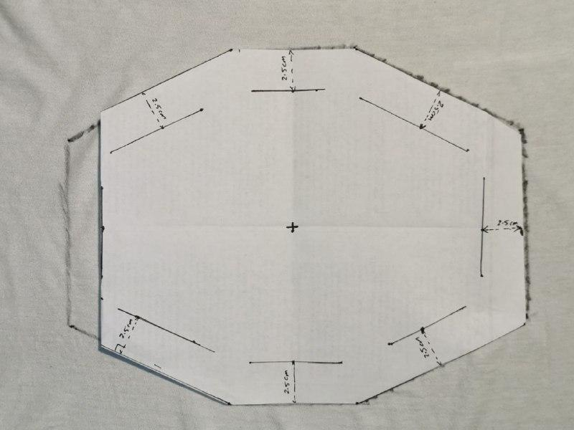4. Draw the inner hexagon. You can start by folding along an inner hexagon’s side and drawing a line along it. Then repeat this process one side at the time.
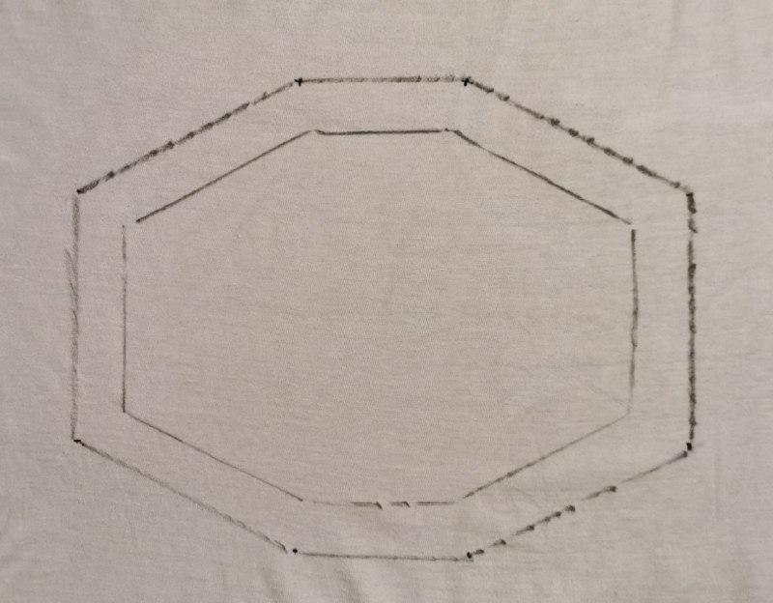5. You should be left with a pattern like this. An outer hexagon and an inner hexagon with 2.5 cm gap between the two. | 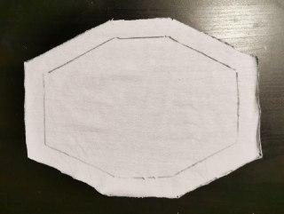6. Cut the fabric along the outer hexagon’s sides.
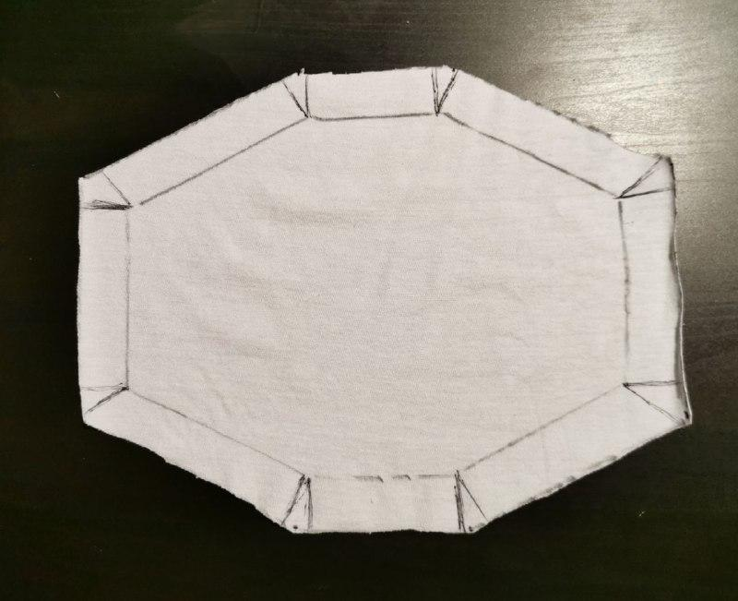7. Draw triangles on the outside of every inner hexagon vertex. Feel free to make them wider. This will be used as a cutting guide in the next step. | 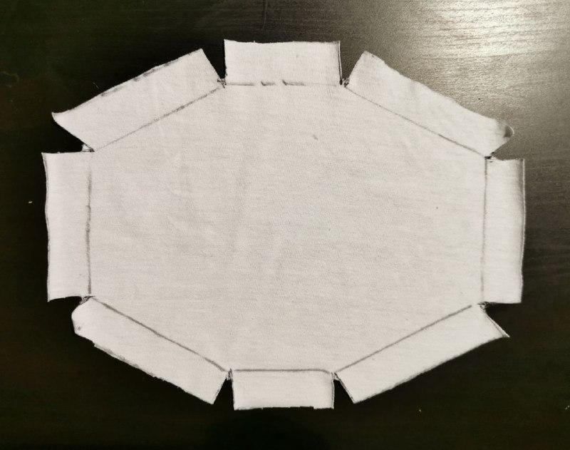  8. Cut out these triangles. I recommend making them wider if your straps are wider than a 1 cm.

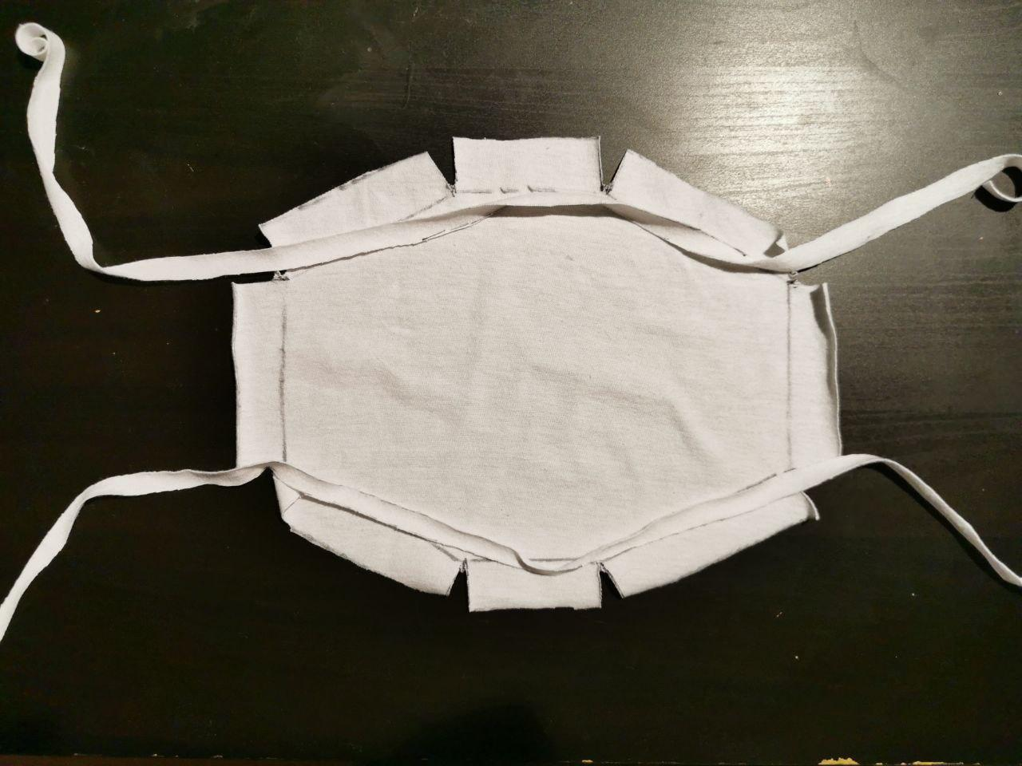9. Place the two 60 cm x 1 cm 100% cotton strips on the upper and bottom edges of the hexagon. We are going to fold over the outer edges (flaps) along the inner hexagon and sew them onto the fabric. This will create a “tunnel” for the strips to pass through freely. | 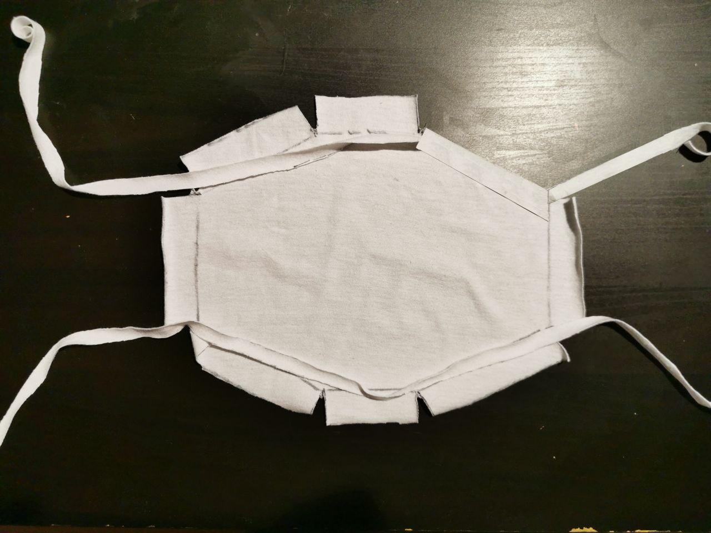10. Fold over the top right edge (flap) and sew it to the fabric without sewing the stripe. Then Skip the top centre flap and sew the other flaps to the fabric without sewing the stripe.
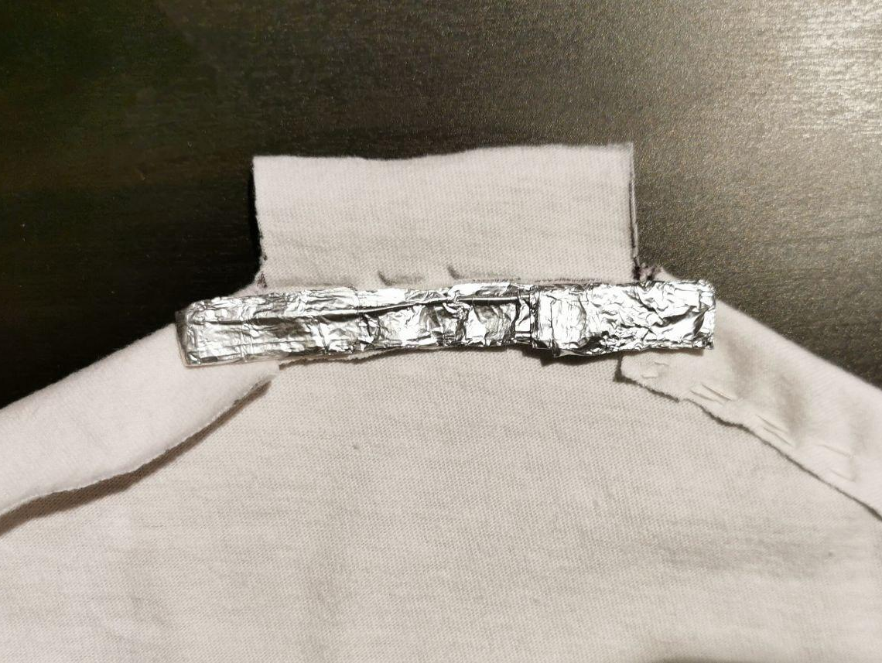11. Place the wrapped paper clip at top as shown and stitch the top flap onto the fabric. | 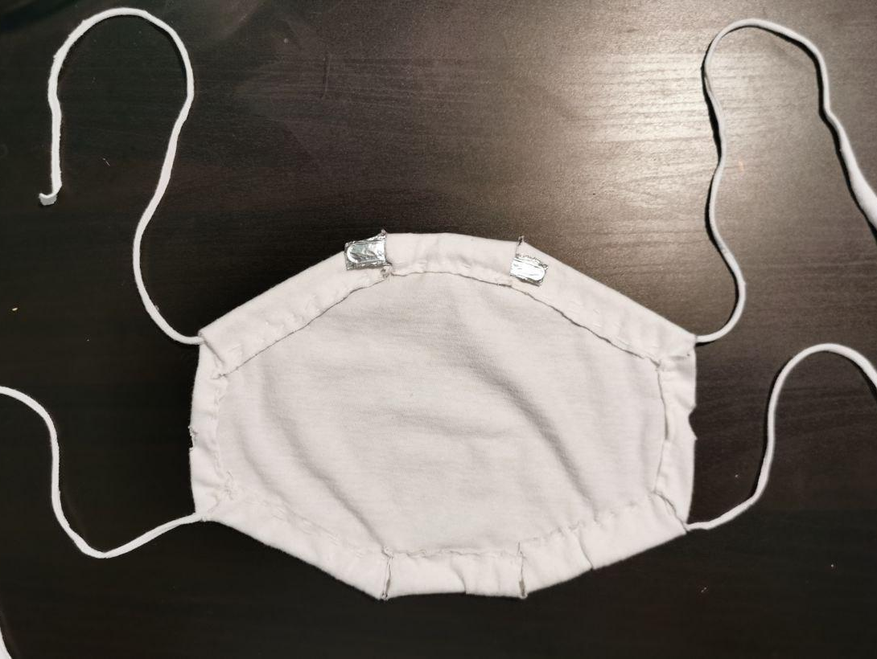12. The result should look like this. You can also hide the remaining portions of the wrapped paper by sliding them into the neighboring flaps.

Layer Integration

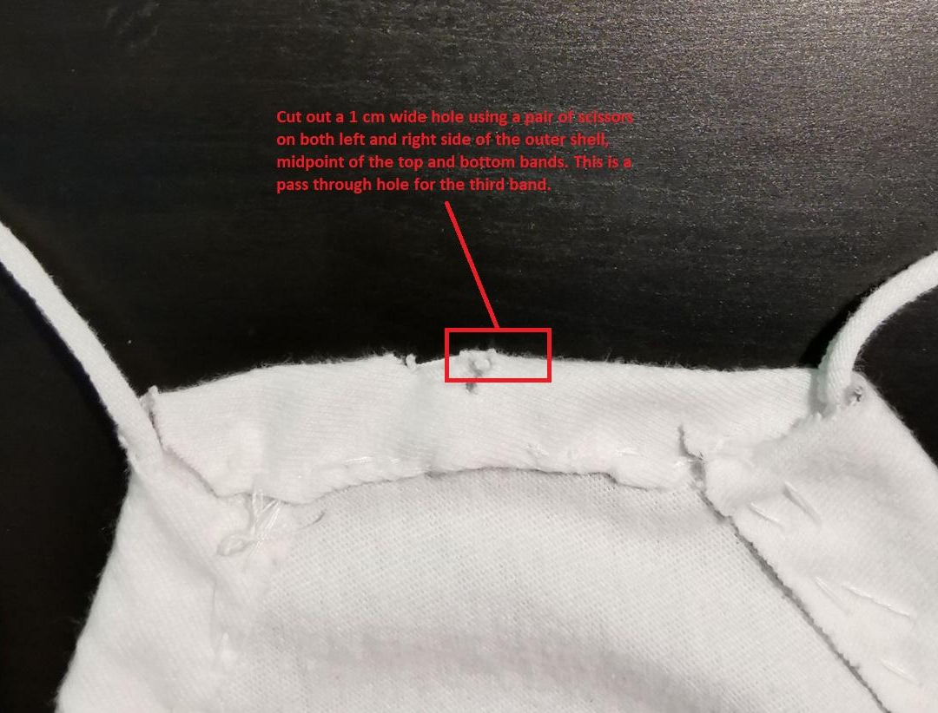13. Cut out two 1 cm wide holes on both left and right sides of the outer shell, midway between top and bottom strips. | 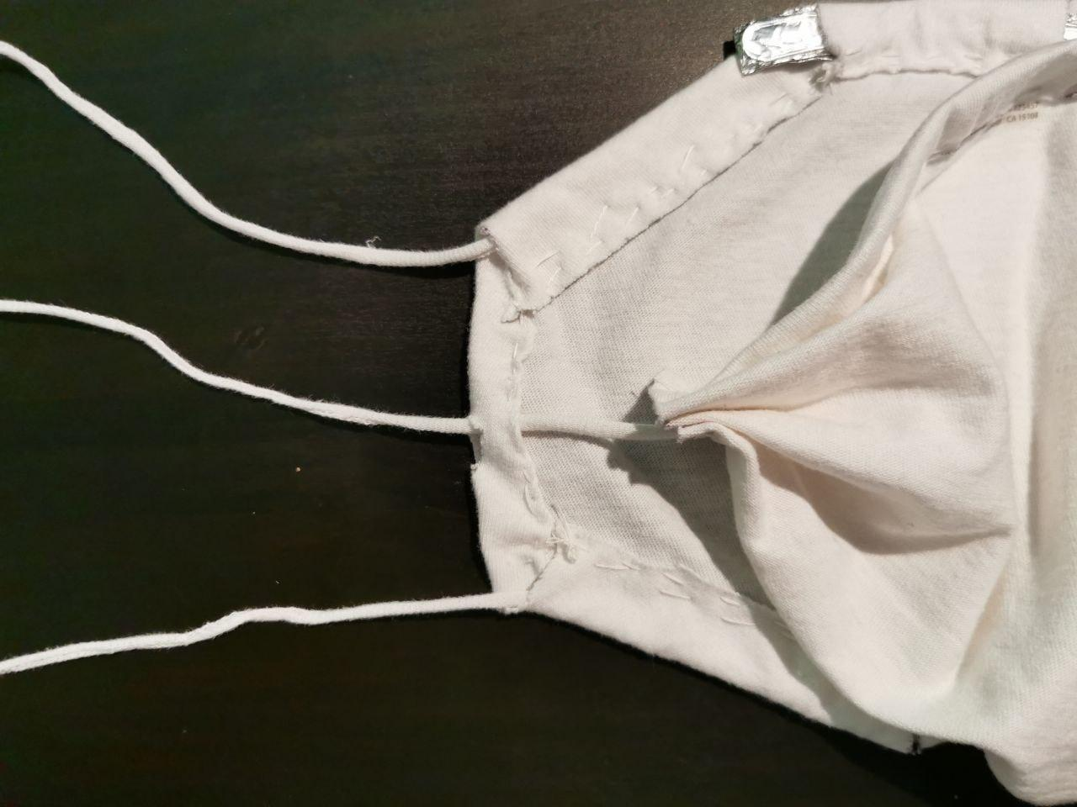14. Pass through the two strips from the inner shell on both left and right openings. Please note that the embedded folded aluminum piece should face up and should line up with the paper clip nose clamp of the outer shell.
15. The final result should look like this.

Disposable Filter Insertion
Use any of the following materials:

  - Paper towel
  - Microfiber (better alternative than paper towel)
  - PM0.3 HEPA filter (Ideal but rare)
  - Surgical mask

Fold them or cut them if necessary, so that they can fit inside the inner layer. Use the inner layer’s rims to stabilize the inserted filter. In the example below, a paper towel was folded in half first and the corners were folded again to better match the inner layer’s silhouette.

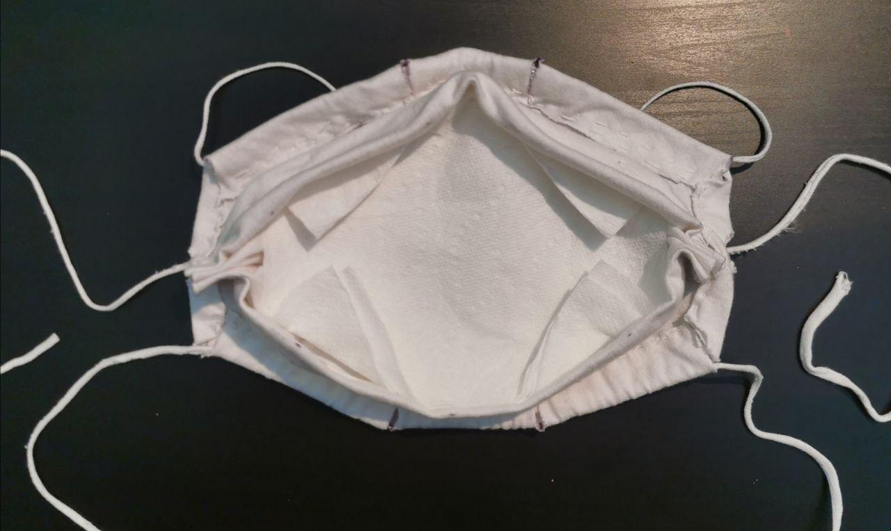
Fig 6: Paper towel, as a disposable filter, is used inside the inner layer.

Operation

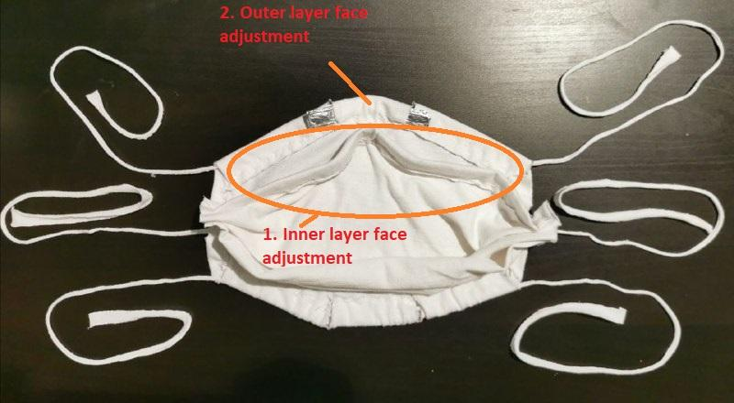
1. Place the mask on the face and adjust the upper rim of the inner layer to conform to your face geometry.

2. Adjust the nose clamp on the outer layer.
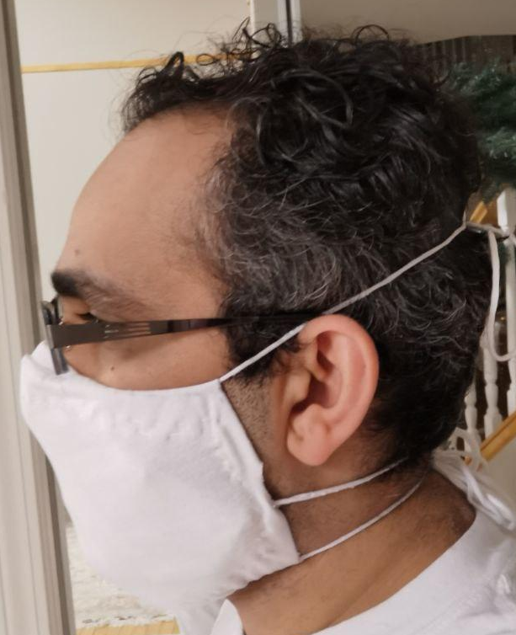  2. Wrap the top band around the top of your ears.  3. Wrap the middle band just beneath your ears.  4. Wrap the bottom bands so that they go around the back of the neck. |   5. Ensure tight fitting by looking at the areas around the nose, around the cheeks, above the neck and under the jaw.

Fit Testing

Qualitative Testing: Tightness Inspection
  1. The nose grip holds very tightly in comparison to v0.3 and V0.2. | 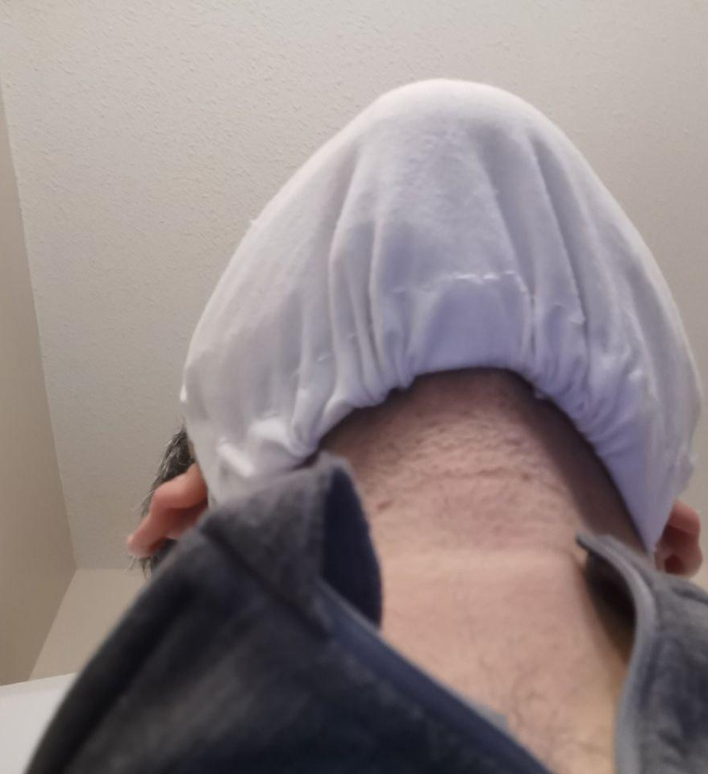  2. The grip from the bottom is also tight, tighter grip can be achieved by adjustment of bottom bands.

1. The nose grip holds very tightly in comparison to v0.3 and V0.2.

References

- AnnaDavies,KatyAnneThompson,KarthikaGiri,GeorgeKafatos,JimmyWalkerandAllanBennettTestingtheEfﬁcacyofHomemadeMasks:WouldTheyProtectinanInﬂuenzaPandemic?.DisasterMedicineandPublicHealthPreparedness,AvailableonCJO2013doi:10.1017/dmp.2013.43
- Characteristics of Respirators and Medical Masks." Institute of Medicine. 2006. Reusability of Facemasks During an Influenza Pandemic: Facing the Flu. Washington, DC: The National Academies Press. doi: 10.17226/11637.
- Wilkes A, Benbough J, Speight S, Harmer M. The bacterial and viral filtration performance of breathing system filters. Anaesthesia. 2000;55:458-465.

Appendix

Three sizes are provided for this mask, these are:

Size | Small  80% of Reference | Medium  90% of Reference | Large  (Reference or 100%)

1. Design Layout

Small

Inner Layer Dimensions
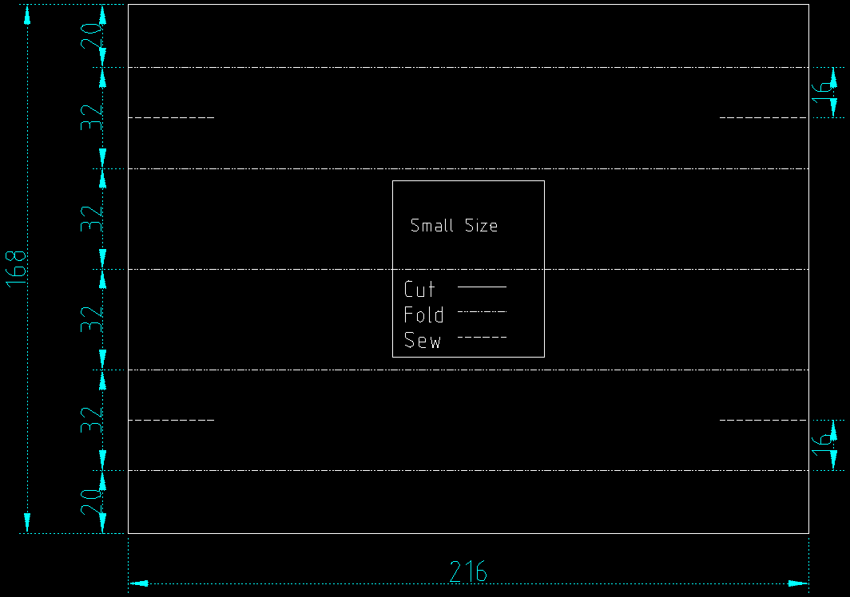
Small Size - Inner Layer

Outer Layer Dimensions
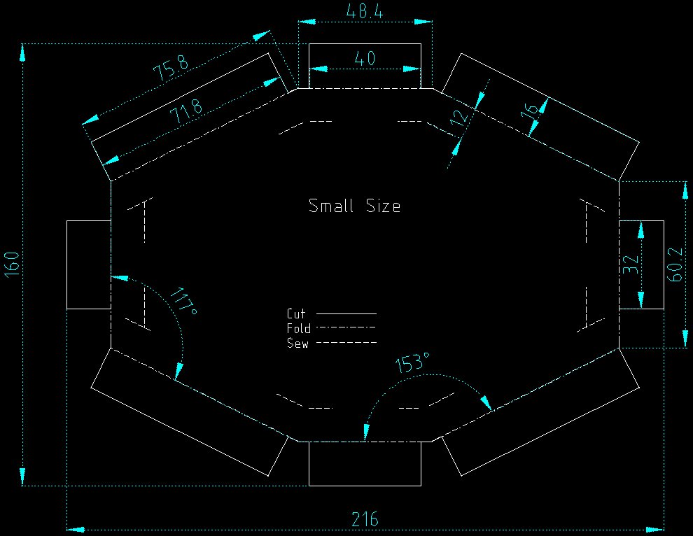Small Size - Outer Layer

Medium

Inner Layer Dimension

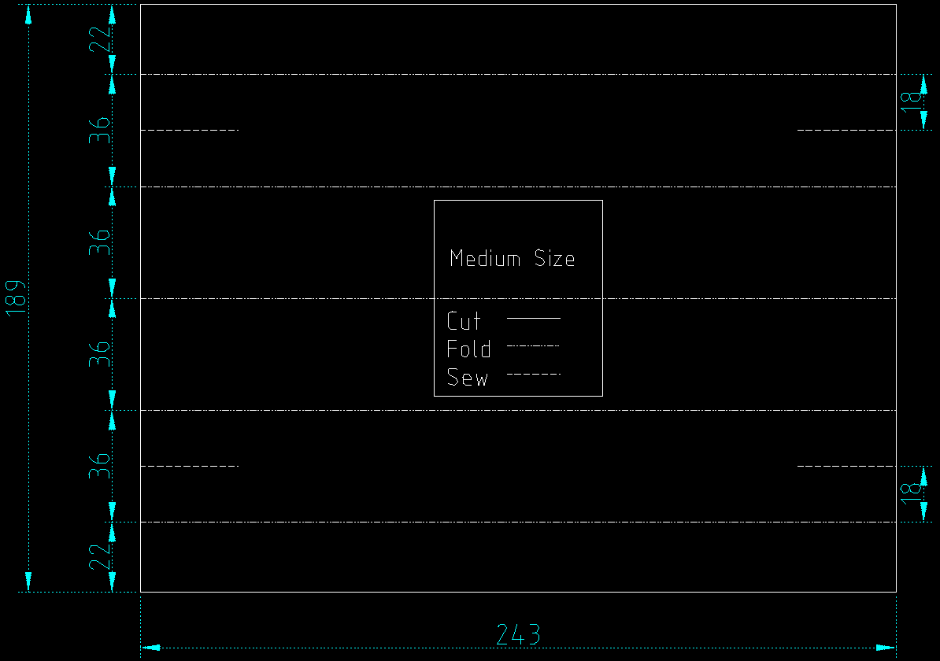
Medium Size - Inner Layer

Outer Layer Dimensions
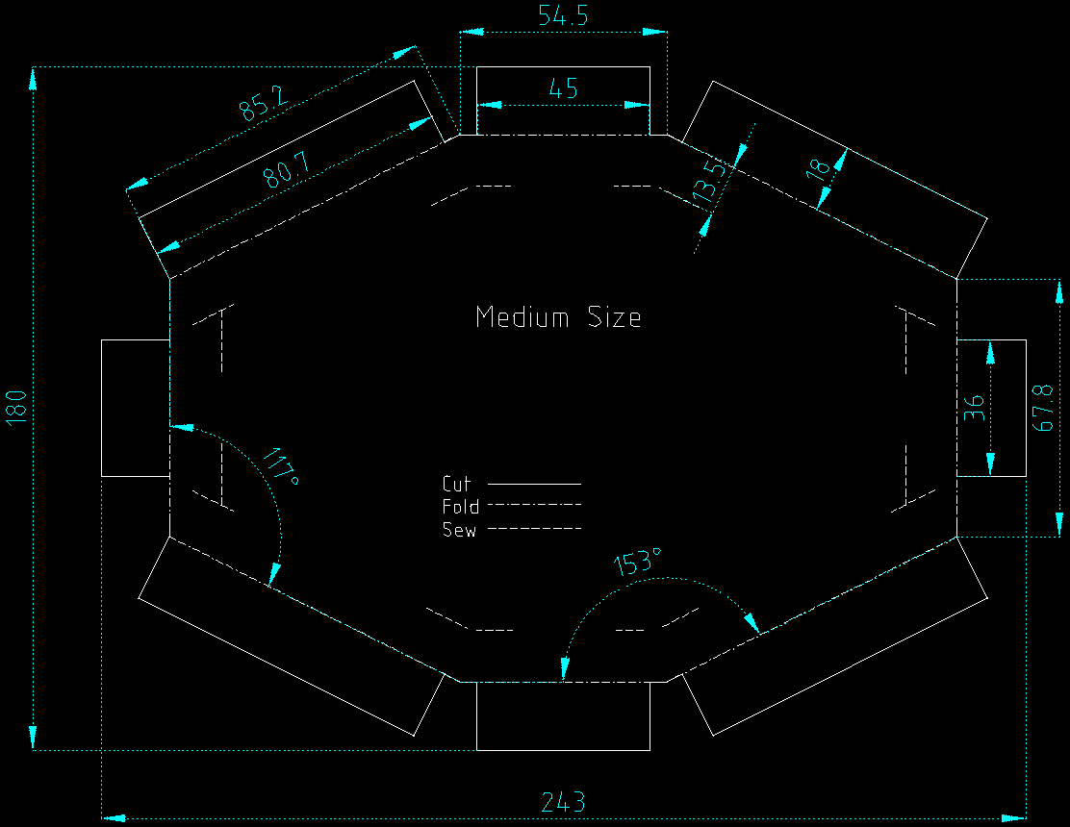
Medium Size - Outer Layer

Large

Inner Layer Dimensions
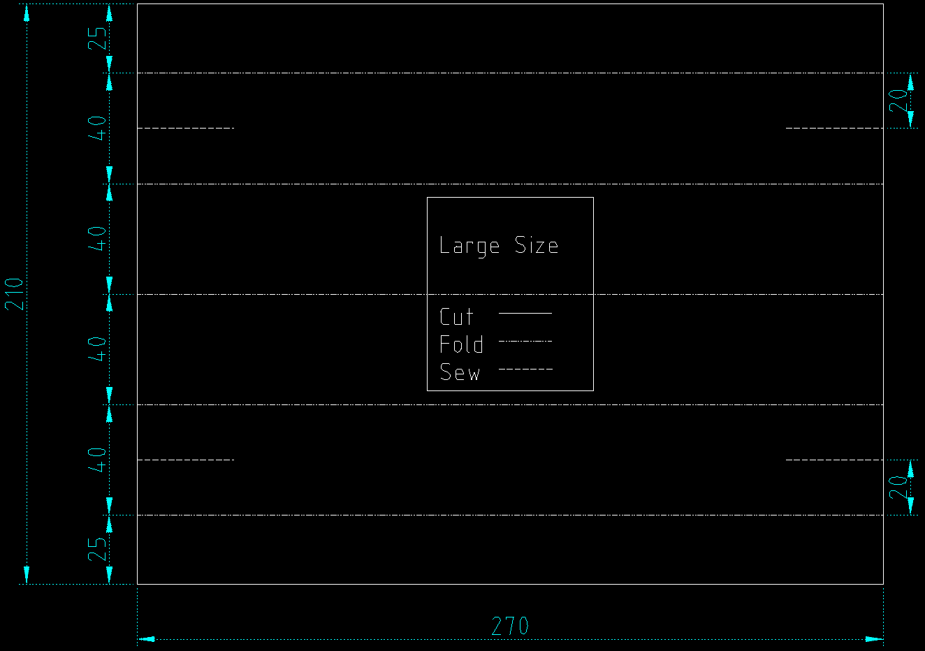
Large Size - Inner Layer

Outer Layer Dimensions
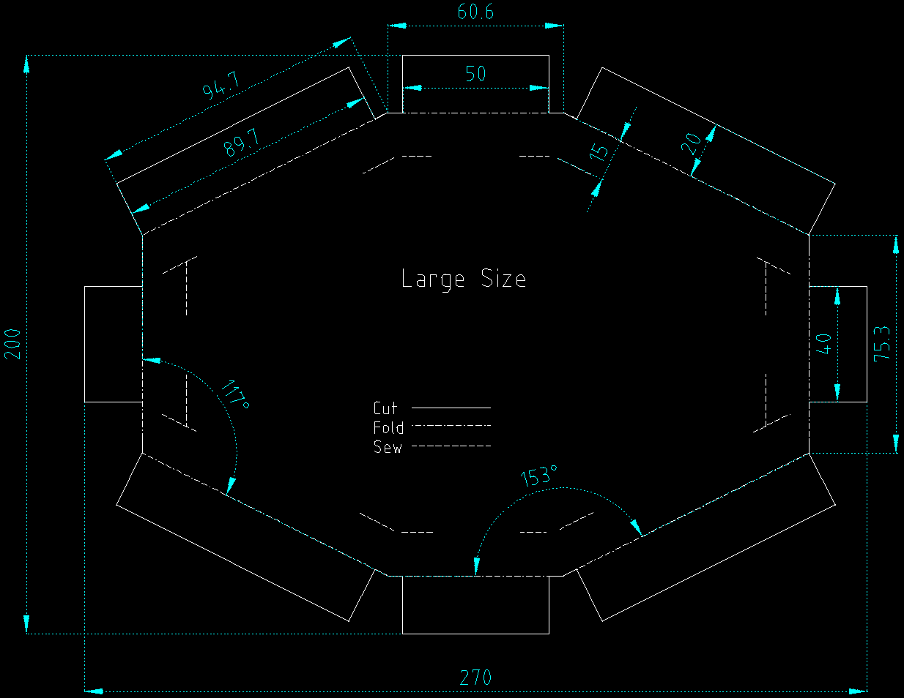
Large Size - Outer Layer

2. Stencils

2.1 Outer Layer Stencils

Small
- Inner Layer
- Outer Layer

Medium
- Inner Layer
- Outer Layer

Large
- Inner Layer
- Outer Layer

