TERCET
https://gisco-services.ec.europa.eu/tercet/flat-files

Klassifikationen - Metadaten - Eurostat

versions 2010, 2013, 2016, 2021 and 2024
The TERCET NUTS-postal codes matching tables contain a lookup-list of European postal codes and their corresponding NUTS codes for the NUTS versions 2010, 2013, 2016 and 2021.
There are matching tables for most of the EU, Candidate, EFTA and the United Kingdom. Eurostat has applied a number of quality assurance measures to ensure the best possible quality of the data including formatting checks, checks for completeness of postal codes and checks for spatial accuracy of the geocoding.

pc2025_DE_NUTS-2024_v1.0.zip | Postal codes for DE, 2025 | 13/11/2025

https://gisco-services.ec.europa.eu/tercet/NUTS-2024/pc2025_DE_NUTS-2024_v1.0.zip

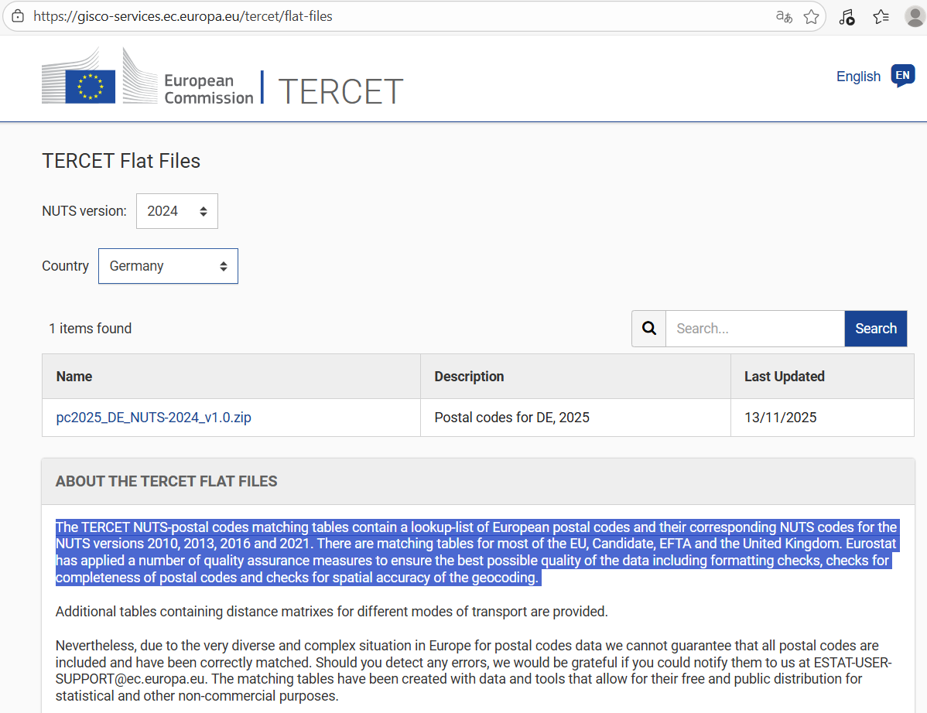

Kraftfahrt-Bundesamt - Statistik - Zusammenfassung NUTS 2006 - NUTS 2024
https://www.kba.de/DE/Statistik/Kraftverkehr/ve_methodik/Zusammenfassung_NUTS_2006-NUTS_2024.xlsx

