I would like a keyboard that made from 7mm dome switches from snaptron. I would like to ask you to make a footprint for it at the first place. This is the design page: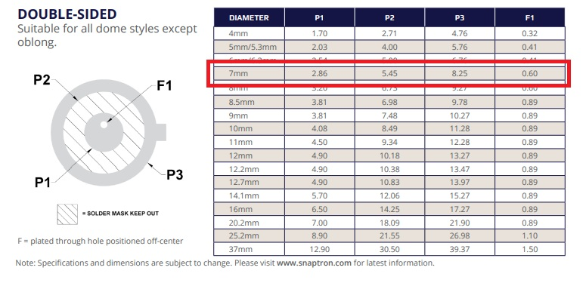
More info in snaptron design document:
After that I would like to ask you to build a keyboard that has a layout like this: 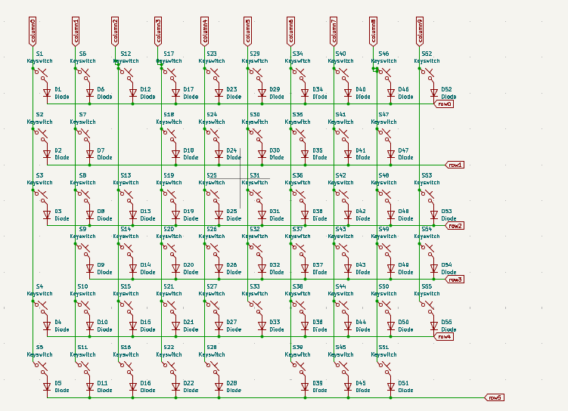
I can share this schematic. I would like testing point as well in the PCB so I can hardwire things later. The PCB side will look like this: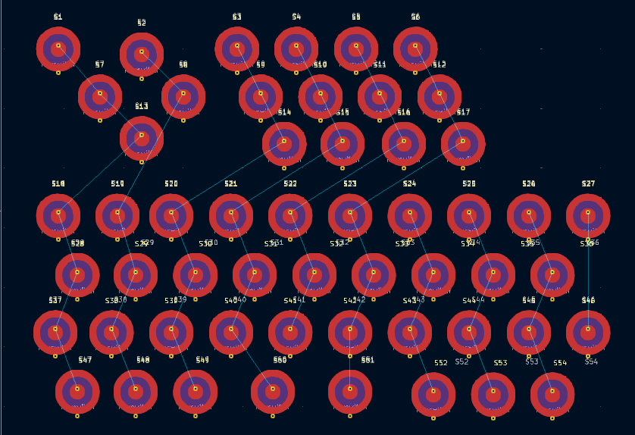
And will be connected like this
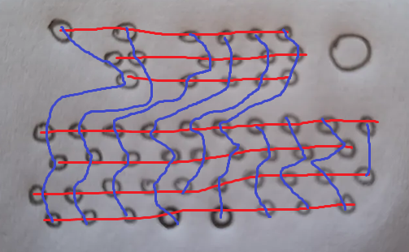
It has to be a matrix that has rows and columns like in the picture and I would like testing points on the back side so I can check every row and column.

The right top circle will be a joystick that has 5 pins that I would like to connect to the chip as well. 1 GND, 1 5V, 2 digital and an analog output.
In this case we will need 13 pin (+3 from the joystick) for the controller that will be a RP2040 microcontroller chip. I would like you to design a raspberry pi clone that makes a HUD and converts the data to USB-C.

