**Deep Learning – Assignment 1**

**Part I**

1) Below is the code implemented using Python for calculating the loss function “soft-max regression” and its gradient with respect to W and its gradient with respect to the biases. For efficiency purposes, we are calculating the gradient for all $w_{j}$ and $bias_{j}$ ($j=1,…,n$) using matrix multiplication, and return the Jacobian with respect to W (which is – row $j$ of the output would be $∇_{w_{j}}f_{softmax}$) and the Jacobian with respect to the biases (which is – row $j$ of the output would be $∇_{bias_{j}}f_{softmax})$:

import numpy as np  
  
def softmax_regression(X_L, W, bias, C):  
 probs = sigmoid(X_L, W, bias)  
 m = X_L.shape[1]  
 cost = (-1 / m) * (np.sum(C.T * np.log(probs)))  
 return cost, probs  
  
  
def sigmoid(X_L, W, bias):  
 output_layer = X_L.T @ W + bias  
 output_layer -= np.max(output_layer)  
 probs = (np.exp(output_layer).T / np.sum(np.exp(output_layer), axis=1)).T  
 return probs  
  
  
def softmax_grad(X, W, bias, C):  
 probs = sigmoid(X, W, bias)  
 m = X.shape[1]  
 grad_W = (-1 / m) * (X @ (C.T - probs))  
 grad_b = (-1 / m) * (np.sum(C.T - probs, axis=0)).T  
 return grad_W, grad_b

To verify that the derivatives are correct, we implemented a gradient test for the gradient with respect to the weights and the biases (and a plot function for the result):

import numpy as np  
import matplotlib.pyplot as plt  
from softmax import softmax_regression, softmax_grad  
from loadData import extract_frad_test_data  
  
num_of_iterations = 10  
  
  
def grad_W_test(X, W, bias, C):  
 # calculate F(W) and the gradient w.r.t W  
 F_0, _ = softmax_regression(X, W, bias, C)  
 grad_W, _ = softmax_grad(X, W, bias, C)  
 grad_W_flat = grad_W.flatten()  
  
 # define a random d for the test  
 d = np.random.rand(grad_W.shape[0], grad_W.shape[1])  
 d /= np.linalg.norm(d)  
 d_flat = d.flatten()  
  
 zero_order = []  
 first_order = []  
 print('\nGradient test w.r.t W results:')  
 print('k\t\terror order 0\t\terror order 1')  
 for k in range(num_of_iterations):  
 epsilon = 0.5 ** k  
 F_k, _ = softmax_regression(X, W + epsilon * d, bias, C)  
 F_1 = F_0 + epsilon * d_flat.T @ grad_W_flat  
 zero_order.append(abs(F_k - F_0))  
 first_order.append(abs(F_k - F_1))  
 print(k, '\t', abs(F_k - F_0), '\t', abs(F_k - F_1))  
 return zero_order, first_order  
  
  
def grad_bias_test(X, W, bias, C):  
 # calculate F(W) and the gradient w.r.t bias  
 F_0, _ = softmax_regression(X, W, bias, C)  
 _, grad_bias = softmax_grad(X, W, bias, C)  
  
 # define a random d for the test  
 d = np.random.rand(grad_bias.shape[0])  
 d /= np.linalg.norm(d)  
  
 zero_order = []  
 first_order = []  
 print('\nGradient test w.r.t bias results:')  
 print('k\t\terror order 0\t\terror order 1')  
 for k in range(num_of_iterations):  
 epsilon = 0.5 ** k  
 F_k, _ = softmax_regression(X, W, bias + epsilon * d, C)  
 F_1 = F_0 + epsilon * d.T @ grad_bias  
 zero_order.append(abs(F_k - F_0))  
 first_order.append(abs(F_k - F_1))  
 print(k, '\t', abs(F_k - F_0), '\t', abs(F_k - F_1))  
 return zero_order, first_order  
  
  
def draw_results(y_0, y_1, result_for='Weights'):  
 plt.semilogy([i for i in range(num_of_iterations)], y_0)  
 plt.semilogy([i for i in range(num_of_iterations)], y_1)  
 plt.legend(["Zero order approx", "First order approx"])  
 plt.title("Successful {res_for} Gradient Test In Semilog Scale".format(res_for=result_for))  
 plt.xlabel("Iteration")  
 plt.ylabel("Error")  
 plt.show()

To test our code, we ran a small experiment over a small batch of data points (0.01 of the dataset) from the provided dataset “Peaks”. The code for the test is as follows:

if __name__ == '__main__':  
 X_batches, W, bias, C_batches = extract_frad_test_data("PeaksData.mat", 100)  
 zero_order_W, first_order_W = grad_W_test(X_batches[0], W, bias, C_batches[0])  
 draw_results(zero_order_W, first_order_W)  
 zero_order_bias, first_order_bias = grad_bias_test(X_batches[0], W, bias, C_batches[0])  
 draw_results(zero_order_bias, first_order_bias, result_for='Biases')

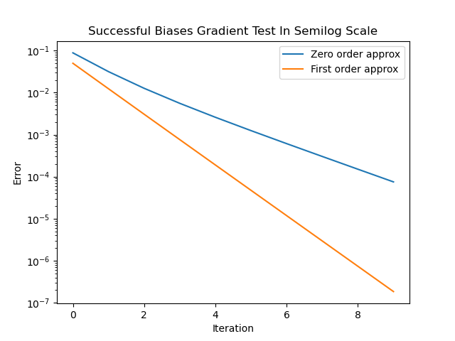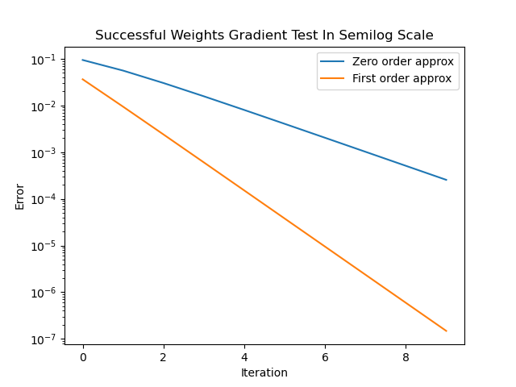And the plots we got for the gradient tests are:

Note that we defined $ϵ={0.5}^{i-1}$, where $i=current iteration number$, and ran the test for 10 iterations ($i=1, …, 10)$. We can clearly see that the test for both the weights and the biases is successful, as the error for the first order taylor expansion approximation decreases quadratically compared to the zero order taylor expansion approximation.

2( The code below is our implementation for the SGD:

def sgd(grad_function, cost_function, X, W, C, bias, batch_size, learning_rate, iter_num):  
 costs = []  
 for iter in range(iter_num):  
 shuffler = np.random.permutation(X.shape[1])  
 X = X[shuffler]  
 C = C[shuffler]  
 m = X.shape[1]  
 for i in range(batch_size):  
 X_i = X[i * batch_size:i * batch_size + batch_size, :]  
 C_i = C[i * batch_size:i * batch_size + batch_size]  
 grad = grad_function(X_i, W, C_i, bias)  
 W = W - (1 / batch_size) * learning_rate * (grad)  
 costs.append(cost_function(X, W, C, bias))  
 return W, costs

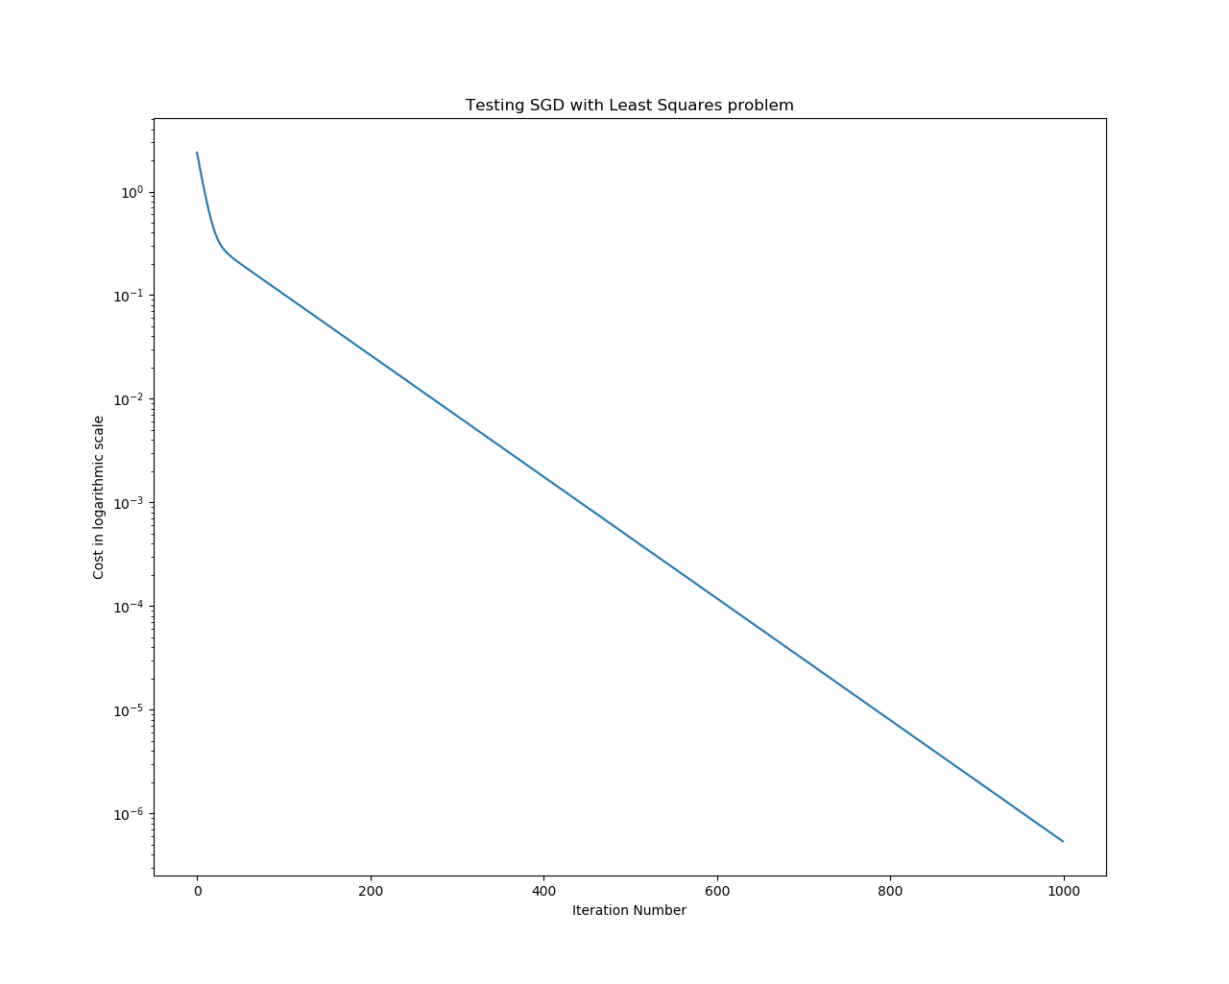The graph at the plot is the result of testing the code on a simple least squares problem. We chose a random matrix $A∈R^{6×10}$, random result vector $b∈R^{10}$ and a random initial guess $x∈R^{6}$. Also we implemented the cost function and gradient for LS. We took the learning rate to be 1 and run SGD for 1000 iterations. As you can see in the plot, the cost decreases in each iteration:

def least_squares_gradient(A, x, b, bias=None):  
 grad = 2 * A.T @ A @ x - 2 * A.T @ b  
 return grad  
  
  
def least_squares_cost_function(A, x, b, bias=None):  
 cost = np.linalg.norm(A @ x - b)  
 return cost  
  
  
if __name__ == '__main__':  
 iter_num = 1000  
 A = np.random.rand(10, 6)  
 b = np.random.rand(10, 1)  
 x = np.random.rand(6, 1)  
 x, costs = sgd(least_squares_gradient, least_squares_cost_function, A, x, b, None, 10, 1, iter_num)  
 actual = np.linalg.lstsq(A, b)  
 errors = [np.linalg.norm(W - actual[0]) for W in costs]  
 plt.semilogy([i for i in range(iter_num)], costs)  
 plt.title("Testing SGD with Least Squares problem")  
 plt.xlabel("Iteration Number")  
 plt.ylabel("Cost in logarithmic scale")  
 plt.show()

3) After running a few experiments with different batch sizes, learning rates and maximum iterations number, we noticed the following observations:

|  |  |  |
| --- | --- | --- |
|  | Smaller | Bigger |
| Batch size | As we decreased the batch size, we noticed that it took the SGD algorithm less time to converge (as the computation of the gradient in each step takes less time), but we get noisier (or less steady) success rate as the gradient calculation depended on less data points on each iteration. | As we increased the batch size, we noticed that it took the SGD algorithm more time to converge (harder to compute the gradient each step), but we got a “cleaner” success rate, as the gradient approximation was closer to the real gradient each iteration. |
| Learning rate | As we decreased the learning rate, it took the SGD algorithm more time to converge (as we’re making smaller “steps” each iteration until reaching the minimum), but we also decrease the risk of moving too far and not converge | As we increased the learning rate, we noticed that it took us less time to converge, but there’s a limit – if we increase it too much we might not converge at all |

After a few experiments, we observed that we get the best result with a **learning rate of $0.001$**  and a **batch size of 71**. We let the SGD algorithm run for 400 iterations (epochs), but we saw that we get to the maximum success rate after about 75 iterations, and after that we maintained that success rate (approximately) for the rest of the iterations.

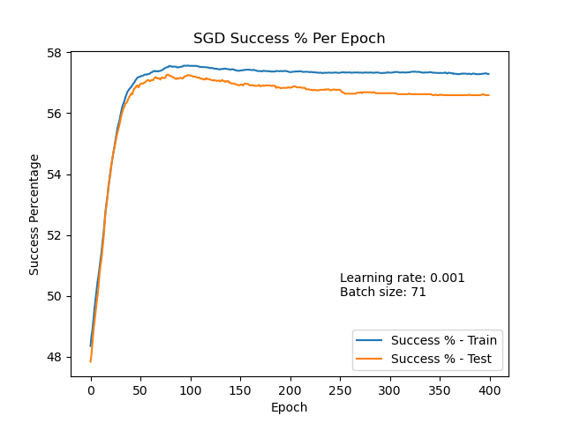With these parameters, SGD converged and gave a **success rate** of approximately **58%** for both train and validation data. The following plot demonstrate the execution of SGD algorithm with the above parameters, and displays the success rate (in percentage) per epoch (we show how the success rate is maintained throughout the entire run of 400 epochs):