# Power BI Dashboard "Business Insights" Summary Tomer Orly, Shahar Horovitz

## Project Objective

The dashboard was developed to consolidate and analyze key organizational performance data. It offers a multi-dimensional view covering Sales, Customers, Products & Inventory, and Human Resources. The primary goal is to enable data-driven decision-making, identify business trends, and monitor performance over time.

## Data Model Overview

The Power BI data model is architected to facilitate comprehensive business performance analysis. The model seamlessly consolidates data from key operational areas, encompassing sales, customer relations, product management, and human resources.

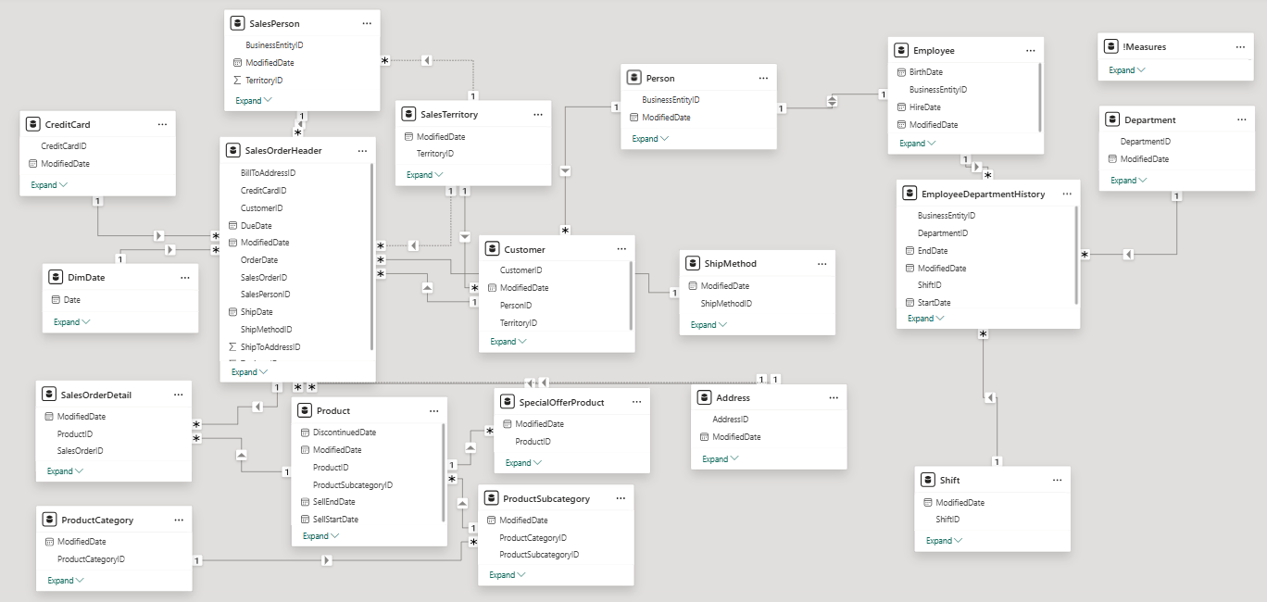

The model comprises several interconnected tables:

* Sales-related tables: Central to tracking and analyzing sales transactions and overall performance.
* Customer-related tables: Provide detailed insights into customer demographics, payment methods, and shipping logistics.
* Product-related tables: Enable in-depth analysis of product performance, inventory levels, and sales categorized by product hierarchy.
* Employee/HR-related tables: Crucial for human resources analytics, encompassing employee data, departmental assignments, and work shifts.
* Date Dimension: Essential for time-intelligence calculations and analyzing trends across various periods.
* Fact and Dimension Tables: The model clearly differentiates between fact tables (e.g., orders, employee history) and dimension tables (e.g., dates, products, customers, employees), optimizing for efficient querying and data aggregation.

Relationships are meticulously established with appropriate cardinality (one-to-many, one-to-one) to ensure data integrity and enable seamless filtering and slicing capabilities across the dashboard.

## Data Manipulation, Cleaning, and DAX Calculations

To prepare the data for insightful analysis, significant data manipulation and cleaning processes were undertaken, including:

* Data Transformation: Raw data from disparate sources was transformed to ensure consistency and usability within PowerQuery, including handling data types, formatting, and resolving inconsistencies.
* Data Cleaning: Thorough cleaning addressed missing values, duplicates, and errors, ensuring data accuracy and reliability.
* DAX Calculations: A comprehensive set of Data Analysis Expressions (DAX) was developed to create powerful measures and calculated columns, fundamental for deriving KPIs and enabling deep analytical insights.
* '!Measures' Table: To maintain a clean and organized model, all DAX calculations were consolidated into a dedicated table named '!Measures'. This centralized approach streamlines management, location, and reuse of measures throughout the report, enhancing maintainability and user experience.

## Key Development Activities

Development efforts focused on enhancing the functionality and analytical depth of the Power BI dashboard:

* Data Model Refinement: Reviewed and optimized to ensure efficient relationships and appropriate data types, contributing to performance and scalability.
* Advanced DAX Measure Implementation: Developed complex DAX measures to support key analysis areas: Sales Performance, Customer Insights, Product & Inventory Analysis, and HR metrics.
* Data Quality Assurance: Executed meticulous cleaning and transformation processes to guarantee the highest data quality for accurate reporting.
* Organized Measure Management: Created the '!Measures' table to improve organization and accessibility of calculated fields, contributing to a more user-friendly and maintainable solution.

## Key Analysis Areas

### Sales Performance

* The United States leads in total sales volume, with approximately $63 million.
* The “Bikes” category is the dominant revenue generator, totaling around $95 million.
* Other categories such as Accessories, Clothing, and Components contribute significantly less.
* Approximately 31,000 total orders were recorded, with cumulative revenue of $110 million.

### Customer Insights

* Customer count increased steadily from 2011 to 2013, with a moderate decline in 2014.
* Credit card usage is fairly evenly distributed across four major card types.
* The majority of shipments are handled by a single logistics company.
* Customer data is segmented by geography (North America, Europe, Pacific), as well as by country and city.

### Product & Inventory

* The five best-selling products account for 13% of total item sales.
* Approximately 275,000 items were sold.
* The average item price is $465.
* Comparison between item quantities sold and total revenue by product category.

### Employees & Human Resources

* Total number of employees: 290.
* Most employees belong to Manufacturing, Sales & Marketing, and Administration departments.
* Gender distribution varies between departments.
* The average employee age is 46.9 years (youngest 34, oldest 73).
* Includes yearly hiring data, employee levels, and retention rates by level.