Project description:
A website where you can play a best-of-5 game of rock-paper-scissors against a computer.

Features:
- A GUI in the form of a website

- Website should have an intro page, welcoming player to Rock Paper Scissors. The intro page should have a 'Lets Begin' button.

- After pressing 'Lets Begin', The website shows:
- Title
- Round number (1 trough 5)
- Player score
- Computer score
- Three buttons: Rock, paper, or scissors.
- Upon choosing an item, the website will choose for the computer at random and display the result in text form.

- After 5 rounds have been played, the website tells the player whether he won, lost, or drew. And gives the option to play again.

Design:

Intro page:

Game page:

V1:
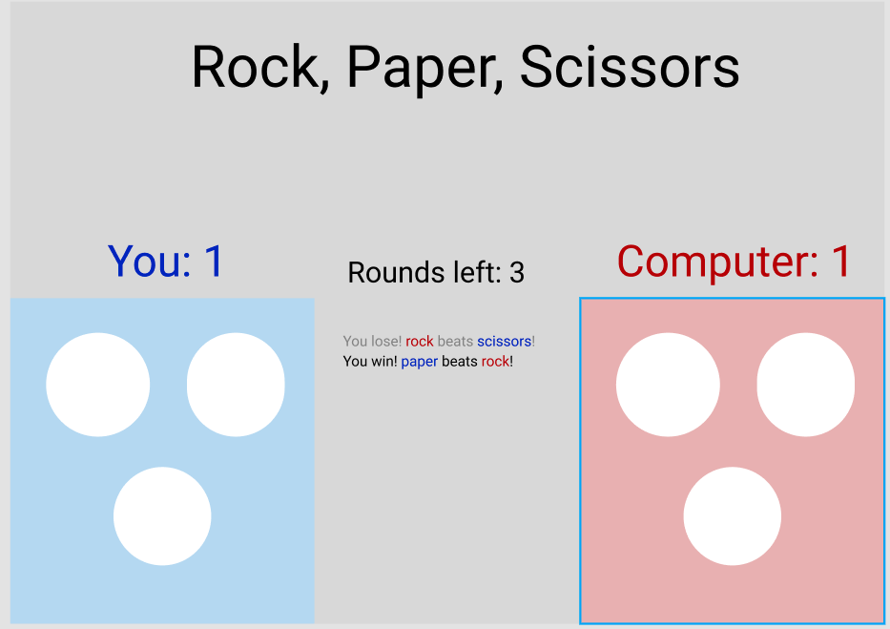

End result page:

