Greedy Weighted Graph Spanners
Implementation and Experimental Evaluation
Mini-Project on Embeddings of Graphs
Ben-Gurion University of the Negev
Student: Alon Ganot (ID: __________)
Date: June 2026
Source paper: I. Althofer, G. Das, D. Dobkin, D. Joseph, and J. Soares, "On Sparse Spanners of Weighted Graphs", Discrete & Computational Geometry, 1993.
Abstract. This report presents an implementation and empirical evaluation of the greedy weighted graph spanner algorithm of Althofer et al. The algorithm processes weighted edges in nondecreasing order and keeps an edge only when the current spanner distance is too long. The project implements the construction in Java, verifies the stretch and MST-related invariants, and evaluates the tradeoff between sparsity, total weight, and observed stretch across paths, cycles, trees, complete graphs, random connected graphs, planar grids, and theta-style hard examples. Across 270 full experimental runs, no stretch violations were found. Increasing k from 1 to 5 raised average edge reduction from 24.24% to 48.56%, while average lightness dropped from 3.91 to 1.01 times MST weight.

Table of Contents
1. Project Requirements and Scope
2. Background and Paper Summary
3. Implemented Algorithm
4. Software Design
5. Experimental Methodology
6. Experimental Results
7. Discussion
8. Conclusions
9. Future Work
References
Appendix A. Reproducibility Commands
Appendix B. Full Experiment Summary

1. Project Requirements and Scope
The syllabus defines the mini-project goal as reading a paper in low-distortion graph embeddings, implementing one algorithm from the paper, running experiments, and summarizing the results in a final report [2]. The selected paper is Althofer, Das, Dobkin, Joseph, and Soares, "On Sparse Spanners of Weighted Graphs" [1]. The implemented algorithm is the paper's greedy SPANNER construction for weighted undirected graphs.
The project focuses on sparse subgraphs called spanners. In a weighted graph, the distance between two vertices is the minimum total weight of any path between them, where the weight of a path is the sum of the weights of its edges. Given a connected weighted graph G, the goal is to build a subgraph H on the same vertex set such that all pairwise distances in H are at most a controlled multiplicative factor larger than in G. The experiments therefore measure three quantities: distance preservation, edge sparsity, and total weight relative to a minimum spanning tree.
- Algorithmic requirement: implement the weighted greedy spanner construction. This means scanning the weighted edges from lightest to heaviest and keeping an edge only when the current partial spanner does not yet contain a short enough replacement path between its endpoints. Section 2.4 gives the paper-level algorithm, and Section 3 describes the Java implementation.
- Experimental requirement: evaluate the algorithm on several graph families and parameters.
- Report requirement: explain the theory, implementation decisions, measured results, and limitations.

2. Background and Paper Summary

2.1 Spanner definition
Let G=(V,E,w) be an undirected graph with positive edge weights. For a path P=(e_1,...,e_q), define w(P)=Σ_{i=1}^{q} w(e_i). For vertices u,v in V, the weighted shortest-path distance is d_G(u,v)=min{w(P): P is a u-v path in G}. A subgraph H=(V,E_H,w), where E_H⊆E, is an r-spanner of G if:
d_H(u,v) ≤ r · d_G(u,v) for every u,v ∈ V.
The parameter r is the stretch parameter. The r-stretch guarantee means that every distance in H is allowed to be at most r times the corresponding distance in G. Since H is a subgraph of G, distances in H cannot be shorter than distances in G, so for u≠v the measured ratio satisfies 1 ≤ d_H(u,v)/d_G(u,v) ≤ r. A good spanner removes many edges while keeping r small. This is the standard graph-spanner definition used in the original weighted-spanner paper and in earlier graph-spanner work [1,3].

2.2 Sparsity and lightness
The paper distinguishes between two types of sparsity. Size sparsity concerns the number of spanner edges, Size(H)=|E_H|. Weight sparsity concerns the total edge weight, Weight(H)=Σ_{e∈E_H}w(e). The minimum spanning tree MST(G) is the natural baseline for weight because it is the lightest connected spanning subgraph. The lightness metric used in the experiments is Weight(H)/Weight(MST(G)). An MST alone can still have poor stretch on graphs such as cycles, so a spanner may need to keep extra non-MST edges.
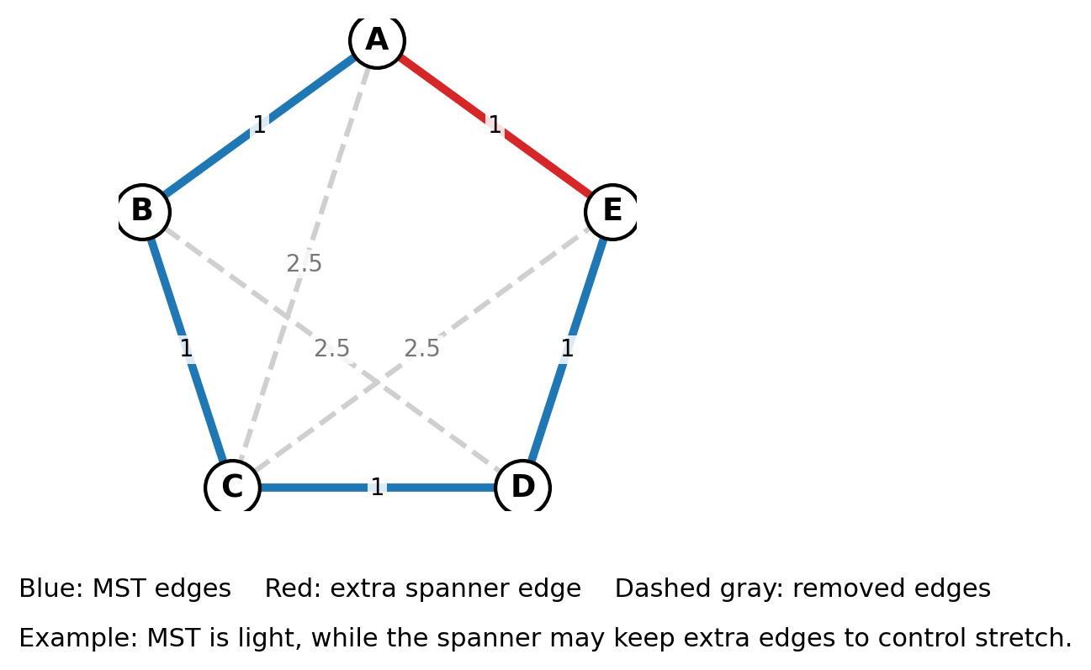
Figure 1. A small weighted example illustrating the difference between an MST and a spanner. The MST is light and connected, but the spanner may keep extra edges so that distances do not grow too much; edges with sufficiently short replacement paths can be removed.

2.3 Main theoretical guarantees used in the project
The paper proves that the greedy construction produces sparse spanners for arbitrary weighted graphs [1]. In the paper notation, running SPANNER(G,r) with r=2t+1 yields a (2t+1)-spanner. The project uses the more common implementation parameter k and sets r=2k-1. Therefore, for the theorems that use t, the mapping is t=k-1.

case | stretch | size comparison | use in report
General weighted graph | r=2k-1 | O(n^{1+1/k}) edges | paper gives a polynomially constructible sparse spanner; project reports |E_H|/n^(1+1/k)
Planar weighted graph, k>=2 | r=2k-1, k≥2 | (n-1)(1+1/(k-1)) edges | paper gives a sharper planar bound; project computes this ratio for planar families
Weight baseline | same stretch | MST(G)⊆H and Weight(H) is compared with Weight(MST(G)) | measured as w(H)/w(MST(G))
Table 1. Mapping between the paper notation and the project notation.

2.4 Greedy SPANNER algorithm from the paper
Before using the proof ideas, the algorithm itself should be stated. The greedy SPANNER algorithm starts with an empty subgraph on the same vertex set. It sorts all edges by nondecreasing weight. When it examines an edge e=(u,v), it checks the current distance d_H(u,v) inside the partial spanner H. If d_H(u,v)>r·w(e), the current spanner does not yet approximate this edge well enough, so e is added. Otherwise, e is rejected because the existing u-v path is already short enough.
This is a weighted analogue of Kruskal-style greedy processing: light edges are considered first, and edges that connect different current components are always accepted because their current distance is infinite. The difference from Kruskal is that cycle-forming edges may still be accepted when they are needed to keep stretch small.

2.5 Key proof ideas from the paper
- Shortest-path replacement proves stretch. A replacement path for a rejected edge e=(u,v) is the u-v path that already exists in the current spanner when e is processed. Since e is rejected only when that path has length at most r·w(e), every removed edge on a shortest G-path can be replaced by a short path in H. This gives the r-stretch guarantee: d_H(a,b)≤r·d_G(a,b) for all vertex pairs a,b.
- No short cycles proves edge sparsity. If the output contained a short cycle, the last edge of that cycle processed by the greedy order would have been rejected. Therefore the output has large girth, which implies few edges by extremal graph bounds.
- MST containment follows from Kruskal-like behavior. When an edge connects two disconnected components in the current partial spanner, its current distance is infinite and it is accepted. This parallels Kruskal's algorithm and implies that the output contains at least one MST of the input graph.
- Planar graphs admit stronger bounds. In planar graphs, face-size and Euler-formula arguments give a linear edge bound with a better multiplicative constant.

3. Implemented Algorithm
The implementation follows the greedy SPANNER algorithm directly. The input is a weighted undirected graph with positive finite edge weights. The output is a new graph H containing all vertices and only the selected edges. In words, the code repeatedly asks whether the edge currently being considered is still necessary. If the current spanner already gives a short enough route between the two endpoints, the edge is skipped; otherwise it is inserted into H.
GreedyWeightedSpanner(G, k):
r = 2k - 1
sort all edges by nondecreasing weight
H = graph with V(G) and no edges
for each edge e=(u,v) in sorted order:
compute d_H(u,v) by running Dijkstra on the current H
if d_H(u,v) > r * w(e):
add e to H with its original weight
return H
The strict comparison is important: the edge is added only when the current path is longer than the allowed threshold. If the current path is equal to the threshold, the edge is not needed for the requested stretch. The value d_H(u,v) is computed on the partial spanner before e is inserted. Since all edge weights are positive, Dijkstra's algorithm is valid. If u and v are disconnected in the current H, the distance is treated as infinity, and the edge is accepted.
Running time. Let n=|V| and m=|E|. Sorting the edges costs O(m log m). The clarity-first implementation then runs one Dijkstra computation for each candidate edge. With a standard heap implementation this gives a conservative worst-case bound of O(m·(m+n)log n) for construction, because the current spanner can contain O(m) edges in the worst case. The actual measured runtime is much smaller on the tested instances, but the implementation is not designed to be asymptotically optimal.

3.1 Behavior at k=1
For k=1, the stretch bound is 1. This does not necessarily mean that every original edge must remain. The output must preserve all shortest-path distances exactly. A heavy direct edge can still be removed if an equal or shorter path already exists through lighter edges. The unit-weight case is different: in complete graphs where every edge has weight 1, each direct edge is the unique length-1 connection between its endpoints, while every alternative path has length at least 2. Therefore complete unit-weight graphs keep all edges at k=1, but for k≥2 they can collapse to a tree-like spanner in the tested cases.

4. Software Design
The implementation is written in Java and uses JGraphT for weighted graph storage, Dijkstra shortest paths, and Kruskal MST computations [5]. The design separates graph construction, spanner construction, metric computation, experiments, tests, and plotting.
component | role
GreedyWeightedSpanner.java | Core greedy construction; validates k and positive weights; computes Dijkstra on the current spanner for each candidate edge.
GraphMetrics.java | Computes total weight, MST weight, maximum observed stretch, stretch violations, and tie-safe MST containment.
GraphFactory.java | Creates deterministic graph families: paths, cycles, random trees, complete graphs, random connected graphs, grids, and theta-style examples.
ExperimentRunner.java | Runs quick and full experiment suites for k=1..5 and writes CSV rows.
SanityTests.java | Checks correctness properties before running the experimental pipeline.
make_plots.py | Creates derived metrics, tables, quantitative plots, and visual graph examples.
Table 2. Main project components.

4.1 Correctness checks
The current project archive was compiled and the Java sanity tests were run under OpenJDK 21.0.10. All six tests passed:
PASS triangle heavy edge skipped
PASS tree unchanged
PASS k=1 exact distances
PASS MST containment
PASS stretch bound on deterministic random graphs
PASS invalid weights rejected
PASS all sanity tests (6/6)
A practical implementation detail is that MST containment is checked in a tie-safe way. If weights are equal, several MSTs may exist, so the project checks whether the spanner contains some MST of the original graph by comparing MST weights, instead of requiring a particular arbitrary MST returned by a library.

5. Experimental Methodology
The full experiment suite evaluates k=1,2,3,4,5 on 54 deterministic scenarios, giving 270 rows. The scenario set intentionally mixes trivial cases, dense cases, planar cases, random cases, wide-weight cases, and constructed hard examples. Because the scenarios have different numbers of vertices and edges, aggregate tables should be read as averages over the whole benchmark suite rather than as results for one fixed graph size.
Runtime measurement. The reported runtime is the elapsed Java runtime recorded by the experiment runner for the greedy construction on each generated graph. Table 4 averages those measurements over graph families and sizes, so the runtime column is descriptive only; it should not be interpreted as an asymptotic timing curve.
Random sparse, random medium, and random dense are connected random-graph benchmark groups with increasing realized edge density. Table 5 reports their average input edge counts at k=3: 205.7, 366.3, and 489.0 edges respectively. The exact n,m values are written in the experiment CSV for each scenario. Theta-style hard graphs are lower-bound-inspired graphs built from several internally vertex-disjoint chains between two terminal vertices; deleting an edge forces the replacement path to go around a long alternate route, so these graphs intentionally resist sparsification near the target stretch.
family | purpose
paths and trees | Sparse baselines; no cycle edges should be removable because the graph is already minimally connected.
cycles and cycle-threshold examples | Show exactly when the final cycle edge can be skipped under a given stretch.
complete weighted graphs | Dense inputs where greedy sparsification is expected to be strongest.
complete unit graphs | Clean contrast between k=1 exact preservation and k>=2 tree-like output.
random connected graphs | Connected G(n,p)-style benchmarks with increasing realized densities; grouped as sparse, medium, and dense according to original edge count.
grid planar graphs | Structured planar weighted examples connected to the paper's planar theorem.
theta-style lower-bound graphs | Lower-bound-inspired theta graphs: multiple internally vertex-disjoint chains between two terminals, designed so replacement paths are long.
wide-weight-range graphs | Study behavior when weights vary over a larger range.
Table 3. Experiment graph families and their role.

5.1 Metrics
- Edge reduction: 100·(1 - |E_H|/|E_G|). Higher is sparser.
- Lightness: w(H)/w(MST(G)). A value close to 1 means the spanner is nearly as light as an MST.
- Maximum observed stretch: maximum over pairs u,v of d_H(u,v)/d_G(u,v).
- Stretch violations: number of pairs exceeding the allowed bound 2k-1.
- General size-bound ratio: |E_H|/n^(1+1/k), used as an empirical scale comparison for general graphs.
- Planar size-bound ratio for known planar scenarios and k>=2: |E_H| / ((n-1)(1+1/(k-1))).

6. Experimental Results
The headline result is that the empirical behavior matches the theory: no stretch violations occurred in any of the 270 full experiment rows. A replacement path is the path already present in H between the endpoints of a candidate edge. As k increases, the allowed stretch r=2k-1 increases, so longer replacement paths become acceptable and the algorithm tends to keep fewer and lighter edges.
k | 2k-1 | avg |E_H| | avg edge reduction % | avg w(H)/w(MST) | maximum observed stretch | avg stretch utilization | avg runtime ms
1.000 | 1.000 | 147.5 | 24.24 | 3.909 | 1.000 | 1.000 | 2.370
2.000 | 3.000 | 78.61 | 43.50 | 1.224 | 3.000 | 0.711 | 1.389
3.000 | 5.000 | 71.93 | 46.40 | 1.065 | 5.000 | 0.645 | 0.981
4.000 | 7.000 | 70.04 | 47.89 | 1.024 | 7.000 | 0.604 | 1.000
5.000 | 9.000 | 69.20 | 48.56 | 1.009 | 9.000 | 0.561 | 0.852
Table 4. Summary by k over all 54 scenarios.
Table 4 averages over all 54 scenarios for each k value. These scenarios include paths, trees, cycles, complete graphs, random graphs, planar grids, theta-style hard graphs, and wide-weight graphs, so the row average intentionally mixes different n and m values. This explains why the average edge reduction reaches only about 50% even though dense complete and random graphs shrink much more: paths, trees, cycles, and theta-style hard graphs contribute little or no edge reduction and pull the overall average down.
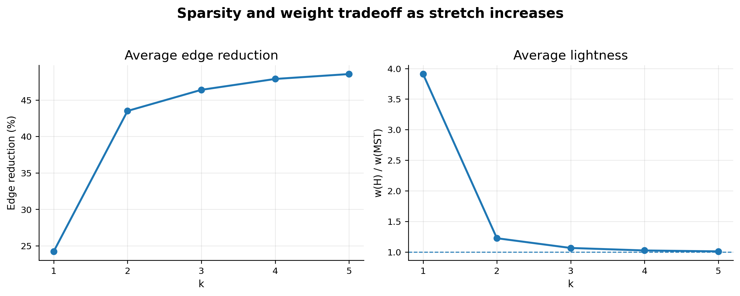
Figure 2. Average sparsity and lightness over all 54 scenarios. The dashed line in the right panel marks MST weight; the edge-reduction average is limited by sparse and hard families that cannot shrink much.

6.1 Stretch validation
The maximum observed stretch reached the allowed bound in some constructed cases, but never exceeded it. This is a useful result: it shows that the test suite is not only passing easy cases where the observed stretch is far below the bound. Some examples hit the bound exactly, which exercises the edge-rejection threshold.
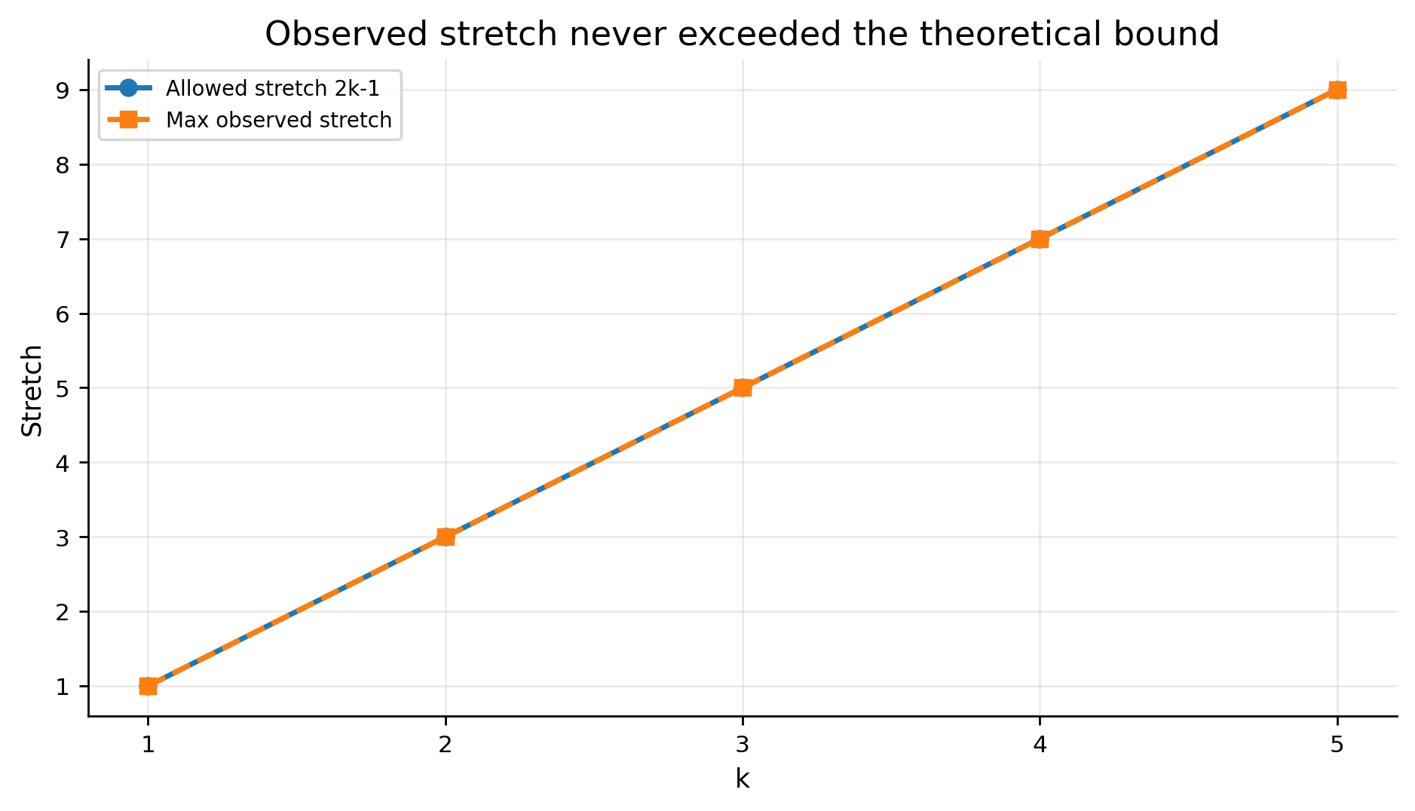
Figure 3. Maximum observed stretch compared with the theoretical bound 2k-1.

6.2 Behavior by graph family
Dense graphs are the easiest to sparsify, which is exactly the expected behavior: dense graphs contain many alternate paths, while sparse graphs have fewer replacement options. Complete weighted graphs averaged about 92.05% edge reduction at k=3 while remaining close to MST weight. Complete unit graphs show a sharper transition: at k=1 all unit edges are required to preserve exact distances, while for k≥2 the greedy output collapses to n-1 edges in the tested cases. Paths and trees do not shrink, because removing any edge disconnects the graph. Theta-style lower-bound examples resist sparsification around their target stretch, matching the lower-bound intuition in the paper [1].
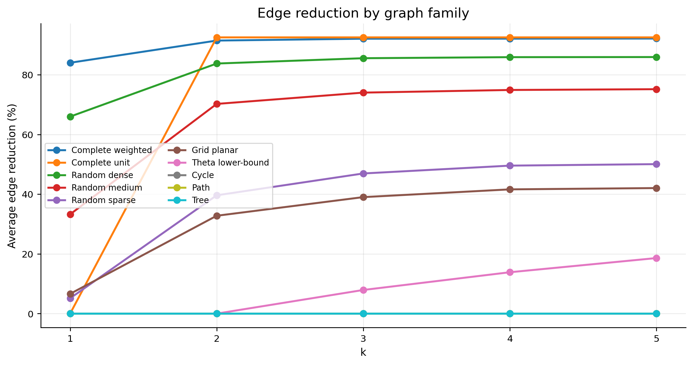
Figure 4. Average edge reduction by selected graph family. The pattern is expected: dense families shrink strongly, while paths, trees, and theta-style hard cases do not.
family | scenarios | avg |E_G| | avg |E_H| | avg edge reduction % | avg w(H)/w(MST) | max stretch
Complete wtd | 6 | 579.3 | 31.50 | 92.05 | 1.016 | 5.000
Complete unit | 2 | 485.0 | 29.00 | 92.50 | 1.000 | 2.000
Cycle | 4 | 85.00 | 85.00 | 0.000 | 1.017 | 1.000
Grid planar | 3 | 185.3 | 110.0 | 39.01 | 1.145 | 5.000
Path | 4 | 84.00 | 84.00 | 0.000 | 1.000 | 1.000
Random dense | 4 | 489.0 | 71.25 | 85.52 | 1.045 | 4.900
Random medium | 11 | 366.3 | 95.45 | 74.00 | 1.081 | 5.000
Random sparse | 3 | 205.7 | 110.3 | 46.93 | 1.134 | 5.000
Theta hard | 4 | 90.00 | 85.25 | 7.917 | 1.184 | 5.000
Tree | 4 | 84.00 | 84.00 | 0.000 | 1.000 | 1.000
Table 5. Family highlights at k=3.
Table 5 should be read as a k=3 family summary. Random sparse, random medium, and random dense denote increasing realized densities in the connected random benchmark generator; the average input edge counts in the table make the density difference explicit. Theta hard denotes the theta-style construction described above, not an ordinary random graph family.

6.3 Planar benchmarks
A planar graph is a graph that can be drawn in the plane without edge crossings. For planar families and k≥2, the project computed the ratio between the produced number of spanner edges and the paper's planar edge bound after applying the parameter mapping t=k-1. A ratio below 1 means that the empirical spanner size is below the theoretical planar upper bound. All tested planar families stayed below ratio 1. Grid graphs were nontrivial because the greedy spanner removed many edges while maintaining shortest-path approximation on a structured weighted planar graph.
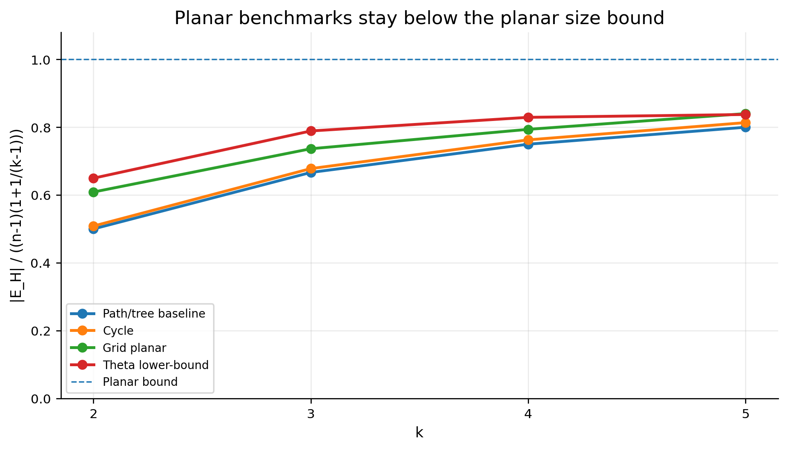
Figure 5. Ratio to the planar size bound for selected planar benchmark families. Lower is better; ratio 1 is the theoretical upper-bound line.

6.4 Visual examples
The visual examples compare the original graph with the greedy spanner. Blue edges are a chosen MST contained in the spanner; red edges are additional spanner edges; pale gray edges are removed. The example names encode the generator parameters: complete n10 means the complete graph K10; random n14 means a connected random graph on 14 vertices whose realized instance has 35 edges; grid 5x5 means a 5 by 5 planar grid with 25 vertices and 40 grid edges; theta K3 means the theta-style hard construction for target k=3; cycle n7 means a 7-cycle; and unit K20 means the complete graph K20 with unit edge weights. These examples are useful for the presentation because they make the abstract distance/sparsity tradeoff visible.
example | k | n | |E_G| | |E_H| | edge reduction % | max stretch | bound | w(H)/w(MST)
complete n10 | 2 | 10 | 45 | 10 | 77.78 | 2.091 | 3.000 | 1.214
random n14 | 3 | 14 | 35 | 13 | 62.86 | 3.000 | 5.000 | 1.000
grid 5x5 | 3 | 25 | 40 | 24 | 40.00 | 4.500 | 5.000 | 1.000
theta K3 | 3 | 20 | 24 | 24 | 0.000 | 1.000 | 5.000 | 1.263
cycle n7 | 4 | 7 | 7 | 6 | 14.29 | 6.000 | 7.000 | 1.000
unit K20 | 2 | 20 | 190 | 19 | 90.00 | 2.000 | 3.000 | 1.000
Table 6. Metrics for the generated visual examples.
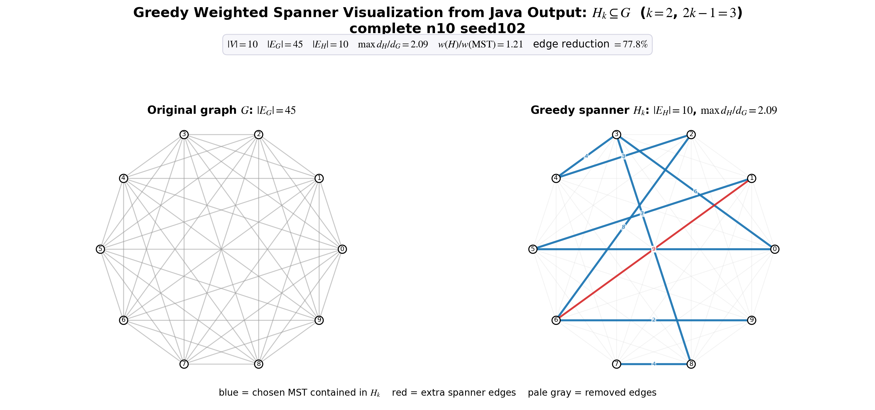
Figure 6. Complete weighted graph: 45 original edges reduced to 10 spanner edges at k=2.
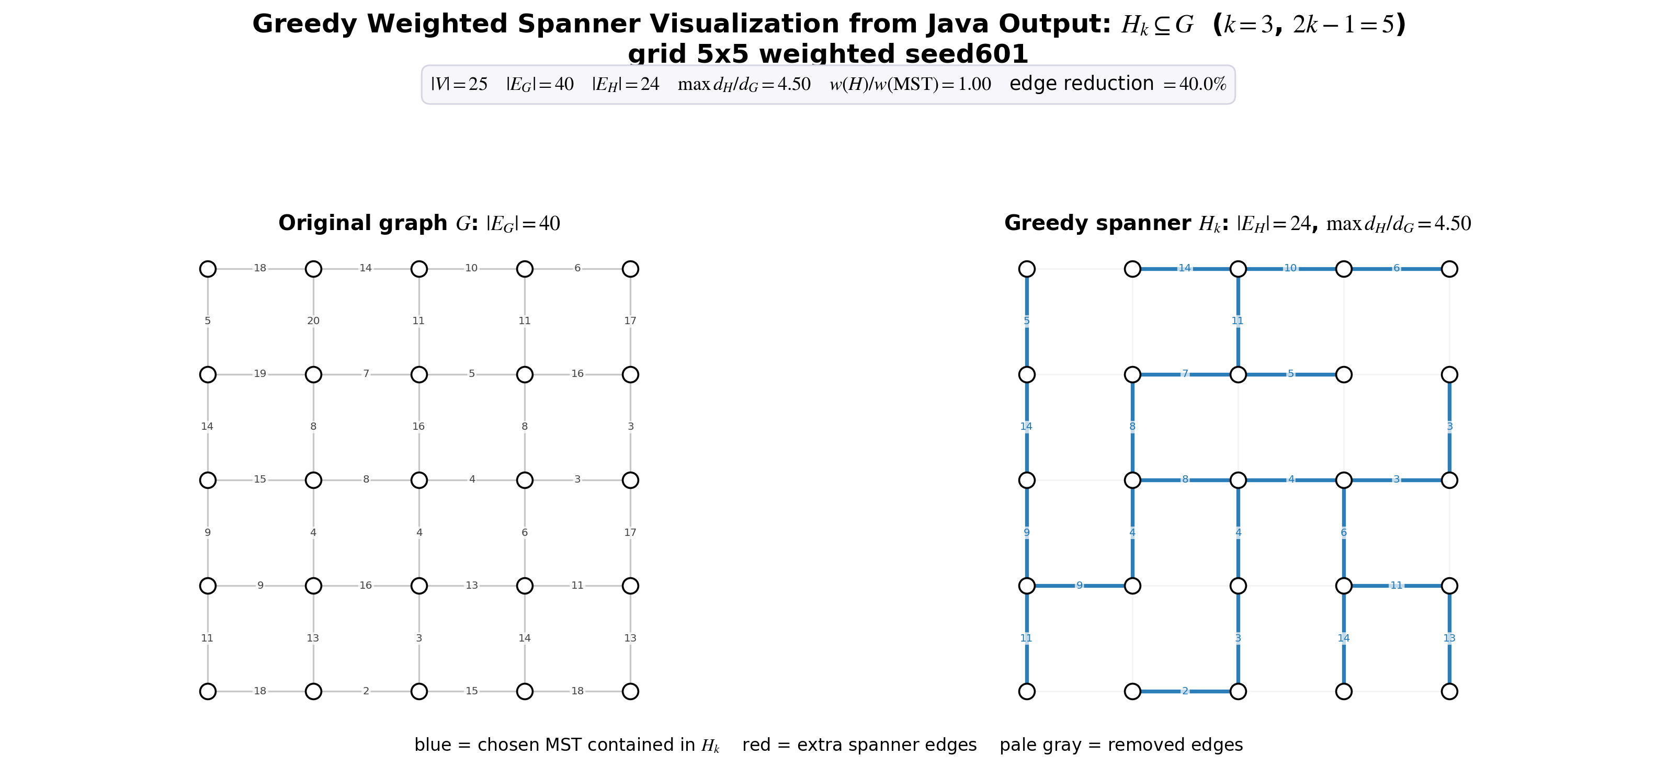
Figure 7. Weighted planar grid: 40 original edges reduced to 24 spanner edges at k=3. The numeric labels drawn along the highlighted path are path/order labels, not stretch values; the measured maximum stretch for this example is 4.5, below the bound 5 reported in Table 6.
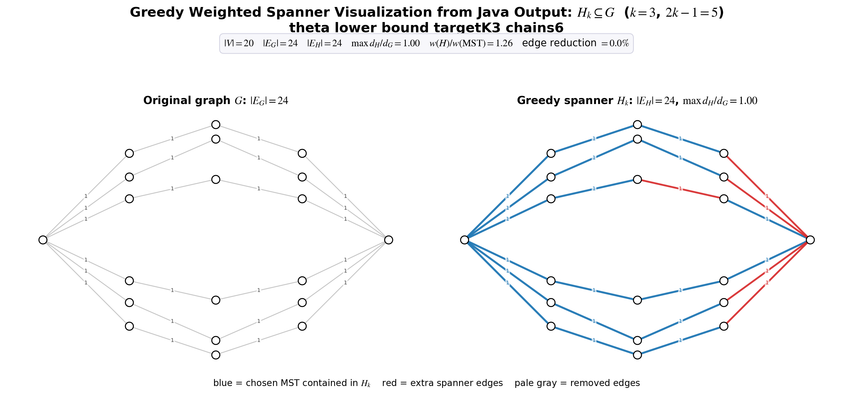
Figure 8. Theta-style example: no edge reduction at the matching target k=3. The graph is generated from several internally vertex-disjoint chains between the same two terminals, so removing one edge forces a long detour and can violate the target stretch.

7. Discussion

7.1 What the experiments confirm
- The greedy construction is correct on the tested inputs: all measured pairs satisfy d_H(u,v) ≤ (2k-1)d_G(u,v).
- The sparsity/stretch tradeoff is visible: larger k gives more room to replace direct edges by paths, so fewer edges are selected.
- The weight behavior is strong in practice: for k>=3 the average lightness was close to 1, meaning the output was often near MST weight while still preserving bounded stretch.
- The graph family matters. Dense graphs shrink dramatically, while paths and trees are already minimal. Lower-bound-inspired graphs are deliberately hard to sparsify.

7.2 Limitations
- The implementation prioritizes clarity over asymptotic speed. It recomputes Dijkstra during construction for each candidate edge, which gives a conservative O(m·(m+n)log n) construction bound for n vertices and m edges. This should be acceptable for the current mini-project scale, but larger dense graphs need a separate timing table.
- The current aggregate tables mix graph sizes and families. They validate correctness and qualitative behavior, but they should be extended with a dedicated large-graph benchmark: for example, connected random graphs with larger n and increasing edge probabilities, reporting n, m, p, construction time, edge reduction, and maximum stretch separately.
- The planar experiments use known planar generated families; the code does not perform a general planarity test for arbitrary inputs.
- The theoretical weight bounds are worst-case guarantees; the reported lightness is empirical and should not be overclaimed as proof of a stronger theorem.

8. Conclusions
The project satisfies the mini-project requirements: it studies a spanner paper, implements a central algorithm from that paper, performs a broad experimental evaluation, and summarizes the results. The greedy weighted spanner algorithm is simple but effective. It preserves the required stretch bound in all tested cases and often produces spanners that are both sparse and close to MST weight.
The strongest empirical pattern is that dense and weighted graphs benefit heavily from the greedy filter, while minimally connected or lower-bound-style graphs do not. This matches the theory: a spanner can only remove edges that have sufficiently short replacement paths.

9. Future Work
- Compare against Baswana-Sen-style faster spanner algorithms, especially the linear-time weighted (2k-1)-spanner algorithm [4].
- Run larger benchmarks and report runtime growth separately from construction and metric evaluation, with explicit n, m, and random-edge probability p for each graph family.
- Add a formal planarity detector and automatically apply planar-bound comparisons only when valid.
- Add memory measurements and repeated timing runs to reduce noise.
- Compare the greedy spanner against MST, random subgraphs, and Delaunay/geometry-based spanners when inputs have coordinates.

References
[1] I. Althofer, G. Das, D. Dobkin, D. Joseph, and J. Soares. "On Sparse Spanners of Weighted Graphs." Discrete & Computational Geometry, 9:81-100, 1993.
[2] Ben-Gurion University of the Negev. "Mini-Project on Embeddings of Graphs" course syllabus, 202-1-4071, semester B 2026.
[3] D. Peleg and A. Schaffer. "Graph Spanners." Journal of Graph Theory, 13(1):99-116, 1989.
[4] S. Baswana and S. Sen. "A Linear Time Algorithm for Computing a (2k-1)-Spanner of O(n^(1+1/k)) Size in Weighted Graphs." ICALP 2003.
[5] JGraphT project. JGraphT core graph library, version 1.5.2, used by the implementation.

Appendix A. Reproducibility Commands
From the project root on Windows PowerShell:
Set-ExecutionPolicy -Scope CurrentUser -ExecutionPolicy RemoteSigned -Force; Get-ChildItem .\scripts -Recurse -File -Filter *.ps1 | Unblock-File
.\scripts\java21.ps1
.\scripts\compile.ps1
.\scripts\test.ps1
.\scripts\run_experiments.ps1 full results\results.csv
.\scripts\make_plots.ps1
Expected sanity-test final line:
PASS all sanity tests (6/6)

Appendix B. Full Experiment Summary
The full run contains 270 rows over 54 scenarios and k values 1, 2, 3, 4, 5. Total stretch violations: 0. Maximum edge reduction: 96.00%. Maximum observed stretch: 9.00. For full reproducibility, the CSV should be kept with the submitted project so that each aggregated value can be traced back to its scenario name, n, m, and k.

